Support Information
Simulation study on the effect of pore structure and surface curvature of activated carbon on the adsorption and separation performance of CO₂/N₂
Weihua Chen ª, Weiqiu Huang ^{a*}, Lipei Fu ^{a*}, Xufei Li ^{b,a}, Xinya Wang ^{b,a}, Yongyin Zheng ª, Yilong Zhang ^{c}, Jiahui Zhuª and Bing Zhuª
a Jiangsu Provincial Key Laboratory of Oil-Gas Storage and Transportation Technology, Engineering Technology Research Center for Oil Vapor Recovery (ETRCOVR), Changzhou University, Changzhou 213164, China
b School of Materials Science and Engineering, Changzhou University, Changzhou 213164, China
c School of Emergency Management and Safety Engineering, China University of Mining and Technology (Beijing), Beijing 100083, Beijing, China
*Corresponding authors:
Weiqiu Huang, E-mail: hwq213@cczu.edu.cn, Telephone: +86-13506127318;
Lipei Fu, E-mail: fulipei@cczu.edu.cn, Telephone: +86-15695207997
1. Forcefield parameters
The interaction energy including van der Waals interaction force (E_{vdw}) and the electrostatic interaction force (E_{elc}) are shown in Equ. S1 and Equ S2, respectively. Tab. S1 shows LJ parameters of atoms.
 | 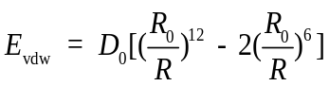 | (S1)
 | 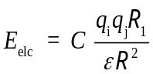 | (S2)
where, D₀ is the equilibrium well depth; R₀ is equilibrium distance; R is the distance between the two adsorption sites; C is the unit conversion factor; q_{i} and q_{j} are the charges of adsorption sites; R₁ is the constant and its value is 1 Å; ε is the relative dielectric constant.
Table S1 LJ parameters of activated carbon, CO₂ and N₂
Atom | D₀ (kcal · mol⁻¹) | R₀ (Å)
C (aromatic) | 3.8983 | 0.0951
C (CO₂) | 3.8983 | 0.0951
O | 3.4046 | 0.0957
N | 3.6621 | 0.0774

2. Structural characterization of the models
Fig. S1 Typical BSUs in the activated carbon models

Fig. S2 Adsorption processes of CO₂ (a) and N₂ (b) in the disordered model

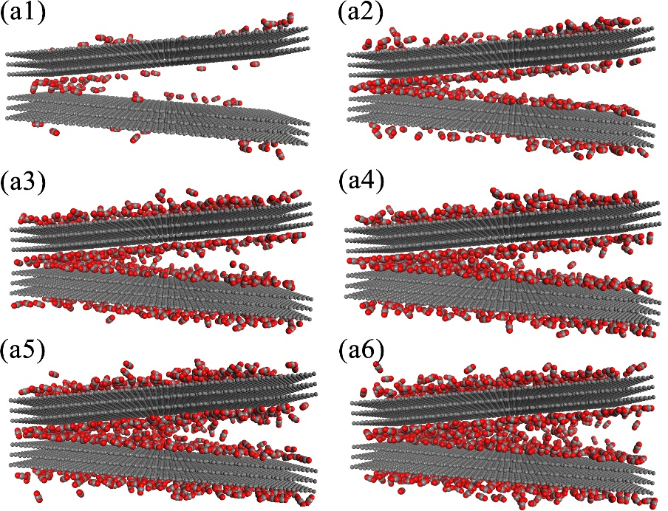
Fig. S3 Adsorption processes of CO₂ (a) and N₂ (b) in the wedge model

Fig. S4 Adsorption processes of CO₂ (a) and N₂ (b) in the nanotube model

Fig. S5 Adsorption processes of CO₂ (a) and N₂ (b) in the slit model

Fig. S6 Stable adsorption configures of CO₂ on activated carbon adsorbed with CO₂ from different directions: (a-h) side view and front view, (i-l) top view and front view

Fig. S7 Stable adsorption configures of N₂ on activated carbon adsorbed with CO₂ from different directions: (a-h) side view and front view, (i-l) top view and front view

