Supporting information
for

Precipitation and land use alter soil respiration in an Inner Mongolian grassland

Chi Zhang¹, Chao Song², Donghui Wang¹, Wenkuan Qin³, Biao Zhu³, Frank Yonghong Li¹, Yonghui Wang^{1*}, Wenhong Ma^{1*}

¹Ministry of Education Key Laboratory of Ecology and Resource Use of the Mongolian Plateau & Inner Mongolia Key Laboratory of Grassland Ecology, School of Ecology and Environment, Inner Mongolia University, Hohhot, 010021, China
²State Key Laboratory of Grassland Agro-Ecosystems, and College of Ecology, Lanzhou University, Lanzhou, 730000, China
³Institute of Ecology, College of Urban and Environmental Sciences, and Key Laboratory for Earth Surface Processes of the Ministry of Education, Peking University, Beijing 100871, China

This file includes:
Tables: Table S1–S6
Figures: Figure S1–S13

Supporting Tables

Table S1. Results (F-values) for effects of precipitation amount (P), land-use regime (L) and measurement date (D or Year, Y) on soil temperature (ST) and moisture (SM) at 5 cm depth, aboveground (ANPP) and belowground net primary production (BNPP) as well as soil microbial biomass carbon (MBC) and nitrogen (MBN). The effects were analyzed using repeated-measure analyses of variance or two-way analyses of variance (for ANPP and BNPP of different years and MBC and MBN), indicated by *** when P < 0.001, ** when P < 0.01, * when P < 0.05, # when P < 0.10 and n.s. (not statistically significant) when P > 0.10.

 | 2017 |  |  | 2018 |  |  | 2019 |  |  | Overall
 | df | F-value |  | df | F-value |  | df | F-value |  | df | F-value
Soil temperature at 5 cm depth
P | 2, 12 | 7.80 ** |  | 2, 12 | 8.13 ** |  | 2, 12 | 6.31 * |  | 2, 12 | 12.80 **
L | 2, 4 | 0.47 n.s. |  | 2, 4 | 1.21 n.s. |  | 2, 4 | 0.20 n.s. |  | 2, 4 | 0.83 n.s.
D | 10, 180 | 182.15 *** |  | 10, 180 | 121.71 *** |  | 11, 198 | 1417.69 *** |  | 33, 594 | 221.14 ***
P:L | 4, 12 | 1.77 n.s. |  | 4, 12 | 0.19 n.s. |  | 4, 12 | 0.95 n.s. |  | 4, 12 | 0.92 n.s.
P:D | 20, 180 | 0.49 n.s. |  | 20, 180 | 0.48 n.s. |  | 22, 198 | 1.33 n.s. |  | 66, 594 | 0.55 n.s.
L:D | 20, 180 | 2.77 *** |  | 20, 180 | 0.82 n.s. |  | 22, 198 | 2.08 ** |  | 66, 594 | 1.32 #
P:L:D | 40, 180 | 0.50 n.s. |  | 40, 180 | 0.27 n.s. |  | 44, 198 | 0.84 n.s. |  | 132, 594 | 0.39 n.s.
Soil moisture at 5 cm depth
P | 2, 12 | 860.72 *** |  | 2, 12 | 272.10 *** |  | 2, 12 | 80.13 *** |  | 2, 12 | 618.82 ***
L | 2, 4 | 1.21 n.s. |  | 2, 4 | 10.57 * |  | 2, 4 | 4.71 # |  | 2, 4 | 10.89 *
D | 10, 180 | 173.27 *** |  | 10, 180 | 94.00 *** |  | 11, 198 | 139.17 *** |  | 33, 594 | 114.00 ***
P:L | 4, 12 | 4.51 * |  | 4, 12 | 13.40 *** |  | 4, 12 | 1.30 n.s. |  | 4, 12 | 10.99 ***
P:D | 20, 180 | 9.34 *** |  | 20, 180 | 1.39 n.s. |  | 22, 198 | 2.20 ** |  | 66, 594 | 3.23 ***
L:D | 20, 180 | 3.91 *** |  | 20, 180 | 1.34 n.s. |  | 22, 198 | 1.83 * |  | 66, 594 | 3.46 ***
P:L:D | 40, 180 | 0.87 n.s. |  | 40, 180 | 0.83 n.s. |  | 44, 198 | 1.07 n.s. |  | 132, 594 | 0.98 n.s.
Aboveground net primary productivity
P | 2, 12 | 77.10 *** |  | 2, 12 | 125.11 *** |  | 2, 12 | 67.17 *** |  | 2, 12 | 379.71 ***
L | 2, 4 | 26.06 ** |  | 2, 4 | 0.41 n.s. |  | 2, 4 | 20.62 ** |  | 2, 4 | 3.93 n.s.
Y |  |  |  |  |  |  |  |  |  | 2, 36 | 0.94 n.s.
P:L | 4, 12 | 0.46 n.s. |  | 4, 12 | 3.02 # |  | 4, 12 | 0.87 n.s. |  | 4, 12 | 2.09 n.s.
P:Y |  |  |  |  |  |  |  |  |  | 4, 36 | 3.22 *
L:Y |  |  |  |  |  |  |  |  |  | 4, 36 | 4.01 **
P:L:Y |  |  |  |  |  |  |  |  |  | 8, 36 | 1.35 n.s.
Belowground net primary productivity
P |  |  |  | 2, 12 | 65.11 *** |  | 2, 12 | 158.81 *** |  | 2, 12 | 119.94 ***
L |  |  |  | 2, 4 | 14.87 * |  | 2, 4 | 16.13 * |  | 2, 4 | 17.71 *
Y |  |  |  |  |  |  |  |  |  | 1, 18 | 37.86 ***
P:L |  |  |  | 4, 12 | 0.57 n.s. |  | 4, 12 | 0.96 n.s. |  | 4, 12 | 0.47 n.s.
P:Y |  |  |  |  |  |  |  |  |  | 2, 18 | 0.31 n.s.
L:Y |  |  |  |  |  |  |  |  |  | 2, 18 | 28.44 ***
P:L:Y |  |  |  |  |  |  |  |  |  | 4, 18 | 0.35 n.s.
Microbial biomass carbon
P |  |  |  |  |  |  | 2, 12 | 17.77 ***
L |  |  |  |  |  |  | 2, 4 | 8.17 *
P:L |  |  |  |  |  |  | 4, 12 | 2.56 #
Microbial biomass nitrogen
P |  |  |  |  |  |  | 2, 12 | 11.09 **
L |  |  |  |  |  |  | 2, 4 | 0.61 n.s.
P:L |  |  |  |  |  |  | 4, 12 | 3.70 *
*** : P < 0.001, ** : P < 0.01, * : P < 0.05, # : P < 0.1, n.s. : P > 0.1

Table S2. Results (F-values) for effects of precipitation amount (P), land-use regime (L) and measurement date (D) on (natural logarithm transformed) soil respiration (R_{s}) and its autotrophic (R_{a}) and heterotrophic (R_{h}) components. The effects were analyzed using repeated-measure analyses of variance, indicated by *** when P < 0.001, ** when P < 0.01, * when P < 0.05, # when P < 0.10 and n.s. (not statistically significant) when P > 0.10.

 | 2017 |  |  | 2018 |  |  | 2019 |  |  | Overall
 | df | F-value |  | df | F-value |  | df | F-value |  | df | F-value
Soil respiration
P | 2, 12 | 334.93 *** |  | 2, 12 | 283.73 *** |  | 2, 12 | 496.86 *** |  | 2, 12 | 893.08 ***
L | 2, 4 | 7.82 * |  | 2, 4 | 1.97 n.s. |  | 2, 4 | 3.66 n.s. |  | 2, 4 | 14.06 *
D | 10, 180 | 139.14 *** |  | 10, 180 | 359.69 *** |  | 11, 198 | 315.76 *** |  | 33, 594 | 205.90 ***
P:L | 4, 12 | 4.59 * |  | 4, 12 | 0.37 n.s. |  | 4, 12 | 1.52 n.s. |  | 4, 12 | 2.35 n.s.
P:D | 20, 180 | 2.64 *** |  | 20, 180 | 4.15 *** |  | 22, 198 | 5.35 *** |  | 66, 594 | 3.33 ***
L:D | 20, 180 | 1.54# |  | 20, 180 | 5.63 *** |  | 22, 198 | 2.79 *** |  | 66, 594 | 3.00 ***
P:L:D | 40, 180 | 0.55 n.s. |  | 40, 180 | 1.96 ** |  | 44, 198 | 1.27 n.s. |  | 132, 594 | 1.06 n.s.
Autotrophic respiration
P | 2, 12 | 41.76 *** |  | 2, 12 | 10.69 ** |  | 2, 12 | 152.36 *** |  | 2, 12 | 153.28 ***
L | 2, 4 | 3.36 n.s. |  | 2, 4 | 0.15 n.s. |  | 2, 4 | 1.75 n.s. |  | 2, 4 | 13.08 *
D | 10, 180 | 38.16 *** |  | 10, 180 | 19.11 *** |  | 11, 198 | 44.89 *** |  | 33, 594 | 28.63 ***
P:L | 4, 12 | 1.42 n.s. |  | 4, 12 | 3.01 # |  | 4, 12 | 0.41 n.s. |  | 4, 12 | 1.38 n.s.
P:D | 20, 180 | 1.89 * |  | 20, 180 | 1.29 n.s. |  | 22, 198 | 2.99 *** |  | 66, 594 | 2.55 ***
L:D | 20, 180 | 1.61 # |  | 20, 180 | 1.22 n.s. |  | 22, 198 | 6.31 *** |  | 66, 594 | 2.48 ***
P:L:D | 40, 180 | 0.70 n.s. |  | 40, 180 | 1.07 n.s. |  | 44, 198 | 2.48 *** |  | 132, 594 | 1.37 **
Heterotrophic respiration
P | 2, 12 | 509.90 *** |  | 2, 12 | 532.20 *** |  | 2, 12 | 505.49 *** |  | 2, 12 | 1310.29 ***
L | 2, 4 | 3.82 n.s. |  | 2, 4 | 10.07 * |  | 2, 4 | 8.34 * |  | 2, 4 | 6.67 #
D | 10, 180 | 67.15 *** |  | 10, 180 | 283.53 *** |  | 11, 198 | 239.80 *** |  | 33, 594 | 139.23 ***
P:L | 4, 12 | 3.36 * |  | 4, 12 | 1.74 n.s. |  | 4, 12 | 0.95 n.s. |  | 4, 12 | 3.07 #
P:D | 20, 180 | 0.98 n.s. |  | 20, 180 | 4.11 *** |  | 22, 198 | 2.76 *** |  | 66, 594 | 2.12 ***
L:D | 20, 180 | 1.04 n.s. |  | 20, 180 | 8.56 *** |  | 22, 198 | 4.02 *** |  | 66, 594 | 3.40 ***
P:L:D | 40, 180 | 0.42 n.s. |  | 40, 180 | 1.75 ** |  | 44, 198 | 2.29 *** |  | 132, 594 | 0.98 n.s.
*** : P < 0.001, ** : P < 0.01, * : P < 0.05, # : P < 0.1, n.s. : P > 0.1

Table S3. Results of the initial structural equation model quantifying direct and indirect impacts of growing-season precipitation (GSP), land use, abiotic (soil temperature, ST, and moisture, SM, at 5 cm depth) and biotic (aboveground, ANPP, and belowground, BNPP, net primary productivities) factors on (natural logarithm transformed) autotrophic (R_{a}) component of soil respiration. These results were illustrated in Figure S7a. Given are the standard coefficients of pathways, standard errors of regression (S.E.), Z-value and level of significance for the regression weight (P-value).

Pathway |  |  | Standard coefficient | S.E. | Z-value | P-value
SM | ↔ | ST | –0.123 | 0.073 | –1.673 | 0.094
BNPP | ↔ | ANPP | 0.154 | 0.052 | 2.943 | 0.003
ST | ← | GSP | –0.496 | 0.167 | –2.970 | 0.003
SM | ← | GSP | 0.839 | 0.083 | 10.096 | <0.001
SM | ← | Mowing | 0.398 | 0.090 | 4.411 | <0.001
SM | ← | Grazing | 0.208 | 0.090 | 2.302 | 0.021
ANPP | ← | SM | 0.968 | 0.117 | 8.270 | <0.001
ANPP | ← | ST | 0.115 | 0.110 | 1.046 | 0.296
ANPP | ← | Mowing | –0.651 | 0.114 | –5.704 | <0.001
ANPP | ← | Grazing | –0.354 | 0.107 | –3.314 | 0.001
BNPP | ← | SM | 0.868 | 0.124 | 7.003 | <0.001
BNPP | ← | ST | –0.014 | 0.117 | –0.123 | 0.902
BNPP | ← | Mowing | –0.630 | 0.121 | –5.213 | <0.001
BNPP | ← | Grazing | –0.249 | 0.113 | –2.195 | 0.028
R_{a} | ← | ANPP | 0.060 | 0.208 | 0.290 | 0.772
R_{a} | ← | BNPP | 0.724 | 0.205 | 3.531 | <0.001
R_{a} | ← | ST | 0.077 | 0.097 | 0.797 | 0.425
R_{a} | ← | SM | 0.227 | 0.121 | 1.875 | 0.061

Table S4. Results of the initial structural equation model quantifying direct and indirect impacts of growing-season precipitation (GSP), land use, abiotic (soil temperature, ST, and moisture, SM, at 5 cm depth) and biotic (aboveground, ANPP, and belowground, BNPP, net primary productivities) factors on (natural logarithm transformed) heterotrophic (R_{h}) component of soil respiration. These results were illustrated in Figure S7b. Given are the standard coefficients of pathways, standard errors of regression (S.E.), Z-value and level of significance for the regression weight (P-value).

Pathway |  |  | Standard coefficient | S.E. | Z-value | P-value
SM | ↔ | ST | –0.123 | 0.073 | –1.673 | 0.094
MBN | ↔ | MBC | 0.548 | 0.160 | 3.428 | 0.001
ST | ← | GSP | –0.496 | 0.167 | –2.970 | 0.003
SM | ← | GSP | 0.839 | 0.083 | 10.096 | <0.001
SM | ← | Mowing | 0.398 | 0.090 | 4.411 | <0.001
SM | ← | Grazing | 0.208 | 0.090 | 2.302 | 0.021
MBN | ← | SM | 0.532 | 0.162 | 3.275 | 0.001
MBC | ← | SM | 0.387 | 0.158 | 2.453 | 0.014
MBC | ← | ST | –0.245 | 0.086 | –2.836 | 0.005
MBC | ← | Mowing | 0.142 | 0.089 | 1.586 | 0.113
MBC | ← | Grazing | –0.148 | 0.084 | –1.763 | 0.078
R_{h} | ← | MBC | –0.330 | 0.255 | –1.292 | 0.196
R_{h} | ← | MBN | 0.446 | 0.242 | 1.839 | 0.066
R_{h} | ← | ST | –0.171 | 0.145 | –1.184 | 0.237
R_{h} | ← | SM | 0.636 | 0.151 | 4.208 | <0.001

Table S5. Results of the final structural equation model quantifying direct and indirect impacts of abiotic (soil temperature, ST, and moisture, SM, at 5 cm depth) and biotic (aboveground, ANPP, and belowground, BNPP, net primary productivities) factors on (natural logarithm transformed) autotrophic (R_{a}) component of soil respiration. These results were illustrated in Figure 5a. Given are the standard coefficients of pathways, standard errors of regression (S.E.), Z-value and the level of significance for the regression weight (P-value).

Pathway |  |  | Standard coefficient | S.E. | Z-value | P-value
SM | ↔ | ST | –0.499 | 0.209 | –2.389 | 0.017
BNPP | ↔ | ANPP | 0.396 | 0.118 | 3.345 | 0.001
ANPP | ← | SM | 0.721 | 0.133 | 5.405 | <0.001
BNPP | ← | SM | 0.633 | 0.143 | 4.428 | <0.001
BNPP | ← | ST | –0.117 | 0.086 | –1.359 | 0.174
R_{a} | ← | ANPP | 0.060 | 0.209 | 0.289 | 0.773
R_{a} | ← | BNPP | 0.724 | 0.205 | 3.532 | <0.001
R_{a} | ← | ST | 0.077 | 0.094 | 0.817 | 0.414
R_{a} | ← | SM | 0.227 | 0.122 | 1.855 | 0.064

Table S6. Results of the final structural equation model quantifying direct and indirect impacts of abiotic (soil temperature, ST, and moisture, SM, at 5 cm depth) and biotic (aboveground, ANPP, and belowground, BNPP, net primary productivities) factors on (natural logarithm transformed) heterotrophic (R_{h}) component of soil respiration. These results were illustrated in Figure 5b. Given are the standard coefficients of pathways, standard errors of regression (S.E.), Z-value and the level of significance for the regression weight (P-value).

Pathway |  |  | Standard coefficient | S.E. | Z-value | P-value
SM | ↔ | ST | –0.499 | 0.209 | –2.389 | 0.017
MBN | ↔ | MBC | 0.541 | 0.163 | 3.324 | 0.001
MBN | ← | SM | 0.532 | 0.163 | 3.261 | 0.001
MBC | ← | SM | 0.431 | 0.162 | 2.664 | 0.008
MBC | ← | ST | –0.247 | 0.099 | –2.481 | 0.013
R_{h} | ← | MBC | –0.330 | 0.255 | –1.293 | 0.196
R_{h} | ← | MBN | 0.446 | 0.240 | 1.856 | 0.063
R_{h} | ← | ST | –0.171 | 0.146 | –1.174 | 0.241
R_{h} | ← | SM | 0.636 | 0.150 | 4.253 | <0.001

Supporting Figures

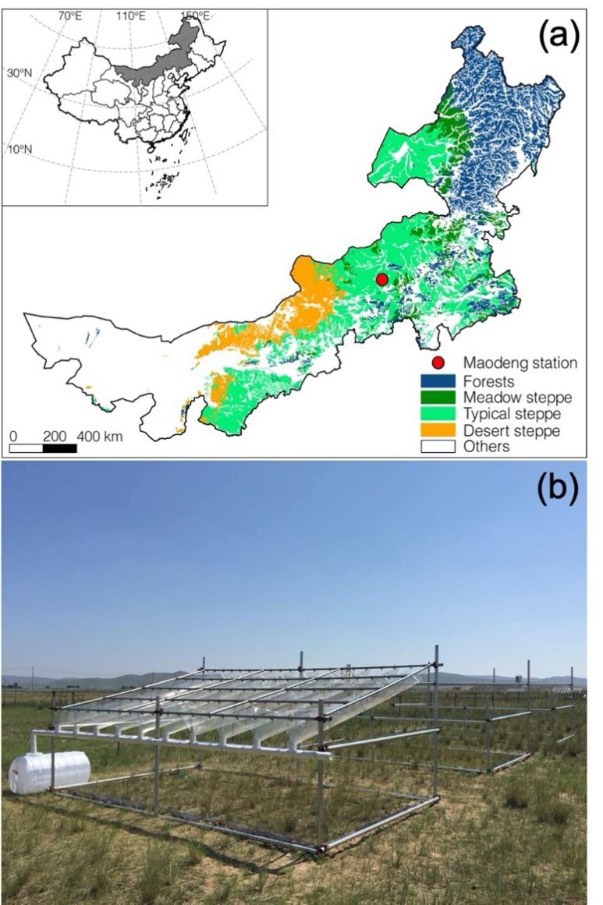

Figure S1. Location (a) and photo (b) of the altered precipitation amount and land-use regime experiment in an Inner Mongolian grassland (typical steppe).

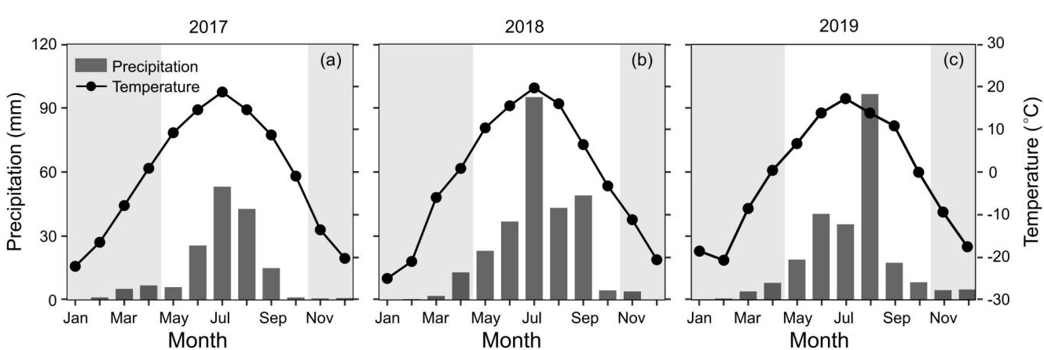
Figure S2. Seasonal and annual variations in monthly air temperature (cycles) and precipitation (bars) during the study period (a–c). The blank and shading periods represent the growing and non-growing seasons, respectively.

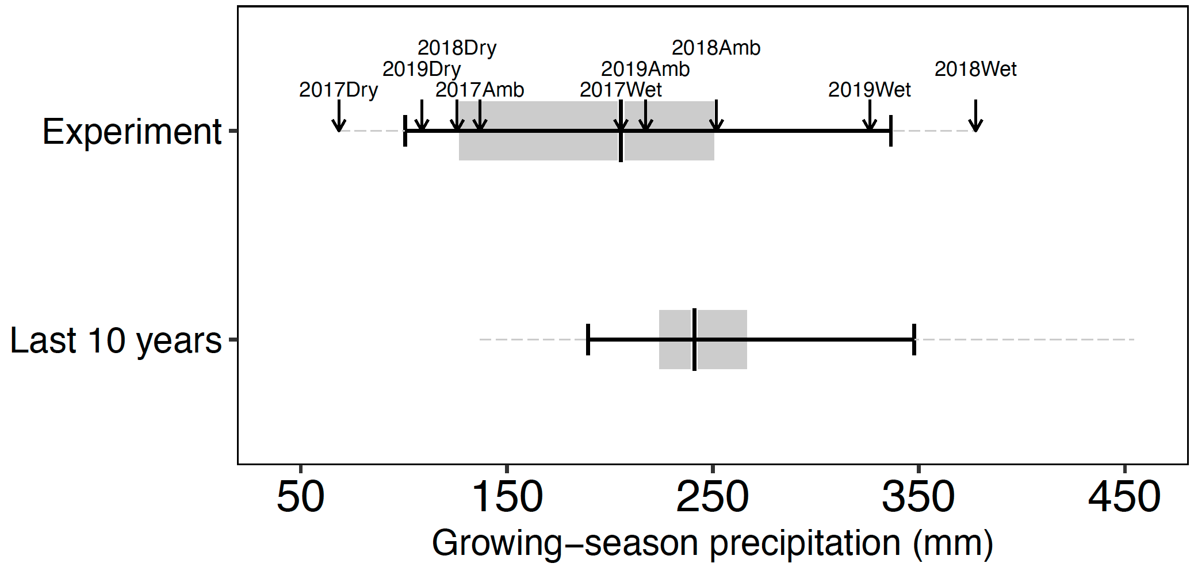
Figure S3. Box plots of growing-season precipitation in the in-situ experimental study and in the studied area over the last 10 years (2010-2019). The box plots show the medians (vertical solid black lines in the grey boxes), inter-quartile ranges (grey boxes), 10th and 90th percentiles (short black lines) and the minimum and maximum precipitation (dashed grey lines). Black arrows represent growing-season precipitation received by subplots of precipitation treatments (ambient growing-season precipitation ± 50%).

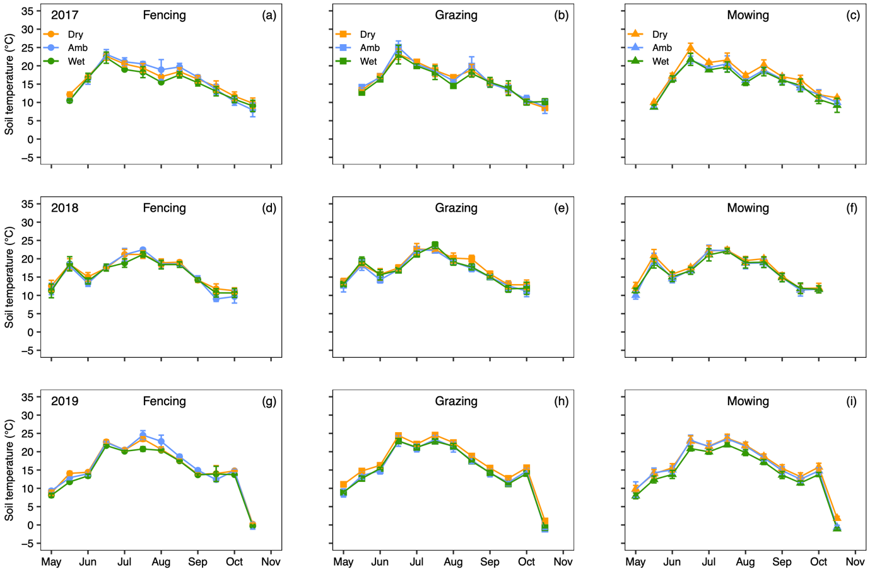
Figure S4. Seasonal variation in soil temperature (at 5 cm depth) under different precipitation amount and land use treatments during growing seasons of the 3-year study period (2017–2019). Symbols represent means ± standard error of the means (SE, n = 3).

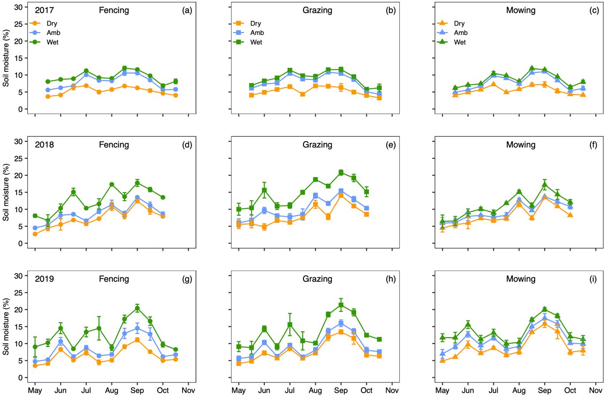
Figure S5. Seasonal variation in soil moisture (at 5 cm depth) under different precipitation amount and land use treatments during growing seasons of the 3-year study period (2017–2019). Symbols represent means ± standard error of the means (SE, n = 3).

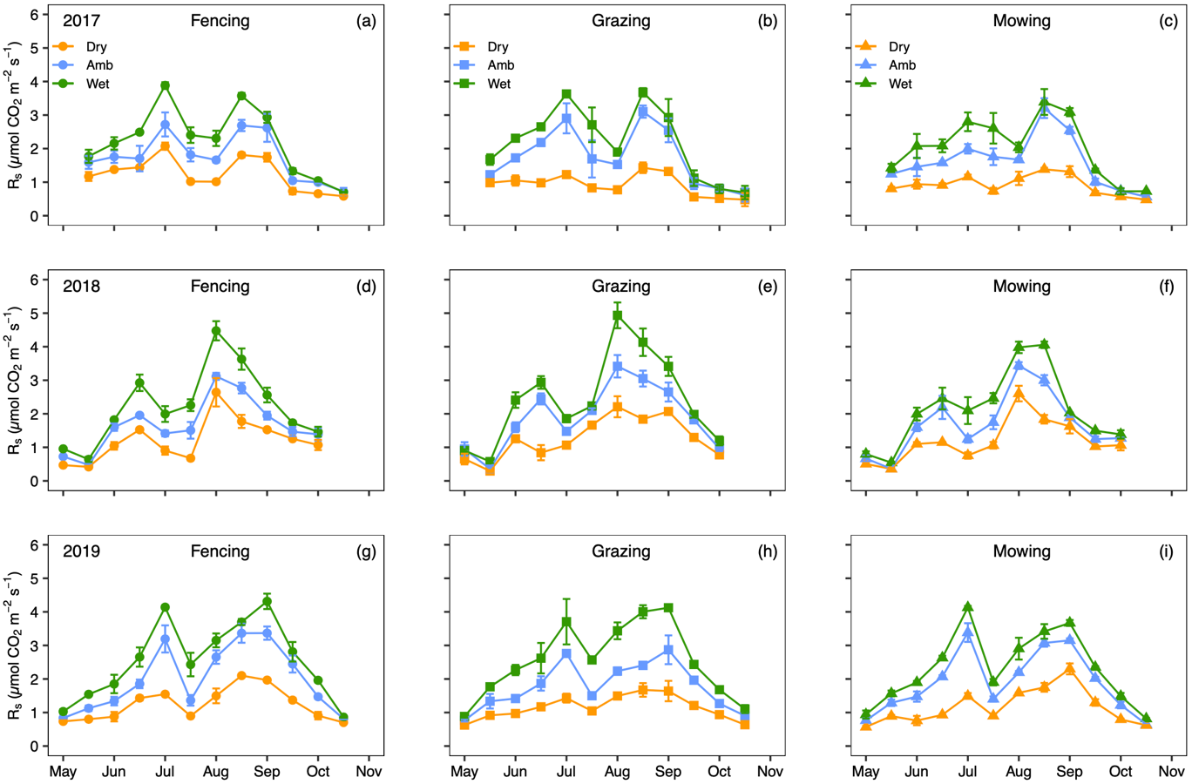
Figure S6. Seasonal variation in soil respiration (R_{s}) under different precipitation amount and land use treatments during growing seasons of the 3-year study period (2017–2019). Symbols represent means ± standard error of the means (SE, n = 3).

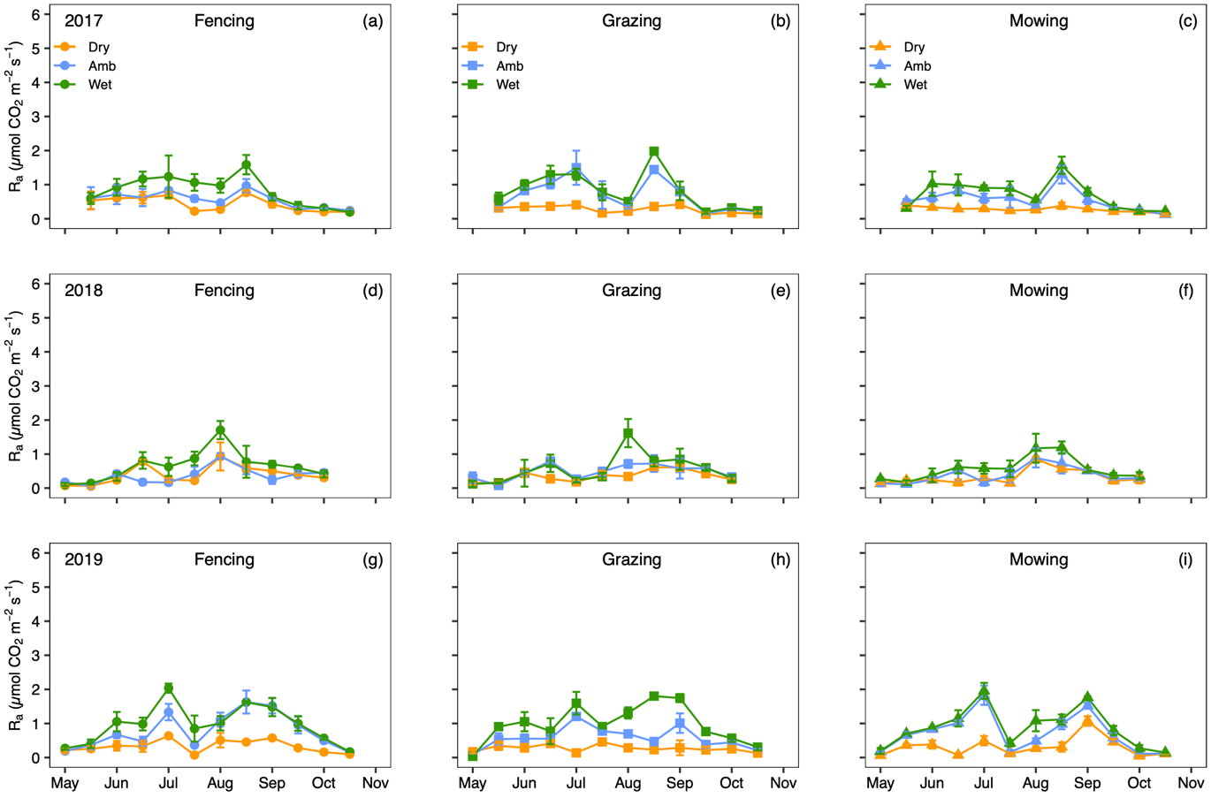
Figure S7. Seasonal variation in autotrophic component of soil respiration (R_{a}) under different precipitation amount and land use treatments during growing seasons of the 3-year study period (2017–2019). Symbols represent means ± standard error of the means (SE, n = 3).

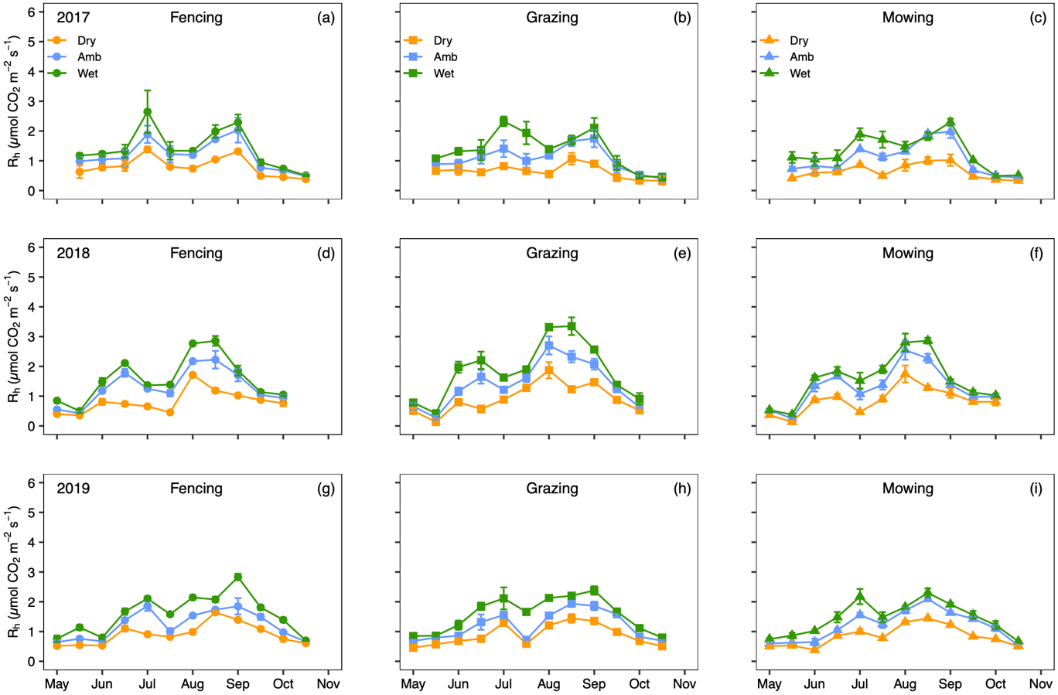
Figure S8. Seasonal variation in heterotrophic component of soil respiration (R_{h}) under different precipitation amount and land use treatments during growing seasons of the 3-year study period (2017–2019). Symbols represent means ± standard error of the means (SE, n = 3).

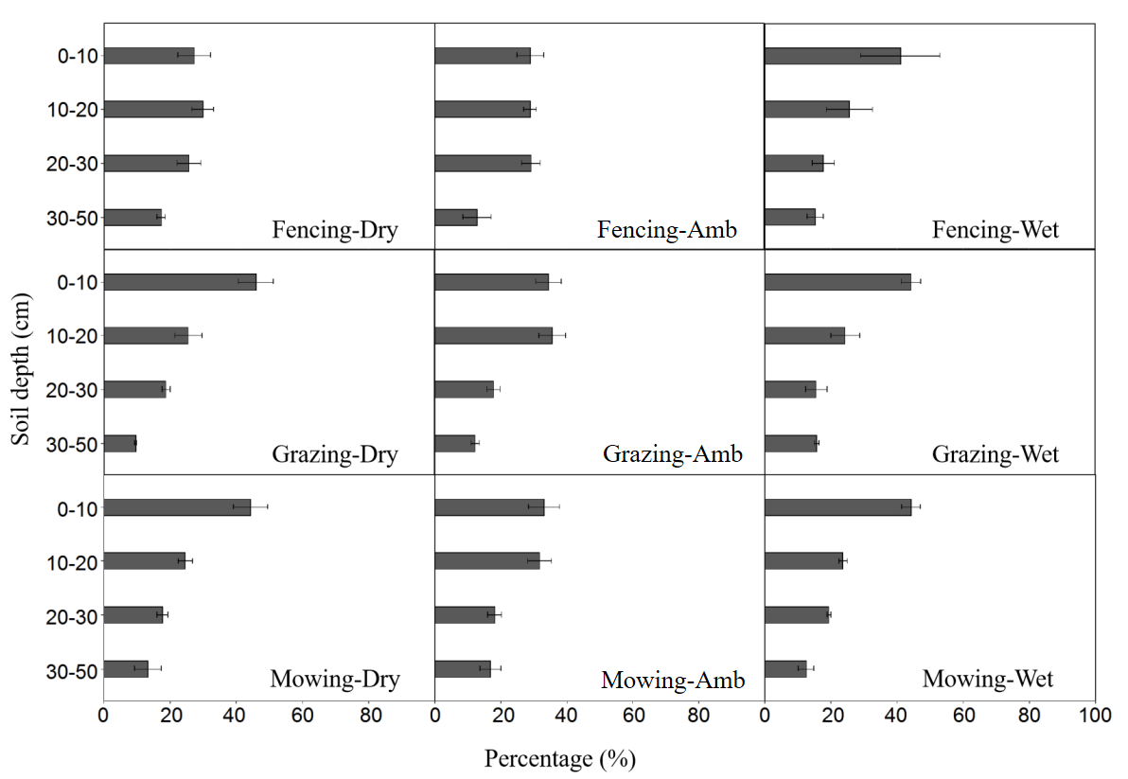
Figure S9. Vertical distributions of root biomass for different treatments in our experiment.

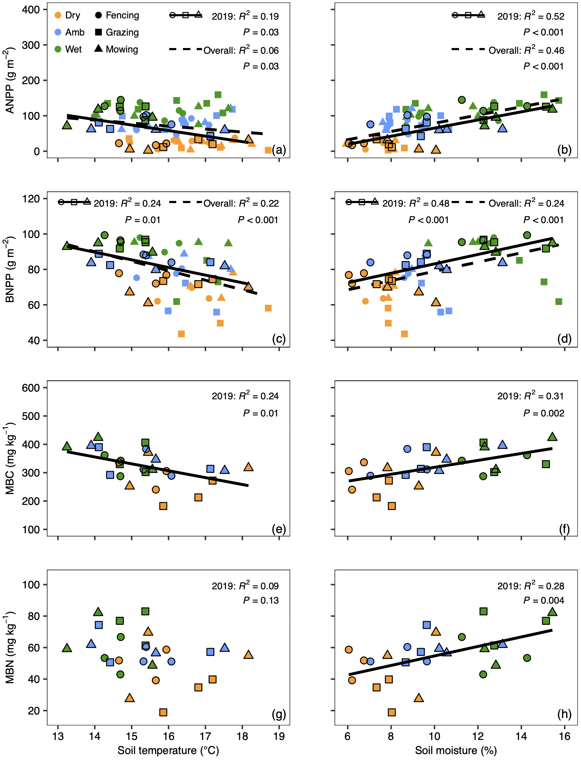
Figure S10. Aboveground (ANPP, a–b) and belowground (BNPP, c–d) net primary productivities as well as soil microbial biomass carbon (MBC, e–f) and nitrogen (MBN, g–h) in relation to soil temperature (a, c, e, and g) and moisture (b, d, f and h) at 5 cm depth. Annual mean values were used in analyses and results of linear regressions for 2019 only (solid lines) and overall 3-year study period (dashed lines) were shown in panels.

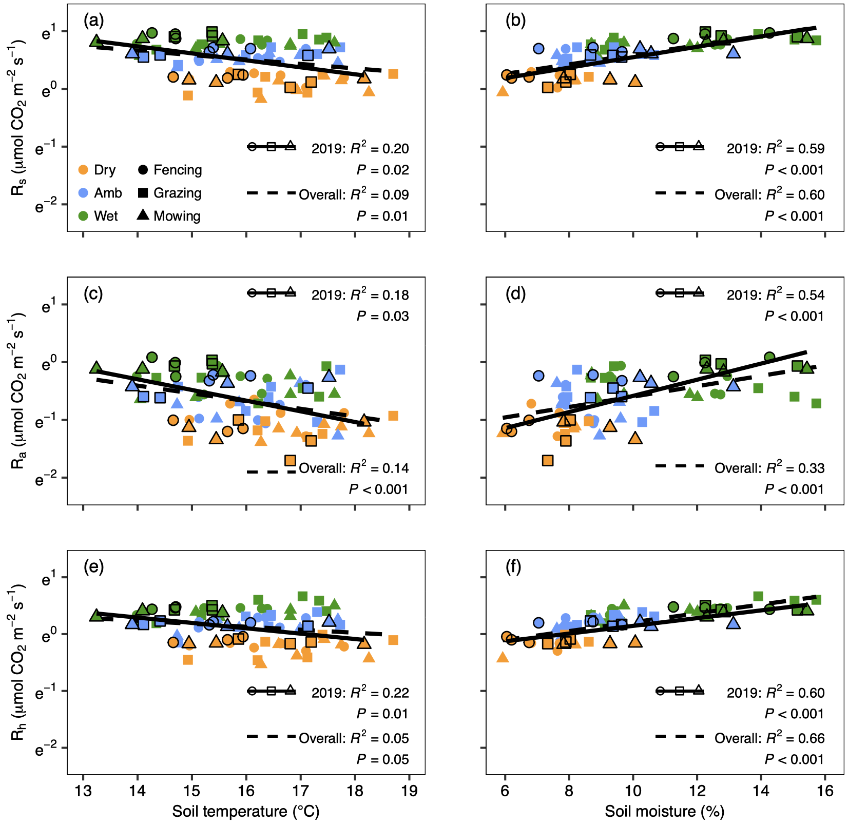
Figure S11. Soil respiration (R_{s}, a–b) and its autotrophic (R_{a}, c–d) and heterotrophic (R_{h}, e–f) components (natural logarithm transformed) in relation to soil temperature (a, c, and e) and moisture (b, d and f) at 5 cm depth. Annual mean values were used in analyses and results of linear regressions for 2019 only (solid lines) and overall 3-year study period (dashed lines) were shown in panels.

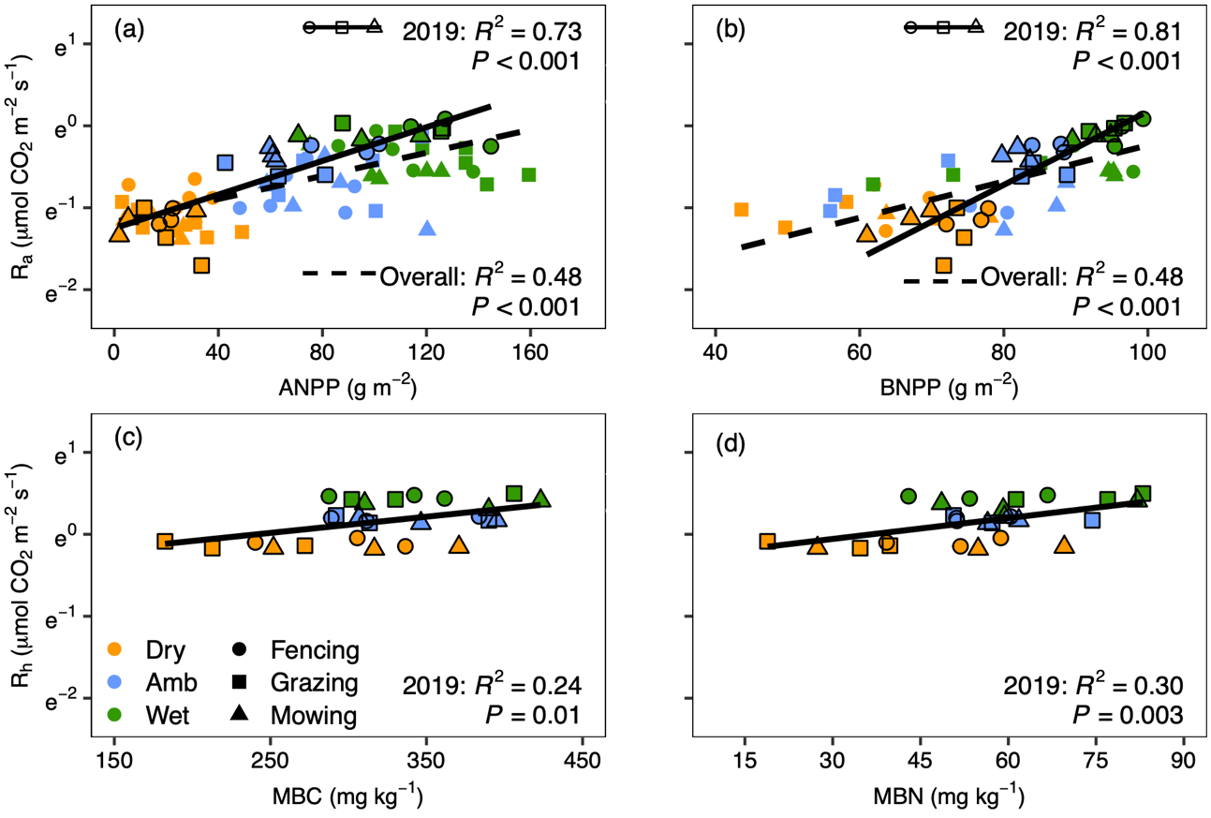
Figure S12. Autotrophic respiration (natural logarithm transformed) of plant roots (R_{a}) in relation to aboveground (ANPP, a) and belowground (BNPP, b) net primary productivities and heterotrophic respiration (natural logarithm transformed) of soil microbes (R_{h}) in relation to soil microbial biomass carbon (MBC, c) and nitrogen (MBN, d). Annual mean values were used in analyses and results of linear regressions for 2019 only (solid lines) and overall 3-year study period (dashed lines) were shown in panels.

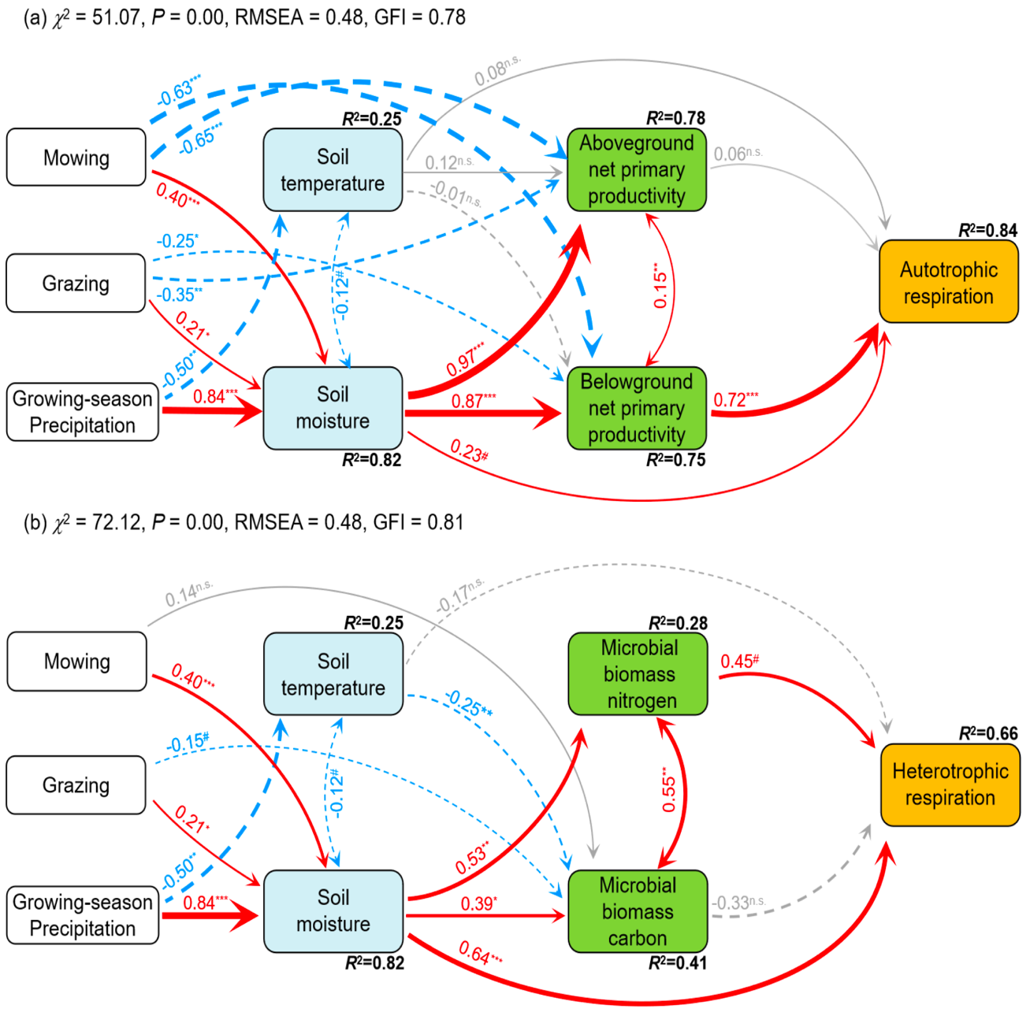
Figure S13. Diagrams of initial structural equation models (SEMs) for relating the (natural logarithm transformed) autotrophic (a) and heterotrophic (b) components of soil respiration to their biotic and abiotic driving factors as well as treatments of precipitation amount and land use. These initial SEMs were constructed based on theoretical knowledge and discovered treatment effects and linear relationships with using observations only in 2019 (n = 27 observations for each variable). We did not consider direct impacts of Dry and Wet treatments on NPP and microbial biomass, although they were significant (Figure 1–2 and Table S1–S2), as these impacts should be largely caused by influenced soil microclimate. All arrows are scaled in relation to the strength of the relationship, with numbers showing the standard path coefficients and indicated by *** when P < 0.001, ** when P < 0.01, * when P < 0.05, # when P < 0.10 and n.s. (not statistically significant) when P > 0.10. R² values are proportions of variance explained by dependent variables in the model. Model-fit statistics such as χ²-test, RMSEA and GFI are shown in each panel. Details of these SEMs can also be found in Table S3–S4. Results of final SEMs can be found in Figure 4 and Table S5–S6.

