Looking Beyond the Cytogenetics in Haematological Malignancies - Decoding the Role of Tandem Repeats in DNA Repair Genes

Priyanjali Bhattacharya¹, Trupti N Patel^{1*}
¹Department of Integrative Biology, Vellore Institute of Technology, Vellore, India

*Correspondence Address- tnpatel@vit.ac.in, Dr.TNPatel@gmail.com
Supplementary data
Table 1: Characteristics of the six cell lines as available from online source.
Cell lines | Cytogenetic features* | Mismatch Repair proficiency | Disease
HCT116 | Human near diploid karyotype with 3% polyploidy- 45(44-46)(2n)X/XY, add(10)(q24-26), der(16)t(8;16)(q13;p13), der(18)t(17;18)(q13-21;p11.3) | MLH1, MSH3–Negative – Nonproficient | Colorectal cancer
MCF-7 | Human hypotetraploid karyotype with 8% polyploidy - 86(80-87)<4n>XX, -X, -X, -1, -1, +6, +7, -9, -10, -10, -12, -13, -13, +14, -17, -17, -18, -18, -20, -20, -20, -22, +6-8mar, add(X)(q27), add(2)(q35-37)x1-2, add(5)(p15), del(6)(q25)x1-2, add(7)(p11), add(7)(p14;hsr), add(10)(q23), del(11)(q21q23), add(15)(p11), i(15q), add(16)(q24), add(19)(q13), add(19)(p13)x1-2 | MMR proficient | Breast  Cancer
KG-1 | Human hypodiploid karyotype with 4.5% polyploidy- 45(42-47)<2n>X/XY, -4, +8, -12, -17, -20, +2mar, der(5;17)(q10;q10)del(5)(q?11q?13), dup(7)(q12q33), del(7)(q22q35), i(8q)X2, der(8)t(6;8)(p11;q22), der(8)t(8;12)(p11;q13), der(11)t(1;11)(q13-21; p11-13), der(16)t(?12;16)(?p13;q13/21) | MMR proficient | AML
Daudi | Human near diploid karyotype with 20% polyploidy- 46 (45-48)(2n)XY/XXY, +7, -9, t(8;14)(q24;q32) | MMR proficient | Burkitt’s lymphoma
Molt-4 | Human flat moded hypertetraploid karyotype- 89-99<4n>XXYY, +4, +7, +8, +20, del(6)(q16)X2, der(7)t(7;7)(p15;q11)X2 | Mutations in either of the MSH2/MSH6 or MLH1/PMS2 – Nonproficient | T-ALL
K562 | Human hypotriploid karyotype without sharp mode- 61-68<3n>XX, -X, -3, +7, -13, -18, +3mar, del(9)(p11/13), der(14)t(14;?)(p11;?), der(17)t(17;?)(p11/13;?), der(?18)t(15;?18)(q21;?q12), del(X)(p22) | MMR proficient | CML
*Source-DSMZ.de (The Leibniz Institute DSMZ-German Collection of Microorganisms and Cell Cultures)

Table 2: The passage number and growth conditions maintained for each cell line under study.

Cell line | Passage number received | Growth condition
K562 | 22 | RPMI-1640 supplemented with 10% FBS
KG-1 | 13 | IMDM, and supplemented with 5% FBS
Molt-4 | 14 | RPMI-1640 supplemented with 10% FBS
Daudi | 20 | RPMI-1640 supplemented with 10% FBS
HCT116 | 3 | RPMI-1640 supplemented with 10% FBS
MCF-7 | 28 | RPMI-1640 supplemented with 10% FBS

Table 3: Definition of microsatellite repeat sequences.
Types of microsatellites | Definition | Example
Perfect | A continuous stretch of nucleotide repeat | CACACACACACA
Imperfect | Repetitive sequence interrupted by another nucleotide base | CACACACATCACACACA
Interrupted | Presence of small sequence in between that do not match with the repeat | CACACAGTATCACACA
Composite/compound | Two adjacent distinct sequence repeats | CACACATATATA

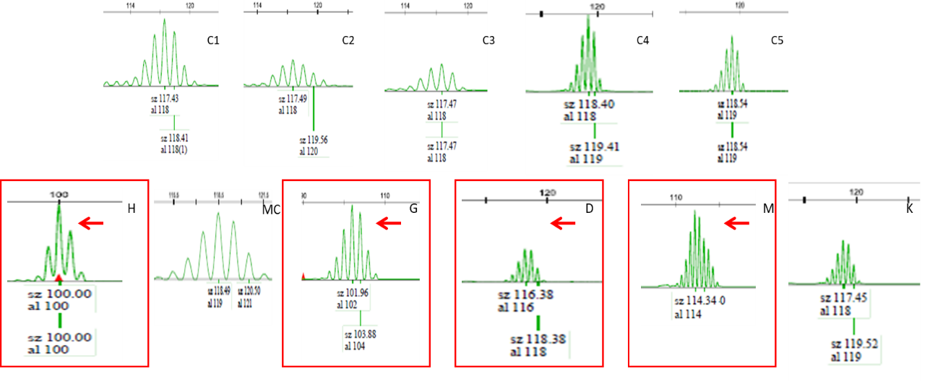
Figure 1: Tandem repeat instability for BAT26 marker; C1-5- Control, H-HCT116, MC-MCF-7, G-KG-1, D-Daudi, M-Molt-4, K-K562.

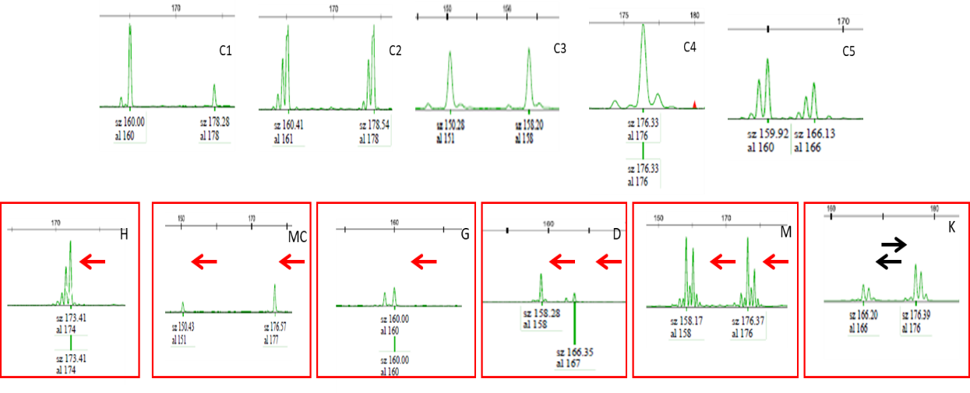
Figure 2: Tandem repeat instability for MSH3 marker; C1-5- Control, H-HCT116, MC-MCF-7, G-KG-1, D-Daudi, M-Molt-4, K-K562.

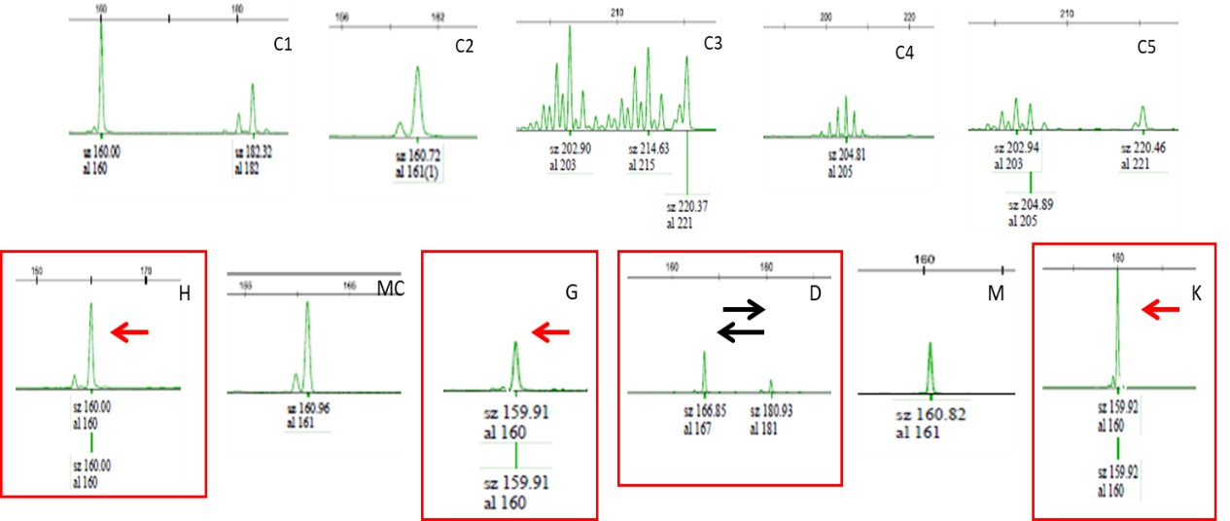
Figure 3: Tandem repeat instability for MSH4 marker; C1-5- Control, C1-5- control, H-HCT116, MC-MCF-7, G-KG-1, D-Daudi, M-Molt-4, K-K562.

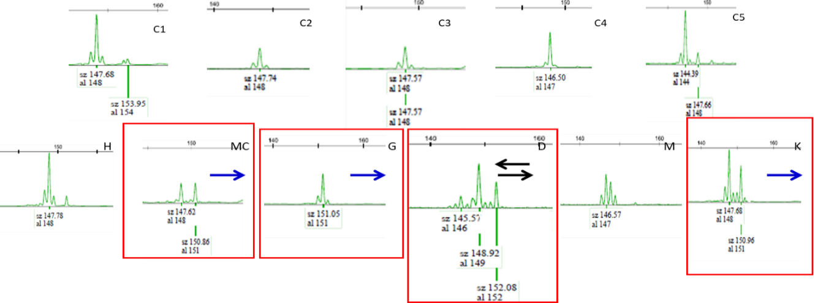
Figure 4: Tandem repeat instability for MSH5 marker in the cell lines; C1-5- Control, H-HCT116, MC-MCF-7, G-KG-1, D-Daudi, M-Molt-4, K-K562.
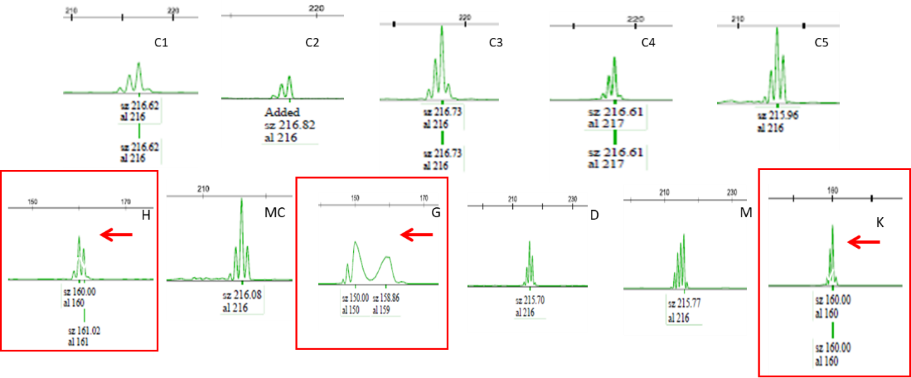
Figure 5: Tandem repeat instability for MSH6 marker in the cell lines; C1-5- Control, H-HCT116, MC-MCF-7, G-KG-1, D-Daudi, M-Molt-4, K-K562.

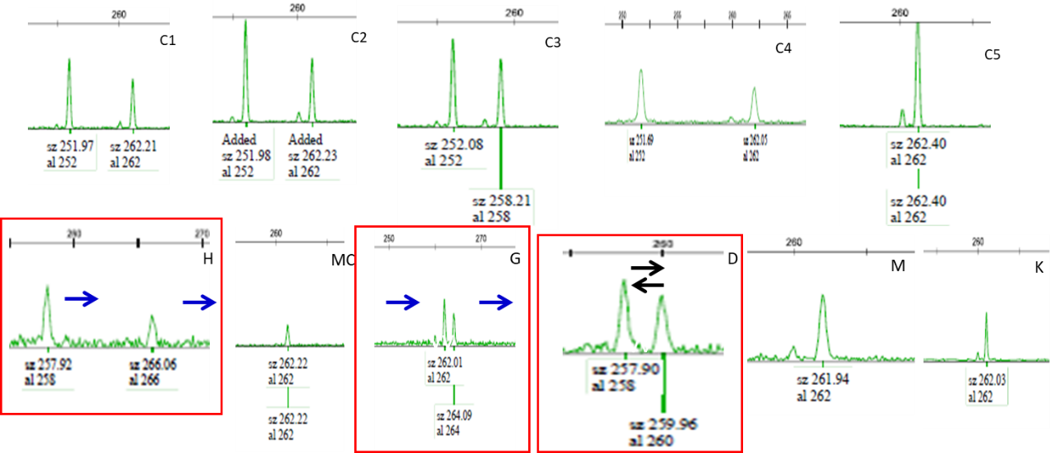
Figure 6: Tandem repeat instability for MLH1 marker in the cell lines; C1-5- Control, H-HCT116, MC-MCF-7, G-KG-1, D-Daudi, M-Molt-4, K-K562.

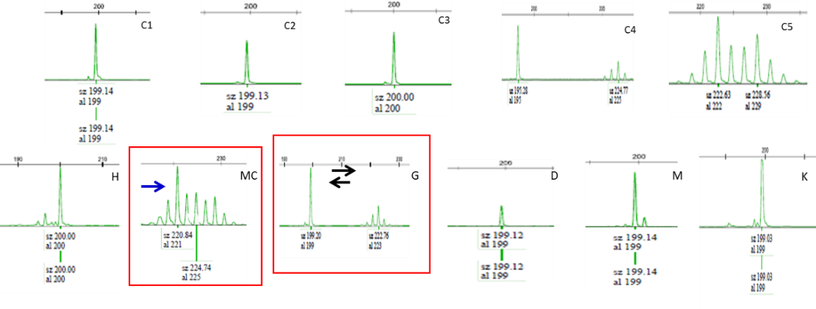
Figure 7: Tandem repeat instability for MLH3 marker in the cell lines; C1-5- Control, H-HCT116, MC-MCF-7, G-KG-1, D-Daudi, M-Molt-4, K-K562.
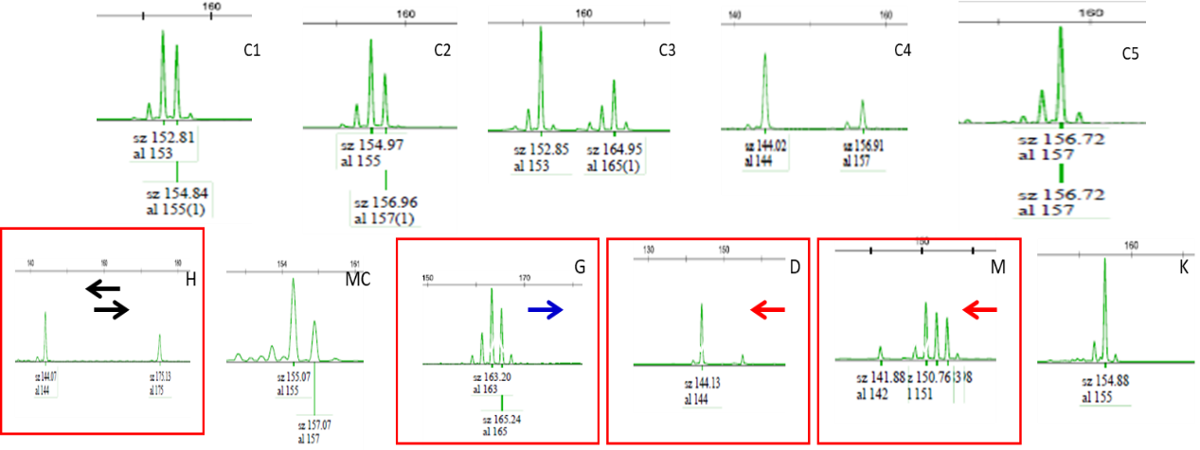
Figure 8: Tandem repeat instability for PMS1 marker in the cell lines; C1-5- Control, H-HCT116, MC-MCF-7, G-KG-1, D-Daudi, M-Molt-4, K-K562.

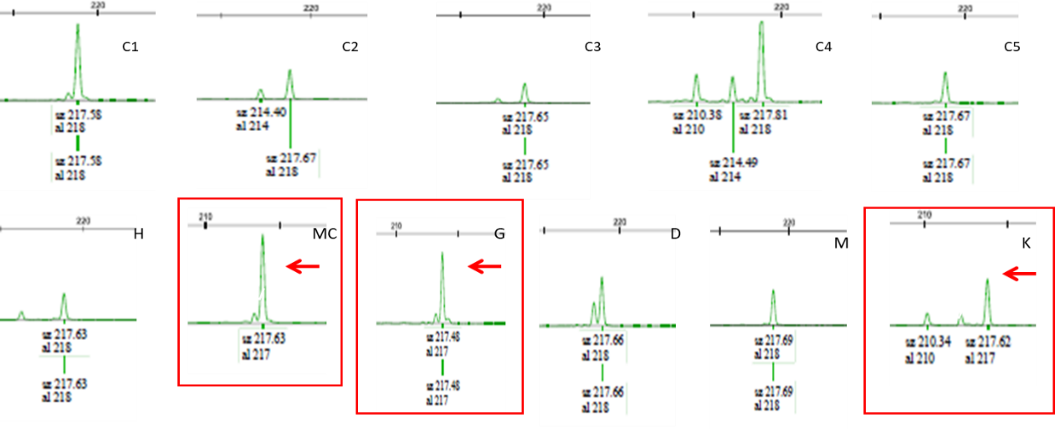
Figure 9: Tandem repeat instability for PMS2 marker in the cell lines; C1-5- Control, H-HCT116, MC-MCF-7, G-KG-1, D-Daudi, M-Molt-4, K-K562.

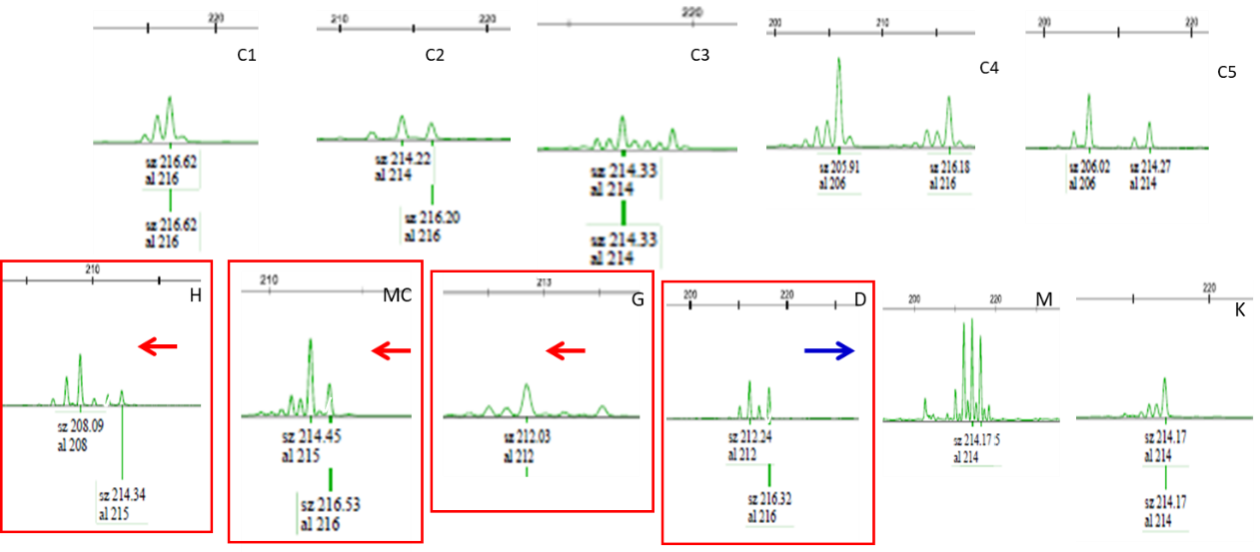
Figure 10: Tandem repeat instability for MGMT marker in the cell lines; C1-5- Control, H-HCT116, MC-MCF-7, G-KG-1, D-Daudi, M-Molt-4, K-K562.

