Supporting Information

How to Predict Future Upcoming Harmful Agents: Array Type Meta-Predictor Based Classification
Surendra Kumar^{a,†}, Chandni Kumari^{a,†}, Sangjin Ahn^{a,b}, Hyoungrae Kim^{c} and Mi-hyun Kim^{a,*}
ªGachon Institute of Pharmaceutical Science and Department of Pharmacy, College of Pharmacy, Gachon University, 191 Hambakmoeiro, Yeonsu-gu, Incheon, Republic of Korea. ^{b}Department of Financial Engineering, College of Business, Ajou University, Suwon, 16499, Republic of Korea. ^{c}Department of Data Management, KEIS, 56 Mullae-ro 20-gil,Yeongdeungpo-gu, Seoul, Republic of Korea

† The authors are co-first authors
*Author for correspondence
E-mail: kmh0515@gachon.ac.kr

Table of Contents
S. No. | Descriptions | Page No.
1. | Table S1: Dataset Description. | S3
2. | Figure S1: The workflow to build the SAR classification model. | S4
3. | Table S2: The statistical performance of nAChR. | S5
4. | Table S3: The statistical performance of mAChR. | S6
5. | Table S4: The statistical performance of BuChE. | S7
6. | Table S5: The statistical performance of AChE. | S8
7. | Table S6: The statistical performance of VAChT. | S9
8. | Table S7: The ensemble-AUC based on different machine learning method for different models. | S10
9. | Figure S2: The statistical performance (ROC plot) of nAChR models on the test set. | S11
10. | Figure S3: The statistical performance (ROC plot) of nAChR models on the test set. | S12
11. | Figure S4: The statistical performance (ROC plot) of BuChE models on the test set. | S13
12. | Figure S5: The statistical performance (ROC plot) of AChE models on the test set. | S14
13. | Figure S6: The statistical performance (ROC plot) of VAChT models on the test set. | S15
14. | Figure S7: Principle Component Analysis of Cholinergic Models (a) nAChR; (b) mAChR; (c) BuChE; (d) AChE; (e) VAChT. | S16-S20
15. | Figure S8: The workflow to build Array Type Meta-Predictor. | S21
16. | Table S7: The ensemble-AUC based on different machine learning method for different models. | S22
17. | Figure S9: A typical convolutional neural network (CNN) model architecture. | S23
18. | Table S8: The statistical performance of (CNN) model under different Array Shapes. | S24

Table S1: Dataset Description.
Targets | Collected Data | Training Set |  | Test Set |  | Total
Targets | Collected Data | Active | Inactive | Active | Inactive
nAChR | 3175 | 637 | 637 | 272 | 272 | 1818
mAChR | 24223 | 2431 | 2431 | 1041 | 1041 | 6944
BuChE | 2414 | 484 | 484 | 207 | 207 | 1382
AChE | 8212 | 1086 | 1086 | 464 | 464 | 3098
VAChT | 231 | 106 | 106 | 45 | 45 | 302
CWA | 95 | - | - | - | - | 95
NPS | 3126 | - | - | - | - | 3126
Note: Collected Data: For each targets, respective number of chemicals were collected from ChEMBL database, which were arranged in four activity threshold of active, inactive, margin and unclear. Among all the activity threshold, the chemicals with threshold of < 1000 nM assigned as active. Notably, to keep the balance in between active and inactive class, the decoy finder¹ was used to select the representative chemicals from dataset with activity threshold > 1000 nM as inactive class. CWA (Chemical Warfare Agents) and NPS (New Psychoactive Substances) were considered as third set, which were used to access the machine learning model performance and were obtained from https://www.emcdda.europa.eu and https://www.emcdda.europa.eu; https://nps-datahub.com respectively. The training and test sets contained 70% and 30% of chemicals per targets.

Reference:
- Cereto-Massagué, A.; Guasch, L.; Valls, C.; Mulero, M.; Pujadas, G.; Garcia-Vallvé, S. DecoyFinder: an easy-to-use python GUI application for building target-specific decoy sets, Bioinformatics, 2012 28(12):1661-2. doi: 10.1093/bioinformatics/bts249

Figure S1: The workflow to build SAR classification model.
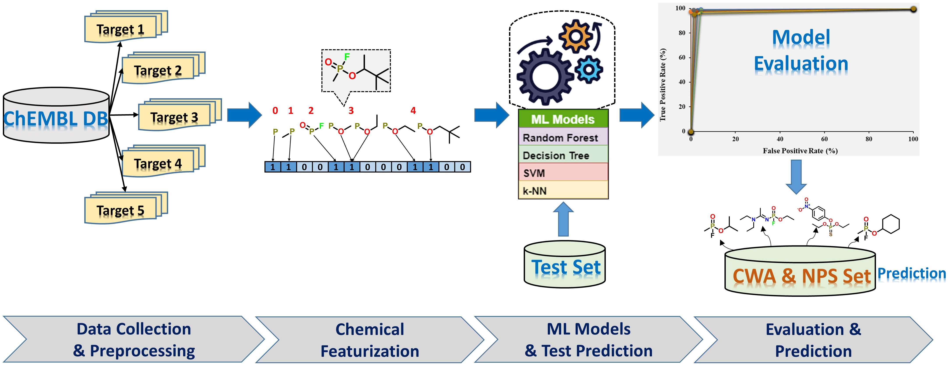
Note: The ChEMBL data with prerequisite target information were selected to retrieve the chemical data, which further processed for any duplicates. All the chemical data was featurized based on ECFP and FCFP (RDKit) fingerprint. The obtained feature matrix along with class data, were used to build various machine learning models, followed by the evaluation on test set. The best model was used to predict the CWA and NPS set as third sets.

Table S2: The statistical performance of nAChR (Nicotinic Acetylcholinesterase Receptor).
ML  Methods | Models | Train |  |  |  | Test
ML  Methods | Models | MCC | ACC | ROC | F-Score | MCC | ACC | AUC | F-Score
RF | M-1 | 0.907 | 0.954 | 0.993 | 0.954 | 0.942 | 0.971 | 0.971 | 0.971
RF | M-2 | 0.918 | 0.959 | 0.994 | 0.959 | 0.975 | 0.987 | 0.987 | 0.987
RF | M-3 | 0.938 | 0.969 | 0.995 | 0.969 | 0.941 | 0.971 | 0.971 | 0.970
RF | M-4 | 0.934 | 0.967 | 0.994 | 0.967 | 0.938 | 0.969 | 0.969 | 0.969
RF | M-5 | 0.955 | 0.977 | 0.998 | 0.977 | 0.949 | 0.974 | 0.974 | 0.974
RF | M-6 | 0.947 | 0.973 | 0.997 | 0.973 | 0.942 | 0.971 | 0.971 | 0.970
RF | M-7 | 0.933 | 0.966 | 0.996 | 0.966 | 0.956 | 0.978 | 0.978 | 0.978
RF | M-8 | 0.950 | 0.975 | 0.997 | 0.975 | 0.956 | 0.978 | 0.978 | 0.978
RF | M-9 | 0.956 | 0.978 | 0.996 | 0.978 | 0.978 | 0.989 | 0.989 | 0.989
RF | M-10 | 0.922 | 0.961 | 0.993 | 0.961 | 0.938 | 0.969 | 0.969 | 0.969
DT | M-1 | 0.549 | 0.773 | 0.790 | 0.784 | 0.610 | 0.805 | 0.805 | 0.806
DT | M-2 | 0.678 | 0.836 | 0.845 | 0.824 | 0.764 | 0.871 | 0.871 | 0.854
DT | M-3 | 0.724 | 0.861 | 0.889 | 0.866 | 0.648 | 0.816 | 0.816 | 0.834
DT | M-4 | 0.538 | 0.766 | 0.775 | 0.782 | 0.529 | 0.763 | 0.763 | 0.775
DT | M-5 | 0.477 | 0.739 | 0.739 | 0.735 | 0.472 | 0.735 | 0.735 | 0.724
DT | M-6 | 0.598 | 0.788 | 0.824 | 0.755 | 0.560 | 0.763 | 0.763 | 0.714
DT | M-7 | 0.546 | 0.773 | 0.784 | 0.774 | 0.438 | 0.719 | 0.719 | 0.711
DT | M-8 | 0.565 | 0.779 | 0.809 | 0.762 | 0.578 | 0.774 | 0.774 | 0.731
DT | M-9 | 0.474 | 0.736 | 0.767 | 0.724 | 0.558 | 0.759 | 0.759 | 0.704
DT | M-10 | 0.657 | 0.827 | 0.843 | 0.820 | 0.666 | 0.825 | 0.825 | 0.805
SVM | M-1 | 0.934 | 0.967 | 0.989 | 0.967 | 0.956 | 0.978 | 0.978 | 0.978
SVM | M-2 | 0.936 | 0.968 | 0.994 | 0.968 | 0.978 | 0.989 | 0.989 | 0.989
SVM | M-3 | 0.955 | 0.977 | 0.997 | 0.977 | 0.953 | 0.976 | 0.976 | 0.976
SVM | M-4 | 0.937 | 0.969 | 0.995 | 0.969 | 0.938 | 0.969 | 0.969 | 0.969
SVM | M-5 | 0.950 | 0.975 | 0.997 | 0.975 | 0.945 | 0.972 | 0.972 | 0.972
SVM | M-6 | 0.934 | 0.967 | 0.993 | 0.967 | 0.945 | 0.972 | 0.972 | 0.972
SVM | M-7 | 0.939 | 0.969 | 0.996 | 0.969 | 0.949 | 0.974 | 0.974 | 0.975
SVM | M-8 | 0.936 | 0.968 | 0.995 | 0.968 | 0.964 | 0.982 | 0.982 | 0.982
SVM | M-9 | 0.939 | 0.969 | 0.989 | 0.969 | 0.952 | 0.976 | 0.976 | 0.976
SVM | M-10 | 0.934 | 0.967 | 0.991 | 0.967 | 0.960 | 0.980 | 0.980 | 0.980
KNN | M-1 | 0.778 | 0.887 | 0.972 | 0.892 | 0.791 | 0.892 | 0.892 | 0.899
KNN | M-2 | 0.551 | 0.741 | 0.965 | 0.791 | 0.558 | 0.737 | 0.737 | 0.792
KNN | M-3 | 0.722 | 0.849 | 0.975 | 0.866 | 0.729 | 0.853 | 0.853 | 0.869
KNN | M-4 | 0.506 | 0.704 | 0.961 | 0.772 | 0.475 | 0.684 | 0.684 | 0.760
KNN | M-5 | 0.693 | 0.827 | 0.983 | 0.851 | 0.723 | 0.846 | 0.972 | 0.865
KNN | M-6 | 0.675 | 0.814 | 0.975 | 0.843 | 0.674 | 0.816 | 0.816 | 0.843
KNN | M-7 | 0.619 | 0.779 | 0.967 | 0.818 | 0.646 | 0.796 | 0.796 | 0.830
KNN | M-8 | 0.638 | 0.790 | 0.980 | 0.826 | 0.647 | 0.730 | 0.798 | 0.831
KNN | M-9 | 0.506 | 0.705 | 0.971 | 0.772 | 0.546 | 0.730 | 0.730 | 0.787
KNN | M-10 | 0.643 | 0.799 | 0.970 | 0.830 | 0.687 | 0.822 | 0.822 | 0.848
Abbreviations: MCC: Matthew’s Correlation Coefficient; ACC: Accuracy; ROC: Receiver Operative Characteristic; F-Score: Fisher Value; AUC: Area Under the Curve; RF: Random Forest; DT: Decision Tree; SVM: Support Vector Machine; KNN: K-Nearest Neighbor.
Table S3: The statistical performance of mAChR (Muscarinic Acetylcholinesterase Receptor).
ML  Methods | Models | Train |  |  |  | Test
ML  Methods | Models | MCC | ACC | ROC | F-Score | MCC | ACC | AUC | F-Score
RF | M-1 | 0.945 | 0.972 | 0.996 | 0.972 | 0.935 | 0.967 | 0.967 | 0.967
RF | M-2 | 0.959 | 0.979 | 0.997 | 0.979 | 0.974 | 0.987 | 0.987 | 0.987
RF | M-3 | 0.965 | 0.983 | 0.998 | 0.983 | 0.966 | 0.983 | 0.983 | 0.983
RF | M-4 | 0.929 | 0.965 | 0.995 | 0.965 | 0.927 | 0.963 | 0.963 | 0.964
RF | M-5 | 0.959 | 0.980 | 0.997 | 0.980 | 0.968 | 0.984 | 0.984 | 0.984
RF | M-6 | 0.952 | 0.976 | 0.997 | 0.976 | 0.954 | 0.977 | 0.977 | 0.977
RF | M-7 | 0.964 | 0.982 | 0.998 | 0.982 | 0.965 | 0.983 | 0.983 | 0.983
RF | M-8 | 0.964 | 0.982 | 0.998 | 0.982 | 0.966 | 0.983 | 0.983 | 0.983
RF | M-9 | 0.932 | 0.966 | 0.995 | 0.966 | 0.933 | 0.966 | 0.966 | 0.966
RF | M-10 | 0.938 | 0.969 | 0.996 | 0.969 | 0.928 | 0.964 | 0.964 | 0.964
DT | M-1 | 0.650 | 0.825 | 0.826 | 0.823 | 0.608 | 0.804 | 0.804 | 0.799
DT | M-2 | 0.663 | 0.831 | 0.837 | 0.827 | 0.681 | 0.840 | 0.840 | 0.833
DT | M-3 | 0.731 | 0.865 | 0.869 | 0.860 | 0.725 | 0.860 | 0.860 | 0.852
DT | M-4 | 0.693 | 0.846 | 0.858 | 0.845 | 0.665 | 0.831 | 0.831 | 0.824
DT | M-5 | 0.696 | 0.847 | 0.853 | 0.843 | 0.655 | 0.826 | 0.826 | 0.817
DT | M-6 | 0.673 | 0.837 | 0.841 | 0.834 | 0.642 | 0.820 | 0.820 | 0.813
DT | M-7 | 0.666 | 0.832 | 0.838 | 0.833 | 0.658 | 0.828 | 0.828 | 0.821
DT | M-8 | 0.711 | 0.855 | 0.861 | 0.852 | 0.701 | 0.849 | 0.849 | 0.841
DT | M-9 | 0.663 | 0.832 | 0.844 | 0.831 | 0.648 | 0.822 | 0.822 | 0.812
DT | M-10 | 0.599 | 0.799 | 0.807 | 0.799 | 0.615 | 0.806 | 0.806 | 0.799
SVM | M-1 | 0.940 | 0.970 | 0.992 | 0.970 | 0.937 | 0.968 | 0.968 | 0.968
SVM | M-2 | 0.962 | 0.981 | 0.997 | 0.981 | 0.967 | 0.984 | 0.984 | 0.984
SVM | M-3 | 0.962 | 0.981 | 0.996 | 0.981 | 0.967 | 0.984 | 0.984 | 0.984
SVM | M-4 | 0.938 | 0.969 | 0.992 | 0.969 | 0.936 | 0.968 | 0.968 | 0.968
SVM | M-5 | 0.968 | 0.984 | 0.997 | 0.984 | 0.973 | 0.987 | 0.987 | 0.987
SVM | M-6 | 0.959 | 0.979 | 0.996 | 0.979 | 0.962 | 0.981 | 0.981 | 0.981
SVM | M-7 | 0.968 | 0.984 | 0.997 | 0.984 | 0.961 | 0.980 | 0.980 | 0.980
SVM | M-8 | 0.968 | 0.984 | 0.998 | 0.984 | 0.965 | 0.983 | 0.983 | 0.983
SVM | M-9 | 0.934 | 0.967 | 0.991 | 0.967 | 0.941 | 0.970 | 0.970 | 0.970
SVM | M-10 | 0.928 | 0.964 | 0.992 | 0.964 | 0.940 | 0.970 | 0.970 | 0.970
KNN | M-1 | 0.896 | 0.948 | 0.989 | 0.948 | 0.896 | 0.948 | 0.948 | 0.948
KNN | M-2 | 0.876 | 0.934 | 0.987 | 0.93 | 0.895 | 0.945 | 0.945 | 0.942
KNN | M-3 | 0.904 | 0.950 | 0.989 | 0.947 | 0.894 | 0.945 | 0.945 | 0.942
KNN | M-4 | 0.888 | 0.942 | 0.985 | 0.940 | 0.916 | 0.957 | 0.957 | 0.955
KNN | M-5 | 0.868 | 0.930 | 0.985 | 0.925 | 0.873 | 0.932 | 0.932 | 0.927
KNN | M-6 | 0.911 | 0.956 | 0.992 | 0.955 | 0.917 | 0.958 | 0.958 | 0.958
KNN | M-7 | 0.917 | 0.958 | 0.993 | 0.956 | 0.932 | 0.965 | 0.965 | 0.965
KNN | M-8 | 0.898 | 0.947 | 0.989 | 0.944 | 0.899 | 0.947 | 0.947 | 0.944
KNN | M-9 | 0.883 | 0.939 | 0.982 | 0.936 | 0.888 | 0.942 | 0.942 | 0.939
KNN | M-10 | 0.862 | 0.930 | 0.987 | 0.932 | 0.839 | 0.919 | 0.919 | 0.921
Abbreviations: MCC: Matthew’s Correlation Coefficient; ACC: Accuracy; ROC: Receiver Operative Characteristic; F-Score: Fisher Value; AUC: Area Under the Curve; RF: Random Forest; DT: Decision Tree; SVM: Support Vector Machine; KNN: K-Nearest Neighbor.
Table S4: The statistical performance of BuChE (Butyryl cholinesterase Enzyme).
ML  Methods | Models | Train |  |  |  | Test
ML  Methods | Models | MCC | ACC | ROC | F-Score | MCC | ACC | AUC | F-Score
RF | M-1 | 0.949 | 0.974 | 0.999 | 0.974 | 0.948 | 0.973 | 0.973 | 0.973
RF | M-2 | 0.969 | 0.985 | 0.999 | 0.985 | 0.971 | 0.986 | 0.986 | 0.985
RF | M-3 | 0.977 | 0.989 | 0.999 | 0.989 | 0.952 | 0.976 | 0.976 | 0.976
RF | M-4 | 0.971 | 0.986 | 0.999 | 0.986 | 0.986 | 0.993 | 0.993 | 0.993
RF | M-5 | 0.953 | 0.976 | 0.997 | 0.976 | 0.943 | 0.971 | 0.971 | 0.970
RF | M-6 | 0.953 | 0.976 | 0.996 | 0.976 | 0.957 | 0.978 | 0.978 | 0.978
RF | M-7 | 0.933 | 0.966 | 0.992 | 0.965 | 0.948 | 0.973 | 0.973 | 0.973
RF | M-8 | 0.949 | 0.974 | 0.995 | 0.974 | 0.948 | 0.973 | 0.973 | 0.973
RF | M-9 | 0.938 | 0.969 | 0.994 | 0.969 | 0.952 | 0.976 | 0.976 | 0.976
RF | M-10 | 0.973 | 0.987 | 0.999 | 0.987 | 0.933 | 0.966 | 0.966 | 0.967
DT | M-1 | 0.523 | 0.761 | 0.796 | 0.760 | 0.566 | 0.773 | 0.773 | 0.799
DT | M-2 | 0.655 | 0.826 | 0.864 | 0.833 | 0.644 | 0.821 | 0.821 | 0.816
DT | M-3 | 0.660 | 0.830 | 0.892 | 0.833 | 0.649 | 0.821 | 0.821 | 0.833
DT | M-4 | 0.699 | 0.848 | 0.874 | 0.854 | 0.567 | 0.783 | 0.783 | 0.791
DT | M-5 | 0.641 | 0.810 | 0.818 | 0.782 | 0.604 | 0.780 | 0.780 | 0.730
DT | M-6 | 0.647 | 0.807 | 0.809 | 0.771 | 0.674 | 0.814 | 0.814 | 0.773
DT | M-7 | 0.574 | 0.775 | 0.780 | 0.737 | 0.522 | 0.754 | 0.754 | 0.721
DT | M-8 | 0.557 | 0.770 | 0.771 | 0.737 | 0.535 | 0.754 | 0.754 | 0.707
DT | M-9 | 0.660 | 0.816 | 0.819 | 0.786 | 0.592 | 0.780 | 0.780 | 0.738
DT | M-10 | 0.807 | 0.902 | 0.912 | 0.906 | 0.763 | 0.874 | 0.874 | 0.886
SVM | M-1 | 0.961 | 0.980 | 0.995 | 0.980 | 0.947 | 0.973 | 0.973 | 0.973
SVM | M-2 | 0.971 | 0.986 | 0.999 | 0.985 | 0.986 | 0.993 | 0.993 | 0.993
SVM | M-3 | 0.973 | 0.987 | 0.942 | 0.987 | 0.952 | 0.976 | 0.976 | 0.975
SVM | M-4 | 0.957 | 0.978 | 0.998 | 0.978 | 0.976 | 0.988 | 0.988 | 0.988
SVM | M-5 | 0.969 | 0.985 | 0.997 | 0.985 | 0.947 | 0.973 | 0.973 | 0.973
SVM | M-6 | 0.959 | 0.979 | 0.997 | 0.979 | 0.981 | 0.990 | 0.990 | 0.990
SVM | M-7 | 0.945 | 0.972 | 0.992 | 0.972 | 0.952 | 0.976 | 0.976 | 0.976
SVM | M-8 | 0.958 | 0.979 | 0.997 | 0.979 | 0.947 | 0.973 | 0.973 | 0.973
SVM | M-9 | 0.946 | 0.973 | 0.993 | 0.973 | 0.961 | 0.981 | 0.981 | 0.981
SVM | M-10 | 0.981 | 0.991 | 1.000 | 0.991 | 0.937 | 0.969 | 0.969 | 0.969
KNN | M-1 | 0.408 | 0.643 | 0.909 | 0.737 | 0.447 | 0.667 | 0.667 | 0.750
KNN | M-2 | 0.404 | 0.641 | 0.921 | 0.736 | 0.451 | 0.669 | 0.669 | 0.751
KNN | M-3 | 0.420 | 0.741 | 1.000 | 0.682 | 0.583 | 0.754 | 0.754 | 0.802
KNN | M-4 | 0.558 | 0.738 | 0.963 | 0.792 | 0.620 | 0.778 | 0.778 | 0.818
KNN | M-5 | 0.421 | 0.651 | 0.924 | 0.741 | 0.420 | 0.650 | 0.650 | 0.741
KNN | M-6 | 0.606 | 0.769 | 0.938 | 0.812 | 0.650 | 0.797 | 0.797 | 0.831
KNN | M-7 | 0.397 | 0.636 | 0.885 | 0.733 | 0.459 | 0.674 | 0.674 | 0.754
KNN | M-8 | 0.455 | 0.672 | 0.902 | 0.753 | 0.459 | 0.674 | 0.674 | 0.754
KNN | M-9 | 0.569 | 0.745 | 0.944 | 0.797 | 0.587 | 0.756 | 0.756 | 0.804
KNN | M-10 | 0.584 | 0.754 | 0.985 | 0.803 | 0.620 | 0.778 | 0.778 | 0.818
Abbreviations: MCC: Matthew’s Correlation Coefficient; ACC: Accuracy; ROC: Receiver Operative Characteristic; F-Score: Fisher Value; AUC: Area Under the Curve; RF: Random Forest; DT: Decision Tree; SVM: Support Vector Machine; KNN: K-Nearest Neighbor.
Table S5: The statistical performance of AChE (Acetylcholinesterase Enzyme).
ML  Methods | Models | Train |  |  |  | Test
ML  Methods | Models | MCC | ACC | ROC | F-Score | MCC | ACC | AUC | F-Score
RF | M-1 | 0.940 | 0.970 | 0.995 | 0.969 | 0.951 | 0.975 | 0.975 | 0.975
RF | M-2 | 0.965 | 0.983 | 0.999 | 0.983 | 0.963 | 0.982 | 0.982 | 0.982
RF | M-3 | 0.942 | 0.971 | 0.997 | 0.971 | 0.962 | 0.981 | 0.981 | 0.981
RF | M-4 | 0.936 | 0.968 | 0.994 | 0.967 | 0.959 | 0.980 | 0.980 | 0.979
RF | M-5 | 0.934 | 0.967 | 0.992 | 0.966 | 0.910 | 0.955 | 0.955 | 0.954
RF | M-6 | 0.933 | 0.966 | 0.994 | 0.966 | 0.929 | 0.964 | 0.964 | 0.964
RF | M-7 | 0.917 | 0.959 | 0.994 | 0.958 | 0.953 | 0.976 | 0.976 | 0.976
RF | M-8 | 0.923 | 0.961 | 0.991 | 0.961 | 0.944 | 0.972 | 0.972 | 0.972
RF | M-9 | 0.929 | 0.964 | 0.992 | 0.964 | 0.931 | 0.966 | 0.966 | 0.965
RF | M-10 | 0.948 | 0.974 | 0.998 | 0.974 | 0.944 | 0.972 | 0.972 | 0.972
DT | M-1 | 0.542 | 0.771 | 0.785 | 0.776 | 0.514 | 0.755 | 0.755 | 0.768
DT | M-2 | 0.570 | 0.779 | 0.806 | 0.755 | 0.586 | 0.778 | 0.778 | 0.737
DT | M-3 | 0.627 | 0.808 | 0.832 | 0.824 | 0.597 | 0.789 | 0.789 | 0.813
DT | M-4 | 0.652 | 0.813 | 0.817 | 0.783 | 0.678 | 0.828 | 0.828 | 0.802
DT | M-5 | 0.648 | 0.816 | 0.821 | 0.794 | 0.609 | 0.796 | 0.796 | 0.770
DT | M-6 | 0.624 | 0.806 | 0.812 | 0.784 | 0.597 | 0.789 | 0.789 | 0.758
DT | M-7 | 0.537 | 0.769 | 0.774 | 0.770 | 0.507 | 0.753 | 0.753 | 0.746
DT | M-8 | 0.666 | 0.824 | 0.830 | 0.802 | 0.637 | 0.803 | 0.803 | 0.767
DT | M-9 | 0.674 | 0.825 | 0.829 | 0.799 | 0.644 | 0.806 | 0.806 | 0.770
DT | M-10 | 0.620 | 0.794 | 0.818 | 0.822 | 0.653 | 0.801 | 0.801 | 0.833
SVM | M-1 | 0.936 | 0.968 | 0.994 | 0.967 | 0.940 | 0.970 | 0.970 | 0.970
SVM | M-2 | 0.979 | 0.989 | 0.999 | 0.989 | 0.974 | 0.987 | 0.987 | 0.987
SVM | M-3 | 0.943 | 0.971 | 0.996 | 0.972 | 0.972 | 0.986 | 0.986 | 0.986
SVM | M-4 | 0.929 | 0.965 | 0.993 | 0.964 | 0.933 | 0.967 | 0.967 | 0.967
SVM | M-5 | 0.926 | 0.963 | 0.990 | 0.963 | 0.912 | 0.956 | 0.956 | 0.956
SVM | M-6 | 0.923 | 0.961 | 0.988 | 0.962 | 0.912 | 0.956 | 0.956 | 0.956
SVM | M-7 | 0.915 | 0.958 | 0.989 | 0.958 | 0.925 | 0.962 | 0.962 | 0.963
SVM | M-8 | 0.932 | 0.966 | 0.994 | 0.966 | 0.881 | 0.954 | 0.969 | 0.969
SVM | M-9 | 0.919 | 0.959 | 0.988 | 0.959 | 0.925 | 0.962 | 0.962 | 0.962
SVM | M-10 | 0.946 | 0.973 | 0.996 | 0.973 | 0.957 | 0.978 | 0.978 | 0.978
KNN | M-1 | 0.614 | 0.774 | 0.983 | 0.816 | 0.586 | 0.757 | 0.756 | 0.804
KNN | M-2 | 0.715 | 0.838 | 0.968 | 0.861 | 0.722 | 0.842 | 0.844 | 0.863
KNN | M-3 | 0.704 | 0.832 | 0.982 | 0.856 | 0.683 | 0.818 | 0.818 | 0.846
KNN | M-4 | 0.879 | 0.939 | 0.983 | 0.939 | 0.871 | 0.935 | 0.935 | 0.936
KNN | M-5 | 0.500 | 0.702 | 0.977 | 0.770 | 0.481 | 0.691 | 0.691 | 0.763
KNN | M-6 | 0.448 | 0.668 | 0.922 | 0.750 | 0.434 | 0.658 | 0.658 | 0.745
KNN | M-7 | 0.383 | 0.629 | 0.855 | 0.729 | 0.397 | 0.638 | 0.638 | 0.734
KNN | M-8 | 0.520 | 0.713 | 0.958 | 0.777 | 0.533 | 0.721 | 0.721 | 0.782
KNN | M-9 | 0.612 | 0.779 | 0.963 | 0.817 | 0.592 | 0.767 | 0.767 | 0.809
KNN | M-10 | 0.701 | 0.830 | 0.985 | 0.855 | 0.721 | 0.843 | 0.843 | 0.864
Abbreviations: MCC: Matthew’s Correlation Coefficient; ACC: Accuracy; ROC: Receiver Operative Characteristic; F-Score: Fisher Value; AUC: Area Under the Curve; RF: Random Forest; DT: Decision Tree; SVM: Support Vector Machine; KNN: K-Nearest Neighbor.
Table S6: The statistical performance of VAChT (Vesicular Acetylcholine Transporter).
ML  Methods | Models | Train |  |  |  | Test
ML  Methods | Models | MCC | ACC | ROC | F-Score | MCC | ACC | AUC | F-Score
RF | M-1 | 0.658 | 0.802 | 0.995 | 0.835 | 0.620 | 0.778 | 0.778 | 0.818
RF | M-2 | 0.563 | 0.741 | 1.000 | 0.794 | 0.429 | 0.656 | 0.656 | 0.744
RF | M-3 | 0.991 | 0.995 | 1.000 | 0.995 | 1.000 | 1.000 | 0.778 | 1.000
RF | M-4 | 0.771 | 0.873 | 1.000 | 0.887 | 0.603 | 0.767 | 0.767 | 0.811
RF | M-5 | 0.702 | 0.830 | 1.000 | 0.887 | 0.915 | 0.956 | 0.911 | 0.957
RF | M-6 | 0.702 | 0.830 | 1.000 | 0.855 | 0.290 | 0.578 | 0.578 | 0.703
RF | M-7 | 0.972 | 0.986 | 1.000 | 0.986 | 0.978 | 0.989 | 0.989 | 0.988
RF | M-8 | 0.815 | 0.901 | 0.998 | 0.909 | 0.875 | 0.933 | 0.933 | 0.938
RF | M-9 | 0.981 | 0.991 | 1.000 | 0.991 | 0.978 | 0.989 | 0.989 | 0.989
RF | M-10 | 0.981 | 0.991 | 1.000 | 0.991 | 1.000 | 1.000 | 1.000 | 1.000
DT | M-1 | 0.906 | 0.953 | 0.956 | 0.954 | 0.891 | 0.944 | 0.944 | 0.946
DT | M-2 | 0.815 | 0.906 | 0.945 | 0.910 | 0.800 | 0.900 | 0.900 | 0.899
DT | M-3 | 0.944 | 0.972 | 0.970 | 0.972 | 0.915 | 0.956 | 0.944 | 0.957
DT | M-4 | 0.887 | 0.943 | 0.971 | 0.943 | 0.850 | 0.922 | 0.922 | 0.926
DT | M-5 | 0.953 | 0.976 | 0.975 | 0.976 | 0.934 | 0.967 | 0.944 | 0.966
DT | M-6 | 0.962 | 0.981 | 0.981 | 0.981 | 0.889 | 0.944 | 0.944 | 0.945
DT | M-7 | 0.877 | 0.939 | 0.958 | 0.938 | 0.911 | 0.956 | 0.956 | 0.955
DT | M-8 | 0.953 | 0.976 | 0.976 | 0.977 | 0.912 | 0.956 | 0.956 | 0.957
DT | M-9 | 0.962 | 0.981 | 0.981 | 0.981 | 0.957 | 0.978 | 0.978 | 0.978
DT | M-10 | 0.953 | 0.976 | 0.976 | 0.977 | 0.957 | 0.978 | 0.989 | 0.978
SVM | M-1 | 0.953 | 0.976 | 0.993 | 0.976 | 1.000 | 1.000 | 1.000 | 1.000
SVM | M-2 | 0.991 | 0.995 | 1.000 | 0.995 | 0.957 | 0.978 | 0.978 | 0.977
SVM | M-3 | 1.000 | 1.000 | 1.000 | 1.000 | 1.000 | 1.000 | 1.000 | 1.000
SVM | M-4 | 0.981 | 0.991 | 0.998 | 0.991 | 1.000 | 1.000 | 1.000 | 1.000
SVM | M-5 | 0.991 | 0.995 | 0.998 | 0.991 | 1.000 | 1.000 | 1.000 | 1.000
SVM | M-6 | 0.981 | 0.991 | 0.998 | 0.991 | 1.000 | 1.000 | 1.000 | 1.000
SVM | M-7 | 0.991 | 0.995 | 0.999 | 0.995 | 1.000 | 1.000 | 1.000 | 1.000
SVM | M-8 | 0.991 | 0.995 | 0.999 | 0.995 | 1.000 | 1.000 | 1.000 | 1.000
SVM | M-9 | 1.000 | 1.000 | 1.000 | 1.000 | 0.978 | 0.989 | 0.989 | 0.989
SVM | M-10 | 0.972 | 0.986 | 0.998 | 0.986 | 1.000 | 1.000 | 1.000 | 1.000
KNN | M-1 | 0.429 | 0.656 | 0.846 | 0.744 | 0.373 | 0.622 | 0.622 | 0.726
KNN | M-2 | 0.357 | 0.613 | 0.879 | 0.721 | 0.392 | 0.633 | 0.633 | 0.732
KNN | M-3 | 0.925 | 0.962 | 0.996 | 0.963 | 0.957 | 0.978 | 0.622 | 0.978
KNN | M-4 | 0.944 | 0.972 | 0.996 | 0.972 | 0.934 | 0.967 | 0.967 | 0.967
KNN | M-5 | 0.953 | 0.976 | 0.998 | 0.977 | 0.934 | 0.967 | 0.956 | 0.967
KNN | M-6 | 0.991 | 0.995 | 1.000 | 0.995 | 0.957 | 0.957 | 0.978 | 0.978
KNN | M-7 | 0.991 | 0.995 | 0.995 | 0.995 | 0.978 | 0.989 | 0.989 | 0.989
KNN | M-8 | 0.981 | 0.991 | 0.995 | 0.991 | 0.978 | 0.989 | 0.989 | 0.989
KNN | M-9 | 0.925 | 0.962 | 0.999 | 0.963 | 0.915 | 0.956 | 0.956 | 0.957
KNN | M-10 | 0.934 | 0.967 | 1.000 | 0.967 | 0.957 | 0.978 | 0.989 | 0.978
Abbreviations: MCC: Matthew’s Correlation Coefficient; ACC: Accuracy; ROC: Receiver Operative Characteristic; F-Score: Fisher Value; AUC: Area Under the Curve; RF: Random Forest; DT: Decision Tree; SVM: Support Vector Machine; KNN: K-Nearest Neighbor.
Table S7: The ensemble-AUC based on different machine learning method for different models.
Models | Ensemble-AUC
Models | nAChR | mAChR | AChE | BuChE | VAChT
M-1 | 0.708 | 0.378 | 0.495 | 0.475 | 0.732
M-2 | 0.749 | 0.370 | 0.502 | 0.443 | 0.739
M-3 | 0.729 | 0.370 | 0.517 | 0.459 | 0.729
M-4 | 0.720 | 0.357 | 0.502 | 0.470 | 0.778
M-5 | 0.714 | 0.370 | 0.499 | 0.457 | 0.790
M-6 | 0.721 | 0.380 | 0.506 | 0.449 | 0.753
M-7 | 0.718 | 0.370 | 0.500 | 0.460 | 0.775
M-8 | 0.180 | 0.364 | 0.510 | 0.467 | 0.752
M-9 | 0.709 | 0.364 | 0.498 | 0.441 | 0.709
M-10 | 0.712 | 0.377 | 0.500 | 0.452 | 0.786
Abbreviations: nAChR: Nicotinic Acetylcholinesterase Receptor; mAChR: Muscarinic Acetylcholinesterase Receptor; AChE: Acetylcholinesterase Enzyme; BuChE: Butyryl cholinesterase Enzyme; VAChT: Vesicular Acetylcholine Transporter.

Figure S2: The statistical performance (ROC plot) of nAChR models on the test set.
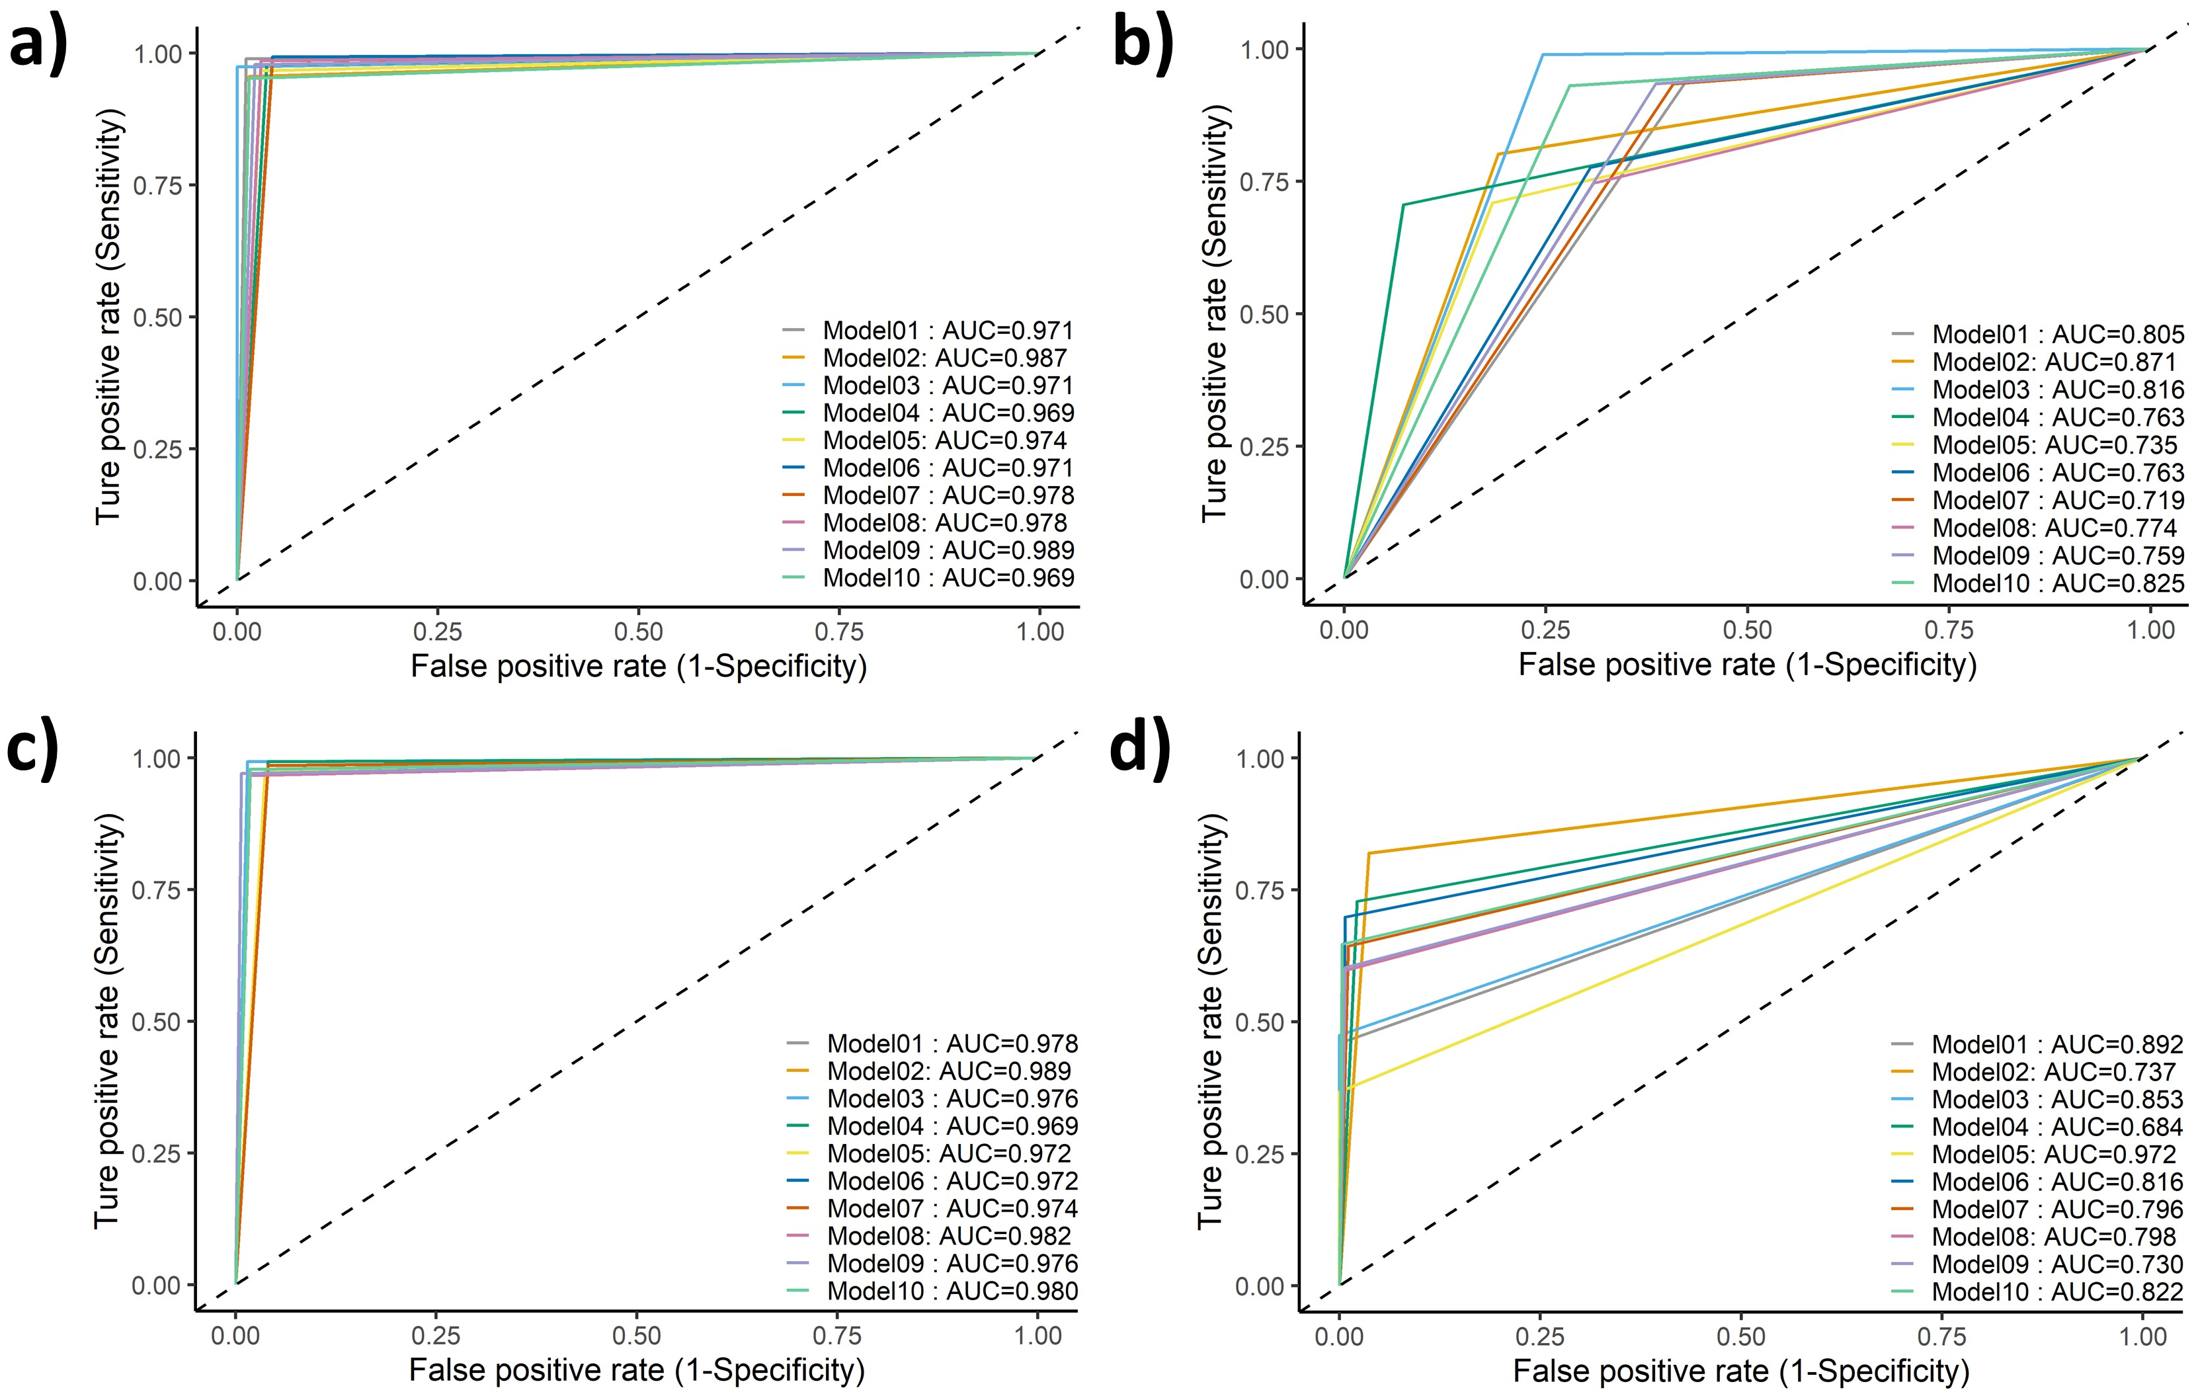

Figure S3: The statistical performance (ROC plot) of mAChR models on the test set.
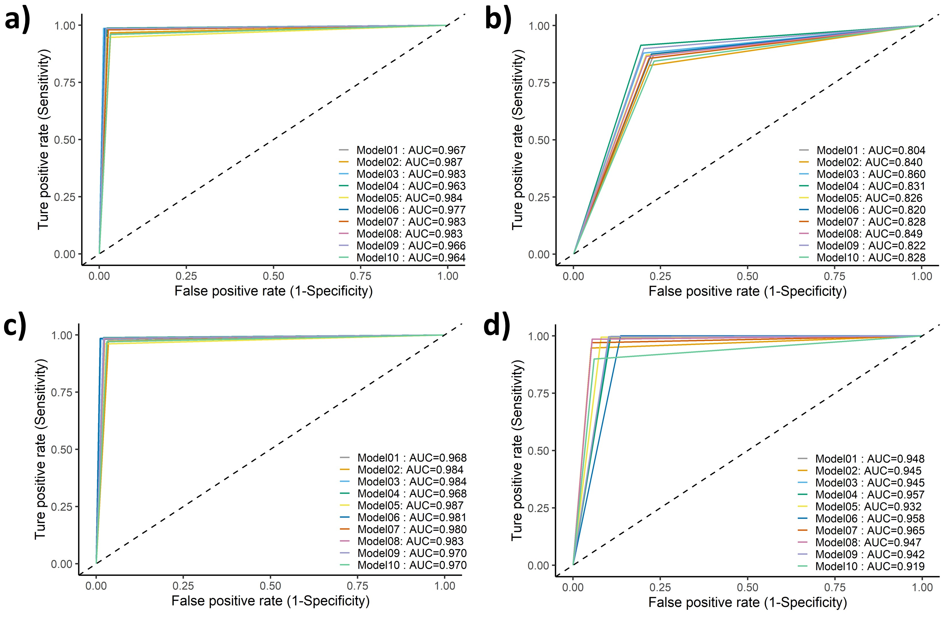

Figure S4: The statistical performance (ROC plot) of BuChE models on the test set.
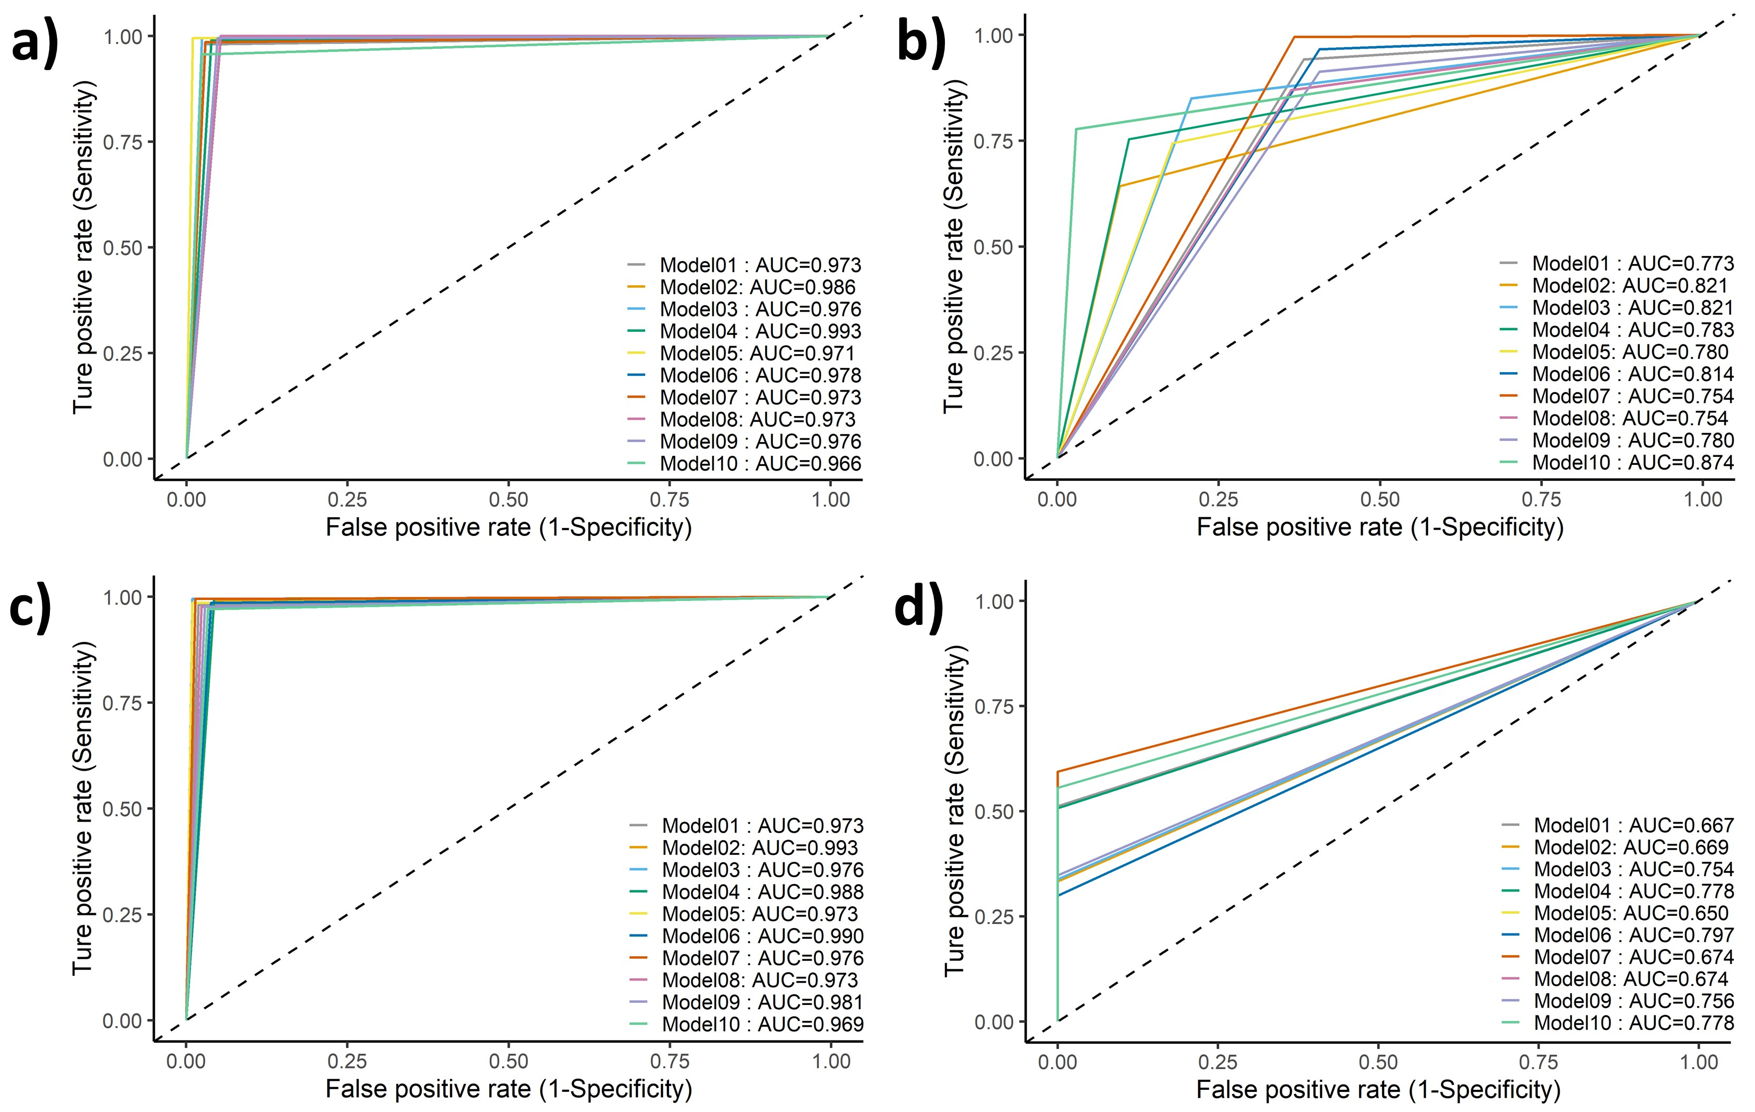

Figure S5: The statistical performance (ROC plot) of AChE models on the test set.
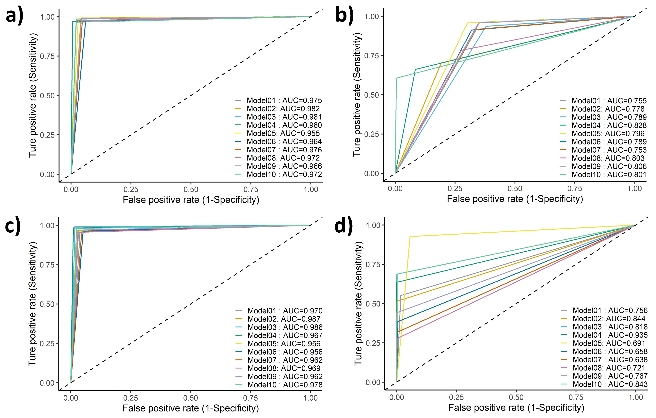
Figure S6: The statistical performance (ROC plot) of VAChT models on the test set.
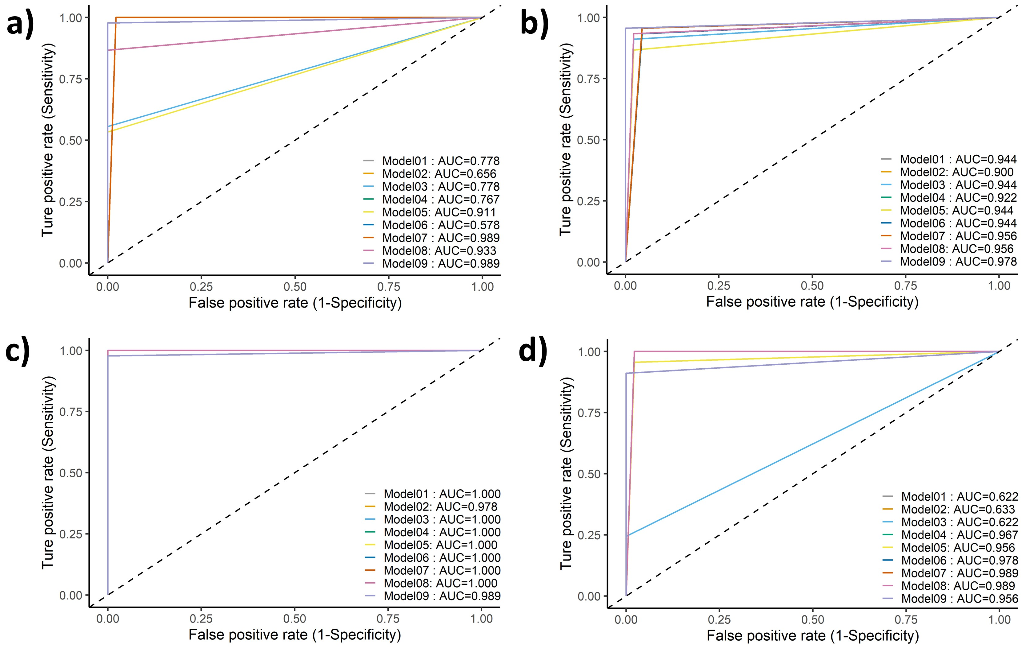

Figure S7: Principle Component Analysis of Cholinergic Models (a) nAChR; (b) mAChR; (c) BuChE; (d) AChE; (e) VAChT.

(a)
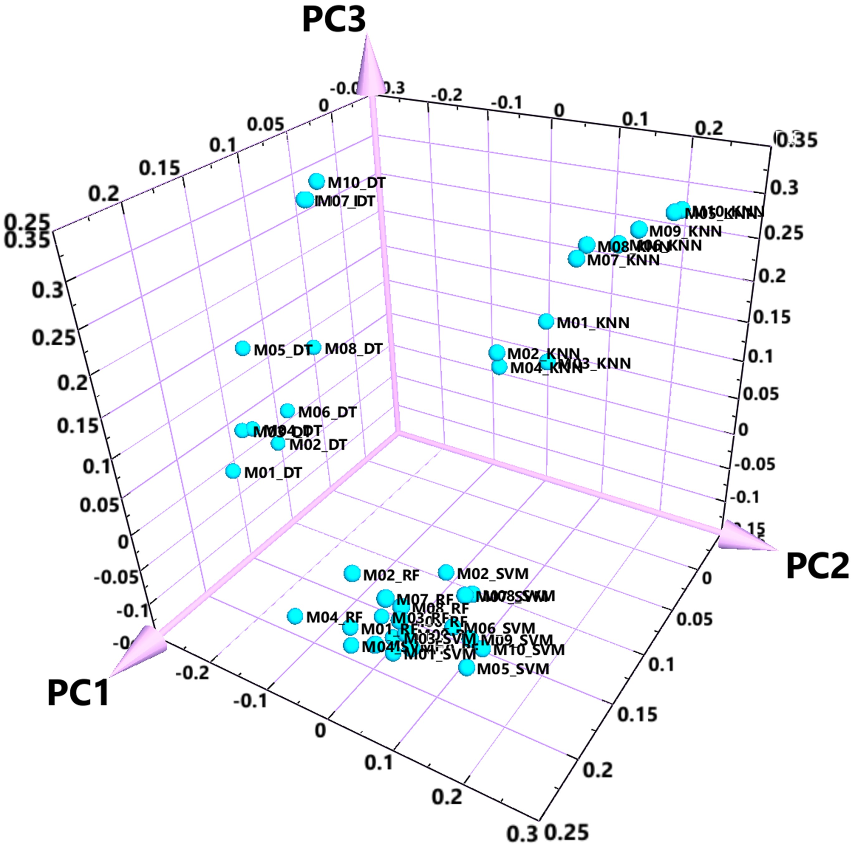

(b)
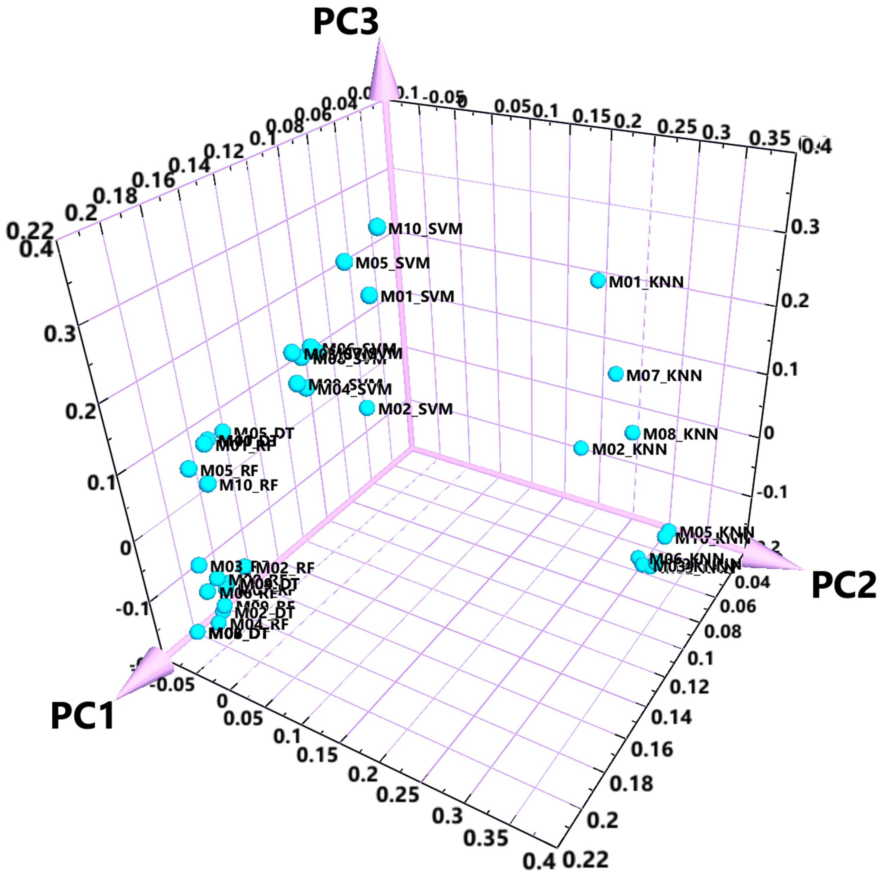

(c) 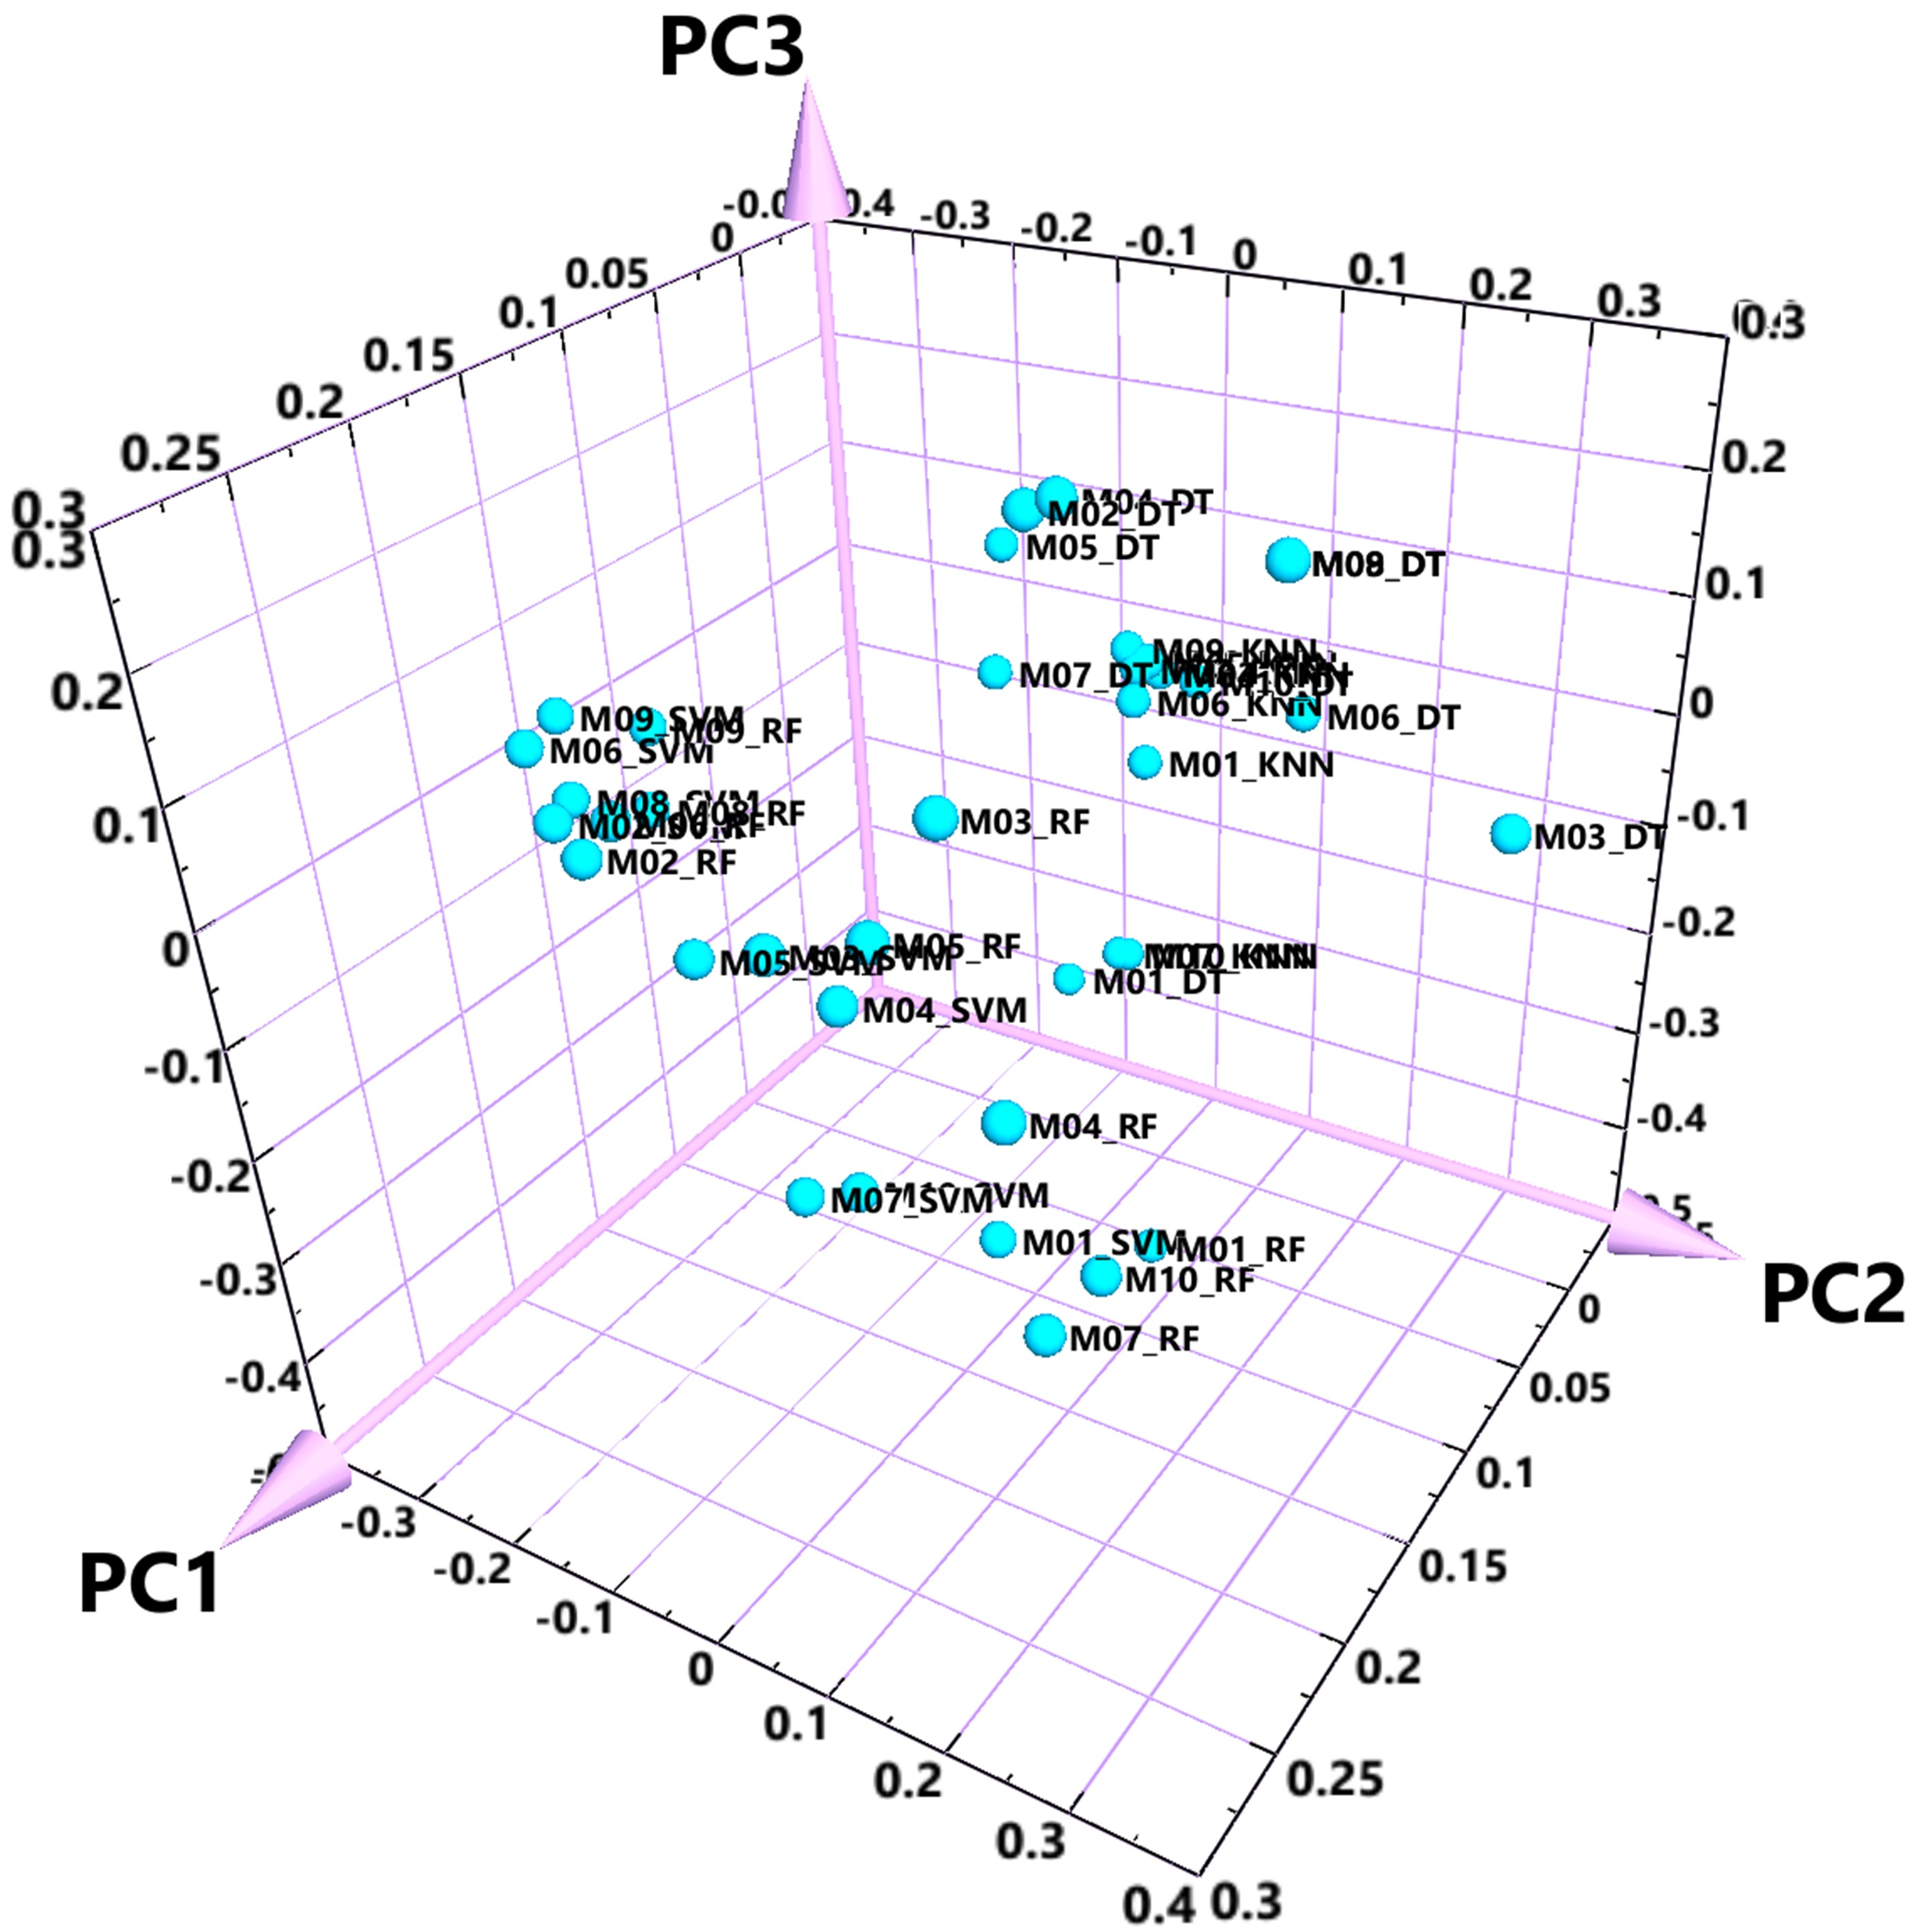

(d)
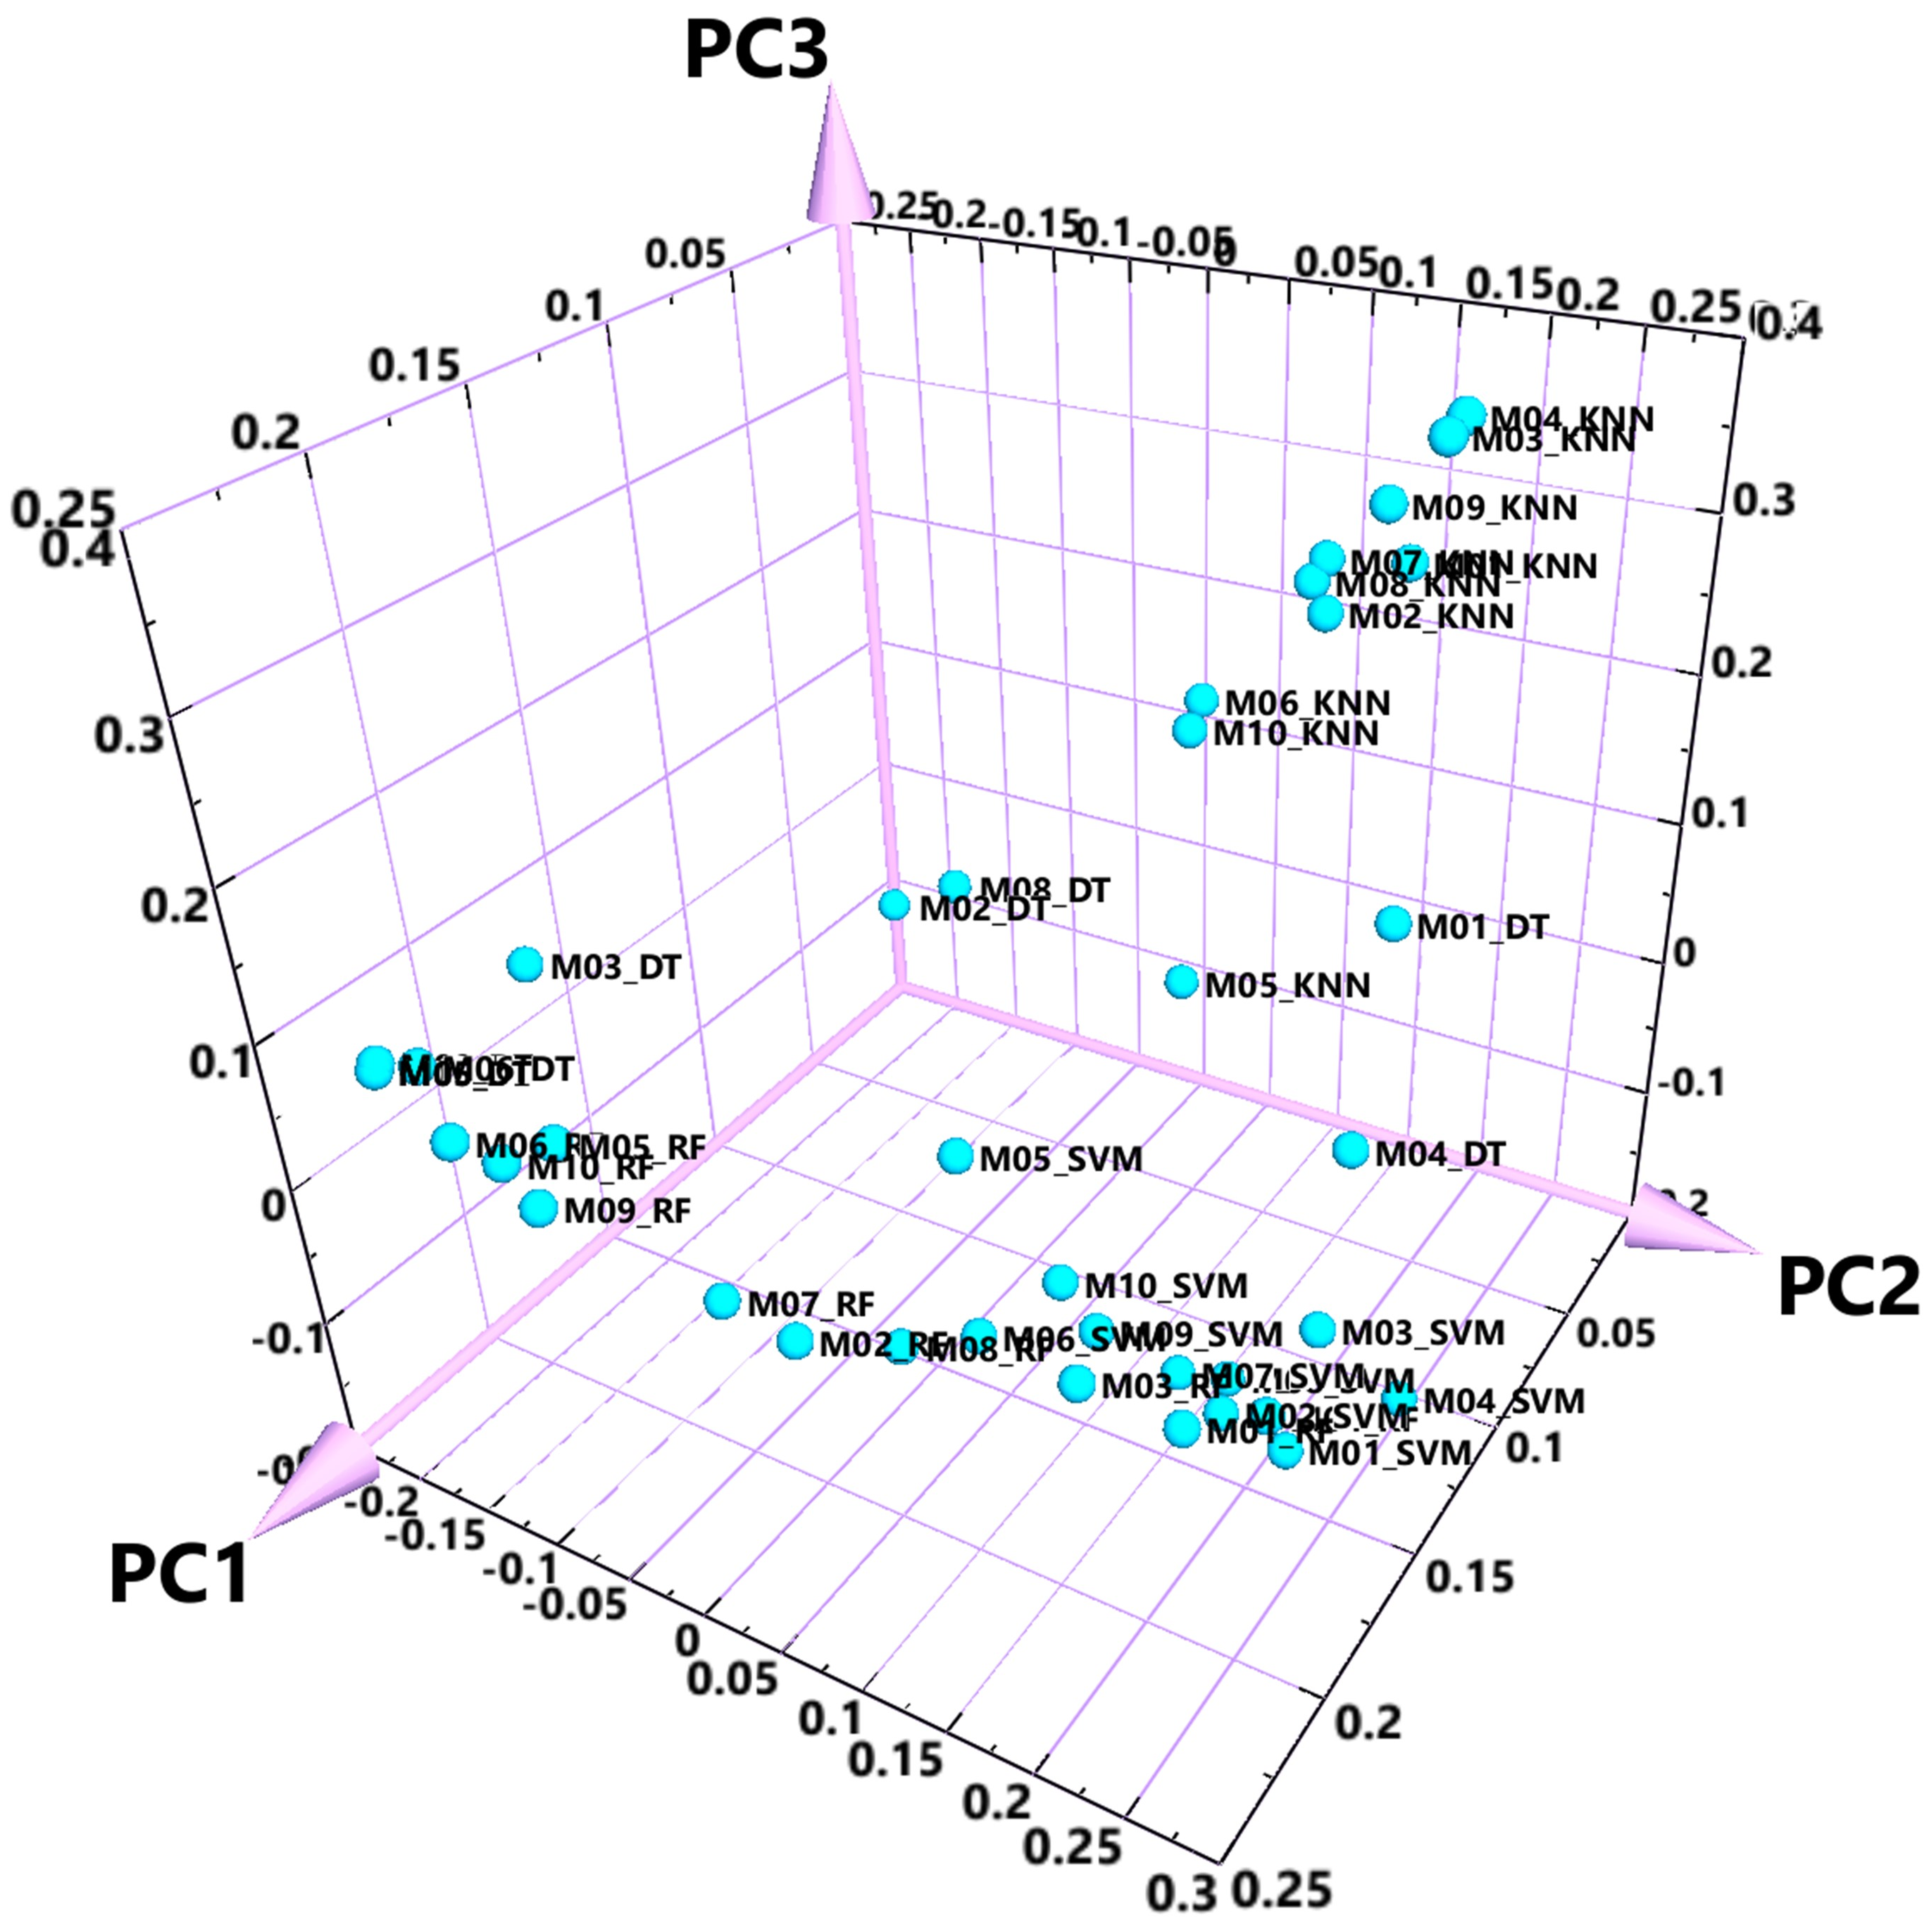

(e)
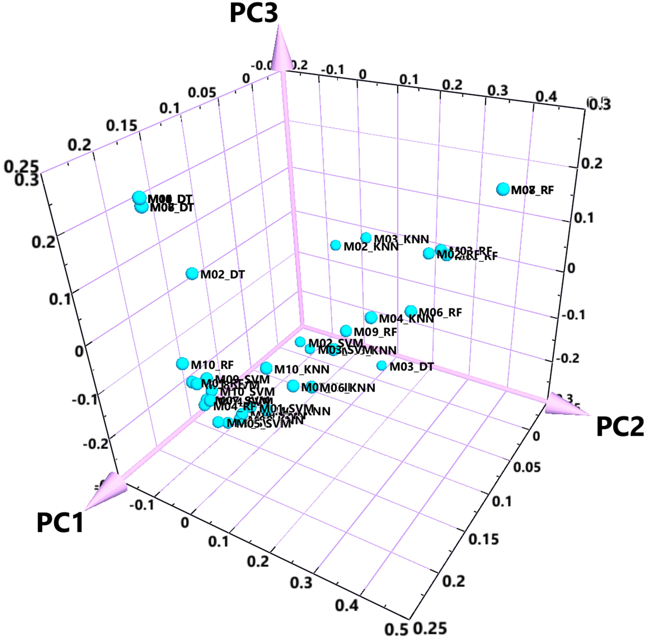

Figure S8: The workflow to build Array Type Meta-Predictor.

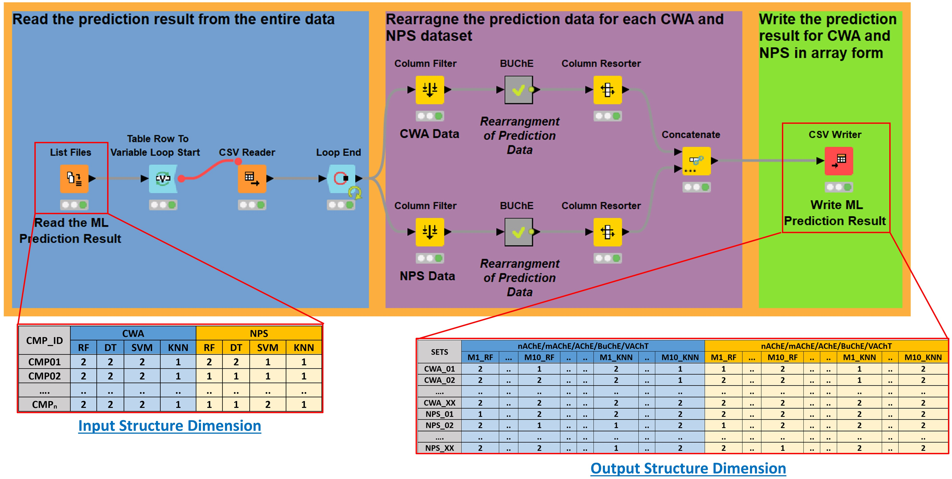
Given the input of different target prediction result from machine learning models, this KNIME workflow allows anyone to transform the input data into an array matrix with the dimensions of (4ML * 5targets * 10models = 200*number of compounds).

Figure S9: A Typical Convolutional neural network (CNN) model architecture used in this study. The architecture shown here is for CNN model with input shape of (50 x 4).
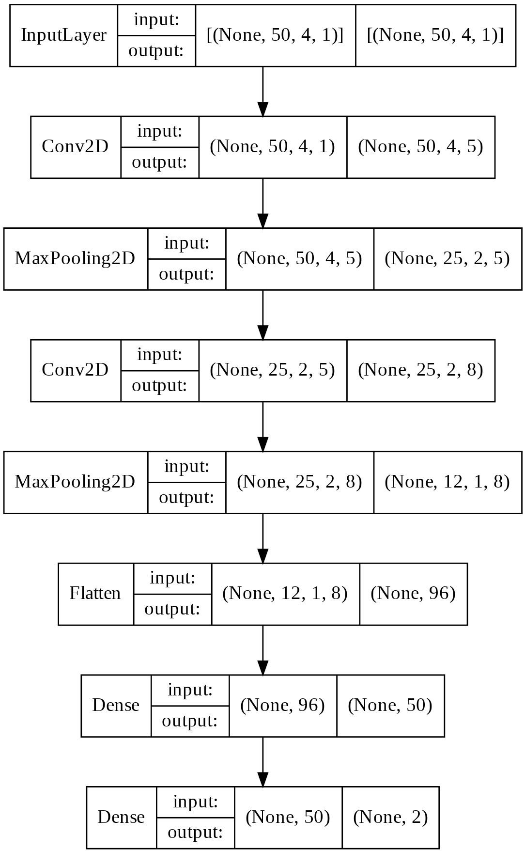

Table S8: The statistical performance of (CNN) model under different Array Shapes.

CNN Models Shapes | Models | Train Set |  | Test Set
CNN Models Shapes | Models | ACC | Loss | ACC | Loss | MCC | CWA |  |  | NPS
 |  |  |  |  |  |  | auROC | auPR | F1-Score | auROC | auPR | F1-Score
CNN  (50, 4) | Model01 | 0.985 | 0.045 | 0.982 | 0.075 | 0.638 | 0.933 | 0.724 | 0.585 | 0.933 | 0.997 | 0.991
CNN  (50, 4) | Model02 | 0.995 | 0.028 | 0.980 | 0.131 | 0.599 | 0.942 | 0.695 | 0.585 | 0.939 | 0.997 | 0.990
CNN  (50, 4) | Model03 | 0.998 | 0.014 | 0.977 | 0.138 | 0.581 | 0.925 | 0.688 | 0.593 | 0.936 | 0.997 | 0.988
CNN  (50, 4) | Model04 | 0.937 | 0.445 | 0.864 | 1.031 | 0.348 | 0.921 | 0.360 | 0.298 | 0.917 | 0.996 | 0.925
CNN-3D (10, 5, 4) | Model01 | 0.989 | 0.047 | 0.979 | 0.117 | 0.567 | 0.928 | 0.639 | 0.545 | 0.927 | 0.996 | 0.989
CNN-3D (10, 5, 4) | Model02 | 0.985 | 0.039 | 0.976 | 0.106 | 0.558 | 0.929 | 0.569 | 0.565 | 0.929 | 0.997 | 0.988
CNN-3D (10, 5, 4) | Model03 | 0.988 | 0.043 | 0.963 | 0.156 | 0.485 | 0.938 | 0.627 | 0.486 | 0.938 | 0.998 | 0.981
CNN-3D (10, 5, 4) | Model04 | 0.943 | 0.413 | 0.883 | 1.017 | 0.392 | 0.920 | 0.474 | 0.340 | 0.922 | 0.996 | 0.936
CNN-3D Reshaped (5, 10, 4) | Model01 | 0.980 | 0.058 | 0.978 | 0.092 | 0.537 | 0.907 | 0.606 | 0.512 | 0.907 | 0.995 | 0.989
CNN-3D Reshaped (5, 10, 4) | Model02 | 0.960 | 0.097 | 0.941 | 0.132 | 0.397 | 0.925 | 0.611 | 0.395 | 0.925 | 0.994 | 0.969
CNN-3D Reshaped (5, 10, 4) | Model03 | 0.988 | 0.063 | 0.952 | 0.262 | 0.470 | 0.957 | 0.696 | 0.452 | 0.953 | 0.998 | 0.975
CNN-3D Reshaped (5, 10, 4) | Model04 | 0.940 | 0.443 | 0.875 | 0.963 | 0.364 | 0.930 | 0.419 | 0.316 | 0.917 | 0.995 | 0.931
Abbreviations: Model01: Model without SMOTE; Model02: Model without SMOTE and without Duplicates; Model03: Model with SMOTE; Model04: Model with SMOTE and without duplicates; ACC: Accuracy; MCC: Matthew’s Correlation Coefficient; auROC: Area-Under-Receiver Operating Characteristic Curve; auPR: Area-Under-Precision-Recall Curve; CWA: Chemical Warfare agents; NPS: New Psychoactive Substances.

