Figure S1 Linear discriminant analysis effect size (LEfSe) analysis showing the differential distribution of microbiota in mesenteric adipose tissue (MAT) with high and low abundance of Enterobacteriaceae. High E: high abundance of Enterobacteriaceae; Low E: low abundance of Enterobacteriaceae.

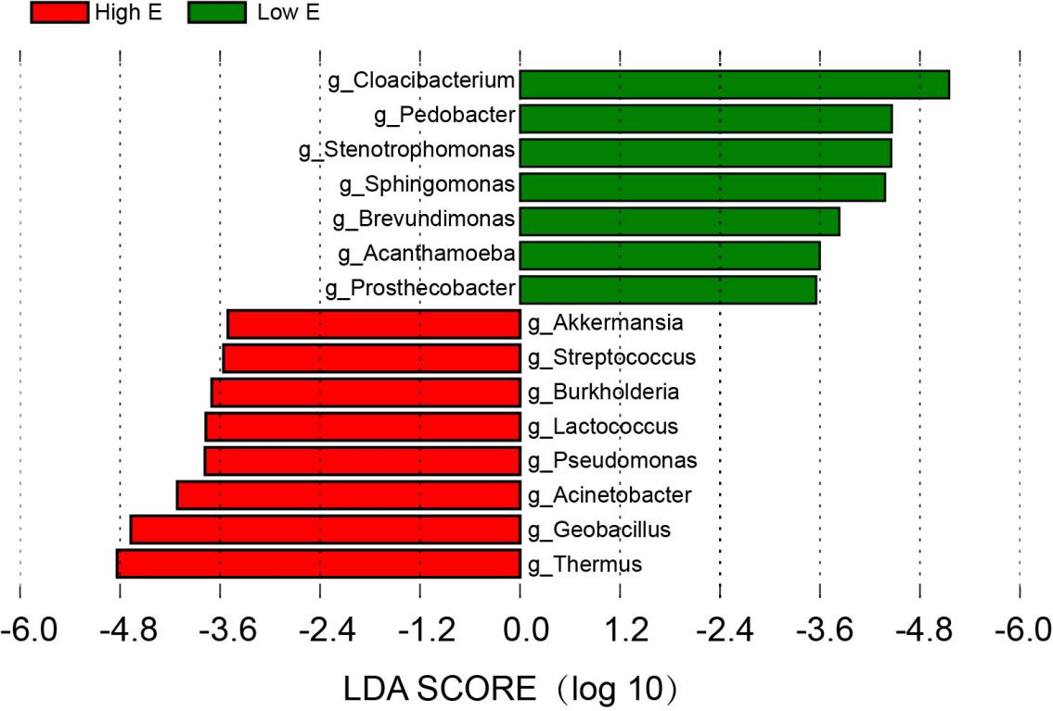

Figure S2 Functional analysis of genomic genes in K. variicola (a) and genes involved in protecting against oxidative damage (b)
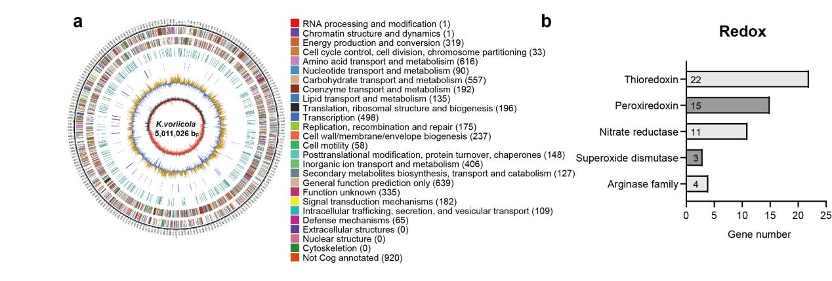

Figure S3 Down-regulated expression of ClpV in K. variicola derived from mice (a) and the comparable colonization ability between K.v-vetor and K.v-dcas-ClpV. K.v-vector, K. variicola transformated with empty plasmid; K.v-dcas-ClpV, K.variicola transformated with sgRNA containing plasmid. Error bars±SEM. *P<0.05; **P<0.01; ***P<0.001; Mann-Whitney
U-test.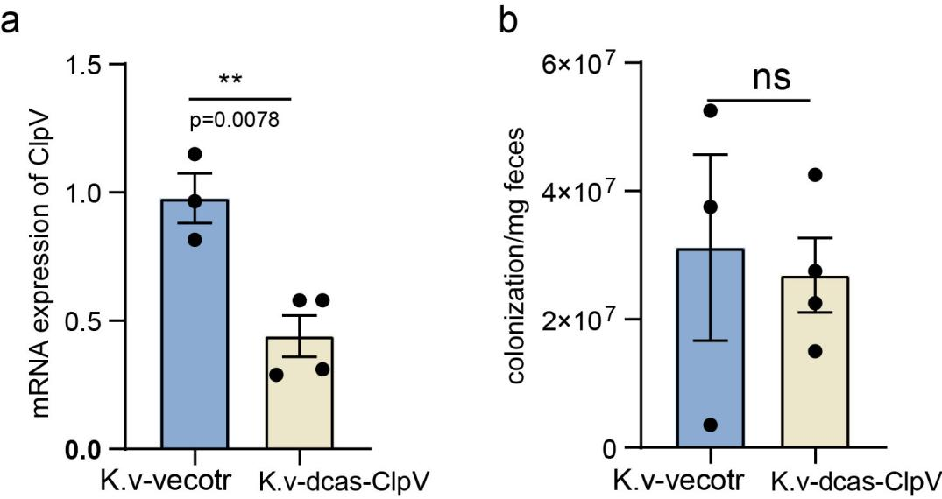

Figure S4 Summary schema showing the proposed mechanism by which MAT-derived K. variicola promotes intestinal colitis
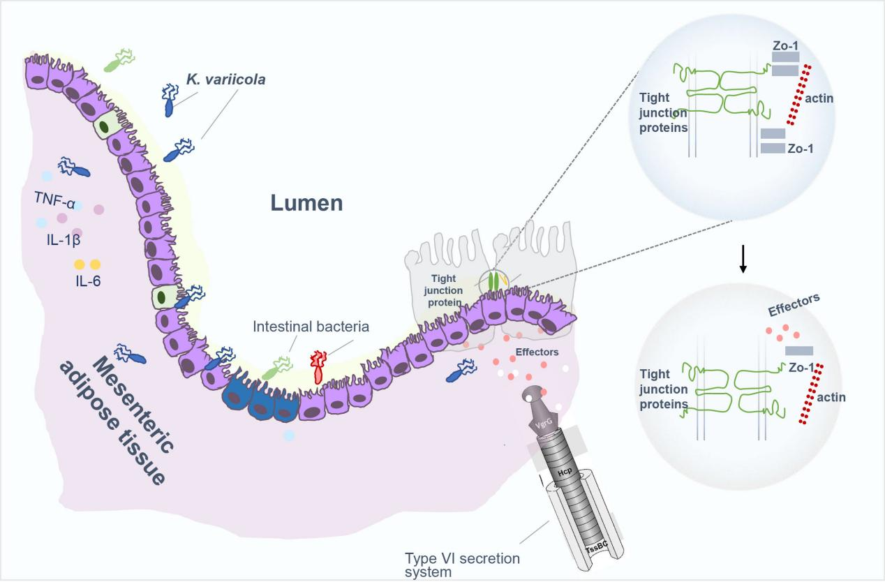

Table S1
Table S1 Primer sequences used in this study.

Origin | Primers | Forward | Reverse
Mouse | IL-1β | GCTGAAAGCTCTCCACCTCA | GCTTGGGATCCACACTCTCC
Mouse | IL-6 | CTCTGCAAGAGACTTCCATCCA | GACAGGTCTGTTGGGAGTGG
Mouse | TNF-α | GCCTCTTCTCATTCCTGCTTG | CTGATGAGGGAGGCCATT
Mouse | ZO-1 | TCATCCCAAATAAGAACAGAGC | GAAGAACAACCCTTTCATAAGC
Mouse | Claudin1 | TGCCCCAGTGGAAGATTTACT | CTTTGCGAAACGCAGGACAT
Mouse | Occludin | TGAAAGTCCACCTCCTTACAGA | CCGGATAAAAAGAGTACGCTGG
Mouse | Synpo | ATGGAGGGGTACTCAGAGGAG | CTCTCGGTTTTGGGACAGGTG
Mouse | Gapdh | TGAAGCAGGCATCTGAGGG | CGAAGGTGGAAGAGTGGGAG
Rat | IL-1β | CACCTCTCAAGCAGAGCACAG | GGGTTCCATGGTGAAGTCAAC
Rat | IL-6 | AAAGAGTTGTGCAATGGCAATTCT | CAGTGCATCATCGCTGTTCATACA
Rat | TNF-α | ACTGAACTTCGGGGTGATTG | GCTTGGTGGTTTGCTACGAC
Rat | Gapdh | GGCATTGCTCTCAATGACAA | AGGGCCTCTCTCTTGCTCTC
K. variicola |  | TACTTGTTCGACACGCGGAA, | CAATGGGCAACGAAAACGGT,
ClpV |  | ATGGGATATGGATGCGCTGT | AGGTGAACACTGCGGATCTG
16S rRNA |  | GTG STG CAY GGY TGT CGT CA | ACG TCR TCC MCA CCT TCC TC
16S rRNA (V1-V9)27F/1492R |  | AGAGTTTGATCCTGGCTCAG | TACGACTTAACCCCAATCGC
N20-ClpV |  | CTGACTAGTCTCCATTGCGCGGGCACAGCGTTTTAGAGCTAGAAATAG

Table S2
Table S2 Strains isolated from MATs of patients with CD and non-CD controls
Strains isolated from ≥2 specimens of patients with CD | Family | CD8 | CD10 | CD12 | CD13 | CD16 | CD14 | CD17 | CD7 | CD5 | CD6 | CD9 | CD3 | CD4 | CD1
Achromobacter deleyi | Alcaligenaceae | 0 | 1 | 0 | 1 | 1 | 1 | 1 | 0 | 0 | 0 | 0 | 0 | 0 | 0
Achromobacter pulmonis | Alcaligenaceae | 1 | 1 | 1 | 1 | 1 | 1 | 0 | 0 | 0 | 0 | 0 | 0 | 0 | 0
Devosia riboflavina | Devosiaceae | 1 | 0 | 0 | 1 | 1 | 1 | 1 | 0 | 0 | 0 | 0 | 0 | 0 | 0
Enterococcus durans | Enterococcaceae | 1 | 0 | 0 | 0 | 0 | 0 | 0 | 1 | 0 | 0 | 0 | 0 | 0 | 0
Enterococcus faecalis | Enterococcaceae | 0 | 0 | 0 | 0 | 0 | 0 | 0 | 0 | 0 | 0 | 0 | 1 | 1 | 1
Escherichia/Shigella | Enterobacteriaceae | 1 | 0 | 1 | 0 | 0 | 0 | 0 | 0 | 1 | 1 | 1 | 0 | 0 | 0
Klebsiella sp. | Enterobacteriaceae | 1 | 0 | 0 | 0 | 0 | 0 | 0 | 0 | 0 | 0 | 0 | 1 | 1 | 1
Ochrobactrum anthropi | Brucellaceae | 1 | 1 | 1 | 1 | 0 | 1 | 1 | 0 | 0 | 0 | 0 | 0 | 0 | 0
Pseudacidovorax intermedius | Comamonadaceae | 0 | 0 | 0 | 1 | 1 | 0 | 1 | 0 | 0 | 0 | 0 | 0 | 0 | 0
Pseudomonas alcaliphila | Pseudomonadaceae | 1 | 1 | 1 | 1 | 1 | 1 | 0 | 0 | 0 | 0 | 0 | 0 | 0 | 0
Staphylococcus capitis | Staphylococcaceae | 0 | 0 | 0 | 0 | 0 | 0 | 0 | 0 | 0 | 0 | 0 | 0 | 0 | 0
Staphylococcus epidermidis | Staphylococcaceae | 0 | 0 | 0 | 0 | 0 | 0 | 0 | 0 | 0 | 0 | 0 | 0 | 0 | 0
Staphylococcus haemolyticus | Staphylococcaceae | 0 | 0 | 0 | 0 | 0 | 0 | 0 | 0 | 0 | 0 | 0 | 0 | 0 | 0
Staphylococcus hominis | Staphylococcaceae | 0 | 1 | 1 | 0 | 0 | 0 | 0 | 0 | 0 | 0 | 0 | 0 | 0 | 0
Staphylococcus warneri | Staphylococcaceae | 0 | 0 | 0 | 0 | 0 | 0 | 0 | 0 | 0 | 0 | 0 | 0 | 0 | 0
Stenotrophomonas maltophilia | Xanthomonadaceae | 1 | 0 | 0 | 0 | 1 | 0 | 1 | 0 | 0 | 0 | 0 | 0 | 0 | 0
Strains isolated from ≥2 specimens of non-CD controls | Family | CRC-1 | CRC-2 | CRC-3 | CRC-4 | CRC-5 | CRC-6 | CRC-7 | CRC-8 | CRC-9
Staphylococcus capitisstrain JCM 2420 | Staphylococcaceae | 1 | 0 | 0 | 1 | 1 | 0 | 0 | 0 | 0
Escherichia fergusoniiATCC 35469 | Enterobacteriaceae | 0 | 0 | 1 | 0 | 0 | 0 | 0 | 0 | 1
Staphylococcus warneri strain AW 25 | Staphylococcaceae | 0 | 1 | 0 | 0 | 1 | 0 | 0 | 1 | 0
Staphylococcus epidermidis strain NBRC 100911 | Staphylococcaceae | 1 | 1 | 0 | 0 | 0 | 0 | 0 | 0 | 0
Staphylococcus hominisstrain DM 122 | Staphylococcaceae | 0 | 1 | 0 | 0 | 0 | 1 | 1 | 0 | 0
Staphylococcus haemolyticus strain JCM 2416 | Staphylococcaceae | 0 | 0 | 0 | 0 | 0 | 0 | 1 | 1 | 0

Table S3
Table S3 Genes assigned to type VI secretion system
#GeneID | start | end | Gene length |  | KEGG_annotation
GE00840 | 892204 | 892695 | 491 | + | K11901|8.41309e-106|kpt:VK055_1132|hypothetical protein; K11901 type VI secretion system protein ImpB (A)
GE00860 | 909497 | 909928 | 431 | + | K11901|1.95084e-85|kvd:KR75_19315|type VI secretion protein; K11901 type VI secretion system protein ImpB (A)
GE00861 | 910030 | 911574 | 1544 | + | K11900|0|kvd:KR75_19320|EvpB family type VI secretion protein; K11900 type VI secretion system protein ImpC (A)
GE00862 | 911584 | 912927 | 1343 | + | K11893|0|kpk:A593_21455|hypothetical protein; K11893 type VI secretion system protein ImpJ (A)
GE00863 | 912924 | 913613 | 689 | + | K11892|1.44184e-165|kva:Kvar_2972|type IV / VI secretion system protein, DotU family; K11892 type VI secretion system protein ImpK (A)
GE00865 | 915318 | 915809 | 491 | + | K11903|7.81129e-118|kps:KPNJ2_03095|hypothetical protein; K11903 type VI secretion system secreted protein Hcp (A)
GE00866 | 916074 | 918728 | 2654 | + | K11907|0|kpe:KPK_3063|clpV; type VI secretion ATPase, ClpV1 family; K11907 type VI secretion system protein VasG (A)
GE00867 | 918721 | 921099 | 2378 | + | K11904|0|kva:Kvar_2968|Rhs element Vgr protein; K11904 type VI secretion system secreted protein VgrG (A)
GE00879 | 931757 | 935185 | 3428 | + | K11891|0|kva:Kvar_2958|ImcF domain-containing protein; K11891 type VI secretion system protein ImpL (A)
GE00880 | 935182 | 936774 | 1592 | + | K11910|0|kpt:VK055_1092|impA-related N-terminal family protein; K11910 type VI secretion system protein VasJ (A)
GE00881 | 936854 | 938608 | 1754 | + | K11896|0|kvd:KR75_19380|type VI secretion protein ImpG; K11896 type VI secretion system protein ImpG (A)
GE00882 | 938572 | 939657 | 1085 | + | K11895|0|kpk:A593_21565|hypothetical protein; K11895 type VI secretion system protein ImpH (A)
GE00883 | 939635 | 940177 | 542 | + | K11906|1.5951e-126|kva:Kvar_2954|type VI secretion lipoprotein; K11906 type VI secretion system protein VasD (A)
GE01790 | 1875806 | 1877191 | 1385 | - | K11911|0|kpe:KPK_2057|ImpA domain-containing protein; K11911 type VI secretion system protein VasL (A)
GE01791 | 1877211 | 1877654 | 443 | - | K11905|1.25542e-101|kvd:KR75_24595|type VI secretion system lysozyme-like protein; K11905 type VI secretion system protein (A)
GE01792 | 1877657 | 1878193 | 536 | - | K11906|3.97974e-126|kpu:KP1_3367|hypothetical protein; K11906 type VI secretion system protein VasD (A)
GE01793 | 1878174 | 1879220 | 1046 | - | K11895|0|kpk:A593_00820|type VI secretion protein; K11895 type VI secretion system protein ImpH (A)
GE01794 | 1879220 | 1880983 | 1763 | - | K11896|0|kpn:KPN_02250|hypothetical protein; K11896 type VI secretion system protein ImpG (A)
GE01795 | 1881118 | 1884513 | 3395 | - | K11891|0|kpk:A593_00830|type VI secretion protein VasK; K11891 type VI secretion system protein ImpL (A)
GE01804 | 1894785 | 1897484 | 2699 | - | K11904|0|kpt:VK055_0186|vgrG2; valine-glycine repeat protein G; K11904 type VI secretion system secreted protein VgrG (A)
GE01806 | 1899647 | 1900300 | 653 | - | K11892|9.64329e-157|kpe:KPK_2042|type IV/VI secretion system protein, DotU family; K11892 type VI secretion system protein ImpK (A)
GE01807 | 1900297 | 1901637 | 1340 | - | K11893|0|kpk:A593_00885|hypothetical protein; K11893 type VI secretion system protein ImpJ (A)
GE02708 | 2876318 | 2876824 | 506 | + | K11903|2.23457e-123|kpx:PMK1_00572|hcpA_1; Secreted protein hcp; K11903 type VI secretion system secreted protein Hcp (A)
GE04306 | 4604093 | 4604578 | 485 | + | K11903|1.5935e-109|ror:RORB6_16040|type VI secretion system effector; K11903 type VI secretion system secreted protein Hcp (A)

Materials and methods
Sample collection
MATs were collected by surgical resection of 48 patients with CD and 16 non-CD controls (patient diagnosis of CRC). The diagnosis of CD was based on an integrated observation of endoscopy, clinical, and histopathological data. The diagnosis of CRC was made according to clinical guidelines and typical histopathological results. Exclusion criteria included patients unwilling to provide informed consent, took antibiotics within two weeks, being contraindicated to surgery, had acute gastrointestinal infection, being pregnant, had known bleeding disorder, or diagnosed with end-stage malignancy. The ethics committee of the Sixth Affiliated Hospital of Sun Yat-sen University (Guangzhou, CN) approved the protocol (No. 2020ZSLYEC-012). Written informed consent was obtained from all participants. To prevent spill-over contamination during surgery, MATs were sampled before opening the intestine. After resection, the specimens were transferred immediately into 50 mL sterile collection tubes (Corning) and transported to the central laboratory of our hospital on ice within 30 minutes of resection. Upon arrival, the specimens were rinsed in sterile PBS to remove the surface blood, which was subsequently subsampled into 4-5 pieces in an anaerobic chamber. MAT from non-CD controls was resected from the terminal ileum at the same location from where the CD-MAT was collected.
DNA extraction, 16S rRNA gene sequencing and data analysis
DNA was extracted from MAT samples using the bead-beating method with a DNeasy Blood & Tissue Kit (QIAGEN, MD). The hypervariable V4 region of the 16S rRNA gene was amplified by PCR using dual barcode primers as previously described²⁴.
Amplicons were purified by AMPure XP (Beckman Coulter), and quantified with Quant-iT PicoGreen ds DNA Assay Kit (Thermo Fisher Scientific). Equal amounts of each amplified DNA were pooled together, which were subsequently qualified and quantified by Bioanalyzer 2100 using the High sensitivity DNA kit (Agilent) as well as the KAPA Library Quantification Kit for Illuminan (Kapa Biosystem). Mixtures with denatured amplicons and 20% PhiX Control v.3 were then sequenced on Hiseq 2500 (Illumina, 2×250 bp paired-end reads). Quantitative Insights into Microbial Ecology 2 (QIIME II) using reference parameters was used for demultiplexing and quality filter. Sequences having 100% similarity were clustered into amplicon sequence variant (ASV). 16S rRNA gene sequence variants were aligned to the Greengenes database (http://greengenes.secondgenome.com) for taxonomic assignment. The relative abundance of each ASV was calculated from the proportion of the sum of sequences in each sample. A random of 10,000 tags were selected from each sample to avoid depth bias of sampling.
MAT bacteria cultivation and identification
MAT (approximately 100 mg) was homogenized using Sample Freezing Grinder (Lu Ka, LUKYM-I) in 1 mL of sterile PBS. The samples were serially diluted and spread onto agar media, including brain heart infusion media (BHI, BD), BHI supplemented with vitamin K (0.5 mg/L), heme (5 mg/L), MacConkey agar (MAC, Oxoid), and tryptic soy agar (TSA, BD). The plates were incubated under aerobic conditions for 14-16 h or under anaerobic conditions at 37℃ for up to 96 hours. Distinct bacterial colonies were selected and re-streaked for purification. The nearly full-length 16S rRNA gene was amplified using the 27F/1492R primer set for taxonomical assignment (Table S1). Amplicons were submitted to Rui Biotech (Guangzhou, CN) for Sanger sequencing. Each colony was identified by sequencing using the Basic Local Alignment Search Tool available on NCBI. The SILVA database was used for taxonomic hierarchy information reference.
Bacterial strains and culture conditions.
The strains isolated from MATs are listed in Supplementary Table S2. Of these, Klebsiella variicola was identified as a CD-specific species for functional and mechanistic analysis in the current study. Additionally, the following reference strains were used in this study: adherent/invasive Escherichia coli strain LF82 and Escherichia fergusonii isolated from SPF C57BL/6 mice. The former has been reported associated with ileac Crohn's disease, and is a lactose fermenter that grows in pink colonies on MacConkey's agar and was used as a prey cell in the inter-bacterial killing assay, while the latter was used as a non-pathogenic bacterial control in our mouse experiments. The three bacteria were grown in LB medium under aerobic conditions at 37℃ for 14-16 h.
Quantification of K. variicola in mice mesenteric adipose tissue
To determine the abundance translocated K. variicola in mice mesenteric adipose tissue (MAT), absolute quantitative PCR (qPCR) was performed with the total DNA extracted from MAT. Amplification was carried out in triplicate with SYBR Green qPCR in accordance with the manufacturer’s protocol (Biomarker, CN). A standard curve was plotted using serially diluted bacterial DNA extracted from K. variicola at 1×10⁹ CFU. Specific qPCR primers for K. variicola were designed based on whole genome sequencing data of K. variicola (Table S1).
Bacterial cell co-culture
Murine preadipocyte 3T3L1 or rat intestinal epithelial cell line IEC‐6 were co-cultured with bacteria (K. variicola, E. fergusonii, K. variicola-vector or K. variicola-dcas-ClpV) at a multiplicity of infection (MOI) of 20 at 37 °C, 5% CO₂ for four hours. Then, they were washed with warm PBS containing antibiotics (kanamycin and ampicillin at 100 ng/mL for K. variicola-and E. fergusonii treated groups). Cells were then cultured for 1 h in DMEM (Gibco) containing the antibiotics mentioned above. RNA from infected cells was extracted using TRIzol reagent (Thermo Fisher Scientific) and the gene expression was measured by qPCR.
Bacteria invasion assay
Murine preadipocyte 3T3L1 cells were seeded in 24-well cell culture plates at a density of 1×10⁵ cells/well. Bacterial cells (K. variicola and E. coli DH5α) were washed three times with PBS and re-suspended in DMEM without antibiotics. Bacteria were added to the cell plates at a multiplicity of infection (MOI) of 20 and incubated at 37℃ in 5% CO₂ for 4 h. Then, the in-well co-cultured systems were washed thrice with warm PBS, followed by an incubation in DMEM (10% FBS) containing antibiotics (kanamycin and ampicillin at 100 ng/mL) at 37℃, 5% CO₂ for 1 h to kill extracellular bacteria. Cells were then lysed with 0.5% Triton X-100 in PBS, and internalized bacteria were enumerated by plate counting.
Mice experiment
C57BL/6 and IL-10^{-/-} mice (6-8 weeks old) were purchased from Gem Pharmatech Co. Ltd. (Guangzhou) and Beijing HFK Bioscience Co. Ltd. (Beijing) and were housed under a 12-hour light-dark cycle in specific pathogen-free (SPF) facilities. For the dextran sulfate sodium (DSS)-induced colitis model, male C57BL/6 mice were treated with an antibiotic cocktail (ampicillin 0.2 g/L, metronidazole 0.2 g/L, Neomycin 0.2 g/L, vancomycin 0.1 g/L) in the drinking water for 5 days. This was followed by a daily gavage of bacteria (1×10⁹ CFU/mouse) for 14 days after the withdrawal of antibiotic treatment for one day. 3% dextran sulfate sodium (DSS) was administered on day 0, which lasted for seven consecutive days, and then changed by regular water for two days. The mice were monitored for weight loss, stool consistency, and hemoccult during the experiments, and the disease activity index (DAI) was calculated from the observations above. For spontaneously developing colitis model, IL-10^{-/-} mice were treated with an antibiotic cocktail (ampicillin 0.2 g/L, metronidazole 0.2 g/L, Neomycin 0.2 g/L, vancomycin 0.1 g/L) in the drinking water for 5 days, followed by daily gavage of bacteria (1×10⁹ CFU/mouse) for 21 consecutive days. During the experiment, mice were monitored for weight loss, stool consistency, and hemoccult, and the DAI was calculated from the observations above.
Contact-dependent neighbor-killing assay
The contact-dependent neighbor-killing assay was performed according to a previously established protocol, with minor modifications ³⁰. Briefly, E. coli LF82 and K. variicola (or K. variicola-vector, K. variicola-dcas-ClpV), which were defined as prey and predator cells, respectively, were harvested after overnight growth, washed, and concentrated to (OD₆₀₀) in PBS. Predator cells were well mixed with E. coli at a ratio of 1:1, which were then spotted onto pre-warmed LB agar plates. We incubated the plates at 37 °C for 4 h and then cut out of each spot in the LB plate and suspended in sterile PBS. The suspensions were serially diluted and spotted onto MAC agar plates. The number of prey cells recovered on the MAC agar plate was counted to determine the colony-forming units per ml.
ClpV knockdown by CRISPR/dCas9-assisted system
We used the CRISPR interference (CRISPR i) system to inhibit ClpV expression in T6SS. This system works from two plasmids: one plasmid encoding constitutive dCas9 (Addgene, plasmid #65006), and another encoding constitutively expressed sgRNA targets (pTargetF, Addgene, plasmid #62226). The newly designed sgRNA on the website http://www.rgenome.net/cas-designer/ (ClpV-N20-CTGactagtCTCCATTGCGCGGGCACAGCgttttagagctagaaatag) targeting the gene ClpV was cloned into plasmid #62226 with a single SpeI restriction site. Construction of the complete N20 containing plasmid was conducted by single digestion with SpeI, template excision with DpnI, and fragment ligation with T4 DNA ligase (Thermo Scientific). This plasmid was subsequently transformed into E. coli DH5α and subjected to Sanger sequencing to confirm successful insertion (RuiBiotech). To create K. variicola-dcas-ClpV, competent K. variicola cells were first transformed with dcas9 with kanamycin resistance and then prepared for competent cells for the second transformation with N20-pTargetF with spectinomycin resistance. The original pTargetF vector without N20 was transformed into K. variicola-dcas competent cells to obtain the K. variicola-vector as a negative control. The inhibition efficiency of ClpV was evaluated by qPCR, and the bacterial 16S rRNA gene was used as an internal reference gene to normalize transcript levels.
Growth Curves
Growth curves were monitored using an automatic biological growth reactor (RTS-1C, Unk Bio). Overnight cultures of K. variicola-vector and K. variicola-dcas-ClpV were diluted in 25 mL LB supplemented with kanamycin (50 μg/mL) and spectinomycin (50 μg/mL). Bacterial growth at OD₆₀₀ was measured every ten minutes (Rev. Spin period: five seconds, 220 rpm/min at 37 °C).
Transmission Electron Microscopy (TEM)
Colon tissue (1 mm³) was collected from K. variicola, E. fergusonii, or PBS-treated C57BL/6 mice and fixed in electron microscopy fixatives (Servicebio, CN). Ultrathin sections were prepared using a Reichert Ultracut E ultramicrotome (Leica Microsystems). Digital images were obtained using TEM (Hitachi H-7000, equipped with an AMT CCD camera XR-41, Hitachi, Japan).
Statistical Analysis
GraphPad Prism 8 was used for statistical analyses, except for ROC, which was analyzed using an online bioinformatics analysis platform (https://www.omicstudio.cn/tool). Significance between two groups was determined by an unpaired two-tailed Student’s t-test. Significance between data that did not pass the normal distribution was determined with the unpaired two-tailed Mann-Whitney test. For comparisons between multiple groups, an ordinary one-way or two-way analysis of variance (ANOVA) was utilized, followed by Tukey’s and Dunnett’s tests. For comparison between multiple groups with two factors, two-way ANOVA was used, followed by Tukey’s multiple comparison test. The specific statistical details were shown in the figure captions and the source data. Differences were regarded as significant when P<0.05. Unless otherwise indicated, data for all experiments are presented as the mean ± standard error of the mean (SEM).

