Supplementary Information for
Wafer-scale and universal van der Waals metal semiconductor contact
Lingan Kong^{1,3}, Ruixia Wu^{2,3}, Yang Chen¹, Fuying Huang², Liting Liu¹, Wei Li², Donglin Lu¹, Quanyang Tao¹, Wenjing Song¹, Wanying Li¹, Zheyi Lu¹, Xiao Liu¹, Zhiwei Li¹, Wei Tong¹, Shuimei Ding¹, Songlong Liu², Likuan Ma¹, Liwang Ren¹, Yiliu Wang¹, Lei Liao¹, Xidong Duan², Yuan Liu^{1,*}
¹Key Laboratory for Micro–Nano Optoelectronic Devices of Ministry of Education, School of Physics and Electronics, Hunan University, Changsha 410082, China.
²State Key Laboratory for Chemo/Biosensing and Chemometrics, College of Chemistry and Chemical Engineering, Hunan University, Changsha 410082, China.
³ These authors contributed equally to this work.
*Corresponding author. E–mail: yuanliuhnu@hnu.edu.cn
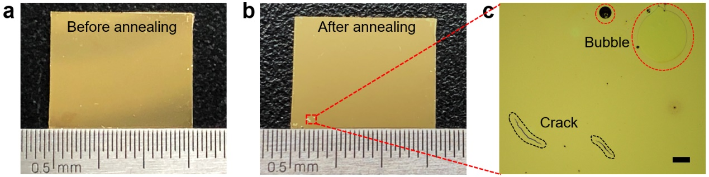
Supplementary Fig. 1. Images of a larger Au film after PPC decomposition. a, Photograph of Au/PPC/WSe₂ using continuous Au film (without stencil) over 1 cm. b, c, Photograph and optical images of the corresponding device after PPC decomposition, where film cracks or air bubbles can be observed. The scale bar in c is 200 μm.
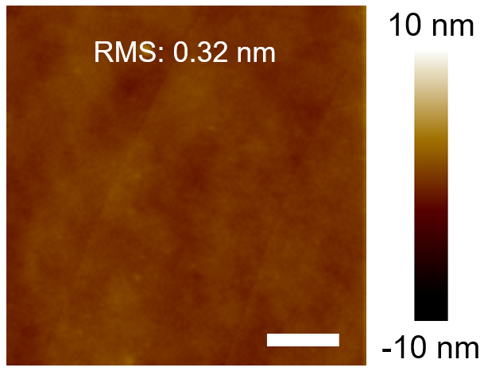
Supplementary Fig. 2. AFM image of PPC surface (spin-coated on silicon substrate), demonstrating a small RMS roughness of 0.32 nm. The scale bar is 6 μm.

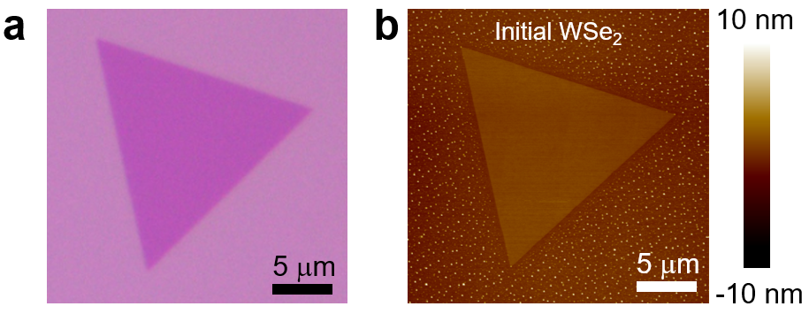
Supplementary Fig. 3. Optical image and AFM image of CVD grown WSe₂ flake. a, Optical image of a CVD grown WSe₂ monolayer. b, The corresponding AFM image, demonstrating a small RMS roughness of 0.1 nm.

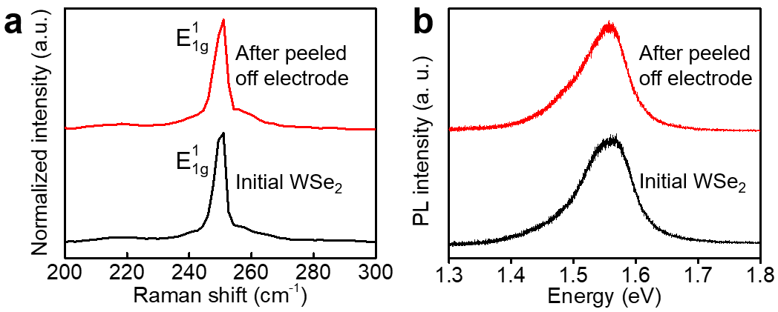
Supplementary Fig. 4. Raman and photoluminescence spectrums with initial WSe₂ and after vdW integration. a, Normalized Raman spectrum of as-grown WSe₂ and after Au metals (60 nm thick) vdW integrated, the peak at 250.68 cm⁻¹ remains identical before and after peeling-off the electrodes. b, The normalized photoluminescence spectrum of as-grown WSe₂ nanosheets and after peeling-off the electrodes.

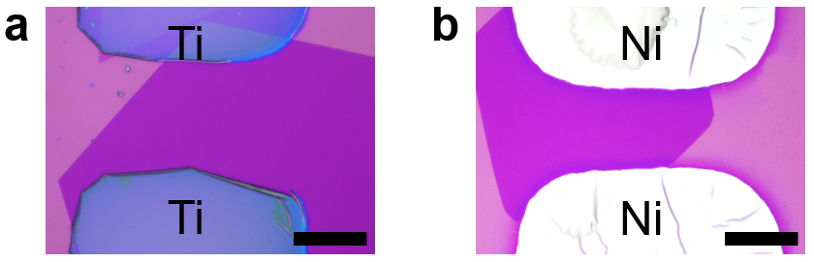
Supplementary Fig. 5. Optical images of WSe₂ transistors with different metals vdW contact. a, Optical image of WSe₂ transistors with Ti contact metal. b, Optical image of WSe₂ transistors with Ni contact metal. The scale bar is 40 μm.
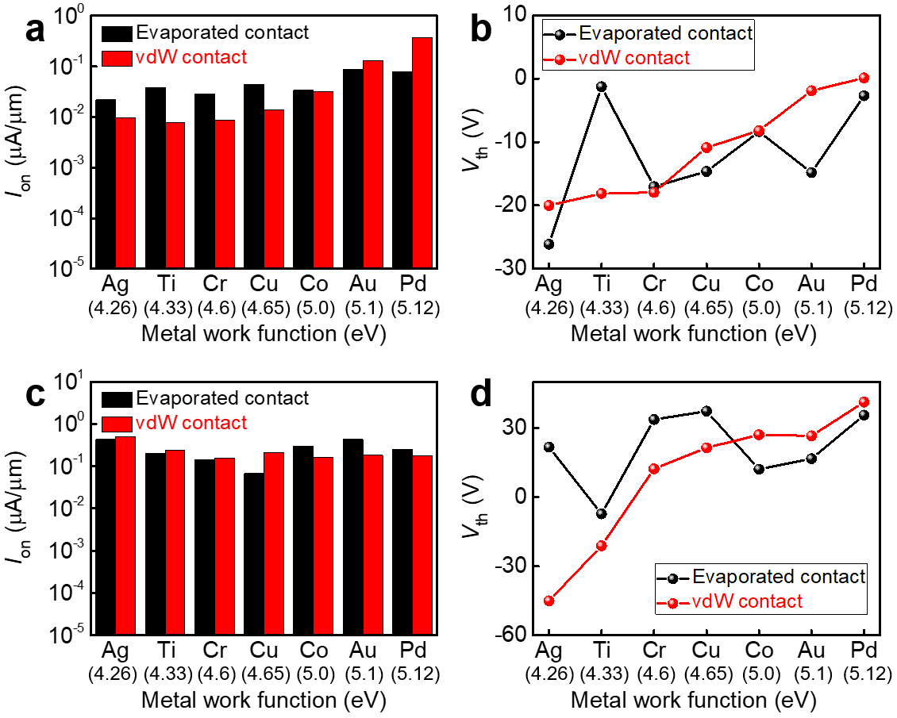
Supplementary Fig. 6. Electrical measurement MoTe₂ and IGZO transistors for different metals fabricated through both evaporation and vdW metal integration. a, b, On-state currents (a) and V_{th} (b) of p-type MoTe₂ transistors using different metal integration approaches, where the vdW integrated devices is more sensitive to the metal work function. c, d, On-state currents (c) and V_{th} (d) of n-type IGZO transistors for different metals fabricated through different metal integration approaches.

