Supplementary Information for;

A Greener Mechanochemical Approach to the Synthesis of Urea-Hydroxyapatite Nanohybrids for Slow Release of Plant Nutrients
Madhavi de Silva¹, Chanaka Sandaruwan², Francisco C. Robles Hernandez^{3,4}, Onur Sahin⁴, Meiyazhagan Ashokkumar⁴, Pulickel M. Ajayan⁴, Veranja Karunaratne⁵, Gehan A. J. Amaratunga⁶, Nilwala Kottegoda^{1*}
¹Department of Chemistry/Center for Advanced Materials Research, University of Sri Jayewardenepura, Sri Soartha Mawatha, Nugegoda 10250, Sri Lanka
²Nanotechnology and Science Park, Center for Excellence in Nanotechnology, Sri Lanka Institute of Nanotechnology (SLINTEC), Mahenawatta, Pitipana, Homagama 10206, Sri Lanka
³College of Engineering Technology, University of Houston, Houston, TX, U.S.A. 77204-4020
⁴Department of Materials Science & NanoEngineering, Rice, University, Houston, Texas, U.S.A. 77005
⁵Department of Chemistry, University of Peradeniya, Peradeniya 20400, Sri Lanka
⁶Department of Engineering, University of Cambridge, Trumpington Street, Cambridge CB2 1PZ, United Kingdom
*Corresponding author: Nilwala Kottegoda (nilwala@sjp.ac.lk)

- X-Ray Photoelectronic Spectral Analysis

Table S1: Quantitative results from the XPS analysis of HA
Electronic core-level | Binding Energy (eV) | Atomic Weight Percentage (%) | FWHM (eV)
Ca 2p | 347.73 | 67.86 | 1.78
P 2p | 133.85 | 100 | 1.99
O 1s | 531.53 | 45.39 | 1.51

Table S2: Quantitative results from the XPS analysis of Urea
Electronic core-level | Binding Energy | Atomic Weight Percentage | FWHM
N 1s | 400.04 | 56.87 | 1.36
O 1s | 531.95 | 10.35 | 1.42

Table S3: Quantitative results from the XPS analysis of Urea-HA nanohybrids
Electronic core-level | Binding Energy | Atomic Weight Percentage | FWHM
N 1s | 399.45 | 100 | 2.33
Ca 2p | 347.11 | 68.05 | 1.62
P 2p | 132.8 | 32.94 | 1.42
O 1s | 530.99 | 40.29 | 1.53

- Fourier Transmission Infrared (FTIR) Spectral Analysis

Table S4: Peak shifts in the C=O stretching and -NH₂ bending regions of the Urea-HA nanohybrids
 | C=O  stretching/ cm⁻¹ | Peak Shift /cm⁻¹ | -NH₂  bending/cm⁻¹ | Peak  Shift/ cm⁻¹
Urea | 1663 | - | 1612 | -
10: 1 U-HA | 1682 | 19 | 1626 | 14

Table S5: Peak shift in the N-C-N stretching region of the Urea-HA nanohybrids
 | N-C-N stretching  / cm⁻¹ | Peak  Shift / cm⁻¹
Urea | 1454 | -
10: 1 U-HA | 1464 | 10

Table S6: Peak shifts in the -NH₂ stretching regions of the Urea-HA nanohybrids
 | -NH₂ stretching  / cm⁻¹ | Peak  shift / cm⁻¹ | - NH₂ stretching  / cm⁻¹ | Peak  Shift / cm⁻¹
Urea | 3440 | - | 3336 | -
10: 1 U-HA | 3438 | 2 | 3343 | 6

Table S7: Peak shift in the PO₄³⁻ stretching regions of the Urea-HA nanohybrids
 | PO₄³⁻ stretching/ cm⁻¹ | Peak Shift / cm⁻¹
Urea | 1039 | -
10: 1 U-HA | 1041 | 2

- Release Kinetic Modeling of Urea-HA nanohybrids in Water

The data received from the nitrogen release behavioral studies in water were fitted into the below-mentioned kinetic models to determine R² values and release exponent (n) values.

i) Zeroth-order rate model,

Q₀ − Q_{t} = k₀t

Q₀ = Initial amount of the active compound
Q_{t} = Amount of active compound dissolved at time t
K₀ = Zero-order rate constant
t = Time

ii) First-order rate model,

Log C_{t} = Log C₀ + kt/2.303

C₀ = Initial concentration of the active compound
C_{t} = Concentration of the active compound released after time t
K = First-order rate constant
t = Time

3. Higuchi model,

Log Q =1/2 log t + log k_{H}

Q = Amount of active compound released
k_{H} = Higuchi dissociation constant
t = time

4. Korsmeyer-Peppas model

M_{t}/M∞ = kt^{n}

M_{t}/M∞ - Fraction of active compound released at time t
n = diffusion exponent
k = kinetic constant
Assumptions: Infinite time

5. Hixson-Crowell model

Q₀^{1/3} – Q_{t} ^{1/3} = K_{HC}t

Q_{t} = Remaining weight of nitrogen at time t
Q₀ = Initial weight of solid at time t = 0
t = Time
K_{HC} = Dissolution rate constant

6. The Avrami-Erofe’ev model,

ln[-ln(C_{t}/C₀ )] = n ln (k_{d}) + n ln (t-t₀)

C₀ = Amount of nitrogen in Urea-HA Nanohybrids at t=0,
C_{t} = Amount of nitrogen remaining in the Urea-HA nanohybrids at time t
k_{d} = Rate of release
n = Constant
Table S8: The R² values obtained from the applying various kinetic models

Kinetic Model | R² Values
Zeroth Order | 0.667
First Order | 0.806
Higuchi | 0.748
Korsmeyer-Peppas | 0.88
Hixson-Crowell | 0.96
Avrami-Erofe’ev | 0.993

- Plant Plot Trials

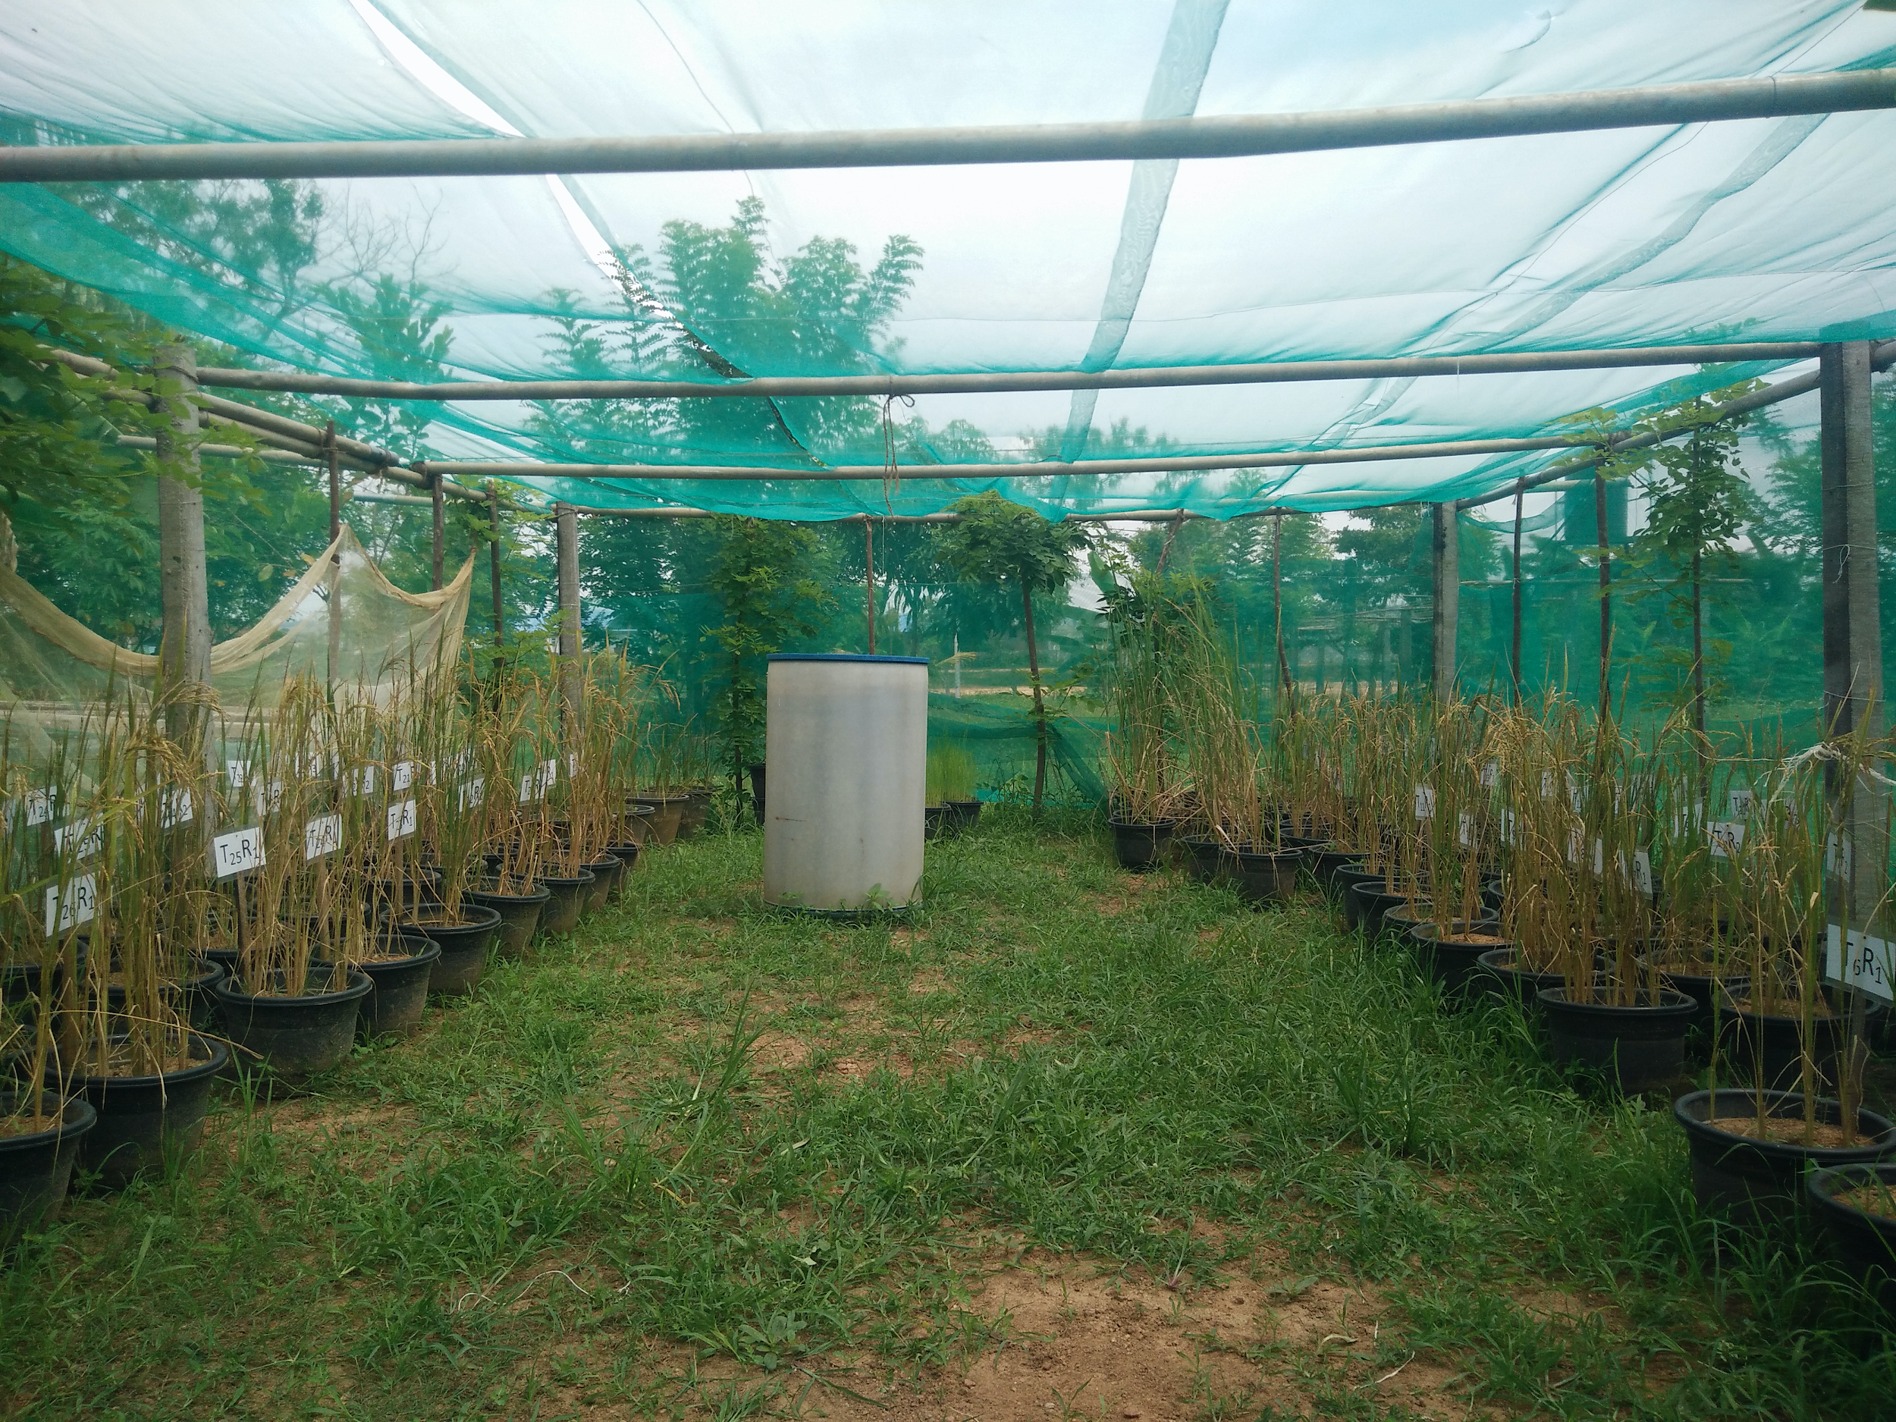

Figure S1: Plant plot trials experiments

- Calculation of Nitrogen Agronomic Use Efficiency (NAE)

Nitrogen Agronomic Use Efficiency was calculated using the below-mentioned equation;

[Yield from Nitrogen Treatment (kg ha⁻¹) / Yield from no nitrogen treatment(kg ha⁻¹)]
NAE (kg N kg⁻¹)
=
Total Nitrogen Applied (kg ha⁻¹)

Table S9: Nitrogen Agronomic Use Efficiencies (NAE)s calculated for urea and Urea-HA nanohybrids

 | Nitrogen Agronomic Use Efficiencies (NAE) (kg N kg⁻¹)
Urea | ~ 8%
Urea-HA nanohybrid | ~16 %

- Proposed Scale-Up Process and Financial Calculations

(i) Industrial Manufacturing Process Layout
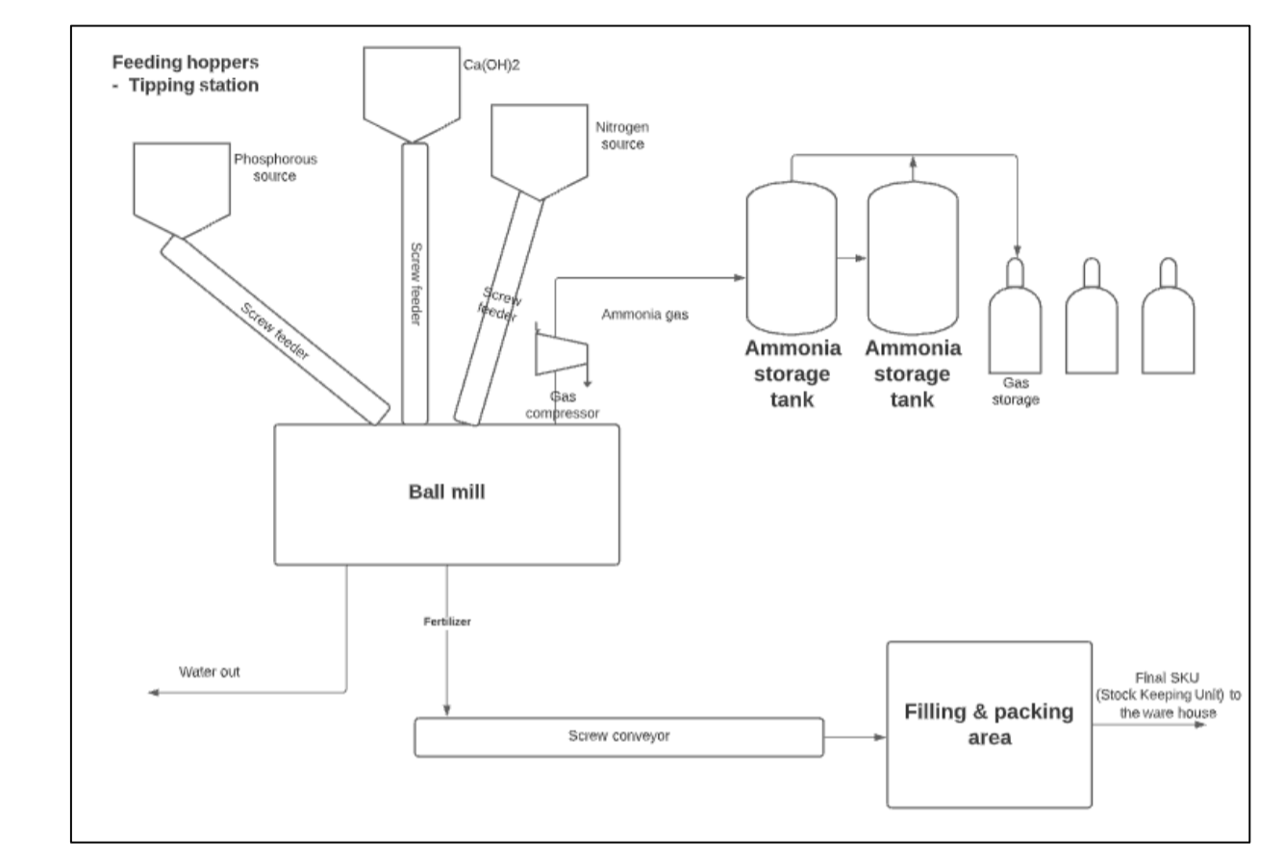

Figure S3: Proposed process layout diagram. Alternatively, the stored ammonia can be bubbled through phosphoric acid to regenerate the phosphorus source used: Diammonium Hydrogen Phosphate

Ammonia is the only by-product coming out from the reaction between Calcium Hydroxide and Diammonium Hydrogen Phosphate and will be collected and stored as Ammonia gas. This ammonia gas could be used to regenerate the starting material Diammonium Hydrogen Phosphate by bubbling phosphoric acid.

iii) Cost Estimation and Financial Analysis
The following calculations present the variable costs that will incur in producing urea-HA nanohybrids and therefore cost of production for 1 kg of the nanofertilizer.
NB: These calculations are made based on the utility, infrastructure, economic conditions of Sri Lanka as of March 2021 (Exchange Rate - 1 USD = LKR 200)

Total Production Capacity per Day: 140 mt per day
Table S10: Operational costs (Per day)

Direct labor (LKR) | 20000
Utilities (LKR) | 100000

Table S11: Raw materials costs (Required for 140 MT/day)

 | Required  amount (kg) | Cost  per 1 kg (LKR) | Total cost (LKR)
Di Ammonium Hydrogen Phosphate | 127260 | 60 | 7635600
Calcium Hydroxide | 9427.6 | 35 | 329966
Urea | 8943.48 | 30 | 268304.4
 |  |  | 8233870.4

Packaging & transportation - LKR 2000000

Total variable costs to produce 140 MT Production cost) = LKR 10533870.4

Total variable costs to produce 1 kg = LKR 75

The cost to produce one kilogram of the nanofertilizer = USD 0.38

