Advanced simulations and screening to design a 3C protease inhibitor against the drug resistant human norovirus-induced gastroenteritis

Esmaeil Behmardª, Ebrahim Barzegari^{b}, Akbar Farjadfar^{c}, Amin Kouhpayeh^{d}, Sohrab Najafipourª
ª School of Advanced Technologies in Medicine, Fasa University of Medical Sciences, Fasa, Iran.
^{b} Medical Biology Research Center, Health Technology Institute, Kermanshah University of Medical Sciences, Kermanshah, Iran.
^{c} Department of Medical Biotechnology, Fasa University of Medical Sciences, Fasa, Iran.
^{d} Department of Pharmacology, Faculty of Medicine, Fasa University of Medical Sciences, Fasa, Iran.
Correspondence: Sohrab Najafipour, School of Advanced Technologies in Medicine, Fasa University of Medical Sciences, Fasa, Iran.
E-mail: sohrabnajafipour@yahoo.com
Correspondence: Amin Kouhpayeh, Department of Pharmacology, Faculty of Medicine, Fasa University of Medical Sciences, Fasa, Iran.
E-mail: kouhpayeha@gmail.com

SUPPLEMENTARY INFORMATION

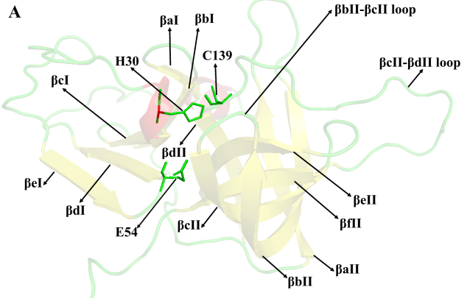 | 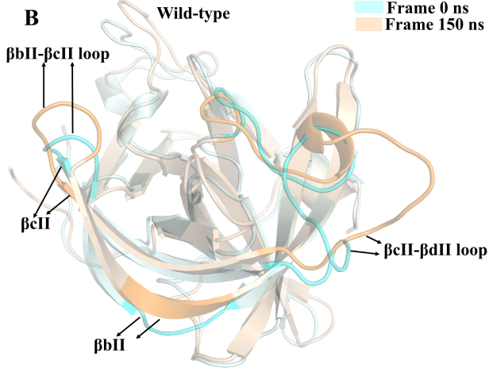
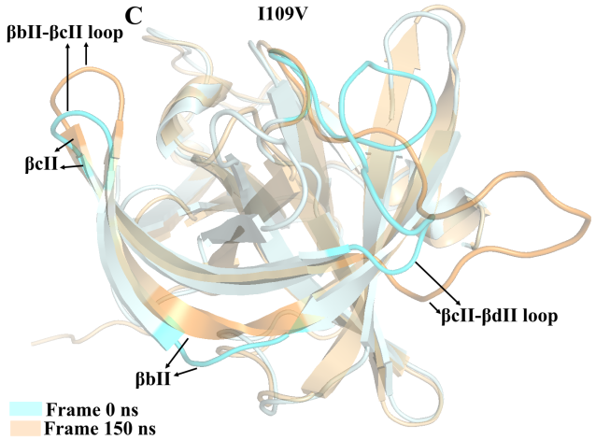 | 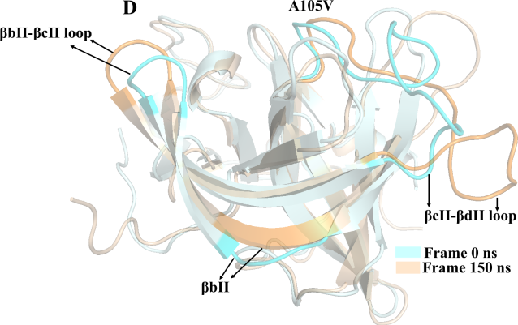
Figure S1: (A) The 3D view of 3C protease of human norovirus; (B-D) The protein structural superposition of frame 0 ns (palecyan cartoon) and frame 150 ns (wheat cartoon). (B) Wild-type protease; (C) I109V mutant protease and (D) A105V mutant protease.

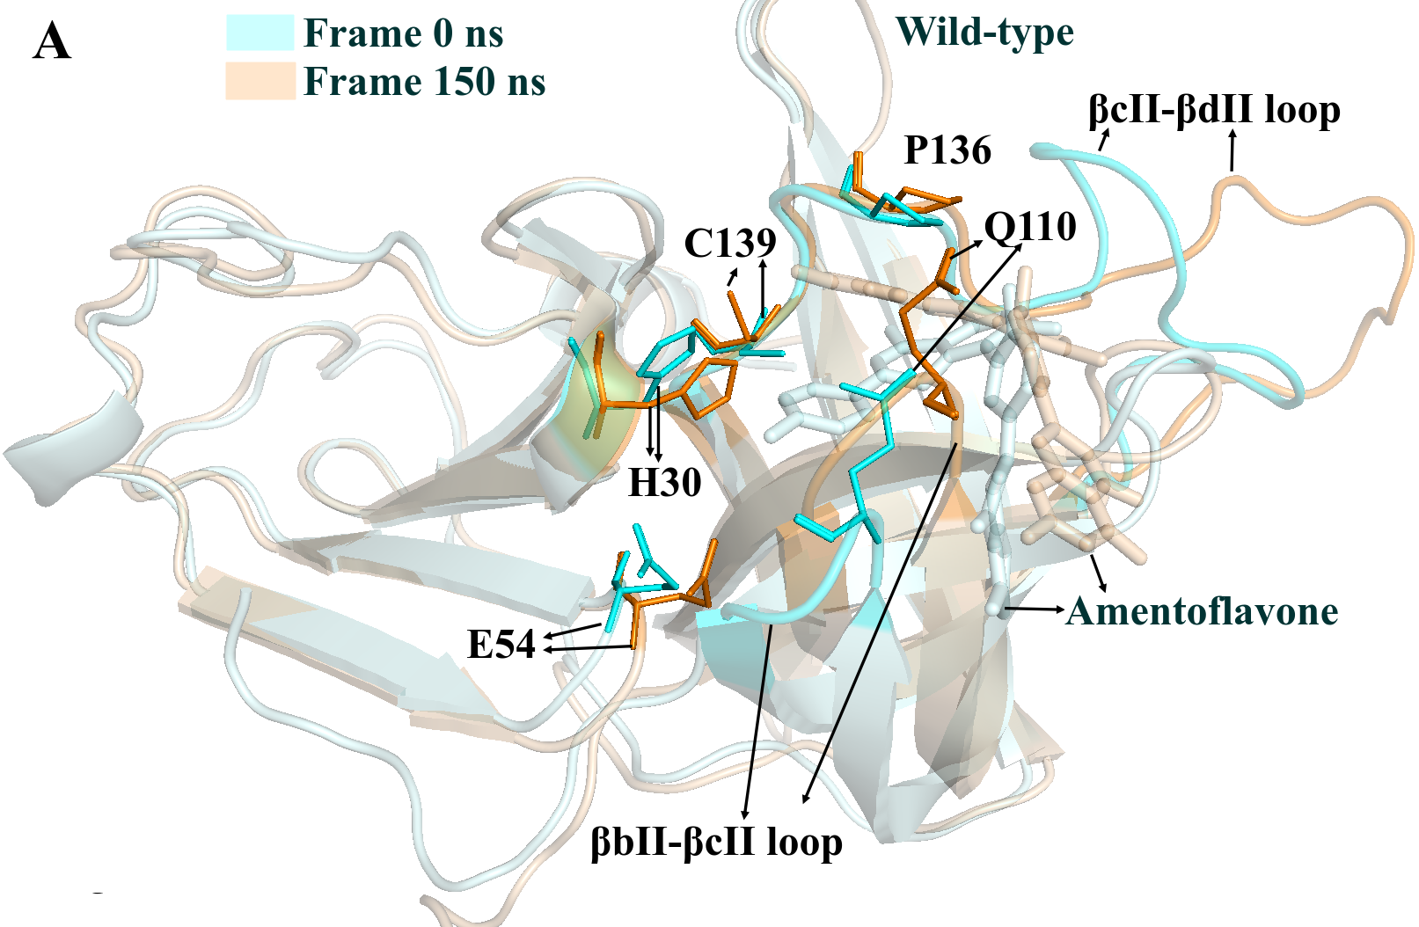 | 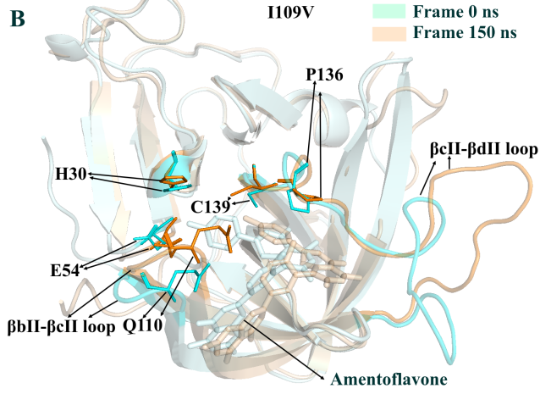
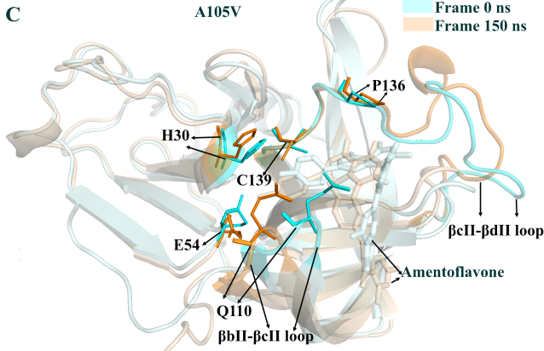

Figure S2: (A-B) The protein structural superposition of frame 0 ns (palecyan cartoon) and frame 150 ns (wheat cartoon). (B) Wild-type protease; (C) I109V mutant protease and (D) A105V mutant protease.

