Differences in lesion- and normal-site microbiota between patients with oral mucosal abnormalities determined using 16S rRNA gene sequencing

Authors: Yawaka Shitozawa ^{1, 2 *}, DDS, Kaoru Haro ¹, MD, PhD, Midori Ogawa ¹, PhD, Akihiko Miyawaki ², DDS, PhD, Mitsumasa Saito ¹, MD, PhD, Kazumasa Fukuda ^{1 *}, PhD

Affiliations: ¹ Department of Microbiology, School of Medicine, University of Occupational and Environmental Health, Japan, 1-1 Iseigaoka, Yahatanishi-ku, Kitakyushu, Fukuoka, 807-8555, Japan, ² Department of Dentistry and Oral Surgery, Hospital of the University of Occupational and Environmental Health, Japan, 1-1 Iseigaoka, Yahatanishi-ku, Kitakyushu, Fukuoka, 807-8556, Japan

Corresponding author
Correspondence to Yawaka Shitozawa & Kazumasa Fukuda.

Supplementary Table 1
Supplementary Figures 1-16

Supplementary Table Legend
Supplementary Table 1. Annotation of representative sequences of OTUs using BLAST.

Supplementary Figure Legends
Supplementary Figure 1. Graphical characteristics of lesions on the tongue.
(a) Patient 1, (b) Patient 2, (c) Patient 3, (d) Patient 4, (e) Patient 5, (f) Patient 6, (g) Patient 7, (h) Patient 8, (i) Patient 9, and (j) Patient 10.

Supplementary Figure 2. Total bacterial cell counts in each sample.
(a) Bacterial cell counts in lesion and normal site swabs. (b) Comparison of bacterial cell counts in lesion and normal site swabs. The box plots show the 25th and 75th quartiles (bottom and top of the box, respectively), median (middle horizontal line), average (cross mark), and minimum and maximum values that are not outliers (top and bottom whiskers). Outliers are defined as 1.5 times the quartile range (points). Statistical significance between two type samples was tested using Mann-Whitney's U test. p > 0.05. L: lesion, N: normal site. (c) Bacterial cell counts in oral rinse samples.

Supplementary Figure 3. Rarefaction curves and rareslopes for bacterial OTU clustering at 99.6% sequence similarity in each sample.
(a) Rarefaction curve showing analysis of OTUs identified in samples. lesion: pink line, normal site: blue line, oral rinse: gray line. (b) Rareslopes. The box plots show the 25th and 75th percentiles (bottom and top of the box, respectively), median (middle horizontal line), average (cross mark), and minimum and maximum values that are not outliers (top and bottom whiskers). Outliers are defined as values greater than 1.5 times the interquartile range (points). Statistical significance among three type samples was tested using the Kruskal–Wallis test, and the Steel–Dwass test was applied for multiple comparisons (bars; p < 0.05). L: lesion, N: normal site, R: oral rinse, OTU: operational taxonomic unit.

Supplementary Figure 4. Relative abundance at OTU level in each sample.
Graph showing the abundance of 13 OTUs and Others (OTUs with relative abundance < 1% in the total sequences). All oral rinse samples had high percentage of Others. Data labels show number of patient. L: lesion, N: normal site, R: oral rinse, OTU: operational taxonomic unit.

Supplementary Figure 5. Phylogenetic analysis of OTU 0,2,4,9,12 assigned as the genus Streptococcus.
The 16S rRNA gene sequences assigned to the genus Streptococcus using BLAST were aligned with those of the type strains of the genus Streptococcus using MEGA-X. A maximum likelihood tree based on the alignments (550 bp) was constructed using MUSCLE. The K2+G+I model (K2: Kimura 2-parameter, G+I: Gamma distribution with invariant sites) selected using the Find best model was used. Accession numbers are provided according to the taxonomic name. OTUs obtained in this study are shown in bold font. Lactobacillus delbrueckii AY773949 was used as an outgroup. Scale bar denotes substitutions per site. Bootstrap values from 500 analyses are shown at the branch points. OTU: operational taxonomic unit.

Supplementary Figure 6. Phylogenetic analysis of OTU 1,10 assigned as the genus Gemella.
The 16S rRNA gene sequences assigned to the genus Gemella using BLAST were aligned with those of type strains of the genus Gemella using MEGA-X. A maximum likelihood tree based on the alignments (548 bp) was constructed using MUSCLE. The K2+G (K2: Kimura 2-parameter, G: Gamma distribution) selected using the Find best model was used. Accession numbers are provided according to the taxonomic name. OTUs obtained in this study are shown in bold font. Dolosigranulum pigrum (T) X70907 was used as an outgroup. Scale bar denotes substitutions per site. Bootstrap values from 500 analyses are shown at the branch points. OTU: operational taxonomic unit.

Supplementary Figure 7. Phylogenetic analysis of OTU 11 assigned as the genus Granulicatella.
The 16S rRNA gene sequence assigned to the genus Granulicatella using BLAST was aligned with those of type strains of the genus Granulicatella using MEGA-X. A maximum likelihood tree based on the alignments (550 bp) was constructed using MUSCLE. The K2+G model (K2: Kimura 2-parameter, G: Gamma distribution) selected using the Find best model was used. Accession numbers are provided according to the taxonomic name. OTUs obtained in this study are shown in bold font. Dolosigranulum pigrum (T) X70907 was used as an outgroup. Scale bar denotes substitutions per site. Bootstrap values from 500 analyses are shown at the branch points. OTU: operational taxonomic unit.

Supplementary Figure 8. Phylogenetic analysis of the OTU 3,5,6 assigned as the genus Neisseria.
The 16S rRNA gene sequences assigned to the genus Neisseria using BLAST were aligned with those of type strains of the genus Neisseria using MEGA-X. A maximum likelihood tree based on the alignments (550 bp) was constructed using MUSCLE. The K2+G+I model (K2: Kimura 2-parameter, G+I: Gamma distribution with invariant sites) selected using the Find best model was used. Accession numbers are provided according to the taxonomic name. OTUs obtained in this study are shown in bold font. Amantichitinum ursilacus (T) FN994890 was used as an outgroup. Scale bar denotes substitutions per site. Bootstrap values from 500 analyses are shown at the branch points. OTU: operational taxonomic unit.

Supplementary Figure 9. Phylogenetic analysis of OTU 7 assigned as the genus Haemophilus.
The 16S rRNA gene sequence assigned to the genus Haemophilus using BLAST was aligned with those of type strains of the genus Haemophilus using MEGA-X. A maximum likelihood tree based on the alignments (547 bp) was constructed using MUSCLE. The K2+G+I model (K2: Kimura 2-parameter, G+I: Gamma distribution with invariant sites) selected using the Find best model was used. Accession numbers are provided according to the taxonomic name. OTUs obtained in this study are shown in bold font. Aeromonas salmonicida (T) AJ009859 was used as an outgroup. Scale bar denotes substitutions per site. Bootstrap values from 500 analyses are shown at the branch points. OTU: operational taxonomic unit.

Supplementary Figure 10. Phylogenetic analysis of OTU 8 assigned as the genus Fusobacterium.
The 16S rRNA gene sequence assigned to the genus Fusobacterium using BLAST in this study was aligned with those of the type strains of the genus Fusobacterium using MEGA-X. A maximum likelihood tree based on the alignments (524 bp) was constructed using MUSCLE. The K2+G model (K2: Kimura 2-parameter, G: Gamma distribution) selected using the Find best model was used. Accession numbers are provided according to the taxonomic name. OTUs obtained in this study are shown in bold font. Leptotrichia shahii (T) AY029806 was used as the outgroup. Scale bar denotes substitutions per site. Bootstrap values from 500 analyses are shown at the branch points. OTU: operational taxonomic unit.

Supplementary Figure 11. Phylogenetic analysis of OTU 14 assigned as the genus Prevotella.
The 16S rRNA gene sequence assigned to the genus Prevotella using BLAST was aligned with those of type strains of the genus Prevotella using MEGA-X. A maximum likelihood tree based on the alignments (540 bp) was constructed using MUSCLE. The K2+G+I model (K2: Kimura 2-parameter, G+I: Gamma distribution with invariant sites) selected using the Find best model was used. Accession numbers are provided according to the taxonomic name. OTUs obtained in this study are shown in bold font. Porphyromonas gingivalis AB035459 was used as the outgroup. Scale bar denotes substitutions per site. Bootstrap values from 500 analyses are shown at the branch points. OTU: operational taxonomic unit.

Supplementary Figure 12. Phylogenetic analysis of OTU 15 assigned as the genus Cutibacterium.
The 16S rRNA gene sequence assigned to the genus Cutibacterium using BLAST was aligned with those of type strains of the genus Cutibacterium and Propionibacterium using MEGA-X. A maximum likelihood tree based on the alignments (531 bp) was constructed using MUSCLE. The HKY+G model (HKY: Hasegawa-Kishino-Yano, G: Gamma distribution) selected using the Find best model was used. Accession numbers are provided according to the taxonomic name. OTUs obtained in this study are shown in bold font. Flindersiella endophytica FJ805430 was used as the outgroup. Scale bar denotes substitutions per site. Bootstrap values from 500 analyses are shown at the branch points. OTU: operational taxonomic unit.

Supplementary Figure 13. Relative abundance at genus level in each sample.
Graph showing the abundance of 11 genera and Neisseriaceae unclassified bacterium and Others (genus with relative abundance < 1.0% in the total sequences). The genus Streptococcus was the most abundant in most samples. Data labels show the patient number. L: lesion, N: normal site, R: oral rinse.

Supplementary Figure 14. Comparison of alpha diversity based on genus level. Chao1 index (a), Simpson index (b), and Shannon index (c).
The box plots show the 25th and 75th percentiles (bottom and top of the box, respectively), median (middle horizontal line), average (cross mark), and minimum and maximum values that are not outliers (top and bottom whiskers). Outliers are defined as values greater than 1.5 × the interquartile range (points). Statistical significance among the three types of samples was tested using the Kruskal–Wallis test. For multiple comparisons, the Steel–Dwass test was applied. Bars; p < 0.05. L: lesion, N: normal site, R: oral rinse.

Supplementary Figure 15. Principal component analysis based on genus level. (a) Three type samples. (b) Two swab samples.
The horizontal axis shows PC1, and the vertical axis shows PC2. The eigenvector is shown in the box below. Lesions are plotted as pink dots, normal sites as blue dots, and oral rinse samples as grey dots. Data labels show the patient number. L: lesion, N: normal site, R: oral rinse, PC1: first principal component, PC2: second principal component.

Supplementary Figure 16. Canonical discriminant analysis based on genus level. (a) Three type samples. (b) Two swab samples.
Each point represents the canonical score (CS) of each sample based on the respective canonical variables. The X-axis is canonical axis 1, and the Y-axis is canonical axis 2. Lesions are plotted as pink dots, normal sites as blue dots, oral rinse samples as gray dots, and each center of gravity as diamonds. Data labels show the patient number. L: lesion, N: normal site, R: oral rinse. (a) Canonical discriminant function1,2 p < 0.001. (b) Canonical discriminant function1 p < 0.01.

Supplementary Table 1. Annotation of representative sequences of OTUs using BLAST.

OTU | Genus
0 | Streptococcus
1 | Gemella
2 | Streptococcus
3 | Neisseria
4 | Streptococcus
5 | Neisseria
6 | Neisseria
7 | Haemophilus
8 | Fusobacterium
9 | Streptococcus
10 | Gemella
11 | Granulicatella
12 | Streptococcus
14 | Prevotella
15 | Cutibacterium.

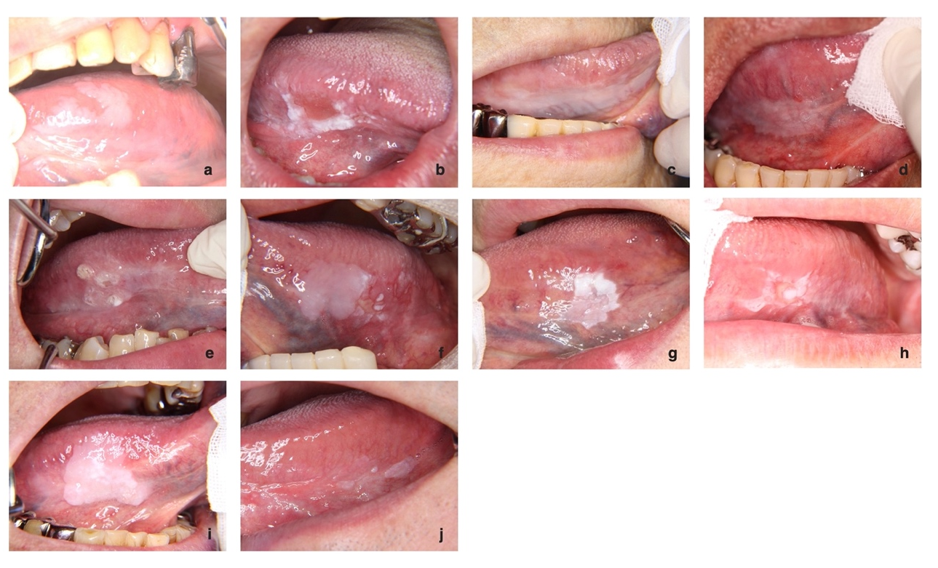

Supplementary Figure 1. Graphical characteristics of lesions on the tongue.
(a) Patient 1, (b) Patient 2, (c) Patient 3, (d) Patient 4, (e) Patient 5, (f) Patient 6, (g) Patient 7, (h) Patient 8, (i) Patient 9, and (j) Patient 10.

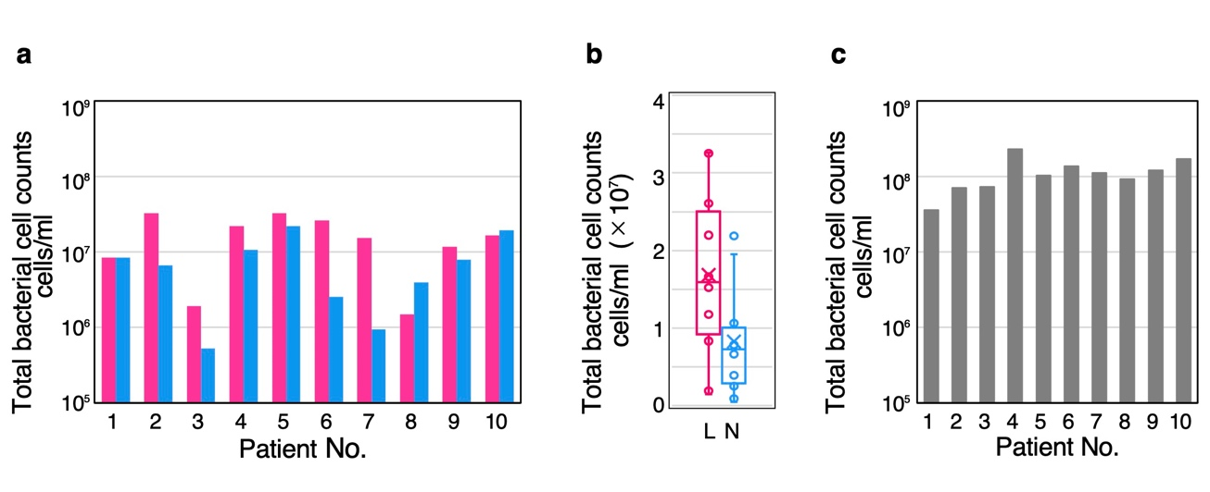

Supplementary Figure 2. Total bacterial cell counts in each sample.
(a) Bacterial cell counts in lesion and normal site swabs. (b) Comparison of bacterial cell counts in lesion and normal site swabs. The box plots show the 25th and 75th quartiles (bottom and top of the box, respectively), median (middle horizontal line), average (cross mark), and minimum and maximum values that are not outliers (top and bottom whiskers). Outliers are defined as 1.5 times the quartile range (points). Statistical significance between two type samples was tested using Mann-Whitney's U test. p > 0.05. L: lesion, N: normal site. (c) Bacterial cell counts in oral rinse samples.

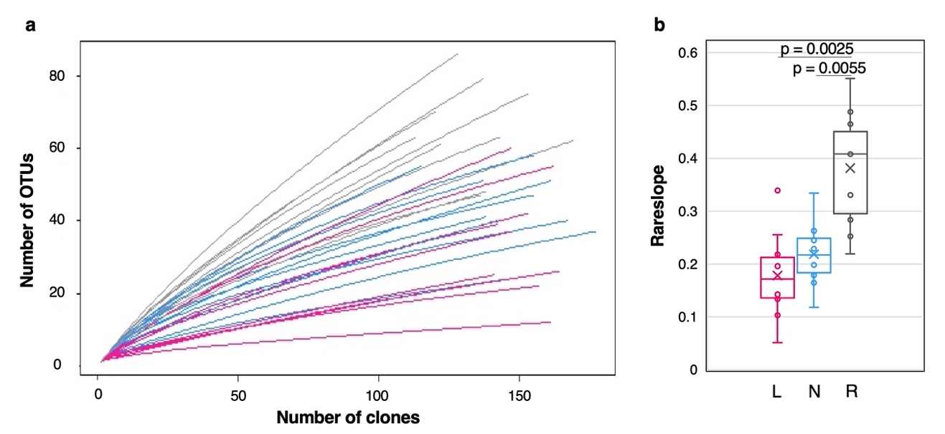

Supplementary Figure 3. Rarefaction curves and rareslopes for bacterial OTU clustering at 99.6% sequence similarity in each sample.
(a) Rarefaction curve showing analysis of OTUs identified in samples. lesion: pink line, normal site: blue line, oral rinse: gray line. (b) Rareslopes. The box plots show the 25th and 75th percentiles (bottom and top of the box, respectively), median (middle horizontal line), average (cross mark), and minimum and maximum values that are not outliers (top and bottom whiskers). Outliers are defined as values greater than 1.5 times the interquartile range (points). Statistical significance among three type samples was tested using the Kruskal–Wallis test, and the Steel–Dwass test was applied for multiple comparisons (bars; p < 0.05). L: lesion, N: normal site, R: oral rinse, OTU: operational taxonomic unit.

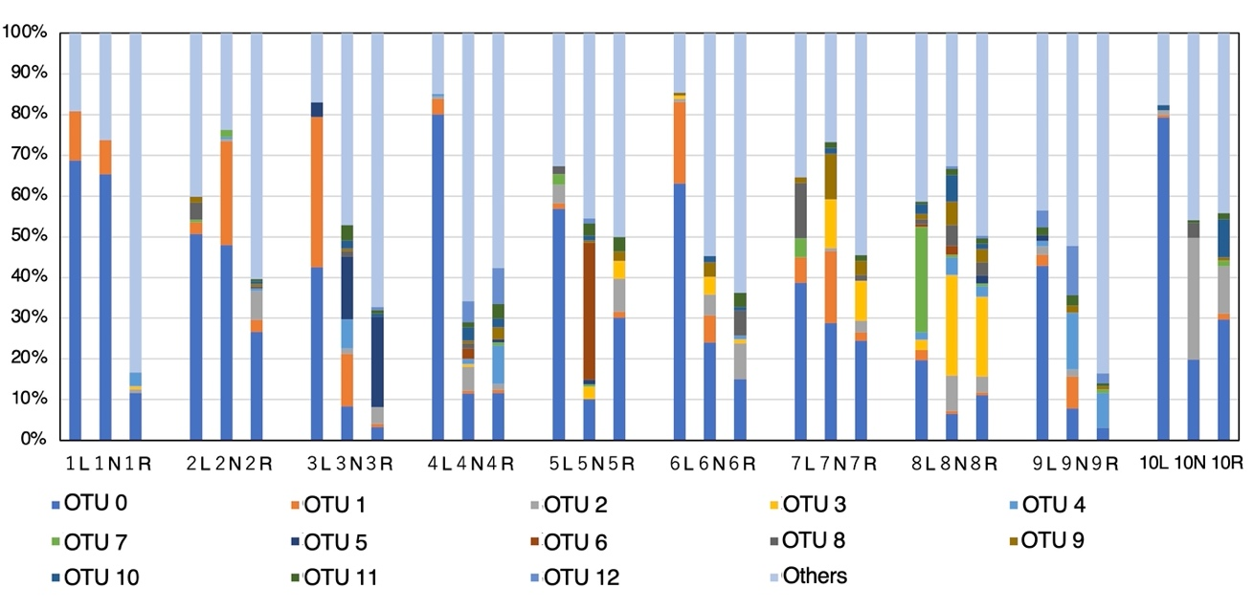

Supplementary Figure 4. Relative abundance at OTU level in each sample.
Graph showing the abundance of 13 OTUs and Others (OTUs with relative abundance < 1% in the total sequences). All oral rinse samples had high percentage of Others. Data labels show number of patient. L: lesion, N: normal site, R: oral rinse, OTU: operational taxonomic unit.

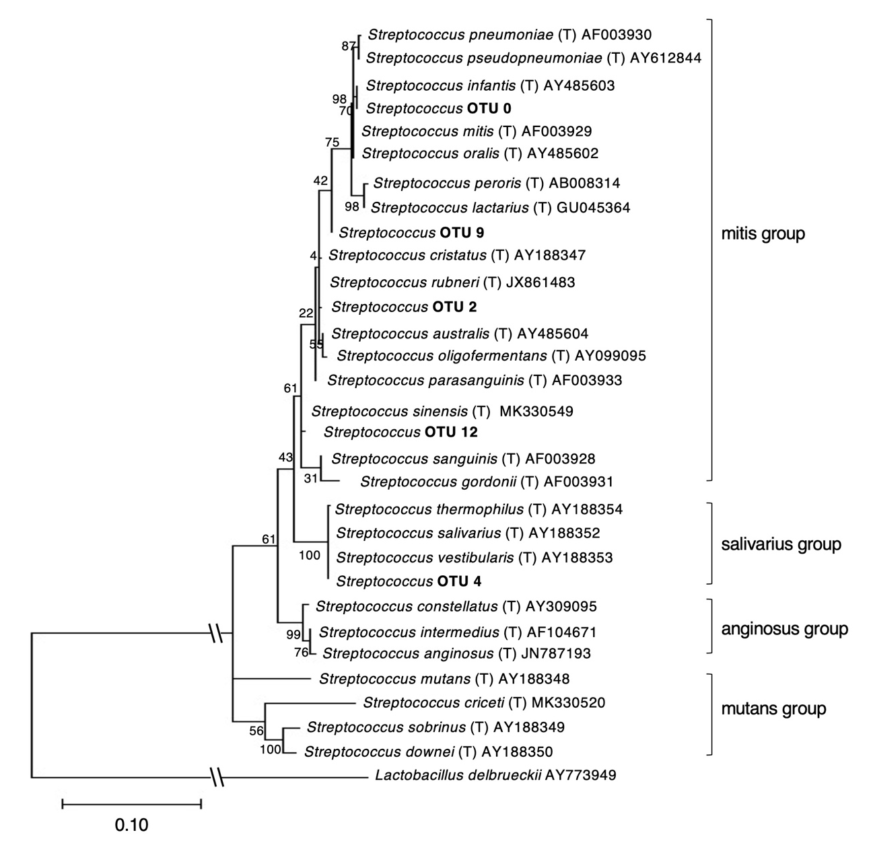

Supplementary Figure 5. Phylogenetic analysis of OTU 0,2,4,9,12 assigned as the genus Streptococcus.
The 16S rRNA gene sequences assigned to the genus Streptococcus using BLAST were aligned with those of the type strains of the genus Streptococcus using MEGA-X. A maximum likelihood tree based on the alignments (550 bp) was constructed using MUSCLE. The K2+G+I model (K2: Kimura 2-parameter, G+I: Gamma distribution with invariant sites) selected using the Find best model was used. Accession numbers are provided according to the taxonomic name. OTUs obtained in this study are shown in bold font. Lactobacillus delbrueckii AY773949 was used as an outgroup. Scale bar denotes substitutions per site. Bootstrap values from 500 analyses are shown at the branch points. OTU: operational taxonomic unit.

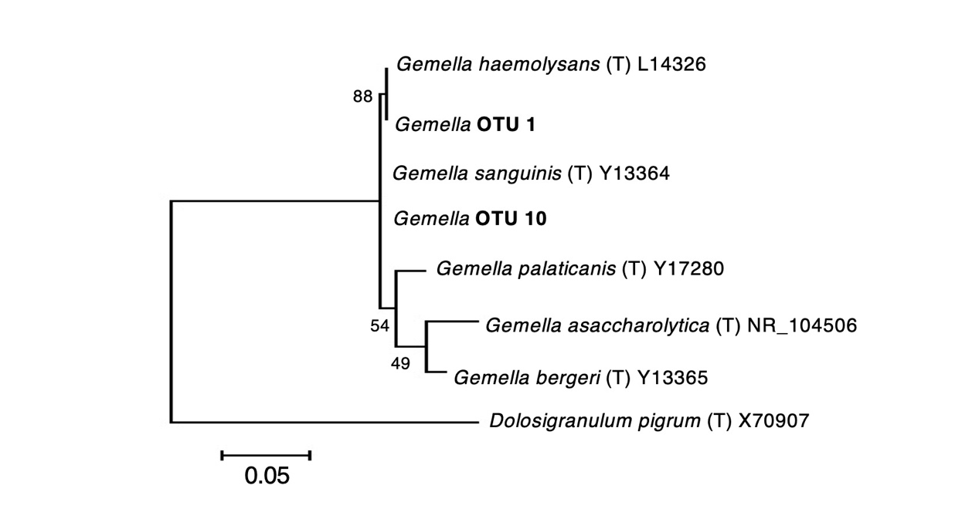

Supplementary Figure 6. Phylogenetic analysis of OTU 1,10 assigned as the genus Gemella.
The 16S rRNA gene sequences assigned to the genus Gemella using BLAST were aligned with those of type strains of the genus Gemella using MEGA-X. A maximum likelihood tree based on the alignments (548 bp) was constructed using MUSCLE. The K2+G (K2: Kimura 2-parameter, G: Gamma distribution) selected using the Find best model was used. Accession numbers are provided according to the taxonomic name. OTUs obtained in this study are shown in bold font. Dolosigranulum pigrum (T) X70907 was used as an outgroup. Scale bar denotes substitutions per site. Bootstrap values from 500 analyses are shown at the branch points. OTU: operational taxonomic unit.

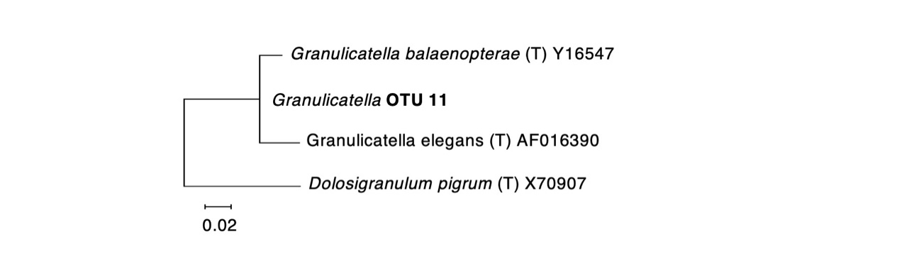

Supplementary Figure 7. Phylogenetic analysis of OTU 11 assigned as the genus Granulicatella.
The 16S rRNA gene sequence assigned to the genus Granulicatella using BLAST was aligned with those of type strains of the genus Granulicatella using MEGA-X. A maximum likelihood tree based on the alignments (550 bp) was constructed using MUSCLE. The K2+G model (K2: Kimura 2-parameter, G: Gamma distribution) selected using the Find best model was used. Accession numbers are provided according to the taxonomic name. OTUs obtained in this study are shown in bold font. Dolosigranulum pigrum (T) X70907 was used as an outgroup. Scale bar denotes substitutions per site. Bootstrap values from 500 analyses are shown at the branch points. OTU: operational taxonomic unit.

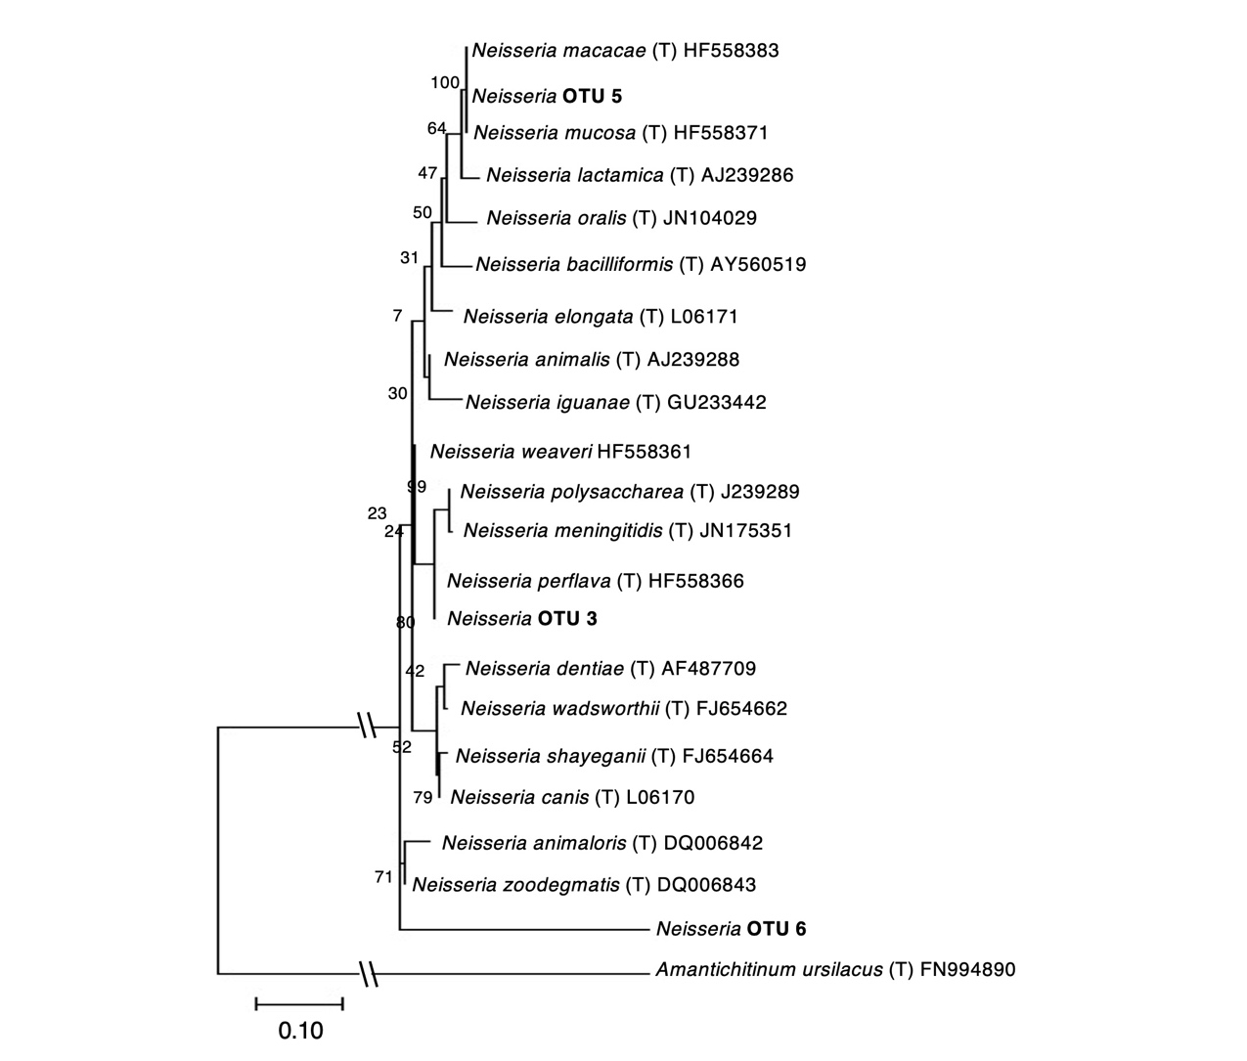

Supplementary Figure 8. Phylogenetic analysis of the OTU 3,5,6 assigned as the genus Neisseria.
The 16S rRNA gene sequences assigned to the genus Neisseria using BLAST were aligned with those of type strains of the genus Neisseria using MEGA-X. A maximum likelihood tree based on the alignments (550 bp) was constructed using MUSCLE. The K2+G+I model (K2: Kimura 2-parameter, G+I: Gamma distribution with invariant sites) selected using the Find best model was used. Accession numbers are provided according to the taxonomic name. OTUs obtained in this study are shown in bold font. Amantichitinum ursilacus (T) FN994890 was used as an outgroup. Scale bar denotes substitutions per site. Bootstrap values from 500 analyses are shown at the branch points. OTU: operational taxonomic unit.

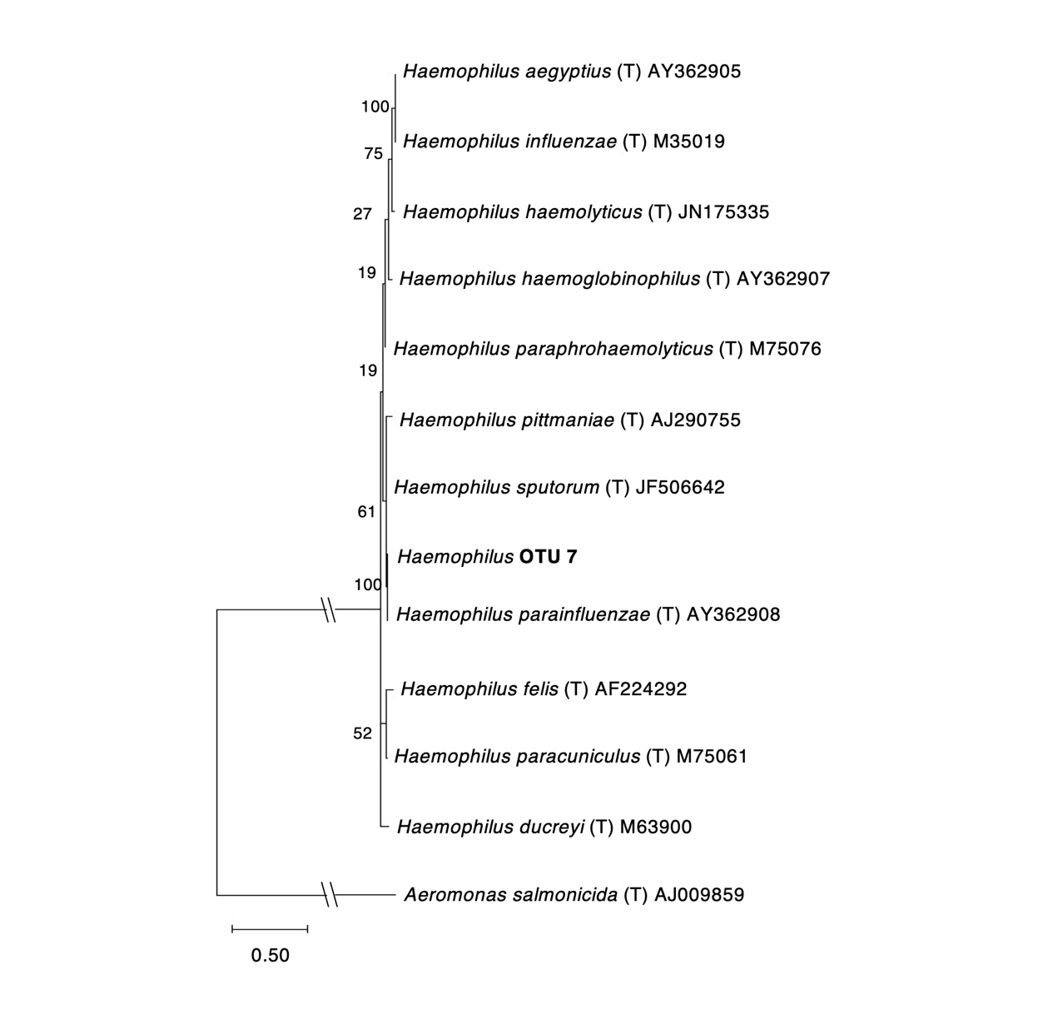

Supplementary Figure 9. Phylogenetic analysis of OTU 7 assigned as the genus Haemophilus.
The 16S rRNA gene sequence assigned to the genus Haemophilus using BLAST was aligned with those of type strains of the genus Haemophilus using MEGA-X. A maximum likelihood tree based on the alignments (547 bp) was constructed using MUSCLE. The K2+G+I model (K2: Kimura 2-parameter, G+I: Gamma distribution with invariant sites) selected using the Find best model was used. Accession numbers are provided according to the taxonomic name. OTUs obtained in this study are shown in bold font. Aeromonas salmonicida (T) AJ009859 was used as an outgroup. Scale bar denotes substitutions per site. Bootstrap values from 500 analyses are shown at the branch points. OTU: operational taxonomic unit.

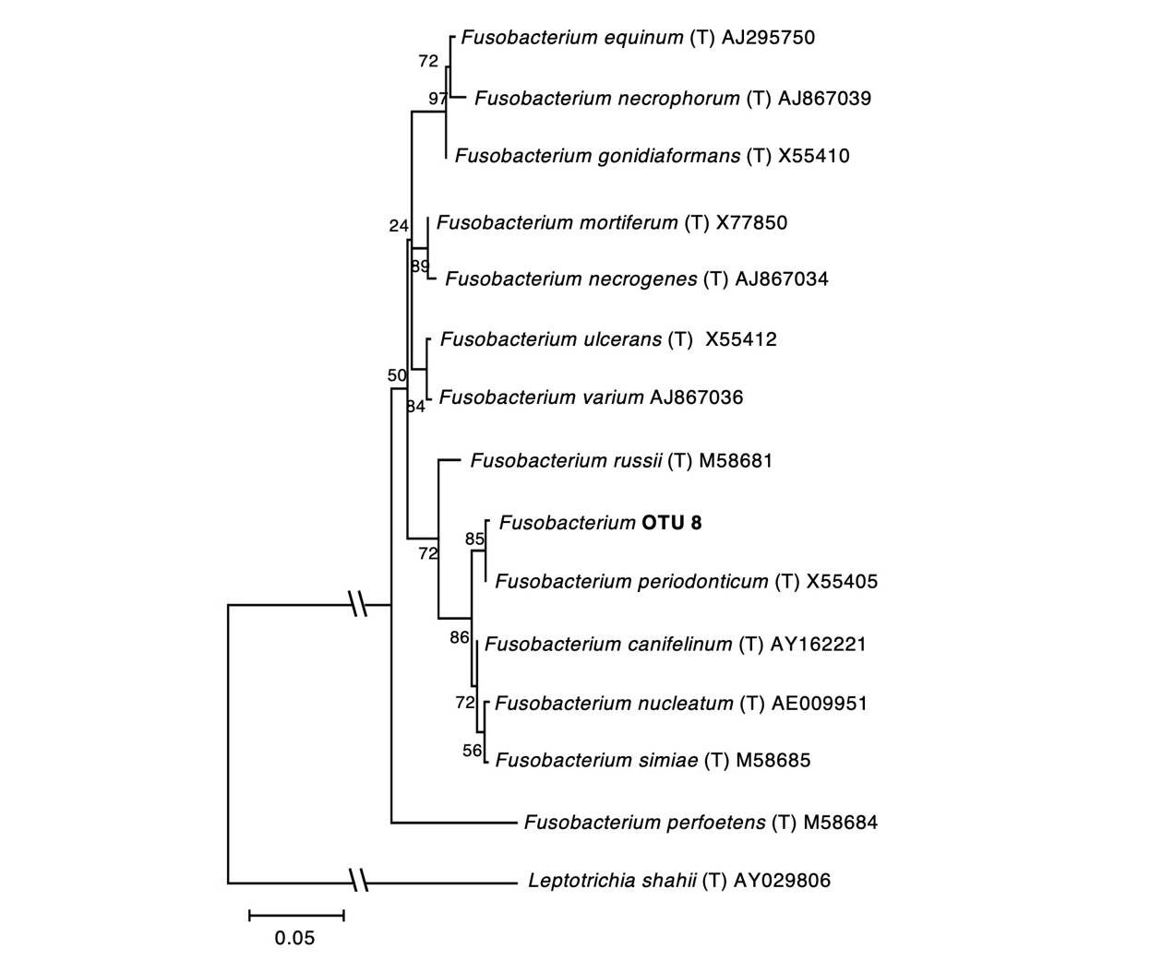

Supplementary Figure 10. Phylogenetic analysis of OTU 8 assigned as the genus Fusobacterium.
The 16S rRNA gene sequence assigned to the genus Fusobacterium using BLAST in this study was aligned with those of the type strains of the genus Fusobacterium using MEGA-X. A maximum likelihood tree based on the alignments (524 bp) was constructed using MUSCLE. The K2+G model (K2: Kimura 2-parameter, G: Gamma distribution) selected using the Find best model was used. Accession numbers are provided according to the taxonomic name. OTUs obtained in this study are shown in bold font. Leptotrichia shahii (T) AY029806 was used as the outgroup. Scale bar denotes substitutions per site. Bootstrap values from 500 analyses are shown at the branch points. OTU: operational taxonomic unit.

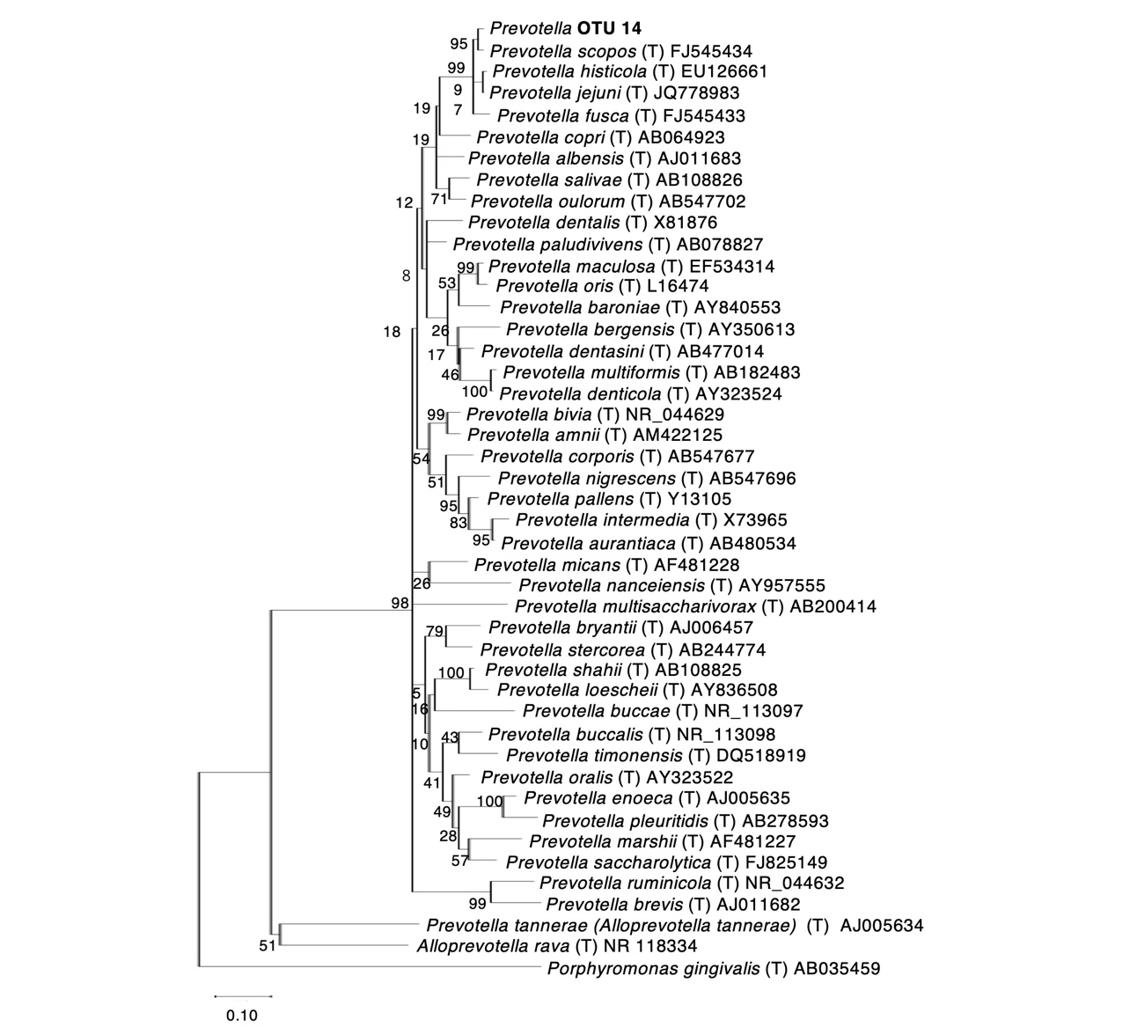

Supplementary Figure 11. Phylogenetic analysis of OTU 14 assigned as the genus Prevotella.
The 16S rRNA gene sequence assigned to the genus Prevotella using BLAST was aligned with those of type strains of the genus Prevotella using MEGA-X. A maximum likelihood tree based on the alignments (540 bp) was constructed using MUSCLE. The K2+G+I model (K2: Kimura 2-parameter, G+I: Gamma distribution with invariant sites) selected using the Find best model was used. Accession numbers are provided according to the taxonomic name. OTUs obtained in this study are shown in bold font. Porphyromonas gingivalis AB035459 was used as the outgroup. Scale bar denotes substitutions per site. Bootstrap values from 500 analyses are shown at the branch points. OTU: operational taxonomic unit.

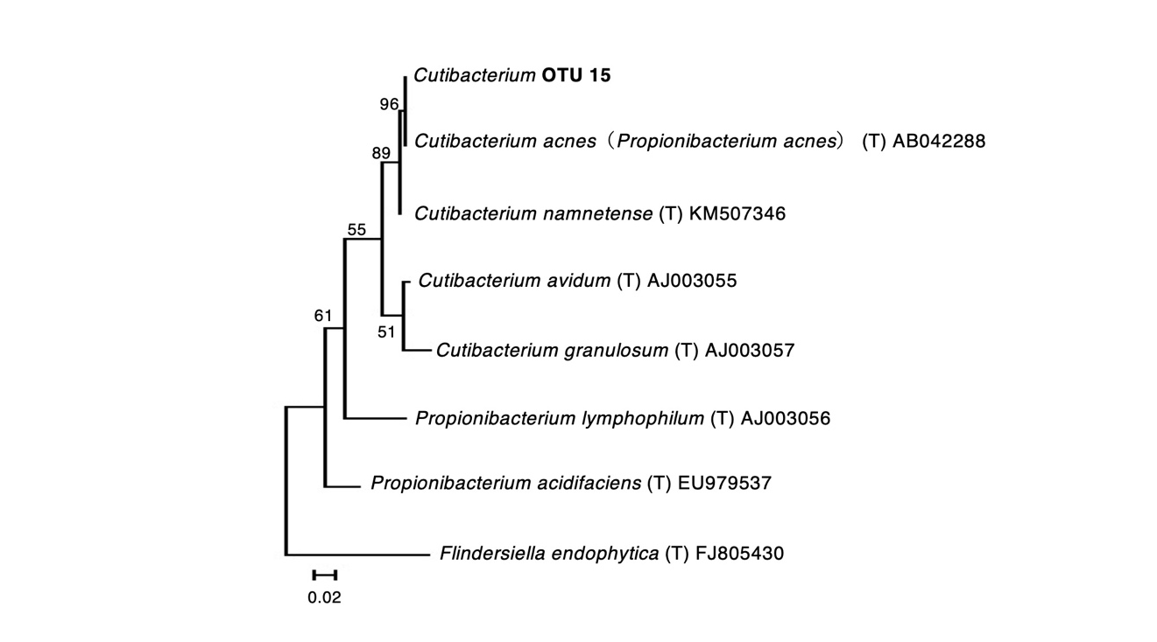

Supplementary Figure 12. Phylogenetic analysis of OTU 15 assigned as the genus Cutibacterium.
The 16S rRNA gene sequence assigned to the genus Cutibacterium using BLAST was aligned with those of type strains of the genus Cutibacterium and Propionibacterium using MEGA-X. A maximum likelihood tree based on the alignments (531 bp) was constructed using MUSCLE. The HKY+G model (HKY: Hasegawa-Kishino-Yano, G: Gamma distribution) selected using the Find best model was used. Accession numbers are provided according to the taxonomic name. OTUs obtained in this study are shown in bold font. Flindersiella endophytica FJ805430 was used as the outgroup. Scale bar denotes substitutions per site. Bootstrap values from 500 analyses are shown at the branch points. OTU: operational taxonomic unit.

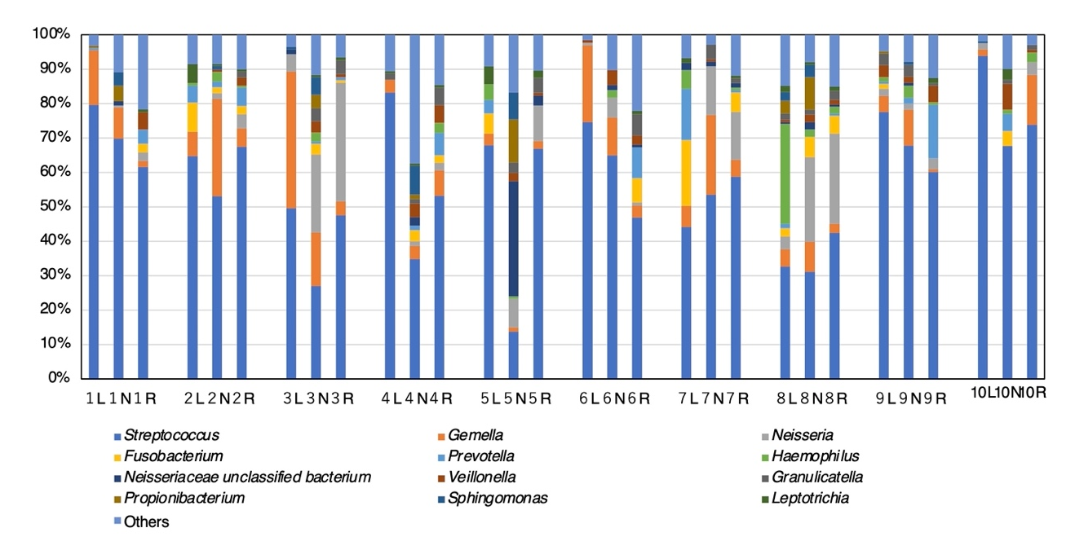

Supplementary Figure 13. Relative abundance at genus level in each sample.
Graph showing the abundance of 11 genera and Neisseriaceae unclassified bacterium and Others (genus with relative abundance < 1.0% in the total sequences). The genus Streptococcus was the most abundant in most samples. Data labels show the patient number. L: lesion, N: normal site, R: oral rinse.

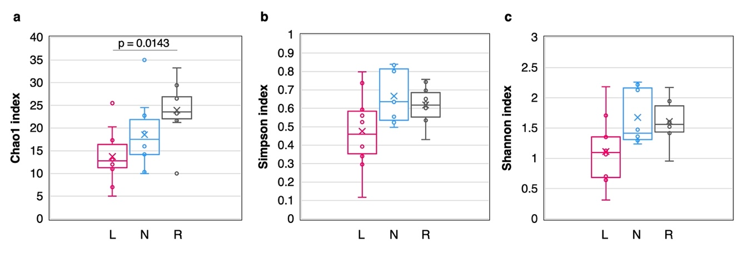

Supplementary Figure 14. Comparison of alpha diversity based on genus level. Chao1 index (a), Simpson index (b), and Shannon index (c).
The box plots show the 25th and 75th percentiles (bottom and top of the box, respectively), median (middle horizontal line), average (cross mark), and minimum and maximum values that are not outliers (top and bottom whiskers). Outliers are defined as values greater than 1.5 × the interquartile range (points). Statistical significance among the three types of samples was tested using the Kruskal–Wallis test. For multiple comparisons, the Steel–Dwass test was applied. Bars; p < 0.05. L: lesion, N: normal site, R: oral rinse.

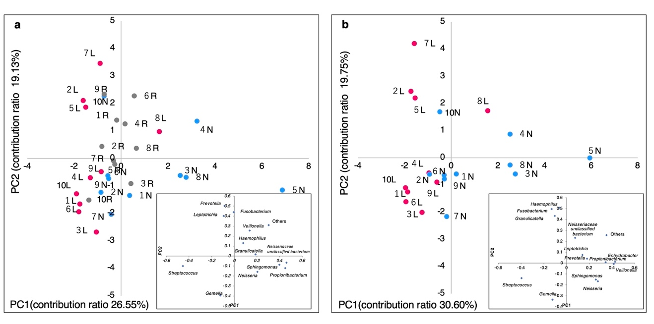

Supplementary Figure 15. Principal component analysis based on genus level. (a) Three type samples. (b) Two swab samples.
The horizontal axis shows PC1, and the vertical axis shows PC2. The eigenvector is shown in the box below. Lesions are plotted as pink dots, normal sites as blue dots, and oral rinse samples as grey dots. Data labels show the patient number. L: lesion, N: normal site, R: oral rinse, PC1: first principal component, PC2: second principal component.

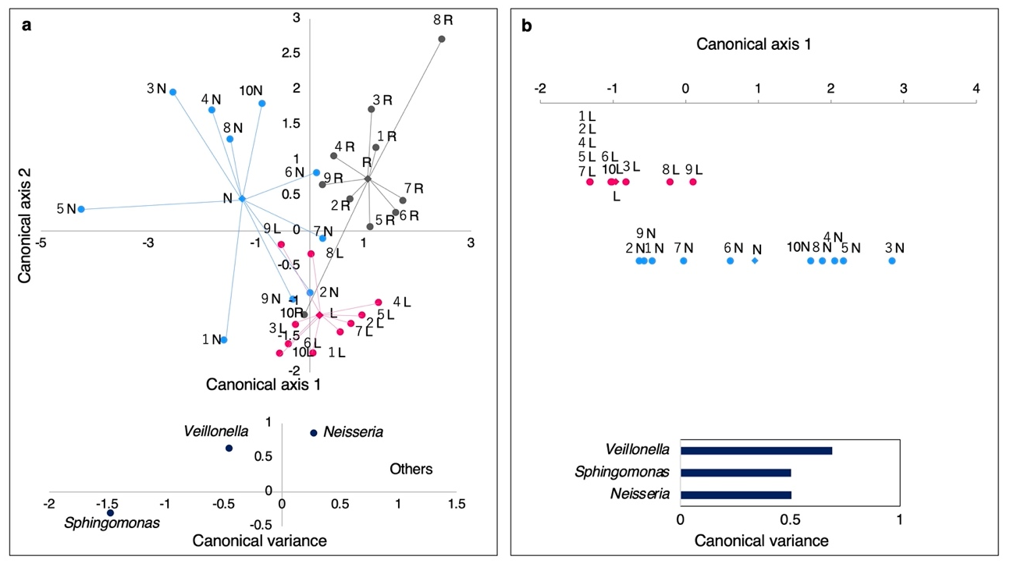

Supplementary Figure 16. Canonical discriminant analysis based on genus level. (a) Three type samples. (b) Two swab samples.
Each point represents the canonical score (CS) of each sample based on the respective canonical variables. The X-axis is canonical axis 1, and the Y-axis is canonical axis 2. Lesions are plotted as pink dots, normal sites as blue dots, oral rinse samples as gray dots, and each center of gravity as diamonds. Data labels show the patient number. L: lesion, N: normal site, R: oral rinse. (a) Canonical discriminant function1,2 p < 0.001. (b) Canonical discriminant function1 p < 0.01.

