Table 2 GO enrichment analysis of KXS in treating depression
Score | Enriched genes | Cluster network | GO biological process | Log(p-value)
7.8 | ADRA2A,APP,HTR1A,CXCL8,DRD2,ADRA2C,DRD4,HTR1B,DRD3,OPRD1,OPRK1,BDKRB1,MTNR1A,NPY5R,HCAR2,P2RY12,CNR1 | 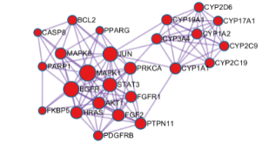 | Adenylate cyclase-modulating G protein-coupled receptor signaling pathway (GO:0007188) | -21
7.8 |  |  | Adenylate cyclase-inhibiting G protein-coupled receptor signaling pathway (GO:0007193) | -21
7.8 |  |  | G protein-coupled receptor signaling pathway (GO:0007187) | -21
4.3 | PRKCA,MAPK1,STAT3,PTPN11,BCL2,CASP8,MAPK8,AKT1,FKBP5,FGFR1,JUN,FGF2,HRAS,PDGFRB,EGFR,PPARG,CYP3A4,CYP17A1,CYP19A1,PARP1,CYP1A1,CYP1A2,C,P2D6,CYP2C9,CYP2C19 | 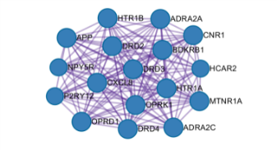 | Estrogen metabolic process (GO:0008210) | -13
4.3 |  |  | Hormone metabolic process (GO:0042445) | -12
4.3 |  |  | Regulation of hormone levels (GO:0010817) | -12
3.4 | GRM1,HCRTR2,TACR1,HTR2A,HTR2C,TACR3,HTR2B,F2,GSK3B,ADRA1A,AR,NFE2L2,RELA,RARA,ESR1,MAPK14,NR3C1 | 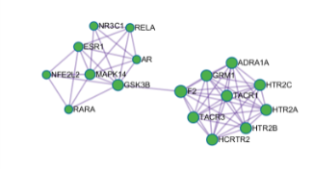 | Phospholipase C-activating G protein-coupled receptor signaling pathway (GO:0007200) | -18
3.4 |  |  | Regulation of cytosolic calcium ion concentration (GO:0051480) | -13
3.4 |  |  | Cellular calcium ion homeostasis (GO:0006874) | -12
2.0 | DRD1,DRD5,HTR7,CRHR1,TAAR1 | 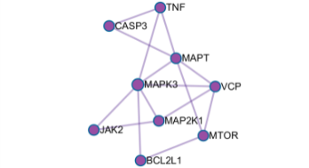 | Regulation of neuron death (GO:1901214) | -10
2.0 | DRD1,DRD5,HTR7,CRHR1,TAAR1 |  | Positive regulation of cell death (GO:0010942) | -10
2.0 | DRD1,DRD5,HTR7,CRHR1,TAAR1 |  | Neuron death (GO:0070997) | -10
1.6 | MAP2K1,VCP,JAK2,MAPK3,BCL2L1,TNF,MAPT,CASP3,MTOR | 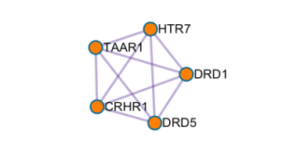 | Activation of adenylate cyclase activity (GO:0007190) | -8
1.6 | MAP2K1,VCP,JAK2,MAPK3,BCL2L1,TNF,MAPT,CASP3,MTOR |  | G protein-coupled receptor signaling pathway (GO:0007187) | -7
1.6 | MAP2K1,VCP,JAK2,MAPK3,BCL2L1,TNF,MAPT,CASP3,MTOR |  | Regulation of blood vessel size (GO:0050880) | -6

