Using Cardiac Magnetic Resonance to Assess Cardiac Geometry in the diagnosis of Chronic Thromboembolic Pulmonary Vascular Disease

M McGettrick, H Dormand, M Brewis, N N Lang, M Johnson, C Church

Supplementary Data

All Affiliated with
The Scottish Pulmonary Vascular Unit
Golden Jubilee National Hospital
Glasgow, UK
G81 4DY

Figure 1 supp. Correlation of standard Pulmonary hypertension haemodynamics versus novel cardiac MRI indices
mPAP – mean Pulmonary Artery Pressure; PVR – Pulmonary Vascular Resistance; SvO2 – Mixed venous saturations; 6MDT – 6-minute walk test distance
Index | Systolic LVEI | Diastolic LVEI*
mPAP (mmHg) | 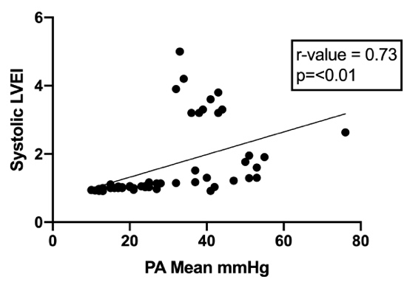 | 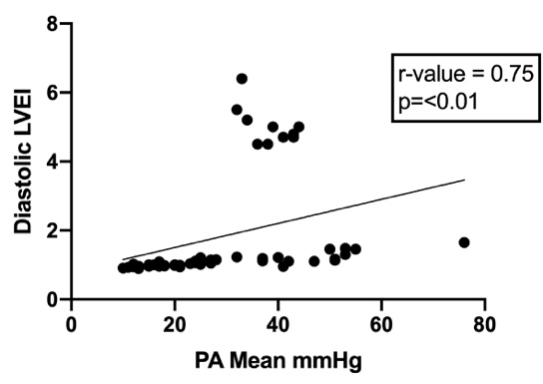
PVR (Wu) | 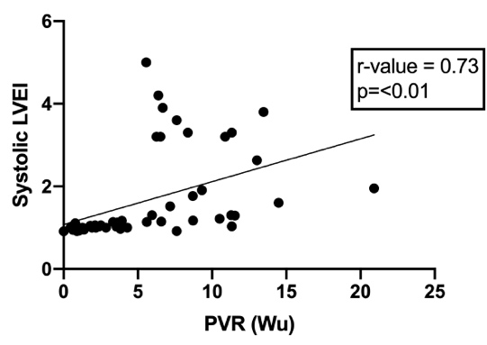 | 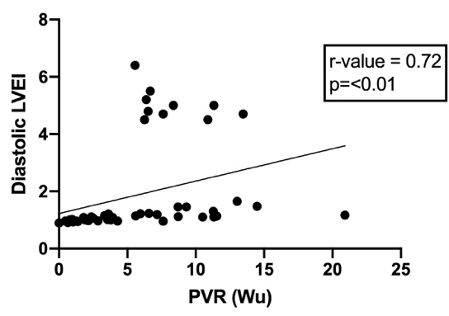
SvO₂(%) | 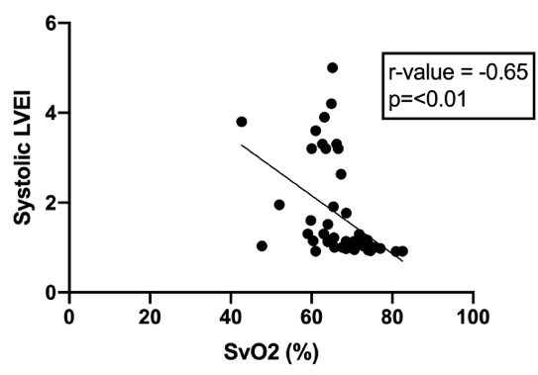 | 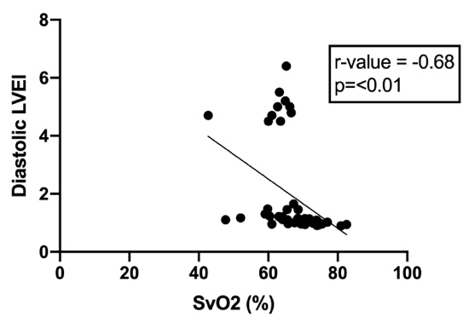
6MWT (m) | 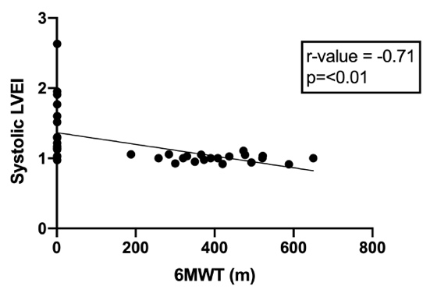 | 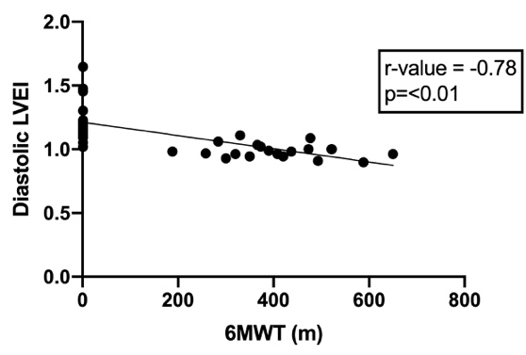

Figure 2 supp. Normal vs CTED Roc curves for novel cardiac MRI indices
CTED – chronic thromboembolic disease; LVEI – left ventricular eccentricity index; AUC – Area Under Curve.
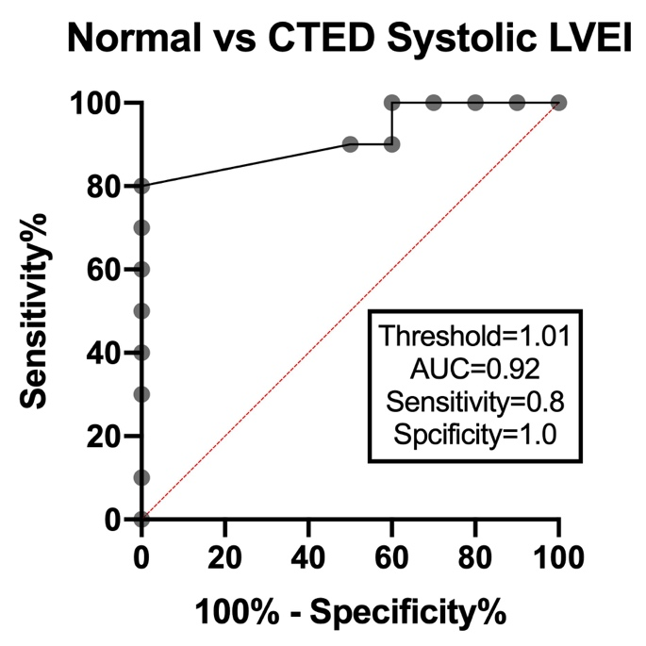 | 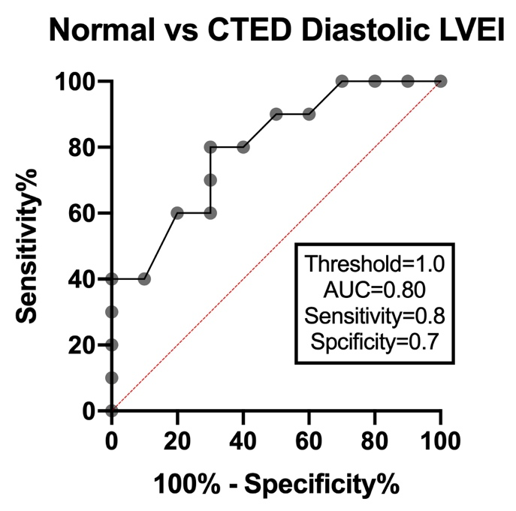
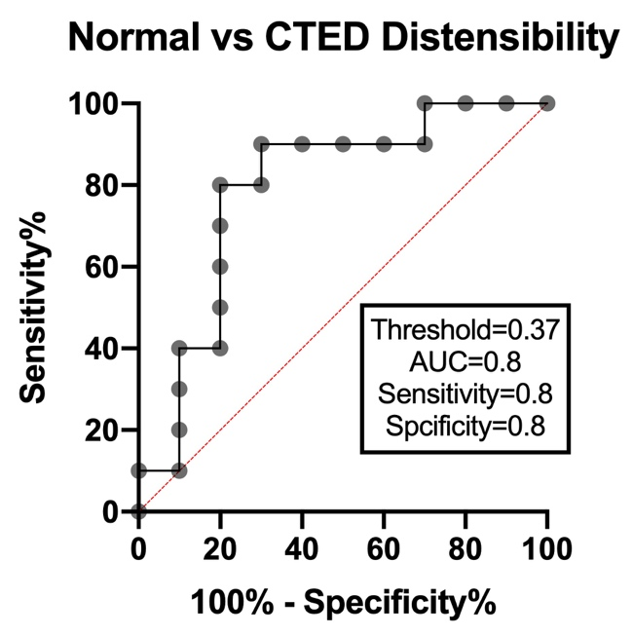 | 