Table S1. Sequences of the primers used for qRT-PCR
Gene | Forward sequences | Reverse sequences
Human CCNA | 5-GGAGACCTTTTACTTGGCACA-3 | 5-TCTGTCACATACGCAAACTGG-3
Human Myc | 5- TGAGGAGACACCGCCCACCA-3 | 5- AGACTCTGACCTTTTGCCAGGA-3
Human IL6 | 5- ACAAATTCGGTACATCCTCGAC-3 | 5- TGATGATTTTCACCAGGCAAG-3
Human IL1β | 5- CCTGCCCACAGACCTTCCAG-3 | 5- ACATAAGCCTCGTTATCCCAT-3
Human TNFα | 5- GATTCTGAGCAAAATAGCCAGCA-3 | 5- GGCTTCCTTCTTGTTGTGTGT-3
Human BCL2 | 5- TGAGTACCTGAACCGGCACCT-3 | 5- CCACCAGGGCCAAACTGAGCA-3
Human BCL-XL | 5- GACCTGACATCCCAGCTCCAC-3 | 5- CCGACTCACCAATACCTGCAT-3
Human VEGF | 5-AAACCTCACCAAGGCCAGCA-3 | 5- GGATTTCTTGCGCTTTCGTTT-3
Human FGF2 | 5- TGTGCTAACCGTTACCTGGCTA-3 | 5- CTGCCCAGTTCGTTTCAGTGC-3
Human MMP1 | 5- GCGACTCTAGAAACACAAGAGC-3 | 5- GCCCAAAGAATTCCTGCAT-3
Human MMP2 | 5- CTTCCCCAAGCTCATCGCAGA-3 | 5- ATGCTTCCAAACTTCACGCTCT-3
Human MMP3 | 5- GACACCAGCATGAACCTTG-3 | 5- GAACTTCTGCATTTCTCGGAT-3
Human MMP9 | 5- TGTGCTCTTCCCTGGAGACCT-3 | 5- CAGGCCCCAGAGATTTCGACT-3
Human MMP10 | 5- TTTCTGCATTTTGGCCCTC-3 | 5- CCTCTTGGATAACCTGCTT-3
Human GAPDH | 5- TCTGACTTCAACAGCGACACC-3 | 5-CTGTTGCTGTAGCCAAATTCGTT-3
Mouse IL6 | 5-CCGTGTGGTTACATCTACCCT-3 | 5- CGTGGTTCTGTTGATGACAGTG-3
Mouse IL1β | 5- GCAACTGTTCCTGAACTCAACT -3 | 5- ATCTTTTGGGGTCCGTCAACT-3
Mouse TNFα | 5-CTGGATGTCAATCAACAATGGGA-3 | 5-ACTAGGGTGTGAGTGTTTTCTGT-3
Mouse GAPDH | 5-AGGTCGGTGTGAACGGATTTG-3 | 5-TGTAGACCATGTAGTTGAGGTCA-3

Table S2. Sequences of the siRNAs for RNA interference
Gene | Forward sequences | Reverse sequences
STAT3#1 | 5- GCAACAGAUUGCCUGCAUUTT-3 | 5- AAUGCAGGCAAUCUGUUGCTT-3
STAT3#2 | 5- CCCGGAAAUUUAACAUUCUTT-3 | 5- AGAAUGUUAAAUUUCCGGGTT-3
STAT3#3 | 5- GCUGAACAACAUGUCAUUUTT-3 | 5- AAAUGACAUGUUGUUCAGCTT-3
EGFR#1 | 5- GCAGAGGAAUUAUGAUCUUTT-3 | 5- AAGAUCAUAAUUCCUCUGCTT-3
EGFR#2 | 5- GCAACAUGUCGAUGGACUUTT-3 | 5- AAGUCCAUCGACAUGUUGCTT-3
EGFR#3 | 5- GGAGAUAAGUGAUGGAGAUTT-3 | 5- AUCUCCAUCACUUAUCUCCTT-3

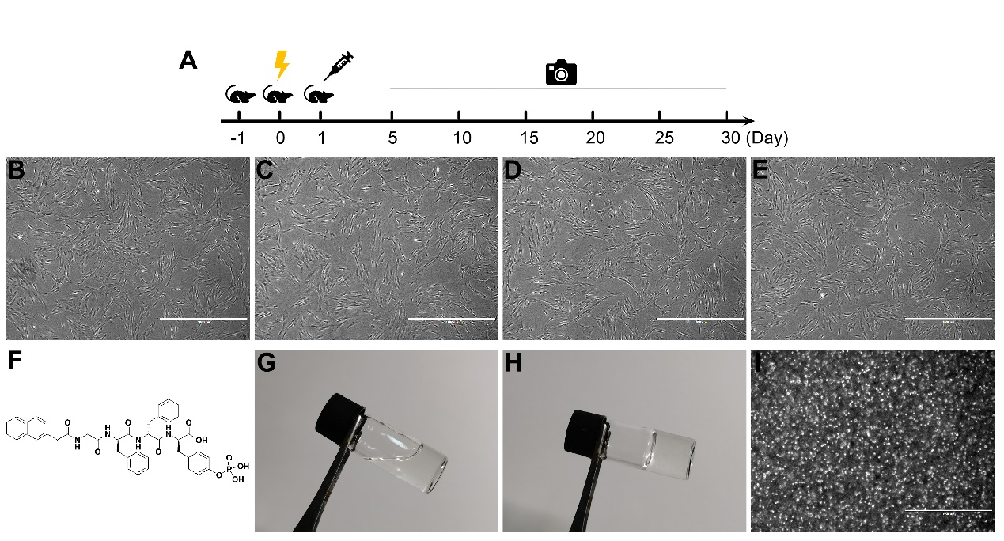
Figure S1. Development and treatment of a mouse model of CRI. A. The flow chart of the development and treatment of a mouse model of CRI. B-E. The morphological changes of GMSCs from the passage 3 to passage 6 (P₃-P₆) were observed under a microscope. F. Chemical structure of pY-Gel. G-H. Optical image of the structure formed by the pY-Gel. I. Optical image of the suspension growth of GMSCs in the pY-Gel. Scale bars, 1,000 μm.

Figure S2. A-C. Measurement of the expression of the IL6, IL1β, and TNFα by qPCR analysis at 6 h after 8 Gy irradiation. D-E. Measurement of the expression of the VEGF and FGF2 by qPCR analysis at 6 h after 8 Gy irradiation. Statistical comparisons were made by two-sample Student's t-test, using the SPSS 25.0 software. *p < 0.05, **p < 0.01 and ***p < 0.001.
Figure S3. A-C. Measurement of the expression of the MMP2, BCL2, and BCL-XL by qPCR analysis at 6 h after 8 Gy irradiation. Statistical comparisons were made by two-sample Student's t-test, using the SPSS 25.0 software. *p < 0.05.
Figure S4. A. Western blot analysis of EGFR levels in skin cells following knockdown of EGFR. B. CCK-8 assay of HaCaT cell proliferation following knockdown of EGFR. C. Western blot analysis of STAT3 levels in skin cells following knockdown of STAT3. D. CCK-8 analysis of HaCaT cell proliferation following knockdown of STAT3. E. Evaluation of the migration ability of HaCaT cells following knockdown of STAT3 by the scratch wound assay. Scale bars, 1,000 μm.
Ethics approval
