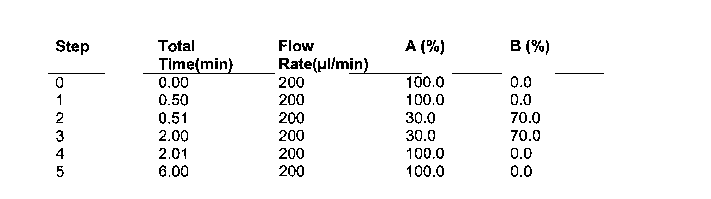
Table (1) Mobile phases of chromatography separation.

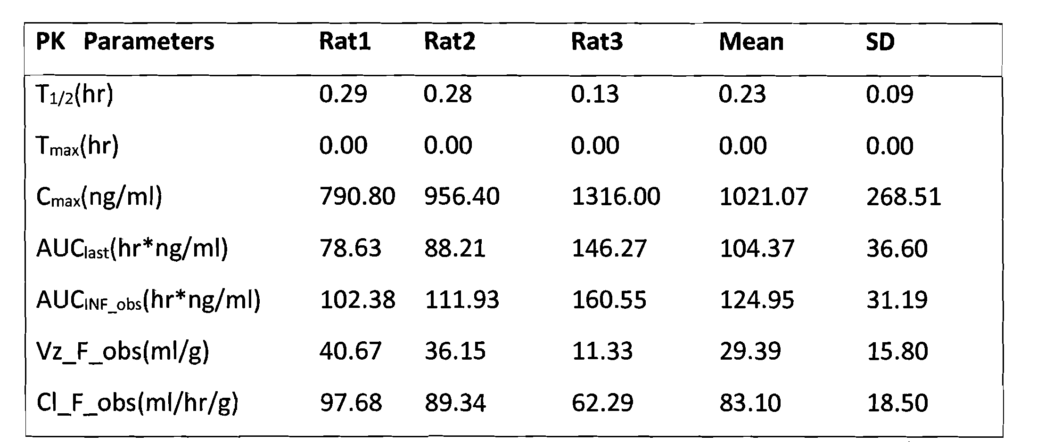
Table (2) Pharmacokinetic parameters of peptide F after i.v.

Area of peptide F | 500 ng/mL |  | 2500 ng/mL
Oh | 4040 (100%) |  | 37300 (100%)
1 hour (room temperature) | 667 (16.5%) |  | 4070 (10.9%)
4 hours (room temperature) | 429 (10.6%) | 4300 (11.5%)

Table (3) The Stability in Plasma at room temperature

Area of peptide F | 30 Oct | 31 Oct (~20 hours)
500 ng/mL | 3620 | 3630
20000 ng/mL | 191000 | 212000

Table (4) Stability after sample preparation (4°C) ~20hours

