Supplementary Table 1 Potential effects of lipid metabolites and statins on sleep apnea syndrome risk
 | Modes | OR | 95%CI
TG vs. SAS risk
 | MR-Egger | 0.988 | 0.899~1.086
 | Weighted median | 0.983 | 0.892~1.084
 | IVW | 1.038 | 0.974~1.108
 | Simple mode | 1.051 | 0.857~1.289
 | Weighted mode | 1.003 | 0.923~1.090
TC vs. SAS risk
 | MR-Egger | 1.011 | 0.867~1.178
 | Weighted median | 0.917 | 0.814~1.033
 | IVW | 0.950 | 0.876~1.029
 | Simple mode | 0.909 | 0.734~1.126
 | Weighted mode | 0.914 | 0.794~1.052
LDL-C vs. SAS risk
 | MR-Egger | 0.978 | 0.876~1.092
 | Weighted median | 0.951 | 0.854~1.059
 | IVW | 0.986 | 0.915~1.063
 | Simple mode | 0.960 | 0.773~1.193
 | Weighted mode | 0.973 | 0.884~1.072
HDL-C vs. SAS risk
 | MR-Egger | 0.980 | 0.872~1.100
 | Weighted median | 0.942 | 0.845~1.051
 | IVW | 0.971 | 0.906~1.041
 | Simple mode | 0.911 | 0.729~1.138
 | Weighted mode | 0.946 | 0.851~1.052
ApoA1 vs. SAS risk
 | MR-Egger | 1.003 | 0.894~1.126
 | Weighted median | 0.958 | 0.859~1.067
 | IVW | 0.979 | 0.911~1.052
 | Simple mode | 0.946 | 0.762~1.175
 | Weighted mode | 0.993 | 0.895~1.100
ApoB vs. SAS risk
 | MR-Egger | 0.992 | 0.911~1.081
 | Weighted median | 0.980 | 0.893~1.077
 | IVW | 0.984 | 0.923~1.049
 | Simple mode | 1.060 | 0.880~1.276
 | Weighted mode | 0.972 | 0.901~1.048
Lpa vs. SAS risk
 | MR-Egger | 1.000 | 0.999~1.001
 | Weighted median | 1.000 | 1.000~1.001
 | IVW | 1.000 | 1.000~1.001
 | Simple mode | 1.000 | 0.999~1.002
 | Weighted mode | 1.000 | 1.000~1.001
MUFA vs. SAS risk
 | MR-Egger | 0.935 | 0.831~1.051
 | Weighted median | 0.985 | 0.883~1.099
 | IVW | 1.019 | 0.947~1.096
 | Simple mode | 0.975 | 0.812~1.170
 | Weighted mode | 0.981 | 0.888~1.085
PUFA vs. SAS risk
 | MR-Egger | 0.977 | 0.839~1.139
 | Weighted median | 0.951 | 0.862~1.050
 | IVW | 0.973 | 0.902~1.050
 | Simple mode | 0.949 | 0.805~1.117
 | Weighted mode | 0.943 | 0.846~1.051
SFA vs. SAS risk
 | MR-Egger | 0.946 | 0.814~1.100
 | Weighted median | 0.964 | 0.852~1.091
 | IVW | 1.008 | 0.928~1.096
 | Simple mode | 0.997 | 0.799~1.245
 | Weighted mode | 0.959 | 0.845~1.088
Rosuvastatin vs. SAS risk
 | MR-Egger | 0.191 | 1.28e-20~2.84e+18
 | Weighted median | 0.011 | 6.44e-07~1.78e+02
 | IVW | 0.020 | 4.58e-06~8.46e+01
 | Simple mode | 0.008 | 1.07e-08~5.93e+03
 | Weighted mode | 0.006 | 1.66e-08~1.98e+03
Atorvastatin vs. SAS risk
 | MR-Egger | 0.244 | 0.004~16.605
 | Weighted median | 0.478 | 0.044~5.175
 | IVW | 0.828 | 0.145~4.733
 | Simple mode | 0.189 | 0.003~10.856
 | Weighted mode | 0.239 | 0.013~4.432
Simvastatin vs. SAS risk
 | MR-Egger | 0.420 | 0.046~3.883
 | Weighted median | 0.738 | 0.254~2.144
 | IVW | 1.453 | 0.456~4.630
 | Simple mode | 0.431 | 0.091~2.048
 | Weighted mode | 0.598 | 0.193~1.855

Supplementary Table 2 Potential effects of sleep apnea syndrome on lipid metabolites in peripheral circulation
 | Modes | OR | 95%CI
SAS vs. TG
 | MR-Egger | 0.927 | 0.815~1.055
 | Weighted median | 1.028 | 0.997~1.061
 | IVW | 1.029 | 1.003~1.056
 | Simple mode | 1.028 | 0.987~1.070
 | Weighted mode | 1.027 | 0.990~1.066
SAS vs. TC
 | MR-Egger | 0.919 | 0.710~1.191
 | Weighted median | 0.897 | 0.842~0.955
 | IVW | 0.902 | 0.857~0.950
 | Simple mode | 0.898 | 0.830~0.971
 | Weighted mode | 0.896 | 0.832~0.965
SAS vs. LDL-C
 | MR-Egger | 0.885 | 0.673~1.163
 | Weighted median | 0.928 | 0.888~0.970
 | IVW | 0.919 | 0.876~0.964
 | Simple mode | 0.963 | 0.890~1.042
 | Weighted mode | 0.943 | 0.872~1.020
SAS vs. HDL-C
 | MR-Egger | 0.922 | 0.727~1.171
 | Weighted median | 0.941 | 0.890~0.996
 | IVW | 0.931 | 0.888~0.976
 | Simple mode | 0.937 | 0.868~1.011
 | Weighted mode | 0.945 | 0.883~1.011
SAS vs. ApoA1
 | MR-Egger | 0.970 | 0.681~1.380
 | Weighted median | 0.943 | 0.907~0.981
 | IVW | 0.931 | 0.876~0.990
 | Simple mode | 1.003 | 0.923~1.090
 | Weighted mode | 0.935 | 0.889~0.985
SAS vs. ApoB
 | MR-Egger | 0.967 | 0.786~1.191
 | Weighted median | 0.933 | 0.898~0.969
 | IVW | 0.942 | 0.918~0.968
 | Simple mode | 0.937 | 0.881~0.996
 | Weighted mode | 0.928 | 0.891~0.966
SAS vs. Lpa
 | MR-Egger | 2.445 | 0.000~14154.202
 | Weighted median | 3.127 | 0.426~22.935
 | IVW | 2.550 | 0.454~14.305
 | Simple mode | 2.108 | 0.156~28.524
 | Weighted mode | 3.273 | 0.316~33.918
SAS vs. MUFA
 | MR-Egger | 1.017 | 0.754~1.372
 | Weighted median | 0.967 | 0.907~1.031
 | IVW | 0.980 | 0.929~1.032
 | Simple mode | 0.971 | 0.890~1.060
 | Weighted mode | 0.970 | 0.902~1.044
SAS vs. PUFA
 | MR-Egger | 1.012 | 0.780~1.314
 | Weighted median | 0.950 | 0.892~1.012
 | IVW | 0.947 | 0.899~0.998
 | Simple mode | 0.966 | 0.894~1.043
 | Weighted mode | 0.953 | 0.887~1.024
SAS vs. SFA
 | MR-Egger | 0.959 | 0.735~1.250
 | Weighted median | 0.955 | 0.896~1.017
 | IVW | 0.960 | 0.911~1.012
 | Simple mode | 0.968 | 0.886~1.057
 | Weighted mode | 0.955 | 0.889~1.025

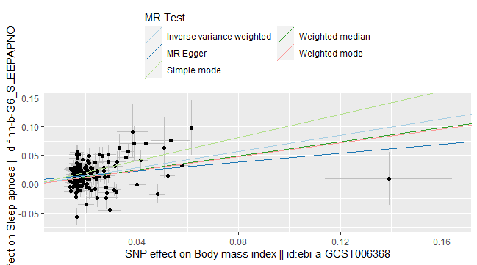
Supplementary Figure 1 Scatter plot of body mass index affecting sleep apnea syndrome risk

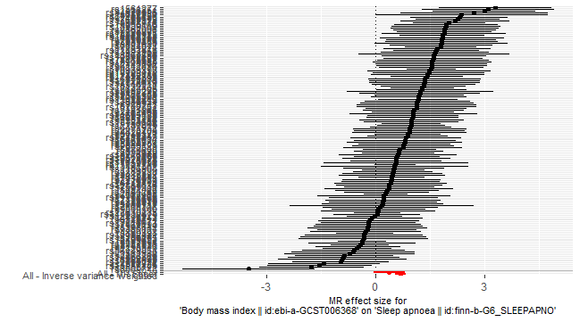
Supplementary Figure 2 Forest plot of body mass index affecting sleep apnea syndrome risk

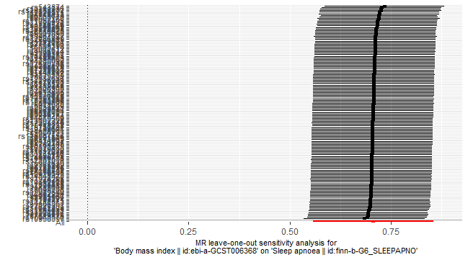
Supplementary Figure 3 “leave-one-SNP-out” analysis of body mass index affecting sleep apnea syndrome risk

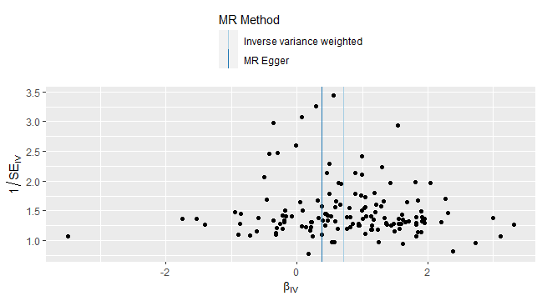
Supplementary Figure 4 Funnel plot of body mass index affecting sleep apnea syndrome risk

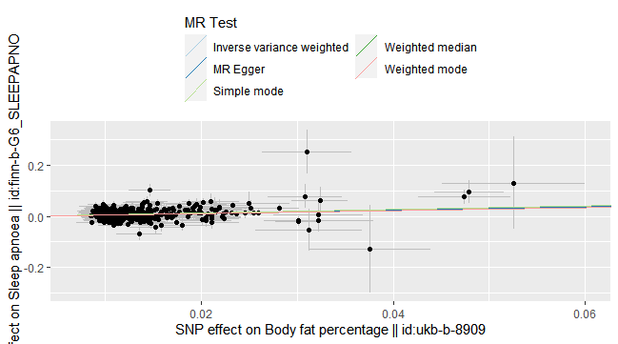
Supplementary Figure 5 Scatter plot of body fat percentage affecting sleep apnea syndrome risk

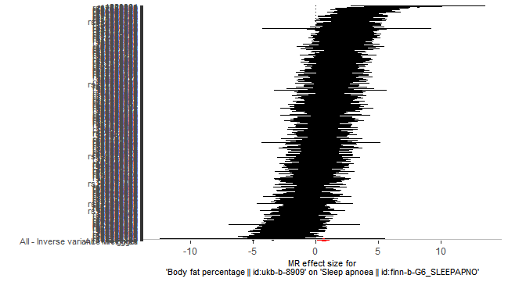
Supplementary Figure 6 Forest plot of body fat percentage affecting sleep apnea syndrome risk

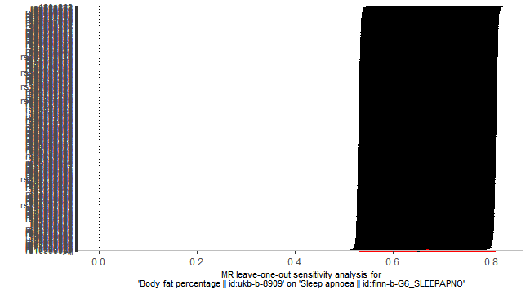
Supplementary Figure 7 “leave-one-SNP-out” analysis of body fat percentage affecting sleep apnea syndrome risk

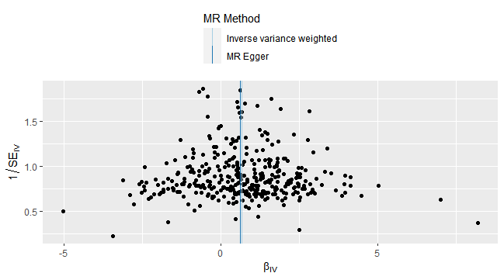
Supplementary Figure 8 Funnel plot of body fat percentage affecting sleep apnea syndrome risk

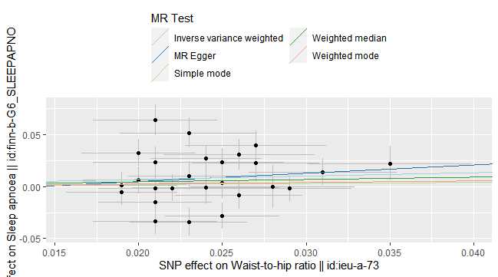
Supplementary Figure 9 Scatter plot of waist-to-hip ratio affecting sleep apnea syndrome risk

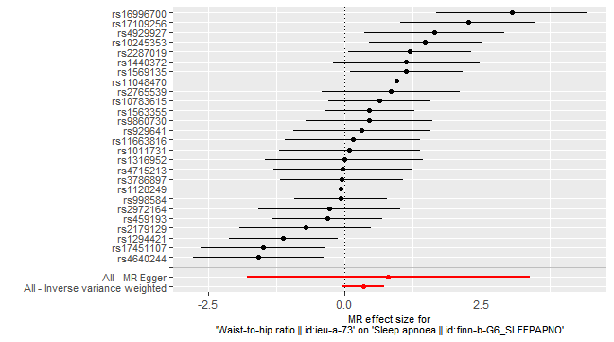
Supplementary Figure 10 Forest plot of waist-to-hip ratio affecting sleep apnea syndrome risk

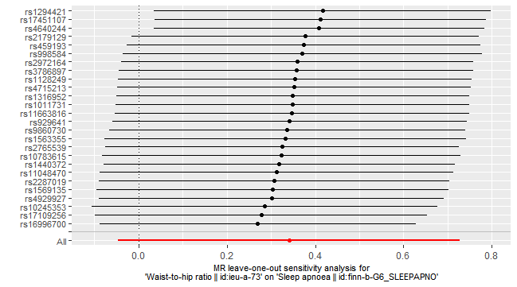
Supplementary Figure 11 “leave-one-SNP-out” analysis of waist-to-hip ratio affecting sleep apnea syndrome risk

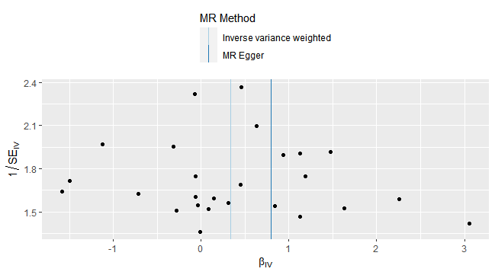
Supplementary Figure 12 Funnel plot of waist-to-hip ratio affecting sleep apnea syndrome risk

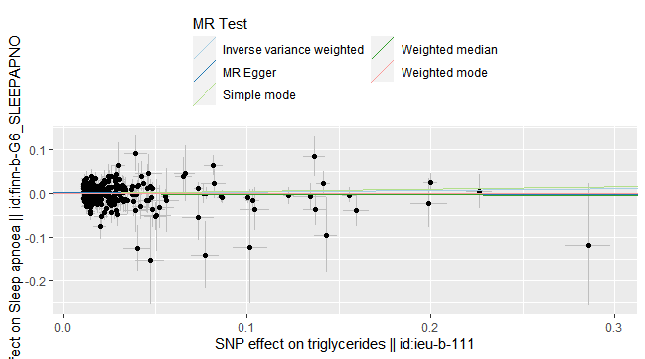
Supplementary Figure 13 Scatter plot of triglycerides in peripheral circulation affecting sleep apnea syndrome risk

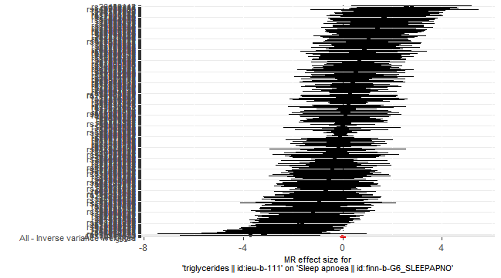
Supplementary Figure 14 Forest plot of triglycerides in peripheral circulation affecting sleep apnea syndrome risk

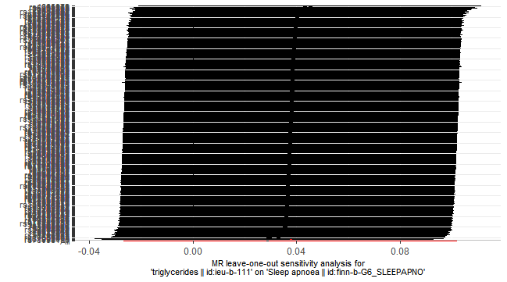
Supplementary Figure 15 “leave-one-SNP-out” analysis of triglycerides in peripheral circulation affecting sleep apnea syndrome risk

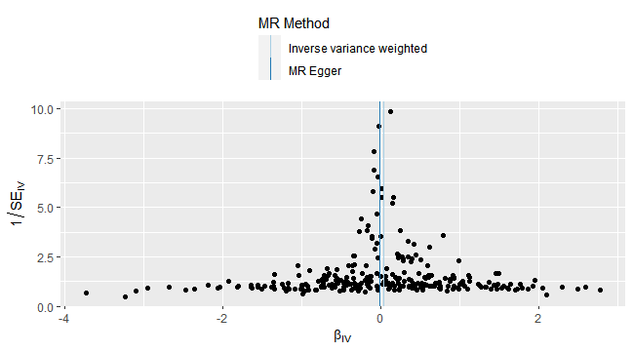
Supplementary Figure 16 Funnel plot of triglycerides in peripheral circulation affecting sleep apnea syndrome risk

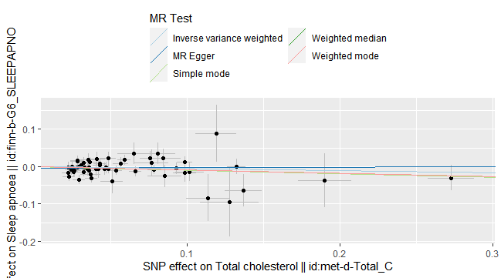
Supplementary Figure 17 Scatter plot of total cholesterol in peripheral circulation affecting sleep apnea syndrome risk

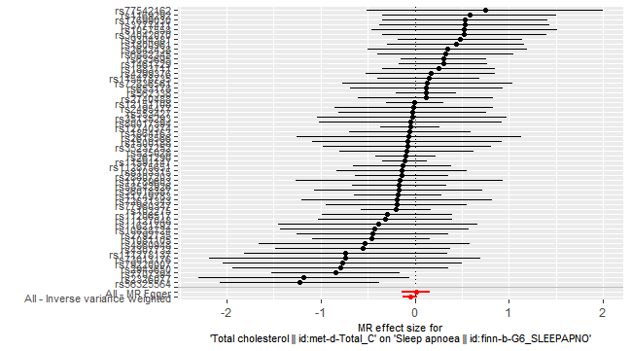
Supplementary Figure 18 Forest plot of total cholesterol in peripheral circulation affecting sleep apnea syndrome risk

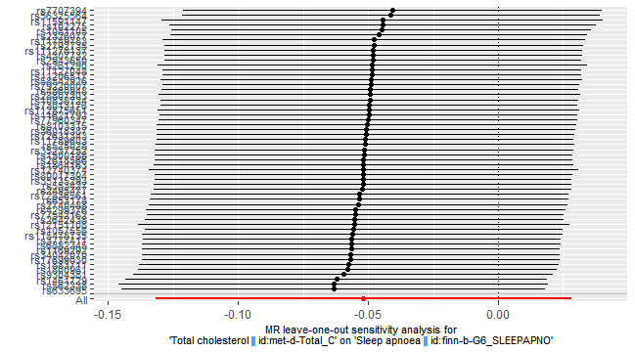
Supplementary Figure 19 “leave-one-SNP-out” analysis of total cholesterol in peripheral circulation affecting sleep apnea syndrome risk

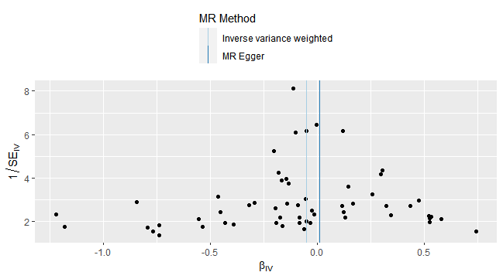
Supplementary Figure 20 Funnel plot of total cholesterol in peripheral circulation affecting sleep apnea syndrome risk

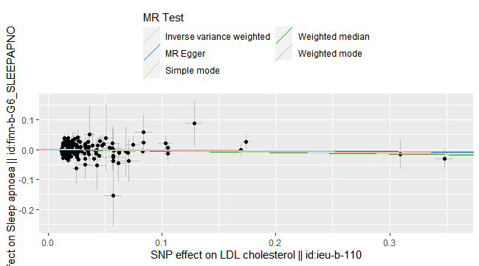
Supplementary Figure 21 Scatter plot of low-density lipoprotein cholesterol in peripheral circulation affecting sleep apnea syndrome risk

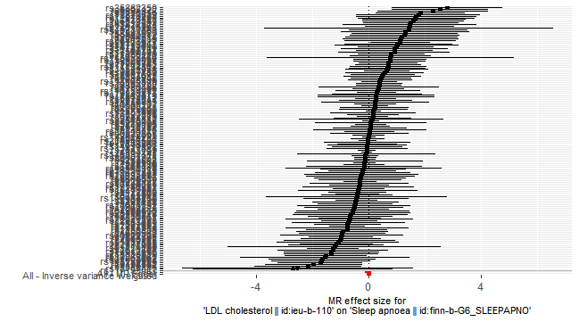
Supplementary Figure 22 Forest plot of low-density lipoprotein cholesterol in peripheral circulation affecting sleep apnea syndrome risk

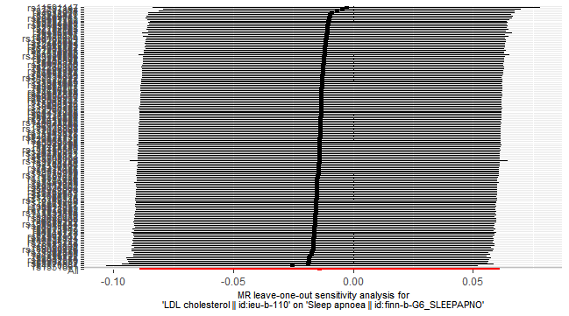
Supplementary Figure 23 “leave-one-SNP-out” analysis of low-density lipoprotein cholesterol in peripheral circulation affecting sleep apnea syndrome risk

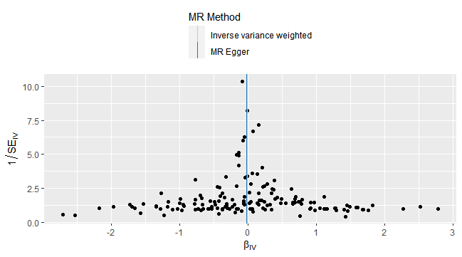
Supplementary Figure 24 Funnel plot of low-density lipoprotein cholesterol in peripheral circulation affecting sleep apnea syndrome risk

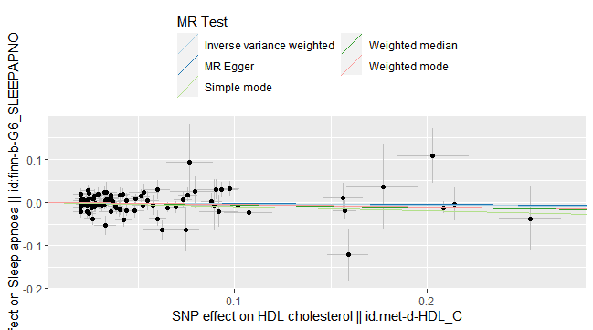
Supplementary Figure 25 Scatter plot of high-density lipoprotein cholesterol in peripheral circulation affecting sleep apnea syndrome risk

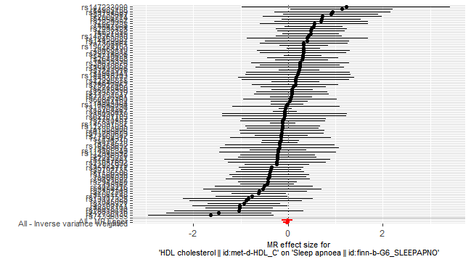
Supplementary Figure 26 Forest plot of high-density lipoprotein cholesterol in peripheral circulation affecting sleep apnea syndrome risk

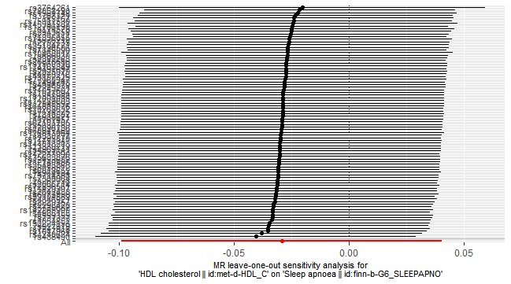
Supplementary Figure 27 “leave-one-SNP-out” analysis of high-density lipoprotein cholesterol in peripheral circulation affecting sleep apnea syndrome risk

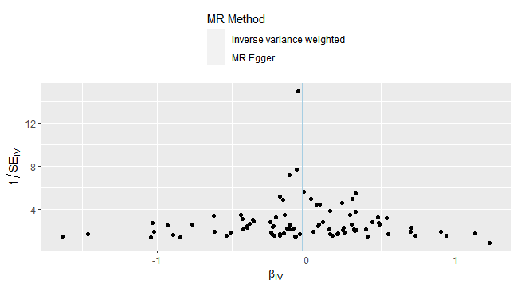
Supplementary Figure 28 Funnel plot of high-density lipoprotein cholesterol in peripheral circulation affecting sleep apnea syndrome risk

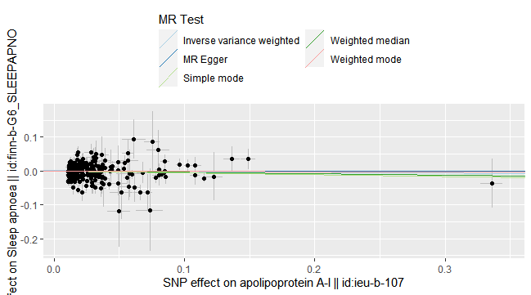
Supplementary Figure 29 Scatter plot of apolipoprotein A1 in peripheral circulation affecting sleep apnea syndrome risk

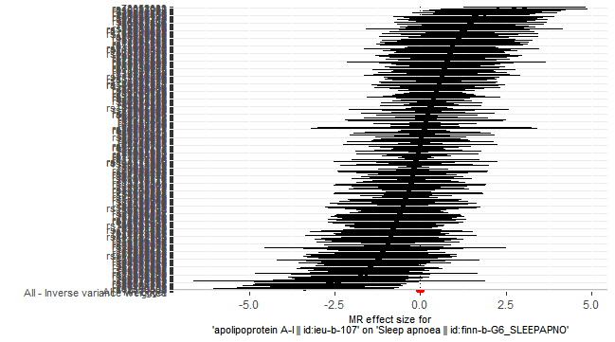
Supplementary Figure 30 Forest plot of apolipoprotein A1 in peripheral circulation affecting sleep apnea syndrome risk

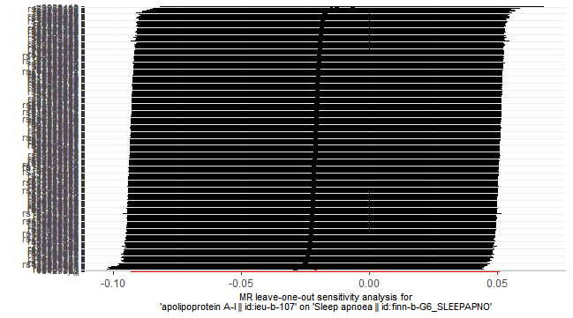
Supplementary Figure 31 “leave-one-SNP-out” analysis of apolipoprotein A1 in peripheral circulation affecting sleep apnea syndrome risk

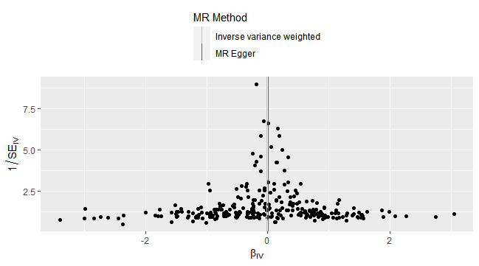
Supplementary Figure 32 Funnel plot of apolipoprotein A1 in peripheral circulation affecting sleep apnea syndrome risk

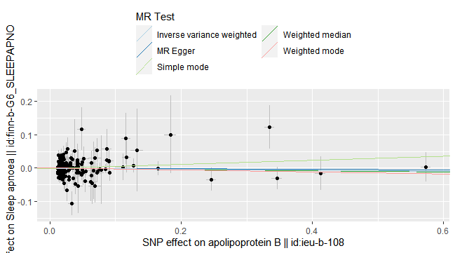
Supplementary Figure 33 Scatter plot of apolipoprotein B in peripheral circulation affecting sleep apnea syndrome risk

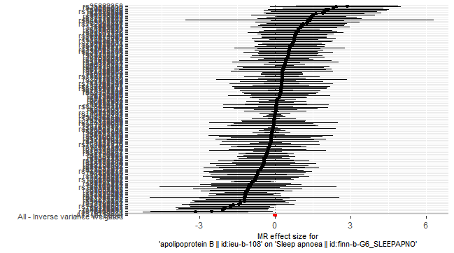
Supplementary Figure 34 Forest plot of apolipoprotein B in peripheral circulation affecting sleep apnea syndrome risk

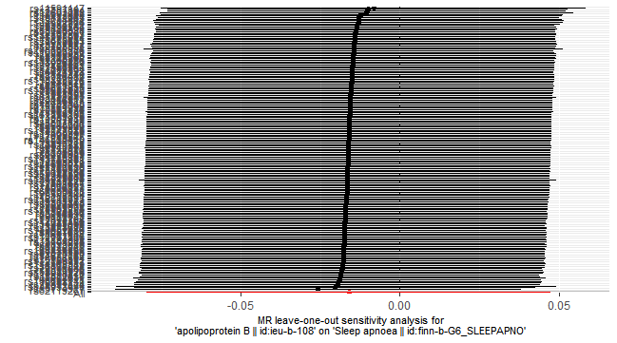
Supplementary Figure 35 “leave-one-SNP-out” analysis of apolipoprotein B in peripheral circulation affecting sleep apnea syndrome risk

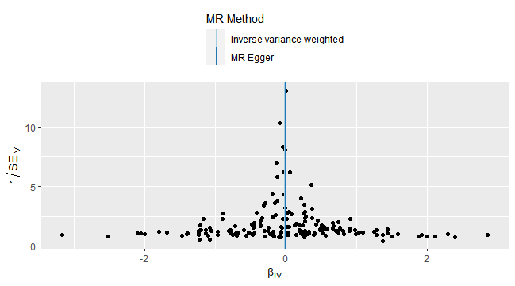
Supplementary Figure 36 Funnel plot of apolipoprotein B in peripheral circulation affecting sleep apnea syndrome risk

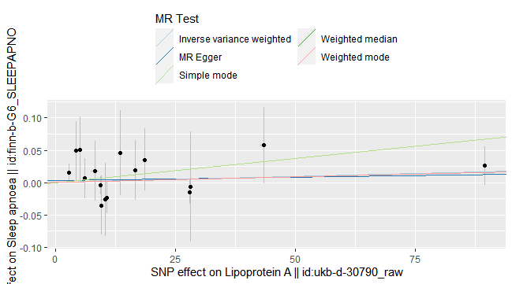
Supplementary Figure 37 Scatter plot of lipoprotein a in peripheral circulation affecting sleep apnea syndrome risk

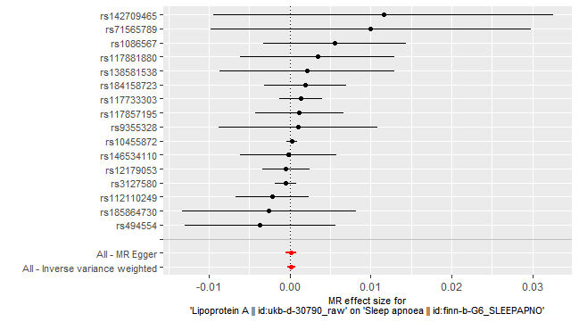
Supplementary Figure 38 Forest plot of lipoprotein a in peripheral circulation affecting sleep apnea syndrome risk

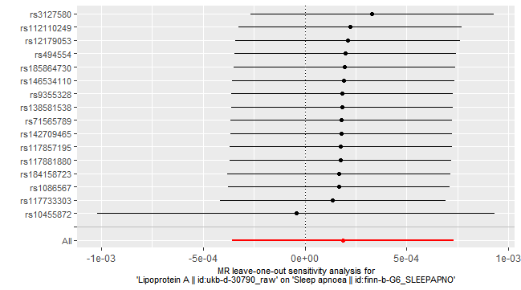
Supplementary Figure 39 “leave-one-SNP-out” analysis of lipoprotein a in peripheral circulation affecting sleep apnea syndrome risk

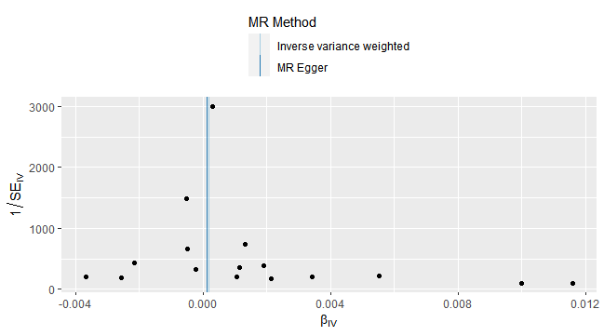
Supplementary Figure 40 Funnel plot of lipoprotein a in peripheral circulation affecting sleep apnea syndrome risk

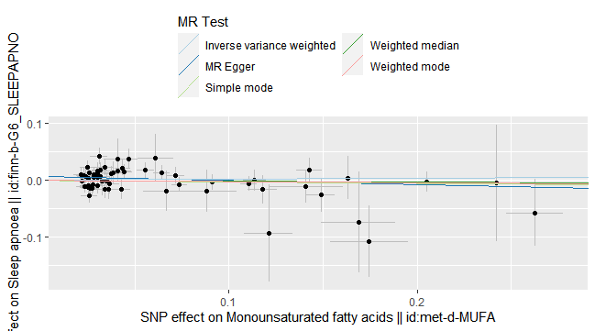
Supplementary Figure 41 Scatter plot of mon-unsaturated fatty acids in peripheral circulation affecting sleep apnea syndrome risk

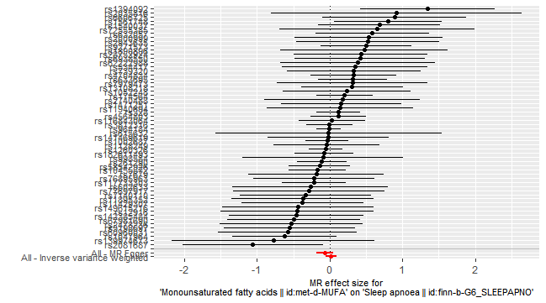
Supplementary Figure 42 Forest plot of mon-unsaturated fatty acids in peripheral circulation affecting sleep apnea syndrome risk

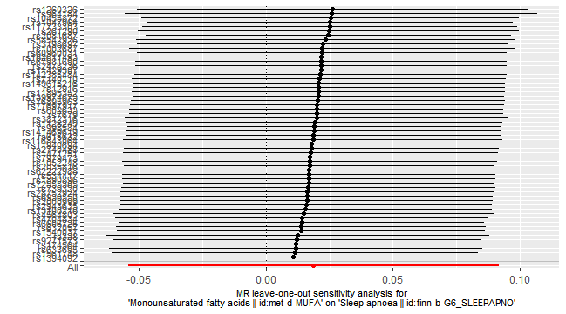
Supplementary Figure 43 “leave-one-SNP-out” analysis of mon-unsaturated fatty acids in peripheral circulation affecting sleep apnea syndrome risk

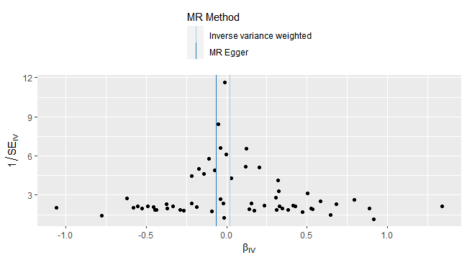
Supplementary Figure 44 Funnel plot of mon-unsaturated fatty acids in peripheral circulation affecting sleep apnea syndrome risk

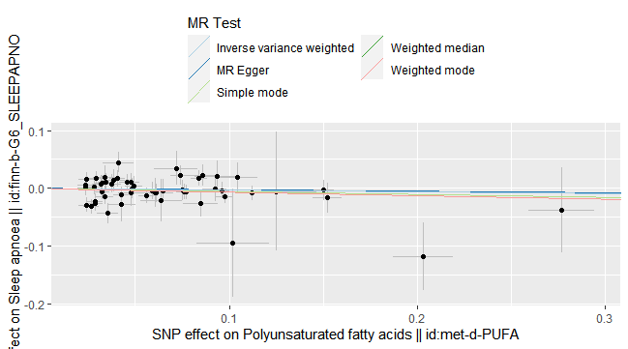
Supplementary Figure 45 Scatter plot of poly-unsaturated fatty acids in peripheral circulation affecting sleep apnea syndrome risk

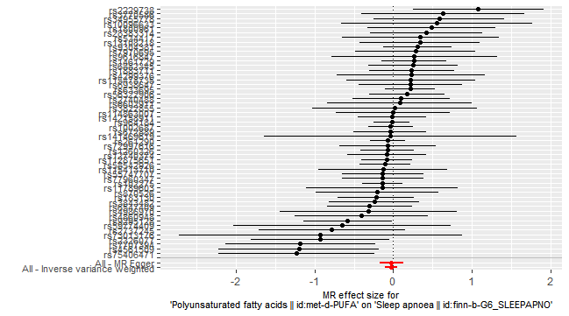
Supplementary Figure 46 Forest plot of poly-unsaturated fatty acids in peripheral circulation affecting sleep apnea syndrome risk

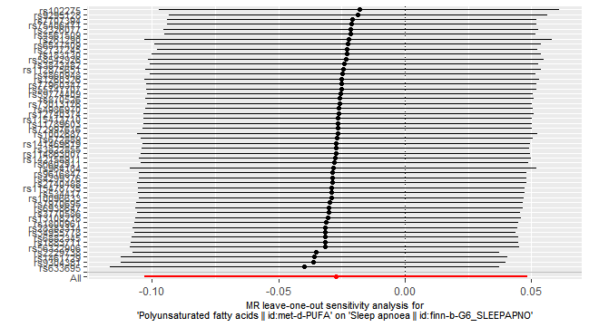
Supplementary Figure 47 “leave-one-SNP-out” analysis of poly-unsaturated fatty acids in peripheral circulation affecting sleep apnea syndrome risk

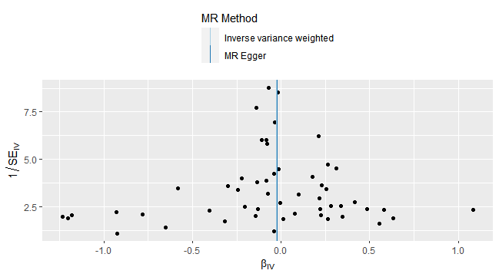
Supplementary Figure 48 Funnel plot of poly-unsaturated fatty acids in peripheral circulation affecting sleep apnea syndrome risk

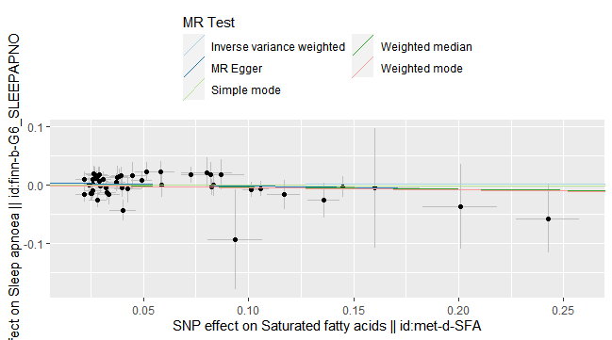
Supplementary Figure 49 Scatter plot of saturated fatty acids in peripheral circulation affecting sleep apnea syndrome risk

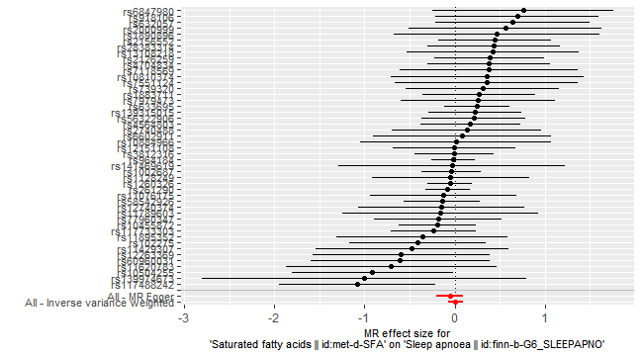
Supplementary Figure 50 Forest plot of saturated fatty acids in peripheral circulation affecting sleep apnea syndrome risk

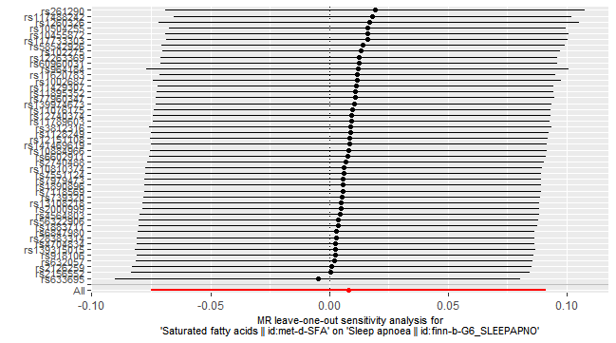
Supplementary Figure 51 “leave-one-SNP-out” analysis of saturated fatty acids in peripheral circulation affecting sleep apnea syndrome risk

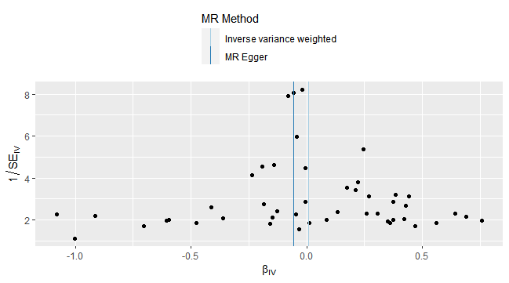
Supplementary Figure 52 Funnel plot of saturated fatty acids in peripheral circulation affecting sleep apnea syndrome risk

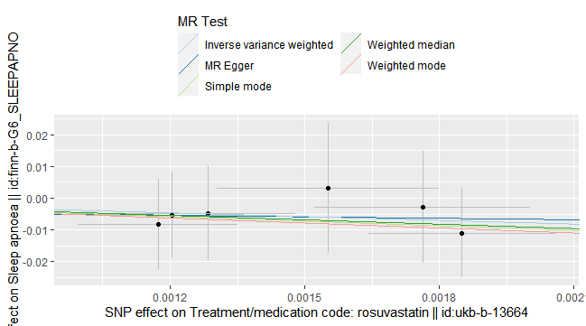
Supplementary Figure 53 Scatter plot of rosuvastatin use affecting sleep apnea syndrome risk

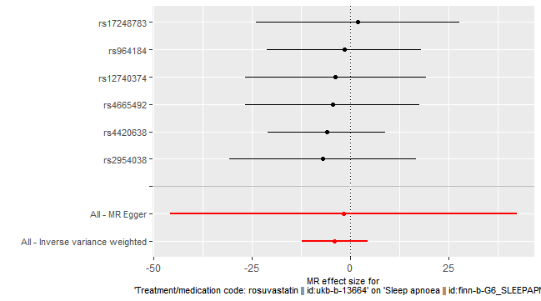
Supplementary Figure 54 Forest plot of rosuvastatin use affecting sleep apnea syndrome risk

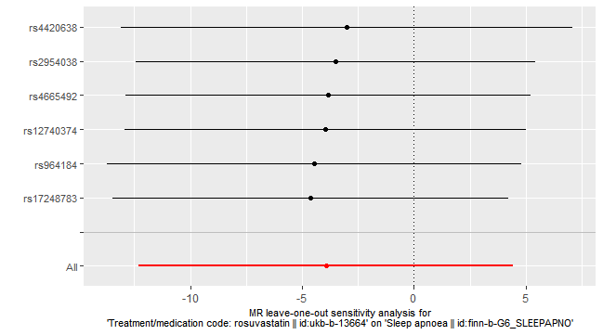
Supplementary Figure 55 “leave-one-SNP-out” analysis of rosuvastatin use affecting sleep apnea syndrome risk

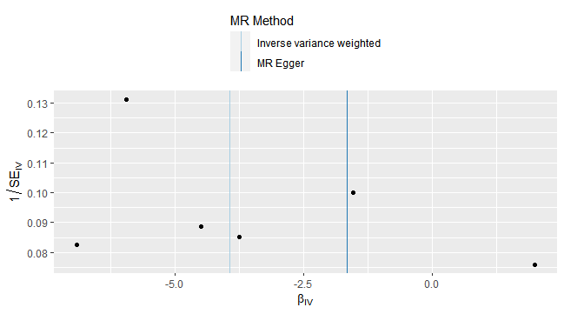
Supplementary Figure 56 Funnel plot of rosuvastatin use affecting sleep apnea syndrome risk

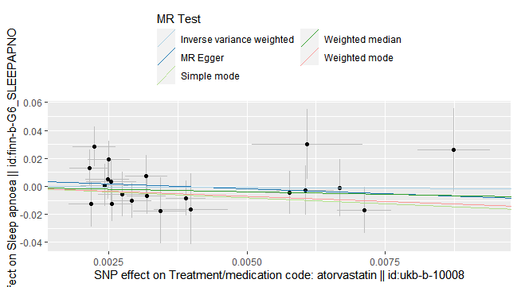
Supplementary Figure 57 Scatter plot of atorvastatin use affecting sleep apnea syndrome risk

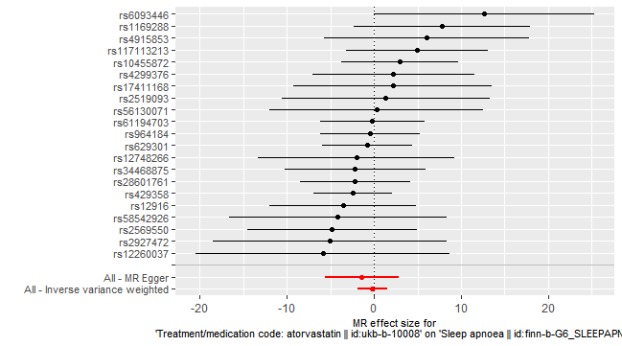
Supplementary Figure 58 Forest plot of atorvastatin use affecting sleep apnea syndrome risk

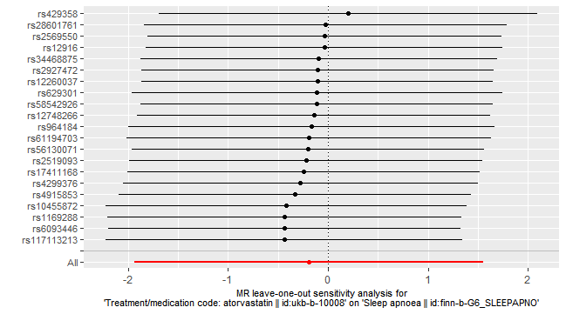
Supplementary Figure 59 “leave-one-SNP-out” analysis of atorvastatin use affecting sleep apnea syndrome risk

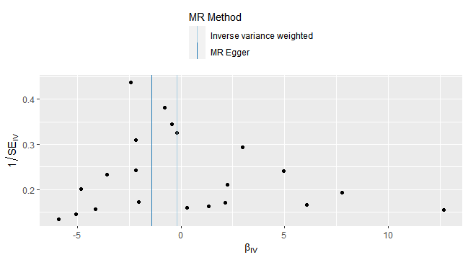
Supplementary Figure 60 Funnel plot of atorvastatin use affecting sleep apnea syndrome risk

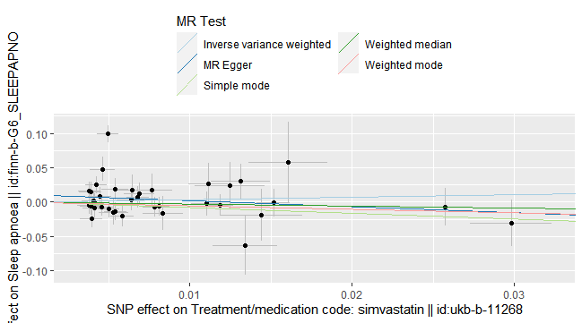
Supplementary Figure 61 Scatter plot of simvastatin use affecting sleep apnea syndrome risk

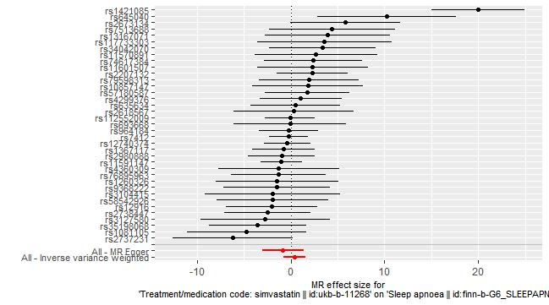
Supplementary Figure 62 Forest plot of simvastatin use affecting sleep apnea syndrome risk

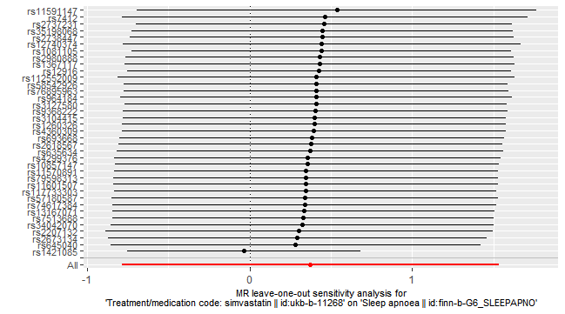
Supplementary Figure 63 “leave-one-SNP-out” analysis of simvastatin use affecting sleep apnea syndrome risk

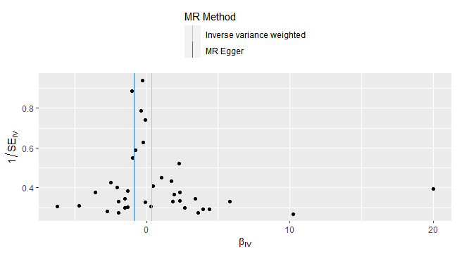
Supplementary Figure 64 Funnel plot of simvastatin use affecting sleep apnea syndrome risk

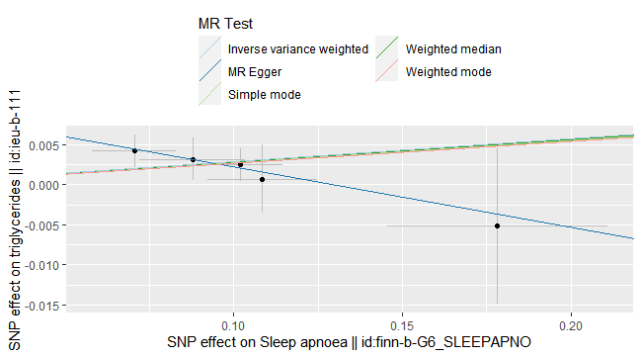
Supplementary Figure 65 Scatter plot of sleep apnea syndrome affecting triglycerides in peripheral circulation

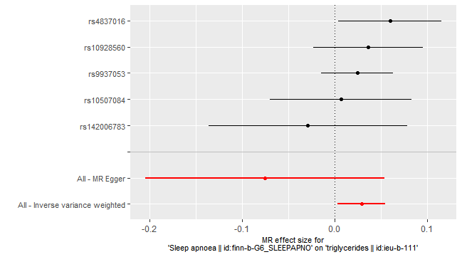
Supplementary Figure 66 Forest plot of sleep apnea syndrome affecting triglycerides in peripheral circulation

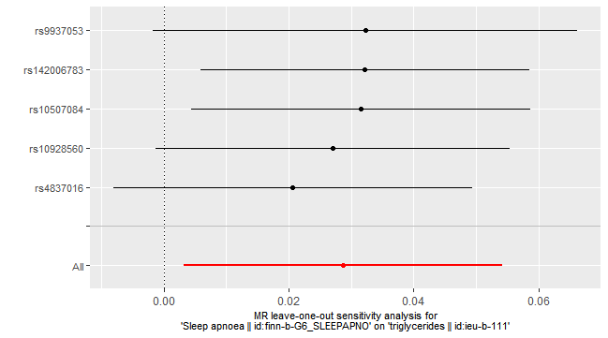
Supplementary Figure 67 “leave-one-SNP-out” analysis of sleep apnea syndrome affecting triglycerides in peripheral circulation

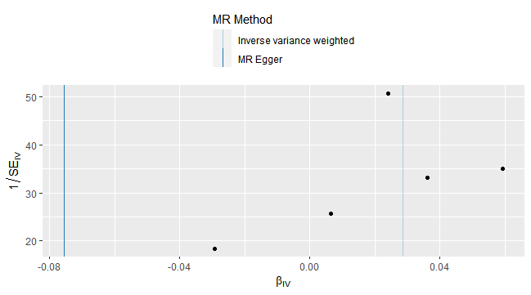
Supplementary Figure 68 Funnel plot of sleep apnea syndrome affecting triglycerides in peripheral circulation

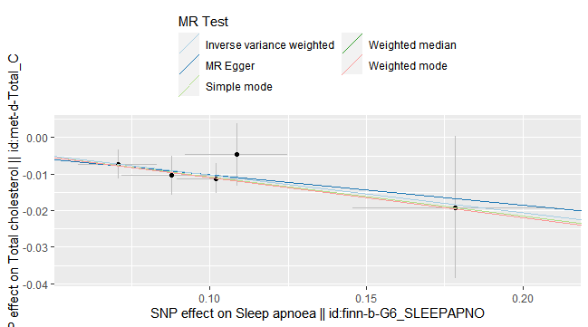
Supplementary Figure 69 Scatter plot of sleep apnea syndrome affecting total cholesterol in peripheral circulation

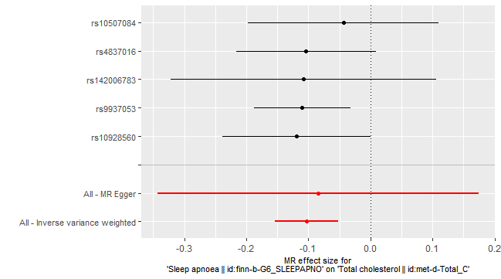
Supplementary Figure 70 Forest plot of sleep apnea syndrome affecting total cholesterol in peripheral circulation

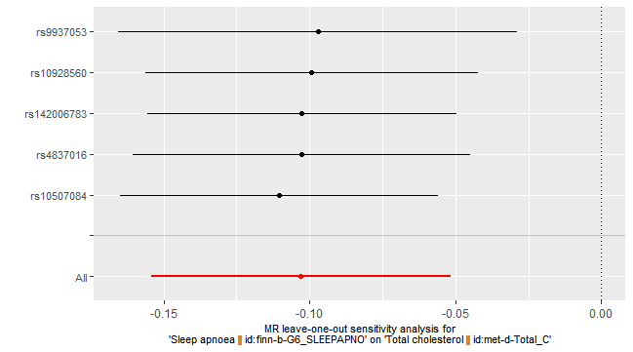
Supplementary Figure 71 “leave-one-SNP-out” analysis of sleep apnea syndrome affecting total cholesterol in peripheral circulation

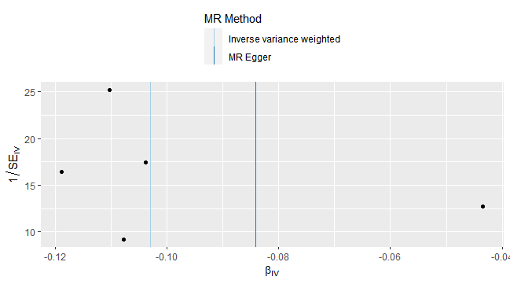
Supplementary Figure 72 Funnel plot of sleep apnea syndrome affecting total cholesterol in peripheral circulation

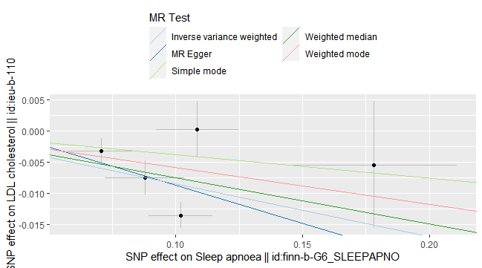
Supplementary Figure 73 Scatter plot of sleep apnea syndrome affecting low-density lipoprotein cholesterol in peripheral circulation

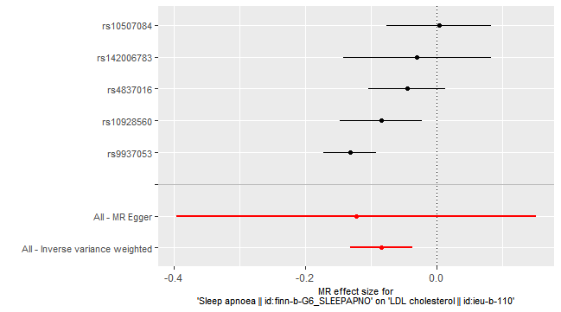
Supplementary Figure 74 Forest plot of sleep apnea syndrome affecting low-density lipoprotein cholesterol in peripheral circulation

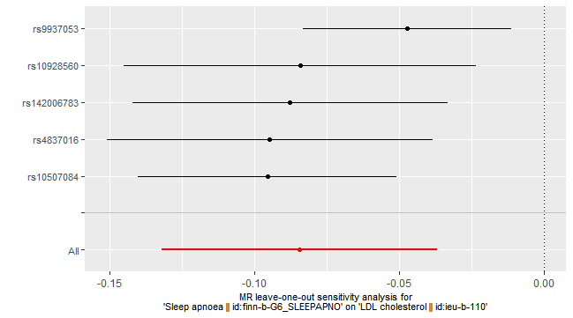
Supplementary Figure 75 “leave-one-SNP-out” analysis of sleep apnea syndrome affecting low-density lipoprotein cholesterol in peripheral circulation

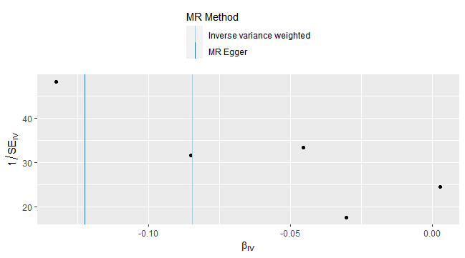
Supplementary Figure 76 Funnel plot of sleep apnea syndrome affecting low-density lipoprotein cholesterol in peripheral circulation

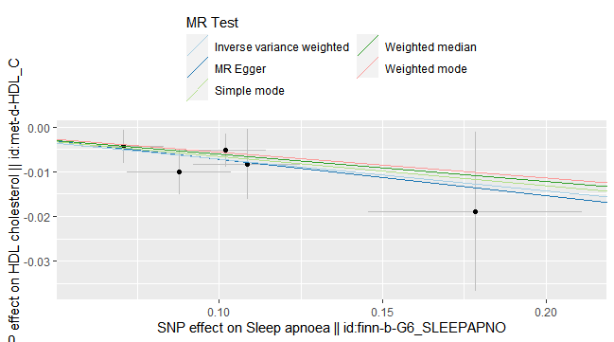
Supplementary Figure 77 Scatter plot of sleep apnea syndrome affecting high-density lipoprotein cholesterol in peripheral circulation

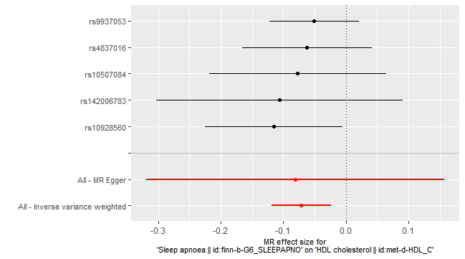
Supplementary Figure 78 Forest plot of sleep apnea syndrome affecting high-density lipoprotein cholesterol in peripheral circulation

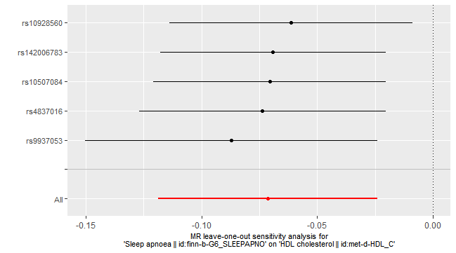
Supplementary Figure 79 “leave-one-SNP-out” analysis of sleep apnea syndrome affecting high-density lipoprotein cholesterol in peripheral circulation

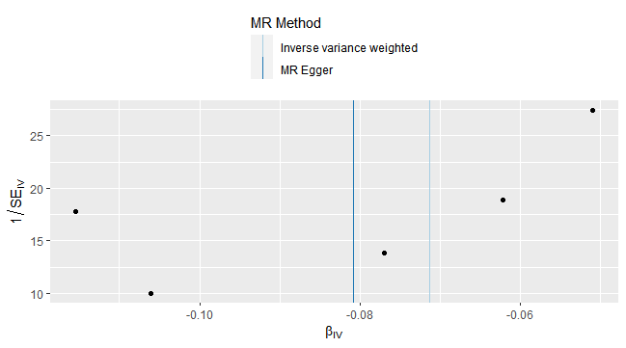
Supplementary Figure 80 Funnel plot of sleep apnea syndrome affecting high-density lipoprotein cholesterol in peripheral circulation

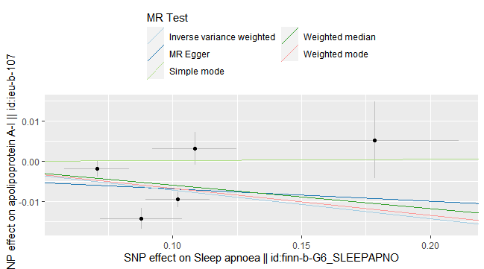
Supplementary Figure 81 Scatter plot of sleep apnea syndrome affecting apolipoprotein A1 in peripheral circulation

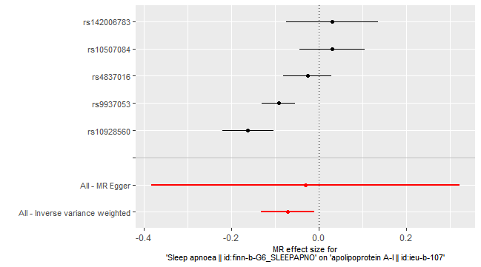
Supplementary Figure 82 Forest plot of sleep apnea syndrome affecting apolipoprotein A1 in peripheral circulation

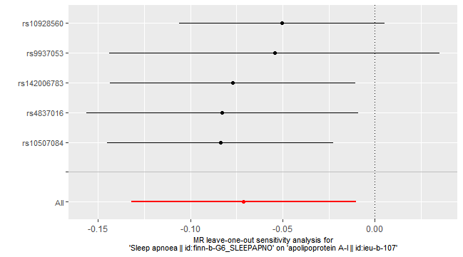
Supplementary Figure 83 “leave-one-SNP-out” analysis of sleep apnea syndrome affecting apolipoprotein A1 in peripheral circulation

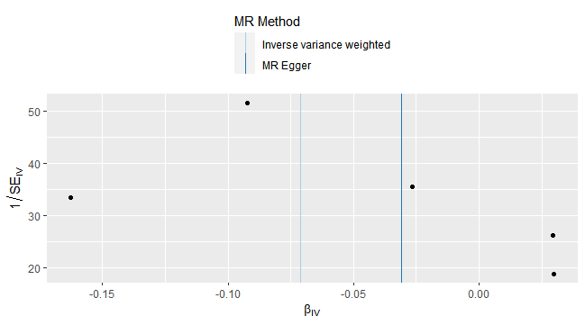
Supplementary Figure 84 Funnel plot of sleep apnea syndrome affecting apolipoprotein A1 in peripheral circulation

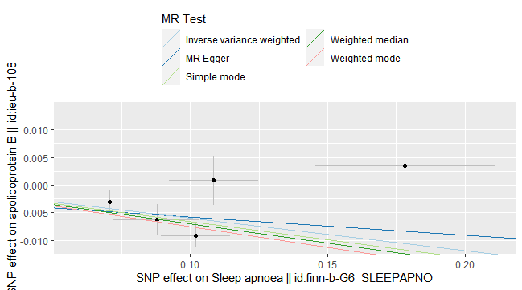
Supplementary Figure 85 Scatter plot of sleep apnea syndrome affecting apolipoprotein B in peripheral circulation

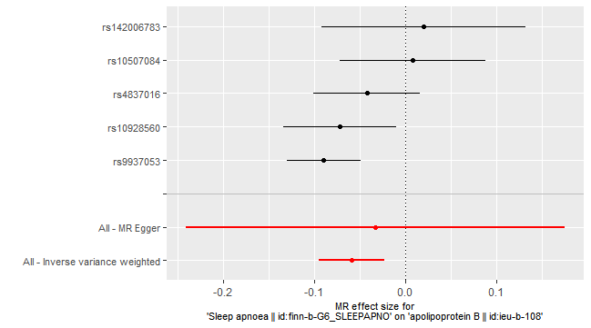
Supplementary Figure 86 Forest plot of sleep apnea syndrome affecting apolipoprotein B in peripheral circulation

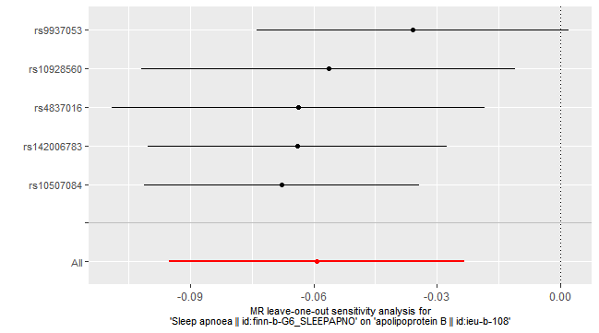
Supplementary Figure 87 “leave-one-SNP-out” analysis of sleep apnea syndrome affecting apolipoprotein B in peripheral circulation

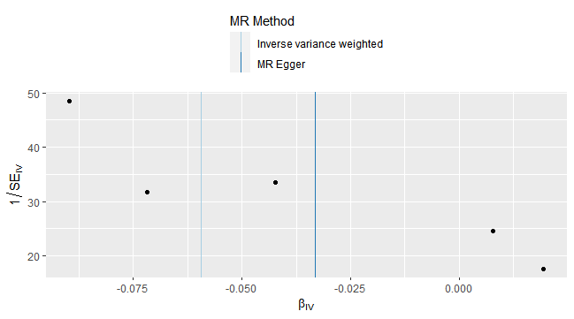
Supplementary Figure 88 Funnel plot of sleep apnea syndrome affecting apolipoprotein B in peripheral circulation

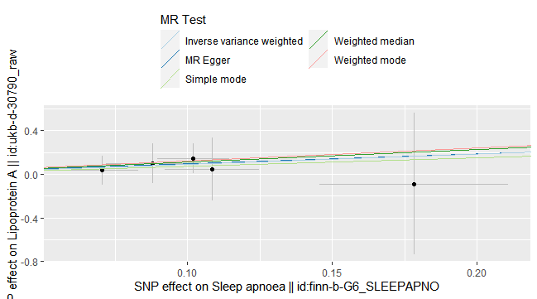
Supplementary Figure 89 Scatter plot of sleep apnea syndrome affecting lipoprotein a in peripheral circulation

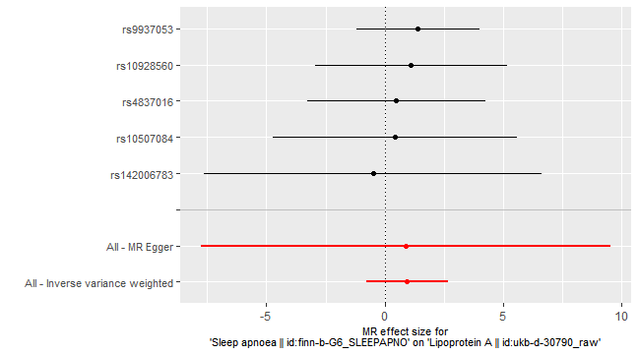
Supplementary Figure 90 Forest plot of sleep apnea syndrome affecting lipoprotein a in peripheral circulation

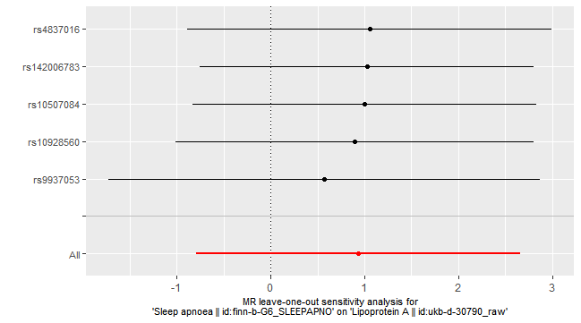
Supplementary Figure 91 “leave-one-SNP-out” analysis of sleep apnea syndrome affecting lipoprotein a in peripheral circulation

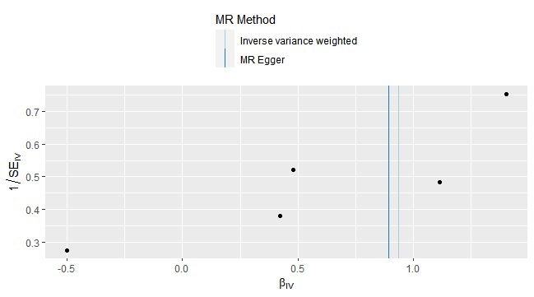
Supplementary Figure 92 Funnel plot of sleep apnea syndrome affecting lipoprotein a in peripheral circulation

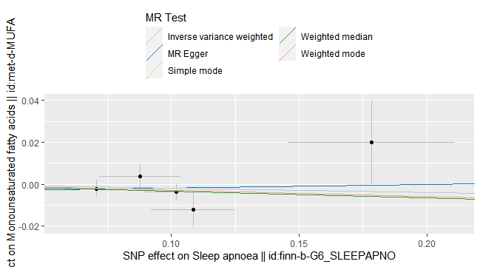
Supplementary Figure 93 Scatter plot of sleep apnea syndrome affecting mon-unsaturated fatty acids in peripheral circulation

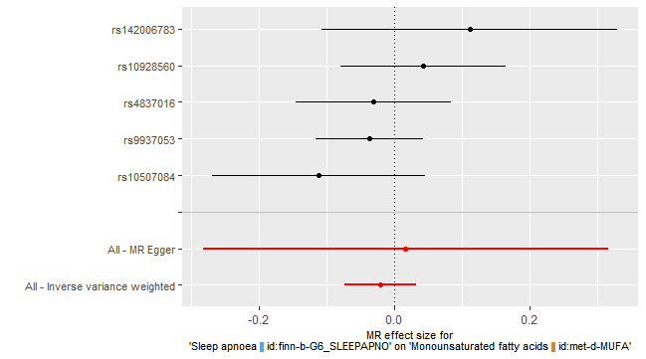
Supplementary Figure 94 Forest plot of sleep apnea syndrome affecting mon-unsaturated fatty acids in peripheral circulation

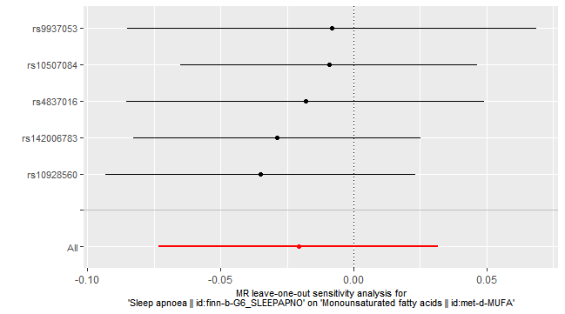
Supplementary Figure 95 “leave-one-SNP-out” analysis of sleep apnea syndrome affecting mon-unsaturated fatty acids in peripheral circulation

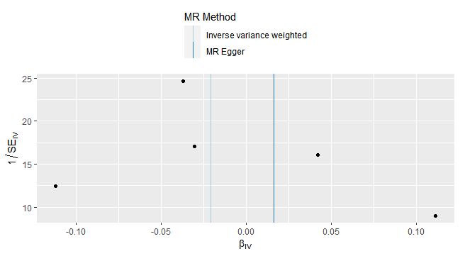
Supplementary Figure 96 Funnel plot of sleep apnea syndrome affecting mon-unsaturated fatty acids in peripheral circulation

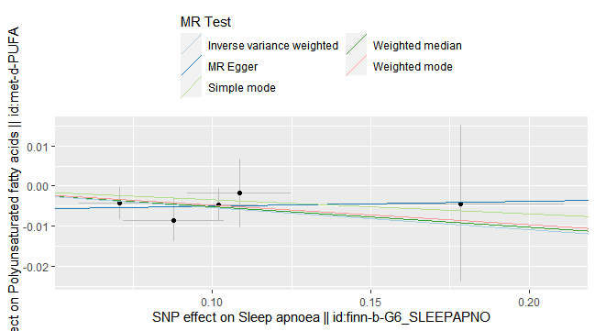
Supplementary Figure 97 Scatter plot of sleep apnea syndrome affecting poly-unsaturated fatty acids in peripheral circulation

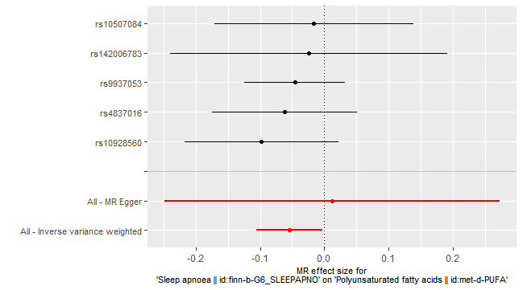
Supplementary Figure 98 Forest plot of sleep apnea syndrome affecting poly-unsaturated fatty acids in peripheral circulation

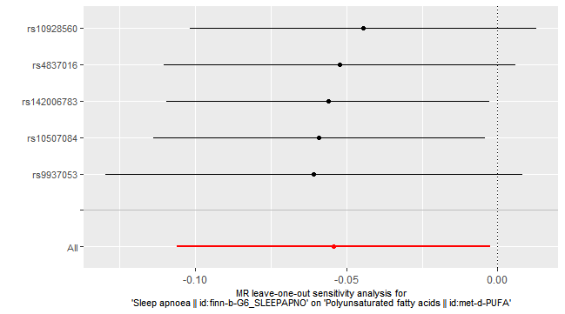
Supplementary Figure 99 “leave-one-SNP-out” analysis of sleep apnea syndrome affecting poly-unsaturated fatty acids in peripheral circulation

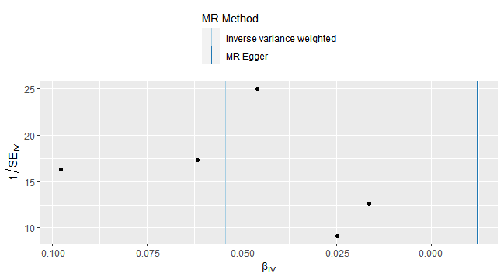
Supplementary Figure 100 Funnel plot of sleep apnea syndrome affecting poly-unsaturated fatty acids in peripheral circulation

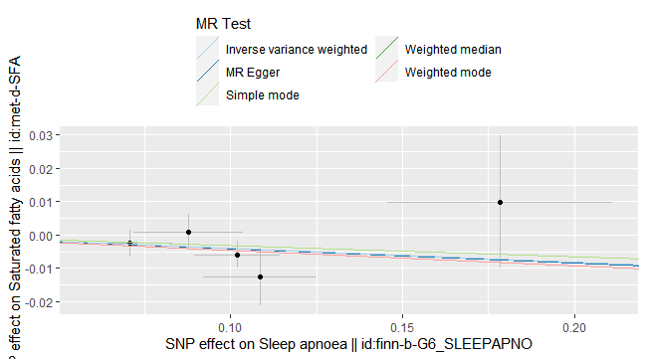
Supplementary Figure 101 Scatter plot of sleep apnea syndrome affecting saturated fatty acids in peripheral circulation

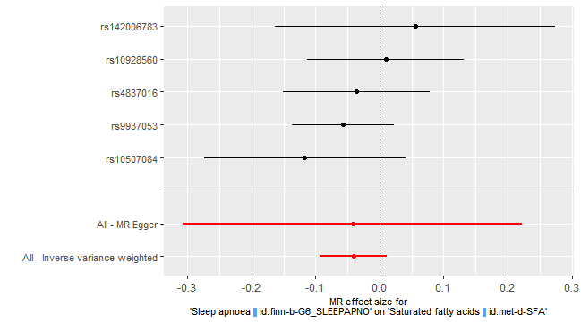
Supplementary Figure 102 Forest plot of sleep apnea syndrome affecting saturated fatty acids in peripheral circulation

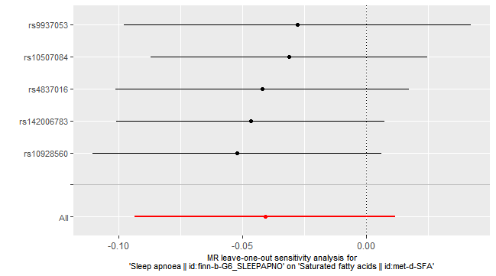
Supplementary Figure 103 “leave-one-SNP-out” analysis of sleep apnea syndrome affecting saturated fatty acids in peripheral circulation

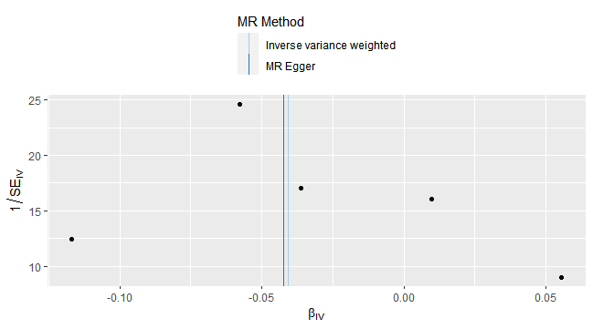
Supplementary Figure 104 Funnel plot of sleep apnea syndrome affecting saturated fatty acids in peripheral circulation

