Supplementary material for: Efficient development of gait classification models for five-gaited horses

Toltsense validation
Dr Torben A Rees, TöltSense Limited

A study to assess the accuracy of the TS gait classification algorithm was conducted in the autumn / winter of 2021/22. Horses were ridden and filmed with the TS equipment in place creating a log file of gait labels with timestamps. A web application was created where experienced observers could watch the videos and click buttons to indicate the gait, creating a series of gait labels and timestamps. Taking the aggregated classification from several judges as the ground truth, a comparison was then made to establish the accuracy of TS. It was shown that TS achieves a gait classification accuracy of up to 99.7%.

In addition, the accuracy and precision of hoof-on and hoof-off measurement was investigated. Frame-by-frame analysis of 100 fps video of a single 5-gaited Icelandic horse was used to create a series of hoof-on/off events to serve as a benchmark. The hoof-on timings from TS were then aligned with this signal using cross correlation and for each event a difference was calculated. The resulting distribution was then subjected to analysis. It is shown that the accuracy of TS as a tool for measuring beat quality, duty factor, and suspension is at least as good as the best possible result from analysis of 30 fps video.

Part 1: Validation of Gait Classification

Introduction
TöltSense (TS) is a gait classification and performance monitoring system designed for use with Icelandic horses. It provides real-time feedback to the trainer using voice synthesis as well as post-session graphical and statistical information. The system comprises a network of four wireless inertial sensors worn on the lower limbs of the horse and an app on a mobile phone carried by the rider. The principle is to detect stride events (hoof on/off times) with enough accuracy and precision to reliably discriminate which of the 5 Icelandic gaits is being shown, and in addition, to provide analysis of the quality of the gait in terms of beat, balance, suspension, speed, and stride length. To achieve this in real-time, TS uses efficient algorithms and data streaming strategies, together with aggregation and error correction based on domain-specific knowledge.

The kind of information that TS can generate and supply to the rider would normally require an expert eye on the ground or an in-depth frame-by-frame analysis of video. Such circumstances inevitably incur costs and are restrictive in terms of environment, such as being confined to a riding hall, or needing good lighting, or fair weather. Moreover, the volume and utility of information gathered this way is limited. By contrast, TS can instantly analyse the rhythm of the horse’s gait and channel this information back to the rider without any external assistance or environmental restrictions. This approach creates a short feedback loop, resulting in accelerated learning for the horse and rider.

Further, the data is logged and can be collated over many sessions, which opens numerous possibilities for incremental performance improvement and research. We will show that TS’s gait classification is as good as any expert human observer. Specifically, the gait classification has been shown to have 99% agreement with the classifications of a panel of 4 qualified Icelandic sport judges. In addition, the measurement of inter-limb stride event timings, which forms the basis of gait quality evaluation, is at least as accurate as an idealised frame-by-frame analysis of 30 fps video. TS therefore massively increases the accessibility of detailed and reliable gait performance metrics to the rider and trainer.

A wealth of research has been conducted in recent years in the field of horse gait analysis using inertial sensors, most of which is geared towards lameness detection, remedial farriery, or cutting-edge research into equine gaits in general. Several commercial systems have arisen from this endeavour, costing thousands or even tens of thousands of pounds to purchase. TS is not as technically advanced as these systems and does not aspire to cutting edge veterinary research. Rather, the aim is to produce an affordable and accessible system that is accurate and fast enough to support the training needs of amateur and professional Icelandic horse enthusiasts.

Materials and methods
Eight Icelandic horses of varying levels of training and ability were ridden and filmed while wearing the TS equipment at a horse farm in the UK. Some of the sessions were captured during warm-up for an oval track competition in an indoor arena. The rest were captured during a training day on an oval track.

At the beginning of each session, we started filming by recording the press of the TS app’s “START” button before continuing to film without interruption (see Figure 1). This button press initiates the creation of a log file of gait classifications and timestamps, and recording it provides an easy way to line up the video with the log. Each video was trimmed to start exactly when the ‘START’ button was pressed so that the times in the video would correspond to the times in the app log.

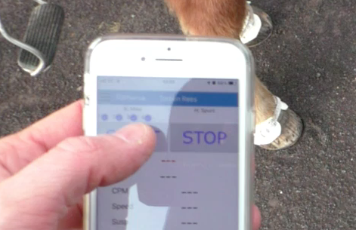
Figure 1: Filming the start event

A panel of 4 qualified Icelandic sport judges independently suggested gait labels while watching the videos, using a custom-made web application (see Figure 2). For each video, a continuous observation window of 4-5 minutes was defined so as to include as many transitions and gaits as possible and to avoid judges having to watch unnecessary footage. At no point were the classifications of TS revealed to the judges.

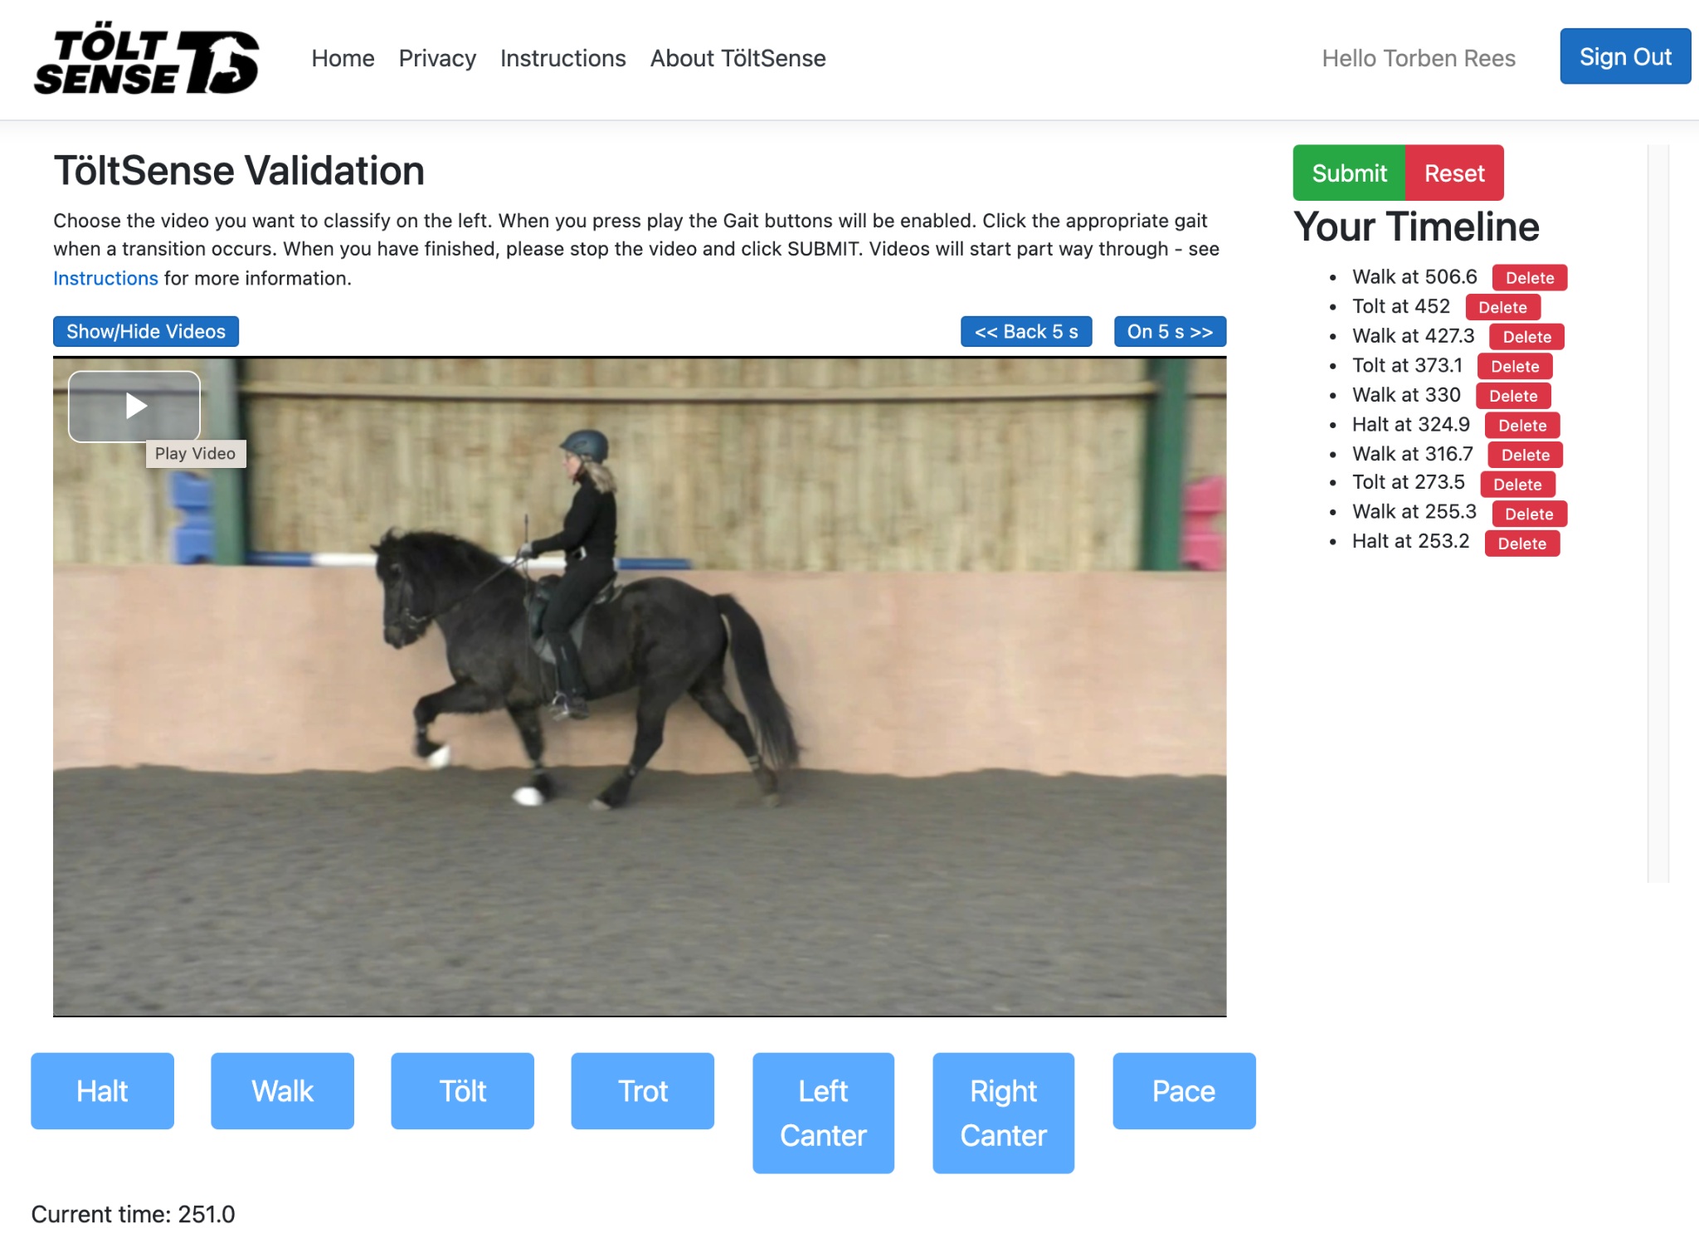
Figure 2: The validation web app

A gait was determined every 250ms by choosing the most common label suggested during the given time interval. Such a majority vote was applied throughout the observation window, and a new data point was created whenever the majority gait changed. This processing step resulted in a series that defined the gait at any given moment during the observation window. We refer to this time series as aggregate judge classifications. An illustration of this time series is shown for a single example in Figure 3. The values in the time series correspond to gaits according to Table 1.

No majority / disputed | -2
Not classified | -1
Halt | 0
Walk | 1
Trot | 2
Tölt | 3
Left Canter | 4
Right Canter | 5
Pace | 6
Table 1: Gait labels.

The category “No majority / disputed” is required because there are occasions where judges do not agree on the gait. Mostly these are brief periods around gait transitions. However, Icelandic horses often display movements that are “between gaits” (e.g., pacey tölt, or 4-beated trot), and in these cases, it is not clear which gait is being shown. If qualified observers do not agree on the gait, there is no ground truth to compare TS against, so periods labelled as -2 were excluded from the assessment. “Not classified” appears once at the very start of each session before any classification has been given; such periods were also excluded. The other labels are self-explanatory but note that left and right canter are included as separate gaits because it is important to demonstrate that TS can distinguish between them.

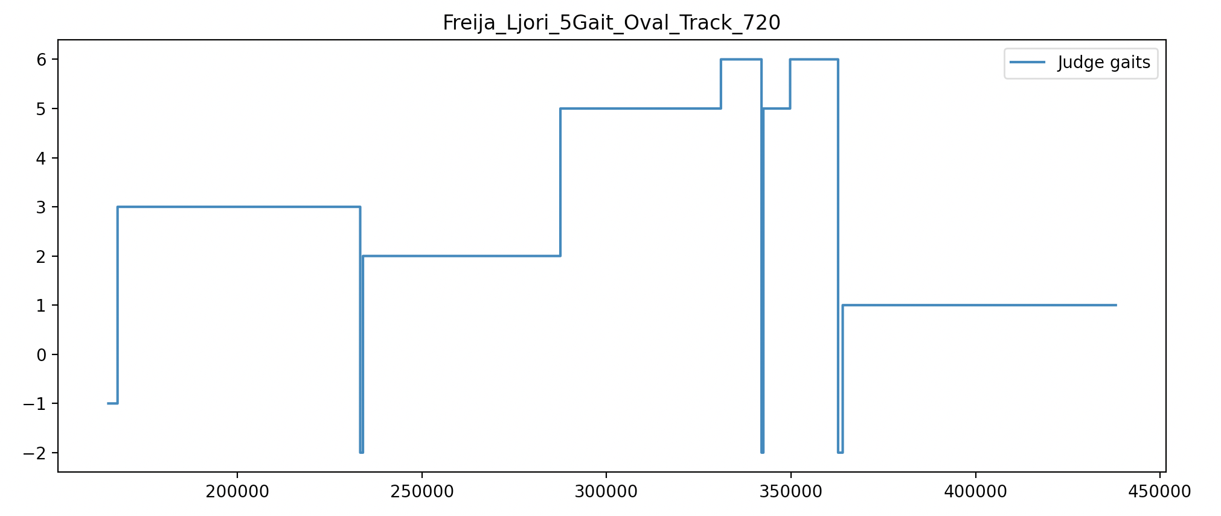
Figure 3: Plot of aggregate judge classifications against time, showing initial -1 period and 3 periods of -2 dispute

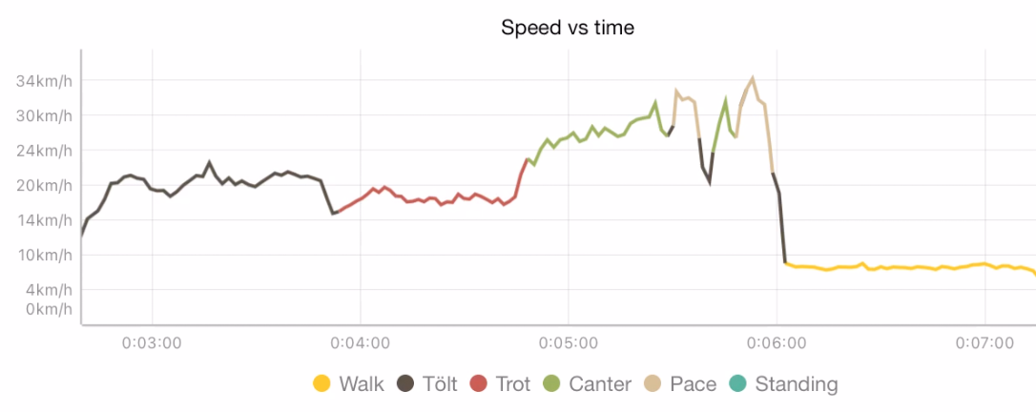
Figure 4: Plot of speed vs time colour coded by gait from TöltSense session overview screen

TS calculates the gait label every time a hoof-on event is registered from any leg. Hence the gait labels are produced at a variable rate from about 4Hz to 10Hz, depending on the horse’s activity. We use a sliding window of 1s length with a step of 0.5s to produce a timeline for analysis. For each window, all gait labels falling within that window were collected and the most frequent gait label was taken and paired with the timestamp from the middle of the window. The timestamp of the first sample in the log was subtracted from all windows, which resulted in a timeline of gaits starting at 0s and progressing forward at 0.5s intervals for the whole session.

At this point, we now have two synchronised series containing timestamps and gait labels. The series from TS should be regarded as the ‘predicted value’ set, and the series aggregated from the judges is the ‘true value’ set. For each video, an observation window has been defined where we have both a TS prediction and the ground truth labels generated by judges. We take the timestamp from the predicted value and retrieve the ground truth value at that given time to make a prediction-truth pair, or ‘test case’.

As mentioned above, when aggregate judge classifications result in -2 or -1, the test case is discarded. In addition, it is appropriate to discard test cases that are very close to transitions. In other words, leeway should be allowed for both TS and judges when it comes to identifying and registering the moment of a transition. There are several reasons for this. First, there is always a delay between the horse making the transition, the judge recognising the transition has occurred, and then again a delay before the gait button is clicked in the web application. TS may already have correctly recorded the transition when the judge clicks the button, so a false negative will be produced. Second, in cases of momentary loss or change of gait (for example, a few steps of trotty tölt in the middle of a section of trot going straight back to trot), a judge is unlikely to react fast enough to register the gait change. If they do, it is likely to be registered late.

On the other hand, TS is very likely to register the momentary gait change, and so again, a false positive or false negative may be produced. There are also cases where the human eye (and hand) is quicker to register the gait change than TS. The main example is the transition to walk, where the stride frequency is low, and it takes longer for TS to build a buffer of steps to analyse as opposed to when going into fast tölt, for example. In such cases, the judges may log a transition before TS does, which results in a false negative. For these reasons, we propose a 1s exclusion period for transitions (as identified by either TS or the judges) as a fair degree of leeway. Any test cases falling within these exclusion periods are removed from the analysis.

Results
A total of 4,421 one-second windows were generated from the TS logs, which included 179 gait transitions. Excluding cases that were subsequently marked as -2, or -1, and without exclusion periods, 4,371 valid test cases were generated. Factoring in transition exclusion periods reduces the number of valid test cases (see table below). The accuracy of the TS predictions was calculated simply as the total number of correct predictions divided by the total number of valid test cases.

In Table 2, we show how the calculated accuracy varies when you alter the exclusion period for both judge-identified and TS-identified transitions.

TS Excl (ms) | Judge Excl (ms) | Test Cases | Accuracy %
2000 | 2000 | 3358 | 99.73
1000 | 1000 | 3757 | 98.86
1000 | 0 | 3909 | 97.95
0 | 1000 | 3990 | 96.62
0 | 0 | 4371 | 93.89
Table 2: Gait classification accuracy for different sizes of exclusion windows.

The exclusion period was varied from 0s to 2s, and it was found that the longer the period, the greater the accuracy. Without any exclusion periods, the accuracy 93.89% and with 2s for each, the accuracy was 99.73%. The gait distribution is shown in Figure 5 and the confusion matrix for the case where both TS and Judge exclusion period was 1000ms is shown in Figure 6.

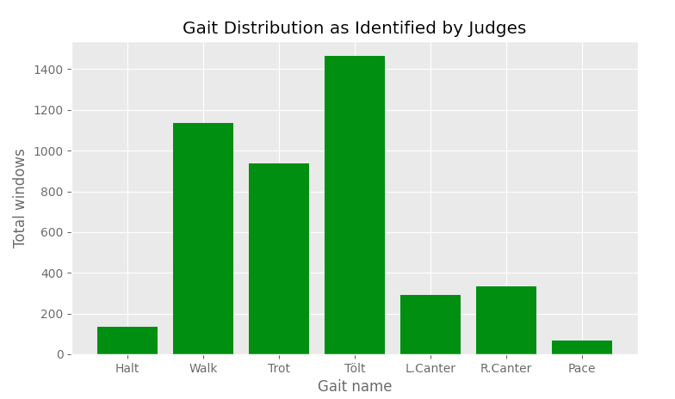
Figure 5: Distribution of gaits as identified by the judges was as below. We note that pace is underrepresented here.

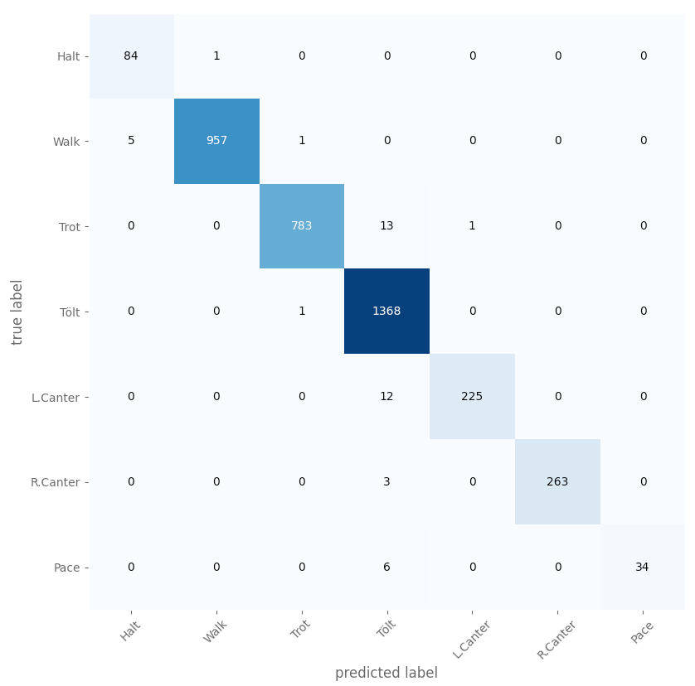
Figure 6: A confusion matrix for the case where both TS and Judge exclusion period was 1000ms.

The confusion matrix without any exclusion periods the matrix is shown in Figure 7.
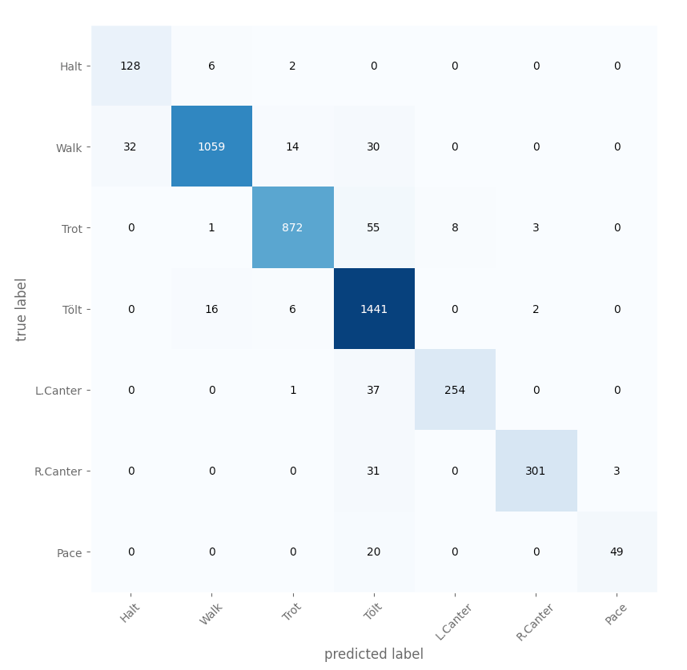
Figure 7: A confusion matrix for the case where both TS and Judge exclusion period was 0ms.

Discussion
We have demonstrated a very high level of agreement between TS and qualified sport judges when classifying the gait of Icelandic horses. The use of exclusion periods around transitions can take the agreement to over 99% but the agreement is around 94% even without any exclusion. We earlier framed this in terms of ‘accuracy’ by considering the judge classifications as the ground truth. In reality we are assessing the agreement between two different measuring approaches, and it is valid to question whether TS is more accurate than human observers in some circumstances. There are often areas where the judges disagree about the gait. For example, a very pacey tölt coming out of canter may be classed as pace by some and tölt by others. There are also cases on the boundary between walk and tölt and between tölt and trot. It may be interesting to analyse these disagreements as a project in itself.

The main shortcoming of this study is that more instances of flying pace should have been included. If the opportunity arises to study some more pace horses, we will update our findings accordingly.

Acknowledgements
We would like to thank Ann Winter, Nanco Lekkerkerker, Rebecca Hughes, and Harriet Vincent for labelling in this validation study.

For commercial reasons, this paper will not go into details about how these mechanisms work.
We are not suggesting that TS is a replacement for a qualified riding instructor or can somehow make up for any lack of experience in horse training. Rather, TS is a tool that both riders and trainers can use to enhance their existing ways of working.
Ann Winter (IS, International Sport Judge), Nanco Lekkerkerker (NL, National Sport Judge), Rebecca Hughes (UK, Regional Sport Judge and IHSGB trustee), Harriet Vincent (UK, Regional Sport Judge and qualified Veterinary Surgeon)

