Designing and fabricating an unprecedented wide temperature range of novel elastomer: simulation and experiment
Guanyi Hou^{1,2}, Yingxue Hao^{1,3}, Ruifeng Jiang⁴, Sai Li^{1.3}, Yonglai Lu^{1.3*}, Jun Liu^{1.3*}, Liqun Zhang^{1.3*}, Krzysztof Matyjaszewski⁵*
¹ State Key Laboratory of Organic-Inorganic Composites, Beijing University of Chemical Technology, People’s Republic of China
² College of Chemistry and Materials Engineering, Beijing Technology and Business University, People’s Republic of China
³ Engineering Research Center of Elastomer Materials on Energy Conservation and Resources of Ministry of Education, Beijing University of Chemical Technology, People’s Republic of China
⁴ School of Materials Science and Engineering, Hainan University, People’s Republic of China
⁵ Department of Chemistry, Carnegie Mellon University, United States of America

Supplementary Information
Method
Simulation details
In this study, we adopt full-atomistic molecular dynamics simulation (FAMD) to study the physicochemical properties of novel silicone elastomer. As illustrated in Figure S1, the silicone elastomer is consisted of two parts: dimethyl siloxane and monomethyl siloxane with long-side chain siloxane (LCS), while the influence of length (L) and content (ϕ) of LCS on the performance of silicone elastomer are investigated. Each molecule contains 100 repeat units and each system contains 10 molecules. The molecular weight for each system is at least 100000, and each system is equilibrated over a long time so that each chain has moved at least 2R_{g}, where R_{g} is the root mean square radius of gyration of polymer chains. Meanwhile, a series of small systems are designed to investigate the structural properties of the silicone system. Each system contains 1 molecule and each molecule contains 80 repeat units. The periodical boundaries are applied to the systems. The simulations have been performed under the NPT ensemble. To more precisely predict the physicochemical properties of silicone rubber, we use two different force fields to characterize different properties: for the characterization of the glass transition temperature, FAMD runs are carried out by COMPASS force field¹, which is suitable for condensed-phase optimized molecular potentials for atomistic simulation studies. And for the characterization of the decomposition temperature, FAMD runs are carried out by REAXFF force field^{2, 3, 4}, which provides accurate descriptions of bond breaking and bond formation in high temperature. Decomposition simulation of each system contains 1 molecule, which contains 300 repeat units, and 25 nitrogen molecule (N₂). The simulations have been performed under the periodical boundaries and NPT ensemble. In the non-equilibrium simulation section, the decomposition temperature is defined as the hinge of the variation of the mean-squared distance change rate of all molecule in simulation box as a function of the temperature. The simulation data with repeat progresses and in the experiment section and the comparison in Figure 3, the decomposition temperature is defined as the 5% weight loss temperature. All FAMD runs are performed by LAMMPS, distributed by Sandia National Laboratories⁵. More simulation details can be found in our previous studies^{6, 7, 8, 9, 10}.
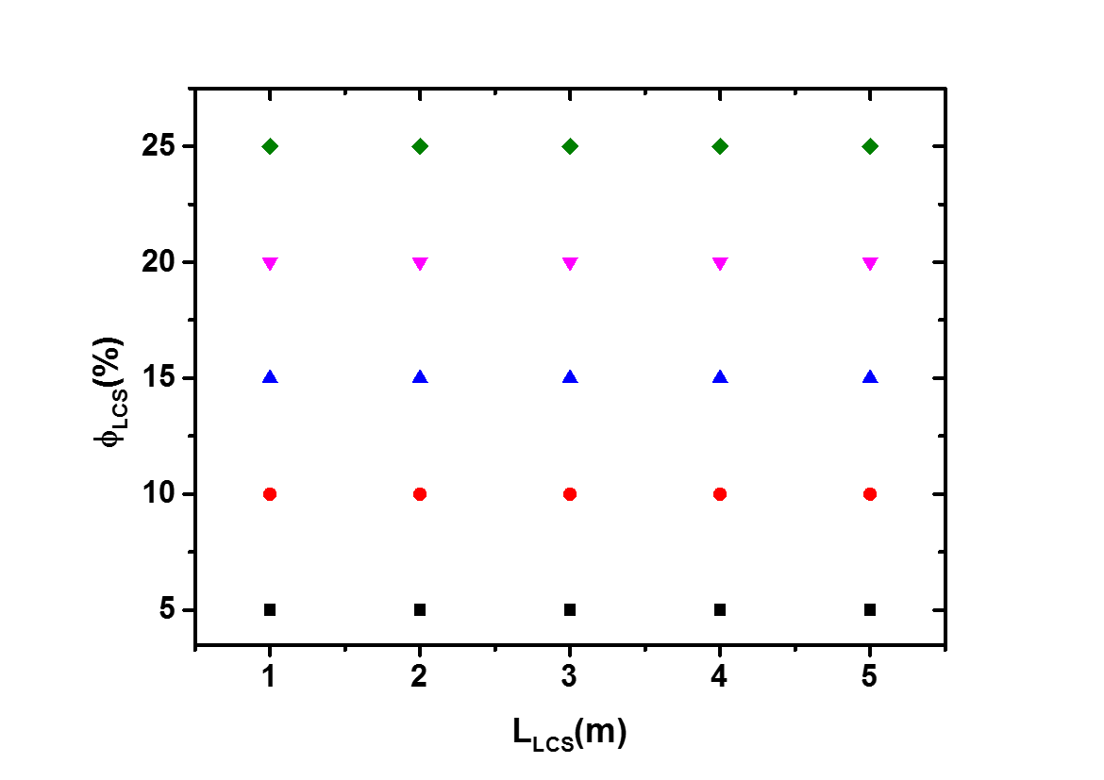
Figure S1. All systems of novel silicone elastomer with various contents and length of LCS.

Experimental Section
Materials
Octa-methyl-cyclo-tetrasiloxane (99.9%), 2,4,6,8-tetramethyl-2,4,6,8 tetravinylcyclotetrasiloxane Decamethyltetrasiloxane (97.5%) are purchased from J&K Scientific Ltd. China. Potassium hydroxide (99.99%) is purchased from Adamas Pharmaceuticals, Inc, China. Decamethyltetrasiloxane (97%) and Acetic acid (99.5%) are purchased from Tokyo Chemical Industry Co., Ltd, Japan. Karstedt’s catalyst (3000ppm) is purchased from AB Specialty Silicones Nantong Co. Ltd, China. Pentamethyldisiloxane is purchased from Shanghai Macklin Biochemical Co, Ltd. China. Toluene (AR) is purchased from Beijing Tongguang Chemical Co., Ltd, China. deuterated chloroform is purchased from Cambridge Isotope Laboratories, Inc, USA. Methanol (AR) and tetrahydrofuran (AR) are purchased from Beijing Chemical Co., Ltd, China. Water used to prepare the aqueous solutions are purified with a Ulupure ultrapure water system.
Experimental detail
- The synthesis of KOH silanolate
A 100 mL three-neck glass flask equipped with a condenser, a thermometer, and a nitrogen sparging device, 20.0 g D₄ and 0.4 g KOH is added to synthesize KOH silanolate containing 2.0 wt% KOH as an initiator. The system is heated to 80 ◦C and vacuumized to 0.095 kPa for 2 h to remove H₂O. Then the system is heated to 120 ◦C to start the reaction and keep for 4 h until the product became transparent.
Figure S2. The formula of the synthesis of KOH silanolate
- Synthesis of poly(methylvinylsiloxane) (PVMS)
A 250 mL three-neck glass flask equipped with a condenser, a mechanical agitator, and a nitrogen sparging device. 2,2,4,4,6,6,8,8-Octamethylcyclotetrasiloxane(D₄), 2,4,6,8-Tetraethenyl-2,4,6,8-tetramethylcyclotetrasiloxane(V₄), and 1,1,1,3,3,5,5,7,7,7-Decamethyltetrasiloxane in given molar ratios (0.95 : 0.05 : 0.0008, 0.90 : 0.10 : 0.0008, 0.85 : 0.15 : 0.0008, and 0.80 : 0.20 : 0.0008, 0.75 : 0.25 : 0.0008) are added. And then the mixture was heated to 80 ◦C and vacuumed to 0.095 kPa for 2 h, add KOH silanolate. The reaction was started at 153 ◦C under a nitrogen atmosphere. After 8h, toluene and acetic acid are added until the polymer dissolved for a night. Then the system is vacuumed to 0.1 kPa to removed toluene and acetic acid, and then a transparent (PVMS) is obtained.
Figure S3. The formula of synthesis of PVMS
- Synthesis of the polysiloxane with LCS
A 250 ml four necks dry round-bottom flask with a magnetic stirrer, a condenser, and a thermometer is filled with 3 g of poly(methyl-vinylsiloxane) dissolved in 100 mL toluene and then add into 30 ppm Karstedt catalyst and 1,1,1,3,3-Pentamethyldisiloxaneunder. The mixture is under a nitrogen atmosphere and allows to proceed under constant, gentle stirring at 90 ◦C for 4 h. The reaction mixture is precipitated into a 2-fold excess of methanol, filtered, washed with methanol and dried at 50 ◦C under vacuum for 12 h and then get polysiloxane with LCS.
Figure S4. The synthesis of novel silicone elastomer with LCS
Characterization
The FT-IR spectra and ¹H-NMR spectra are performed by Bruker instrument Avance. The FT-IR spectra are recorded from 500 to 4500 cm⁻¹ at room temperature and the ¹H-NMR spectra are recorded under the conditions that are CHCl₃-d solvent with a tetramethylsilane reference, and the frequency is set at 400 Hz. Differential scanning calorimetry (DSC) is performed using Mettler Toledo instruments STAR@ operated at a scanning rate of 5 ◦C /min⁻¹. Thermogravimetric Analysis (TGA) Experiment is performed by Mettler Toledo instruments STAR@ and the temperature range from 30-1000 ◦C under Inert atmosphere.
Supplementary Figures and Tables
The FT-IR spectra and ¹H-NMR spectra of novel silicone elastomer when m=1 and m=2
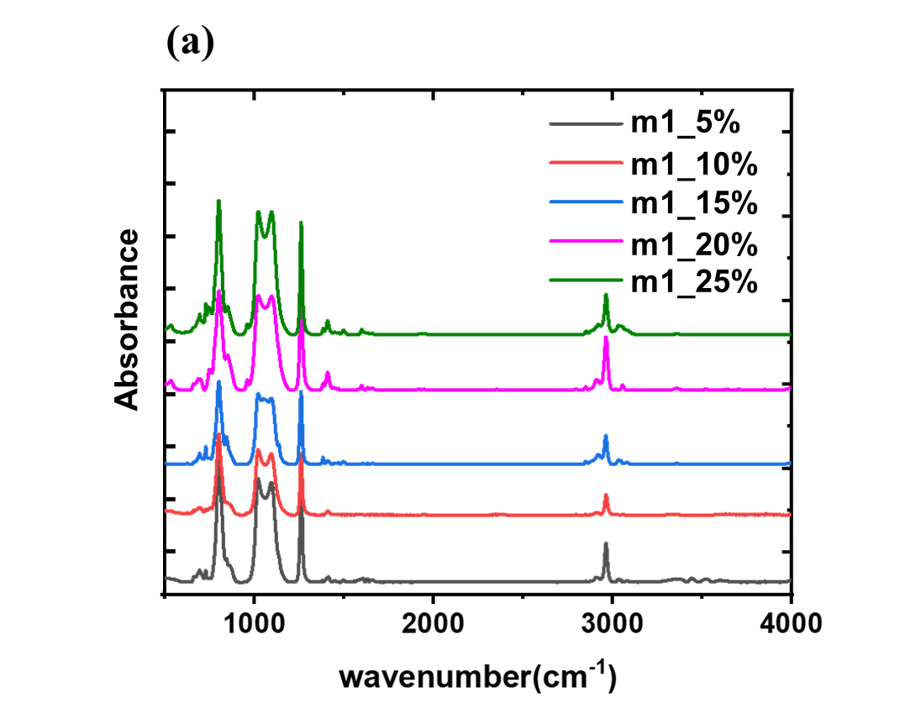
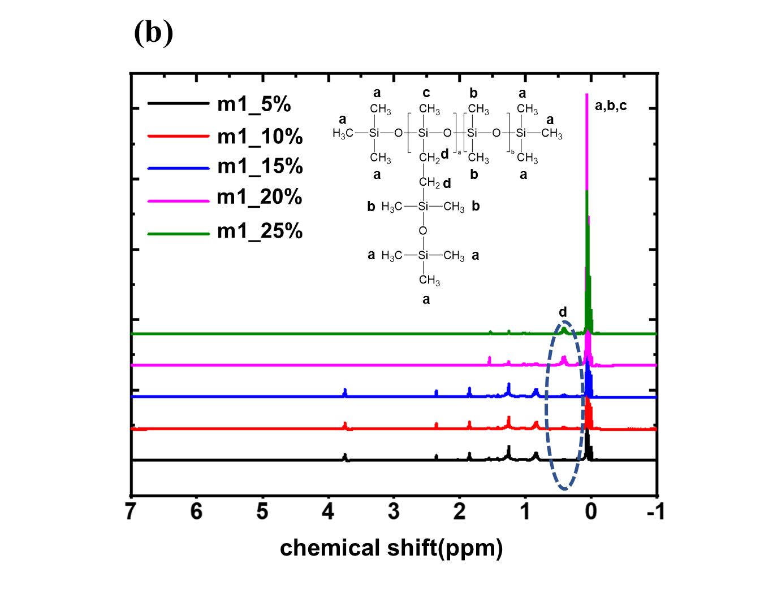
Figure S5. (a) the FT-IR spectra and (b) the ¹H-NMR spectra of novel silicone elastomer when m=1
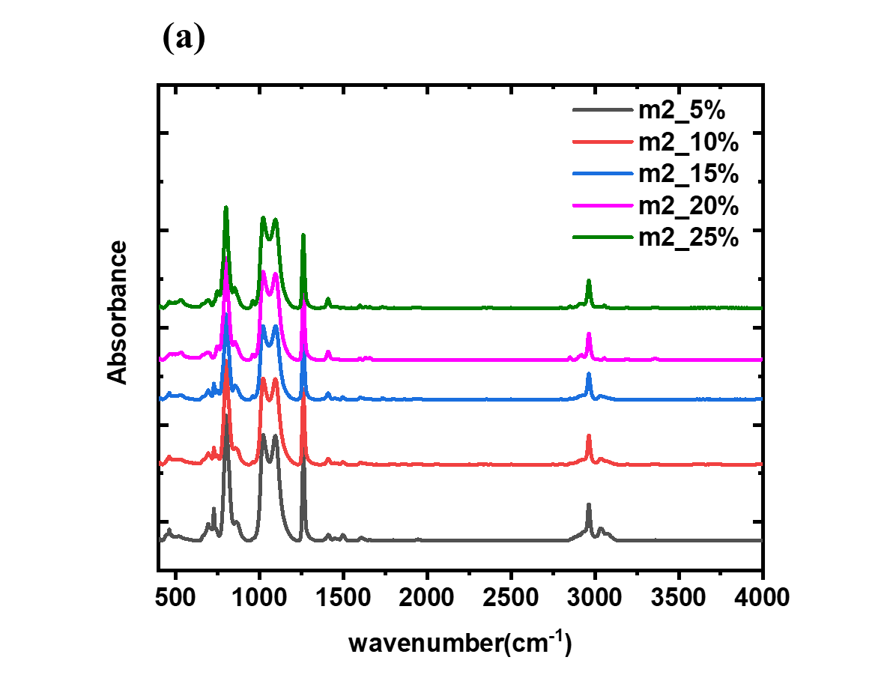
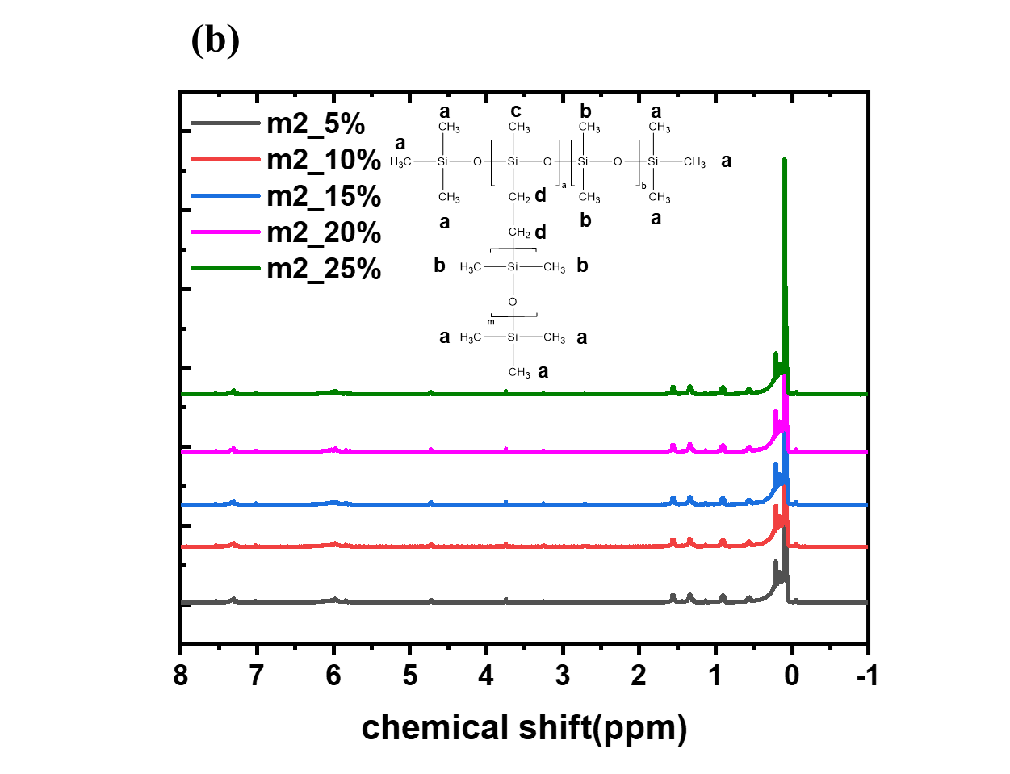
Figure S6. (a) the FT-IR spectra and (b) the ¹H-NMR spectra of novel silicone elastomer when m=2

The glass transition temperature (T_{g}) and the decomposition temperature (T_{d}) of novel silicone elastomer when m=1 and m=2
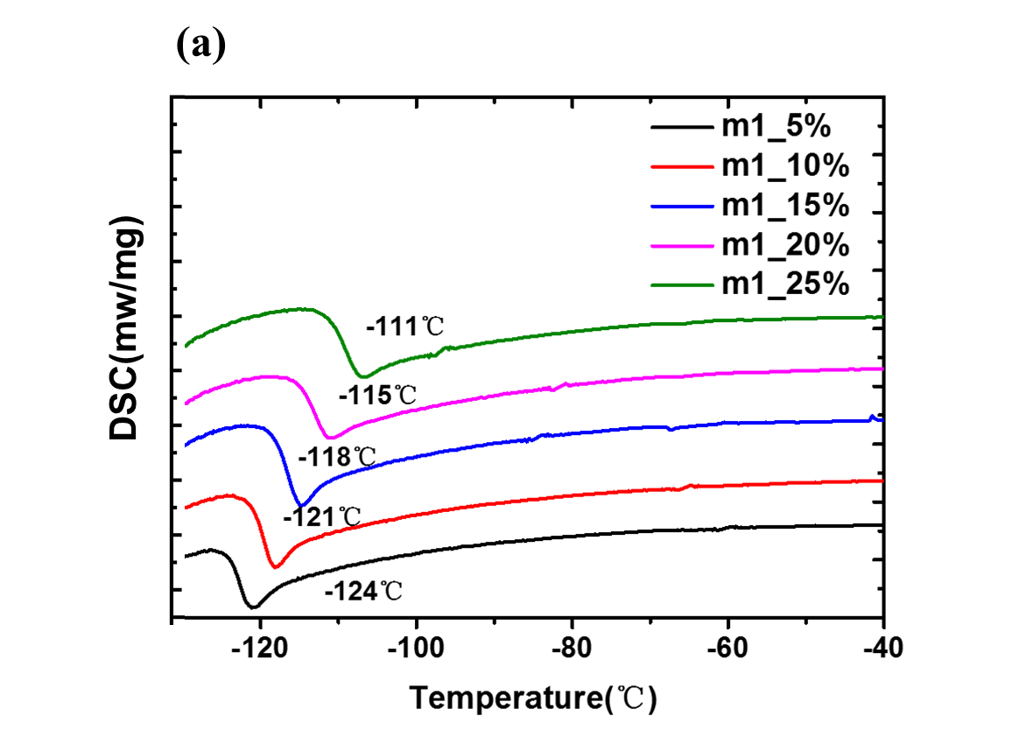
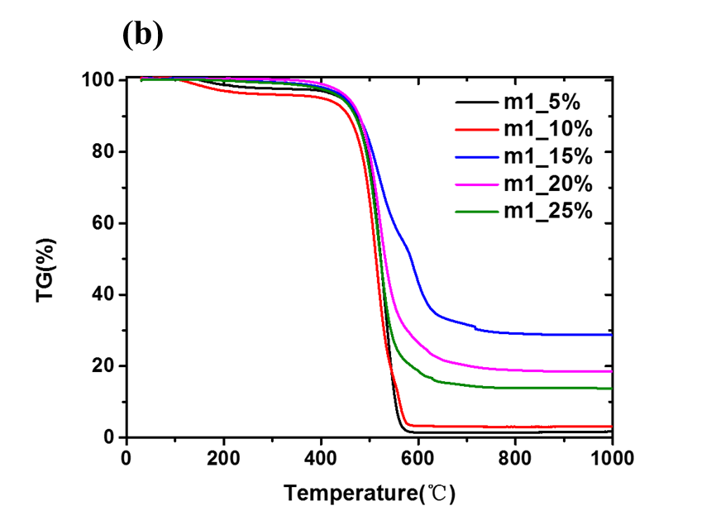
Figure S7. (a) The DSC thermograms and (b) the TGA thermograms for novel silicone elastomer when m=1.
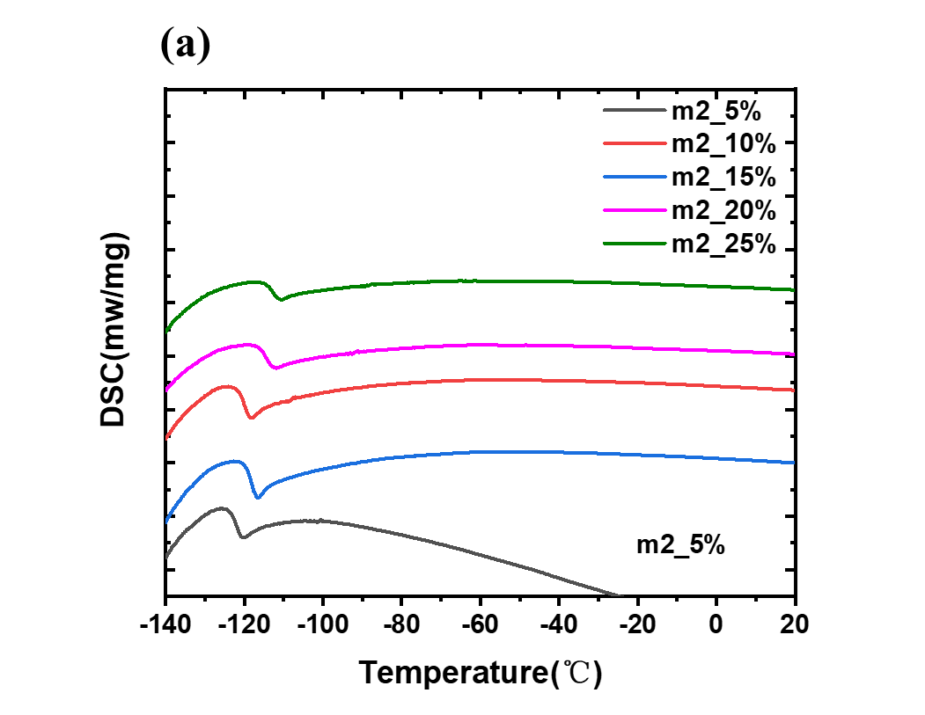
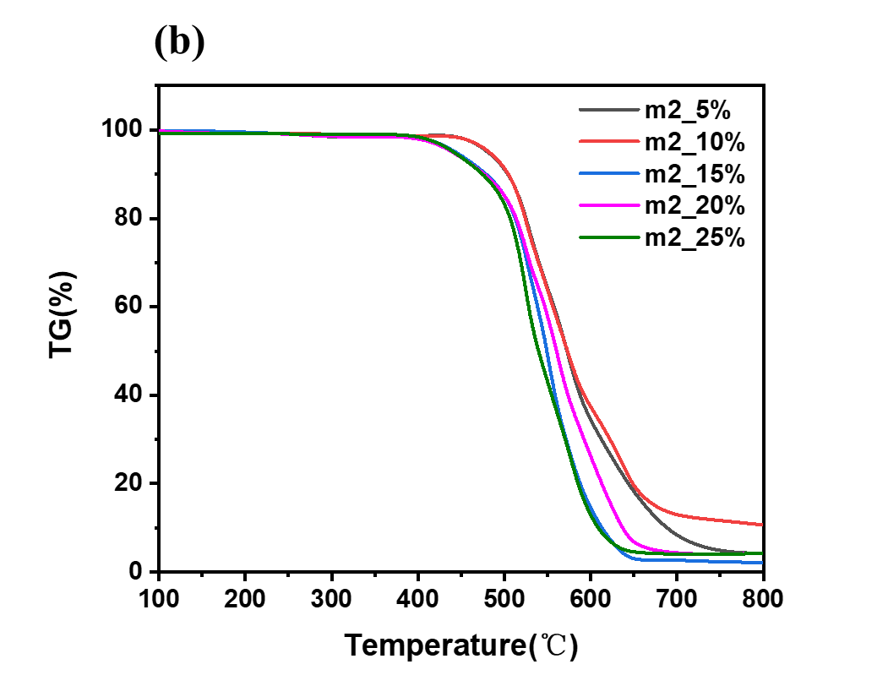
Figure S8. (a) The DSC thermograms and (b) the TGA thermograms for novel silicone elastomer when m=2.
Table S1. The 5% thermal weight loss temperature (T_{d(5%)}) and the residue substance with various contents of LCS for m=1.
Φ_{LCS}(%) | 5 | 10 | 15 | 20 | 25
T_{d(5%)}/ ◦C | 442 | 404 | 449 | 456 | 442
Residue/% | 1.65 | 3.12 | 28.71 | 18.60 | 13.74

Based on Figure S7, we observe that as the increment of the content of LCS, the value of T_{g} increases. The results of DSC thermograms are very close to that of simulation.
Table S2. The molecular weight of novel silicone elastomer when m=1
Φ_{LCS}(%) | M_{n} (10⁴g/mol) | M_{w} (10⁴g/mol) | PDI
5 | 38.9 | 59.3 | 1.52
10 | 33.8 | 56.9 | 1.68
15 | 32.4 | 56.6 | 1.74
20 | 33.5 | 55.7 | 1.66
25 | 35.7 | 60.7 | 1.70

Table S3. The molecular weight of novel silicone elastomer when m=2
Φ_{LCS}(%) | M_{n} (10⁴g/mol) | M_{w} (10⁴g/mol) | PDI
5 | 39.9 | 72.7 | 1.82
10 | 39.3 | 60.9 | 1.55
15 | 34.7 | 63.6 | 1.84
20 | 39.6 | 74.8 | 1.89
25 | 39.2 | 69.8 | 1.78

The effect of content and length of side chain on the T_{g} of novel silicone rubber
m=1
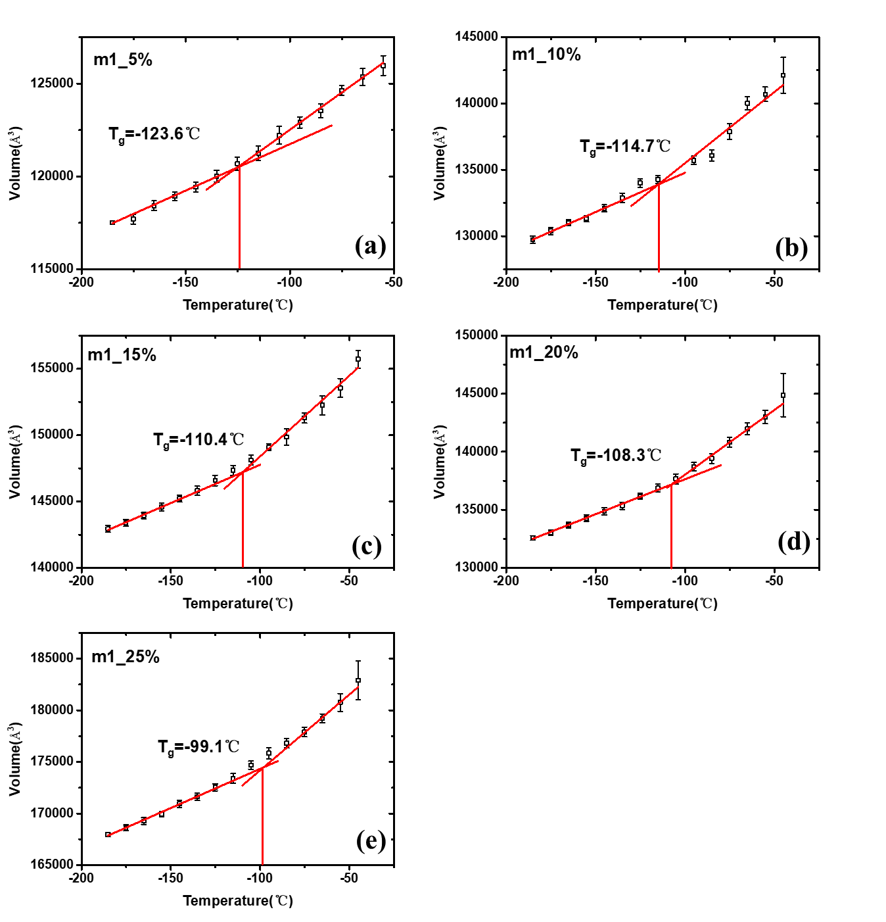

m=2
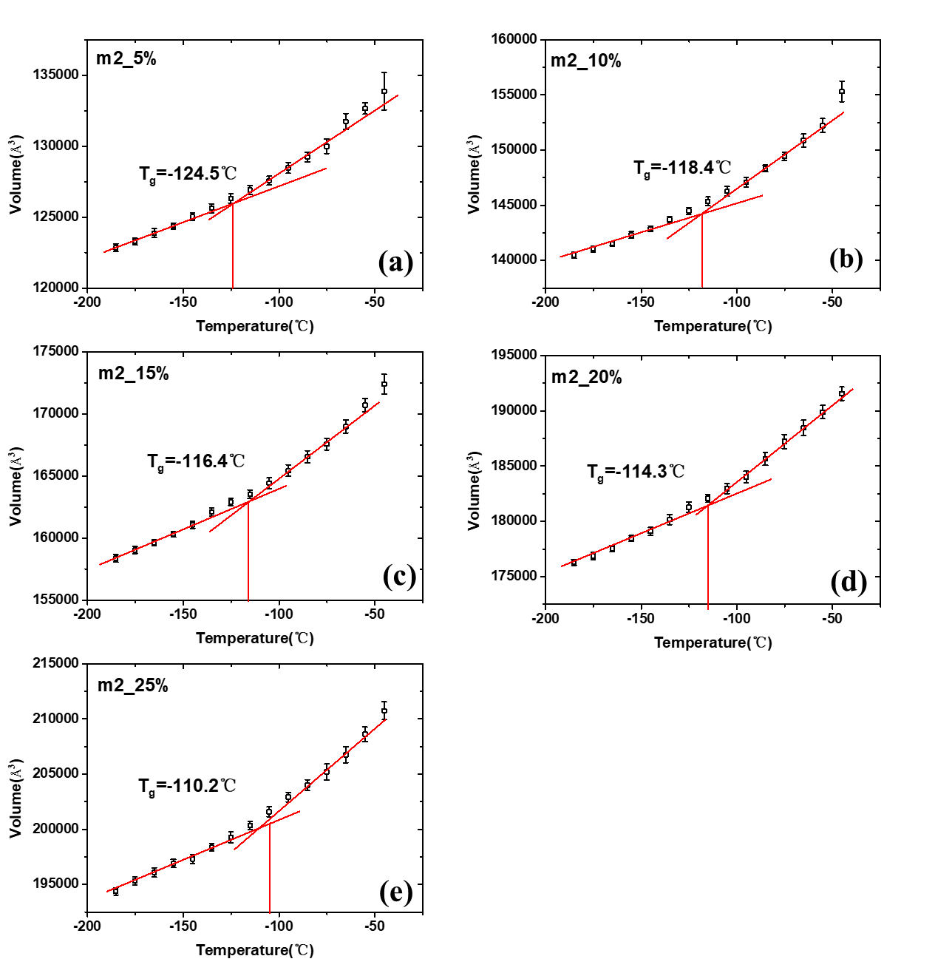

m=3

m=4
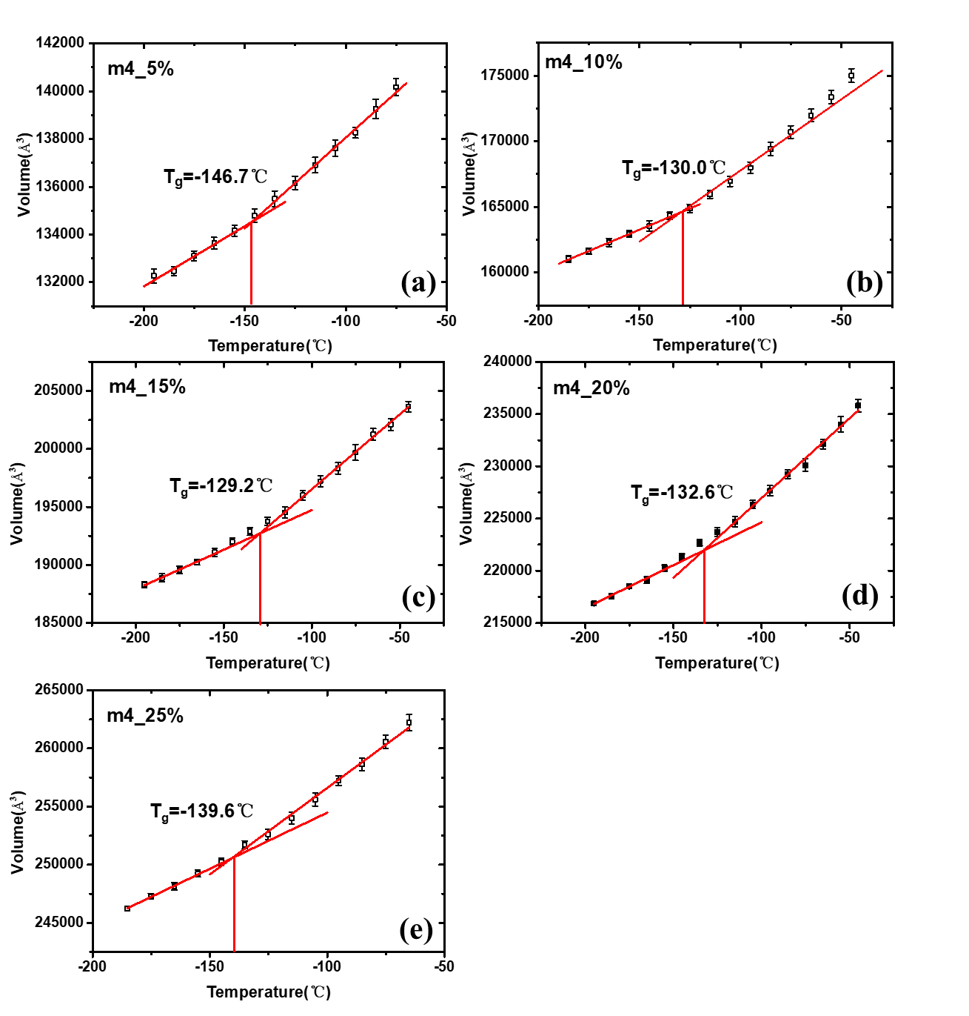

m=5
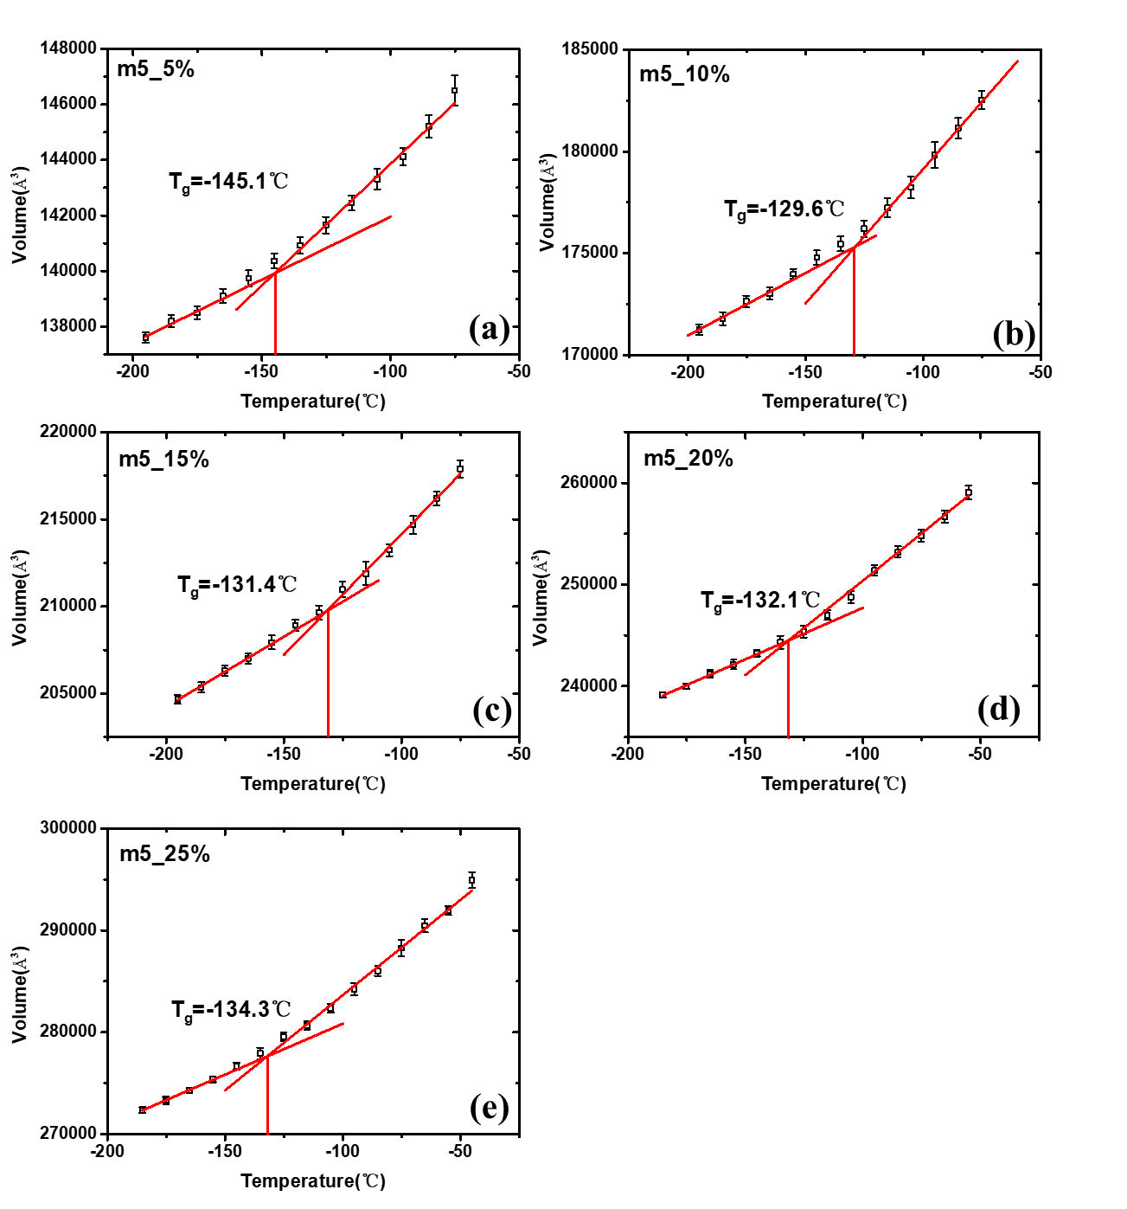
Figure S9. the glass transition temperature (T_{g}) obtained by specific volume for a series of silicone polymer with different length of side chain and content for (a) 5%; (b) 10%; (c) 15%; (d) 20% and (e) 25%.

The effect of content and length of side chain on the T_{d} of novel silicone rubber
m=1

m=2

m=3

m=4

m=5
Figure S10. the decomposition temperature (T_{d}) obtained by specific volume for a series of silicone polymer with different length of side chain and content for (a) 5%; (b) 10%; (c) 15%; (d) 20% and (e) 25%.
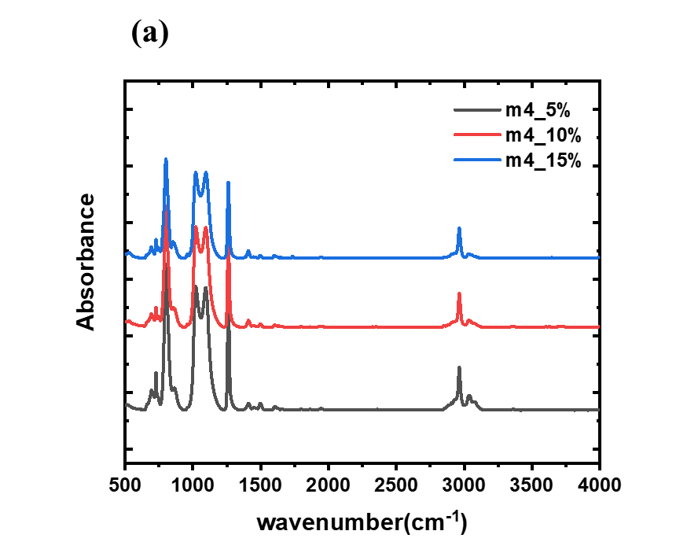
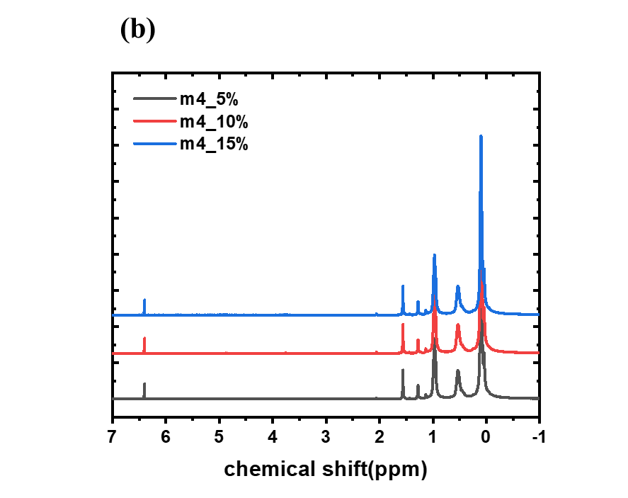
Figure S11. (a) the FT-IR spectra and (b) the ¹H-NMR spectra of novel silicone elastomer when m=4
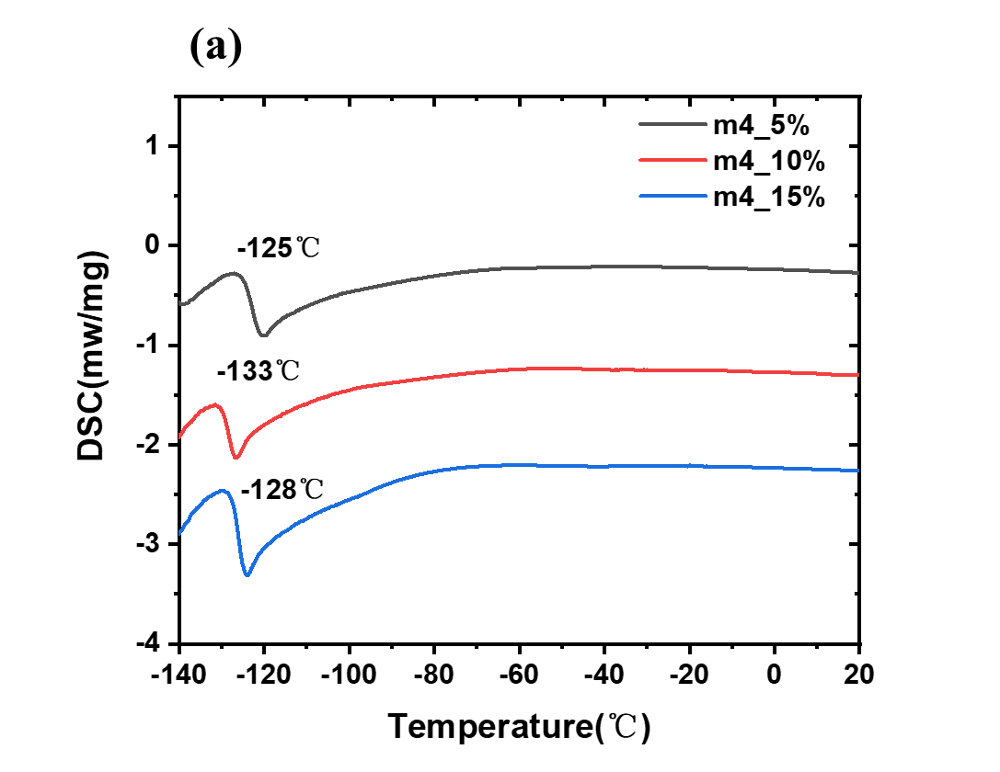
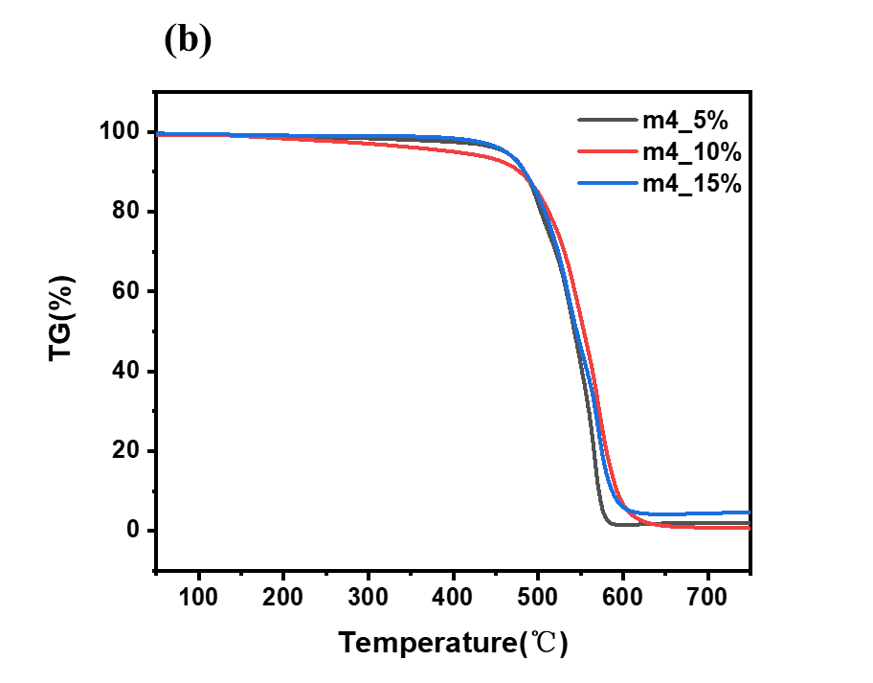
Figure S12. (a) The DSC thermograms and (b)TGA thermograms for novel silicone elastomer when m=4.

TableS4. GC-MS test data for silicone when m=4, φ = 5%.
Index | RT/min | Compound | M_{n} (g/mol) | Relative ratio (%)
1 | 2.29 | Cyclohexane | 84 | 100
2 | 2.34 | MM^{H} | 147 | 7.27
3 | 3.23 | M^{H}DM^{H} | 208 | 2.71
4 | 3.45 | D₃ | 222 | 39.84
5 | 3.62 | MDM^{H} | 222 | 13.86
6 | 4.89 | M^{H}D₂M^{H} | 282 | 6.55
7 | 5.25 | MD₂M^{H} | 296 | 24.32
8 | 5.93 | D₄ | 296 | 1.05
9 | 6.25 | D₅H | 356 | 7.87
10 | 6.32 | M^{H}D₃M^{H} | 356 | 30.85
11 | 6.63 | MD₃M^{H} | 370 | 55.08
12 | 6.93 | MD₃M | 384 | 1.34
13 | 7.54 | MD₄M^{H} | 430 | 9.65
14 | 7.82 | MD₄M^{H} | 444 | 17.35
15 | 8.08 | MD₄M | 458 | 1.73
16 | 8.63 | D₇ | 504 | 9.59
17 | 8.86 | MD₅M^{H} | 518 | 12.21
18 | 9.79 | MD₆M^{H} | 592 | 25.14
19 | 10.02 | MD₆M^{H} | 606 | 0.58
20 | 10.63 | MD₇M^{H} | 666 | 4.7
21 | 10.85 | MD₅M^{H} | 532 | 0.58
22 | 11.32 | M^{H}D₆M^{H} | 578 | 1.69
23 | 11.4 | M^{H}D₇M^{H} | 652 | 1.2
24 | 12.11 | MD₈M^{H} | 740 | 23.2
25 | 12.75 | MD₈M | 754 | 0.42
26 | 13.92 | MD₉M^{H} | 814 | 1.27

The effect of content and length of side chain on the conformational transition of silicone polymer chain
Figure S13. (a) the code function of the state H(φ(t)) with the width was equal to 20◦; (b)the distribution of torsional angle for m1_5%.

m=1

m=2

m=3

m=4

m=5
Figure S14. the glass transition temperature (T_{g}) obtained by conformational transition for a series of silicone polymer with different length of side chain and content for (a) 5%; (b) 10%; (c) 15%; (d) 20% and (e) 25%.

Table S5. The average number of the Count(0) per torsion bond with various content and length of LCS
 | m1_5% | m1_10% | m1_15% | m1_20% | m1_25%
-185.15 | 0.35443 | 0.48101 | 0.39241 | 0.48101 | 0.31646
-175.15 | 0.25949 | 0.43038 | 0.26582 | 0.39873 | 0.31646
-165.15 | 0.17089 | 0.31646 | 0.17722 | 0.38608 | 0.26582
-155.15 | 0.1519 | 0.21519 | 0.1962 | 0.32911 | 0.1962
-145.15 | 0.11392 | 0.14557 | 0.12025 | 0.23418 | 0.18354
-135.15 | 0.09494 | 0.11392 | 0.10759 | 0.22152 | 0.17089
-125.15 | 0.03797 | 0.07595 | 0.05696 | 0.10759 | 0.07595
-115.15 | 0.02532 | 0.05063 | 0.01899 | 0.05063 | 0.05063
-105.15 | 0.00633 | 0.01899 | 0.01266 | 0.01899 | 0.02532
-95.15 | 0 | 0 | 0 | 0.01899 | 0.01266
-85.15 | 0 | 0 | 0 | 0 | 0
-75.15 | 0 | 0 | 0 | 0 | 0
-65.15 | 0 | 0 | 0 | 0 | 0
-55.15 | 0 | 0 | 0 | 0 | 0
-45.15 | 0 | 0 | 0 | 0 | 0
 | m2_5% | m2_10% | m2_15% | m2_20% | m2_25%
-185.15 | 0.29091 | 0.28324 | 0.34807 | 0.48148 | 0.33503
-175.15 | 0.22424 | 0.26012 | 0.21547 | 0.43386 | 0.33503
-165.15 | 0.18182 | 0.17919 | 0.11602 | 0.3545 | 0.28426
-155.15 | 0.18182 | 0.11561 | 0.08287 | 0.28042 | 0.17766
-145.15 | 0.11515 | 0.10983 | 0.09945 | 0.25397 | 0.11168
-135.15 | 0.12121 | 0.04624 | 0.04972 | 0.16402 | 0.11168
-125.15 | 0.07273 | 0.04624 | 0.0221 | 0.1164 | 0.08122
-115.15 | 0.07879 | 0.0289 | 0.01105 | 0.10053 | 0.05584
-105.15 | 0.04242 | 0.01156 | 0 | 0.10053 | 0.02538
-95.15 | 0.01818 | 0 | 0 | 0.06349 | 0.0203
-85.15 | 0.02424 | 0 | 0 | 0.07407 | 0
-75.15 | 0 | 0 | 0 | 0.03704 | 0.00508
-65.15 | 0 | 0 | 0 | 0.01058 | 0
-55.15 | 0 | 0 | 0 | 0 | 0
-45.15 | 0 | 0 | 0 | 0.01058 | 0
 | m3_5% | m3_10% | m3_15% | m3_20% | m3_25%
-185.15 | 0.3526 | 0.39683 | 0.34634 | 0.26832 | 0.45926
-175.15 | 0.34104 | 0.34921 | 0.26341 | 0.23982 | 0.36287
-165.15 | 0.24855 | 0.2328 | 0.20976 | 0.20362 | 0.26582
-155.15 | 0.19653 | 0.1746 | 0.16098 | 0.14932 | 0.21519
-145.15 | 0.15029 | 0.11111 | 0.1561 | 0.13122 | 0.17722
-135.15 | 0.10983 | 0.06349 | 0.07805 | 0.07692 | 0.14346
-125.15 | 0.04046 | 0.03704 | 0.03902 | 0.03167 | 0.05907
-115.15 | 0 | 0.02646 | 0.01951 | 0.04525 | 0.04219
-105.15 | 0 | 0 | 0 | 0.0181 | 0.0211
-95.15 | 0 | 0 | 0.01463 | 0 | 0.0211
-85.15 | 0 | 0 | 0 | 0 | 0.00422
-75.15 | 0 | 0 | 0 | 0 | 0
-65.15 | 0 | 0 | 0 | 0 | 0
-55.15 | 0 | 0 | 0 | 0 | 0
-45.15 | 0 | 0 | 0 | 0 | 0
 | m4_5% | m4_10% | m4_15% | m4_20% | m4_25%
-185.15 | 0.35912 | 0.34634 | 0.36245 | 0.38526 | 0.36101
-175.15 | 0.32044 | 0.25854 | 0.28821 | 0.35178 | 0.29964
-165.15 | 0.18785 | 0.29268 | 0.24454 | 0.32806 | 0.18773
-155.15 | 0.1989 | 0.19512 | 0.19214 | 0.25296 | 0.12996
-145.15 | 0.16022 | 0.18049 | 0.17467 | 0.18972 | 0.11191
-135.15 | 0.10497 | 0.0878 | 0.131 | 0.11858 | 0.06498
-125.15 | 0.04972 | 0.07317 | 0.04803 | 0.05138 | 0.04693
-115.15 | 0.01657 | 0.02439 | 0.00873 | 0.01976 | 0.01805
-105.15 | 0 | 0.00976 | 0.00873 | 0.03162 | 0.00722
-95.15 | 0 | 0.01463 | 0 | 0.02767 | 0
-85.15 | 0 | 0 | 0 | 0.02372 | 0
-75.15 | 0 | 0 | 0 | 0 | 0
-65.15 | 0 | 0 | 0 | 0 | 0
-55.15 | 0 | 0 | 0 | 0 | 0
-45.15 | 0 | 0 | 0 | 0 | 0
 | m5_5% | m5_10% | m5_15% | m5_20% | m5_25%
-185.15 | 0.49106 | 0.38914 | 0.39921 | 0.40702 | 0.36909
-175.15 | 0.41799 | 0.25339 | 0.3083 | 0.32982 | 0.28391
-165.15 | 0.33333 | 0.24887 | 0.26482 | 0.26667 | 0.21451
-155.15 | 0.25397 | 0.16742 | 0.18577 | 0.17193 | 0.11672
-145.15 | 0.22222 | 0.17647 | 0.16601 | 0.11228 | 0.08833
-135.15 | 0.1164 | 0.10407 | 0.13043 | 0.09123 | 0.05047
-125.15 | 0.04233 | 0.09955 | 0.10672 | 0.03509 | 0.01577
-115.15 | 0.01587 | 0.03167 | 0.07905 | 0.02105 | 0.00631
-105.15 | 0.00529 | 0.03167 | 0.02372 | 0.01053 | 0.00631
-95.15 | 0 | 0.00452 | 0 | 0.00351 | 0.00946
-85.15 | 0 | 0 | 0 | 0.00351 | 0
-75.15 | 0 | 0 | 0 | 0.00351 | 0
-65.15 | 0 | 0 | 0 | 0 | 0
-55.15 | 0 | 0 | 0 | 0 | 0
-45.15 | 0 | 0 | 0 | 0 | 0

1. McQuaid MJ, Sun H, Rigby D. Development and validation of COMPASS force field parameters for molecules with aliphatic azide chains. The Journal of Computational Chemistry 25, 61-71 (2004).

2. Chenoweth K, van Duin ACT, Goddard WA. ReaxFF Reactive Force Field for Molecular Dynamics Simulations of Hydrocarbon Oxidation. The Journal of Physical Chemistry A 112, 1040-1053 (2008).

3. Senftle TP, et al. The ReaxFF reactive force-field: development, applications and future directions. Npj Computational Materials 2, 15011 (2016).

4. van Duin ACT, Dasgupta S, Lorant F, Goddard WA. ReaxFF: A Reactive Force Field for Hydrocarbons. The Journal of Physical Chemistry A 105, 9396-9409 (2001).

5. Plimpton S. Fast parallel algorithms for short-range molecular dynamics. Journal of Computational Physics 117, 1-19 (1995).

6. Liu J, Gao YG, Cao DP, Zhang LQ, Guo ZH. Nanoparticle Dispersion and Aggregation in Polymer Nanocomposites: Insights from Molecular Dynamics Simulation. Langmuir 27, 7926-7933 (2011).

7. Liu J, et al. Nanoparticle chemically end-linking elastomer network with super-low hysteresis loss for fuel-saving automobile. Nano Energy 28, 87-96 (2016).

8. Zheng Z, et al. Molecular Dynamics Simulation Study of Polymer Nanocomposites with Controllable Dispersion of Spherical Nanoparticles. The Journal of Physical Chemistry B 121, 10146-10156 (2017).

9. Hou G, et al.. Tailoring the dispersion of nanoparticles and the mechanical behavior of polymer nanocomposites by designing the chain architecture.Physical Chemistry Chemical Physics 19, 32024-32037 (2017).

10. Liu J, et al. The Interesting Influence of Nanosprings on the Viscoelasticity of Elastomeric Polymer Materials: Simulation and Experiment. Advanced Functional Materials 23, 1156-1163 (2013).

