Supporting Information
De novo design of a new open-shell nitrogen-centered diradicaloid with tunable stimuli-responsive electronic properties and diradical character
Bin Huang, Hao Kang, Chang-Wei Zhang, Xiao-Li Zhao, Xueliang Shi,* Hai-Bo Yang

Shanghai Key Laboratory of Green Chemistry and Chemical Processes, School of Chemistry and Molecular Engineering, East China Normal University, 3663 N. Zhongshan Road, Shanghai 200062, People’s Republic of China

Corresponding authors: xlshi@chem.ecnu.edu.cn

Table of Contents

1. General 1
2. Synthesis and characterization 2
3. X-ray crystallographic analysis 7
4. Lewis acid-base stimuli-responsive properties 16
5. Theoretical calculation 22
5.1 Spin density and spin population 23
5.2 Nucleus independent chemical shift (NICS) values 26
5.3 y₀ values and singlet-triplet energy gap (∆E_{S-T}) 26
6. ¹H NMR and ¹³C NMR spectra of new compounds 28
7. Mass spectra of new compounds 33
8. Reference 36

- General

All reagents and starting materials were obtained from commercial suppliers and used without further purification. All air-sensitive reactions were carried out under inert N₂ atmosphere. The ¹H NMR, ¹¹B NMR, ¹³C NMR spectra were recorded in solution of CD₂Cl₂ and DMSO-d₆ on Bruker 400 MHz, 500 MHz spectrometer. 2D NMR (NOESY) and variable temperature NMR were measured in solution of CD₂Cl₂ on Agilent DD2 600 MHz. Coupling constants (J) are denoted in Hz and chemical shifts (δ) are denoted in ppm. Multiplicities are denoted as follows: s = singlet, d = doublet, b = broaden and m = multiplet. UV-vis-NIR spectra were recorded in a quartz cell (light path 10 mm) on a Shimadzu UV2700 UV-visible spectrophotometer. Fluorescence spectra and photoluminescence quantum yields (Ф) were recorded on HORIBA Duetta. Cyclic voltammetry was recorded on a Bio-Logic SAS SP-150 spectrometer in anhydrous DCM containing n-BuNPF₆ (0.1 M) as supporting electrolyte at a scan rate of 20 mV/s at room temperature. The CV cell has a glassy carbon electrode, a Pt wire counter electrode, and an Ag/Ag⁺ reference electrode. The potential was externally calibrated against the ferrocene/ferrocenium (Fc/Fc⁺) couple. The highest occupied molecular orbital (HOMO) and lowest unoccupied molecular orbital (LUMO) energy levels were calculated based on the equations: E_{HOMO/LUMO} = -(4.80 + E_{onset}^{ox}/E_{onset}^{red}) eV. EPR spectra for radicals were obtained on Bruker EMX instrument EMXPLUS-10/12. EPR spectra simulation was conducted on the Bruker SpinFit software. For SQUID measurement, magnetic susceptibility of powder sample (30 mg) was measured in a polycarbonate capsule fitted in a plastic straw as a function of temperature in heating (2 K→ 330 K) mode with 30 seconds of temperature stability at each temperature (1 K increment in a range 2-10 K, 2 K increment in a range 10-20 K,5 K increment in a range 20-100 K, 10 K increment in a range 100-330 K,) at 1.0 T using a SQUID magnetometer (Quantum MPMS3). The data was corrected for both sample diamagnetism (Pascal’s constants) and the diamagnetism of the sample holder (polycarbonate capsule).^{[S1]} The single crystals of this work were measured on Bruker Apex duo equipment with Cu Kα radiation (λ = 1.54184 Å). The HR-ESI mass spectra were performed on Q Exactive Focus (Thermo Scientific, USA). The singlet-triplet energy gap (∆E_{S-T} or 2J/k_{B}) was determined by fitting the susceptibility data using the Bleaney-Bowers equation,
$${}_{M}=\frac{2Ng^{2}β^{2}}{k_{B}T}\frac{1}{3+\exp\left(-\frac{2J}{k_{B}T}\right)}\left(1-ρ\right)+\frac{Ng^{2}β^{2}}{2k_{B}T}ρ$$
where -2J is correlated to the excitation energy from the ground state to the first excited state, ρ is the content of paramagnetic impurities, T is the temperature, k_{B} is Boltzmann constant, N is Avogadro constant.

- Synthesis and characterization
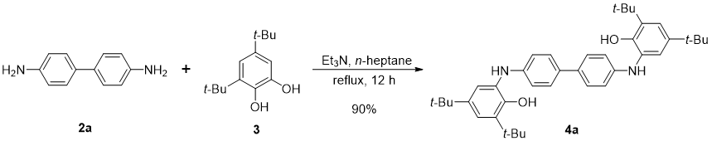
Compound 4a
To a n-heptane solution (30 mL) of compound 3 (2.22 g, 10 mmol), compound 2a (0.92 g, 5.0 mmol) and triethylamine (0.05 g, 0.5 mmol) were added slowly. Then the mixture was heated to reflux for 12 h. After cooling to the room temperature, the mixture was kept at 0 °C for 1.0 h. The precipitate was collected by vacuum filtration and washed by cold n-heptane for three times. The residue was dried in vacuo to give compound 4a (2.67 g, 4.5 mmol) as a grey powder in 90% yield. ¹H NMR (400 MHz, DMSO-d₆, 298 K) δ (ppm) 7.95 (s, 2H), 7.38 (d, J = 8.5 Hz, 4H), 7.17 (s, 2H), 7.05 (d, J = 2.4 Hz, 2H), 6.98 (d, J = 2.4 Hz, 2H), 6.78 (d, J = 8.5 Hz, 4H), 1.40 (s, 18H), 1.24 (s, 18H). ¹³C NMR (100 MHz, DMSO-d₆, 298 K) δ (ppm) 147.42, 145.31, 141.23, 136.59, 130.67, 130.56, 126.59, 118.76, 118.64, 115.57, 35.17, 34.41, 31.93, 30.12. HR-ESI-MS (m/z): [M+H]⁺ calculated for C₄₀H₅₃N₂O₂ 593.4062, found 593.4097.
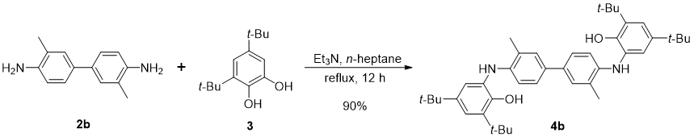
Compound 4b
To a n-heptane solution (30 mL) of compound 3 (2.22 g, 10 mmol), compound 2b (1.06 g, 5.0 mmol) and triethylamine (0.05 g, 0.5 mmol) were added slowly. Then the mixture was heated to reflux for 12 h. After cooling to the room temperature, the mixture was kept at 0 °C for 1.0 h. The precipitate was collected by vacuum filtration and was washed by cold n-heptane for three times. The residue was dried in vacuo to give compound 4b (2.79 g, 4.5 mmol) as a grey powder in 90% yield. ¹H NMR (400 MHz, DMSO-d₆, 298 K) δ (ppm) 7.97 (s, 2H), 7.35 (d, J = 2.2 Hz, 2H), 7.21 (dd, J = 8.4, 2.3 Hz, 2H), 6.98 (d, J = 2.4 Hz, 2H), 6.94 (d, J = 2.3 Hz, 2H), 6.55 (d, J = 8.4 Hz, 2H), 6.38 (s, 2H), 2.29 (s, 6H), 1.40 (s, 18H), 1.23 (s, 18H). ¹³C NMR (100 MHz, DMSO-d₆, 298 K) δ (ppm) 147.24, 143.36, 141.27, 136.56, 131.14, 130.80, 128.19, 125.62, 124.06, 119.37, 118.48, 114.48, 35.18, 34.39, 31.92, 30.15, 18.50. HR-ESI-MS (m/z): [M+H]⁺ calculated for C₄₂H₅₇N₂O₂ 621.4375, found 621.4397.
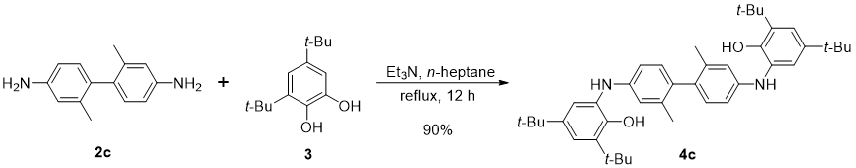
Compound 4c
To a n-heptane solution (30 mL) of compound 3 (2.22 g, 10 mmol), compound 2c (1.06 g, 5.0 mmol) and triethylamine (0.05 g, 0.5 mmol) were added slowly. Then the mixture was heated to reflux for 12 h. After cooling to the room temperature, the mixture was kept at 0 °C for 1.0 h. The precipitate was collected by vacuum filtration and was washed by cold n-heptane for three times. The residue was dried in vacuo to give compound 4c (2.79 g, 4.5 mmol) as a reddish- brown powder in 90% yield. ¹H NMR (500 MHz, DMSO-d₆, 298 K) δ (ppm) 7.94 (s, 2H), 7.10-7.06 (m, 4H), 6.98 (d, J = 2.4 Hz, 2H), 6.80 (d, J = 8.2 Hz, 2H), 6.68 (d, J = 2.4 Hz, 2H), 6.57 (dd, J = 8.3, 2.4 Hz, 2H), 1.93 (s, 6H), 1.40 (s, 18H), 1.24 (s, 18H). ¹³C NMR (125 MHz, DMSO-d₆, 298 K) δ (ppm) 147.50, 145.47, 141.06, 136.43, 136.38, 131.62, 130.69, 130.51, 119.13, 118.57, 116.13, 112.34, 35.16, 34.41, 31.94, 30.10, 20.52. HR-ESI-MS (m/z): [M+H]⁺ calculated for C₄₂H₅₇N₂O₂ 621.4375, found 621.4402.
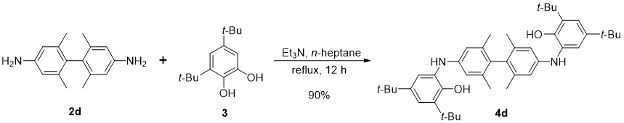
Compound 4d
To a n-heptane solution (30 mL) of compound 3 (2.22 g, 10 mmol), compound 2d (1.2 g, 5.0 mmol) and triethylamine (0.05 g, 0.5 mmol) were added slowly. Then the mixture was heated to reflux for 12 h. After cooling to the room temperature, the mixture was kept at 0 °C for 1.0 h. The precipitate was collected by vacuum filtration and was washed by cold n-heptane for three times. The residue was dried in vacuo to give compound 4d (2.92 g, 4.5 mmol) as a reddish-brown powder in 90% yield. ¹H NMR (500 MHz, DMSO-d₆, 298 K) δ (ppm) 7.91 (s, 2H), 7.09 (d, J = 2.3 Hz, 2H), 6.99-6.93 (m, 4H), 6.57 (s, 4H), 1.77 (s, 12H), 1.40 (d, J = 2.3 Hz, 18H), 1.24 (s, 18H). ¹³C NMR (125 MHz, DMSO-d₆, 298 K) δ (ppm) 147.05, 144.79, 140.95, 136.47, 136.35, 130.85, 130.15, 118.77, 118.11, 114.23, 35.16, 34.41, 31.92, 30.11, 26.82, 20.56. ppm. HR-ESI-MS (m/z): [M+H]⁺ calculated for C₄₄H₆₁N₂O₂ 649.4688, found 649.4717.
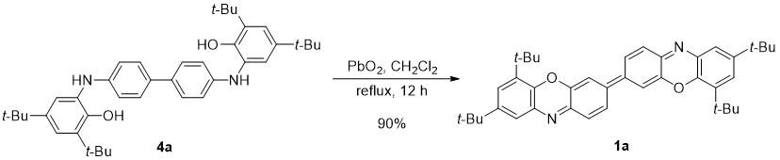
Compound 1a
Compound 4a (592 mg, 1.0 mmol) was dissolved in DCM (20 mL), then lead dioxide (480 mg, 2.0 mmol) was added into the solution. The mixture was heated to reflux for 12 h. After the mixture cooled to the room temperature, precipitate in solution was filtered out, and the solution was collected. The solvent was removed under reduced pressure, and the residue was washed by methanol for several times to give compound 1a (528 mg, 0.9 mmol) as a black purple solid in 90% yield. The target compound was further purified by recrystallization from MeOH/CH₂Cl₂ for magnetic properties test. ¹H NMR (600 MHz, CD₂Cl₂, 233 K) δ (ppm) 7.68 (d, J = 9.5 Hz, 2H), 7.25 (s, 2H), 7.21 (s, 2H), 7.13 (s, 2H), 7.02 (b, 2H), 1.46 (s, 18H), 1.28 (s, 18H). HR-ESI-MS (m/z): [M+H]⁺ calculated for C₄₀H₄₇N₂O₂ 587.3559, found 587.3623.
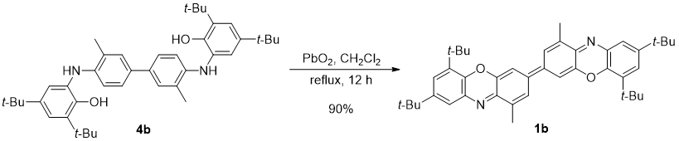
Compound 1b
Compound 4b (620 mg, 1.0 mmol) was dissolved in DCM (20 mL), then lead dioxide (480 mg, 2.0 mmol) was added into the solution. The mixture was heated to reflux for 12 h. After the mixture cooled to the room temperature, precipitate in solution was filtered out, and the solution was collected. The solvent was removed under reduced pressure, and the residue was washed by methanol for several times to give compound 1b (528 mg, 0.9 mmol) as a black purple solid in 90% yield. ¹H NMR (600 MHz, CD₂Cl₂, 248 K) δ (ppm) 7.53 (s, 2H), 7.25 (s, 2H), 7.20 (s, 2H), 7.00 (s, 2H), 2.34 (s, 6H), 1.45 (s, 18H), 1.30 (s, 18H). HR-ESI-MS (m/z): [M+H]⁺ calculated for C₄₂H₅₁N₂O₂ 615.3872, found 615.3931.
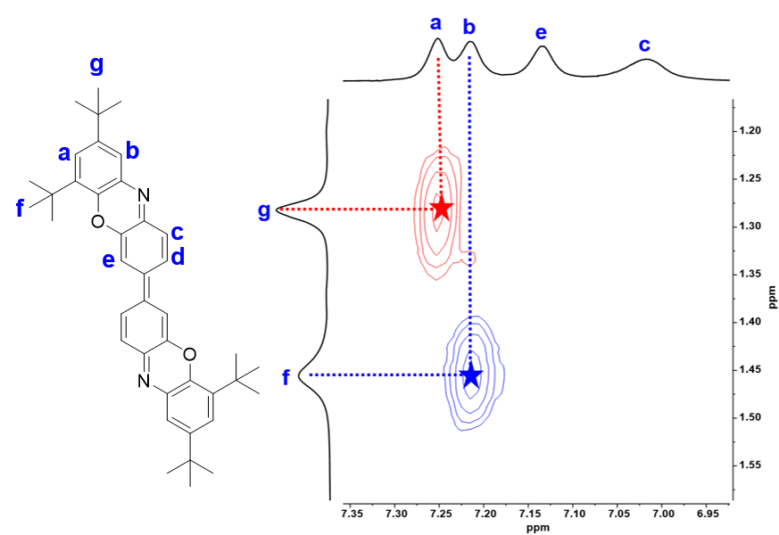
Supplementary Fig. 1: 2D NOESY NMR (600 MHz, CD₂Cl₂, 233 K) spectrum of 1a.
Supplementary Fig. 2: Variable-temperature ¹H NMR (600 MHz, CD₂Cl₂) spectra of 1a from 233 K to 293 K.

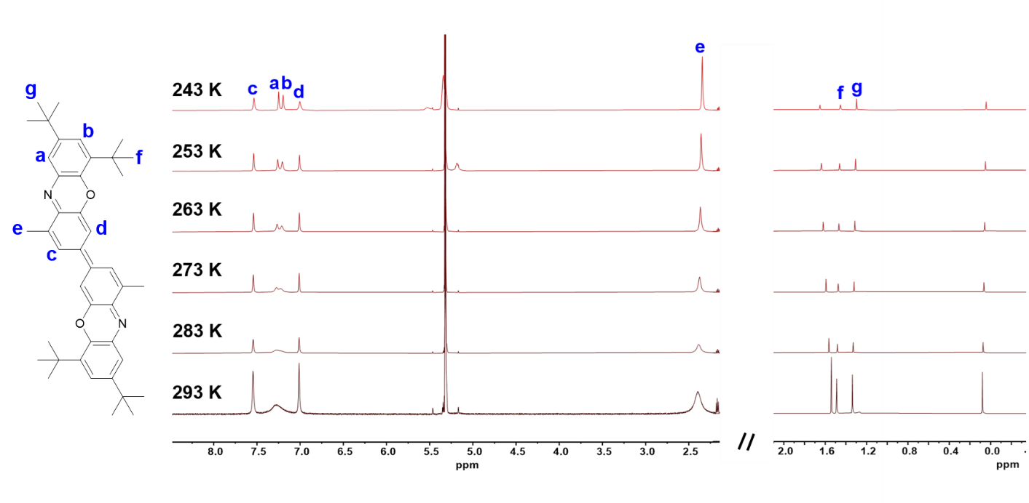
Supplementary Fig. 3: Variable-temperature ¹H NMR (600 MHz, CD₂Cl₂) spectra of 1b from 243 K to 293 K.
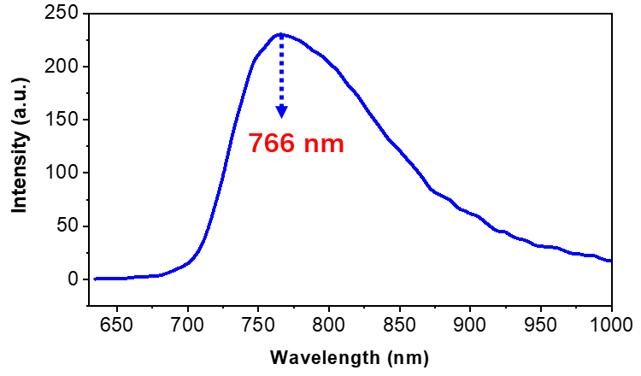
Supplementary Fig. 4: Emission spectrum of 1a (14 μM) in toluene (λ_{ex} = 620 nm). The photoluminescence quantum yields (Ф) of 1a in toluene was determined as ~ 4%.

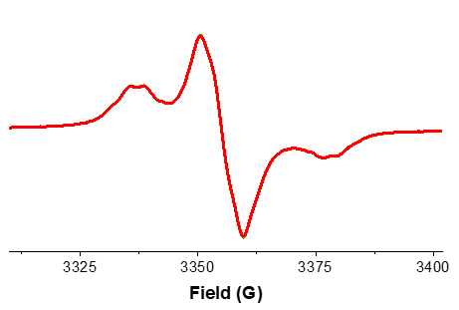
Supplementary Fig. 5: Solid-state EPR of 1a at 298 K.
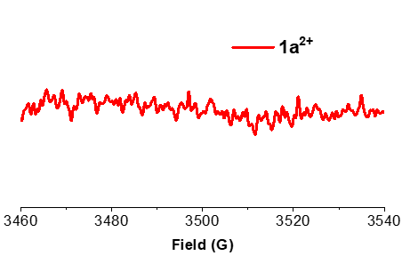
Supplementary Fig. 6: EPR spectrum of 1a²⁺ in CH₂Cl₂ at 298 K.

Supplementary Fig. 7: ¹H NMR (500 MHz, CD₂Cl₂, 298 K) spectrum of 1a²⁺.

3. X-ray crystallographic analysis
Supplementary Fig. 8: Single crystal structure of 1a and bond-length analysis based on X-ray diffraction data. Hydrogen atoms are omitted for clarity.

Supplementary Fig. 9: Packing structure of 1b at 170 K in the crystalline state. Other hydrogen atoms are omitted for clarity.

Supplementary Table 1: Bond-length (Å) data of 1a, 1b.
 | C1-C2 | C2-C3 | C3-C4 | C4-C5 | C5-C6 | C6-C7 |  | C7-C2 |  | C5-N1 |  | N1-C8
1a (Å) | 1.426 | 1.433 | 1.352 | 1.433 | 1.428 | 1.353 |  | 1.428 |  | 1.320 |  | 1.393
1b (Å) | 1.426 | 1.442 | 1.356 | 1.444 | 1.434 | 1.354 |  | 1.423 |  | 1.323 |  | 1.387
 | C8-C9 | C9-O1 | O1-C6 | C9-C10 | C10-C11 |  | C11-C12 |  | C12-C13 |  | C13-C8
1a (Å) | 1.402 | 1.377 | 1.376 | 1.405 | 1.390 |  | 1.398 |  | 1.378 |  | 1.401
1b (Å) | 1.402 | 1.387 | 1.381 | 1.410 | 1.391 |  | 1.394 |  | 1.394 |  | 1.409

Supplementary Fig. 10: Packing structure of 1a²⁺ in the crystalline state in the crystalline state. Hydrogen atoms are omitted for clarity.
Supplementary Fig. 11: (a) Bond-length analysis of 4a and (b) torsion angle of two benzene rings in 4a based on X-ray diffraction data. Hydrogen atoms are omitted for clarity.
Supplementary Fig. 12: (a) Bond-length analysis of 4b and (b) torsion angle of two benzene rings in 4b based on X-ray diffraction data. Hydrogen atoms are omitted for clarity.
Supplementary Fig. 13: (a) Bond-length analysis of 4d and (b) torsion angle of two benzene rings in 4d based on X-ray diffraction data. Hydrogen atoms are omitted for clarity.

Supplementary Table 2: X-ray single crystal data of 4a and 4b.
Compound | 4a | 4b
Empirical formula | C₄₀H₅₀N₂O₂ | C₄₂H₅₄N₂O₂
Formula weight | 590.82 | 618.87
Temperature/K | 100.01(10) | 293.1(8)
Crystal system | monoclinic | orthorhombic
Space group | P2₁/c | Pbca
a / Å | 19.1147(4) | 9.5096(3)
b / Å | 10.0807(2) | 12.0422(4)
c / Å | 9.0952(2) | 34.2936(10)
α / ° | 90 | 90
β / ° | 97.220(2) | 90
γ / ° | 90 | 90
Volume / Å³ | 1738.65(6) | 3927.2(2)
Z | 2 | 4
ρ_{calc}g / cm³ | 1.129 | 1.047
μ / mm⁻¹ | 0.527 | 0.485
F (000) | 640.0 | 1344.0
Crystal size / mm³ | 0.42 × 0.26 × 0.18 | 0.42 × 0.26 × 0.18
Radiation | CuKα (λ = 1.54184) | CuKα (λ = 1.54184)
2θ range for data collection / ° | 9.938 to 134.156 | 10.318 to 134.156
Index ranges | -22 ≤ h ≤ 22,  -12 ≤ k ≤ 12,  -10 ≤ l ≤ 10 | -11 ≤ h ≤ 11,  -8 ≤ k ≤ 14,  -40 ≤ l ≤ 40
Reflections collected | 36061 | 37940
Independent reflections | 3032  R_{int} = 0.0709, | 3439  R_{int} = 0.0576,
Independent reflections | R_{sigma} = 0.0261 | R_{sigma} = 0.0233
Data / restraints / parameters | 3032 / 0 / 215 | 3439/96/284
Goodness-of-fit on F² | 1.116 | 1.065
Final R indexes [I >= 2σ (I)] | R₁ = 0.1029, | R₁ = 0.0986,
Final R indexes [I >= 2σ (I)] | wR₂ = 0.2742 | wR₂ = 0.2733
Final R indexes [all data] | R₁ = 0.1044, | R₁ = 0.1141,
Final R indexes [all data] | wR₂ = 0.2749 | wR₂ = 0.2865
Largest diff. peak / hole / e Å⁻³ | 0.65/-0.41 | 0.34/-0.32
CCDC | 2132537 | 2132539

Supplementary Table 3: X-ray single crystal data of 4d and 1a.
Compound | 4d | 1a
Empirical formula | C₄₄H₆₀N₂O₂ | C₄₀H₄₆N₂O₂
Formula weight | 648.94 | 586.79
Temperature/K | 293.36(12) | 100.01(10)
Crystal system | triclinic | monoclinic
Space group | P-1 | P2₁/n
a / Å | 10.2479(3) | 6.0491(3)
b / Å | 12.4899(4) | 18.1428(5)
c / Å | 21.9716(7) | 15.3109(5)
α / ° | 74.823(3) | 90
β / ° | 79.678(3) | 97.068(4)
γ / ° | 73.455(3) | 90
Volume / Å³ | 2585.11(15) | 1667.57(11)
Z | 2 | 2
ρ_{calc}g / cm³ | 0.834 | 1.169
μ / mm⁻¹ | 0.383 | 0.549
F (000) | 708.0 | 632.0
Crystal size / mm³ | 0.38 × 0.26 × 0.18 | 0.32 × 0.12 × 0.08
Radiation | CuKα (λ = 1.54184) | CuKα (λ = 1.54184)
2θ range for data collection / ° | 9.06 to 134.158 | 7.59 to 134.116
Index ranges | -12 ≤ h ≤ 11,  -14 ≤ k ≤ 14,  -26 ≤ l ≤ 22 | -5 ≤ h ≤ 7,  -18 ≤ k ≤ 21,  -17 ≤ l ≤ 18
Reflections collected | 25519 | 14335
Independent reflections | 8913  R_{int} = 0.0356, | 2965  R_{int} = 0.1332,
Independent reflections | R_{sigma} = 0.0379 | R_{sigma} = 0.0823
Data / restraints / parameters | 8913/102/489 | 2965/6/205
Goodness-of-fit on F² | 1.058 | 1.033
Final R indexes [I >= 2σ (I)] | R₁ = 0.0755, | R₁ = 0.0758,
Final R indexes [I >= 2σ (I)] | wR₂ = 0.2340 | wR₂ = 0.2092
Final R indexes [all data] | R₁ = 0.0949, | R₁ = 0.1024,
Final R indexes [all data] | wR₂ = 0.2531 | wR₂ = 0.2387
Largest diff. peak / hole / e Å⁻³ | 0.47/-0.41 | 0.35/-0.45
CCDC | 2132540 | 2104545

Supplementary Table 4: X-ray single crystal data of 1b and 1a²⁺.
Compound | 1b | 1a²⁺
Empirical formula | C₄₂H₅₀N₂O₂ | C₄₀H₄₆N₂O₂Sb₂F₁₂
Formula weight | 614.84 | 627.84
Temperature/K | 170.00(10) | 170.00(10)
Crystal system | triclinic | monoclinic
Space group | P-1 | C2/c
a / Å | 5.8080(7) | 40.823(2)
b / Å | 9.2231(12) | 9.4048(4)
c / Å | 16.3047(10) | 17.7684(7)
α / ° | 97.258(8) | 90
β / ° | 100.154(7) | 98.280(5)
γ / ° | 90.988(10) | 90
Volume / Å³ | 852.14(16) | 6750.7(5)
Z | 1 | 8
ρ_{calc}g / cm³ | 1.198 | 1.235
μ / mm⁻¹ | 0.559 | 10.930
F (000) | 332.0 | 2488.0
Crystal size / mm³ | 0.26 × 0.09 × 0.07 | 0.36 × 0.12 × 0.11
Radiation | CuKα (λ = 1.54184) | CuKα (λ = 1.54184)
2θ range for data collection / ° | 9.674 to 134.056 | 8.756 to 134.15
Index ranges | -6 ≤ h ≤ 6,  -11 ≤ k ≤ 11,  -19 ≤ l ≤ 19 | -48 ≤ h ≤ 46,  -8 ≤ k ≤ 11,  -19 ≤ l ≤ 21
Reflections collected | 18349 | 31910
Independent reflections | 2966  R_{int} = 0.1276, | 5979  R_{int} = 0.1603,
Independent reflections | R_{sigma} = 0.0780 | R_{sigma} = 0.0896
Data / restraints / parameters | 2966/0/215 | 5979/0/268
Goodness-of-fit on F² | 1.093 | 1.007
Final R indexes [I >= 2σ (I)] | R₁ = 0.1112, | R₁ = 0.0825,
Final R indexes [I >= 2σ (I)] | wR₂ = 0.3078 | wR₂ = 0.2163
Final R indexes [all data] | R₁ = 0.1254, | R₁ = 0.1068,
Final R indexes [all data] | wR₂ = 0.3191 | wR₂ = 0.2312
Largest diff. peak / hole / e Å⁻³ | 0.42/-0.30 | 2.06/-0.73
CCDC | 2104547 | 2132542

4. Lewis acid-base stimuli-responsive properties
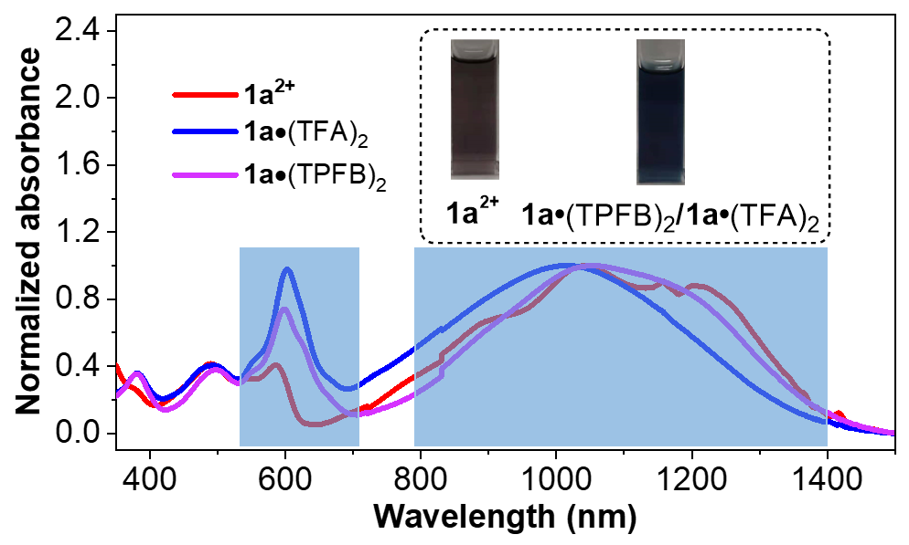
Supplementary Fig. 14: Normalized absorption spectra of 1a²⁺, 1a•(TPFB)₂ and 1a•(TFA)₂. Inserted are the photos of the solutions. The main different parts of the absorption curves of 1a²⁺, 1a•(TPFB)₂ and 1a•(TFA)₂ are marked with blue boxes.

Supplementary Fig. 15: Schematic illustration of the reversible Lewis acid-base reaction between 1a and corresponding acids. EPR spectra change upon (a) addition of TPFB to a solution of 1a in CH₂Cl₂, (b) addition of TEA to a solution of 1a•(TPFB)₂ in CH₂Cl₂, (c) addition of TFA to a solution of 1a in CH₂Cl₂ and (d) addition of TEA to a solution of 1a•(TFA)₂ in CH₂Cl₂.
Supplementary Fig. 16: Variable-temperature ¹H NMR (600 MHz, CD₂Cl₂) spectra of 1a•(TPFB)₂ from 213 K to 293 K.
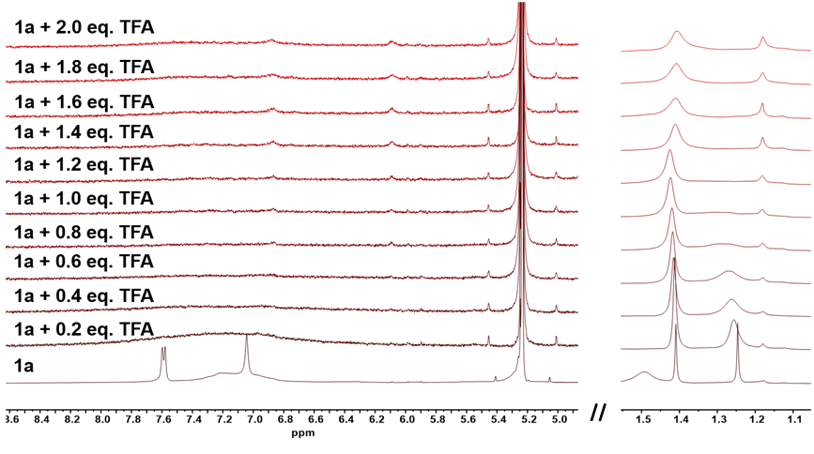
Supplementary Fig. 17: ¹H NMR (600 MHz, CD₂Cl₂, 298 K) spectra of titration of trifluoroacetate (TFA) into a solution of 1a in CD₂Cl₂.
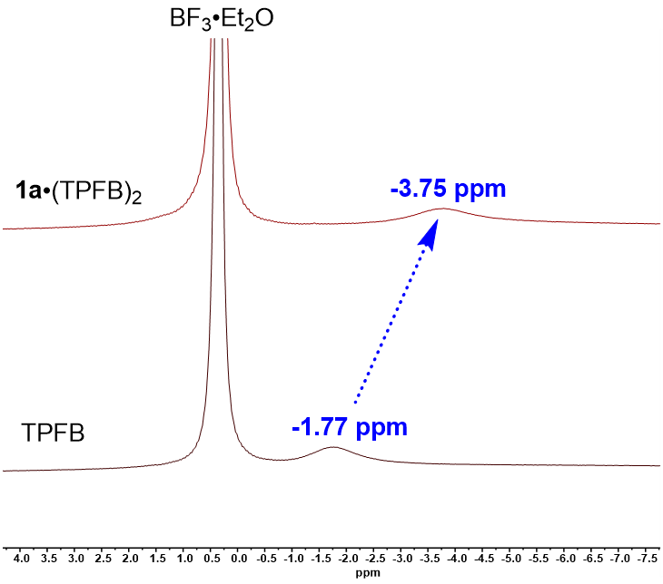
Supplementary Fig. 18: ¹¹B NMR (500 MHz, CD₂Cl₂, 298 K) spectra of 1a•(TPFB)₂ and TPFB.
In-situ ¹¹B NMR spectra showed that after added 1a to the TPFB in CD₂Cl₂, the boron signal of TPFB shifted from -1.17 ppm to -3.54 ppm, indicating the coordination between 1a and TPFB. BF₃·Et₂O as internal standard was used to guarantee the accuracy of the change in chemical shift.

Supplementary Table 5: Summary for the parameters of Bleaney-Bowers equation fitting.ª
 | 2J/k_{B} | ρ | Statistics
 | Value | Value | R²
1a | -581.914 | 0.017 | 0.99253
1a•(TPFB)₂ | -377.745 | 0.070 | 0.99564
ªχ_{p} = χ_{mol} - χ_{d}¹, χ_{d}: diamagnetic susceptibility (χ_{d} of 1a: -425 × 10⁻⁶ emu mol⁻¹, χ_{d} of 1a•(TPFB)₂: -846 × 10⁻⁶ emu mol⁻¹).
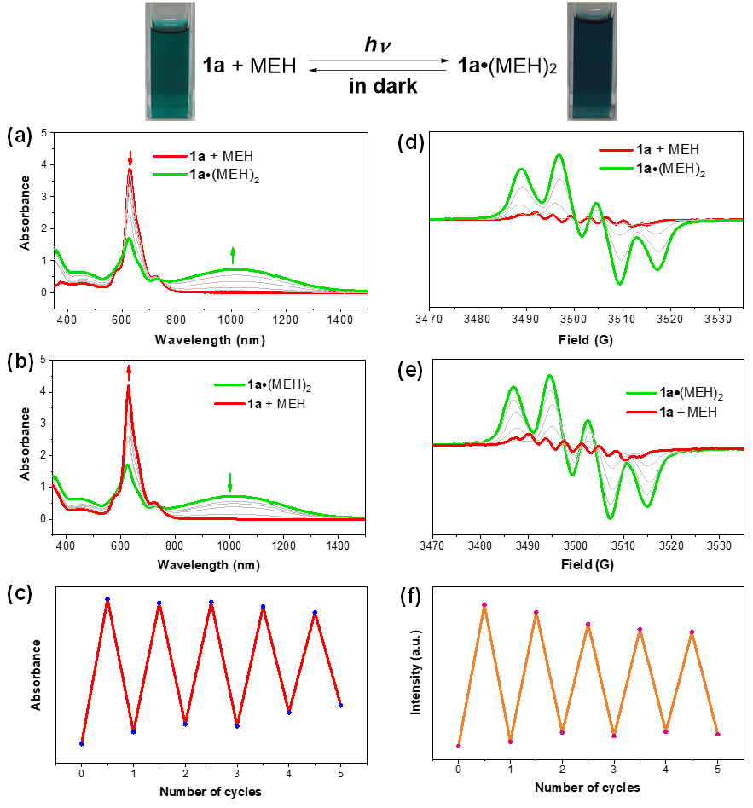
Supplementary Fig. 19: Light-controlled reversible modulation of UV-vis-NIR absorption and diradical character of 1a by reversible Lewis acid-base reaction. Spectral absorption change of (a) the mixture of 1a and MEH (mole ratio 1a: MEH = 1: 5) irradiated by 365 nm light in CH₂Cl₂ for 150 s, then (b) keep the mixture in dark environment for 12 minutes, and (c) cycles under irradiation and in the dark. EPR spectra change of (d) the mixture of 1a and MEH (mole ratio 1a: MEH = 1: 5) irradiated by 365 nm light in CH₂Cl₂ for 150 s, then (e) keep the mixture in dark environment for 12 minutes, and (f) cycles under irradiation and in the dark.

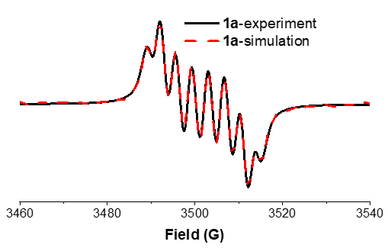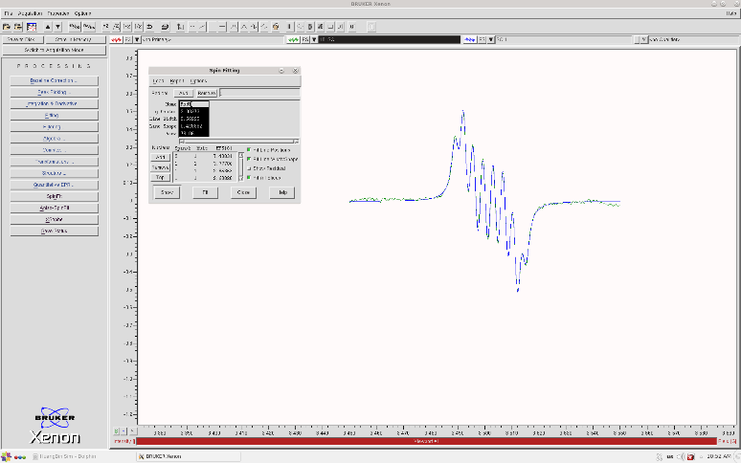
Supplementary Fig. 20: Experimental and simulated EPR spectra of 1a in CH₂Cl₂ (data processing (left) and screenshot (right) from the Bruker SpinFit software). The fitting parameters for the spectral simulation are: g = 2.0024, A_{N} = 7.408 G, A_{Ha} = 3.777 G, A_{Hb} = 2.853 G and A_{Hc} = 2.688 G.

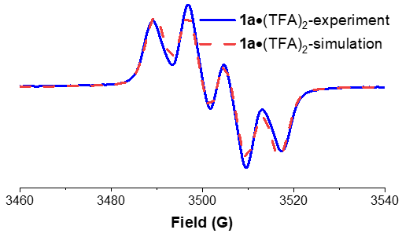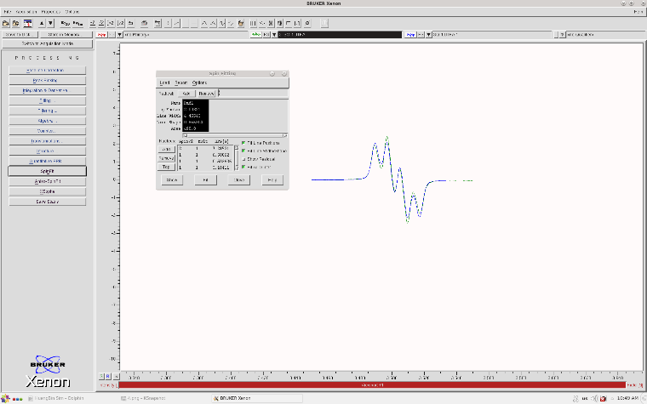
Supplementary Fig. 21: Experimental and simulated EPR spectra of 1a•(TFA)₂ in CH₂Cl₂ (data processing (left) and screenshot (right) from the Bruker SpinFit software). The fitting parameters for the spectral simulation are: g = 2.0032, A_{N} = 7.118 G, A_{Ha} = 6.681 G, A_{Hb} = 0.504 G and A_{Hc} = 3.184 G.

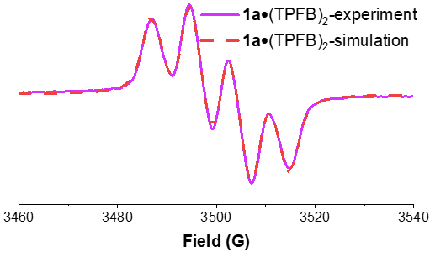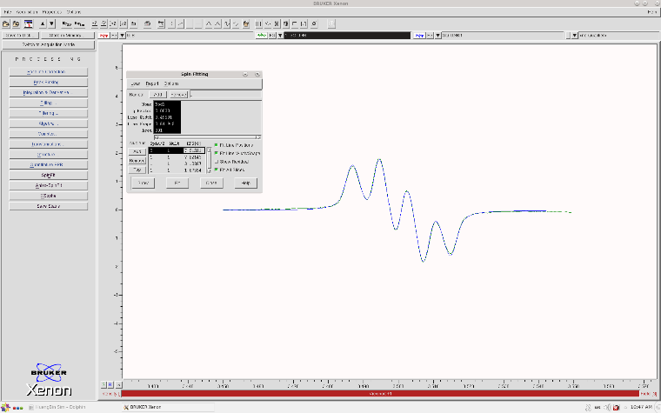
Supplementary Fig. 22: Experimental and simulated EPR spectra of 1a•(TPFB)₂ in CH₂Cl₂ (data processing (left) and screenshot (right) from the Bruker SpinFit software). The fitting parameters for the spectral simulation are: g = 2.0033, A_{N} = 7.215 G, A_{Ha} = 7.221 G, A_{Hb} = 3.123 G and A_{Hc} = 1.676 G.

5. Theoretical calculation
Theoretical calculations were performed with the Gaussian16 program suite². All molecules were optimized at the level of CAM-B3LYP-D3(BJ)/6-311G(d,p), the Handy and coworkers’ long range corrected version of B3LYP³⁻⁵. 6-311G(d,p)⁶ all electron basis sets were employed for all atoms. A spin symmetry broken wavefunction was found with Stable=Opt keyword, then the Guess=Read keyword was used to optimize the open-shell singlet at the UCAM-B3LYP-D3(BJ)/6-311G(d,p) level. Frequency calculations were conducted to ensure that these structures were indeed local minima. Stability test of wave function, singlet closed-shell molecules wavefunction has an RHF→UHF instability. Open-shell molecules wavefunction is stable under the perturbations considered. The single point energy were performed at the level of CAM-B3LYP-D3(BJ)/def2-TZVP⁷. Unrestricted natural orbital (UNO) occupation number calculations were done by spin unrestricted CAM-B3LYP/def2-TZVP method and the double diradical character (y₀) was calculated according to Yamaguchi’s scheme: $y_{0}=1-\frac{2T}{1+T^{2}}$, and$T=\frac{(HONO-LUNO)}{2}$^{8,9}. Where T indicates the orbital overlap between the highest occupied natural orbital (HONO) and the lowest unoccupied natural orbital (LUNO). NICS(1)_{ZZ} values were calculated using the standard GIAO^{10,11} at the level of CAM-B3LYP/def2-TZVP. Electronic structure analyses were performed with the Multiwfn 3.8 (dev) code. The isosurface maps of spin density were rendered by means of Visual Molecular Dynamics (VMD 1.9.3)¹² software based on the files exported from Multiwfn.

5.1 Spin density and spin population
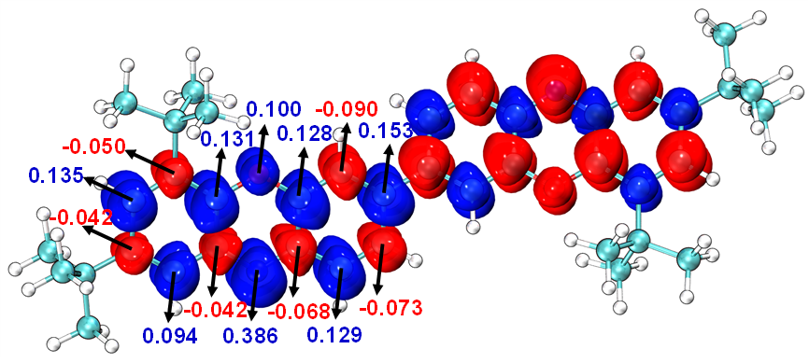
Supplementary Fig. 23: Spin density and spin population of 1a in open-shell singlet based on Becke method at the level of UCAM-B3LYP-D3(BJ)/def2-TZVP.
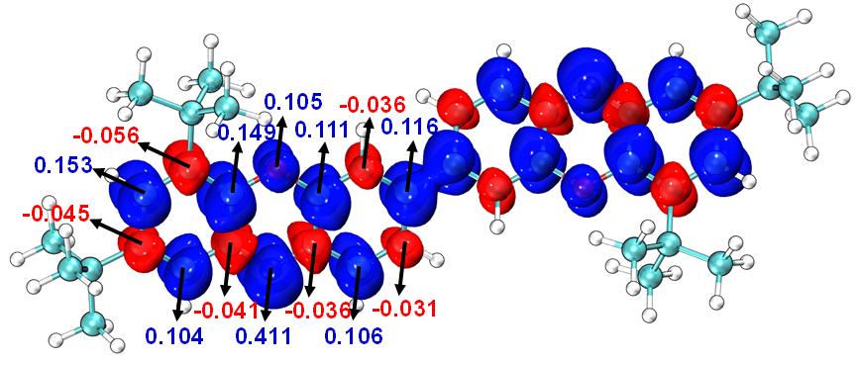
Supplementary Fig. 24: Spin density and spin population of 1a in open-shell triplet based on Becke method at the level of UCAM-B3LYP-D3(BJ)/def2-TZVP.

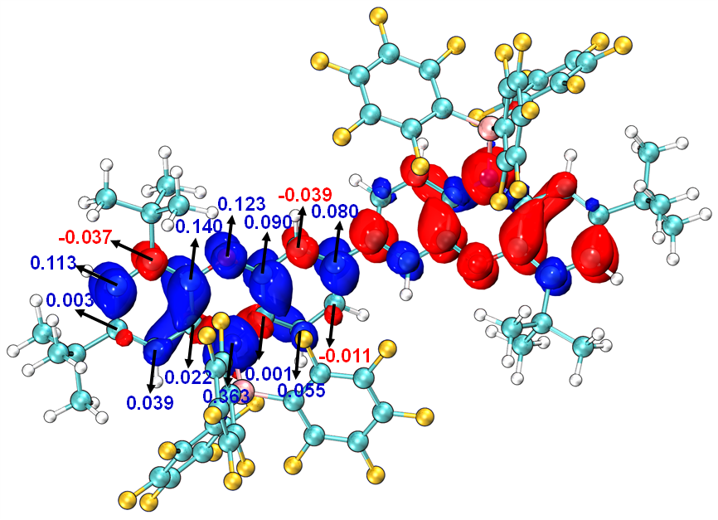
Supplementary Fig. 25: Spin density and spin population of 1a•(TPFB)₂ in open-shell singlet based on Becke method at the level of UCAM-B3LYP-D3(BJ)/def2-TZVP.
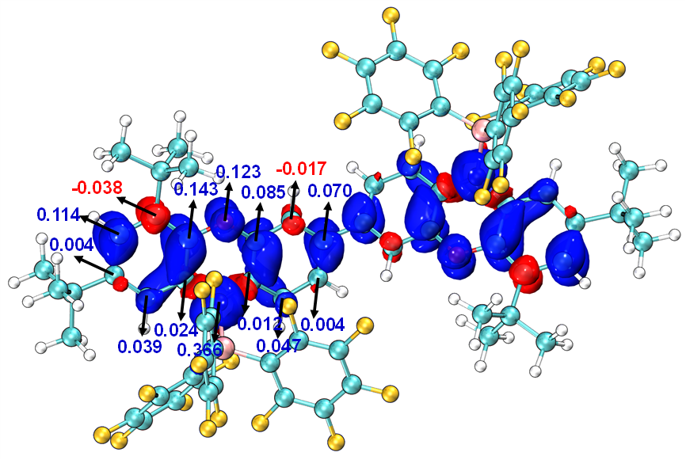
Supplementary Fig. 26: Spin density and spin population of 1a•(TPFB)₂ in open-shell triplet based on Becke method at the level of UCAM-B3LYP-D3(BJ)/def2-TZVP.
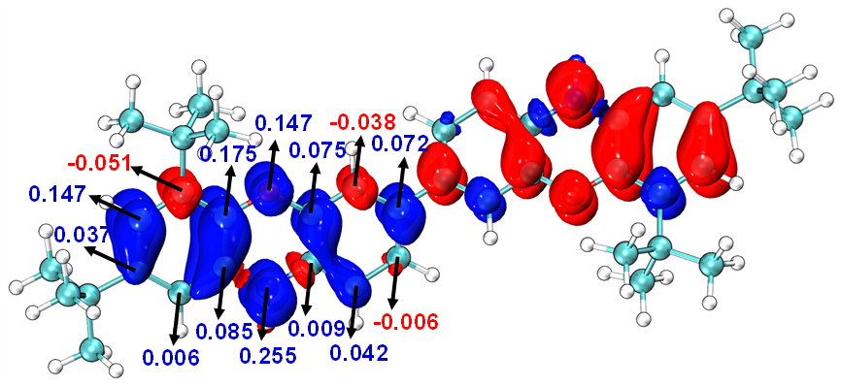
Supplementary Fig. 27: Spin density and spin population of 1a•(TFA)₂ in open-shell singlet based on Becke method at the level of UCAM-B3LYP-D3(BJ)/def2-TZVP.
Supplementary Fig. 28: Spin density and spin population of 1a•(TFA)₂ in open-shell triplet based on Becke method at the level of UCAM-B3LYP-D3(BJ)/def2-TZVP.

5.2 Nucleus independent chemical shift (NICS) values
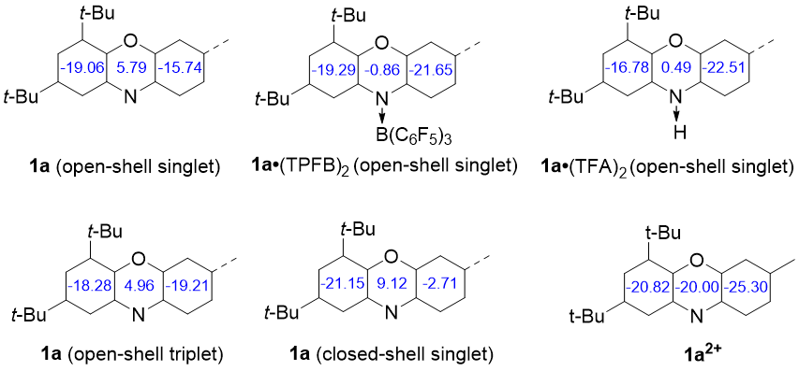
Supplementary Fig. 29: The calculated NICS(1)_{ZZ} of 1a(open-shell singlet), 1a(closed-shell singlet), 1a(open-shell triplet), 1a²⁺, 1a•(TPFB)₂(open-shell singlet) and 1a•(TFA)₂(open-shell singlet) at the level of CAM-B3LYP-D3(BJ)/def2-TZVP.

5.3 y₀ values and singlet-triplet energy gap (∆E_{S-T})
Supplementary Table 6: y₀ values and singlet-triplet energy gap (∆E_{S-T}) of 1a.ª
 | 1a  (open-shell singlet) | 1a  (open-shell triplet) | 1a  (closed-shell)
ΔE  (kcal mol⁻¹) | Ground state | 2.24887482 | 8.21981597
ΔE_{S-T}  (kcal mol⁻¹) | -2.249
<s**2> | 1.0700 | 2.0957
HONO | 1.23976
LUNO | 0.76024
T | 0.23976
y₀ | 0.54655
ªCalculated at the level of CAM-B3LYP-D3(BJ)/def2-TZVP.

Supplementary Table 7: y₀ values and singlet-triplet energy gap (∆E_{S-T}) of 1a•(TPFB)₂ and 1a•(TFA)₂.ª
 | 1a•(TPFB)₂  (open-shell singlet) | 1a•(TPFB)₂  (open-shell triplet) | 1a•(TFA)₂  (open-shell singlet) | 1a•(TFA)₂  (open-shell triplet)
ΔE  (kcal mol⁻¹) | Ground state | 0.52942977 | Ground state | 0.45236532
ΔE_{S-T}  (kcal mol⁻¹) | -0.529 |  | -0.452
<s**2> | 1.0452 | 2.0461 | 1.0342 | 2.0388
HONO | 1.08257 |  | 1.10714
LUNO | 0.91743 |  | 0.89286
T | 0.08257 |  | 0.10714
y₀ | 0.83598 |  | 0.78815
ªCalculated at the level of CAM-B3LYP-D3(BJ)/def2-TZVP.

6. ¹H NMR and ¹³C NMR spectra of new compounds
Supplementary Fig. 30: ¹H NMR (400 MHz, DMSO-d₆, 298 K) spectrum of 4a.
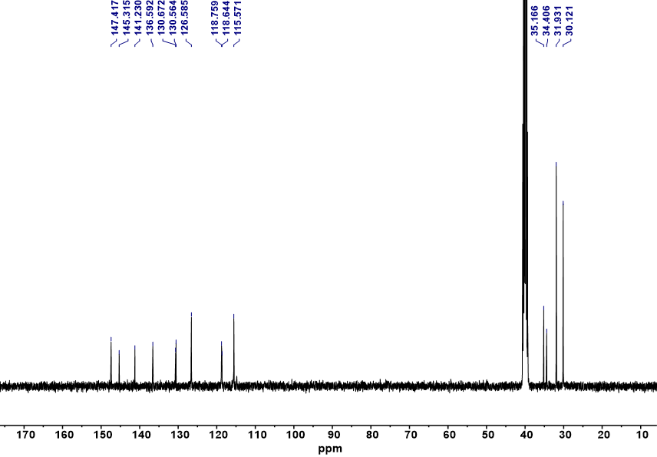
Supplementary Fig. 31: ¹³C NMR (100 MHz, DMSO-d₆, 298 K) spectrum of 4a.
Supplementary Fig. 32: ¹H NMR (400 MHz, DMSO-d₆, 298 K) spectrum of 4b.
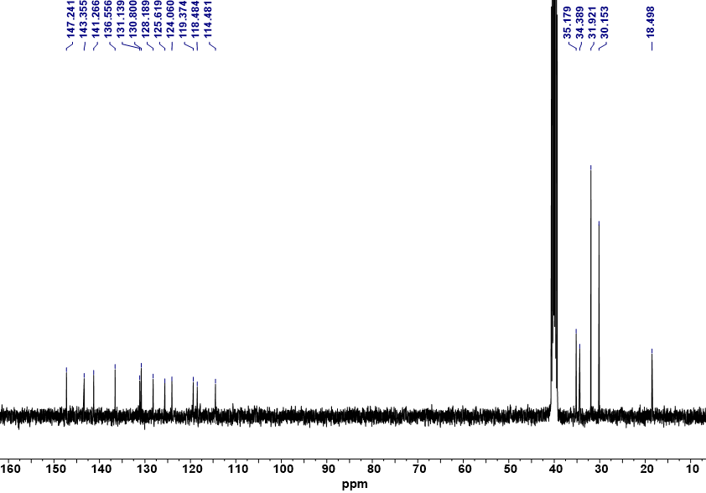
Supplementary Fig. 33: ¹³C NMR (100 MHz, DMSO-d₆, 298 K) spectrum of 4b.
Supplementary Fig. 34: ¹H NMR (500 MHz, DMSO-d₆, 298 K) spectrum of 4c.
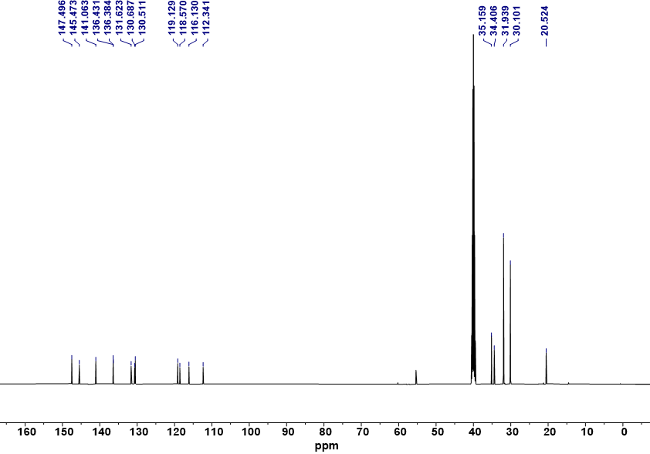
Supplementary Fig. 35: ¹³C NMR (125 MHz, DMSO-d₆, 298 K) spectrum of 4c.

Supplementary Fig. 36: ¹H NMR (500 MHz, DMSO-d₆, 298 K) spectrum of 4d.
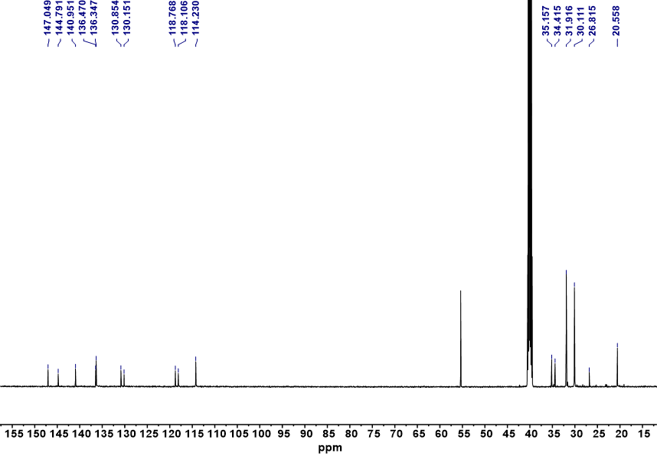
Supplementary Fig. 37: ¹³C NMR (125 MHz, DMSO-d₆, 298 K) spectrum of 4d.

Supplementary Fig. 38: ¹H NMR (600 MHz, CD₂Cl₂, 233 K) spectrum of 1a.
Supplementary Fig. 39: ¹H NMR (600 MHz, CD₂Cl₂, 248 K) spectrum of 1b.

7. Mass spectra of new compounds
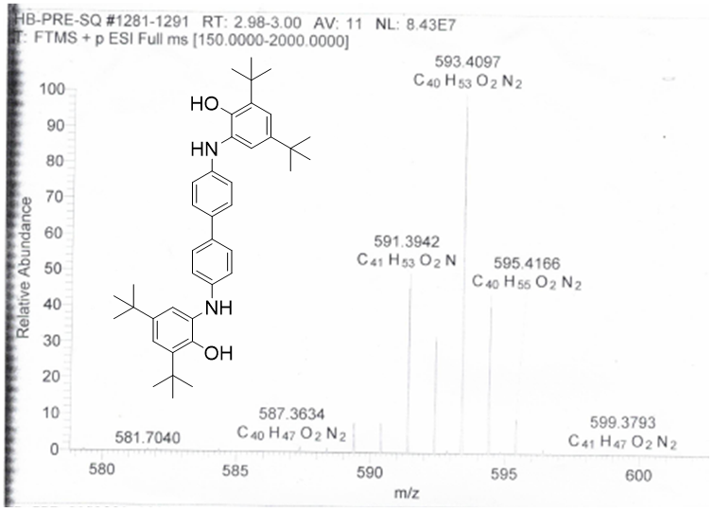
Supplementary Fig. 40: The mass spectrum of compound 4a.
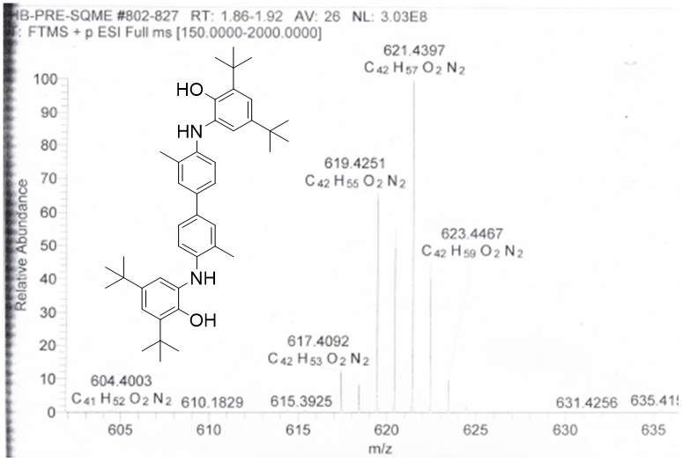
Supplementary Fig. 41: The mass spectrum of compound 4b.
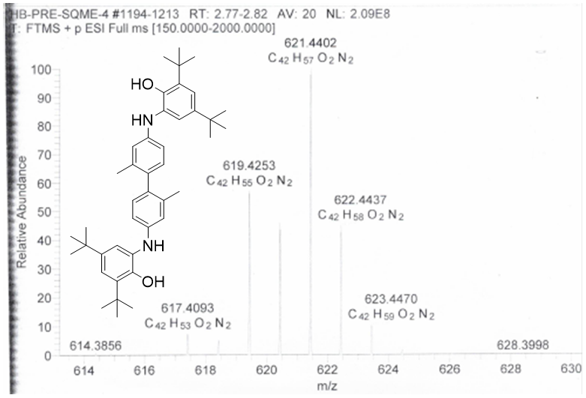
Supplementary Fig. 42: The mass spectrum of compound 4c.
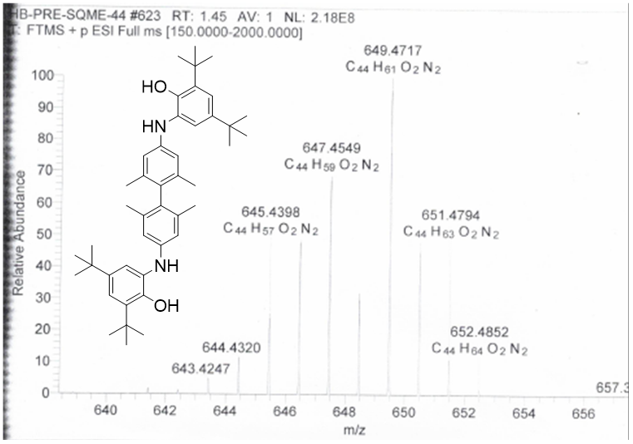
Supplementary Fig. 43: The mass spectrum of compound 4d.
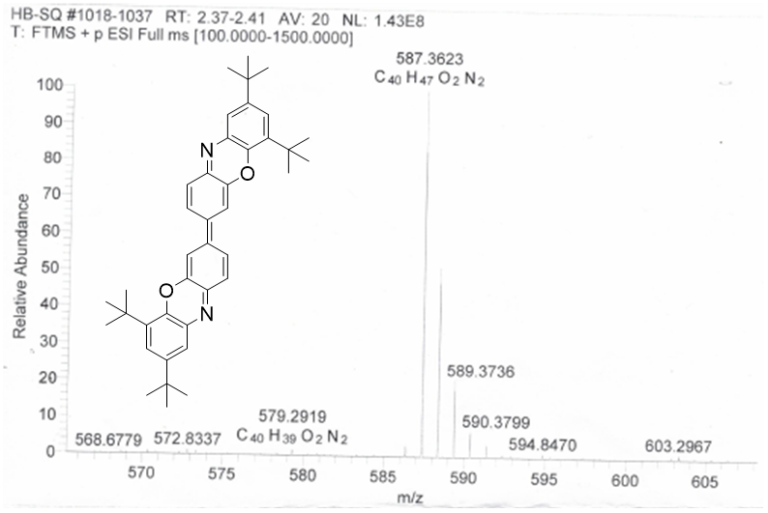
Supplementary Fig. 44: The mass spectrum of compound 1a.
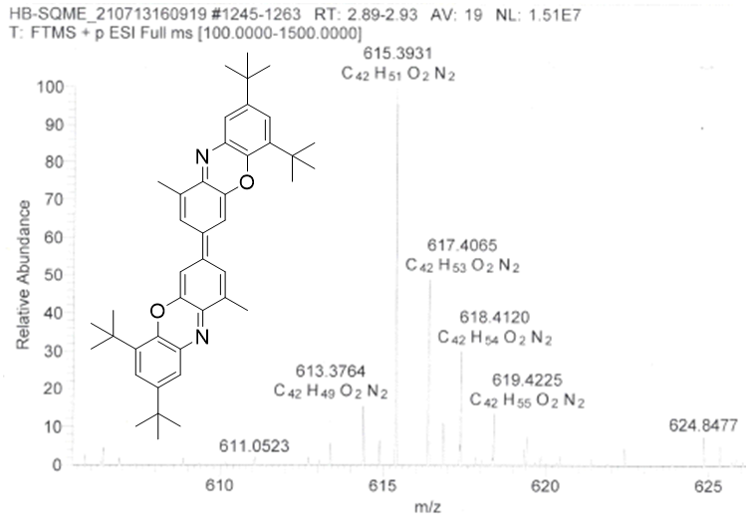
Supplementary Fig. 45: The mass spectrum of compound 1b.

8. Reference
1. Bain, G. A. & Berry, J. F. Diamagnetic Corrections and Pascal's Constants. J. Chem. Educ. 85, 532-536 (2008).
2. M. J. Frisch, G. W. Trucks, H. B. Schlegel, G. E. Scuseria, M. A. Robb, J. R. Cheeseman, G. Scalmani, V. Barone, B. Mennucci, G. A. Petersson, H. Nakatsuji, M. Caricato, X. Li, H. P. Hratchian, A. F. Izmaylov, J. Bloino, G. Zheng, J. L. Sonnenberg, M. Hada, M. Ehara, K. Toyota, R. Fukuda, J. Hasegawa, M. Ishida, T. Nakajima, Y. Honda, O. Kitao, H. Nakai, T. Vreven, J. A. Montgomery, Jr., J. E. Peralta, F. Ogliaro, M. Bearpark, J. J. Heyd, E. Brothers, K. N. Kudin, V. N. Staroverov, R. Kobayashi, J. Normand, K. Raghavachari, A. Rendell, J. C. Burant, S. S. Iyengar, J. Tomasi, M. Cossi, N. Rega, J. M. Millam, M. Klene, J. E. Knox, J. B. Cross, V. Bakken, C. Adamo, J. Jaramillo, R. Gomperts, R. E. Stratmann, O. Yazyev, A. J. Austin, R. Cammi, C. Pomelli, J. W. Ochterski, R. L. Martin, K. Morokuma, V. G. Zakrzewski, G. A. Voth, P. Salvador, J. J. Dannenberg, S. Dapprich, A. D. Daniels, O. N. Farkas, J. B. Foresman, J. V. Ortiz, J. Cioslowski, D. J. Fox, Gaussian 16, Revision A.03, Gaussian, Inc., Wallingford, CT, 2016.
3. Becke, A. D. Density-functional thermochemistry. III. The role of exact exchange. J. Chem. Phys. 98, 5648-5652 (1993).
4. Lee, C., Yang, W. & Parr, R. G. Development of the Colle-Salvetti correlation-energy formula into a functional of the electron density. Phys. Rev. B 37, 785-789 (1988).
5. Yanai, T., Tew, D. & Handy, N. A new hybrid exchange-correlation functional using the Coulomb-attenuating method (CAM-B3LYP). Chem. Phys. Lett. 393, 51-57 (2004).
6. Raghavachari, K., Binkley, J. S., Seeger, R. & Pople, J. A. Self‐consistent molecular orbital methods. XX. A basis set for correlated wave functions. J. Chem. Phys. 72, 650-654 (1980).
7. Weigend, F. & Ahlrichs, R. Balanced basis sets of split valence, triple zeta valence and quadruple zeta valence quality for H to Rn: Design and assessment of accuracy. Phys. Chem. Chem. Phys. 7, 3297-3305 (2005).
8. Yamanaka, S., Okumura, M., Nakano, M. & Yamaguchi, K. EHF theory of chemical reactions Part 4. UNO CASSCF, UNO CASPT2 and R(U)HF coupled-cluster (CC) wavefunctions. J. Mol. Struct. 310, 205-218 (1994).
9. Kamada, K. et al. Singlet Diradical Character from Experiment. J. Phys. Chem. Lett. 1, 937-940 (2010).
10. Chen, Z. et al. Nucleus-Independent Chemical Shifts (NICS) as an Aromaticity Criterion. Chem. Rev. 105, 3842-3888 (2015).
11. Fallah-Bagher-Shaidaei, H. et al. Which NICS Aromaticity Index for Planar π Rings Is Best? Org. Lett. 8, 863-866 (2006).
12. Humphrey, W., Dalke, A. & Schulten, K. VMD: Visual molecular dynamics. J. Mol. Graph. 14, 33-38 (1996).

