Supporting Information

Design, synthesis, cytotoxicity and molecular docking studies of 1-(4-methoxyphenyl)-N-substituted phenyl-1H-1,2,3-triazole-4-carboxamide derivatives.
Ravindra R. Shindeª, Samreen Fatemaª, Sachin Dhawale^{b}, Mazahar Farooquiª*
ªDepartment of Chemistry, Maulana Azad college of Arts, Science and commerce Aurangabad- 431001, India.
^{b}Department of pharmaceutical chemistry, Shreeyash institute of pharmaceutical education and research, Aurangabad, India.
^{a*}Maulana Azad College of Arts, Science and Commerce Aurangabad, Aurangabad- 431001, India.
*Corresponding Author.
Tel: +919422214785.
E-mail:* mazahar_64@rediffmail.com.

Experimental:
All commercially available chemicals and solvents were purchased from Spectrochem Pvt. Ltd, SD Fine Chem and Sigma Aldrich and directly used without further purification. TLC was conducted on 0.25 mm silica gel plates 60 F254 (0.25 mm thick) with appropriate proportion of combination of solvent. Melting point was determined in open capillary tubes on a LABINDIA Visual Melting Range Apparatus (MR-VIS) and is uncorrected. The IR (KBr) spectra were recorded using FTIR spectrophotometer (Shimadzu IR Prestige 21, Shimadzu). 1H-NMR (300 MHz) and 13C-NMR (75 MHz) spectra were recorded on a Bruker TM-300 using tetramethylsilane (TMS) as an internal standard (chemical shifts in δ) and LCMS (ESI-MS) were recorded on Agilent single Quadrupole LC-MS system.

Biological Evolution:
Anti-cancer activity of novel compounds was determined with the help of MTT assay, by using breast cancer cell line (MCF-7) and (MDA-MB-231) were used to screen the compounds. Dulbecco’s Modified Eagle Medium (DMEM), was used for culturing of cell lines, supplemented with 1% antibiotic and 10% fetal bovine serum. The culturing cells were maintained in the incubator with humidified atmosphere at 5% CO₂ at 37°C for 24 hr. A count of cells 1*10⁴ per well has been seeded on sterile 96 well plates. After overnight incubation, (100 µL) of compounds were used to treat the cells for 48 hours for desired dilution. The medium containing the drug solution had been taken out from the wells after the drug treatment and followed by addition of 10 µL of MTT [3-(4,5-dimethylthiazol-2-yl)-2,5- diphenyltetrazolium bromide] (5mg/mL) in phenol red free medium into the well and allowed to incubate for another 4 hours. Then an equal volume of DMSO was added in to each well to dissolve the so formed purple colour formazan crystals. The absorbance was measured at 570 nm and 650 nm by using Spectramax (Molecular Devices, USA) after a gentle shaking of the well plates. IC₅₀ values, at which cell growth was inhibited by 50%, were calculated with GraphPad Prism Software version 7.0.

¹H-NMR Spectra of Compounds 4A-4N.

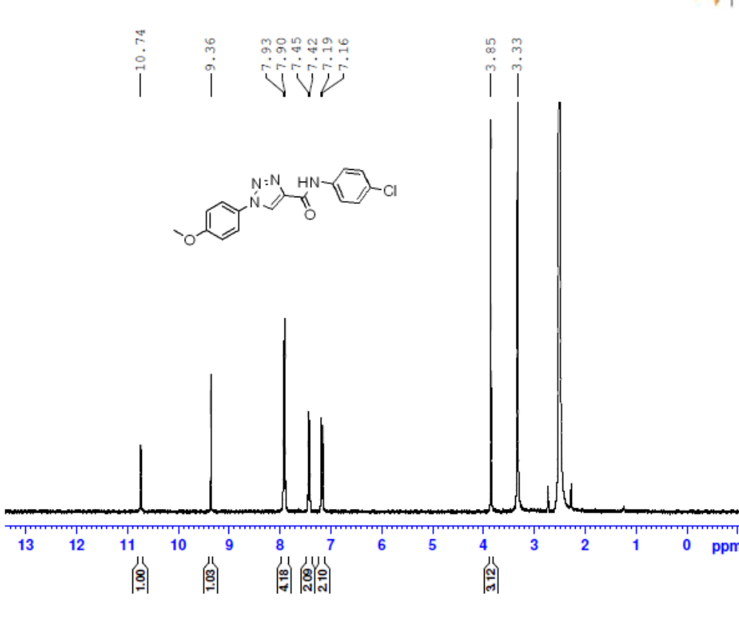
Figure S1. ¹H NMR Spectrum (DMSO, 300 MHz) of N-(4-chlorophenyl)-1-(4-methoxyphenyl)-1H-1,2,3-triazole-4-carboxamide (4A).

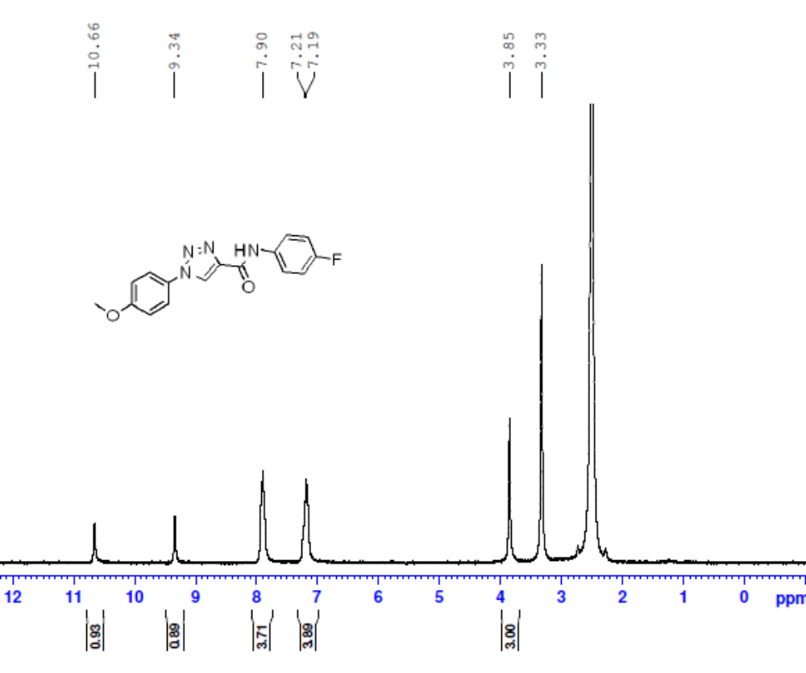

Figure S2. ¹H NMR Spectrum (DMSO, 300 MHz) of N-(4-fluorophenyl)-1-(4-methoxyphenyl)-1H-1,2,3-triazole-4-carboxamide (4B).

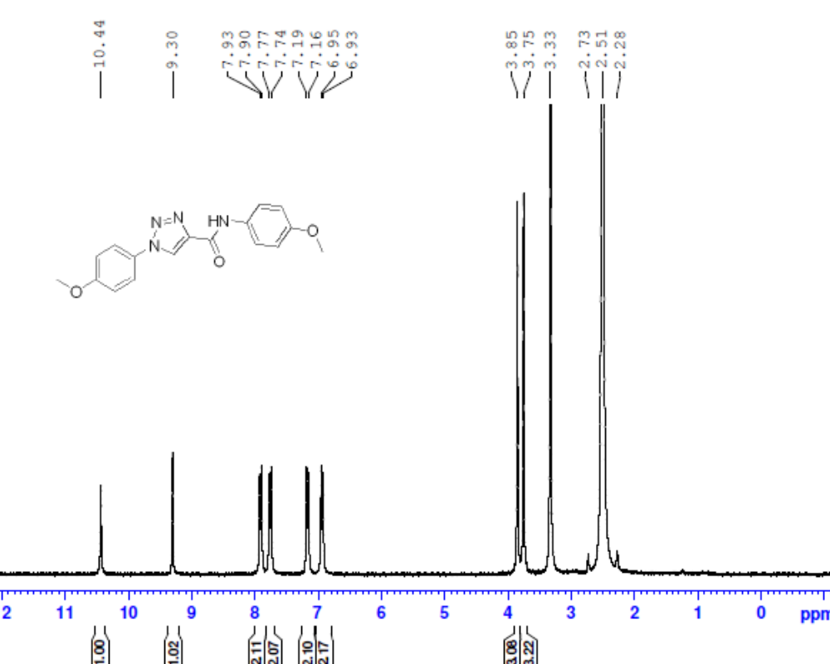
Figure S3. ¹H NMR Spectrum (DMSO, 300 MHz) of N,1-bis(4-methoxyphenyl)-1H-1,2,3-triazole-4-carboxamide (4C).

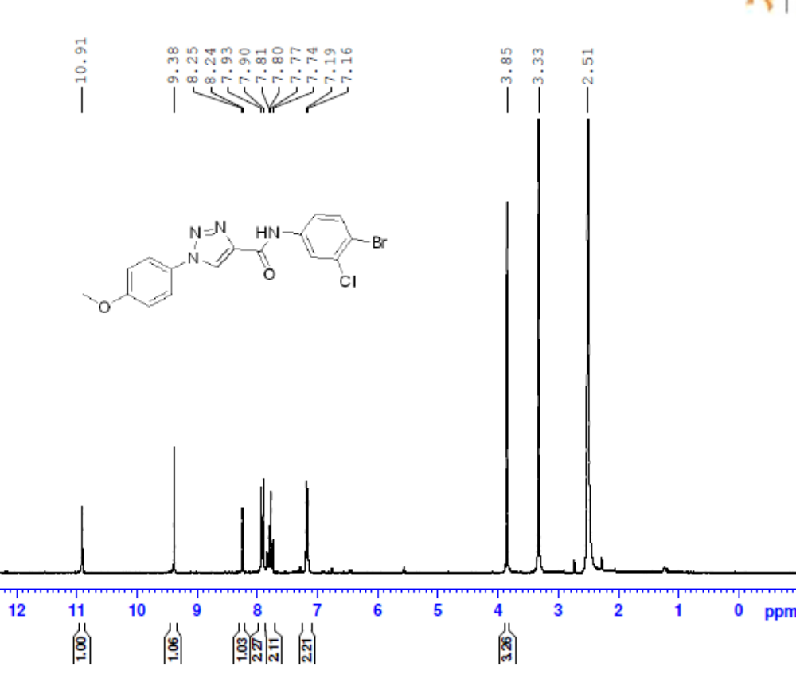
Figure S4. ¹H NMR Spectrum (DMSO, 300 MHz) of N-(4-bromo-3-chlorophenyl)-1-(4-methoxyphenyl)-1H-1,2,3-triazole-4-carboxamide (4D).

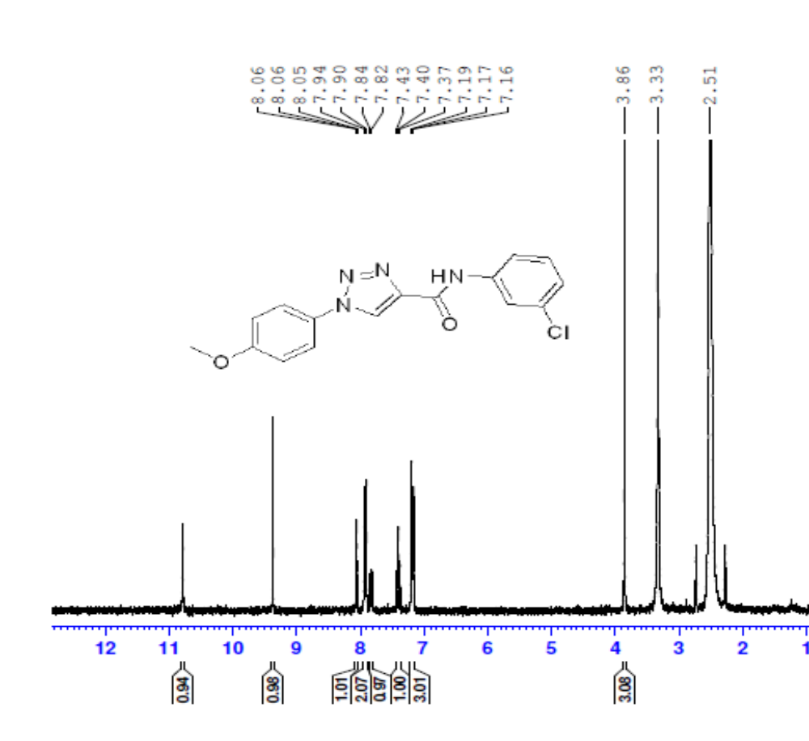
Figure S5. ¹H NMR Spectrum (DMSO, 300 MHz) of N-(3-chlorophenyl)-1-(4-methoxyphenyl)-1H-1,2,3-triazole-4-carboxamide (4E).
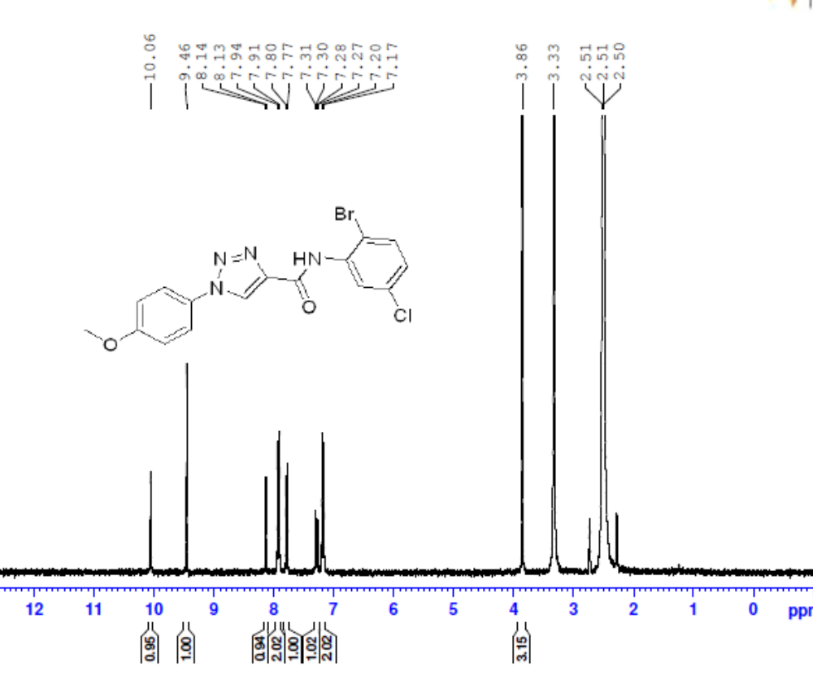

Figure S6. ¹H NMR Spectrum (DMSO, 300 MHz) of N-(2-bromo-5-chlorophenyl)-1-(4-methoxyphenyl)-1H-1,2,3-triazole-4-carboxamide (4F).
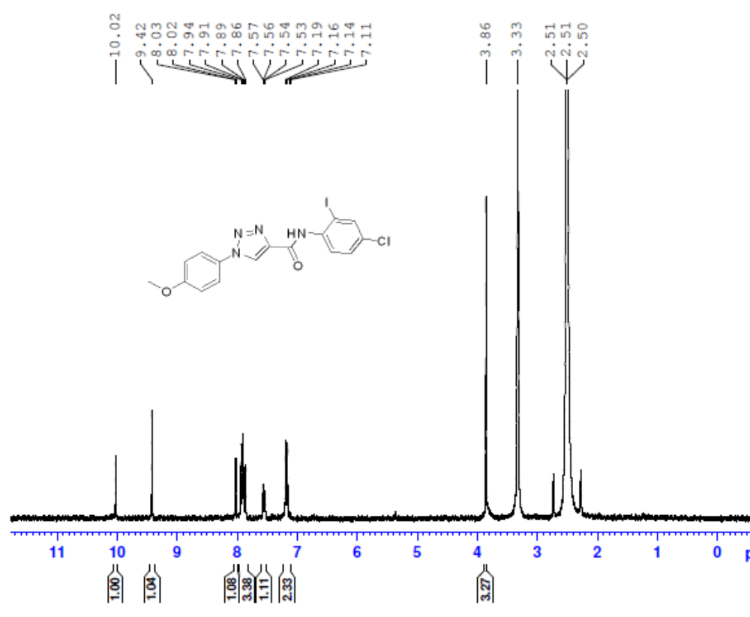
Figure S7. ¹H NMR Spectrum (DMSO, 300 MHz) of N-(4-chloro-2-iodophenyl)-1-(4-methoxyphenyl)-1H-1,2,3-triazole-4-carboxamide (4G).
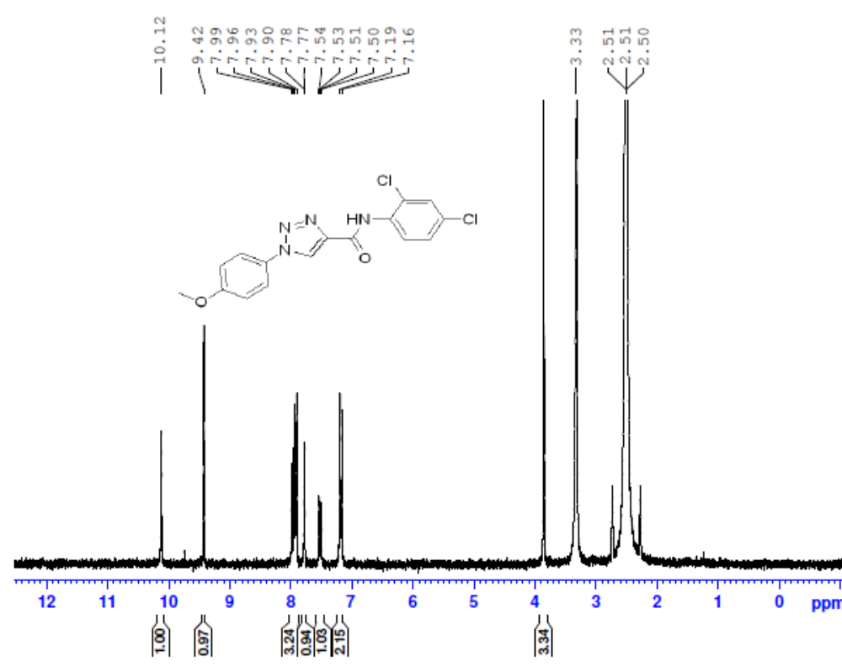
Figure S8. ¹H NMR Spectrum (DMSO, 300 MHz) of N-(2,4-dichlorophenyl)-1-(4-methoxyphenyl)-1H-1,2,3-triazole-4-carboxamide (4H).
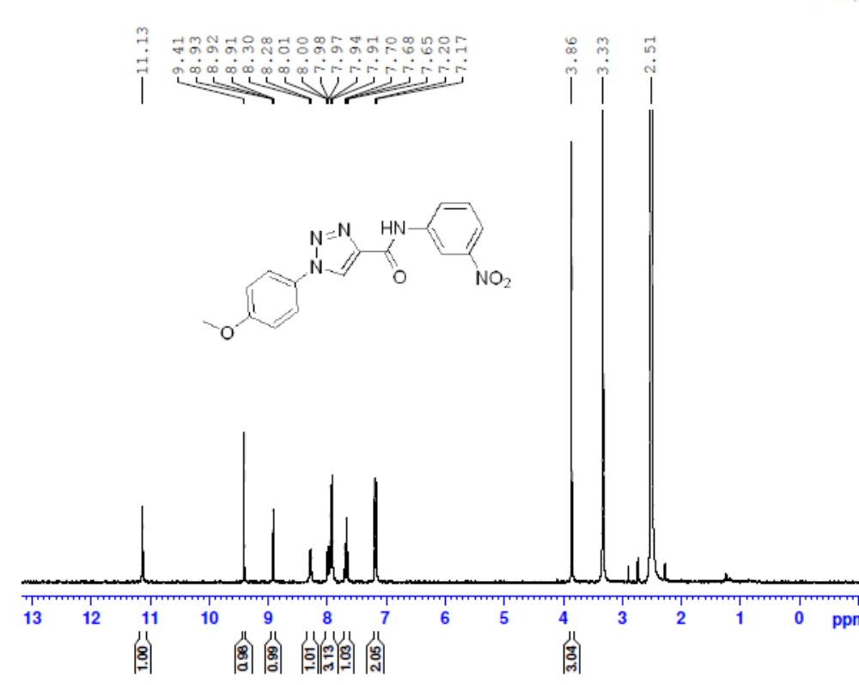
Figure S9. ¹H NMR Spectrum (DMSO, 300 MHz) of 1-(4-methoxyphenyl)-N-(3-nitrophenyl)-1H-1,2,3-triazole-4-carboxamide (4I).
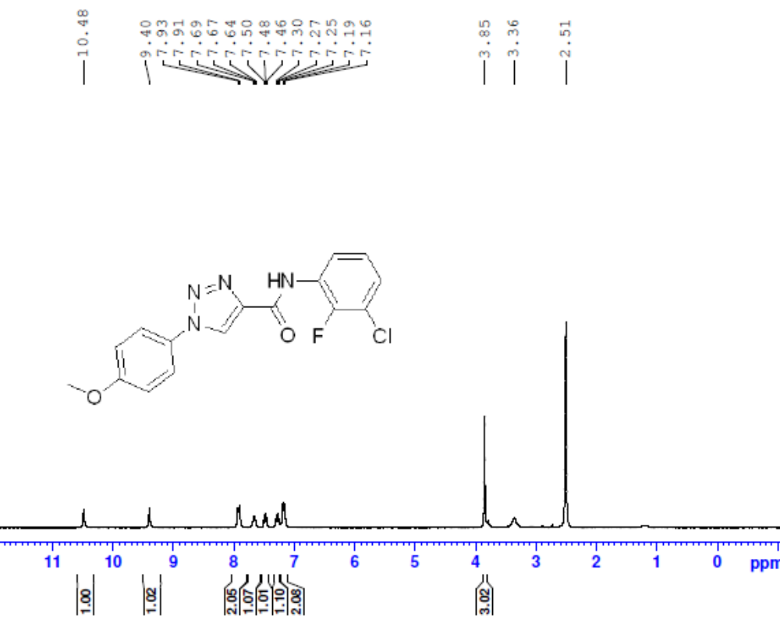
Figure S10. ¹H NMR Spectrum (DMSO, 300 MHz) of N-(3-chloro-2-fluorophenyl)-1-(4-methoxyphenyl)-1H-1,2,3-triazole-4-carboxamide (4J).

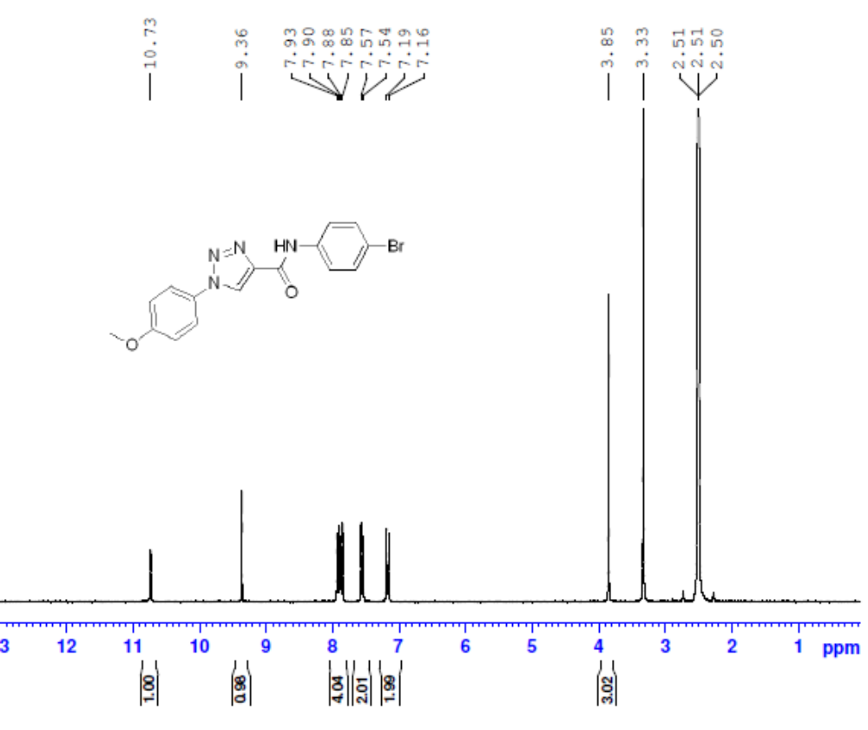
Figure S11. ¹H NMR Spectrum (DMSO, 300 MHz) of N-(4-bromophenyl)-1-(4-methoxyphenyl)-1H-1,2,3-triazole-4-carboxamide (4K).
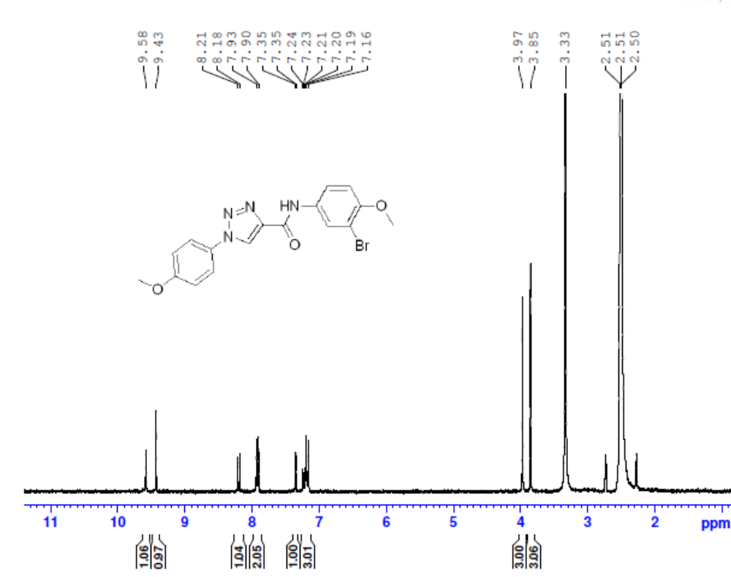
Figure S12. ¹H NMR Spectrum (DMSO, 300 MHz) of N-(3-bromo-4-methoxyphenyl)-1-(4-methoxyphenyl) -1H-1,2,3-triazole-4-carboxamide (4L).
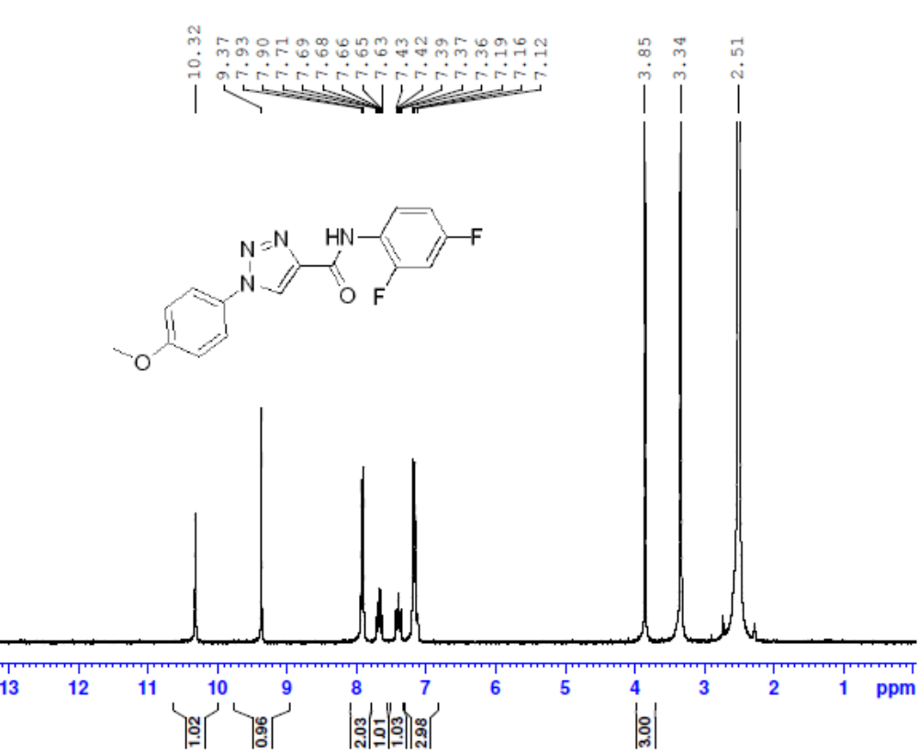
Figure S13. ¹H NMR Spectrum (DMSO, 300 MHz) of N-(2,4-difluorophenyl)-1-(4-methoxyphenyl)-1H-1,2,3-triazole-4-carboxamide (4M).
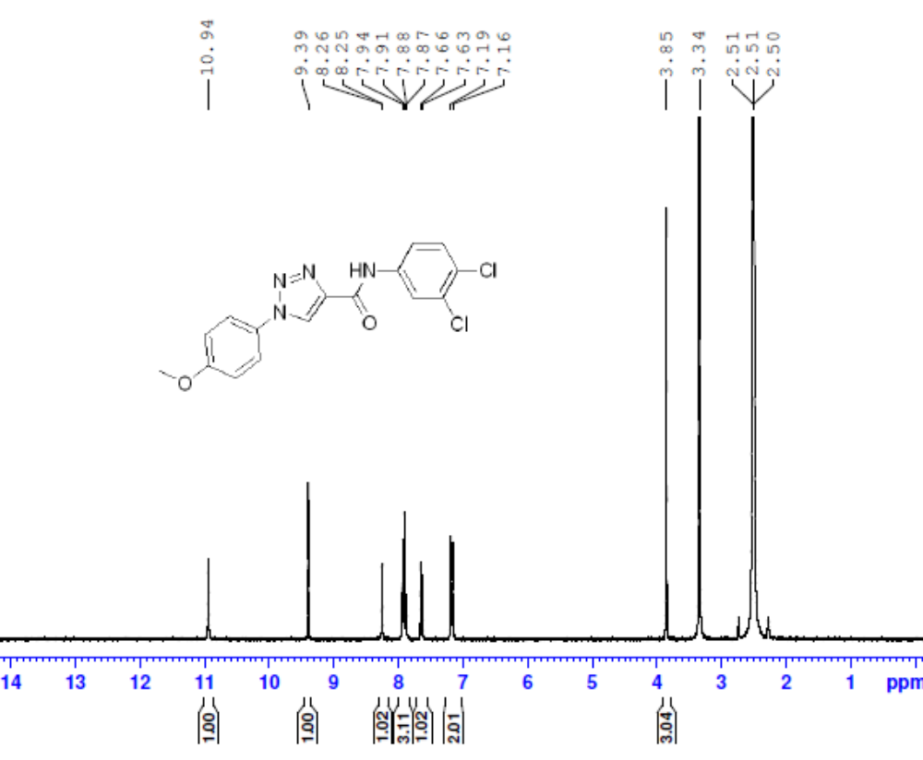
Figure S14. ¹H NMR Spectrum (DMSO, 300 MHz) of N-(3,4-dichlorophenyl)-1-(4-methoxyphenyl)-1H-1,2,3-triazole-4-carboxamide (4N).

¹³C NMR Spectrum of compound 4A-4N

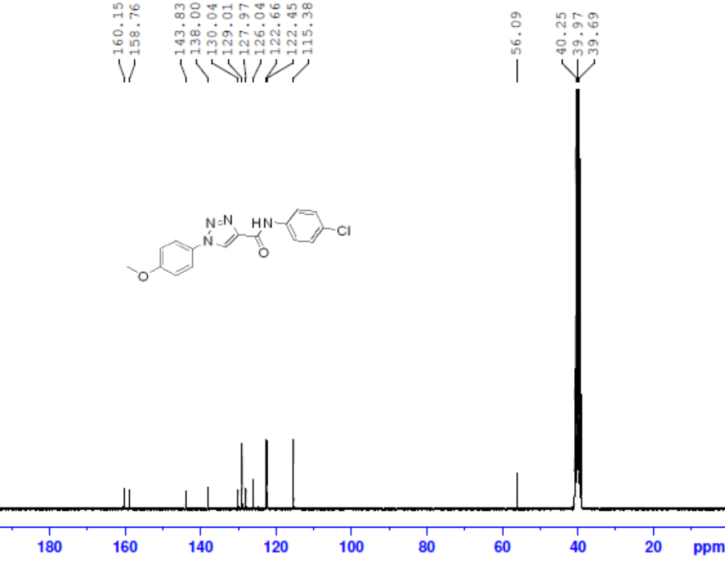
Figure S15. ¹³C NMR Spectrum (DMSO, 75 MHz) of N-(4-chlorophenyl)-1-(4-methoxyphenyl)-1H-1,2,3-triazole-4-carboxamide (4A).
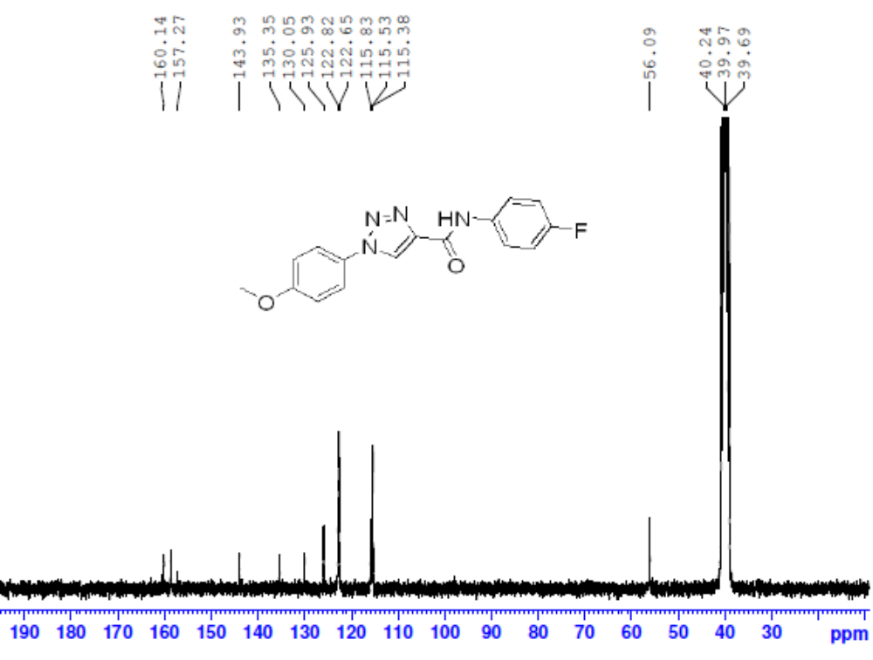
Figure S16. ¹³C NMR Spectrum (DMSO, 75 MHz) of N-(4-fluorophenyl)-1-(4-methoxyphenyl)-1H-1,2,3-triazole-4-carboxamide (4B).
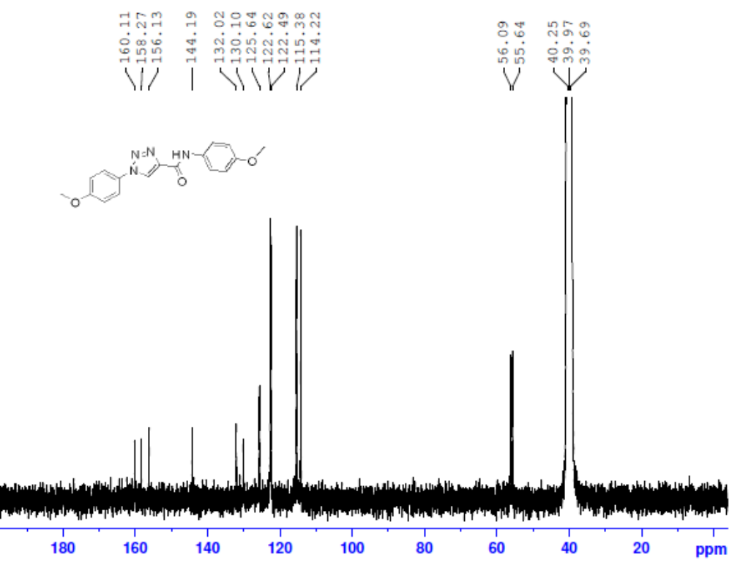
Figure S17. ¹³C NMR Spectrum (DMSO, 75 MHz)) of N,1-bis(4-methoxyphenyl)-1H-1,2,3-triazole-4-carboxamide (4C).
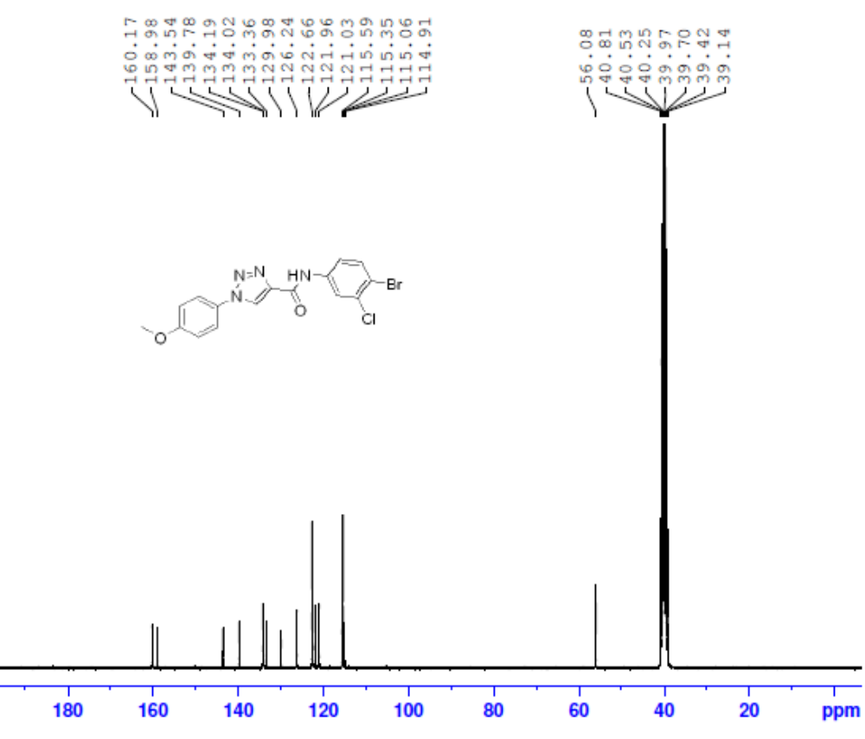
Figure S18. ¹³C NMR Spectrum (DMSO, 75 MHz) of N-(4-bromo-3-chlorophenyl)-1-(4-methoxyphenyl)-1H-1,2,3-triazole-4-carboxamide (4D).
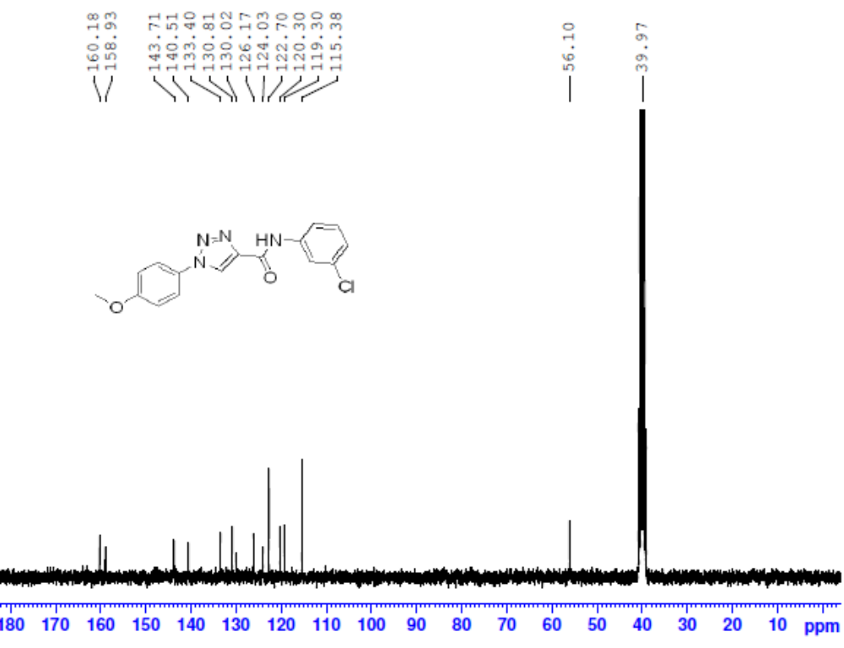
Figure S19. ¹³C NMR Spectrum (DMSO, 75 MHz) of N-(3-chlorophenyl)-1-(4-methoxyphenyl)-1H-1,2,3-triazole-4-carboxamide (4E).
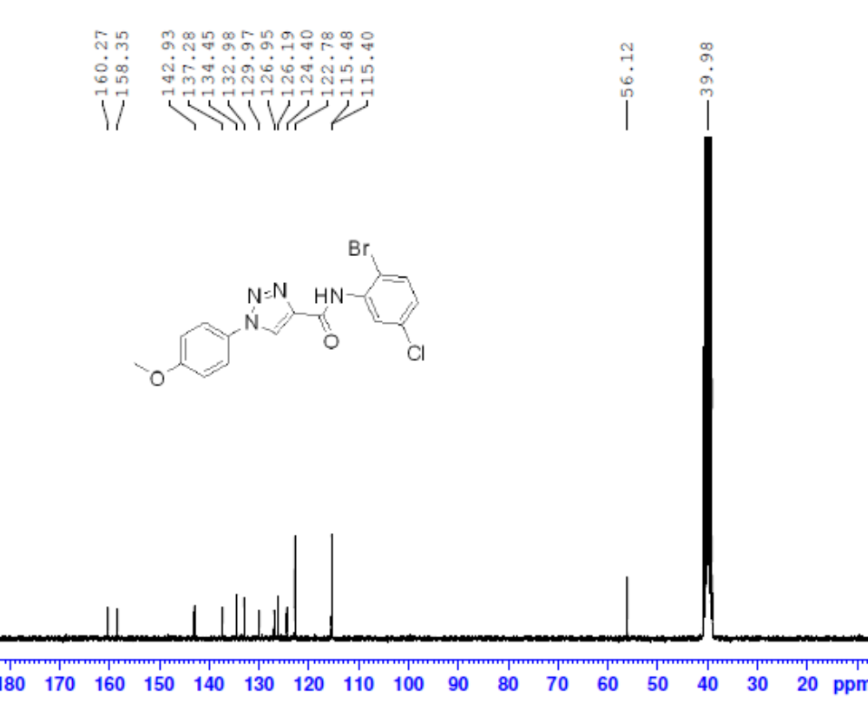
Figure S20. ¹³C NMR Spectrum (DMSO, 75 MHz) of N-(2-bromo-5-chlorophenyl)-1-(4-methoxyphenyl)-1H-1,2,3-triazole-4-carboxamide (4F).
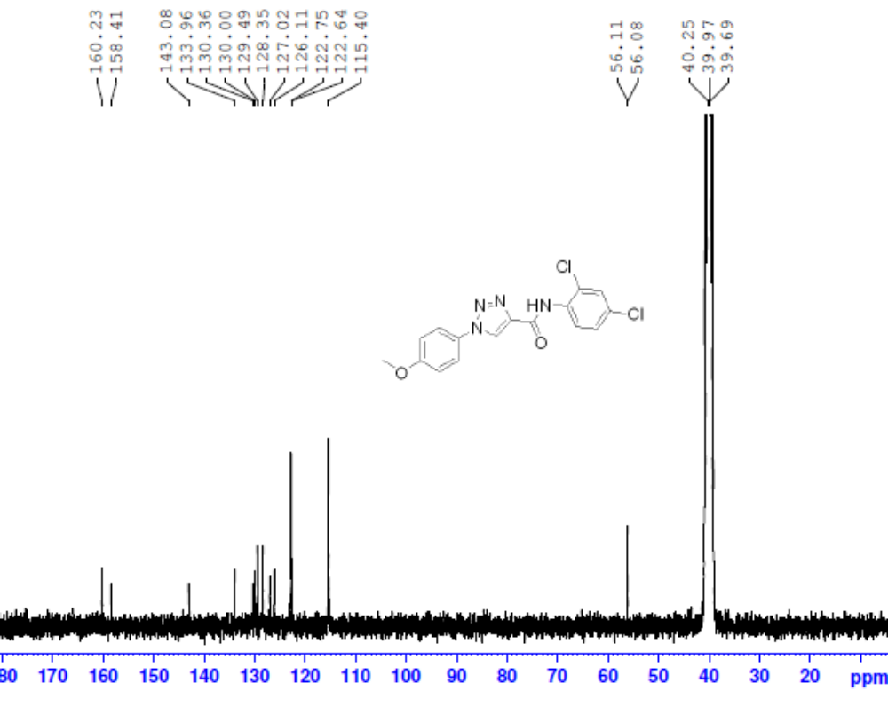
Figure S21. ¹³C NMR Spectrum (DMSO, 75 MHz) of N-(2,4-dichlorophenyl)-1-(4-methoxyphenyl)-1H-1,2,3-triazole-4-carboxamide (4H).
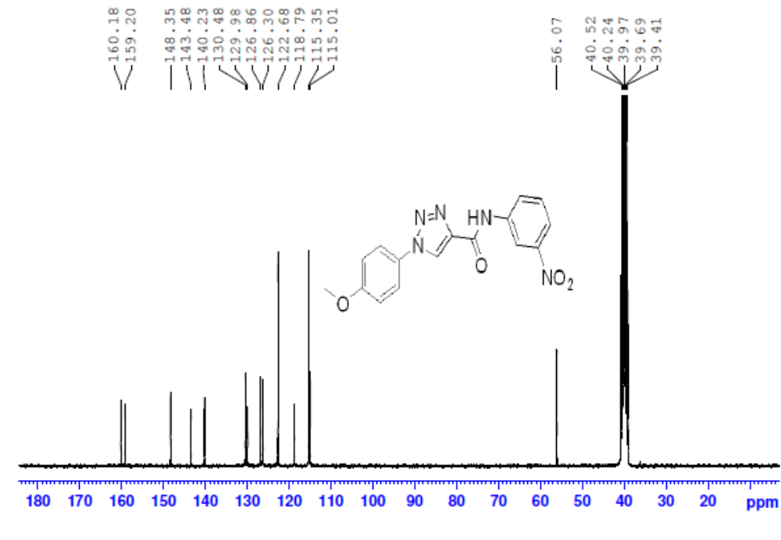
Figure S22. ¹³C NMR Spectrum (DMSO, 75 MHz) of 1-(4-methoxyphenyl)-N-(3-nitrophenyl)-1H-1,2,3-triazole-4-carboxamide (4I).
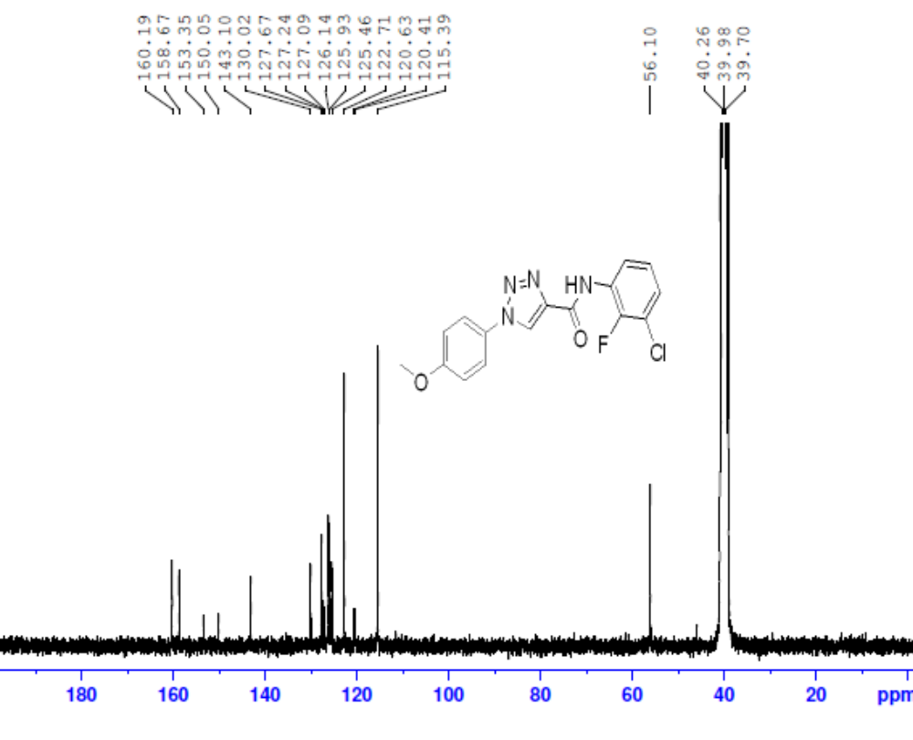
Figure S23. ¹³C NMR Spectrum (DMSO, 75 MHz) of N-(3-chloro-2-fluorophenyl)-1-(4-methoxyphenyl)-1H-1,2,3-triazole-4-carboxamide (4J).
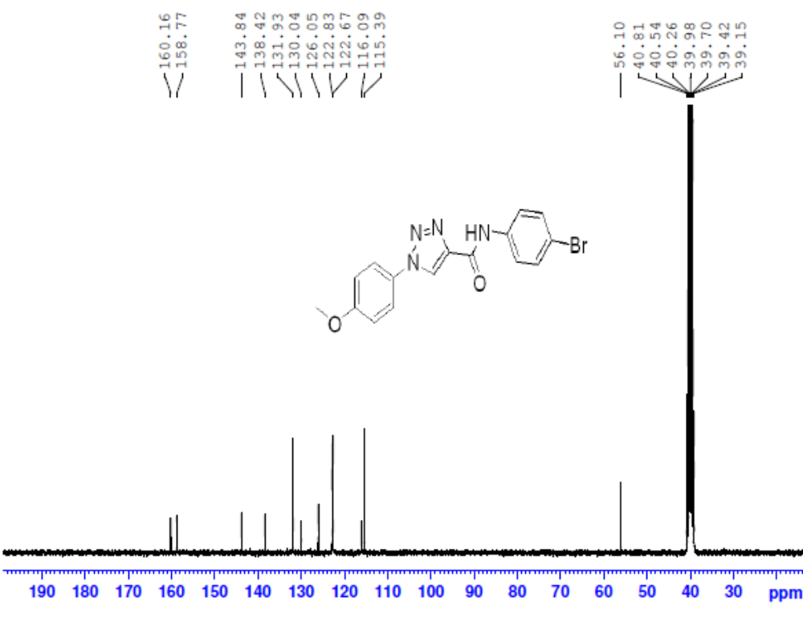
Figure S24. ¹³C NMR Spectrum (DMSO, 75 MHz) of N-(4-bromophenyl)-1-(4-methoxyphenyl)-1H-1,2,3-triazole-4-carboxamide (4K).
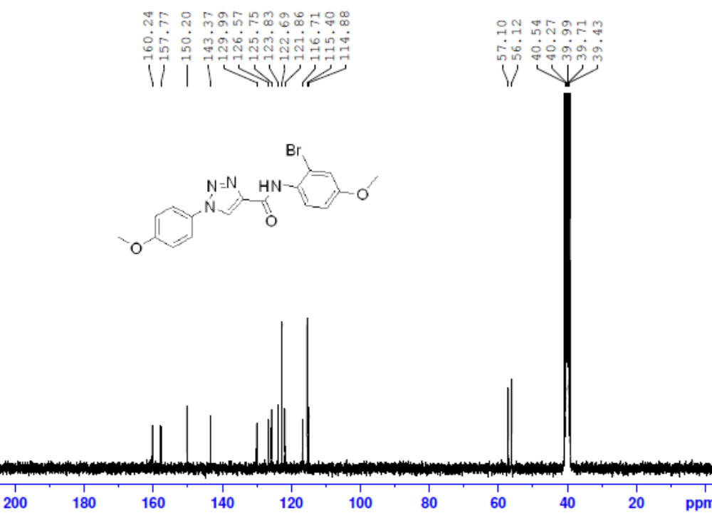
Figure S25. ¹³C NMR Spectrum (DMSO, 75 MHz) of N-(3-bromo-4-methoxyphenyl)-1-(4-methoxyphenyl) -1H-1,2,3-triazole-4-carboxamide (4L).
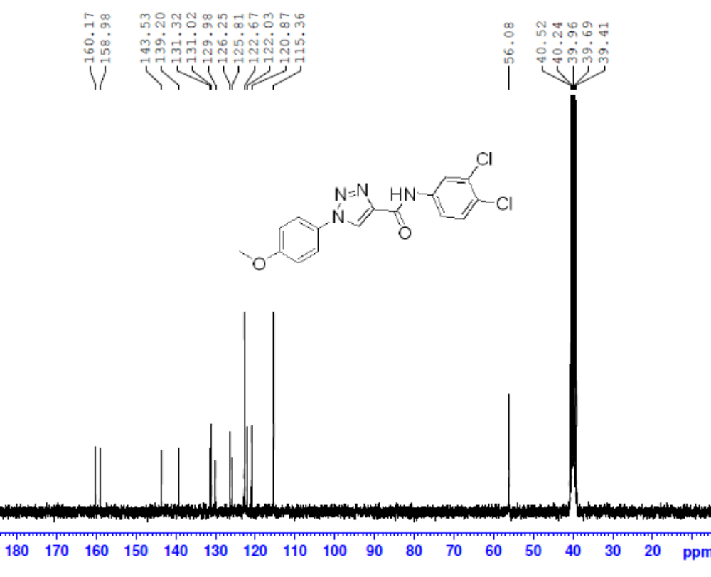
Figure S26. ¹³C NMR Spectrum (DMSO, 75 MHz) of N-(3,4-dichlorophenyl)-1-(4-methoxyphenyl)-1H-1,2,3-triazole-4-carboxamide (4N).

LC-MS Spectra of Compound 4A-4N.

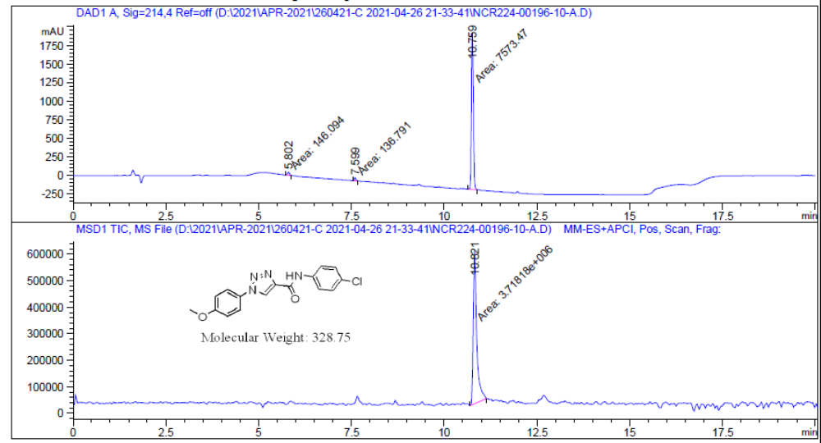
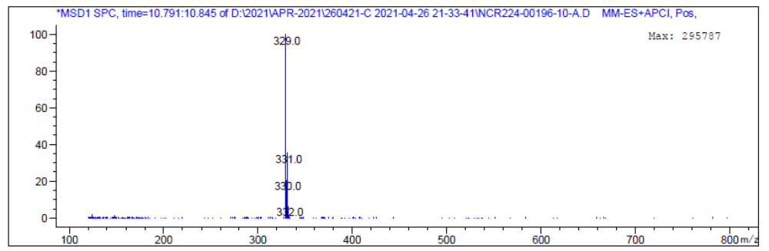
Figure S27. LCMS of of N-(4-chlorophenyl)-1-(4-methoxyphenyl)-1H-1,2,3-triazole-4-carboxamide (4A).
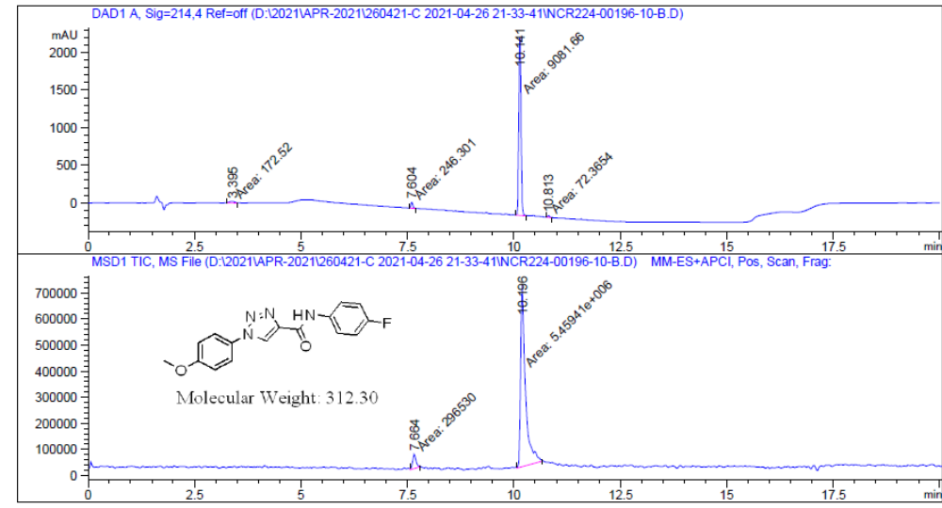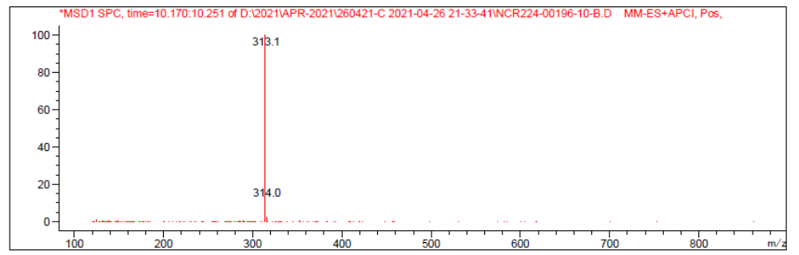

Figure S28. LCMS of N-(4-fluorophenyl)-1-(4-methoxyphenyl)-1H-1,2,3-triazole-4-carboxamide (4B).

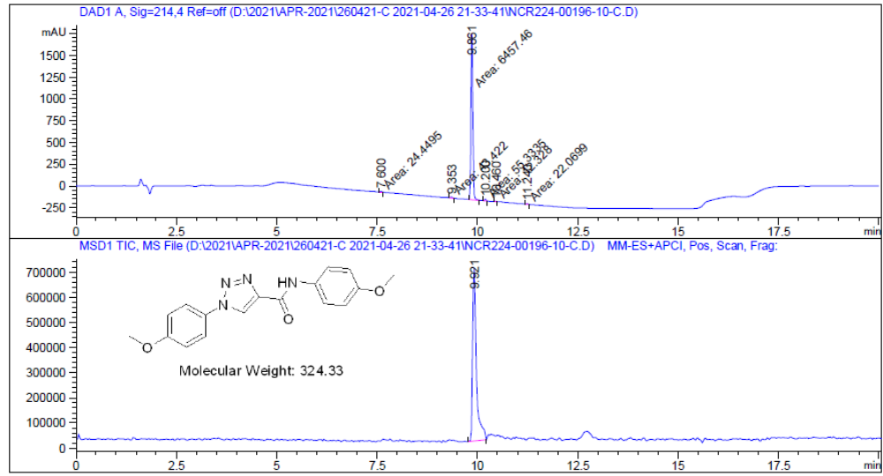
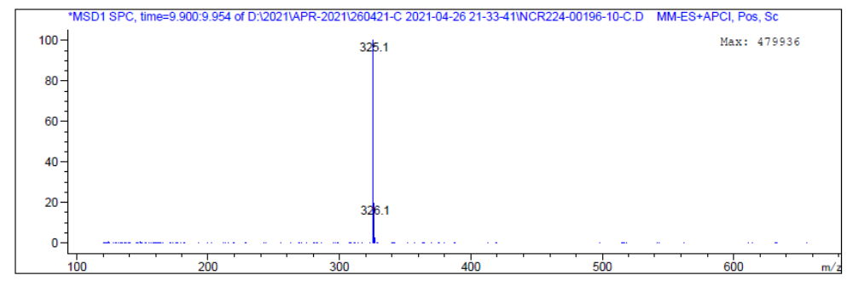
Figure S29. LCMS of N,1-bis(4-methoxyphenyl)-1H-1,2,3-triazole-4-carboxamide (4C).
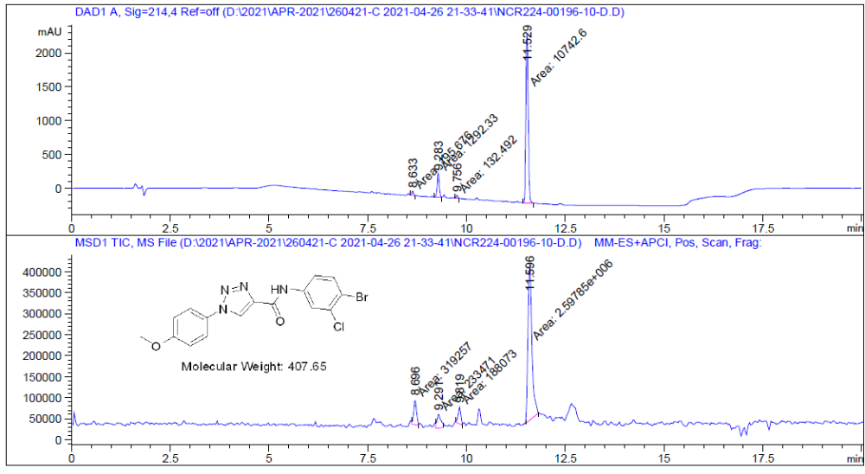
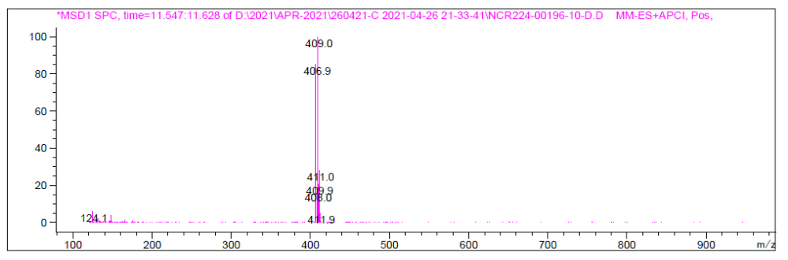
Figure S30. LCMS of N-(4-bromo-3-chlorophenyl)-1-(4-methoxyphenyl)-1H-1,2,3-triazole-4-carboxamide (4D).
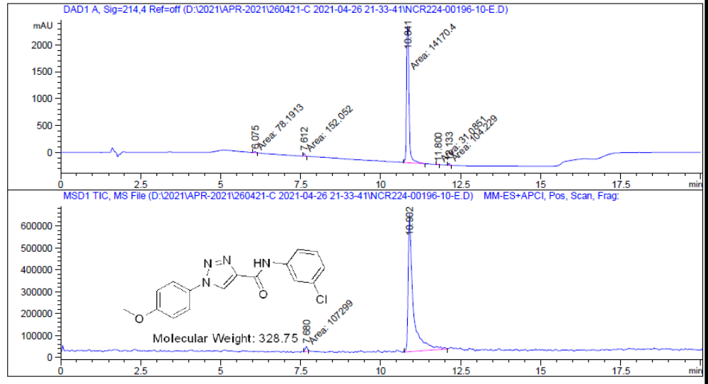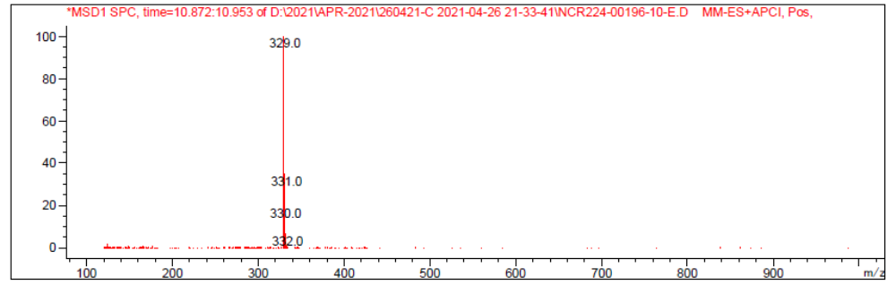
Figure S31. LCMS of N-(3-chlorophenyl)-1-(4-methoxyphenyl)-1H-1,2,3-triazole-4-carboxamide (4E).
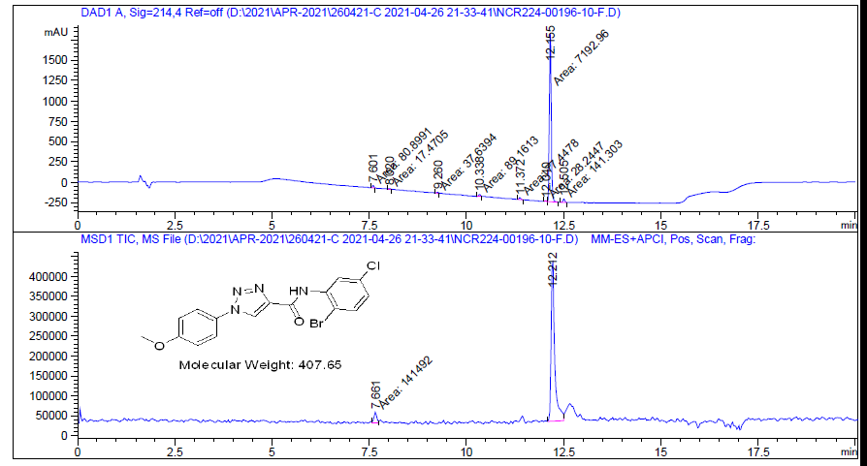
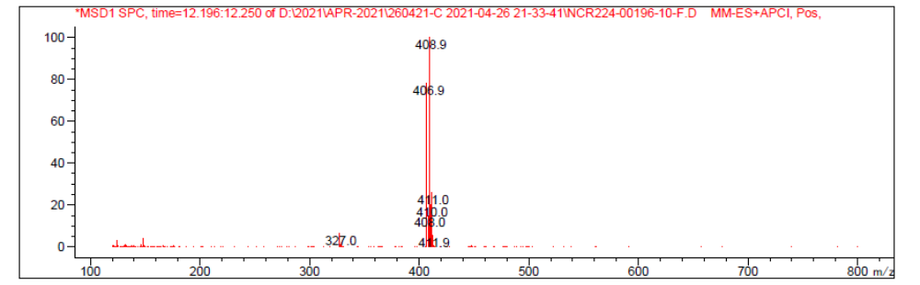
Figure S32. LCMS of N-(2-bromo-5-chlorophenyl)-1-(4-methoxyphenyl)-1H-1,2,3-triazole-4-carboxamide (4F).
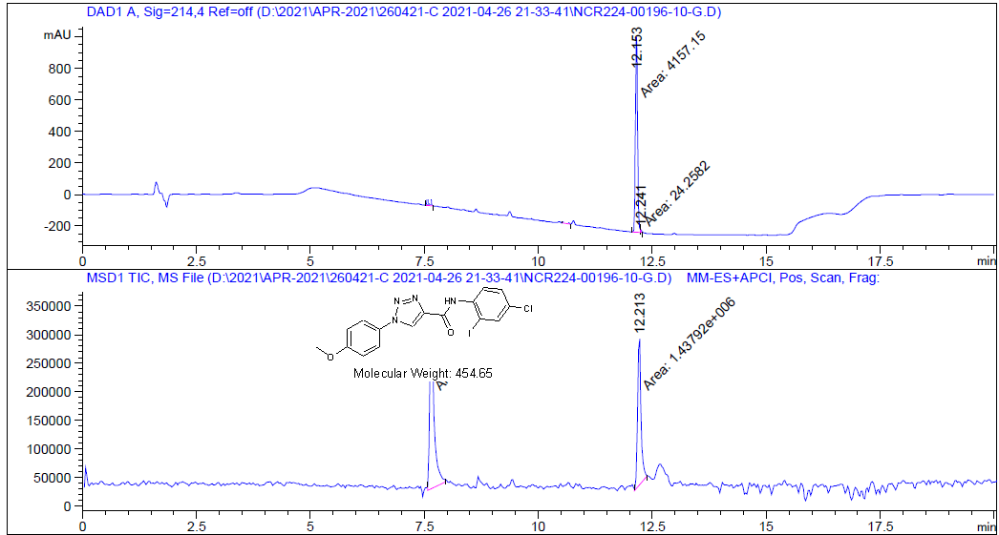
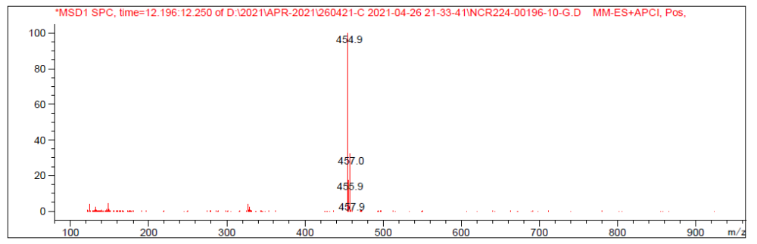
Figure S33. LCMS of N-(4-chloro-2-iodophenyl)-1-(4-methoxyphenyl)-1H-1,2,3-triazole-4-carboxamide (4G).
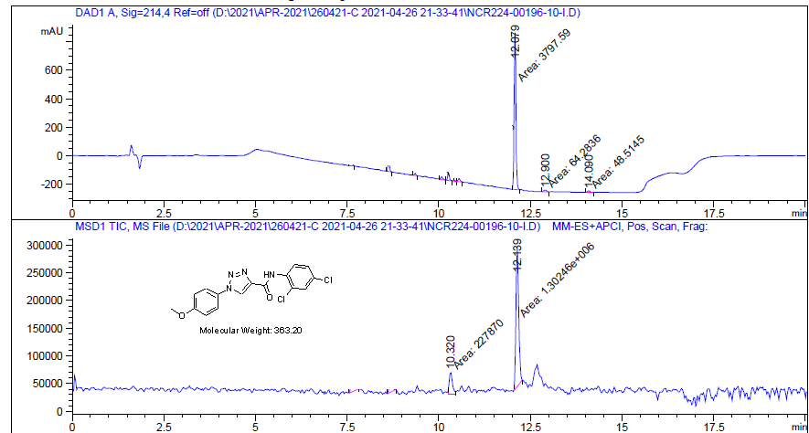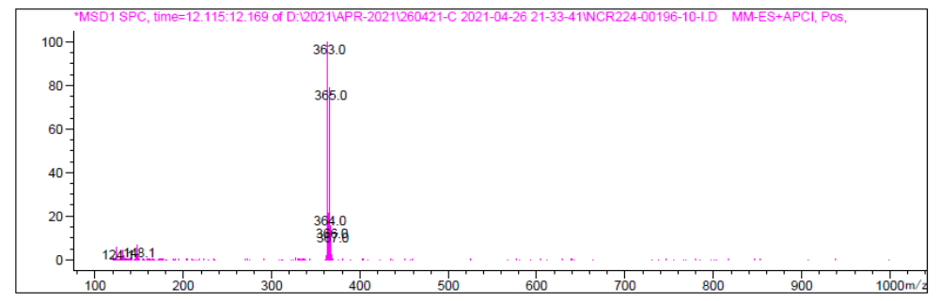
Figure S34. LCMS of N-(2,4-dichlorophenyl)-1-(4-methoxyphenyl)-1H-1,2,3-triazole-4-carboxamide (4H).
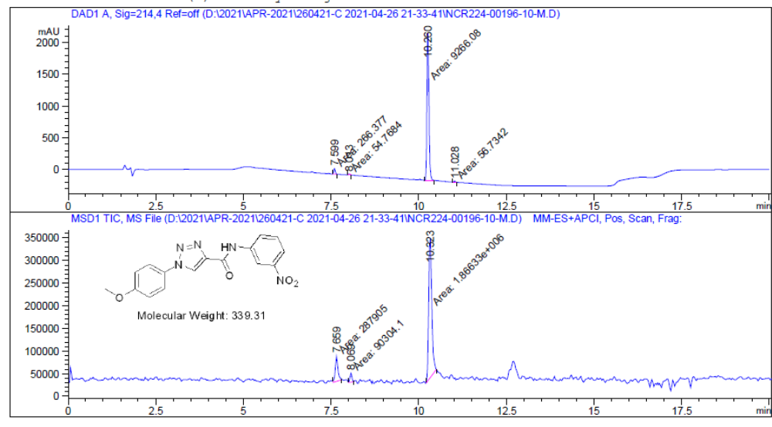
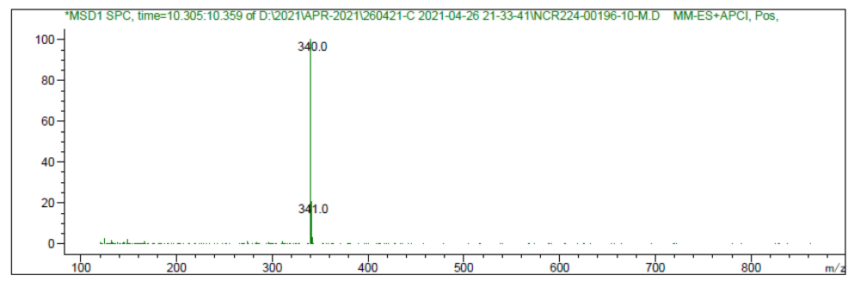
Figure S35. LCMS of 1-(4-methoxyphenyl)-N-(3-nitrophenyl)-1H-1,2,3-triazole-4-carboxamide (4I).
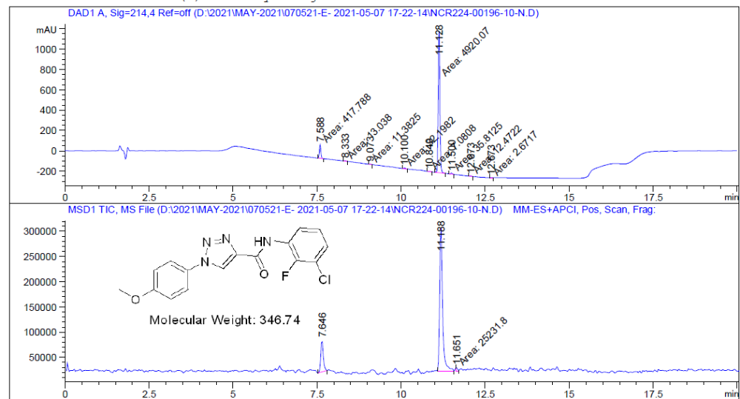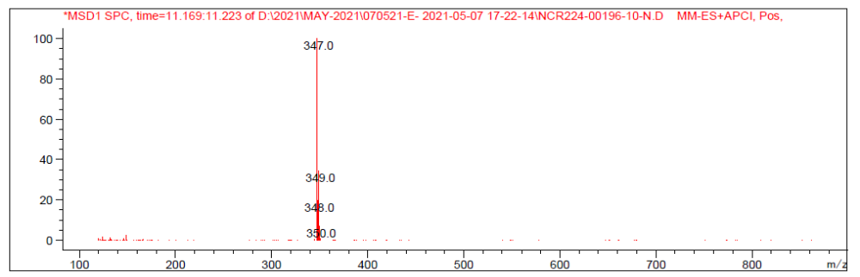
Figure S36. LCMS of N-(3-chloro-2-fluorophenyl)-1-(4-methoxyphenyl)-1H-1,2,3-triazole-4-carboxamide (4J).

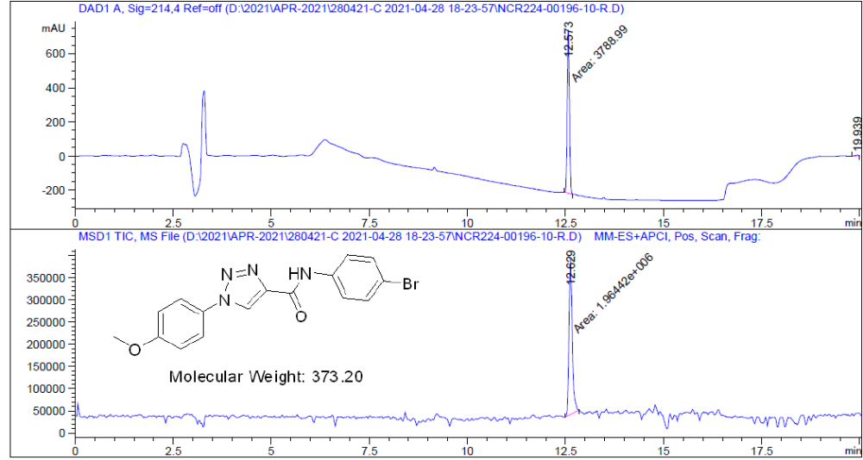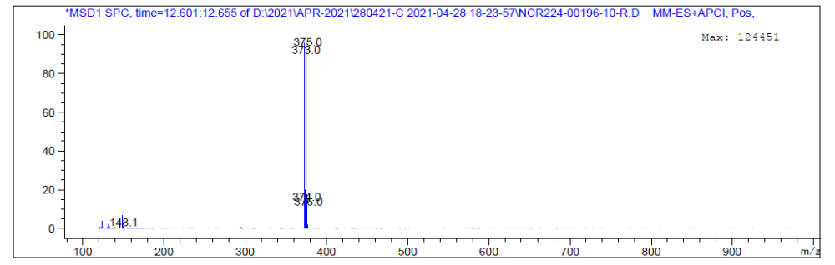

Figure S37. LCMS of N-(4-bromophenyl)-1-(4-methoxyphenyl)-1H-1,2,3-triazole-4-carboxamide (4K).
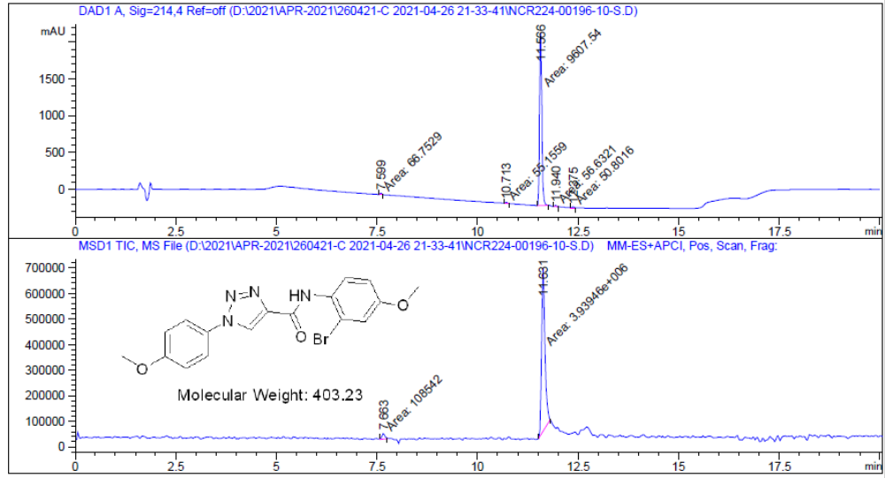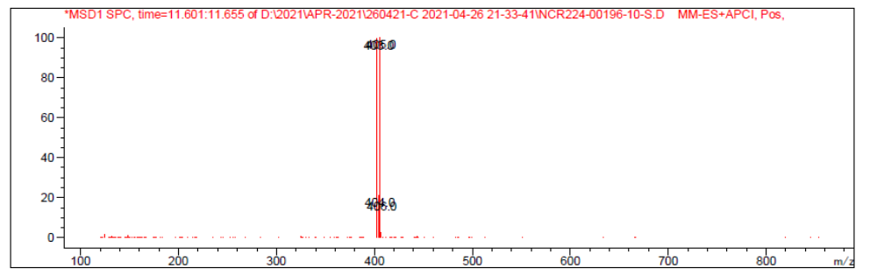
Figure S38. LCMS of N-(3-bromo-4-methoxyphenyl)-1-(4-methoxyphenyl) -1H-1,2,3-triazole-4-carboxamide (4L).
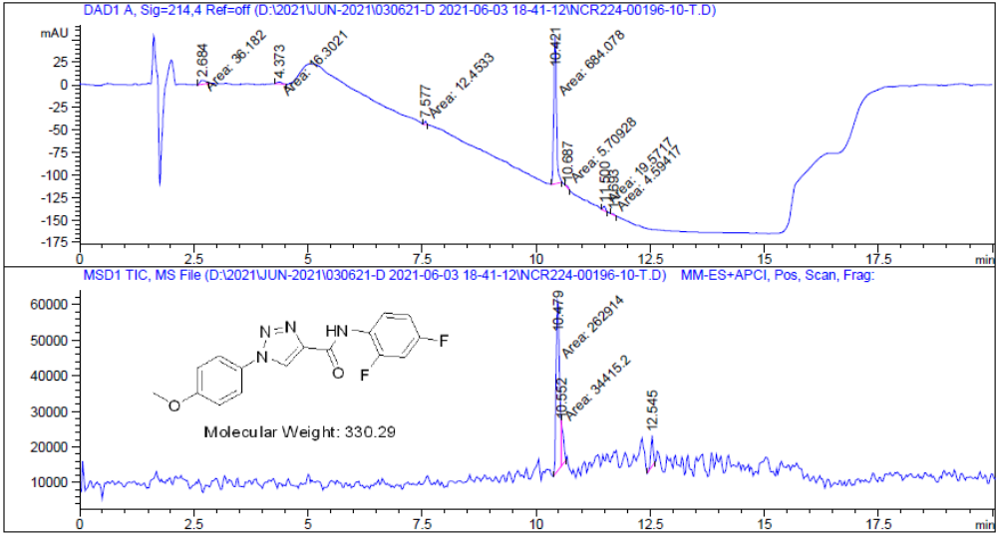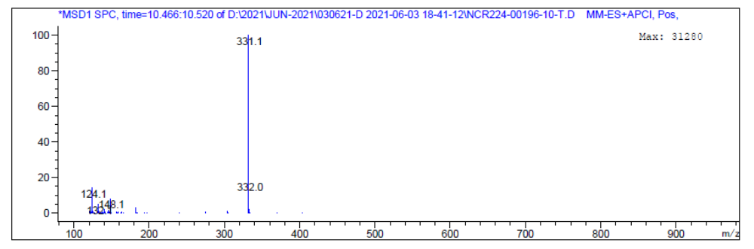
Figure S39. LCMS of N-(2,4-difluorophenyl)-1-(4-methoxyphenyl)-1H-1,2,3-triazole-4-carboxamide (4M).
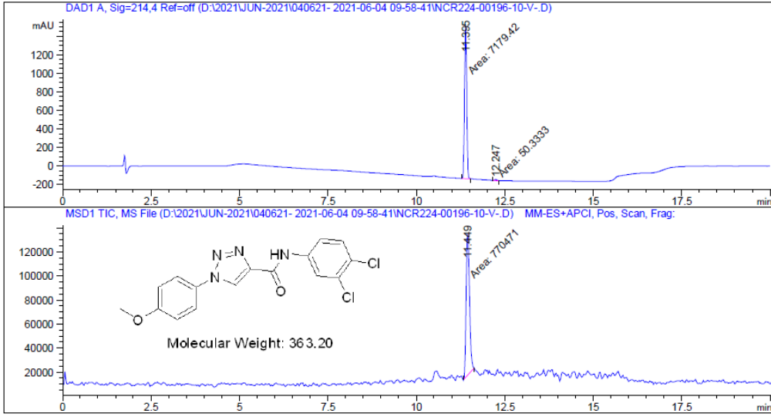
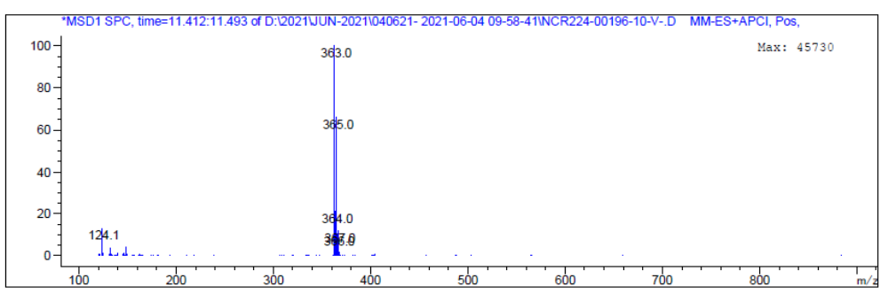
Figure S40. LCMS of N-(3,4-dichlorophenyl)-1-(4-methoxyphenyl)-1H-1,2,3-triazole-4-carboxamide (4N).

FT-IR Spectrum of compound 4A-4N
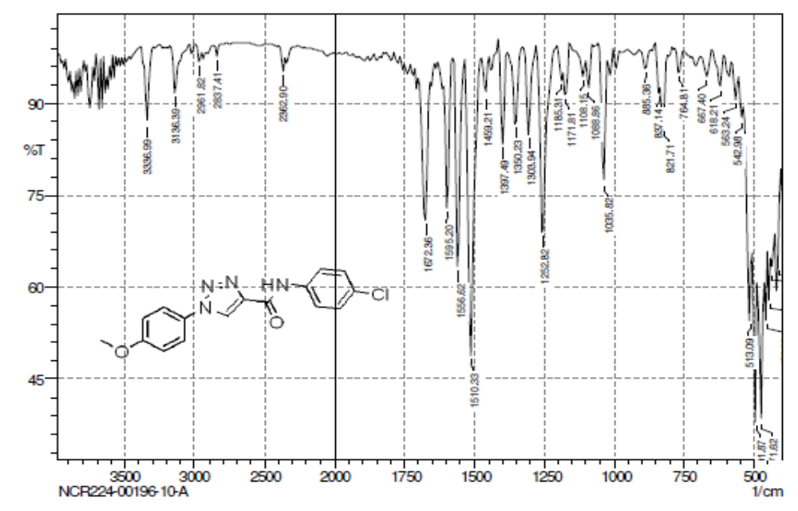
Figure S41. FT-IR of N-(4-chlorophenyl)-1-(4-methoxyphenyl)-1H-1,2,3-triazole-4-carboxamide (4A).

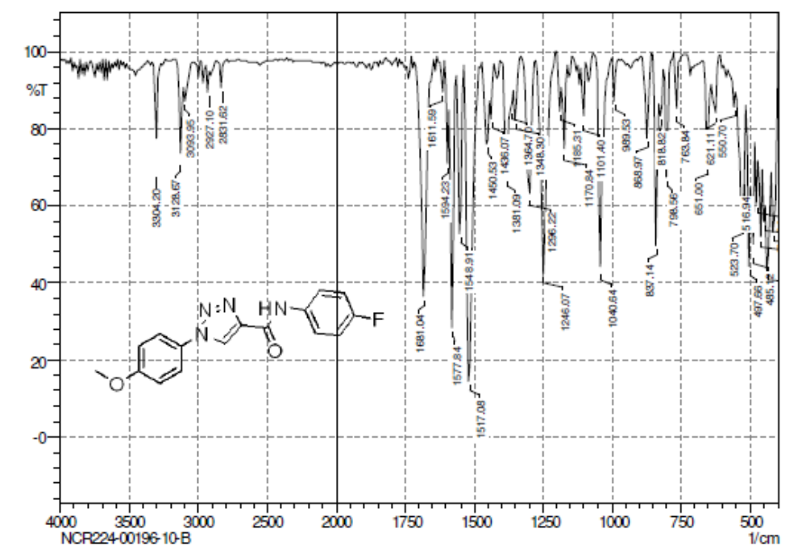
Figure S42. FT-IR of N-(4-fluorophenyl)-1-(4-methoxyphenyl)-1H-1,2,3-triazole-4-carboxamide (4B).
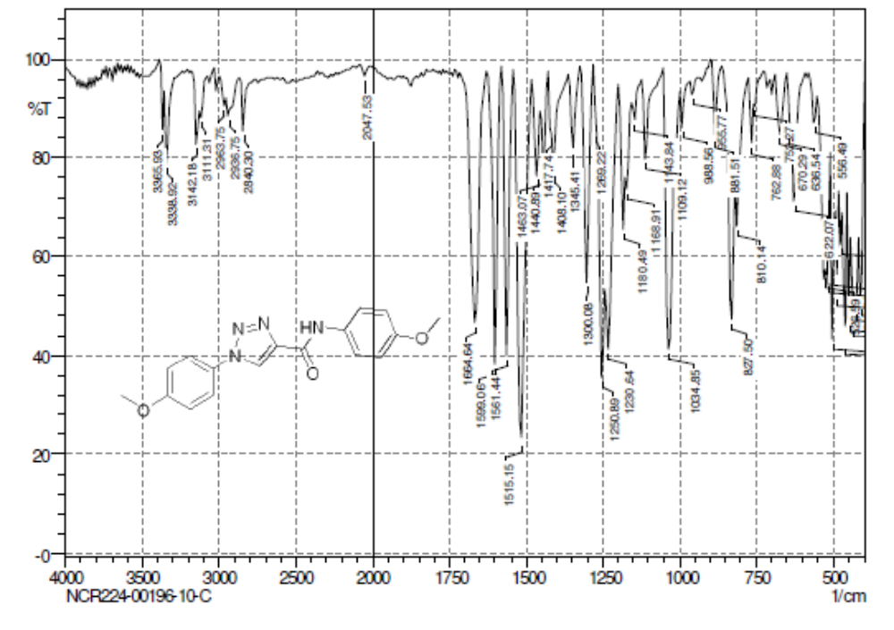
Figure S43. FT-IR of N,1-bis(4-methoxyphenyl)-1H-1,2,3-triazole-4-carboxamide (4C).
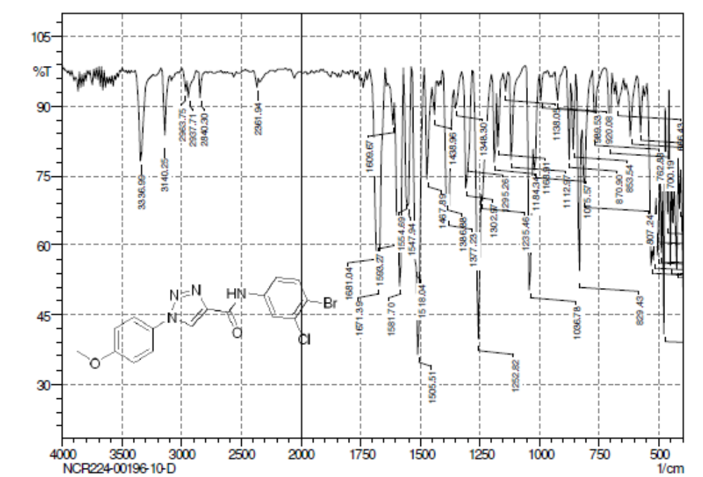
Figure S44. FT-IR of N-(4-bromo-3-chlorophenyl)-1-(4-methoxyphenyl)-1H-1,2,3-triazole-4-carboxamide (4D).
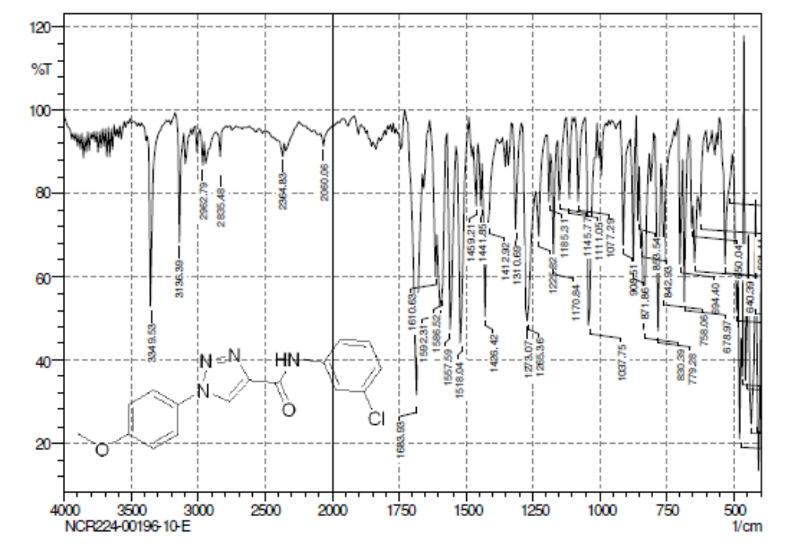
Figure S45. FT-IR of N-(3-chlorophenyl)-1-(4-methoxyphenyl)-1H-1,2,3-triazole-4-carboxamide (4E).
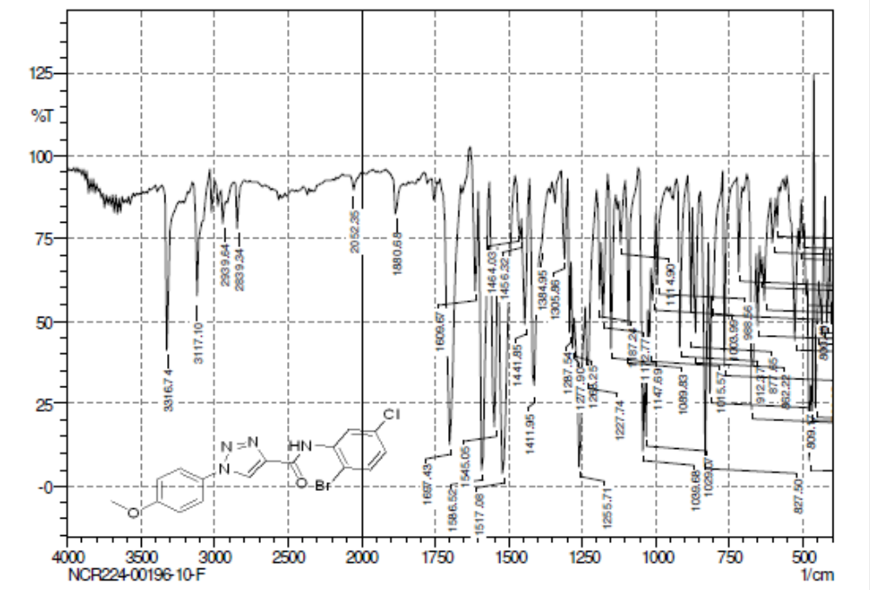
Figure S46. FT-IR of N-(2-bromo-5-chlorophenyl)-1-(4-methoxyphenyl)-1H-1,2,3-triazole-4-carboxamide (4F).
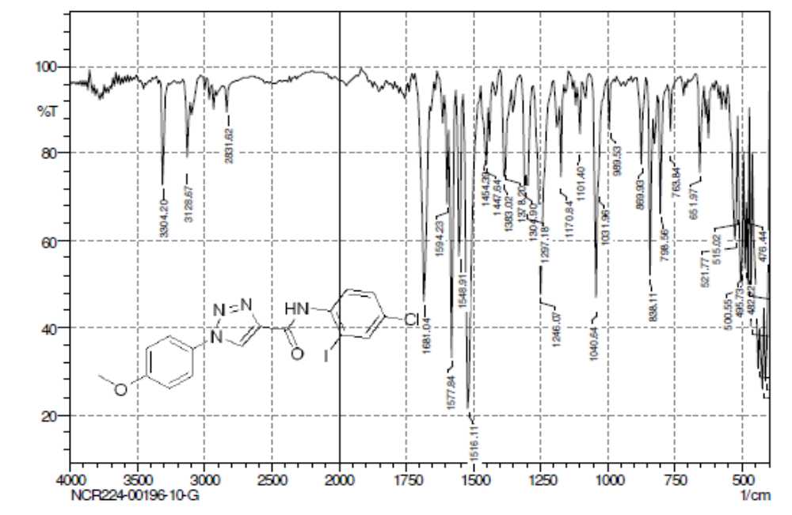
Figure S47. FT-IR of N-(4-chloro-2-iodophenyl)-1-(4-methoxyphenyl)-1H-1,2,3-triazole-4-carboxamide (4G).
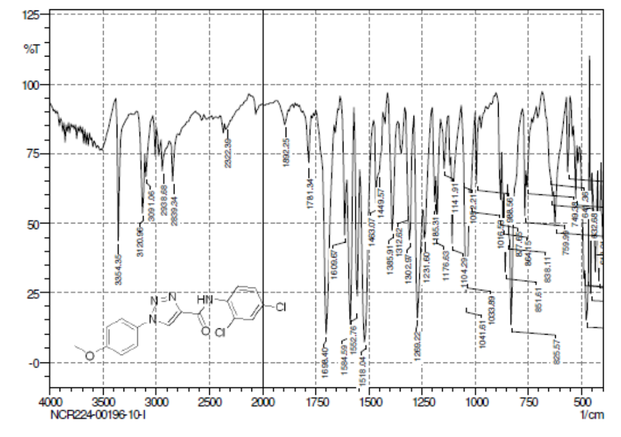
Figure S48. FT-IR of N-(2,4-dichlorophenyl)-1-(4-methoxyphenyl)-1H-1,2,3-triazole-4-carboxamide (4H).
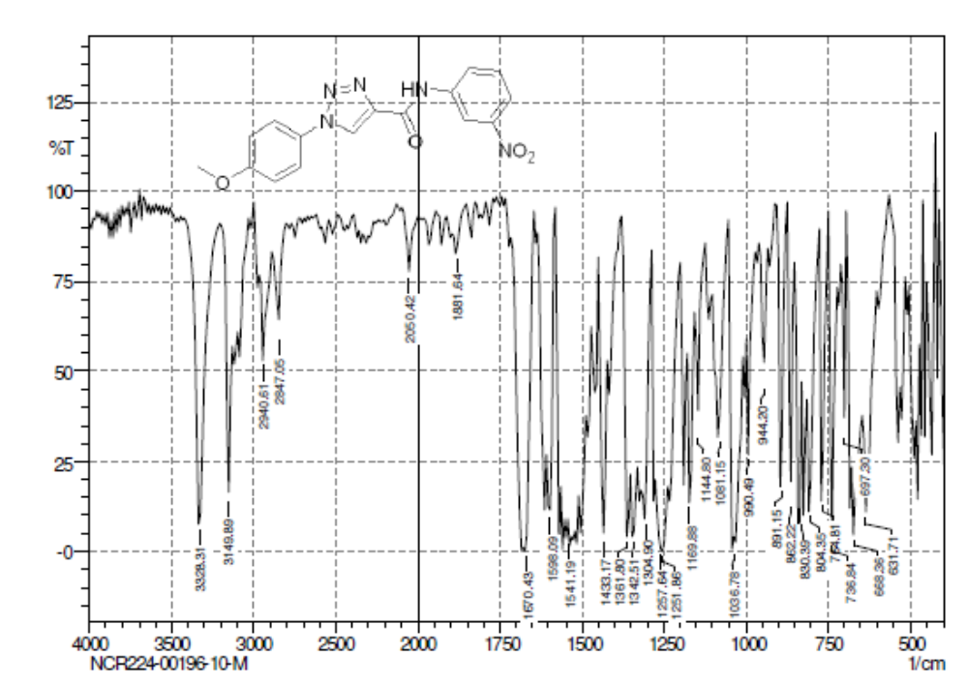
Figure S49. FT-IR of 1-(4-methoxyphenyl)-N-(3-nitrophenyl)-1H-1,2,3-triazole-4-carboxamide (4I).

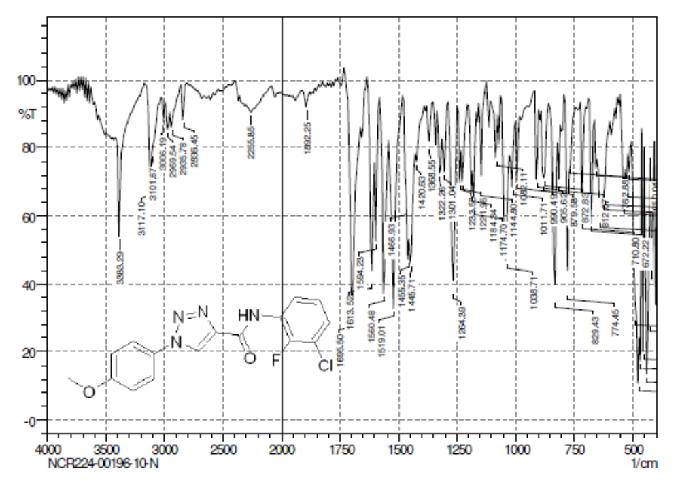
Figure S50. FT-IR of N-(3-chloro-2-fluorophenyl)-1-(4-methoxyphenyl)-1H-1,2,3-triazole-4-carboxamide (4J).
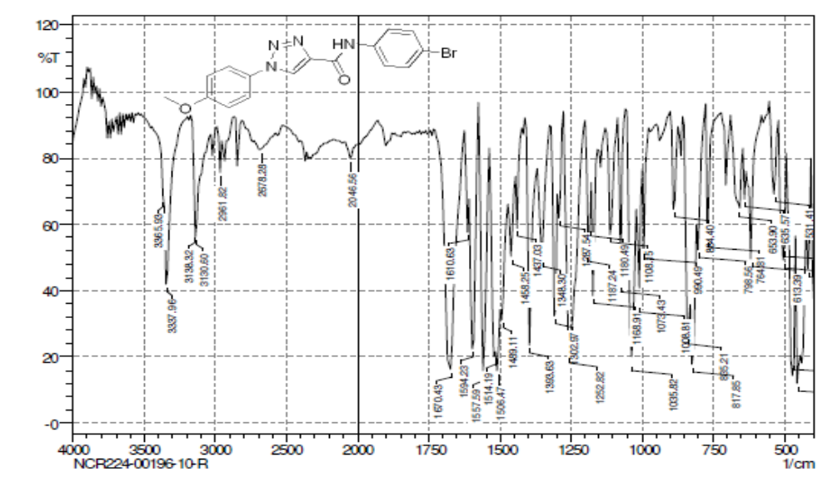
Figure S51. FT-IR of N-(4-bromophenyl)-1-(4-methoxyphenyl)-1H-1,2,3-triazole-4-carboxamide (4K).
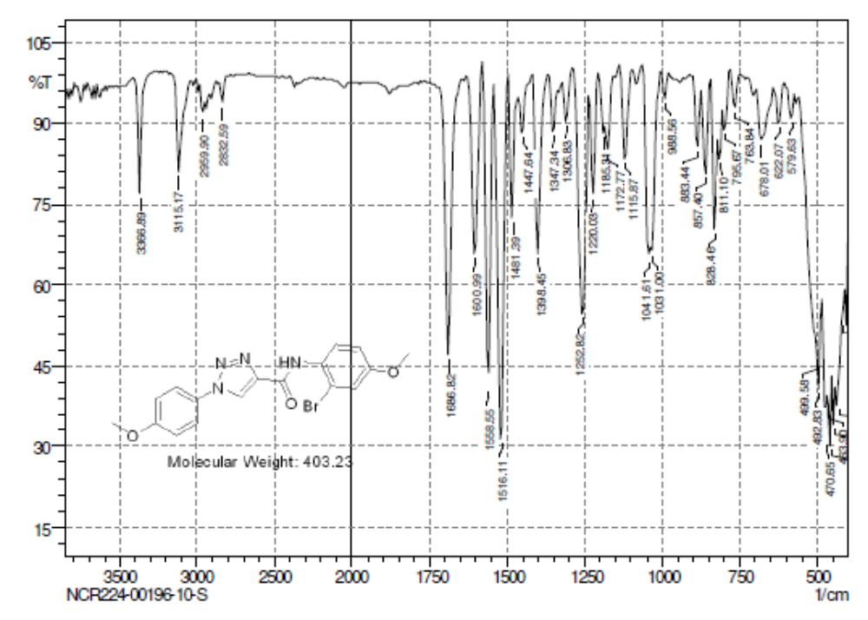
Figure S52. FT-IR of N-(3-bromo-4-methoxyphenyl)-1-(4-methoxyphenyl) -1H-1,2,3-triazole-4-carboxamide (4L).
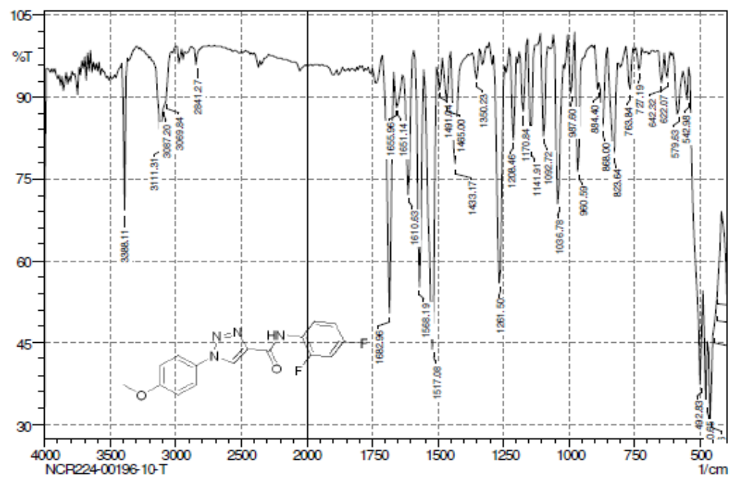
Figure S53. FT-IR of N-(2,4-difluorophenyl)-1-(4-methoxyphenyl)-1H-1,2,3-triazole-4-carboxamide (4M).
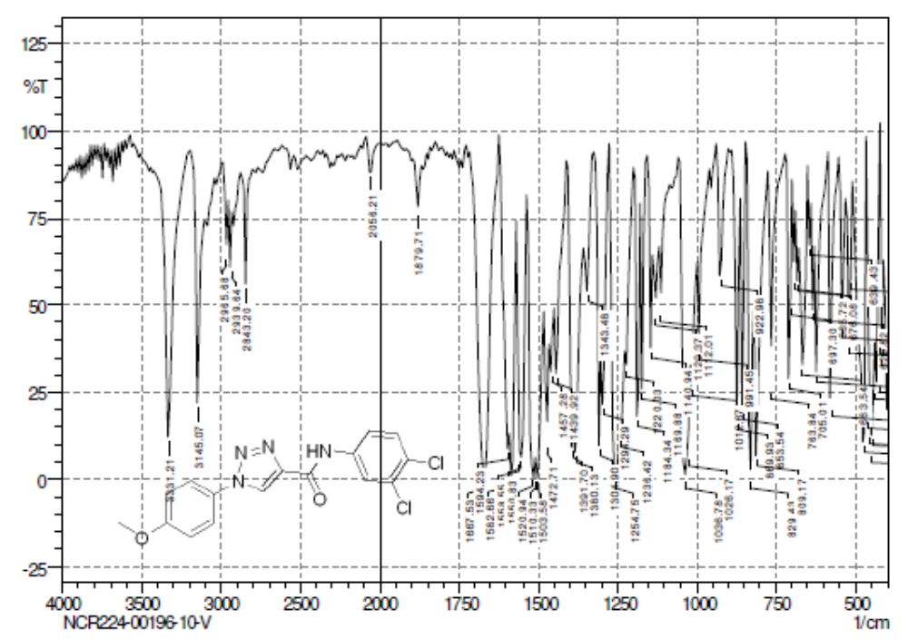
Figure S54. FT-IR of N-(3,4-dichlorophenyl)-1-(4-methoxyphenyl)-1H-1,2,3-triazole-4-carboxamide (4N).

