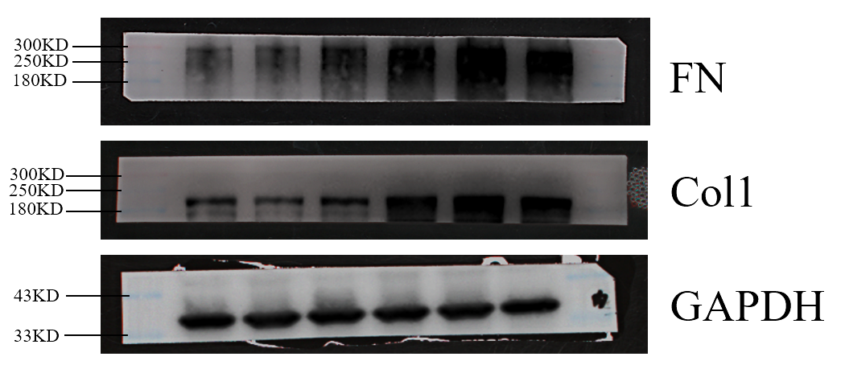
Figure S1. Uncropped images of blots presented in Figures 1M.

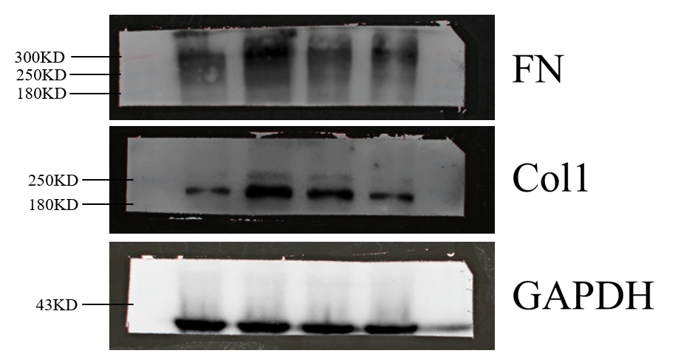
Figure S2. Uncropped images of blots presented in Figures 3P.

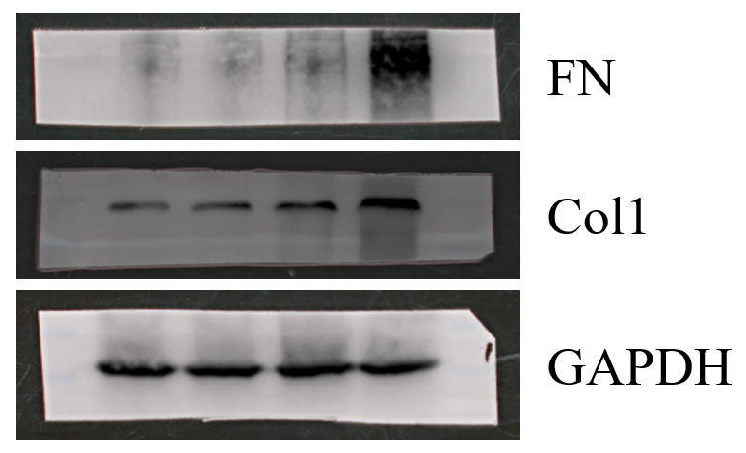
Figure S3. Uncropped images of blots presented in Figures 5X.
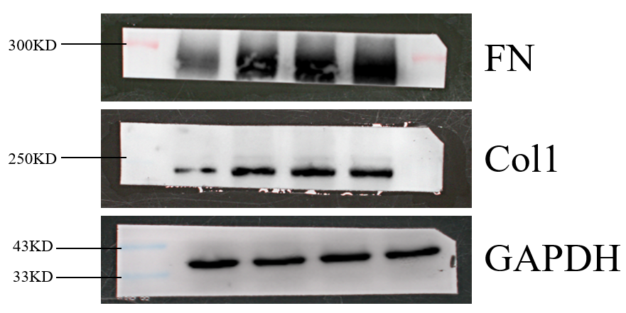
Figure S4. Uncropped images of blots presented in Figures 7M.

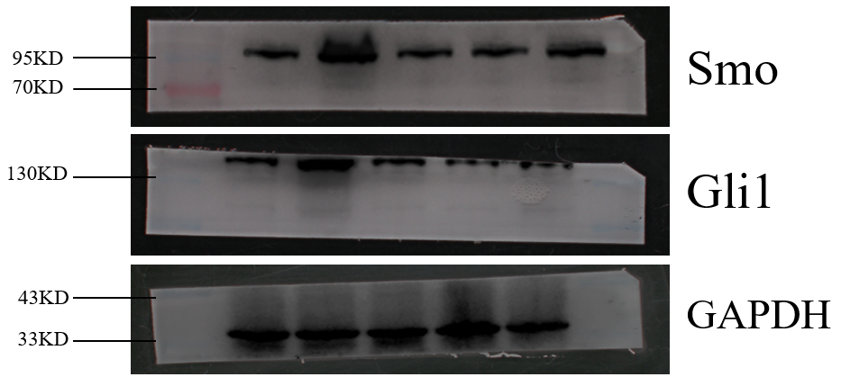
Figure S5. Uncropped images of blots presented in Figures 8A.

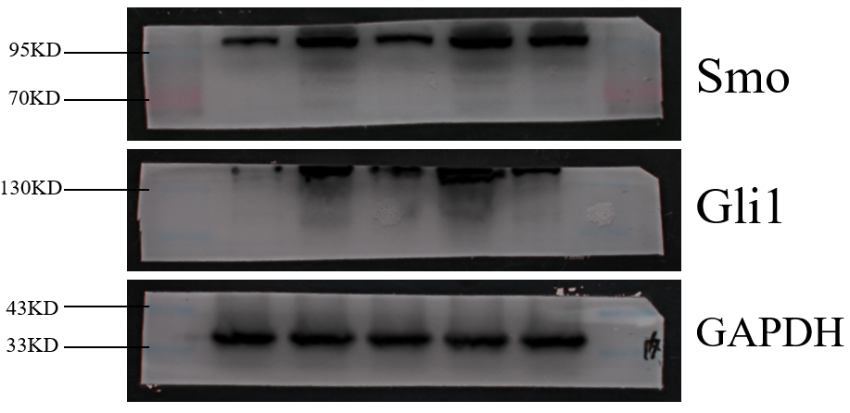
Figure S6. Uncropped images of blots presented in Figures 8B.

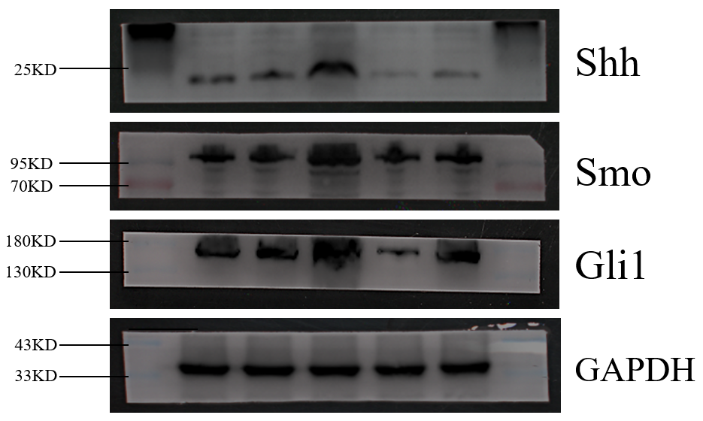
Figure S7. Uncropped images of blots presented in Figures 8C.

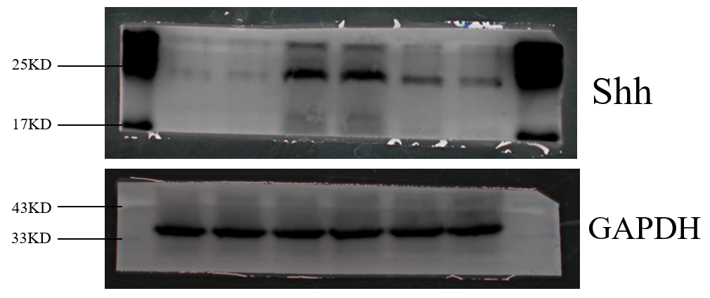
Figure S8. Uncropped images of blots presented in Figures 8E.

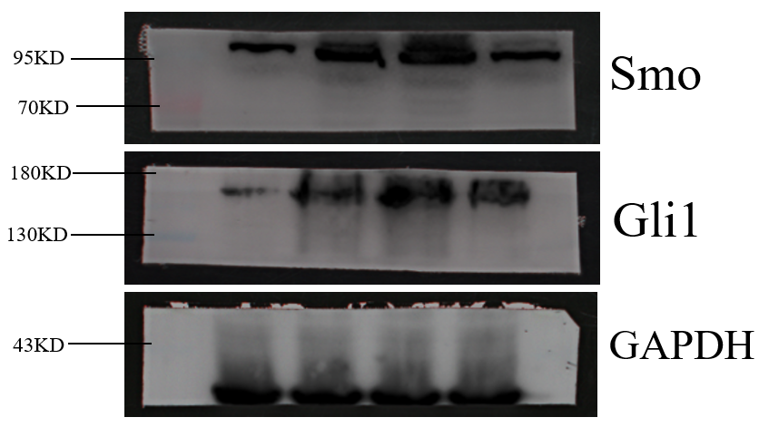
Figure S9. Uncropped images of blots presented in Figures 8F.
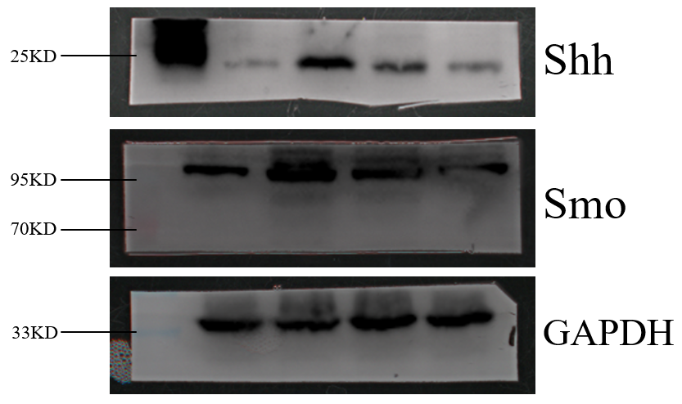
Figure S10. Uncropped images of blots presented in Figures 8G.

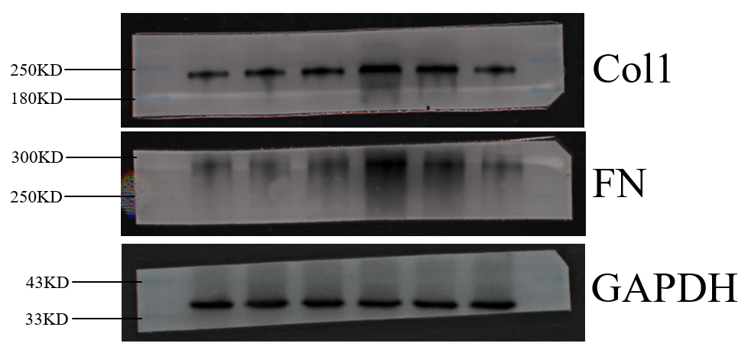
Figure S11. Uncropped images of blots presented in Figures 9A.

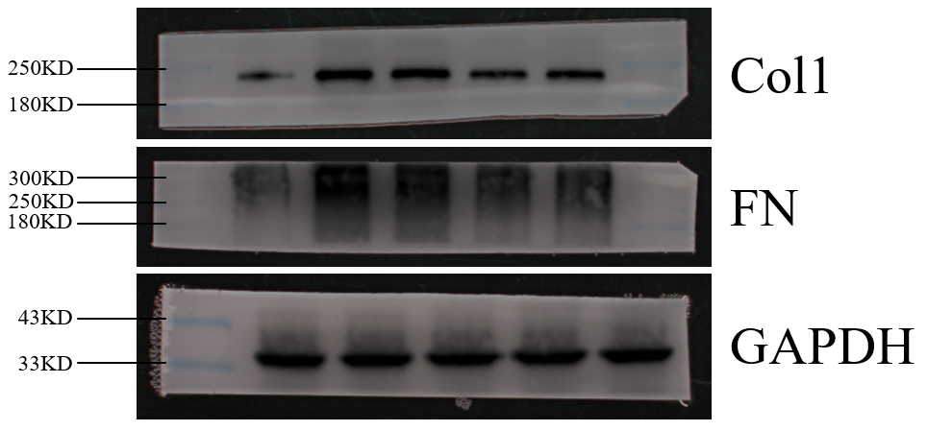
Figure S12. Uncropped images of blots presented in Figures 9C.

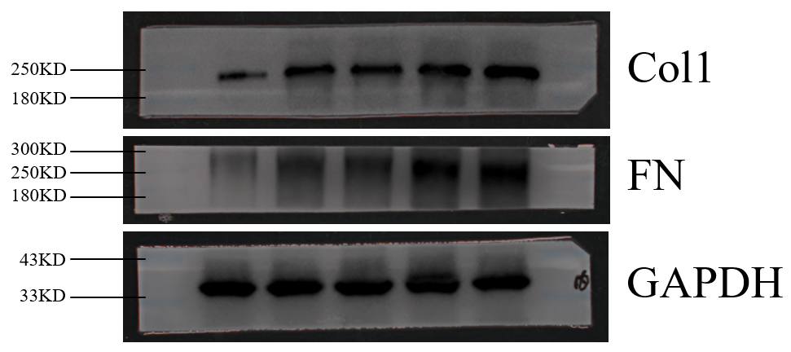
Figure S13. Uncropped images of blots presented in Figures 9E.

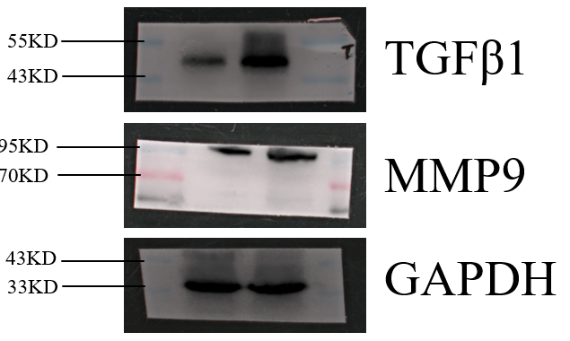
Figure S14. Uncropped images of blots presented in Figures 10A.

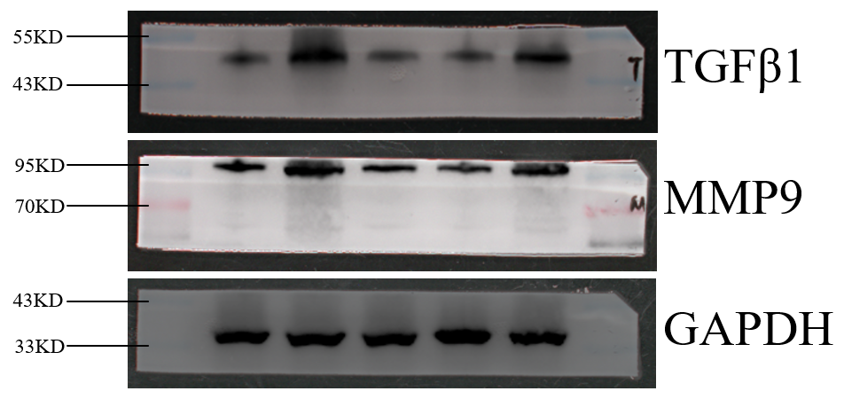
Figure S15. Uncropped images of blots presented in Figures 10B.

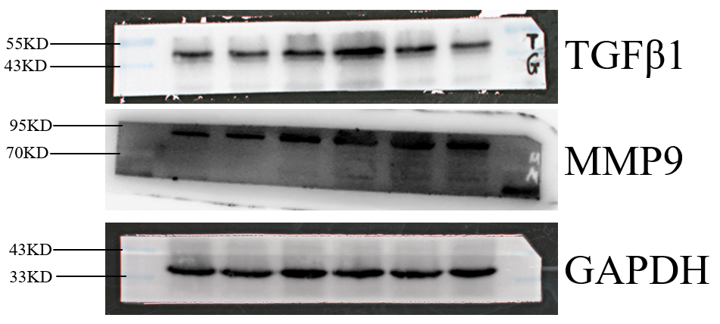
Figure S16. Uncropped images of blots presented in Figures 10D.

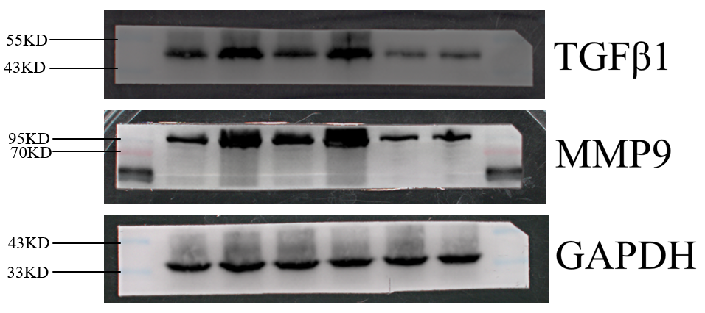
Figure S17. Uncropped images of blots presented in Figures 10E.

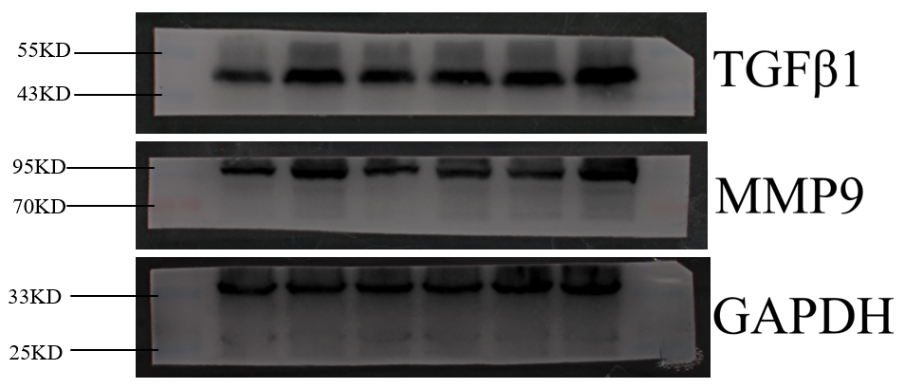
Figure S18. Uncropped images of blots presented in Figures 10F.

