Supplementary Information
Identifying and tailoring C-N coupling sites for efficient urea synthesis on diatomic Fe-Ni catalyst
Xiaoran Zhang^{1,2,‡}, Xiaorong Zhu^{3,‡}, Shuowen Bo^{4,‡}, Chen Chen^{1,*}, Mengyi Qiu¹, Xiaoxiao Wei¹, Nihan He¹, Chao Xie¹, Wei Chen¹, Jianyun Zheng^{1,*}, Pinsong Chen², San Ping Jiang^{2,*}, Yafei Li³, Qinghua Liu⁴ and Shuangyin Wang^{1,*}
¹State Key Laboratory of Chem/Bio-Sensing and Chemometrics, College of Chemistry and Chemical Engineering, Hunan University, Changsha, P. R. China.
²WA School of Mines: Minerals, Energy & Chemical Engineering, Curtin University, Perth, Western Australia 6102, Australia.
³College of Chemistry and Materials Science, Nanjing Normal University, Nanjing, Jiangsu, P. R. China.
⁴National Synchrotron Radiation Laboratory, University of Science and Technology of China, Hefei, P. R. China.
‡There authors contributed equally to this work.
E-mail: chenc@hnu.edu.cn; jyzheng@hnu.edu.cn; s.jiang@curtin.edu.au; shuangyinwang@hnu.edu.cn
Table of contents
Supplementary Figures 1-25
Supplementary Tables 1-2
Supplementary References 1-4
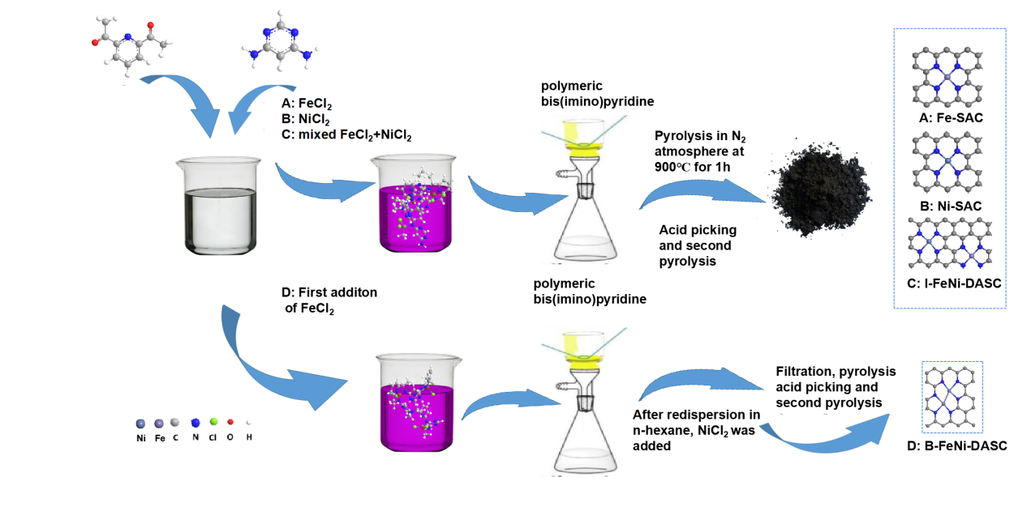Supplementary Figure 1 | Schematic illustration of the synthesis of Fe-SAC, Ni-SAC, I-FeNi-DASC and B-FeNi-DASC.
A series of single-atom catalysts (Fe-SAC and Ni-SAC), isolated diatomic catalyst (I-FeNi-SAC) and diatomic electrocatalyst with bonded Fe-Ni pair sites (B-FeNi-DASC) decorated on nitrogen-doped carbon support were obtained via pyrolysis of the coordination polymer (Bis(imino)-pyridyl ligands) as illustrated in Supplementary Fig. 1, which derived from Schiff base condensation reaction with 2,4-diaminopyrimidine and 2,6-diacetylpyridine as reactants¹.
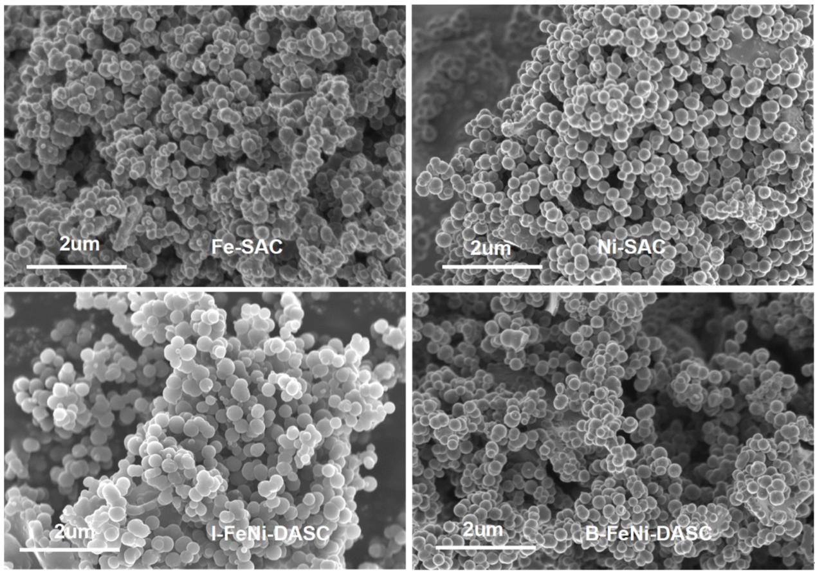
Supplementary Figure 2 | SEM images of Fe-SAC, Ni-SAC, I-FeNi-DASC and B-FeNi-DASC.
As shown in Supplementary Fig. 2, those catalysts display uniform nanosphere microstructure which derived from the self-assembly and polymerization of compounds containing amino and acyl groups.
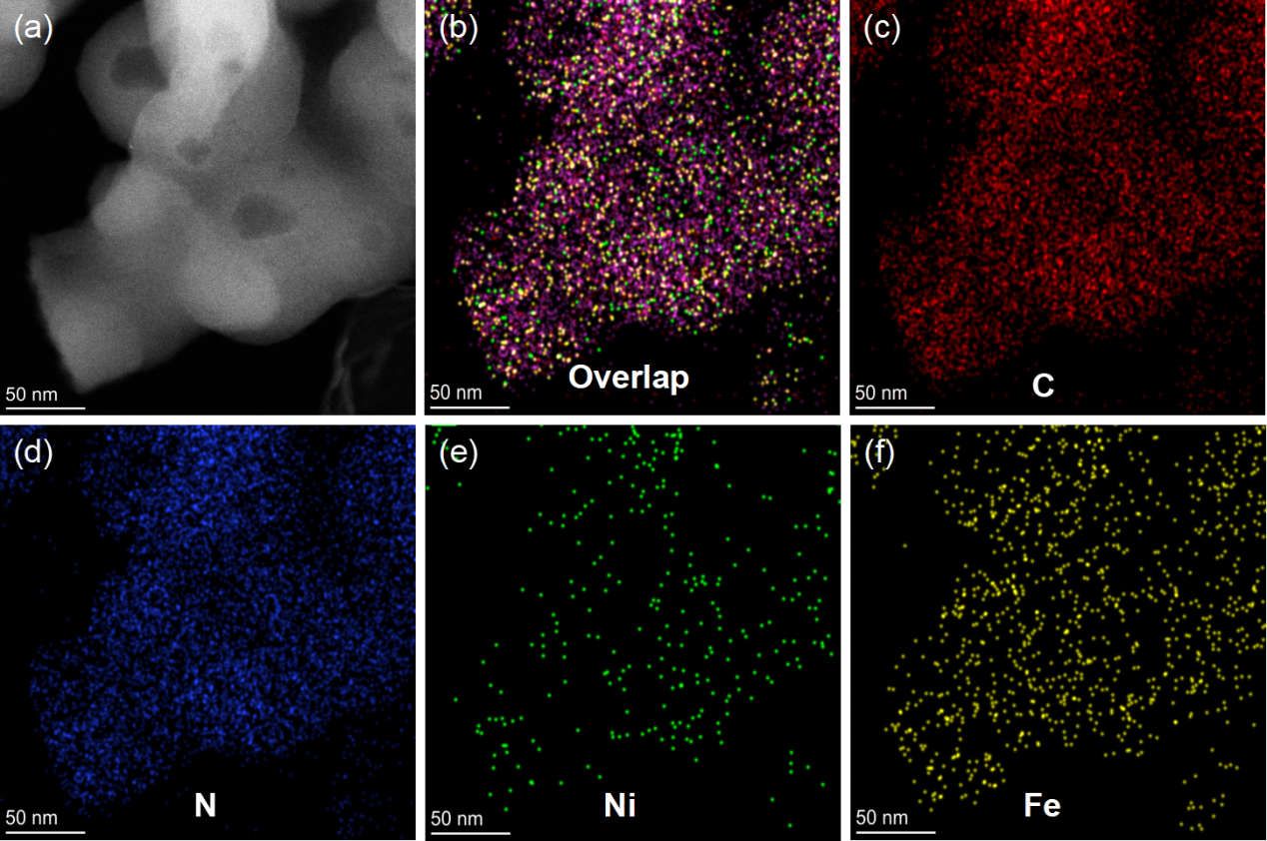
Supplementary Figure 3 | The elemental mapping images of B-FeNi-DASC.
The uniform dispersion of C, N, Fe and Ni elements over the carbon matrix was supported by the elemental mapping of the B-FeNi-DASC as illustrated in Supplementary Fig. 3.

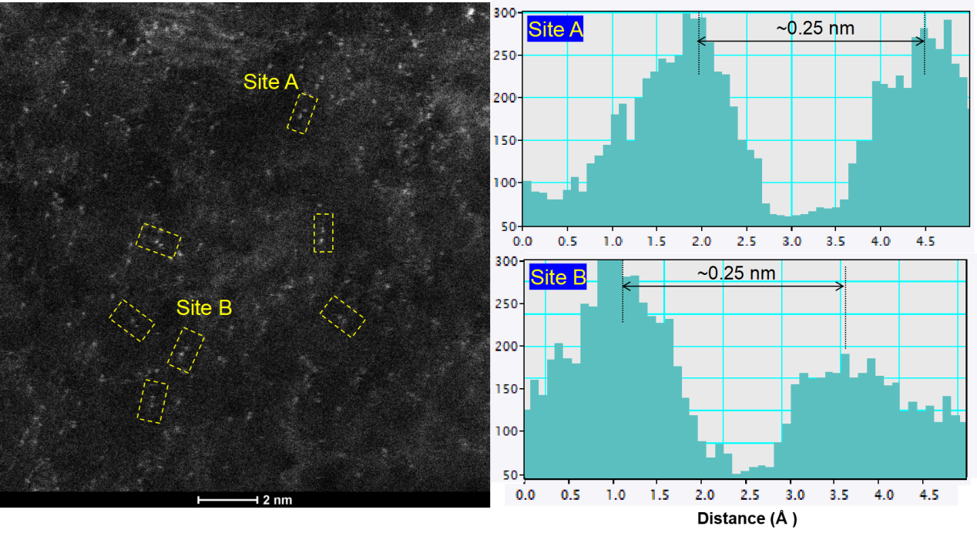Supplementary Figure 4 | Electron energy-loss spectroscopy (EELS) line scan of atomic pairs.
The atomic pair of Fe-Ni exhibits the typical distance of about 0.25 nm, serving as the solid evidence for the successful synthesis of bonded Fe-Ni site configurations, as indicated in Supplementary Figure 4.
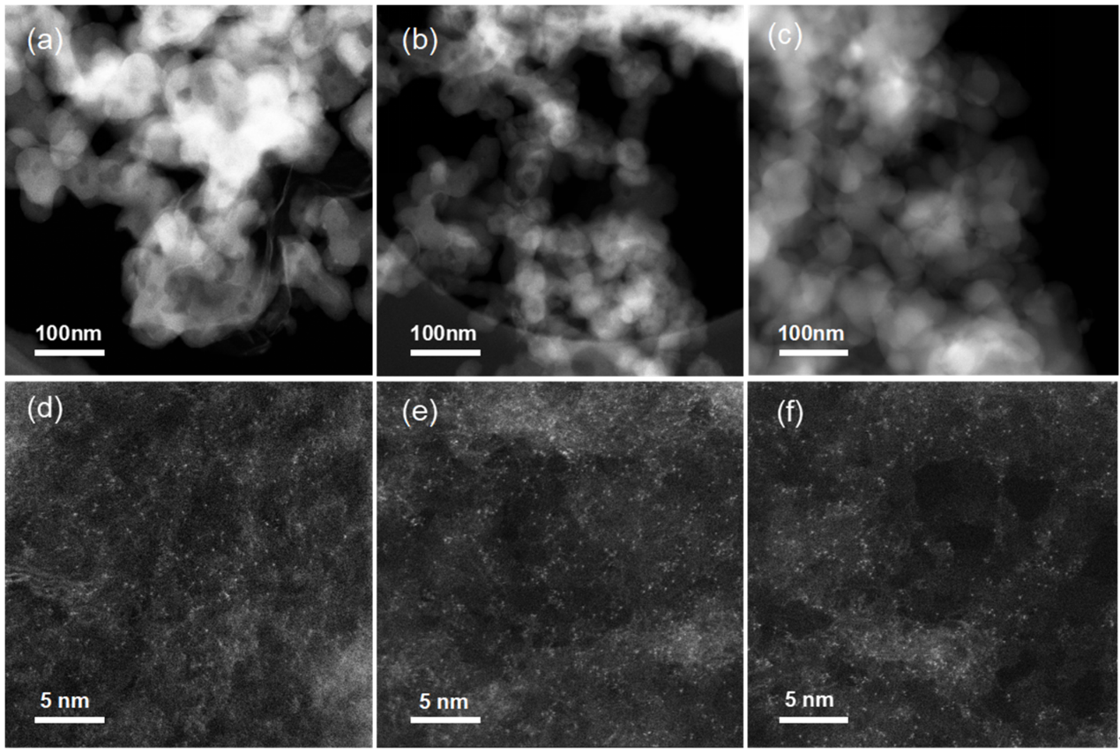
Supplementary Figure 5 | STEM images of (a, d) Fe-SAC. (b, e) Ni-SAC. (c, f) I-FeNi-DASC.
The STEM images of the above electrocatalysts show that there are highly dispersed bright dots anchored on carbon matrix, and there are no obvious metallic nanoparticles and bright dots aggregation appeared in Fe-SAC, Ni-SAC and I-FeNi-DASC, demonstrating that iron and nickel sites are exist with the form of single atoms in those materials.
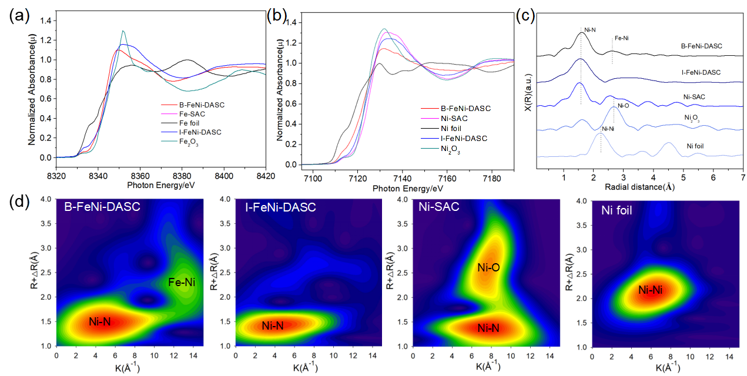
Supplementary Figure 6 | Normalized (a) Ni, (b) Fe K-edge XANES spectra of Ni foil, Fe, Fe₂O₃, Ni₂O₃, Fe-SAC, Ni-SAC, I-FeNi-DASC and B-FeNi-DASC. (c) Experimental Fourier transform at the Ni K-edge of EXAFS data of Ni foil, Fe, Fe₂O₃, Ni₂O₃, Fe-SAC, Ni-SAC, I-FeNi-DASC and B-FeNi-DASC. (d) Wavelet transforms for EXAFS signals of Fe-SAC, Ni-SAC, I-FeNi-DASC and B-FeNi-DASC.
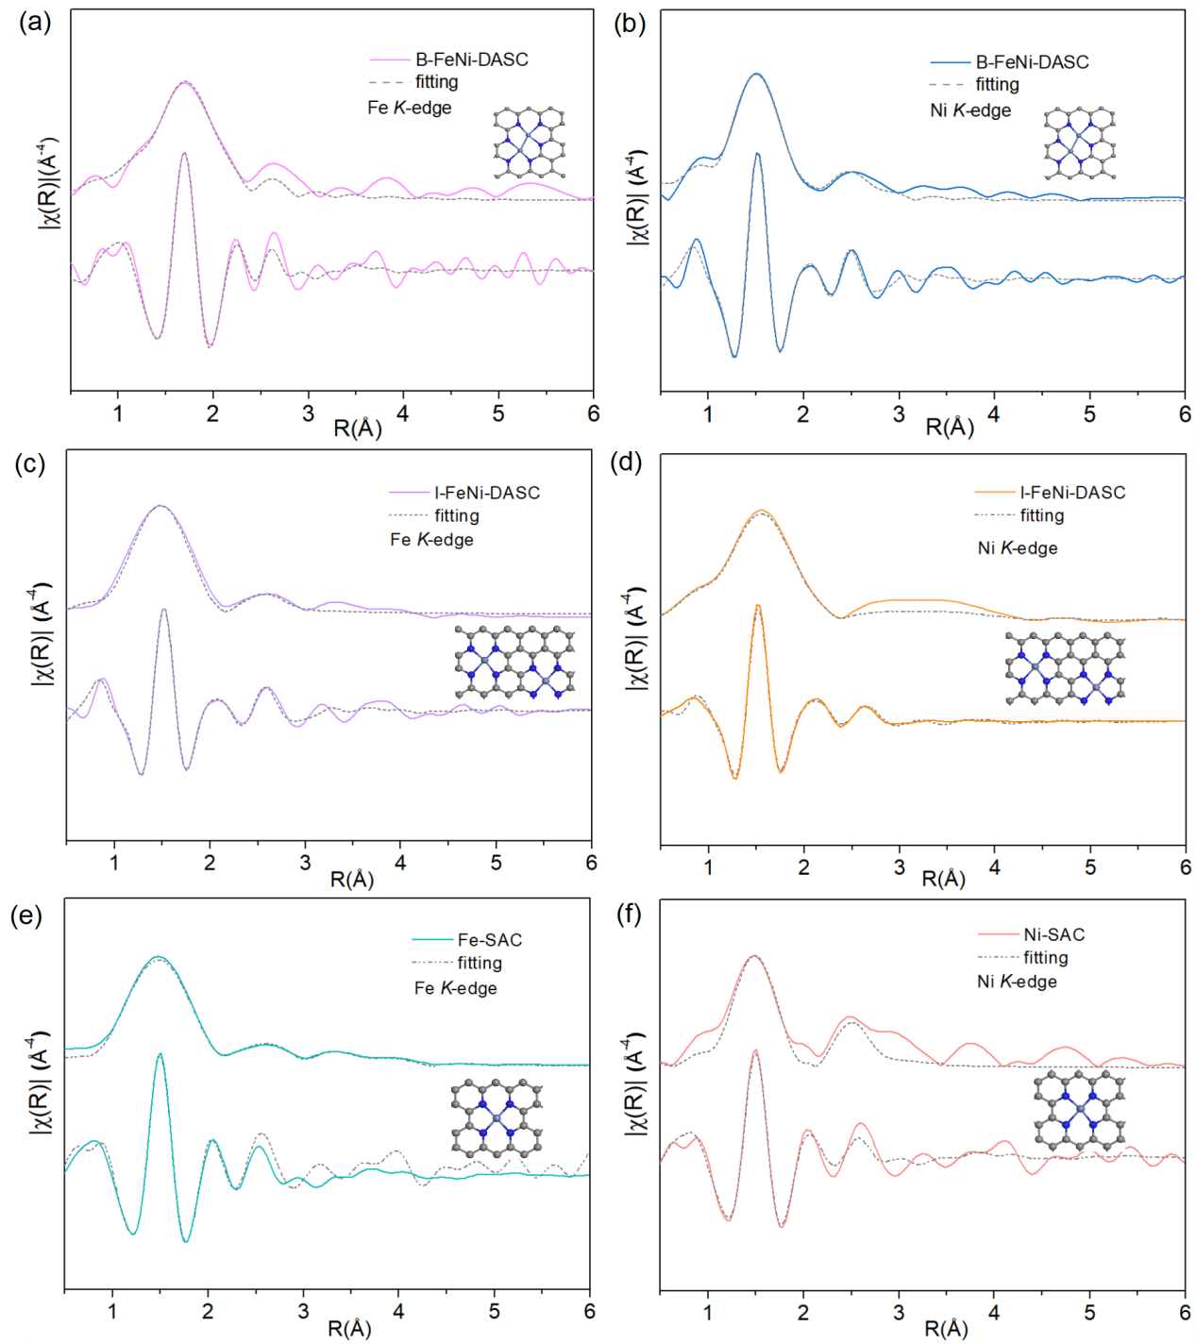
Supplementary Figure 7 | Experimental and fitted EXAFS spectra of the Fe K-edge in (a) B-FeNi-DASC, (b) Ni K-edge in B-FeNi-DASC, (c) Fe K-edge in I-FeNi-DASC, (d) Ni K-edge in I-FeNi-DASC, (e) Fe K-edge in Fe-SAC and (f) Ni K-edge in Ni-SAC. The insets show the corresponding fitted structural modeling. Purple, blue, navy blue and grey spheres refer to Fe, Ni, N and C atoms, respectively.
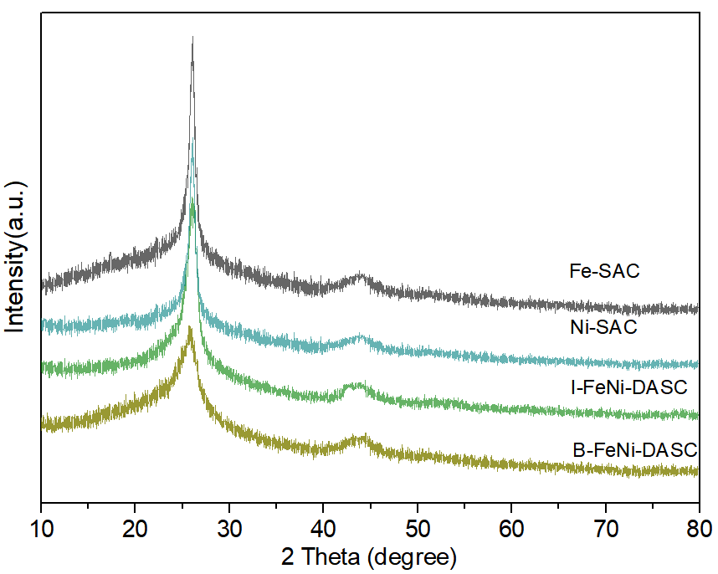
Supplementary Figure 8 | X-ray diffraction (XRD) spectra of Fe-SAC, Ni-SAC, I-FeNi-DASC and B-FeNi-DASC.
The crystal structure of the these electrocatalysts were analyzed by X-ray diffraction spectroscopy, which shows that the four catalysts share similar XRD peaks located at around 26.3° associated with (002) planes of graphitic carbon (PDF#41-1487) and weak diffraction peak at around 43.5° overlapped with that (100) plane of graphitized carbon. Meanwhile, there are no peaks associated with the metallic phase, suggesting the successful fabrication of material with atomically dispersed sites².
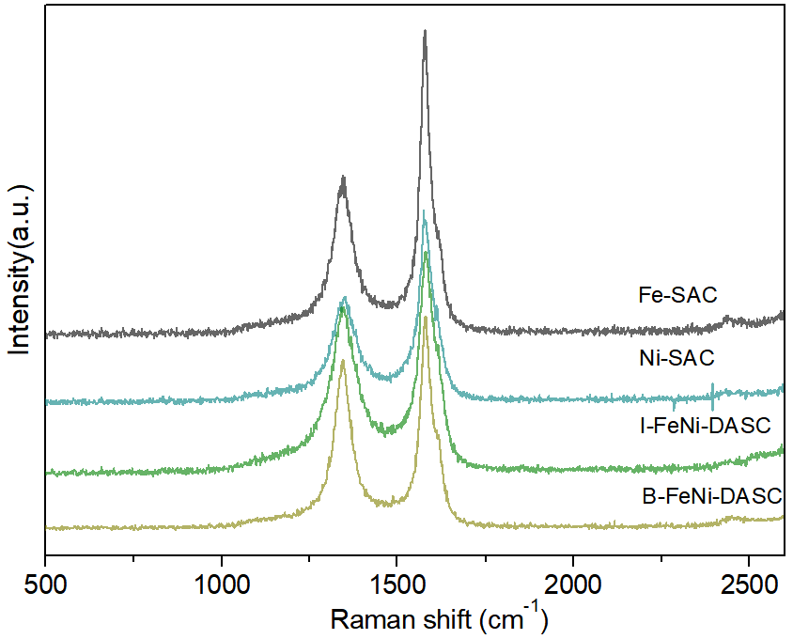
Supplementary Figure 9 | Raman spectra of Fe-SAC, Ni-SAC, I-FeNi-DASC and B-FeNi-DASC.
As presented in Supplementary Fig. 9, Raman spectra indicate that defects exist in those materials, which may be derived from polymer pyrolysis as well as the introduction of Fe, Ni, N, O dopants into carbon matrix. In addition, it is found that these samples share the similar degree of graphitization.
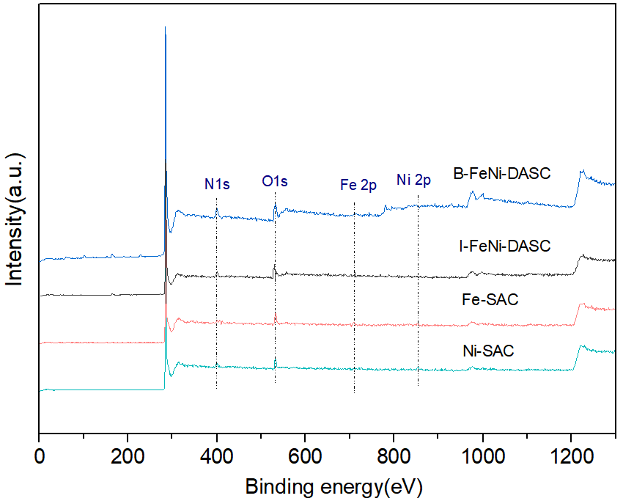
Supplementary Figure 10 | The XPS survey scans in Fe-SAC, Ni-SAC, I-FeNi-DASC and B-FeNi-DASC.
The XPS survey spectra of the single-atom and diatomic electrocatalysts clearly show the presence of corresponding C, N, O and Fe, Ni elements respectively, serving as the evidence for the successful doping of Fe, Ni, or co-doping of Fe and Ni into carbon matrix.
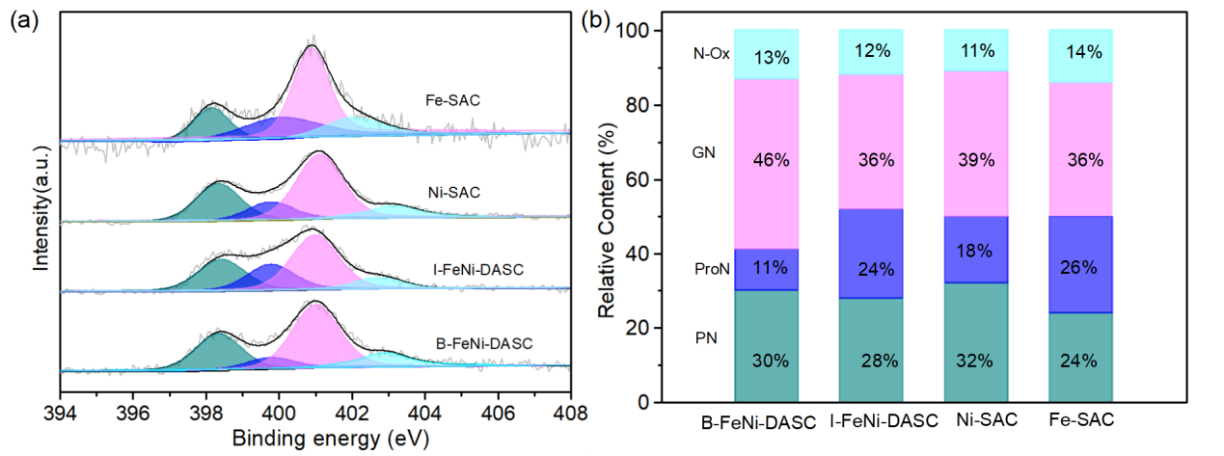
Supplementary Figure 11 | High-resolution XPS spectra of N 1s in Fe-SAC, Ni-SAC, I-FeNi-DASC and B-FeNi-DASC.
Nitrogen is the most important heteroatom dopant in enhancing and manipulating the carbon based electrocatalysts. In single-atom system, the doped N not only acts as the central element of the TM-N₄ center, but also as the host dopant element with high content widely distributed on the carbon matrix around the TM-N₄. The presence of various N species would have significant effect on the chemical and electronic surrounding environment of TM-N₄ sites. The contents of each N species in these samples were detected (Supplementary Fig. 11). The N 1s spectra were deconvoluted into four peaks of pyridinic N (398.4 eV), graphitic N (399.9 eV), pyrrolic N (401.3 eV) and oxidized N (403.2 eV)³.
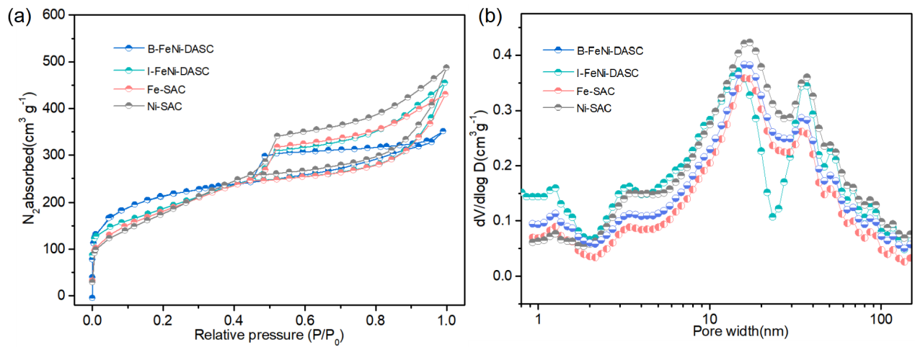
Supplementary Figure 12 | (a) Nitrogen adsorption-desorption isotherms and (b) pore size distribution for Fe-SAC, Ni-SAC, I-FeNi-DASC and B-FeNi-DASC.
Sufficient specific surface area and rational pore structure are conducive to exposing active sites and mass transfer during catalytic process for urea synthesis. Brunauer-Emmett-Teller (BET) surface area and pore size distribution information of these materials are list in Supplementary Fig. 12. It is found that the porous nanospheres anchored with single sites exhibit similar specific surface area of Fe-SAC (864 m² g⁻¹), Ni-SAC (872 m² g⁻¹), I-FeNi-DASC (907 m² g⁻¹) and B-FeNi-DASC (886 m² g⁻¹) as well as hierarchical pore structure of partial mesoporous combined with most of micropore, providing a good mass transfer circumstances for catalytic process.
Supplementary Figure 13 | The schematic diagram of electrochemical measuring apparatus.
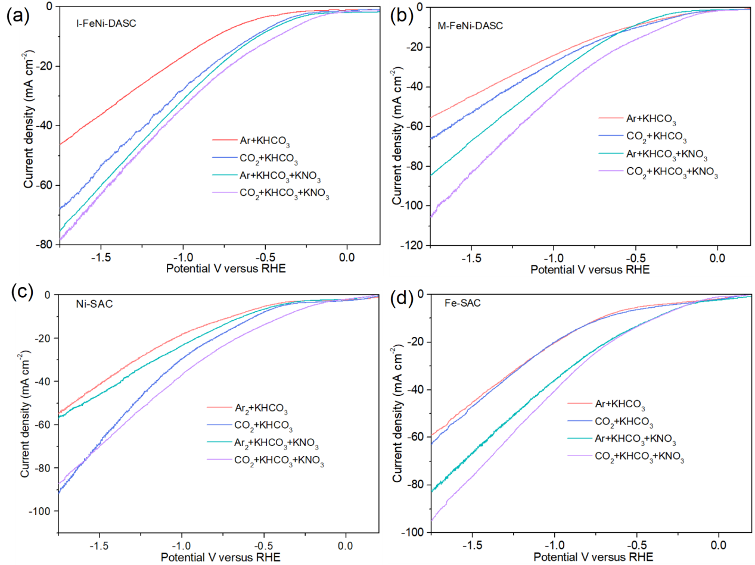
Supplementary Figure 14 | LSV curves for electrolysis of (a) I-FeNi-DASC, (b) M-FeNi-DASC, (c) Ni-SAC and (d) Fe-SAC in the electrolytes of Ar-saturated 0.1 M KHCO₃, CO₂-saturated 0.1MKHCO₃, Ar-saturated 0.1 M KHCO₃ with 50 mM KNO₃ and CO₂-saturated 0.1 M KHCO₃ with 50 mM KNO₃ respectively, the scan rate is 10 mV s⁻¹.
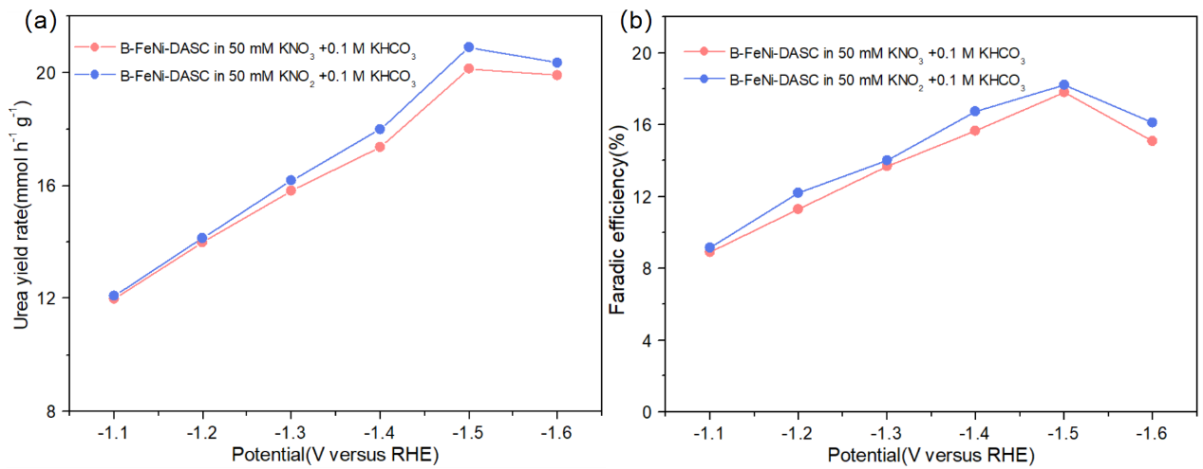
Supplementary Figure 15 | (a) The Urea yield rates and (b) corresponding Faradaic efficiencies of B-FeNi-DASC in electrolytes of CO₂-saturated 0.1 M KHCO₃ with 50 mM KNO₃ and CO₂-saturated 0.1 M KHCO₃ with 50 mM KNO₂.
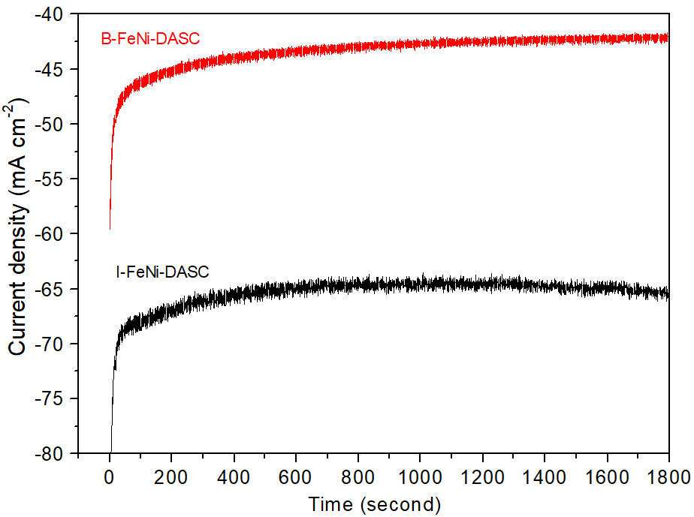
Supplementary Figure 16 | The i-t curves for electrocoupling over B-FeNi-DASC and I-FeNi-DASC at -1.5 V versus RHE.
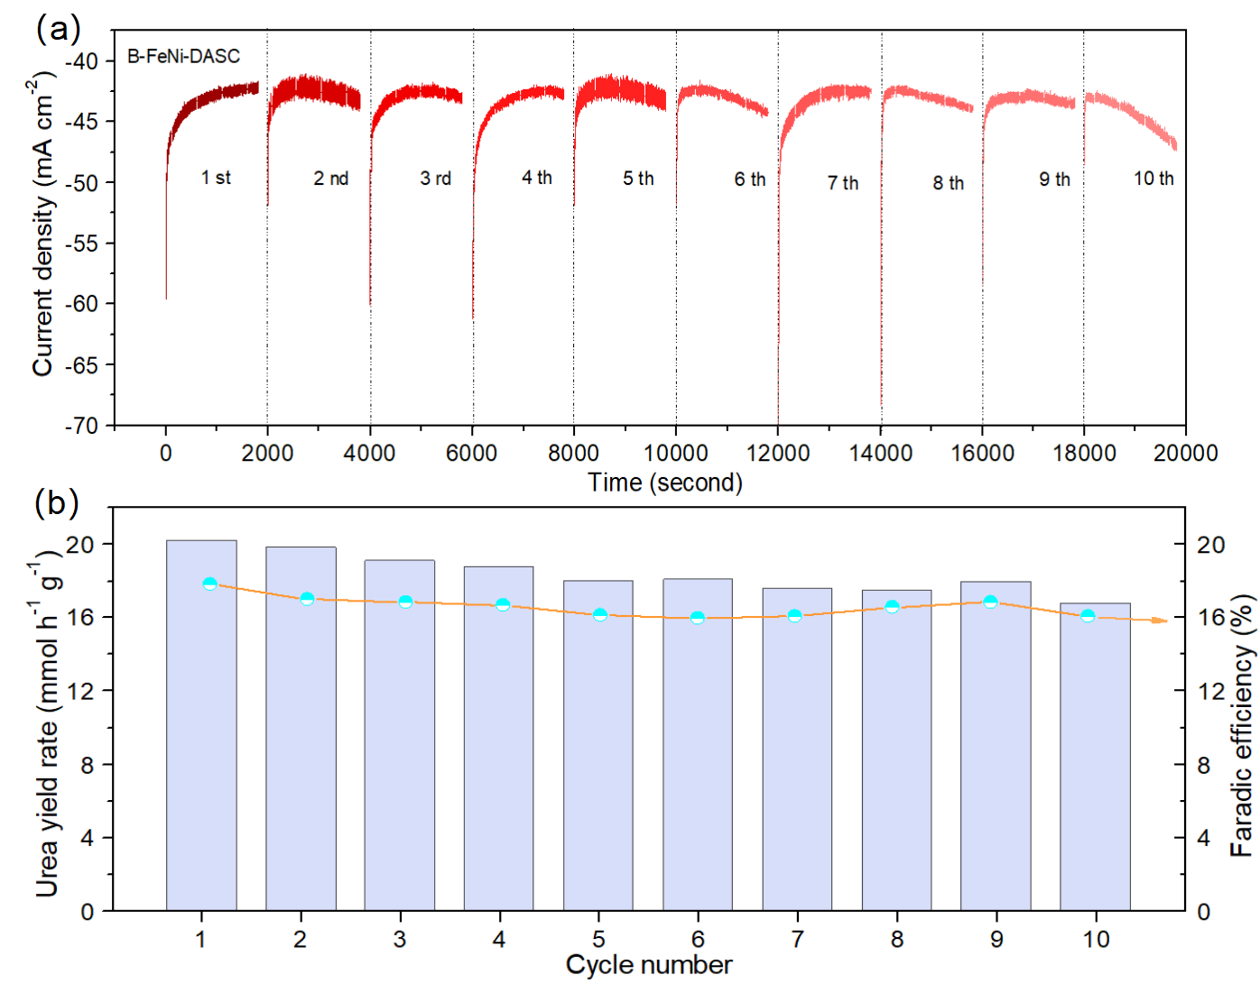
Supplementary Figure 17 | (a) The i-t curves for C-N coupling and (b) urea yield rates and Faradaic efficiencies over B-FeNi-DASC at -1.5 V versus RHE during ten continuous cycles.
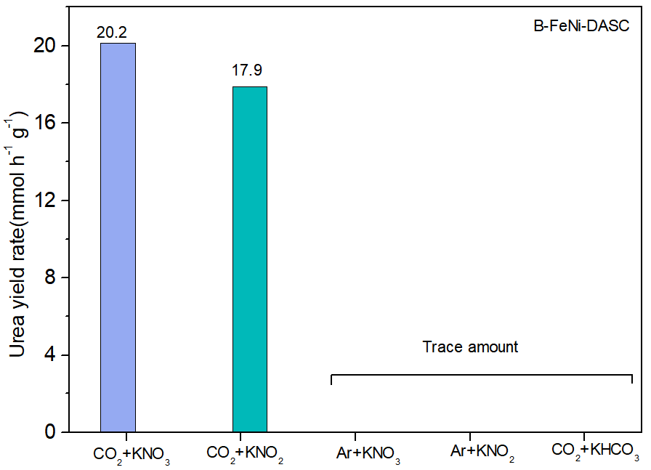
Supplementary Figure 18 | Comparison of urea yield rates in CO₂-saturated 0.1 M KHCO₃ with 50 mM KNO₃, CO₂-saturated 0.1 M KHCO₃ with 50 mM KNO₂, Ar-saturated 0.1 M KHCO₃ with 50 mM KNO₃, Ar-saturated 0.1 M KHCO₃ with 50 mM KNO₂ and CO₂-saturated 0.1 M KHCO₃, respectively, over B-FeNi-DASC at -1.5 V versus RHE.
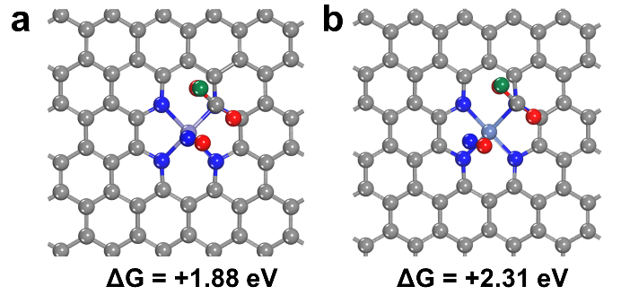
Supplementary Figure 19 | The optimized geometry structures of *NO and *COOH co-adsorbed (a) Fe-Ni₄ and (b) Ni-N₄ respectively. The *COOH formation free energies were also listed.
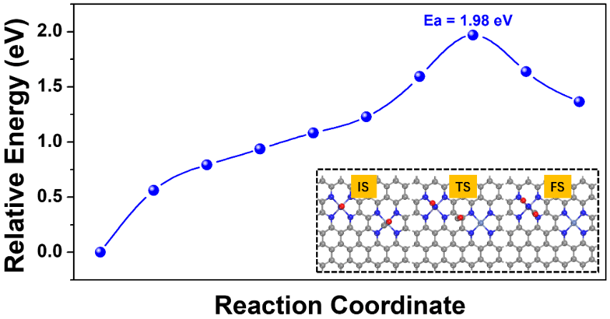
Supplementary Figure 20 | The kinetic energy barrier of *CO+*NO coupling on FeN₄-NiN₄.The insert frame included the optimized structures of initial state, transition state and finial state along the reaction pathway.
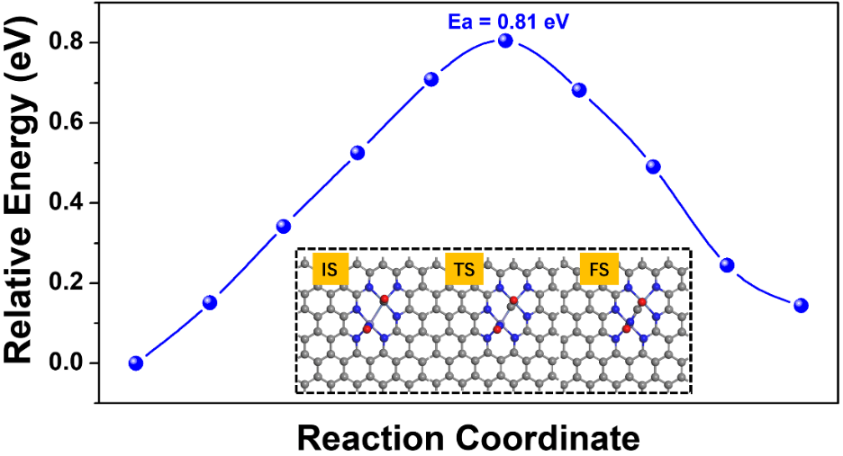
Supplementary Figure 21 | The kinetic energy barrier of *CO+*NO coupling on FeNi-N₆.The insert frame included the optimized structures of initial state, transition state and finial state along the reaction pathway.
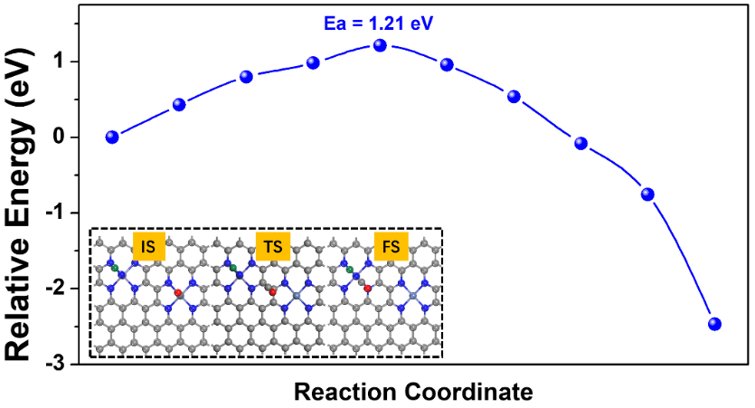
Supplementary Figure 22 | The kinetic energy barrier of *CO+*NH coupling on FeN₄-NiN₄.The insert frame included the optimized structures of initial state, transition state and finial state along the reaction pathway.
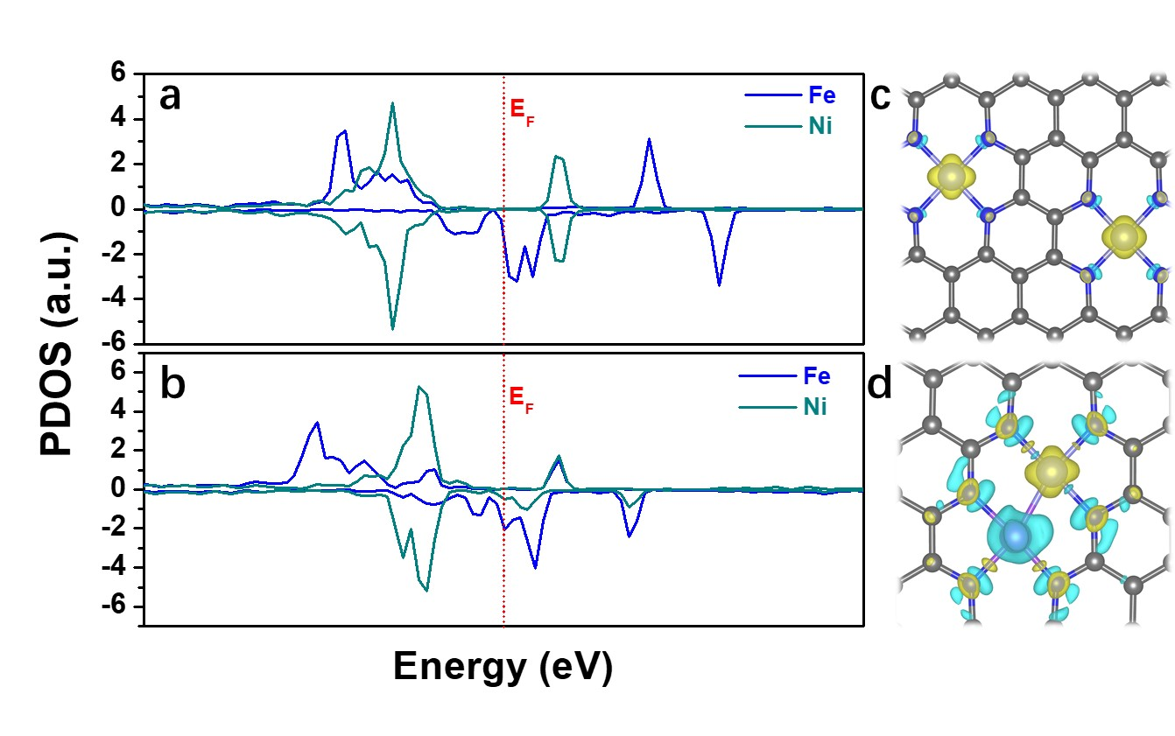
Supplementary Figure 23 | The partial density of states (PDOS) of 3d orbitals of (a) I-FeNi-DASC and (b) B-FeNi-DASC. The differential charge density maps of (c) I-FeNi-DASC and (d) B-FeNi-DASC.
Supplementary Figure 24 | The structural modeling along the urea synthetic path over FeNi-N₆ configuration. The inset values are the Gibbs free energy changes and energy barriers, respectively.
Supplementary Figure 25 | The quantification of ammonia by the indophenols blue method⁴. (a) The absorption curves of indophenols blue method with various concentrations of ammonia. (b) The calibration curve for ammonia quantification, the absorbance at 660 nm exhibits linear relationship with the concentration of ammonia (y=0.3665x+0.0334, R²=0.999).
Supplementary Table 1 | Fe and Ni K-edge EXAFS curve-fitting parameters for SACs and reference samples.
Samples | Path | N | R(Å) | σ²(×10⁻³ Å²) | ΔE₀ | R-factor
Fe-foil | Fe-Fe | 8 | 2.46 | 5.0 | 5.5 | 0.02
Ni-foil | Ni-Ni | 12 | 2.47 | 5.0 | 6.4 | 0.0176
B-FeNi-DASC | Fe-Ni | 6 | 2.49 | 8.0 | 6.2 | 0.016
I-FeNi-DASC | Fe-N | 4 | 2.04 | 8.0 | 5.3 | 0.04
I-FeNi-DASC | Ni-N | 4 | 1.99 | 7.0 | 5.3 | 0.04
Fe-SAC | Fe-N | 4 | 2.09 | 6.0 | 4.2 | 0.033
Ni-SAC | Ni-N | 4 | 2.10 | 8.1 | 6.9 | 0.04
Note: N is coordination number, R is the distance between absorber and backscatter atoms, σ² is Debye-Waller Factor, E_{shift} is inner potential correction; R-factor indicates the goodness of the fit.
Supplementary Table 2 | The quality contents (wt%) of Fe, Ni, C, O and N elements in the catalysts.
Electrocatalysts | Fe | Ni | C | O | N
Fe-SAC | 1.792 | － | 89.98 | 4.088 | 4.14
Ni-SAC | － | 1.566 | 90.83 | 3.284 | 4.32
I-FeNi-DASC | 0.992 | 0.879 | 90.12 | 3.619 | 4.39
B-FeNi-DASC | 0.991 | 0.896 | 89.84 | 3.863 | 4.41
Supplementary references
- Zhang, X. et al. N species tuning strategy in N, S co-doped graphene nanosheets for electrocatalytic activity and selectivity of oxygen redox reactions. Chem. Eng. J. 431, 133216 (2021).
- Liu, J. et al. High performance platinum single atom electrocatalyst for oxygen reduction reaction. Nat. Commun. 8, 1-10 (2017).
- Xu, Y. et al. Highly nitrogen doped carbon nanofibers with superior rate capability and cyclability for potassium ion batteries. Nat. Commun. 9, 1-11 (2018).
- Chen, C. et al. B-N Pairs Enriched Defective Carbon Nanosheets for Ammonia Synthesis with High Efficiency. Small 15, 1805029 (2019).

