e-Fig. 1. Flow diagram

Identification of studies via other methods
Identification of studies via databases and registers

Records identified from:
MEDLINE (n = 863)
CENTRAL (n = 1372)
WHO ICTRP (n = 134)
Clinicaltrials.gov (n = 175)
Update:
MEDLINE (n = 23)
CENTRAL (n = 39)
WHO ICTRP (n = 3)
Clinicaltrials.gov (n = 8)
Records identified from:
Websites (n = 0)
Organisations (n = 0)
Citation searching (n = 1)
Records removed before screening:
Duplicate records removed (n = 454)
Records marked as ineligible by automation tools (n = 0)
Records removed for other reasons (n = 0)

Identification

Records screened
(n = 2163)
Records excluded**
(n = 2075)

Reports not retrieved
(n = 0)
Reports sought for retrieval
(n = 1)
Reports sought for retrieval
(n = 88)
Reports not retrieved
(n = 0)

Screening

Reports excluded (n = 0)
Reports excluded:
Wrong publication type (n = 44)
Wrong study design (n = 7)
Wrong drug (n = 6)
Background article (n = 2)
Wrong outcome (n = 2)
Duplicate (n = 2)
Wrong population (n = 1)
Reports assessed for eligibility
(n = 1)
Reports assessed for eligibility
(n = 88)

Studies included in review
(n = 17)
Reports of included studies
(n = 7)
Included

Abbreviations: ICTRP, international clinical trials registry platform; WHO, world health organization.

e-Table 3. Numbers of studies and patients of each outcome for pairwise comparison
(a) Short-term mortality
Comparisons | Number of studies | Number of patients
Within 4 days vs. 5–12 days | 2 | 160
Within 4 days vs. 13 days or later | 4 | 442
5–12 days vs. 13 days or later | 1 | 419

(b) Adverse events
Comparisons | Number of studies | Number of patients
Within 4 days vs. 5–12 days | 1 | 60
Within 4 days vs. 13 days or later | 4 | 442
5–12 days vs. 13 days or later | 1 | 419

e-Table 4. Characteristics of the included studies
Study  Author year | Country | Number | Age [mean (SD)], years † | Patient characteristics (reason for ICU admission) | Industry funded | Comparison
Rumbak 2004 | USA | 120 | 63 (10.4) vs. 63 (9.3) | Critically ill patients (traumatic and non-traumatic patients) | No | Within 2 days after intubation vs. 14–16 days after intubation
Blot 2008 | France | 123 | 55 (19–88) vs. 50 (20–88) †† | Critically ill patients (traumatic and non-traumatic patients) | Yes | Within 4 days after intubation vs. 14 days or later after intubation
Terragni 2010 | Italy | 419 | 61.8 (17.4) vs. 61.3 (16.8) | Acute respiratory failure without pulmonary infection | Yes | 6–8 days after intubation vs. 13–15 days after intubation
Koch 2012 | Germany | 100 | 62.5 (39.8–76) vs. 55 (47–72) †† | After surgery | No | Within 4 days after intubation vs. 6 days or later after intubation
Zheng 2012 | China | 119 | 67.5 (14.7) vs. 67.9 (17.6) | Critically ill patients (traumatic and non-traumatic patients) | Unclear | 3 days after intubation vs. 15 days after intubation
Bösel 2013 | Germany | 60 | 61 (12) vs. 61 (13) | Severe ischemic or haemorrhagic stroke | Yes | Within 3 days after intubation vs. 7–14 days after intubation†††
ZORAN 2018 | Bosnia and Hercegovina | 80 | 60 (13) vs. 61.5 (28) | After surgery and trauma | Unclear | 2–4 days after intubation vs. 15 days or later after intubation
†This sentence is described as early tracheostomy vs late tracheostomy.
††This sentence is described as early tracheostomy vs late tracheostomy and median [interquartile range (IQR)].
†††In the late tracheostomy group, tracheostomy was performed at 10.5 (9–11) days [median (IQR)] after intubation. Therefore, we included this study into the tracheostomy performed 5–12 days after intubation.
Abbreviations: ICU, intensive care unit; N/A, no assign; SD, standard deviation; USA, United States of America; UK, United Kingdom of Great Britain and Northern Ireland.

e-Table 5. Comments in assessing risk of bias
Study | Comments
Rumbak 2004 | 60 patients were assigned to the late tracheostomy group, but 50 patients underwent late tracheostomy. The intention-to-treat analysis was performed, but this difference is expected to affect the assessment of outcome.
Blot 2008 | 62 patients were assigned to the late tracheostomy group, but only 16 patients underwent late tracheostomy. The intention-to-treat analysis was performed, but this difference is expected to affect the assessment of outcome.
Terragni 2010 | 210 patients were assigned to the late tracheostomy group, but only 119 patients underwent late tracheostomy. The intention-to-treat analysis was performed, but this difference is expected to affect the assessment of the outcomes.
Koch 2012† | The assignment of the two groups was not blinded to the patients and medical personals, but this is not expected to affect the assessment of the outcomes.
Zheng 2012 | 61 patients were assigned to the late tracheostomy group, but 51 patients underwent late tracheostomy. The intention-to-treat analysis was performed, but this difference is expected to affect the assessment of outcome.
Bösel 2013 | The assignment of the two groups was not blinded to the patients and medical personals, but this is not expected to affect the assessment of the outcomes.
ZORAN 2018 | There is not protocol paper, and the randomization procedure is not described in the manuscript. There was a significant difference in the presence of pneumonia and sepsis between the two groups.
†No adverse events were evaluated in this study. Therefore, this study was only conducted for the analysis to evaluate short-term mortality.

e-Table 6. Risk of bias within studies of each outcome in each comparison for performed tracheostomy within 4 days after intubation and 5–12 days.
(a) Short-term mortality
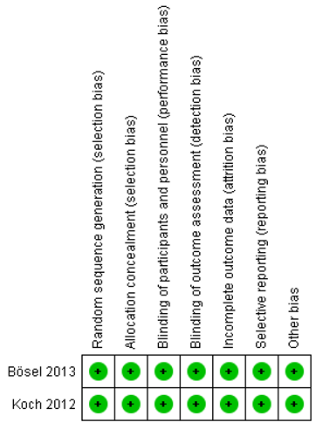

(b) Adverse events
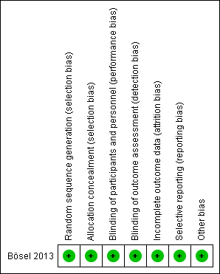

e-Table 7. Risk of bias within studies of each outcome in each comparison for performed tracheostomy within 4 days after intubation and 13 days or later.
(a) Short-term mortality
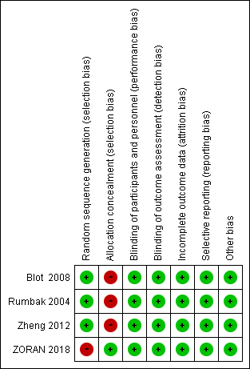

(b) Adverse events

e-Table 8. Risk of bias within studies of each outcome in each comparison for performed tracheostomy 5–12 days after intubation and 13 days or later.
(a) Short-term mortality
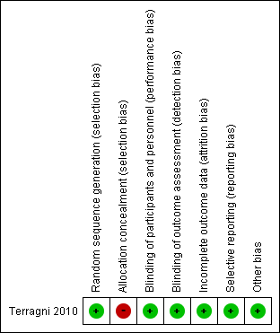

(b) Adverse events

e-Table 9. Forest plots of each outcome for on pairwise comparison for performed tracheostomy within 4 days after intubation and 5–12 days.
(a) Short-term mortality
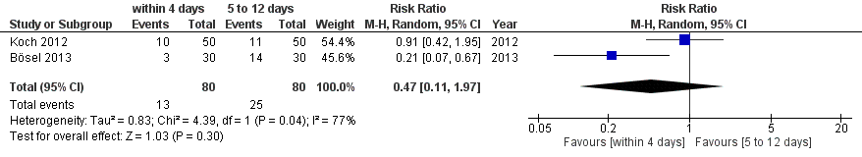
(b) Adverse events
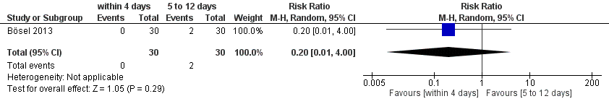

e-Table 10. Forest plots of each outcome for the pairwise comparison for performed tracheostomy within 4 days after intubation and 13 days or later.
(a) Short-term mortality
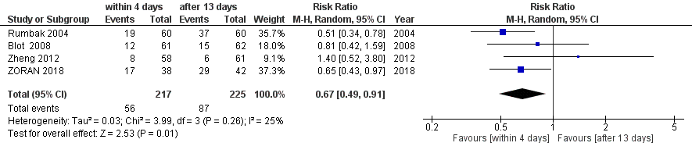
(b) Adverse events
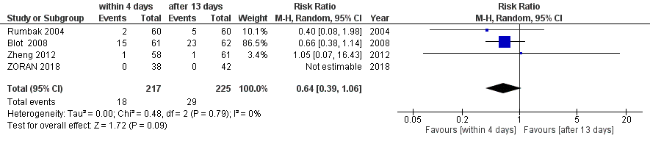

e-Table 11. Forest plots of each outcome for pairwise comparison for performed tracheostomy 5–12 days after intubation and 13 days or later.
(a) Short-term mortality
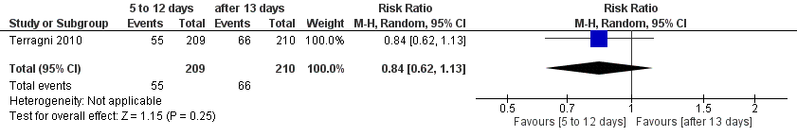
(b) Adverse events
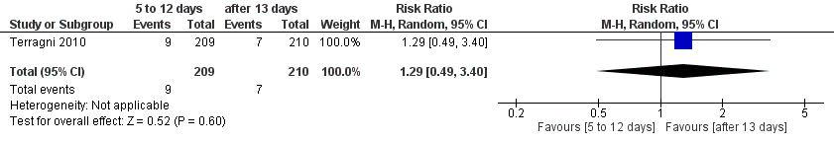

e-Table 12. Forest plots of direct, indirect, and network meta-analysis of each outcome in each comparison for performed tracheostomy within 4 days after intubation and 5–12 days.
(a) Short-term mortality
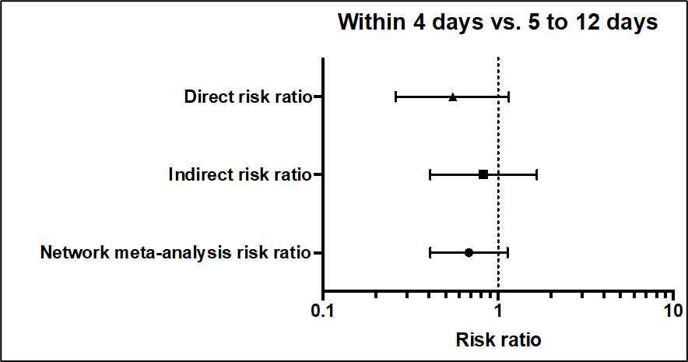

(b) Adverse events
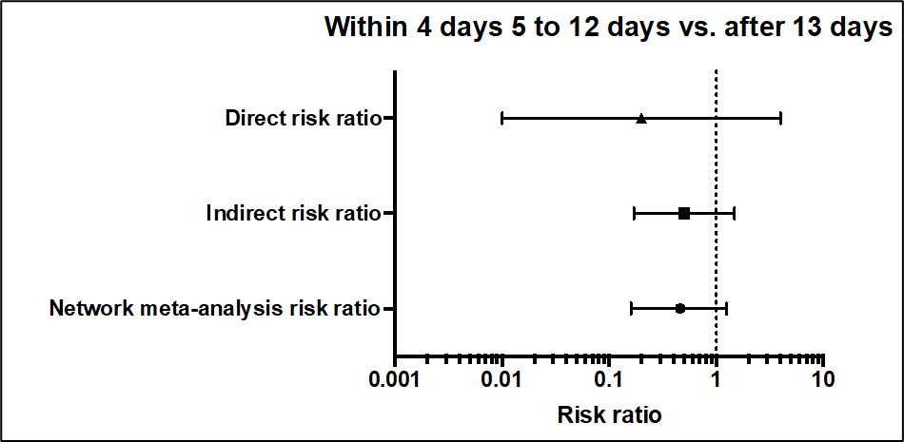

e-Table 13. Forest plots of direct, indirect, and network meta-analysis of each outcome in each comparison for performed tracheostomy within 4 days after intubation and 13 days or later.
(a) Short-term mortality
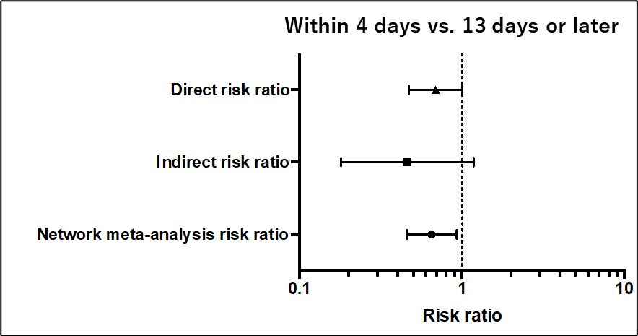

(b) Adverse events
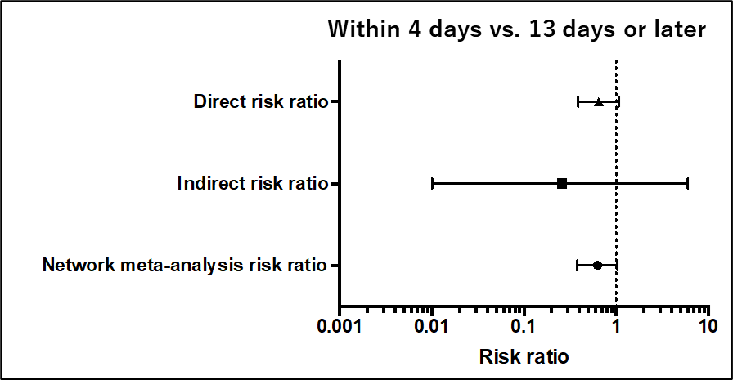

e-Table 14. Forest plots of direct, indirect, and network meta-analysis of each outcome of each comparison for performed tracheostomy 5–12 days after intubation and 13 days or later.
(a) Short-term mortality
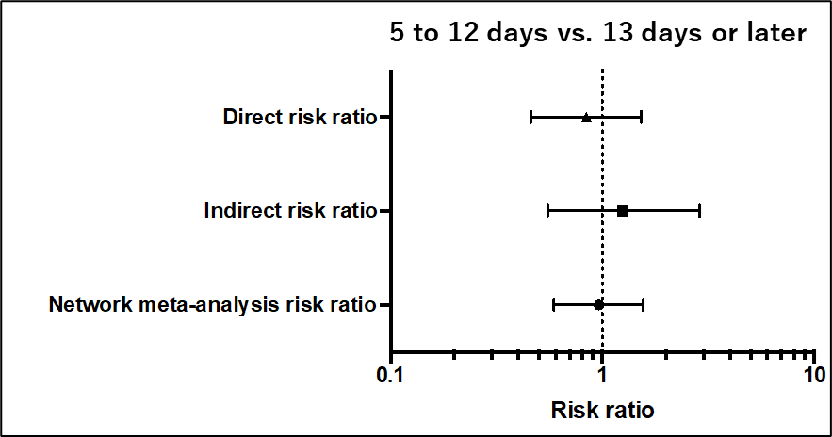

(b) Adverse events
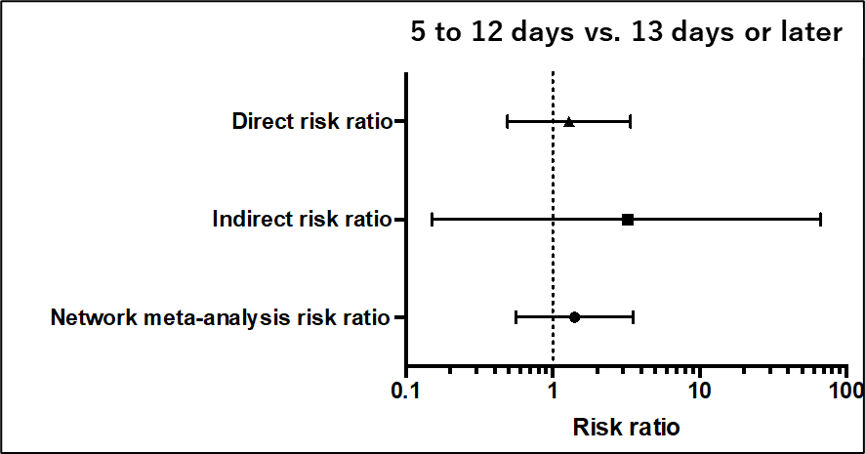

e-Table 15. Inconsistency of each outcome for side split
(a) Short-term mortality
Number of loops = 1.
Comparisons | Number of studies | RR from NMA (95% PI) | RR from direct comparison | RR from indirect comparison | Ratio of ratios (direct vs. indirect) | p-value
within 4 days vs. 5–12 days | 2 | 0.68 (0.24–1.88) | 0.47 | 0.82 | 0.57 | 0.44
within 4 days vs. 13 days or later | 4 | 0.65 (0.27–1.56) | 0.67 | 0.46 | 1.46 | 0.44
5–12 days vs. 13 days or later | 1 | 0.96 (0.35–2.59) | 0.84 | 1.25 | 0.67 | 0.44
Abbreviations: PI, prediction interval; RR, risk ratio.

(b) Adverse events
Number of loops = 1.
Comparisons | Number of studies | RR from NMA (95% PI) | RR from direct comparison | RR from indirect comparison | Ratio of ratios (direct vs. indirect) | p-value
within 4 days vs. 5–12 days | 1 | 0.45 (0.08–2.38) | 0.20 | 0.50 | 0.40 | 0.57
within 4 days vs. 13 days or later | 4 | 0.63 (0.28–1.41) | 0.64 | 0.26 | 2.46 | 0.57
5–12 days vs. 13 days or later | 1 | 1.41 (0.31–6.29) | 1.29 | 3.23 | 0.40 | 0.57
Abbreviations: PI, prediction interval; RR, risk ratio.

e-Table 16. Inconsistency of each outcome for global
(a) Short-term mortality
Q statistic to assess consistency under the assumption of a full design-by-treatment interaction random effects model = 0.59 (degrees of freedom = 1, p = 0.44) .

(b) Adverse events
Q statistic to assess consistency under the assumption of a full design-by-treatment interaction random effects model = 0.32 (degrees of freedom = 1, p = 0.57) .

e-Table 17. Heterogeneity of each outcome: Between-study variance within a comparison and the network
(a) Short-term mortality
Comparisons | Number of studies | Estimated variance |  | Forest plot
Comparisons | Number of studies | In comparison | In network | Forest plot
Within 4 days vs. 5–12 days | 2 | 0.83 | 0.068 | Very serious heterogeneity
Within 4 days vs. 13 days or later | 4 | 0.03 | 0.068 | Moderate heterogeneity
5–12 days vs. 13 days or later | 1 | N/A | 0.068 | N/A
Abbreviations: N/A, not assigned.

(b) Adverse events
Comparisons | Number of studies | Estimated variance |  | Forest plot
Comparisons | Number of studies | In comparison | In network | Forest plot
within 4 days vs. 5–12 days | 1 | N/A | <0.01 | N/A
within 4 days vs. 13 days or later | 4 | <0.01 | <0.01 | No heterogeneity
5–12 days vs. 13 days or later | 1 | N/A | <0.01 | N/A
Abbreviations: N/A, not assigned.

