Supplementary Figures

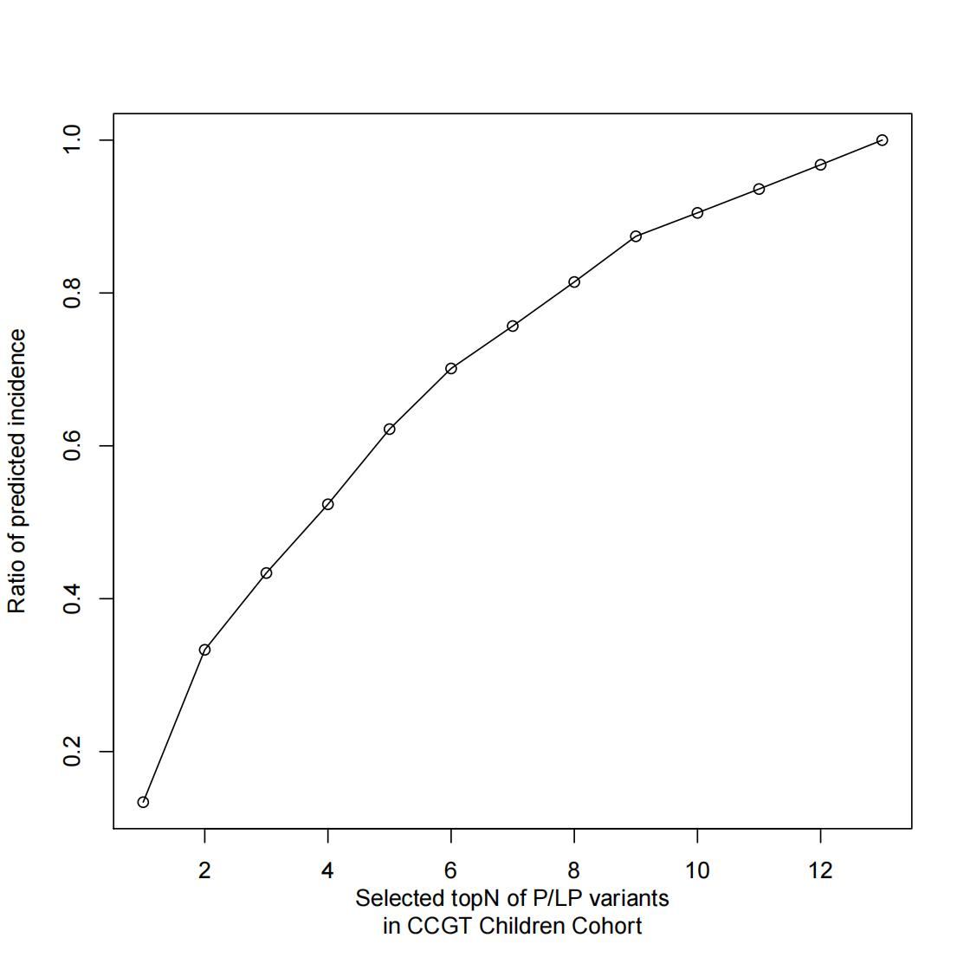
Additional file 4: Figure S1. Ratio of predicted incidence.
Estimated incidence based on 13 P/LP variants from CCGT Children Cohort. Rapid detection of the Top4 high-frequency sites (A338V, N120Kfs*32, A338G and W296*), which maybe cover about 50% of Chinese pediatric patients. Rapid detection of the Top10 variants (A338V, N120Kfs*32, A338G, W296*, E225Rfs*5, R304W, A150P, c.325-1G>C, L289Ffs*10 and Q111*) which maybe cover about 90% of Chinese pediatric patients.

Supplementary Tables

Additional file 1: Table S1. Manually curated ALDOB variants’ pathogenicity.

Additional file 1: Table S2. Allele frequency for top 24 pathogenic variants to different populations.

Additional file 2: Table S3. Summary of genotype-phenotype information of 68 patients with HFI.

Additional file 3: Table S4. Relationship between variant site and phenotype.

Additional file 3: Table S5. Relationship between mutation type and phenotype.

Additional file 3: Table S6. Relationship between zygosity and phenotype.

Additional file 4: Table S7. Different populations from HuaBiao and gnomAD database of HFI prevalence calculated based on the Bayesian framework.
Population name | Estimation of HFI prevalence
HuaBiao | 1/410068(1/1395112-1/178484)
gnomAD-NFE | 1/23147(1/28182~1/19278)
gnomAD-FlN | 1/55539(1/107444~1/32816)
gnomAD-AMR | 1/132801(1/274861~1/75230)
gnomAD-ASJ | 1/263150(1/2275631~1/81267)
gnomAD-AFR | 1/412335(1/702621~1/264931)
gnomAD-SAS | 1/465278(1/7821624~1/121173)
gnomAD-EAS | 1/818758(1/25633515-1/188368)
gnomAD-TOTAL | 1/56399(1/66467~1/48326)

