Supporting information

The safety assessment of irrigation fluid management for shoulder arthroscopy and its effect on postoperative efficacy

Fig S1：CNAP monitor 500

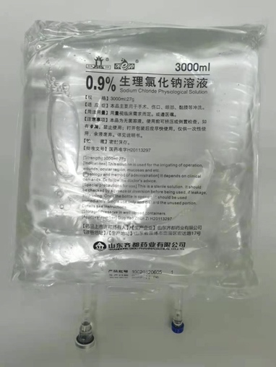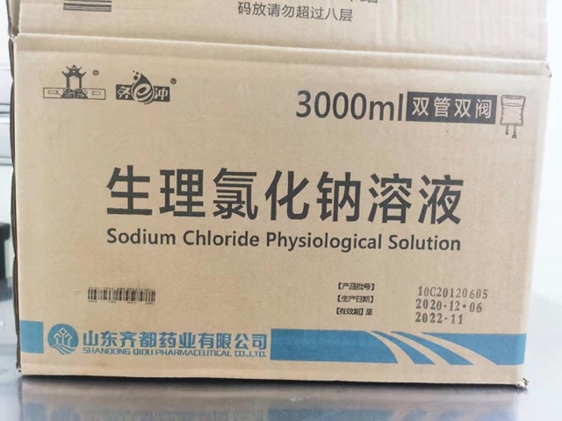
Fig S2：Normal saline

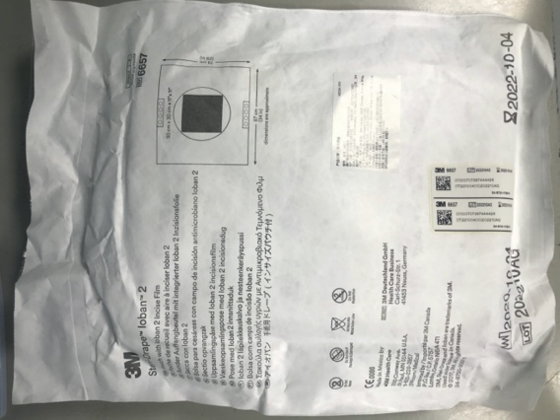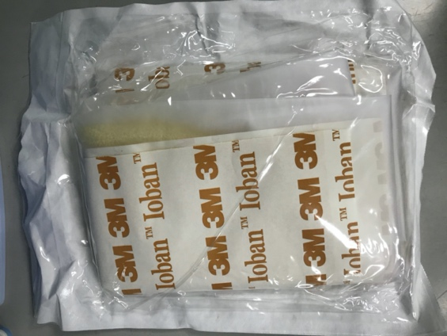
Fig S3: Liquid collection bag (3M IobanTM)

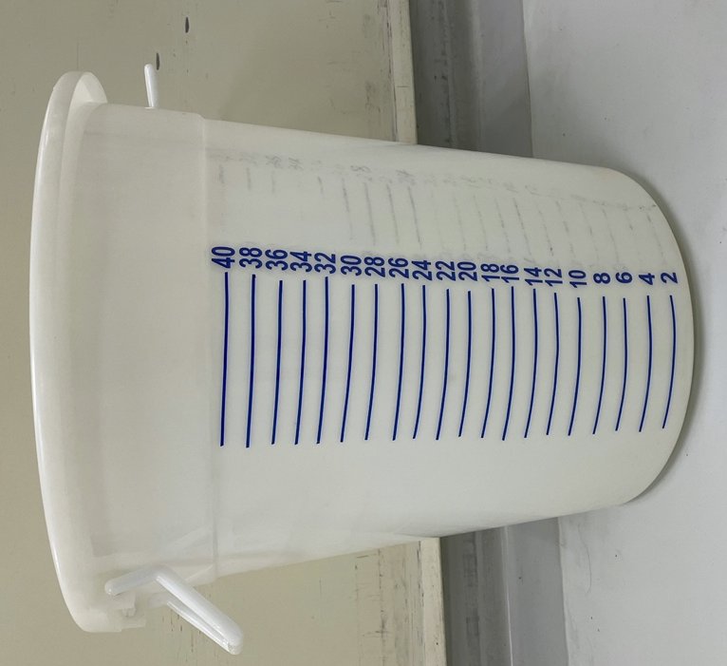
Fig S4：Measuring tank

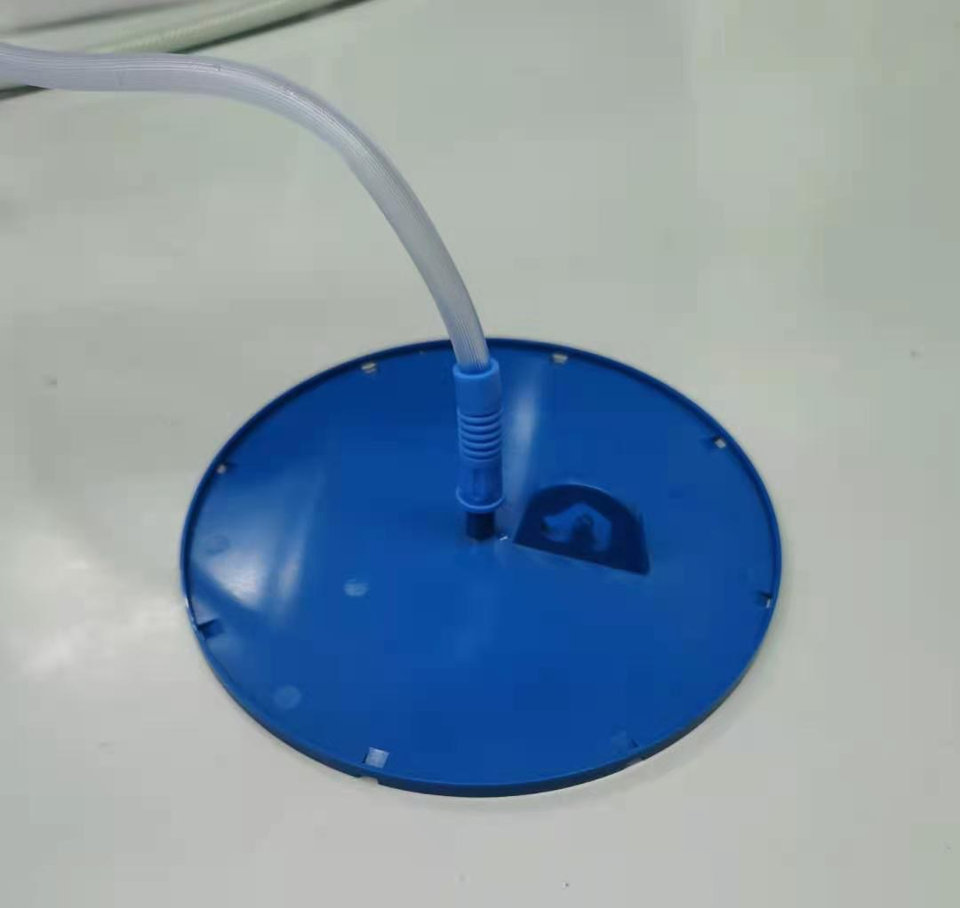
Fig S5：Suction device

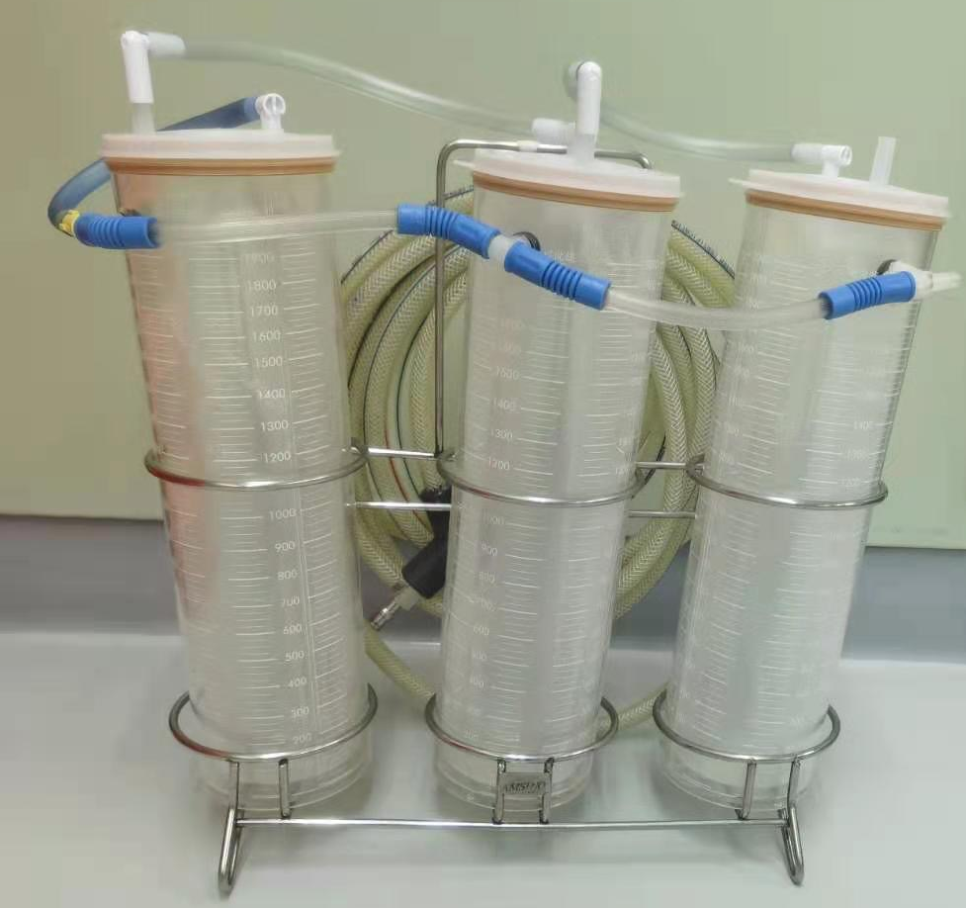
Fig S6：Suction bottle

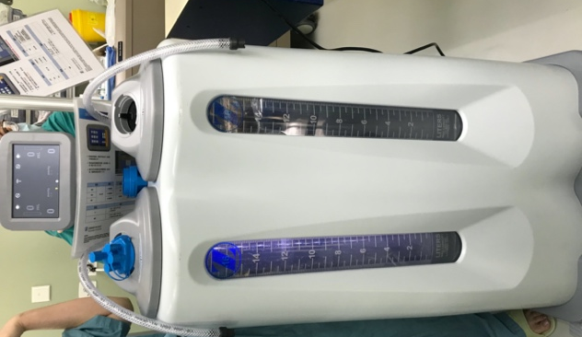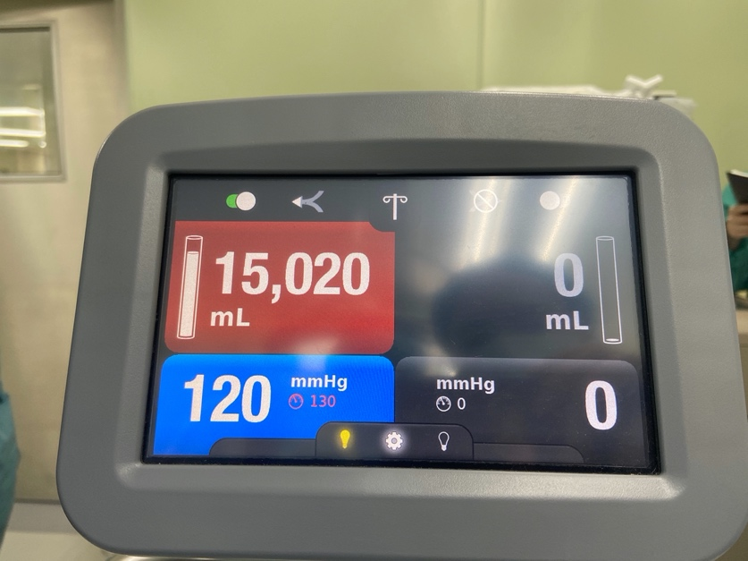
Fig S7：Zimmer liquid waste collector

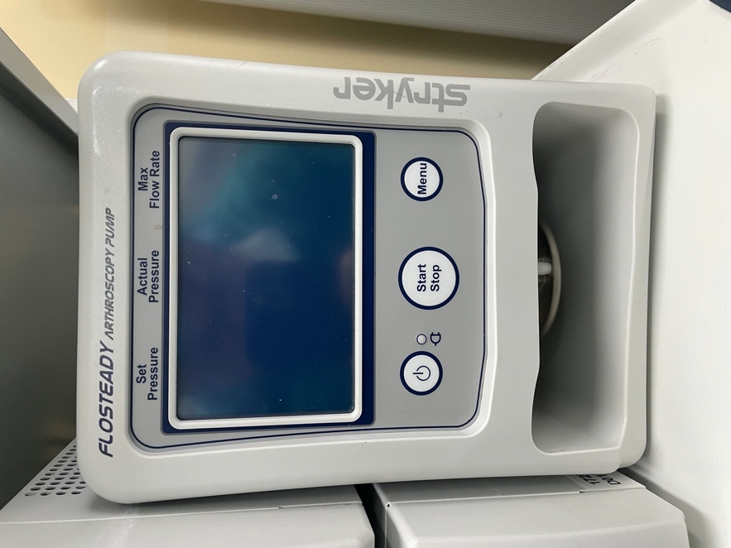
Fig S8：Stryker arthroscopy pump

