Supporting Information

In vivo characterization and analysis of glioblastoma at different stages using multiscale photoacoustic molecular imaging

Jinde Zhang¹, Xiang Sun¹, Honghui Li², Haosong Ma¹, Fei Duan¹, Zhiyou Wu¹, Bowen Zhu², Ronghe Chen¹, and Liming Nie²

Liming Nie, nieliming@gdph.org.cn

Authors and Affiliations
¹Departments of the State Key Laboratory of Molecular Vaccinology and Molecular Diagnostics & Center for Molecular Imaging and Translational Medicine, School of Public Health, Xiamen University, Xiamen, 361102 China.
²Research Center of Medical Sciences, Guangdong Provincial People's Hospital, Guangdong Academy of Medical Sciences, Guangzhou 510080, China.

Keywords: Multiscale photoacoustic imaging; Brain tumor; Vascular quantitative analysis; Blood-Brain Barrier Immune environment

Supplementary Methods
Main instruments
Preparation of A1094 dye
Blood biochemistry and hematology analysis
Molecular docking and prediction of HSA@A1094 binding
Molecular docking and prediction of αCD11b-HSA binding
PA signal detection of CD11b-HSA@A1094 labeled cells
Safety evaluation
Statistical analysis

Supplementary Figures
Figure S1 Lateral resolution and phantom results of photoacoustic microscopy (PAM)
Figure S2 PA combiner for acoustic-optical coaxial alignment in PAM
Figure S3 The flowchart of the vascular extraction algorithm
Figure S4 Synthesis route of A1094
Figure S5 ¹H NMR of A1094
Figure S6 ¹³C NMR of A1094
Figure S7 Mass spectra of A1094
Figure S8 The absorption spectra of ICG and A1094
Figure S9 The schematic diagram of PAI approach for GBM visualization and analysis in malignant progression
Figure S10 In vivo T2-weighted MRI images of GBM-bearing mice at various tumor stages
Figure S11 CD31 staining of mouse brain slice
Figure S12 Photoacoustic (PA) images of EB dye at different concentrations by PAM
Figure S13 The absorption spectra of the EB solution during the illumination of 120 minutes
Figure S14 PA images of other 2 mice in the early-stage group
Figure S15 PA images of other 3 mice in the middle-stage group
Figure S16 PA images of other 2 mice in the advanced-stage group
Figure S17 The stable vascular PA signals during 2 h imaging
Figure S18 Theoretical simulation model of the molecular docking process
Figure S19 TEM, DLS, and surface potential of nanoprobe
Figure S20 Absorption spectra of nanoprobe at different concentrations
Figure S21 Fluorescence spectra of nanoprobe
Figure S22 PA signal detection of αCD11b-HSA@A1094 labeled cells
Figure S23 Confocal imaging and flow cytometry analysis of probes targeting
Figure S24 Blood biochemistry and H&E analysis of mice
Figure S25 Corresponding MRI images of HSA@A1094 and αCD11b-HSA@A1094 groups
Figure S26 Three-dimensional reconstructed images at 970 nm and 1200 nm by PACT
Figure S27 Fluorescence imaging of main organs and tumor-bearing brain
Figure S28 Fluorescent microscopic image analysis and H&E stain of brain slice
Figure S29 CD11b⁺ immunohistochemistry and H&E validation of GBM tumor slice
Figure S30 Multiple views of cortex after injection of HSA@A1094 by PAM
Supplementary Methods

Main instruments
The major chemicals were purchased from Sigma-Aldrich and without being further purified. All organic solvents were in analytical grade. The ¹³C NMR and ¹H NMR spectra were recorded by a WNMR-I spectrometer (400 MHz, Zhongke-Niujin, China). Mass spectra (MS) were obtained by a Xevo G2-XS Tof (Waters, USA) equipped with electrospray ionization (ESI). The hydration particle size and zeta potential were conducted by a nanoparticle analyzer SZ-100 (HORIBA, Japan). The morphology and size of the nanoparticles were observed by a transmission electron microscopy Tecnai G2 Spirit BioTwin (FEI, Holland). The ultraviolet (UV)-visible (vis)-near infrared (NIR) optical absorption spectrum was obtained from a Lambda 1050 2D (Perkin Elmer, USA).

Preparation of A1094
The croconaine dye A1094 was synthesized by a classical route. Briefly, the precursor 5-(N, N-diisobutylamino)-1,3-benzenediol was firstly obtained from a reflux operation. In the process, phloroglucinol and diisobutylamine (molar ratio of 1:1) were dissolved in a mixture solution of n-butanol (25%) and toluene (75%) at 110 °C for 6 hours. After purification and segregation, this precursor was then reacted with croconic acid (molar ratio of 2:1) under the same conditions for 12 minutes to obtain the crude products. Finally, the pure products (A1094) were separated from the crude products by column chromatography.
¹H NMR (400 MHz, CDCl₃, δ): 13.91 (s, 2H, OH), 6.10 (s, 2H, H_{arom}), 5.92 (s, 2H, H_{arom}), 3.40 (s, 8H, NCH₂), 2.20 (m, 4H, CH), 1.01 (d, J = 6.6 Hz, 24H, CH₃). ¹³C NMR (100 MHz, CDCl₃) δ: 165.37(s, C-O⁻), 159.74 (s, C=O), 157.11 (s, C_{arom}-O), 156.93 (s, C_{arom}-N), 95.99 (s, 2C, C_{arom}), 90.58 (s, 4C, C_{arom}), 61.21 (s, NCH₂), 28.48 (s, CH), 20.17 (s, CH₃). MS (ESI, m/z) [(M+H)]⁺: Anal. Calcd for C₃₃H₄₂N₂O₇: 579.70. Found: 579.31.

Cell targeting in vitro
The RAW264.7 and U-87 MG cell lines were selected to evaluate the probe targeting performance at cellular level. αCD11b-HSA@A1094 or HSA@A1094 was co-incubated 1 hour with cells (5×10⁴) at a concentration of 50 µg/mL. Laser scanning confocal microscopy and flow cytometry were used to quantitatively evaluate the targeting characteristic of nanoprobe.

Molecular docking and prediction of HSA@A1094 binding
The three-dimensional (3D) structure of HSA crystal is mainly composed of α-helix and random curl. The small molecular ligand mainly acts in the hydrophobic groove inside the protein. Firstly, small molecular ligand structure of A1094 was simulated by Chemdraw 14.0, which was saved to PDBQT file by MGLTools. Secondly, the initial 3D structure of HSA was obtained from the research Collaboratory for structural bioinformatics protein data bank website (http://rcsb. org, ID: 2BXH) without the ligand and water molecules. The obtained protein structure was processed with hydrogenation, charge calculation, and non-polar hydrogen combination by MGLTools software, and stored as PDBQT files. Thirdly, PDBQT files of HSA and A1094 were calculated by Autogrid4 to show all the space of the HSA in the X, Y, and Z dimensions. The same calculation was repeated 100 times to find out the optimal pose. After that, a 60 Å by 60 Å by 60 Å water box was set for the optimum binding site of HSA (Center X=8.998, Center Y=-6.167, Center Z=6.644). Finally, Lamarckian genetic algorithm was used to calculate the molecular docking of A1094 with HSA by Autodock4 software. The binding free energy, affinity constant, energy minimization, and geometric optimization were performed on the select complex until no more conflict between the A1094 molecule and HSA.

Molecular docking and prediction of αCD11b-HSA binding.
The ZDOCK algorithm for molecular docking between proteins was provided and maintained by ZLAB laboratory in the University of Massachusetts Medical School. The ZDOCK is a protein interaction docking program based on a fast Fourier transform. It was designed to track all possible patterns of binding between two proteins by translation and rotation. The binding models were evaluated by an energy-based scoring function. In this theoretical modeling, we set the Euler rotation angle to 6 degrees, the lattice point width to 1.2 Å. After performing 1000 rigid docking, the lowest energy conformation was selected and analyzed.

PA signal detection of CD11b-HSA@A1094 labeled cells
To demonstrate the cell detection limit of photoacoustic molecular imaging in vitro, an agarose-based phantom containing inclusions of RAW 264.7 cells (mouse-macrophage cell lines) loaded with αCD11b-HSA@A1094 nanoprobe was created. Specifically, RAW 264.7 cells were cultured in DMEM medium supplemented with 10% heat-inactivated fetal bovine serum with 5% CO₂. Cells were incubated with 0.35 μmol/mL nanoprobe for 6 hours. Various concentration of nanoprobe loaded RAW 264.7 cells inclusions (0, 3.125 ×10³, 6.25 × 10³, 1.25 × 10⁴, 2.5 × 10⁴, 5.0 ×10⁴ and 1.0×10⁵ cells/μL) were prepared. 1×10⁵ cells/μL cell concentration was used for the cells' only inclusion. For phantom preparation, cylindrical phantoms were prepared with 2% agarose, a 2 mm diameter tube was placed at a 3 mm depth to create a tunnel where cells suspension could be placed (n = 3 per test). The finished phantom with cell suspensions was submitted to LAZR-X. Quantification was made in a 0.3 mm³ volume of interest corresponding to a slice of the phantom tunnel. For PAM in vitro imaging, we also tested the above cell suspensions in a set of 1×1×5 mm³ square grooves by 3D printing with polylactic acid material.

Safety evaluation
To evaluate the effect on hepatic and renal function, blood samples were collected from the mice fundus artery on 1, 4, and 7 days after intravenous injection of nanoprobes (n = 4). The levels of alanine aminotransferase (ALT), aspartate aminotransferase (AST), alkaline phosphatase (ALP), and urea in the serum were conducted by an automated biochemical analyzer (BS-240VET, Mindray, China). Histological analyses of harvested major organs were also performed.

Statistical analysis
The quantitative results are presented as mean ± standard deviation (SD) and analyzed with GraphPad Prism 7.0 software. The paired t-test was applied to examine the statistical significance of the differences between the extracted vascular parameters in various tumor stages within each group, as shown in Fig. 2e-f. Statistical significance was set at *P <0.05, **P <0.01. A P value less than 0.05 was considered statistically significant.

Supplementary Figures

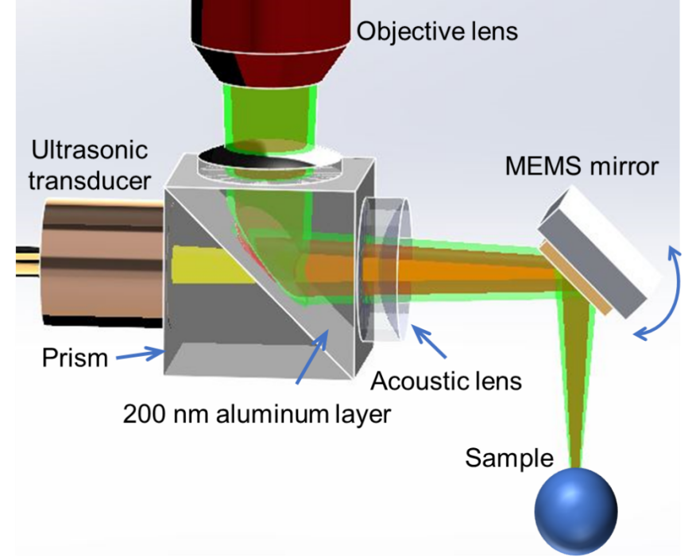
Figure S1. PA combiner for acoustic-optical coaxial alignment in MEMS PAM.

Figure S2. Quantification of lateral resolutions and leaf phantom tests of the MEMS based OR-PAM at dual-wavelength. a and b, Transverse spread profile of a 6 μm carbon fiber along with the white dashed line of inset picture under 532 and 1064 nm laser, respectively. The lateral resolutions were estimated to 7.3 μm for 532 nm and 12.4 μm for 1064 nm. c and d, PA images of a leaf phantom. e and f, PA profiles along the cross section of white dashed Line 1 and Line 2 from (c) and (d). The PA imaging of phantom at the two wavelengths can be perfectly matched.

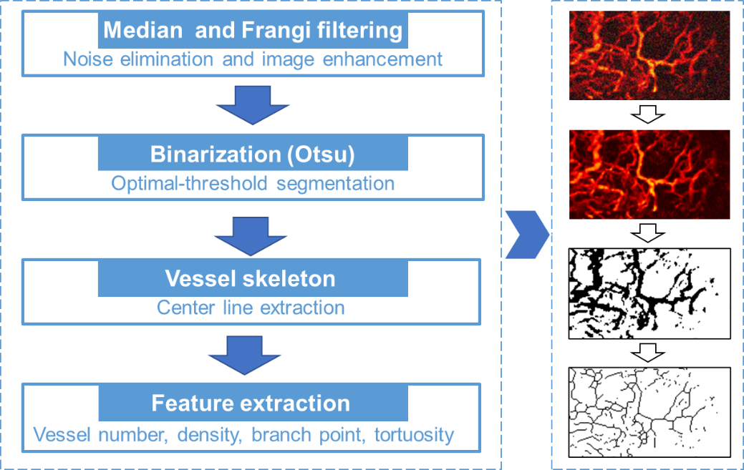
Figure S3. The flowchart of the vascular extraction algorithm.

Figure S4. Synthesis route of A1094 dye. Step (1) is the dehydration condensation reaction operated at 110 °C for 6 hours in a mixture solution (V_{n-butanol}: V_{toluene} =1:3). Step (2) indicates that the intermediates was reacted with croconic acid (molar ratio of 2:1) under the same conditions for 12 minutes.

Figure S5. ¹H NMR spectrum (400 MHz) of croconaine dye A1094 in CDCl_{3.}

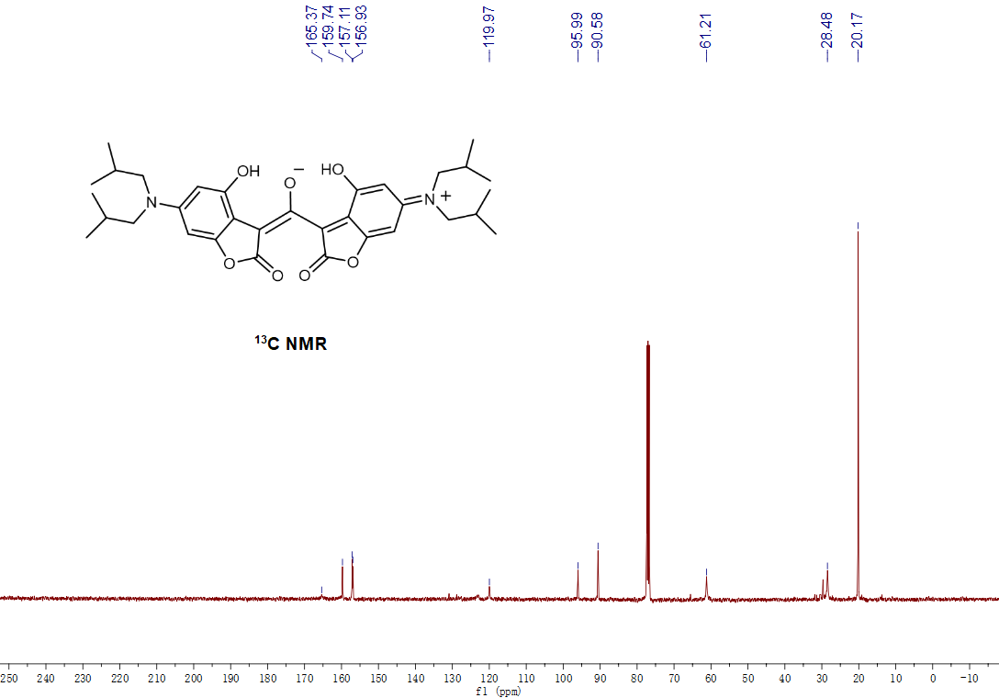
Figure S6. ¹³C NMR. (100 MHz) spectrum of croconaine dye A1094 in CDCl₃.

Figure S7. Mass spectrum of A1094. MS (ESI, m/z) [(M+H)]⁺: Anal. Calcd. for C₃₃H₄₂N₂O₇: 579.70. Found: 579.31.

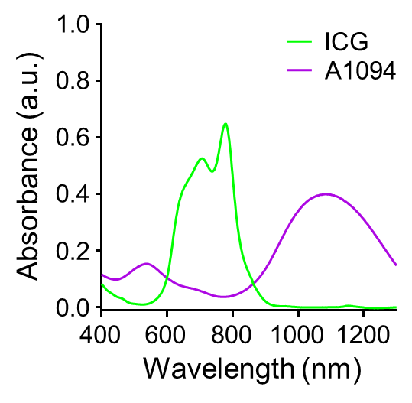
Figure S8. The absorption spectra of ICG and A1094.

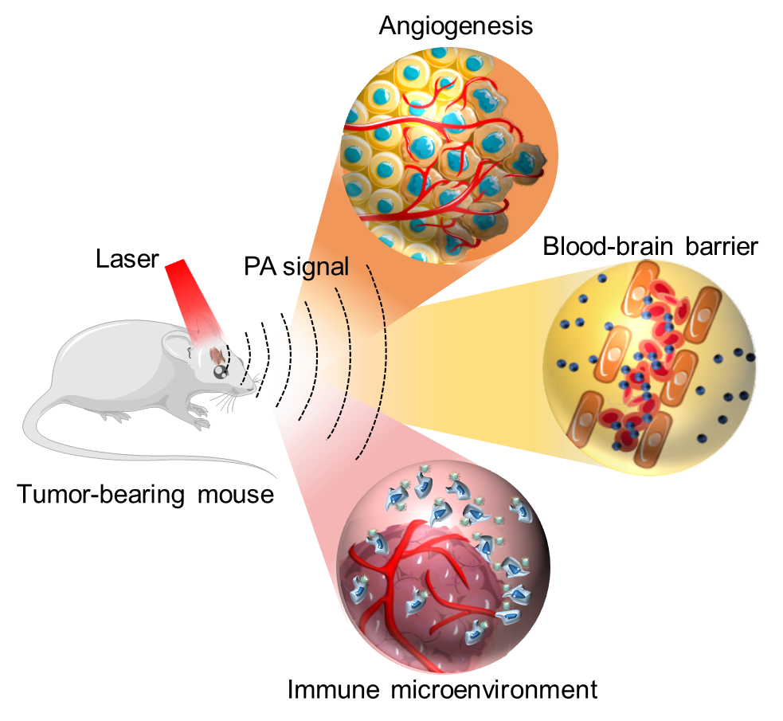
Figure S9. The whole PAI approach for GBM visualization and analysis in malignant progression.

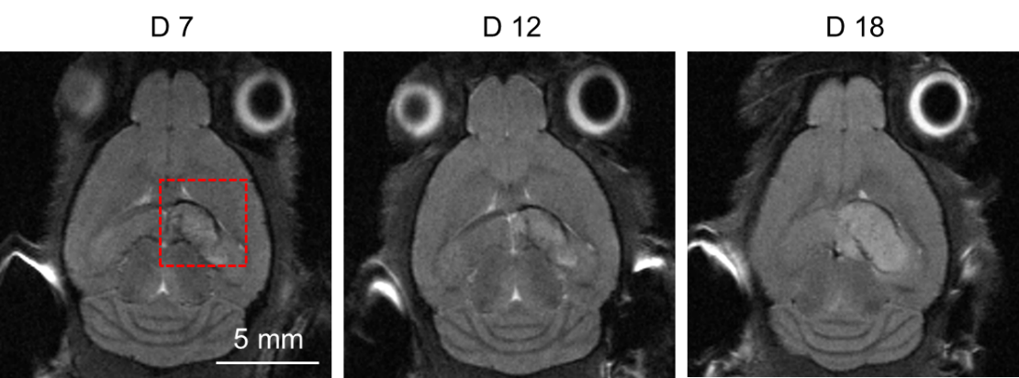
Figure S10. In vivo T2-weighted MRI images of GBM-bearing mice at Day 7, 12, and 18 after tumor cell implantation with detailed structural information of cortex (depth ~2 mm). The red dashed box indicates the tumor region.

Figure S11. CD31 staining of angiogenesis in GBM bearing mouse brain. Angiogenesis in the tumor was identified by positive CD31 staining indicated by red arrows.

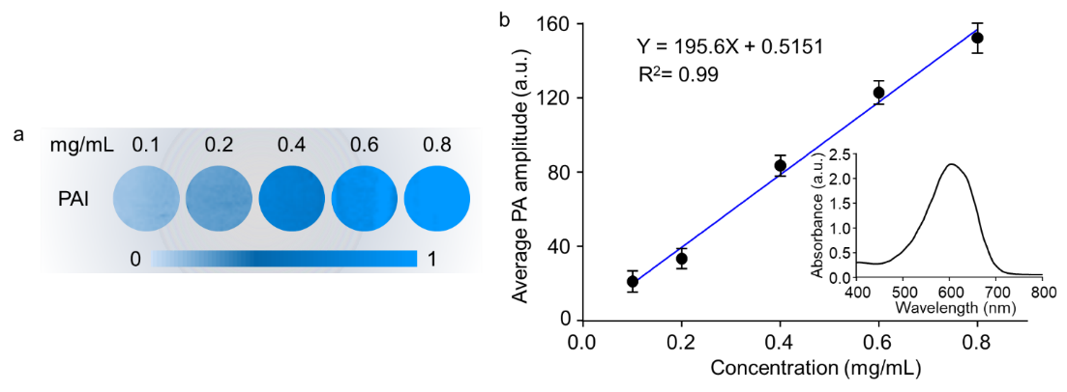
Figure S12. EB solutions at different concentrations detected by PAM. a PA images of EB solution at various concentrations by PAM. b The average PA amplitude showed a linear dependence with concentrations at 532 nm. Error bars represented standard deviations.

Figure S13. The absorption spectra of the EB solution every 15 minutes during the continuous illumination of 120 minutes.

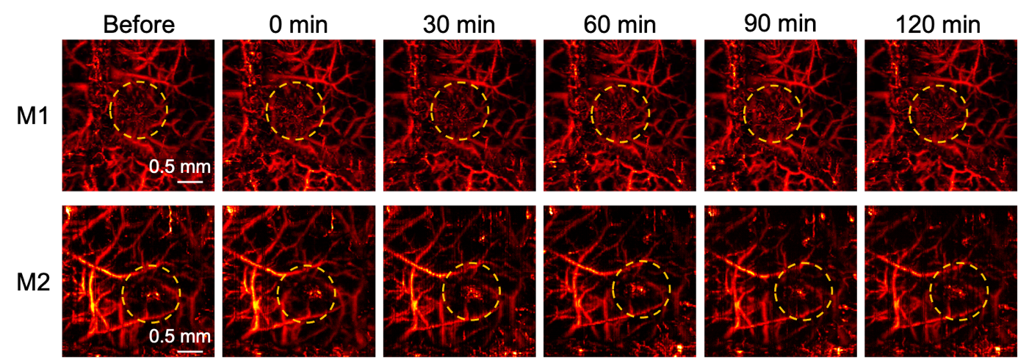
Figure S14. PA images of other 2 mice in the early-stage group.

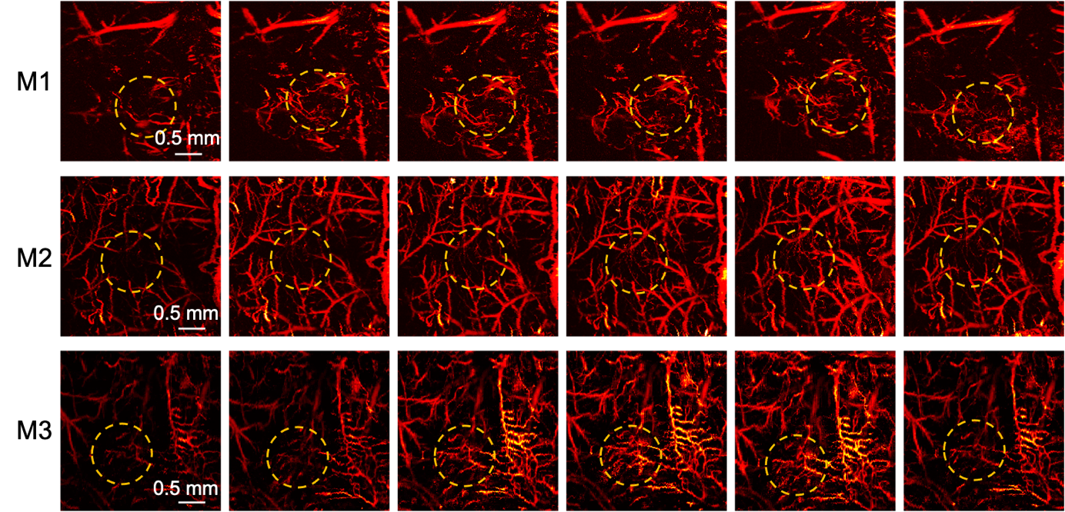
Figure S15. PA images of 3 mice in the middle-stage group.

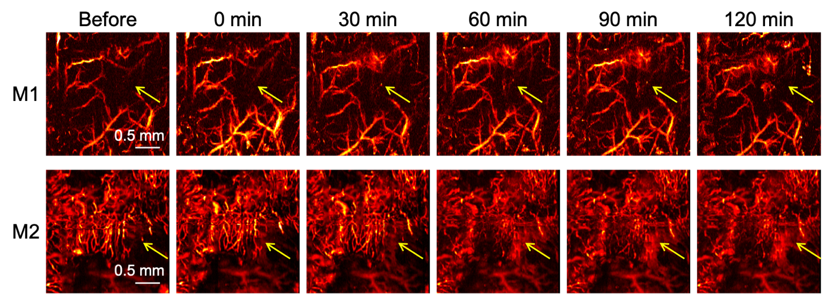
Figure S16. PA images of other 2 mice in the advanced stage group.

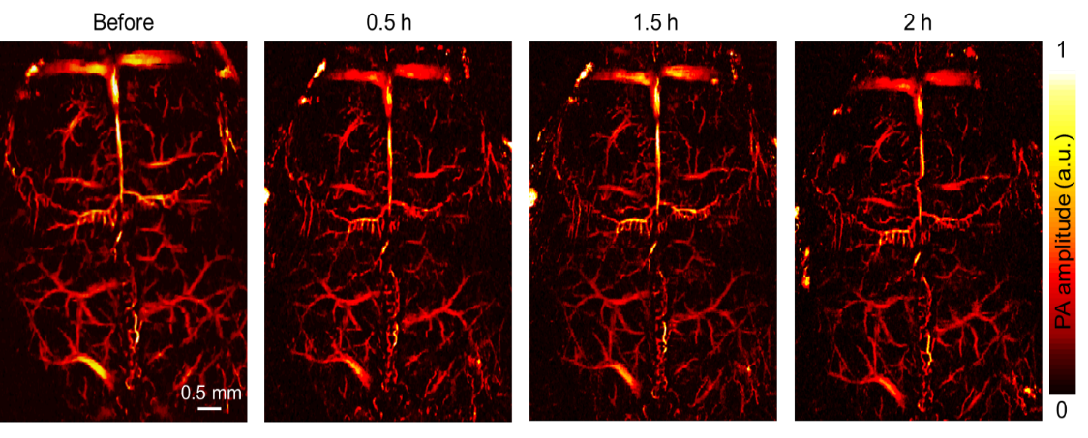
Figure S17. Time-lapse PA images of cortex vessels from normal mouse within 2 hours after EB injection. No EB leakage was visualized in the normal mouse cortex.

Figure S18. Theoretical modeling for the molecular docking process. a The docking model suggests the optimal hydrophobic binding site (green) for A1094 and HSA. b The secondary binding site (blue) of A1094 and HSA. c Schematic structure of αCD11b-HSA@A1094 nanoprobe in the basic unit. A1094 (purple) was bound to the hydrophobic vacancy inside the HSA (gray), αCD11b (blue) was bound with the right helical region of the HSA. Inset picture: The spatial configuration of A1094 at the combined pocket. d Details of binding residues between A1094 and albumin. Sticks represent the amino acid residues at the optimal binding site of HSA, the grayscale model represents the A1094 molecule. The red patches indicate the areas of high static electricity and green dashed lines represent hydrogen bonds between A1094 and amino acids. Inset figure: The hydrogen atoms on A1094 can form a length of 2.2 Å hydrogen bonds with the oxygen on ALA291 amino acid residue. The main interaction amino acid residues include LYS199, TRP214, ARG218, LEU219, ARG222, PHE223, LEU238, LEU260, ALA261, ILE264, SER287, ILE290, ALA291, VAL343, ASP451 at the binding site of HSA. The docking energy is -14.29 kcal/M. e Representative theoretical modeling of binding sites between HSA and αCD11b. The amino acid residue ASN192 on αCD11b forms hydrogen bonds with ALA504, PHE507, and PHE509 on HSA, and the hydrogen bond lengths were 2.90, 2.62, and 3.26 Å, respectively. The amino acid residues on the HSA binding interface include ASP550, ASP549, ALA546, GLU542, GLU505, LYS557, PHE554, CYS558, PHE507, THR508, PHE509, ASN503, PHE502, HIS535, LYS536, LEU544. The amino acid sites on αCD11b include ARG151, PHE147, ASN191, GLU155, ARG196, SER158, ASN192, ASN194, LEU198, GLU188, ILE182, HIS183, PHE184.

Figure S19. Characterization of αCD11b-HSA@A1094. a Negative-stained transmission electron microscopy (TEM) images, inset figure: unstained TEM image of nanoprobe. b Dynamic light scattering profiles. c Zeta potential changes before and after αCD11b modification.

Figure S20. Optical absorption characteristics of αCD11b-HSA@A1094. a Absorption spectra of αCD11b-HSA@A1094 at different concentrations in PBS. b Linear fitting curve of absorbance intensities at 536 and 1094 nm.

Figure S21. Fluorescence emission spectra of αCD11b-HSA@A1094. The excitation wavelengths were 488 nm (left curve) and 980 nm (right curve), respectively.

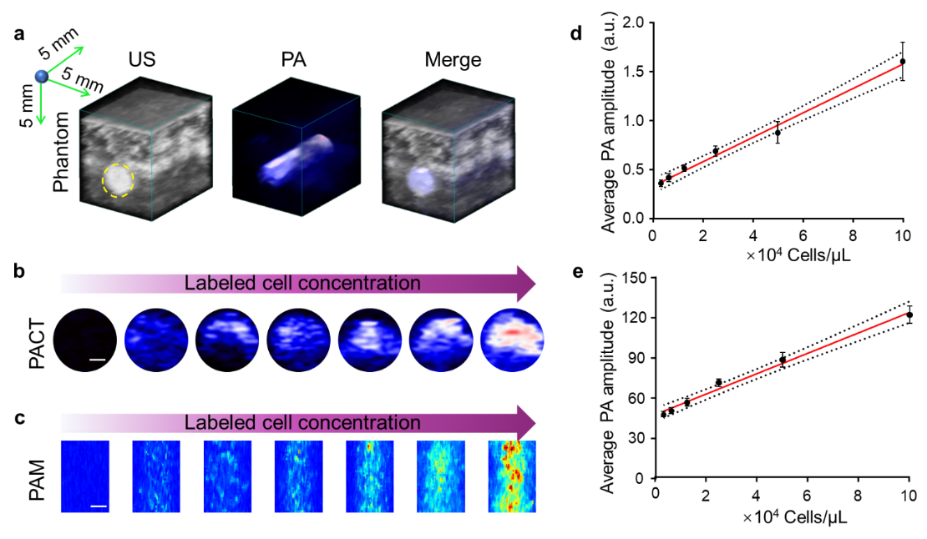
Figure S22. PA signal detection of αCD11b-HSA@A1094 labeled cells in phantoms. a 3D reconstruction of B mode US and PA image of phantom for PACT. b and c Cross-sectional PA images of labeled cells at various concentrations under excitation at 1200 nm by PACT (b) and 1064 nm by PAM (c), respectively. Scale bar: 0.5 mm. d-e The average PA intensities increased with the concentration of labeled cells detected by PACT (d) and PAM (e) system. The experiment was repeated three times independently. All statistical data are expressed as mean ± SD.

Figure S23. Confocal laser scanning microscopy (CLSM) images and flow cytometry analysis of the probe specificity by comparation of RAW 264.7 and U-87 MG cells. a and b The CLSM images of RAW 264.7 and U-87 MG cells incubation with HSA@A1094 and αCD11b-HSA@A1094 nanoprobe for 1 h in 20 µg/mL. Cell nucleis were stained with DAPI (4′,6-diamidino-2-phenylindole) (blue). Green fluorescence was from A1094. Higher fluorescence was observed in RAW 264.7 cells with αCD11b-HSA@A1094 incubation. c and d Corresponding flow cytometry analysis of control, HSA@A1094 and αCD11b-HSA@A1094 incubation groups. The experiment was repeated three times independently.

Figure S24. In vivo toxicity evaluation. a-d, Various serum biochemical parameters including alanine aminotransferase (ALT), alkaline phosphatase (ALP), aspartate aminotransferase (AST), and urea (n=4). Blood biochemistry data of Balb/c mice treated with αCD11b-HSA@A1094 was collected at 1, 4, and 7 days post-injection. e H&E stained histological images of major organs (heart, liver, spleen, lung, and kidney) from mice treated with PBS versus nanoprobe at 200× magnification. Compared with the control group, there was no statistically significant difference of the nanoprobe treated group in all the indexes. No noticeable inflammation or tissue damage was observed in major organs.

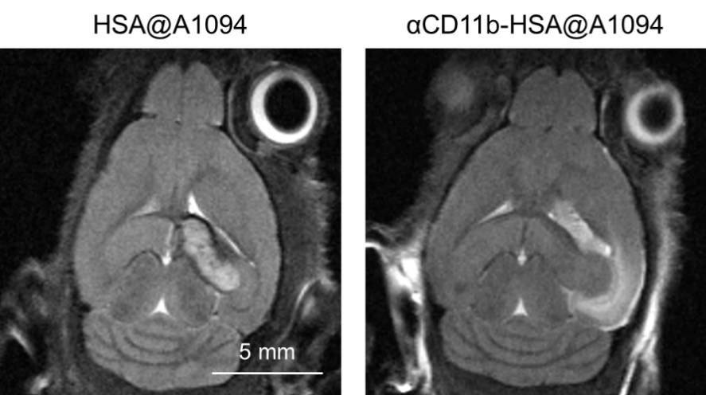
Figure S25. The corresponding MRI images of HSA@A1094 and αCD11b-HSA@A1094 groups.

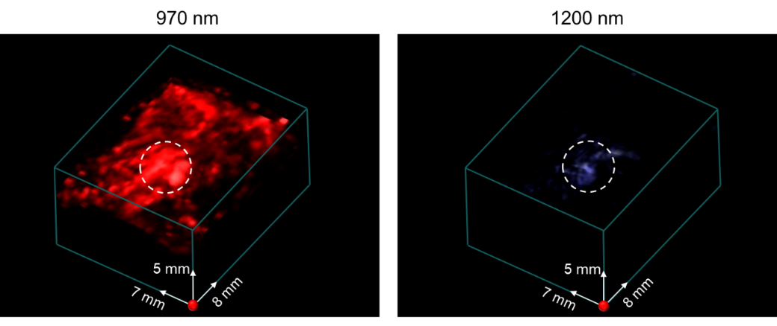
Figure S26. Three-dimensional reconstructed images at 970 nm and 1200 nm by PACT before nanoprobe injection.

Figure S27. Fluorescent analysis of harvested major organs. a Representative fluorescent image of harvested heart, liver, kidney, spleen and brain from orthotopic tumor-bearing mouse 24 hours after the nanoprobe injection (n=4). b Corresponding quantitative results. The results showed that αCD11b-HSA@A1094 mostly aggregated in the brain tumor. All statistical data are expressed as mean ± SD.

Figure S28. Fluorescent image of brain slice by fluorescence microscopy were performed to confirm the αCD11b-HSA@A1094 distribution in tumor and normal tissue.

Figure S29. H&E and Immunohistochemistry (IHC) validation of CD11b⁺ TAMCs in GBM tumor. a and b H&E and IHC of the tumor from the ipsilateral right brain and normal tissue from the contralateral left brain. c CD11b stain area in the tumor and normal tissue. d Comparison of CD11b⁺ area of IHC images in the tumor ipsilateral right brain and contralateral left normal brain in tumor-bearing mice.

Figure S30. Images of the tumor-bearing mouse brain at Day 18 by PAM. a X-Z and, X-Y views and 3D image of cortex at Day 18 of tumor progression 12 hours after intravenous injection of HSA@A1094 complex. b Volume-rendered 3D fusion image.

