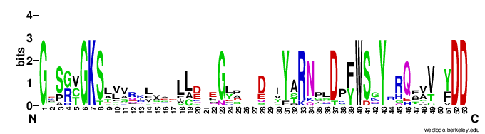

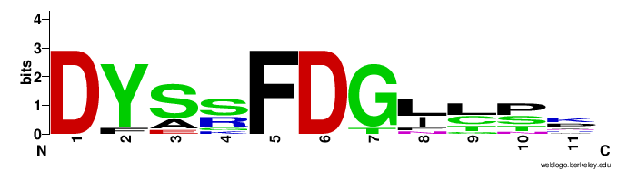
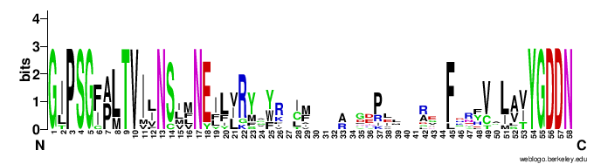
Fig. S1 Visualization of conserved protein domains in the polyprotein of identified viruses using WebLogo 3.

