Supplementary Information

Efficient Acid Screening Using Covalent-Organic-Framework Membranes with Angstrom-Sized Pore Channels and Built-in Charge-Assisted Hydrogen Bond Donors

Qing-Wei Meng,¹ Mingjie Liu,^{2,3} Xiuhui Zuo,¹ Weipeng Xian,¹ Qing Guo,¹ Sai Wang,¹ Hong Yin,¹ Qi Sun^{1,}*
¹Zhejiang Provincial Key Laboratory of Advanced Chemical Engineering Manufacture Technology, College of Chemical and Biological Engineering, Zhejiang University, Hangzhou, 310027, China.
²Key Laboratory of Biomass Chemical Engineering of Ministry of Education, College of Chemical and Biological Engineering, Zhejiang University, Zheda Road 38, Hangzhou 310027, China.
³Institute of Zhejiang University-Quzhou, 78 Jiuhua Boulevard North, Quzhou 324000, China.

*Email: sunqichs@zju.edu.cn (QS)

Experimental Details

Density Functional Theory
The lowest energy configurations of the guanidine-anion complex were searched by the Molclus^{[1]} combined with the MOPAC program.^{[2]} The DFT calculations for further optimization and energy calculation were carried out by Gauss 09 program package,^{[3]} with M062X/6-31G* level. Multiwfn^{[4]} was used for the charge population and interaction analysis, and visual molecular dynamics (VMD)^{[5]} software was used to plot the corresponding structure.

Molecular Dynamics Simulation
Atomistic molecular dynamics (MD) simulations were performed in the GROMACS^{[6]} (version 2020.6) simulation package using the General Amber force field (GAFF2)^{[7,8]}. 10 layers of the COF material with 4 periodic unit structures were simulated with 2D periodic bonding with its images to model an infinite membrane system. The ions were inserted into the COF materials before the solvation of water molecules using the TIP3P water model. After thousands of steps of energy minimization, the iso-thermo and iso-baric (NPT) ensemble MD run of 5 ns was performed to equilibrate the system. Finally, the production runs were performed under the constant volume canonical ensemble (NVT) using the nose-hoover temperature coupling method at 298 K for another 10 ns. A cutoff length of 1.2 nm was implemented for the nonbonded interactions, and the Particle Mesh Ewald method^{[9]} with a Fourier spacing of 0.1 nm was applied for the long-range electrostatic interactions. All covalent bonds with hydrogen atoms were constraint using the LINCS algorithm^{[10]}. The initial velocities of various ions were assigned based on the Maxwell−Boltzmann distribution at 300 K and maintained by the Nose-Hoover thermostat. The simulation was run with a time step of 1 fs.

Fabrication of the Free-standing TpTag-COF Membrane
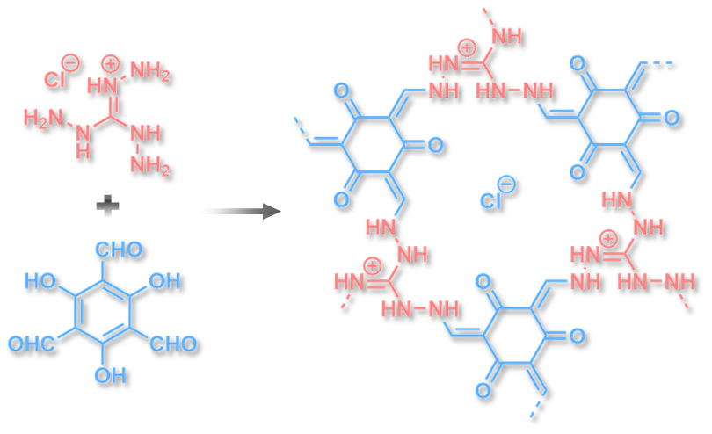
The free-standing TpTag-COF membrane was synthesized via interface condensation of triformylphloroglucino (Tp) and triaminoguanidine hydrochloride (Tag). The Tp (4.2 mg, 0.02 mmol) dissolved in the mixture of ethyl acetate/mesitylene (V/V=1/5, 2 mL) was gently placed on the top of the Tag (2.8mg, 0.026 mmol) acetic acid aqueous solution (3 M, 2 mL). The system was kept at 35 °C for 6 d. The free-standing TpTag-COF membrane was obtained after being washed thoroughly with ethanol and water in sequence and then dried under vacuum for further characterization.

Fabrication of TpTag-COF/PAN
The COF active layer was formed via interface polymerization on the surface of a PAN ultrafiltration membrane with a molecular weight cut off of 50,000 Da. The PAN support was vertically placed in the middle of a homemade diffusion cell, resulting in each volume of 7 cm³ (see Figure S1). An aqueous solution of Tag (9.9 mg, 0.090 mmol) dissolved in 3 M acetic acid (7 mL) and the organic phase with Tp (14.7 mg, 0.070 mmol) dissolved in the mixture of ethyl acetate/mesitylene (V/V=1/5, 7 mL) were separately introduced into the two sides of the diffusion cell. The reaction mixture was kept at 35 °C for 6 days. The resulting membrane was rinsed with ethanol, methanol, 0.01 M HCl, and water in sequence before testing to remove any residual monomers, catalysts, and organic solvents.

Permselectivity Evaluation
For investigating the ion transport property of TpTag-COF/PAN, the ion current was recorded by CHI660E. The membrane was mounted between the two chambers of an electrochemical cell. The voltage was scanned with a step of 0.01 V s⁻¹ using Ag/AgCl electrodes. The H⁺/Cl⁻ selectivity of TpTag-COF/PAN was evaluated by determining the reversal potentials ($V_{r}$) with different HCl concentration gradients, which can be read from the x-intercepts of the I-V plots. The permselectivity was determined according to the Goldman-Hodgin-Katz equation.
$$\frac{P_{H^{+}}}{{ P}_{{Cl}^{-}}}=\frac{a_{{Cl}^{-},cis}∙\exp\left(-V_{r}F/RT\right)-a_{{Cl}^{-},trans}}{a_{H^{+},cis}-a_{H^{+},trans}∙exp⁡(-V_{r}F/RT)}$$
In this equation, $a$, $R$, $F$, and $T$ refer to the ion activity, gas constant, Faraday constant, and absolute temperature, respectively.

Evaluation of Cation Selectivity
For investigating the ion transport property of TpTag-COF/PAN, the ion current was recorded by CHI660E with a homemade two-chamber electrochemical cell. The voltage was scanned with a step of 0.01 V s⁻¹ using Ag/AgCl electrodes. The $P_{{H^{+}}^{ }}/P_{{M^{+}}^{ }}$selectivity of TpTag-COF/PAN was evaluated by determining the $V_{r}$ with identical concentrations, which can be read from the x-intercepts of the I-V plots. The permselectivity was determined according to the following equation:
${ V}_{r}= \left\{RTln(P_{H^{+}}[H^{+}]/P_{M^{+}}[M^{+}])\right\}/zF$

Transmembrane Conductance Measurement
The ionic current was recorded by a CHI660E (CH Instruments). Ag/AgCl electrodes were used to apply a transmembrane potential. The membrane was mounted between the two chambers of a symmetric electrochemical cell and both chambers were filled with an identical concentration of acid solutions. A scanning triangle voltage signal from –1 V to 1 V with a step voltage of 0.05 V and a period of 1 s was applied to record the I–V curves. The conductance values were derived from the slops of the resulting I–V curves.

Dialysis experiments
Ion diffusion tests were carried out using an H-type diffusion cell. Membrane samples were sandwiched between two polydimethylsiloxane O-rings and sealed in the middle of the cells using clips, and the COF layers were set to face the feed solution. The effective area of the membrane samples in the cell was 2 cm². In single-salt dialysis diffusion tests, 30 mL of an electrolyte solution was used as the feed solution, and the permeate side was filled with 30 mL of deionized water. The ion concentration of the permeate solution was recorded using a conductivity meter. The transport kinetics were reflected in the linear slope in the plot of ion concentration in the permeate chamber versus operation time. In binary or trinary ion diffusion tests, 30 mL of an electrolyte solution containing an equimolar concentration of various compounds was used as the feed solution, and the permeate side was filled with 30 mL of deionized water. The concentrations of various ions in the permeate side were measured by ion chromatography. The concentration change of the permeate solution over time was obtained based on the linear relationship between the surface area and concentration of electrolyte solutions (see Figure A). A series of electrolyte solutions with various concentrations were prepared, and their surface areas were measured by ion chromatography to derive the calibration curves. For membrane recycling, the used membrane was washed with deionized water on the diffusion cell for 12 h. This procedure was carried out twice more before being used for the next run.
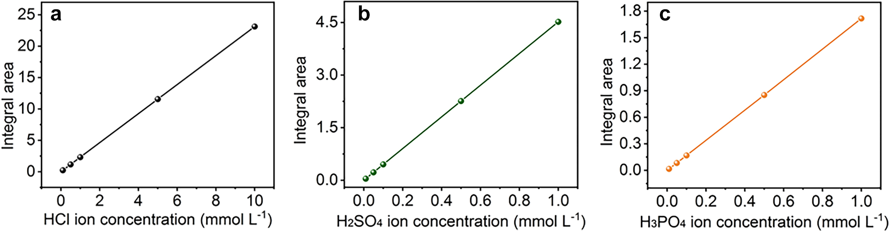
Figure A. Standard curves showing the integral areas in ion chromatography of different concentrations of HCl, H₂SO₄, and H₃PO₄ with an R² value of 1 (the standard curve was corrected before a new group was started).

Ion Transmission Activation Energy Measurement
The membrane was mounted between the two chambers of an H-shaped diffusion cell with an effective surface area of 2 cm². 30 mL of HCl, H₂SO₄, or H₃PO₄ solution (0.1 M) was used as the feed solution, and the permeate side was filled with 30 mL of deionized water. The permeances ($P$) of the acids at various temperatures were recorded by a conductivity meter. The ion transmission activation energies were calculated by the Arrhenius equation:
$$P=Ae^{-\frac{E_{a}}{RT}} (S1)$$
whereby $P$, $A$, $E_{a}$, R, and T represnet the permeance, preexponential factor, activation energy, gas constant, and temperature, respectively.

Table S1. Comparison of the ion separation performances of this study with other membranes from literature.
 | Materials | Method | Experimental Conditions |  | Selectivity
 | UIO-66-(NH-SAG)₂^{[1]} | Electrodialysis |  | 0.1 M HCl + 0.1 M LiCl |  | ∼100 (H⁺/Li⁺)
 | AEM 3-1^{[2]} | Diffusion Dialysis |  | 1.0 M HNO₃ + 0.076 M NaNO₃ |  | ∼20 (H⁺/Na⁺)
 |  |  |  | 1.0 M HNO₃ + 1.0 M HCl |  | ∼1 (Cl⁻/NO₃⁻)
 | H₂N-(Leu-Ser-Ser-Leu-Leu-Ser-Leu)₃-CONH₂^{[3]} | Electrodialysis |  | 0.5 M HCl + 0.5 M LiCl |  | ∼5.6 (H⁺/Li⁺)
H₂N-(Leu-Ser-Leu-Leu- Leu -Ser-Leu)₃-CONH₂^{[3]} |  | Electrodialysis |  | 0.5 M HCl + 0.5 M LiCl |  | ∼40 (H⁺/Li⁺)
 | CardoPES-C₂-Mor^{[4]} | Diffusion Dialysis |  | 1.0 M HCl + 0.25 M KCl |  | 79 (H⁺/K⁺)
 |  |  |  | 1.0 M HCl + 0.25 M NaCl |  | 84 (H⁺/Na⁺)
 |  |  |  | 1.0 M HCl + 0.25 M LiCl |  | 66 (H⁺/Li⁺)
 | CardoPES-C₂-Py^{[4]} | Diffusion Dialysis |  | 1.0 M HCl + 0.25 M KCl |  | 237 (H⁺/K⁺)
 |  |  |  | 1.0 M HCl + 0.25 M NaCl |  | 256 (H⁺/Na⁺)
 |  |  |  | 1.0 M HCl + 0.25 M LiCl |  | 174 (H⁺/Li⁺)
 | AEM2-Bu-2 membrane^{[5]} | Diffusion Dialysis |  | 1.0 M HCl + 0.6105 M NaCl |  | 7.31 (H⁺/Na⁺)
 |  |  |  | 1.0 M HCl + 0.18 M FeCl₂ |  | 130 (H⁺/Fe²⁺)
 |  |  |  | 1.0 M HCl + 0.135 M AlCl₃ |  | 138.5 (H⁺/Al³⁺)
 | Q-DAN-4membrane^{[6]} | Diffusion Dialysis |  | 1.0 M HCl + 0.5 M NaCl |  | ∼15 (H⁺/Na⁺)
 |  |  |  | 1.0 M HCl + 0.166 M AlCl₃ |  | ∼80 (H⁺/Al³⁺)
 |  |  |  | 1.0 M HCl + 0.25 M FeCl₂ |  | ∼30 (H⁺/Fe²⁺)
 | QPPO and QPPO-DM Membranes^{[7]} | Diffusion Dialysis |  | 1.0 M HCl + 0.266 M FeCl₂ |  | 49-1391 (H⁺/Fe²⁺)
 | Porous BPPO Membranes^{[8]} | Diffusion Dialysis |  | 1.0 M HCl + 0.21 M FeCl₂ |  | 81-665 (H⁺/Fe²⁺)
 | TFC-C^{[9]} | Nanofiltration |  | 2 g/L NaCl + 2 g/L Na₂SO₄ |  | 16.7 (Cl⁻/SO₄²⁻)
 | Silicon Nitride/CNT Composite Membranes^{[10]} | Nanofiltration |  | 2 mM KCl + 2 mM K₂SO₄ |  | 2 (Cl⁻/SO₄²⁻)
 | Hollow-Fiber NF membrane^{[11]} | Nanofiltration |  | 1 g/L NaCl + 1 g/L Na₂SO₄ |  | 2.5 (Cl⁻/SO₄²⁻)
 | TFC_{n}^{[12]} | Nanofiltration |  | 1 g/L MgCl₂ + 1 g/L Na₂SO₄ |  | 20.6 (Cl⁻/SO₄²⁻)
 | TFC^{[13]} | Nanofiltration |  | 1 g/L NaCl + 1 g/L Na₂SO₄ |  | ∼9 (Cl⁻/SO₄²⁻)
 | Polyamide Membrane ^{[14]} | Nanofiltration |  | 1 g/L NaCl + 1 g/L Na₂SO₄ |  | 24.7 (Cl⁻/SO₄²⁻)
 | NF270^{[15]} | Nanofiltration |  | 0.2-1.2 M NaCl + 0.1 NaSO₄ |  | 1.7-13.6 (Cl⁻/SO₄²⁻)
 | TS-I^{[16]} | Nanofiltration |  | 2 g/L NaCl + 2 g/L Na₂SO₄ |  | 54.2 (Cl⁻/SO₄²⁻)
 | TS-II^{[16]} | Nanofiltration |  | 2 g/L NaCl + 2 g/L Na₂SO₄ |  | 126 (Cl⁻/SO₄²⁻)
 | GNM/SWNT Membrane ^{[17]} | Nanofiltration |  | 2 g/L NaCl + 2 g/L Na₂SO₄ |  | 3.2 (Cl⁻/SO₄²⁻)
 | Ani 0.1 M PSS 1.0 wt% membrane^{[18]} | Nanofiltration |  | 5 mM NaCl + 5 mM Na₂SO₄ |  | 2.5 (Cl⁻/SO₄²⁻)
 | BPPO Mmbrane^{[19]} | Electrodialysis |  | 0.05 M NaCl + 0.05 M Na₂SO₄ |  | 4.27 (Cl⁻/SO₄²⁻)
 | C-AEM^{[20]} | Electrodialysis |  | 0.01 M NaCl + 0.01 M Na₂SO₄ |  | 11.5 (Cl⁻/SO₄²⁻)
 | MASMs^{[21]} | Electrodialysis |  | 0.05 M NaCl + 0.05 M Na₂SO₄ |  | 2.47 (Cl⁻/SO₄²⁻)
 | Internally Cross-Linked AEM^{[22]} | Electrodialysis |  | 0.05 M NaCl + 0.05 M Na₂SO₄ |  | 15.9 (Cl⁻/SO₄²⁻)
 | PAEK Membrane^{[23]} | Electrodialysis |  | 0.05 M NaCl + 0.05 M Na₂SO₄ |  | 7.7 (Cl⁻/SO₄²⁻)
 | Chemically Assembled AEM^{[24]} | Electrodialysis |  | 0.05 M NaCl + 0.05 M Na₂SO₄ |  | 4.7 (Cl⁻/SO₄²⁻)
 | Hydrophobic Side Chains AEMs^{[25]} | Electrodialysis |  | 0.05 M NaCl + 0.05 M Na₂SO₄ |  | 13.1 (Cl⁻/SO₄²⁻)
 | NH₄HCO₃@MPD^{[26]} | Forward Osmosis |  | 1 g/L NaCl + 1 g/L Na₂SO₄ |  | 13.5 (Cl⁻/SO₄²⁻)
 | KHCO₃@MPD^{[26]} | Forward Osmosis |  | 1 g/L NaCl + 1 g/L Na₂SO₄ |  | 13.5 (Cl⁻/SO₄²⁻)
 | NH₄Cl@MPD^{[26]} | Forward Osmosis |  | 1 g/L NaCl + 1 g/L Na₂SO₄ |  | 14.7 (Cl⁻/SO₄²⁻)
 | ESNA 1-LF, ESNA 1 and LES 90^{[27]} | Electrodialysis |  | NaNO₃ + NaCl |  | ∼1 (Cl⁻/NO₃⁻)
 | t-TpMa-COF membrane^{[28]} | Diffusion Dialysis |  | 5.0 M HNO₃ + 5.0 M HCl |  | ∼1 (Cl⁻/NO₃⁻)
 | This work | Diffusion Dialysis |  | 0.25 M HCl + 0.25 M KCl |  | 253 (H⁺/K⁺)
 |  |  |  | 0.25 M HCl + 0.25 M NaCl |  | 259 (H⁺/Na⁺)
 |  |  |  | 0.25 M HCl + 0.25 M LiCl |  | 346 (H⁺/Li⁺)
 |  |  |  | 0.25 M HCl + 0.25 M CaCl₂ |  | 886 (H⁺/Ca²⁺)
 |  |  |  | 0.25 M HCl + 0.25 M MgCl₂ |  | 1116 (H⁺/Mg²⁺)
 |  |  |  | 0.25 M HCl + 0.25 M FeCl₂ |  | 3545 (H⁺/Fe²⁺)
 |  |  |  | 0.25 M HCl + 0.25 M AlCl₃ |  | 4334 (H⁺/Al³⁺)
 |  |  |  | 0.25 M HNO₃ + 0.25 M HCl |  | 8.3 (NO₃⁻/Cl⁻)
 |  |  |  | 0.05 M HCl + H₂SO₄ + H₃PO₄ |  | 39 (Cl⁻/SO₄²⁻)
 |  |  |  | 0.1 M HCl + H₂SO₄ + H₃PO₄ |  | 183 (Cl⁻/ H_{n}PO₄^{(3-n)−})

(1) Li, X., Zhang, H., Hou, J., Ou, R., Zhu, Y., Zhao, C., Qian, T., Easton, C. D., Selomulya, C., Hill, M. R. & Wang, H. Sulfonated sub-1-nm metal–organic framework channels with ultrahigh proton selectivity. J. Am. Chem. Soc. 142, 9827-9833 (2020).
(2) Chavan, V., Agarwal, C., Adya, V. C. & Pandey, A. K. Hybrid organic-inorganic anion-exchange pore-filled membranes for the recovery of nitric acid from highly acidic aqueous waste streams. Water Res. 133, 87-98 (2018).
(3) Lear, J. D., Wasserman, Z. R. & DeGrado, W. F. Synthetic amphiphilic peptide models for protein ion channels. Science 240, 1177-1181 (1988).
(4) Xia, W., Yang, Y., Shang, X., Yang, X., Wang, S., Gong, F., Wang, L., Wang, X. & Chen, X. Cardopoly(arylene ether sulfone)s membranes bearing N-cyclic cationic groups enable high performance during both diffusion dialysis and electrodialysis. Desalination 529, 115646 (2022).
(5) Mondal, R., Pal, S. & Chatterjee, U. Alkylated imidazole moieties in a cross-linked anion exchange membrane facilitate acid recovery with high purity. ACS Appl. Polym. Mater. 3, 1544-1554 (2021).
(6) Irfan, M., Bakangura, E., Afsar, N. U. & Xu, T. Augmenting acid recovery from different systems by novel Q-DAN anion exchange membranes via diffusion dialysis. Sep. Purif. Technol. 201, 336-345 (2018).
(7) Ji, W., Ge, X., Afsar, N. U., Zhao, Z., Wu, B., Song, W., He, Y., Ge, L. & Xu, T. In-situ crosslinked AEMs with self-assembled nanostructure for acid recovery. Sep. Purif. Technol. 247.116827 (2020).
(8) Ge, L., Mondal, A. N., Liu, X., Wu, B., Yu, D., Li, Q., Miao, J. Ge, Q. & Xu, T. Advanced charged porous membranes with ultrahigh selectivity and permeability for acid recovery. J. Membr. Sci. 536, 11-18 (2017).
(9) Zhu, X., Cheng, X., Luo, X., Liu, Y., Xu, D., Tang, X., Gan, Z., Yang, L., Li, G. & Liang, H. Ultrathin thin-film composite polyamide membranes constructed on hydrophilic poly(vinyl alcohol) decorated support toward enhanced nanofiltration performance. Environ. Sci. Technol. 54, 6365-6374 (2020).
(10) Fornasiero, F., Park, H. G., Holt, J. K., Stadermann, M., Grigoropoulos, C. P., Noy, A. & Bakajin, O. Ion exclusion by sub-2-nm carbon nanotube pores. Proc. Natl. Acad. Sci. U. S. A. 105, 17250-17255 (2008).
(11) Wei, X., Wang, S., Shi, Y., Xiang, H. & Chen, J. Application of positively charged composite hollow-fiber nanofiltration membranes for dye purification. Ind. Eng. Chem. Res. 53, 14036-14045 (2014).
(12) Yang, Z., Zhou, Z., Guo, H., Yao, Z., Ma, X., Song, X., Feng, S.-P. & Tang, C. Y. Tannic acid/Fe³⁺ nanoscaffold for interfacial polymerization: toward enhanced nanofiltration performance. Environ. Sci. Technol. 52, 9341-9349 (2018).
(13) Wang, Z., Wang, Z., Lin, S., Jin, H., Gao, S., Zhu, Y. & Jin, J. Nanoparticle-templated nanofiltration membranes for ultrahigh performance desalination. Nat. Commun. 9, 2004 (2018).
(14) Gao, S., Zhu, Y., Gong, Y., Wang, Z., Fang, W. & Jin, J. Ultrathin polyamide nanofiltration membrane fabricated on brush-painted single-walled carbon nanotube network support for ion sieving. ACS Nano 13, 5278-5290 (2019).
(15) Pérez-González, A., Ibáñez, R., Gómez, P., Urtiaga, A. M., Ortiz, I. & Irabien, J. A. Nanofiltration separation of polyvalent and monovalent anions in desalination brines. J. Membr. Sci. 473, 16-27 (2015).
(16) Tan, Z., Chen, S., Peng, X., Zhang, L. & Gao, C. Polyamide membranes with nanoscale turing structures for water purification. Science 360, 518-521 (2018).
(17) Yang, Y., Yang, X., Liang, L., Gao, Y., Cheng, H., Li, X., Zou, M., Ma, R., Yuan, Q. & Duan, X. Large-area graphene-nanomesh/carbon-nanotube hybrid membranes for ionic and molecular nanofiltration. Science 364, 1057-1062 (2019).
(18) Zhang, H., Quan, X., Fan, X., Yi, G., Chen, S., Yu, H.& Chen, Y. Improving ion rejection of conductive nanofiltration membrane through electrically enhanced surface charge density. Environ. Sci. Technol. 53, 868-877 (2019).
(19) Pan, J., Ding, J., Tan, R., Chen, G., Zhao, Y., Gao, C., Bruggen, B. V. & Shen, J. Preparation of a monovalent selective anion exchange membrane through constructing a covalently crosslinked interface by electro-deposition of polyethyleneimine. J. Membr. Sci. 539, 263-272 (2017).
(20) Zhang, Y., Liu, R., Lang, Q., Tan, M. & Zhang, Y. Composite anion exchange membrane made by layer-by-layer method for selective ion separation and water migration control. Sep. Purif. Technol. 192, 278-286 (2018).
(21) Li, M., Li, W., Zhang, X., Wu, C., Han, X. & Chen, Y. Polyvinyl alcohol-based monovalent anion selective membranes with excellent permselectivity in selectrodialysis. J. Membr. Sci. 620, 118889 (2021).
(22) Pan, J., Ding, J., Zheng, Y., Gao, C., Bruggen, B. V. & Shen, J. One-pot approach to prepare internally cross-linked monovalent selective anion exchange membranes. J. Membr. Sci. 553, 43-53 (2018).
(23) Liao, J., Zhu, J., Yang, S., Pan, N., Yu, X., Wang, C., Li, J. & Shen, J. Long-side-chain type imidazolium-functionalized fluoro-methyl poly(arylene ether ketone) anion exchange membranes with superior electrodialysis performance. J. Membr. Sci. 574, 181-195 (2019).
(24) Zhao, Y., Li, Y., Yuan, S., Zhu, J., Houtmeyers, S., Li, J., Dewil, R., Gao, C. & Bruggen, B. V. A chemically assembled anion exchange membrane surface for monovalent anion selectivity and fouling reduction. J. Mater. Chem. A 7, 6348-6356 (2019).
(25) Irfan, M., Ge, L., Wang, Y., Yang, Z. & Xu, T. Hydrophobic side chains impart anion exchange membranes with high monovalent–divalent anion selectivity in electrodialysis. ACS Sustainable Chem. Eng. 7, 4429-4442 (2019).
(26) Shen, L., Cheng, R., Yi, M., Hung, W.-S., Japip, S., Tian, L., Zhang, X., Jiang, S., Li, S. & Wang, Y. Polyamide-based membranes with structural homogeneity for ultrafast molecular sieving. Nat. Commun. 13, 500 (2022).
(27) Su, M., Wang, D.-X., Wang, X.-L., Ando, M. & Shintani, T. Rejection of ions by NF membranes for binary electrolyte solutions of NaCl, NaNO₃, CaCl₂ and Ca(NO₃)₂. Desalination 191, 303-308 (2006).
(28) Zhou, L., Li, X., Cao, K., Jia, Z., Long, H., Li, Y., Tao, G., Liu, N., Zhang, J. & Ma, L. Covalent organic framework membrane with turing structures for deacidification of highly acidic solutions. Adv. Funct. Mater. 32, 2108178 (2022).

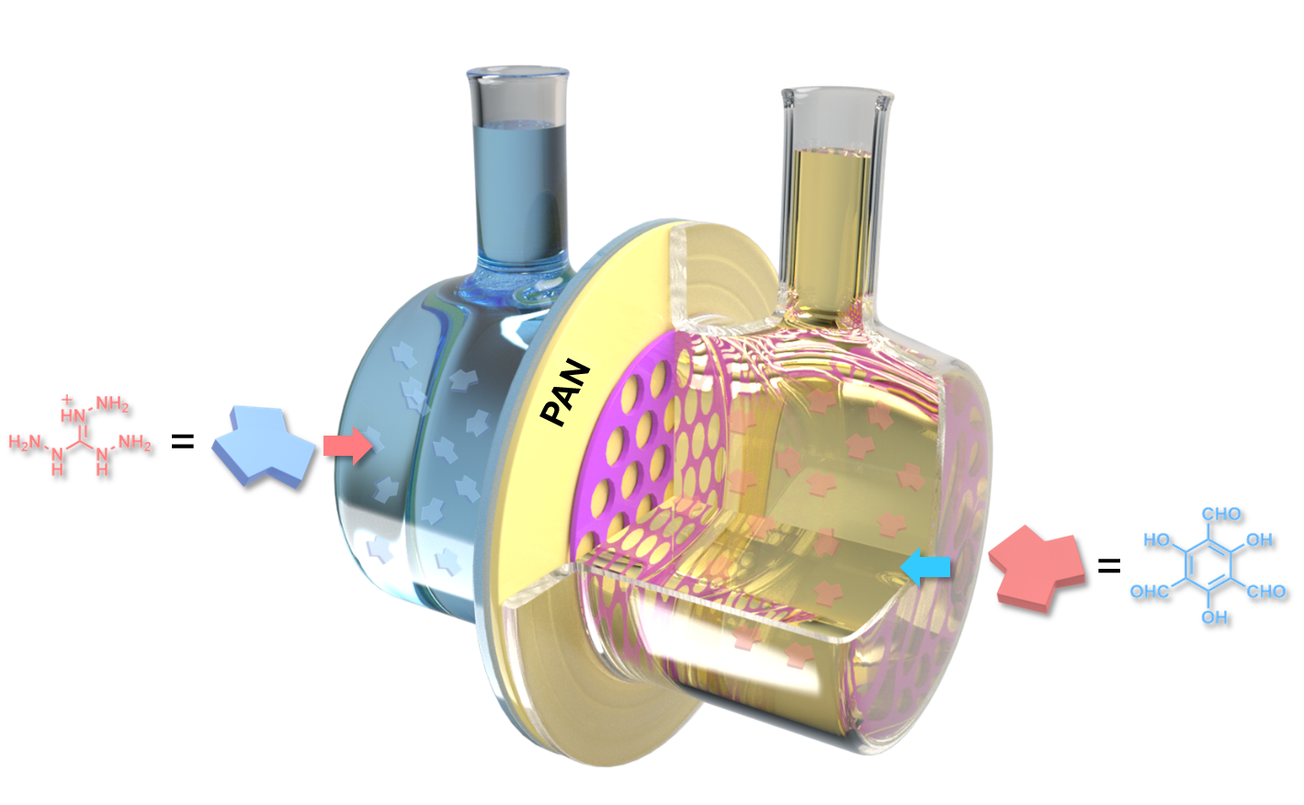
Supplementary Figure 1 | Schematic illustration of the set-up used for the fabrication of TpTag-COF/PAN via interface polymerization. Triaminoguanidine hydrochloride (Tag) was dissolved in the acetic acid aqueous solution, and 1,3,5-triformylphloroglucinol (Tp) was dissolved in the mixture of ethyl acetate and mesitylene.

Supplementary Figure 2 | SEM image. Top-view SEM image of the PAN membrane with a molecular weight cut off of 50,000 Da.

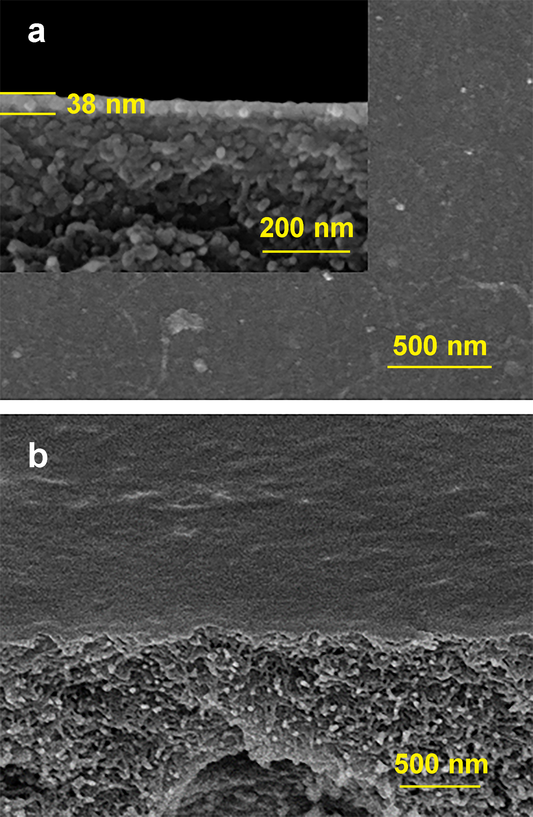
Supplementary Figure 3 | SEM images. (a) Cross section-view and (b) top view SEM images of TpTag-COF/PAN (inset: the thickness of TpTag-COF/PAN).

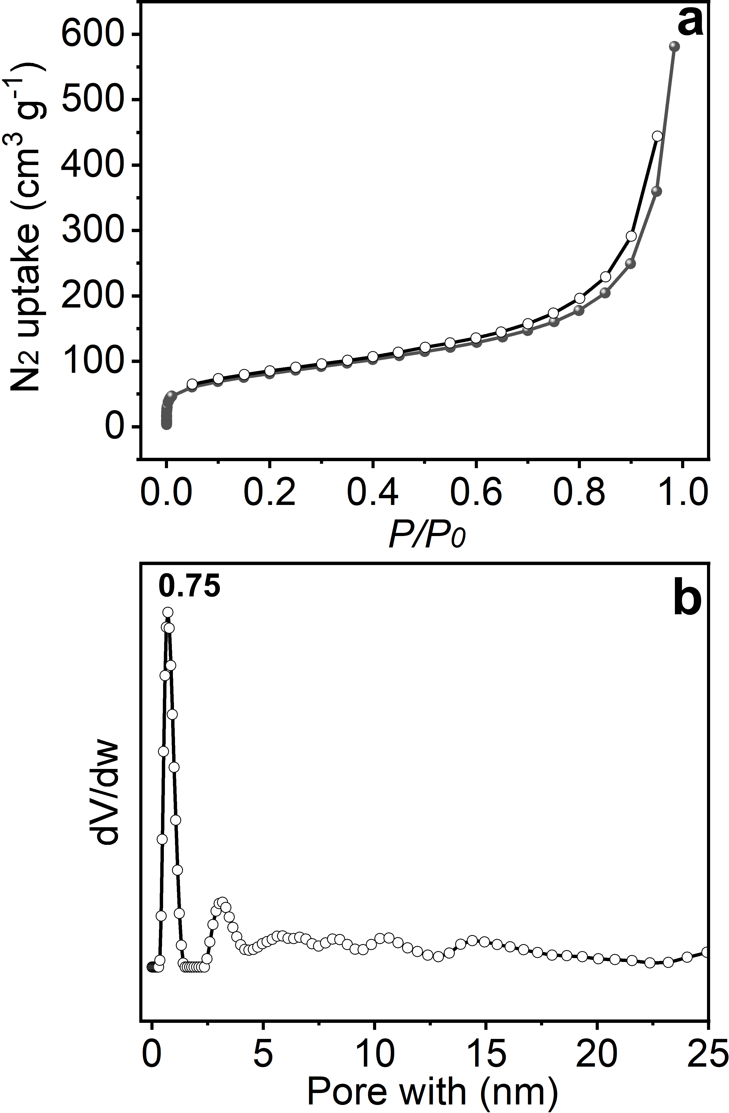
Supplementary Figure 4 | Porosity evaluation. (a) N₂ sorption isotherms collected at 77 K of the free-standing TpTag-COF membrane and (b) the corresponding pore size distribution based on the NLDFT method. The BET surface area was calculated to be 286 m² g⁻¹ with the pore size centered at 0.75 nm.

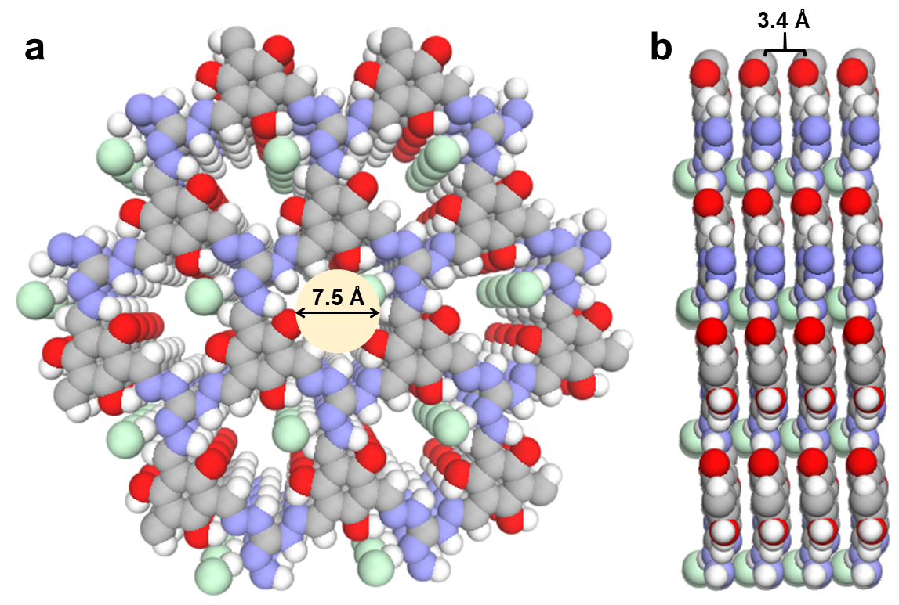

Supplementary Figure 5 | Simulated structures. (a) Top view and (b) side view of the simulated eclipsed stacking for TpTag-COF (gray, C; blue, N; red, O; white, H).

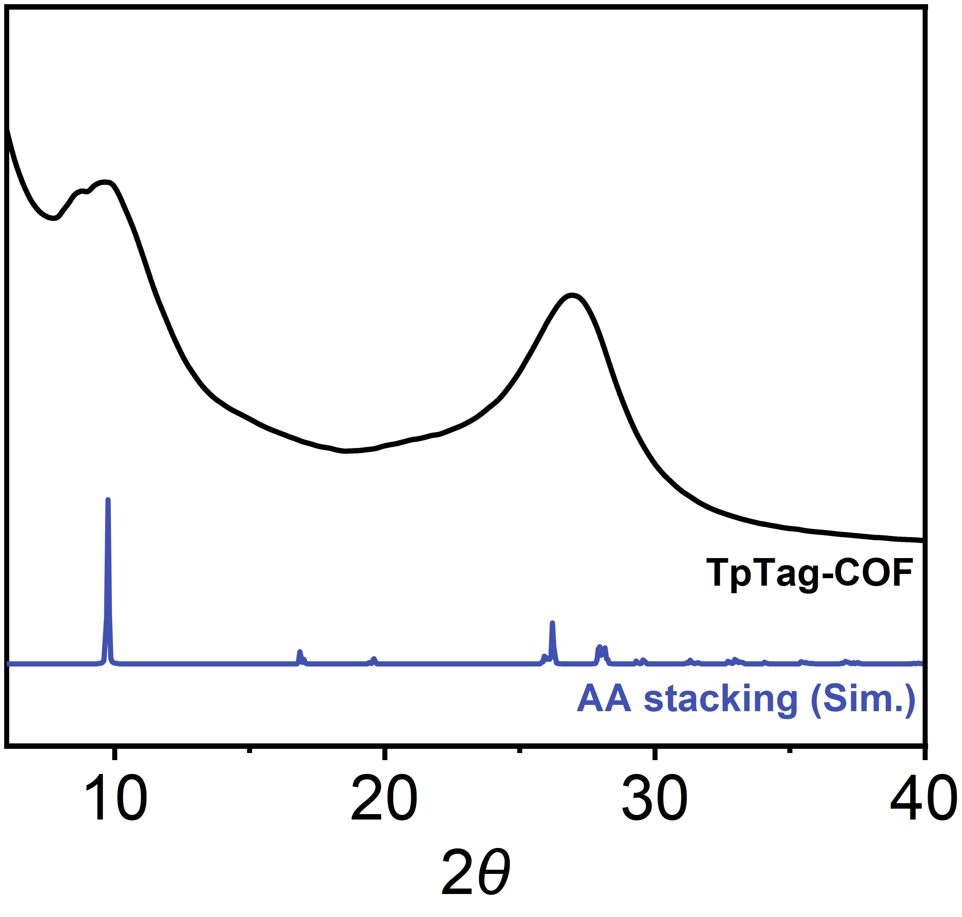
Supplementary Figure 6 | Calculated and experimental PXRD patterns of the free-standing TpTag-COF membrane.

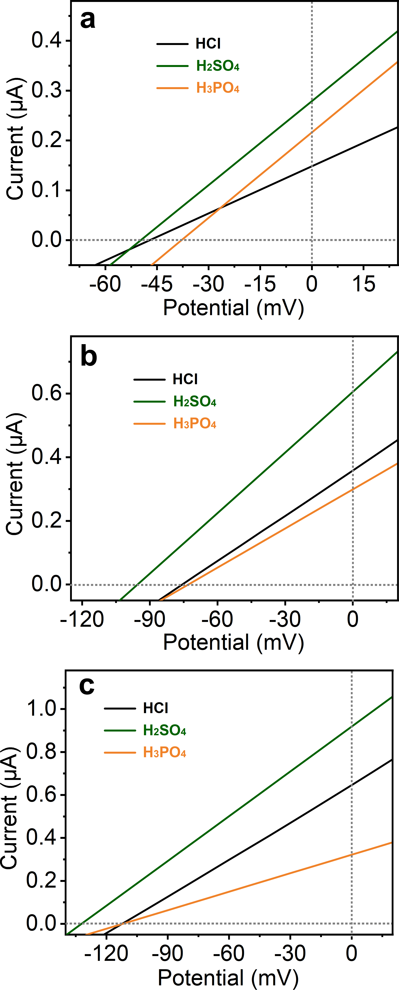
Supplementary Figure 7 | Investigation of transmembrane acid transport behavior. I–V curves collected under various asymmetric acid solutions with a concentration difference of (a) 10 (10 mM/1 mM), (b) 100 (0.1 M/1 mM), and (c) 1000 (1 M/1 mM).

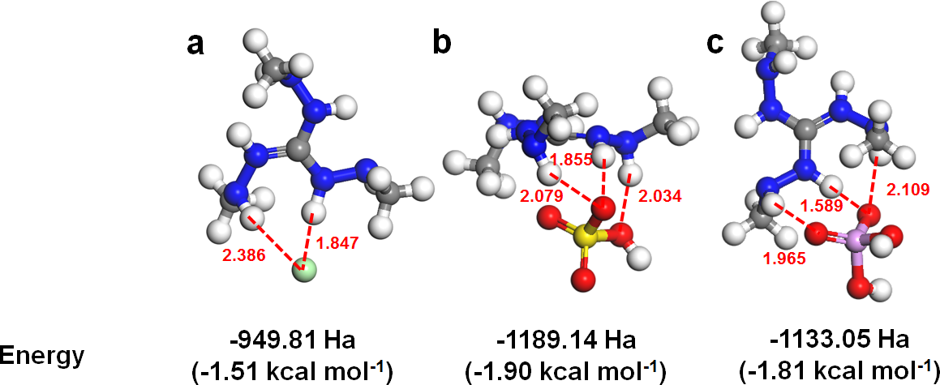
Supplementary Figure 8 | DFT calculation. Top-down view of minimum energy anion binding positions of (a) Cl⁻, (b) HSO₄⁻, and (c) H₂PO₄⁻ with the guanidinium moiety. Grey, blue, red, green, purple, yellow, and white atoms are carbon, nitrogen, oxygen, chlorine, phosphorus, sulfur, and H atoms, respectively.

Supplementary Figure 9 | Evaluation of cation selectivity. Concentration changes of various compounds through TpTag-COF/PAN to the opposite side as a function of time. A conductivity meter was used to record the concentrations of permeated ions of HCl, KCl, NaCl, LiCl, MgCl₂, and CaCl₂, while ICP-OES was used to record the concentrations of FeCl₂ and AlCl₃ in the permeate reservoir.

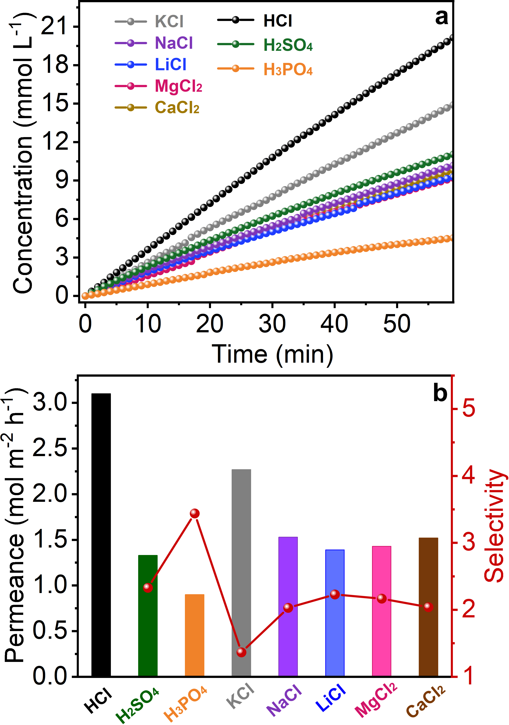
Supplementary Figure 10 | Transmembrane selectivity across PAN. (a) Concentration changes of various electrolytes (0.25 M) through PAN to the opposite side as a function of time recorded by a conductivity meter and (b) the corresponding permeance of various compounds and the selectivity of HCl to H₂SO₄, H₃PO₄, KCl, NaCl, LiCl, MgCl₂, and CaCl₂, respectively.

Supplementary Figure 11 | Selectivity of proton over other cations across TpTag-COF/PAN. The permeance of various electrolytes and the selectivity of HCl to various salts across TpTag-COF/PAN tested under single electrolyte conditions with various feed concentrations.

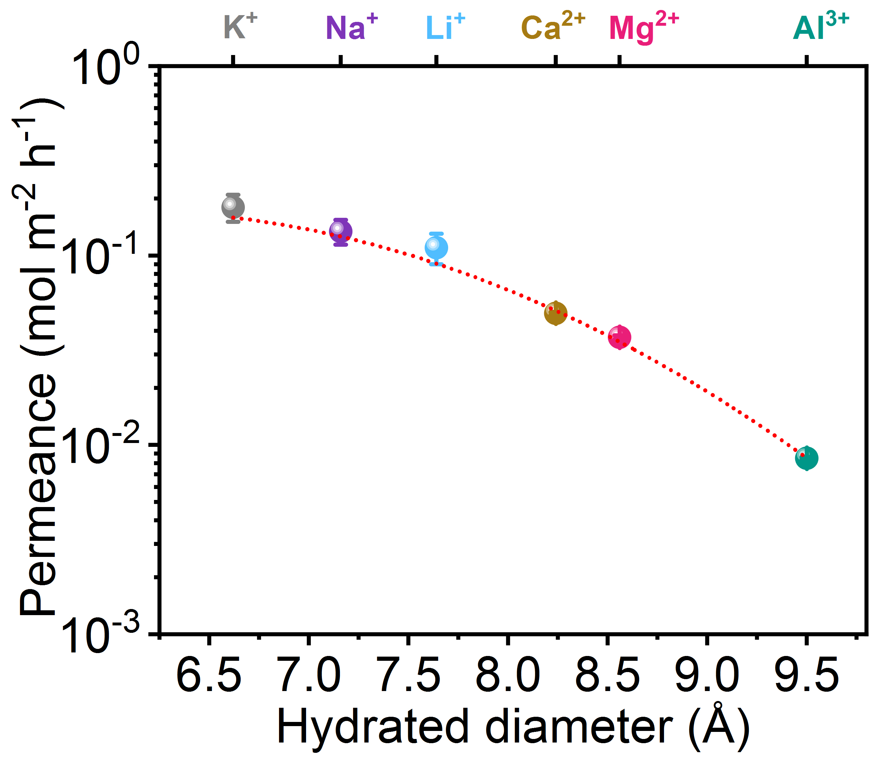
Supplementary Figure 12 | Permeance of various electrolytes (0.1 M) in contact with TpTag-COF/PAN. Cations and their corresponding hydrated diameters are shown on the top and bottom x-axes, respectively.

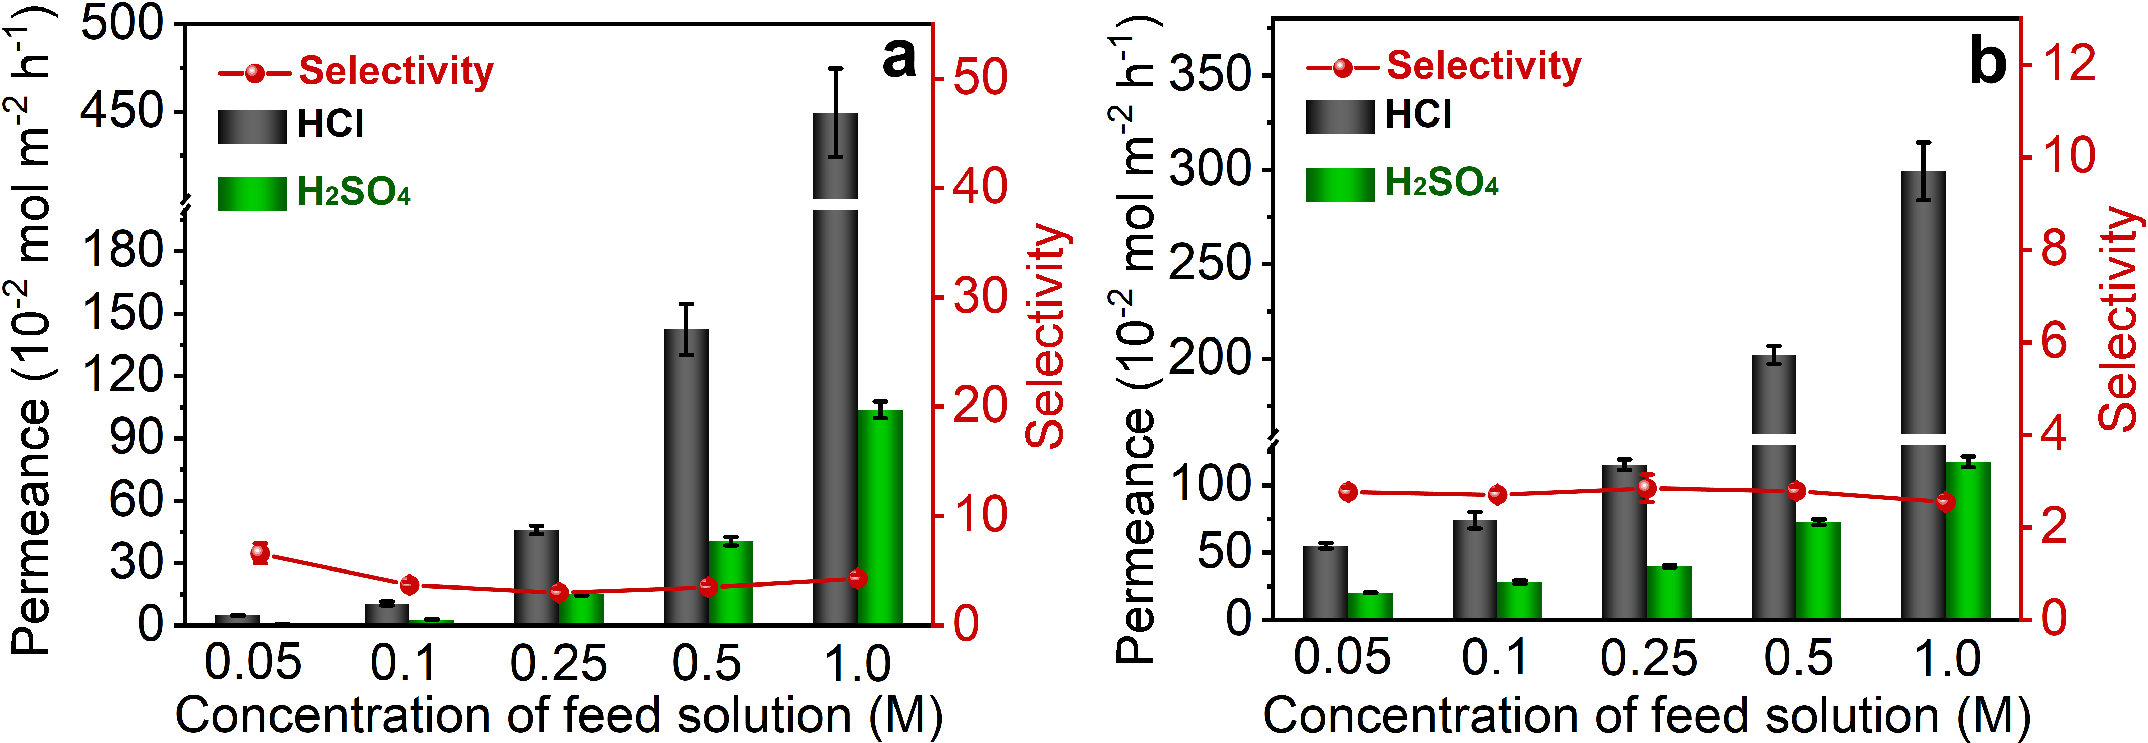
Supplementary Figure 13 | Evaluation of acid selectivity. The permeance of HCl and H₂SO₄, and the selectivity of HCl to H₂SO₄ across (a) Nafion®212 and (b) Selemion AMVN tested under binary acid conditions with various feed concentrations (0.05, 0.1, 0.25, 0.5, and 1.0 M for each acid).

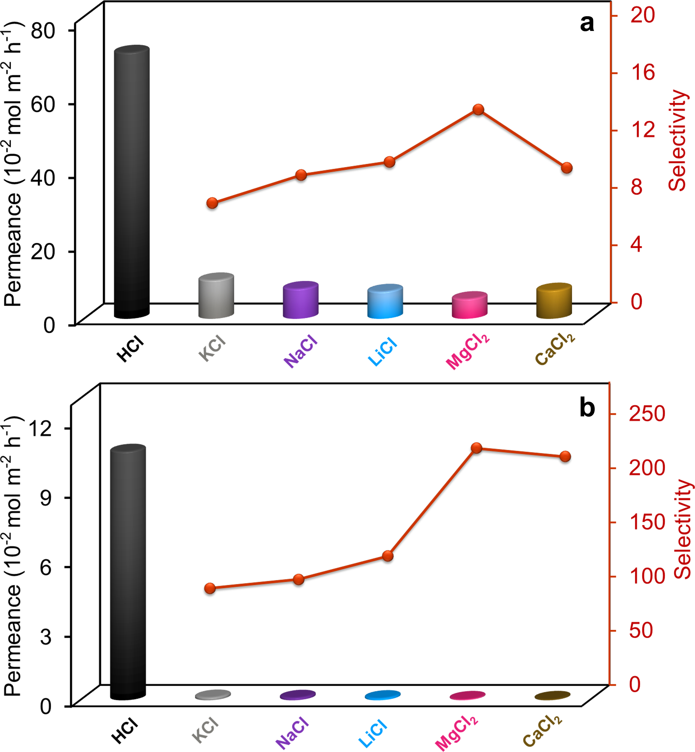
Supplementary Figure 14 | Evaluation of the selectivity of proton over other cations. Permeance of various electrolytes across (a) Nafion®212 and (b) Selemion AMVN, and the corresponding H⁺/M^{x+} selectivity under single electrolyte conditions (0.1 M).

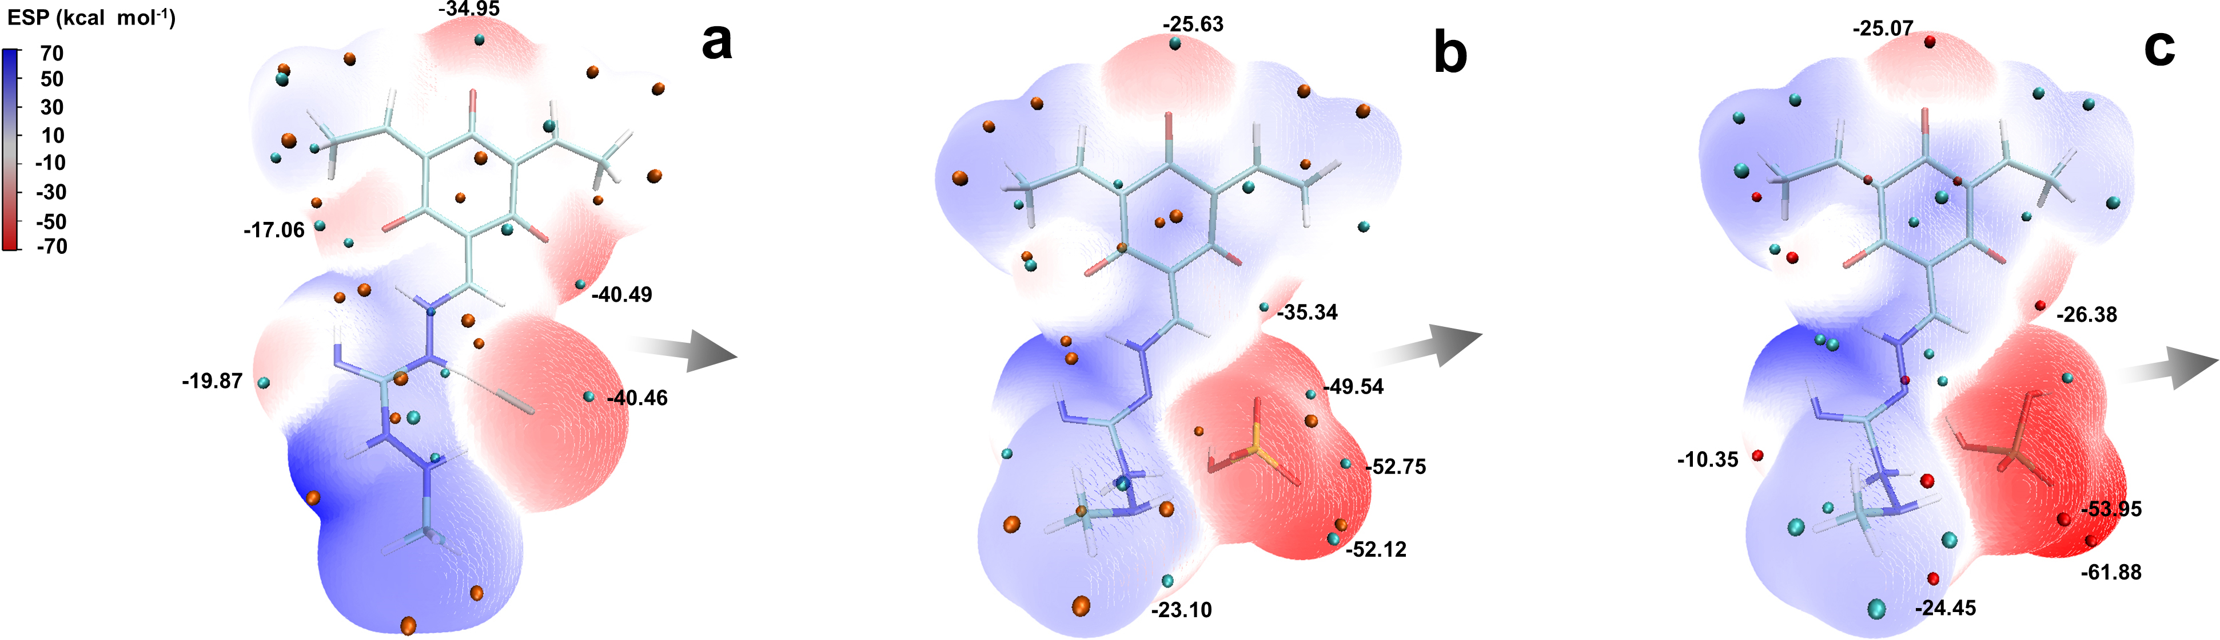
Supplementary Figure 15 | Electrostatic potential (ESP). ESP mapped van der Waals surface of the fragment of TpTag-COF with various counterions for (a) Cl⁻, (b) HSO₄⁻, and (c) H₂PO₄⁻ and area percent in each ESP range. Significant surface local minima and maxima of ESP are represented as red and blue spheres and labeled by black texts. The direction of pore content is marked by grey arrows.

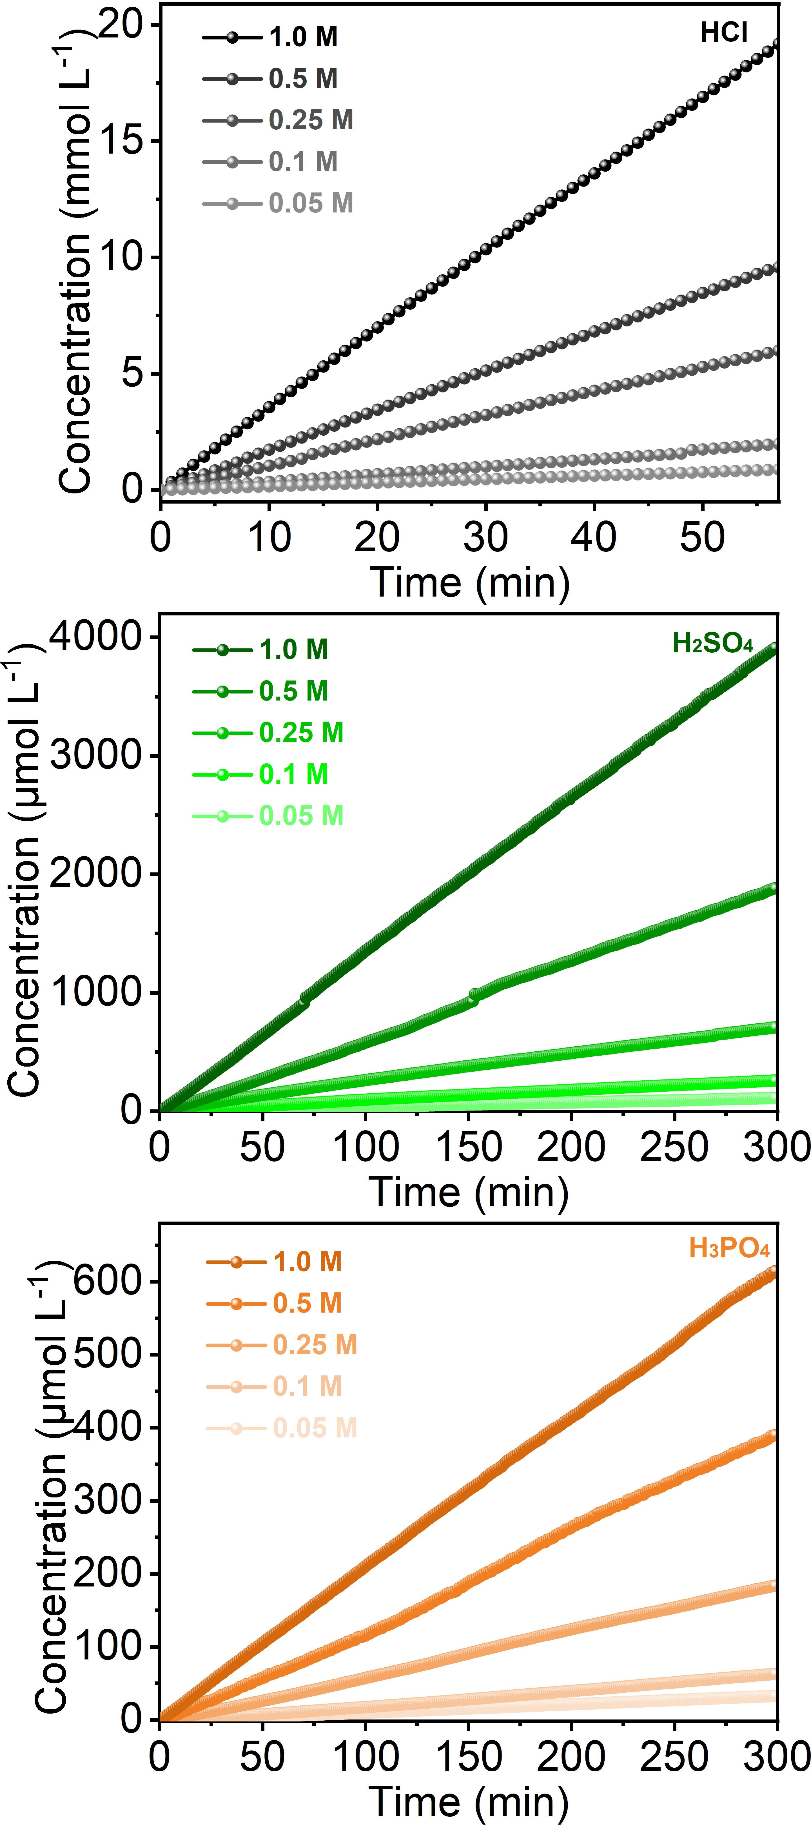
Supplementary Figure 16 | The concentration change of HCl, H₂SO₄, and H₃PO₄ through TpTag-COF/PAN to the opposite side as a function of time. Conductivity meter was used to record the concentrations of ion permeated.

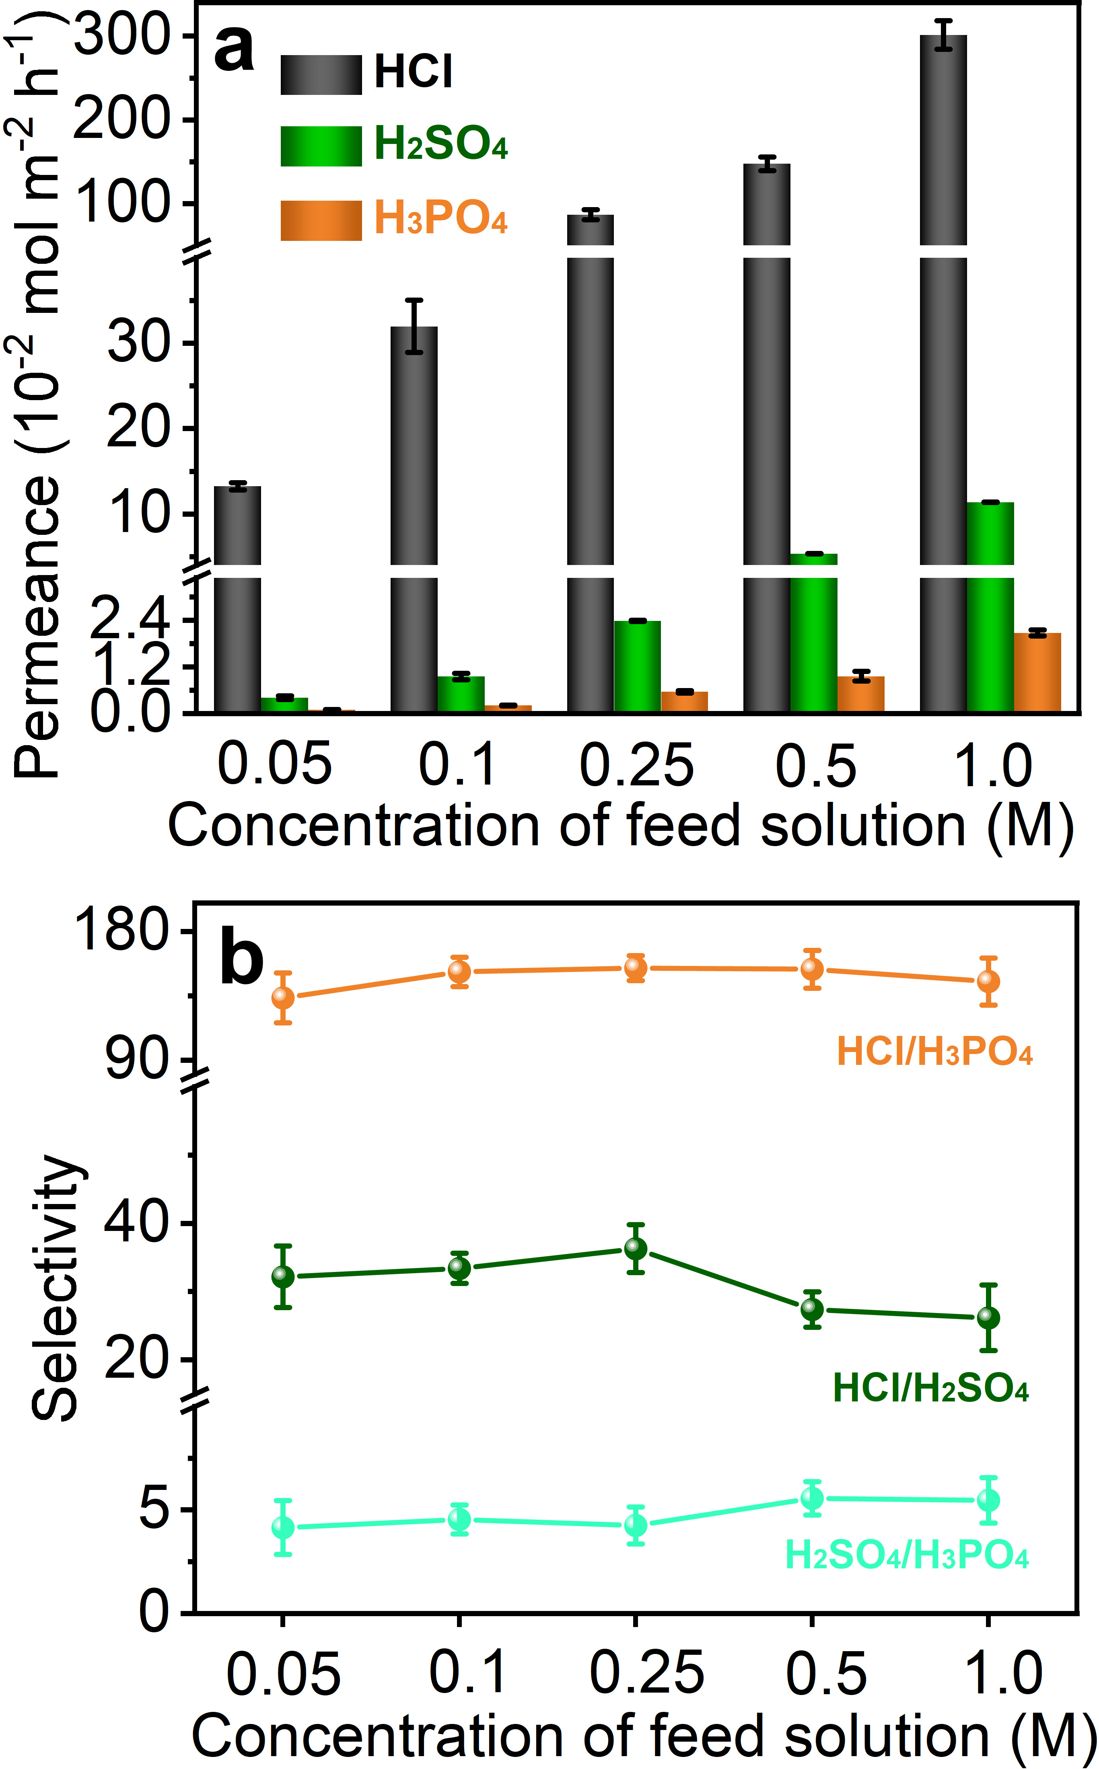
Supplementary Figure 17 | Evaluation of acid selectivity across TpTag-COF/PAN. (a) The permeance of HCl, H₂SO₄, and H₃PO₄, and (b) the relative selectivity of HCl, H₂SO₄, and H₃PO₄ across TpTag-COF/PAN as a function of feed concentration tested under single acid conditions.

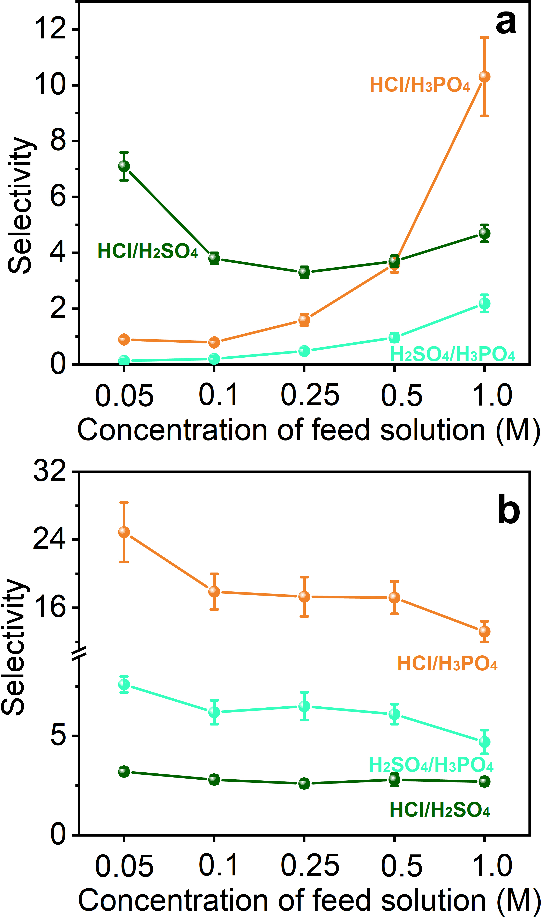
Supplementary Figure 18 | Evaluation of acid selectivity across various membranes. The relative selectivity of HCl, H₂SO₄, and H₃PO₄ across (a) Nafion®212 and (b) Selemion AMVN tested under trinary acid conditions.

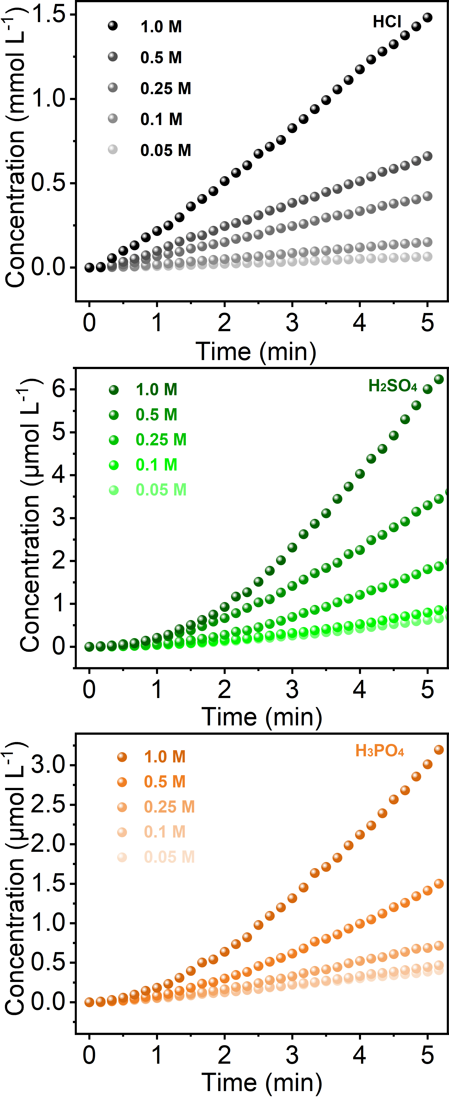
Supplementary Figure 19 | The initial concentration change of HCl, H₂SO₄, and H₃PO₄ across TpTag-COF/PAN to the opposite side as a function of time. Conductivity meter was used to record the concentrations of ion permeated.

Supplementary Figure 20 | Investigation of the impact of acid concentration on the selectivity. Permeance of HCl, H₂SO₄, and H₃PO₄ as a function of time tested under trinary acid conditions with an initial concentration of each acid of (a) 0.05 M, (b) 0.1 M, (c) 0.25 M, (d) 0.5 M, and (e) 1 M, and the corresponding selectivity.

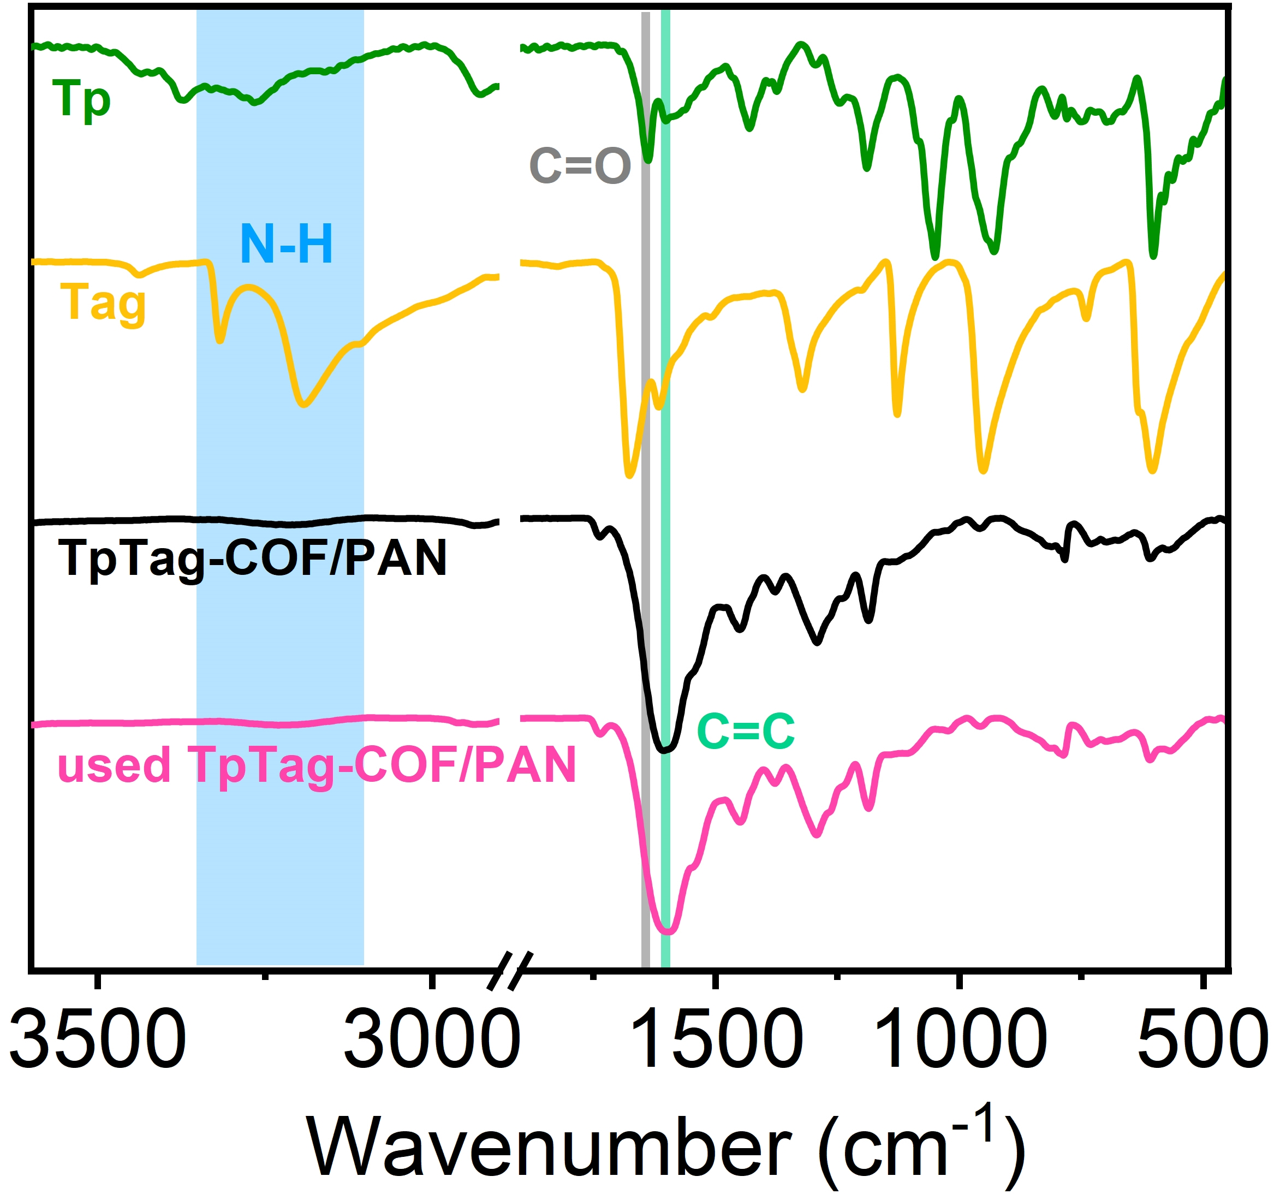
Supplementary Figure 21 | IR spectra. The very similar IR spectrum of TpTag-COF/PAN to that of the reused one, suggestive of the maintained structure during testing. The successful formation of the β-ketoenamine structures of the resulting COF membranes was confirmed by the IR spectra, which displayed a new peak for C=C at 1601 cm⁻¹. The stretching signals of the primary amine (ν_{N-H} ~3320 cm⁻¹ and 3220 cm⁻¹) and aldehyde (ν_{C=O} = 1645 cm⁻¹) were not detected, indicating that no unreacted monomers were trapped.

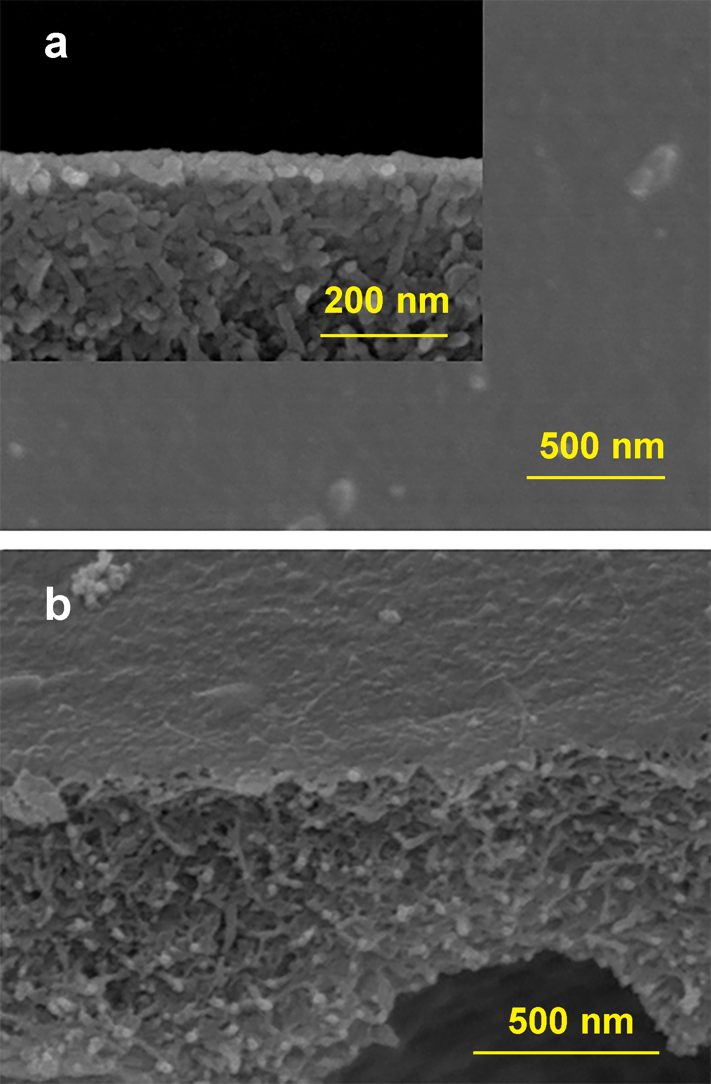
Supplementary Figure 22 | SEM images. (a) Cross section-view and (b) top view SEM images of the long-term used TpTag-COF/PAN (inset: the thickness of TpTag-COF/PAN).

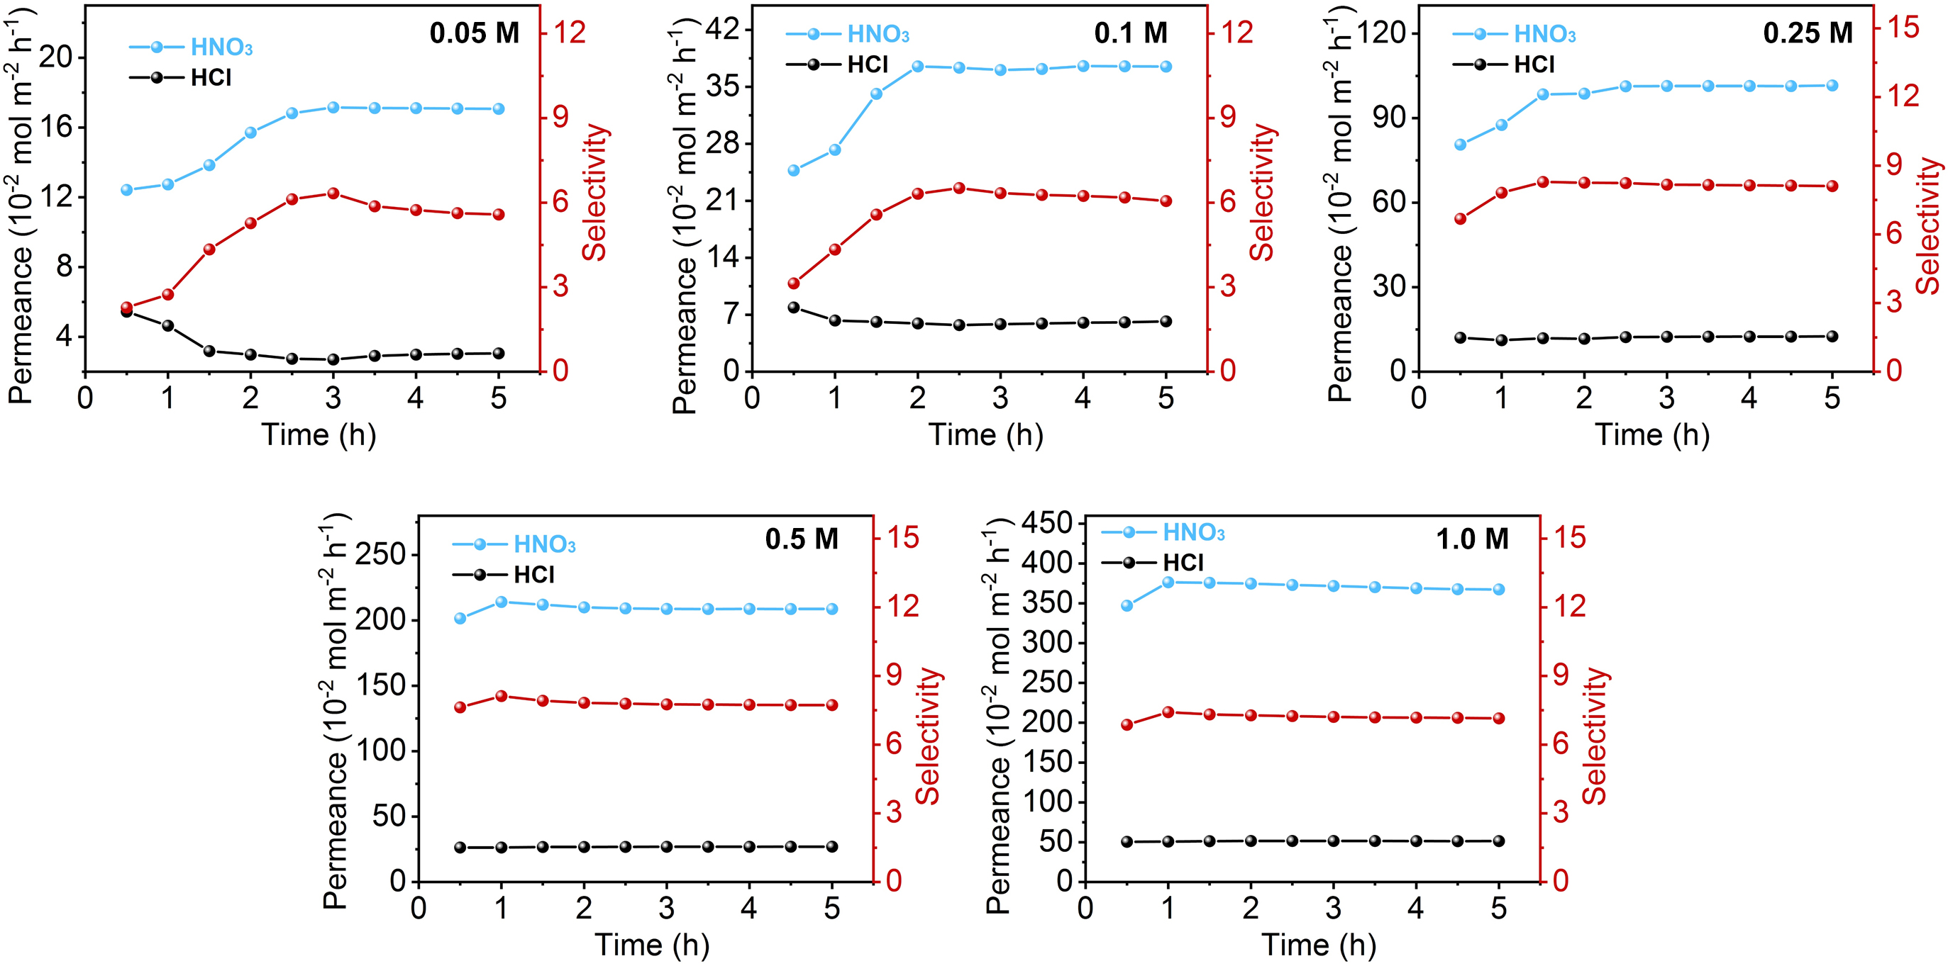
Supplementary Figure 23 | The impact of concentration on the selectivity of HNO₃ and HCl across TpTag-COF/PAN. Permeance of HCl and H₃NO₃ as a function of time tested under binary acid conditions with an initial concentration of each acid of 0.05 M, 0.1 M, 0.25 M, 0.5 M, and 1 M and the corresponding selectivity.

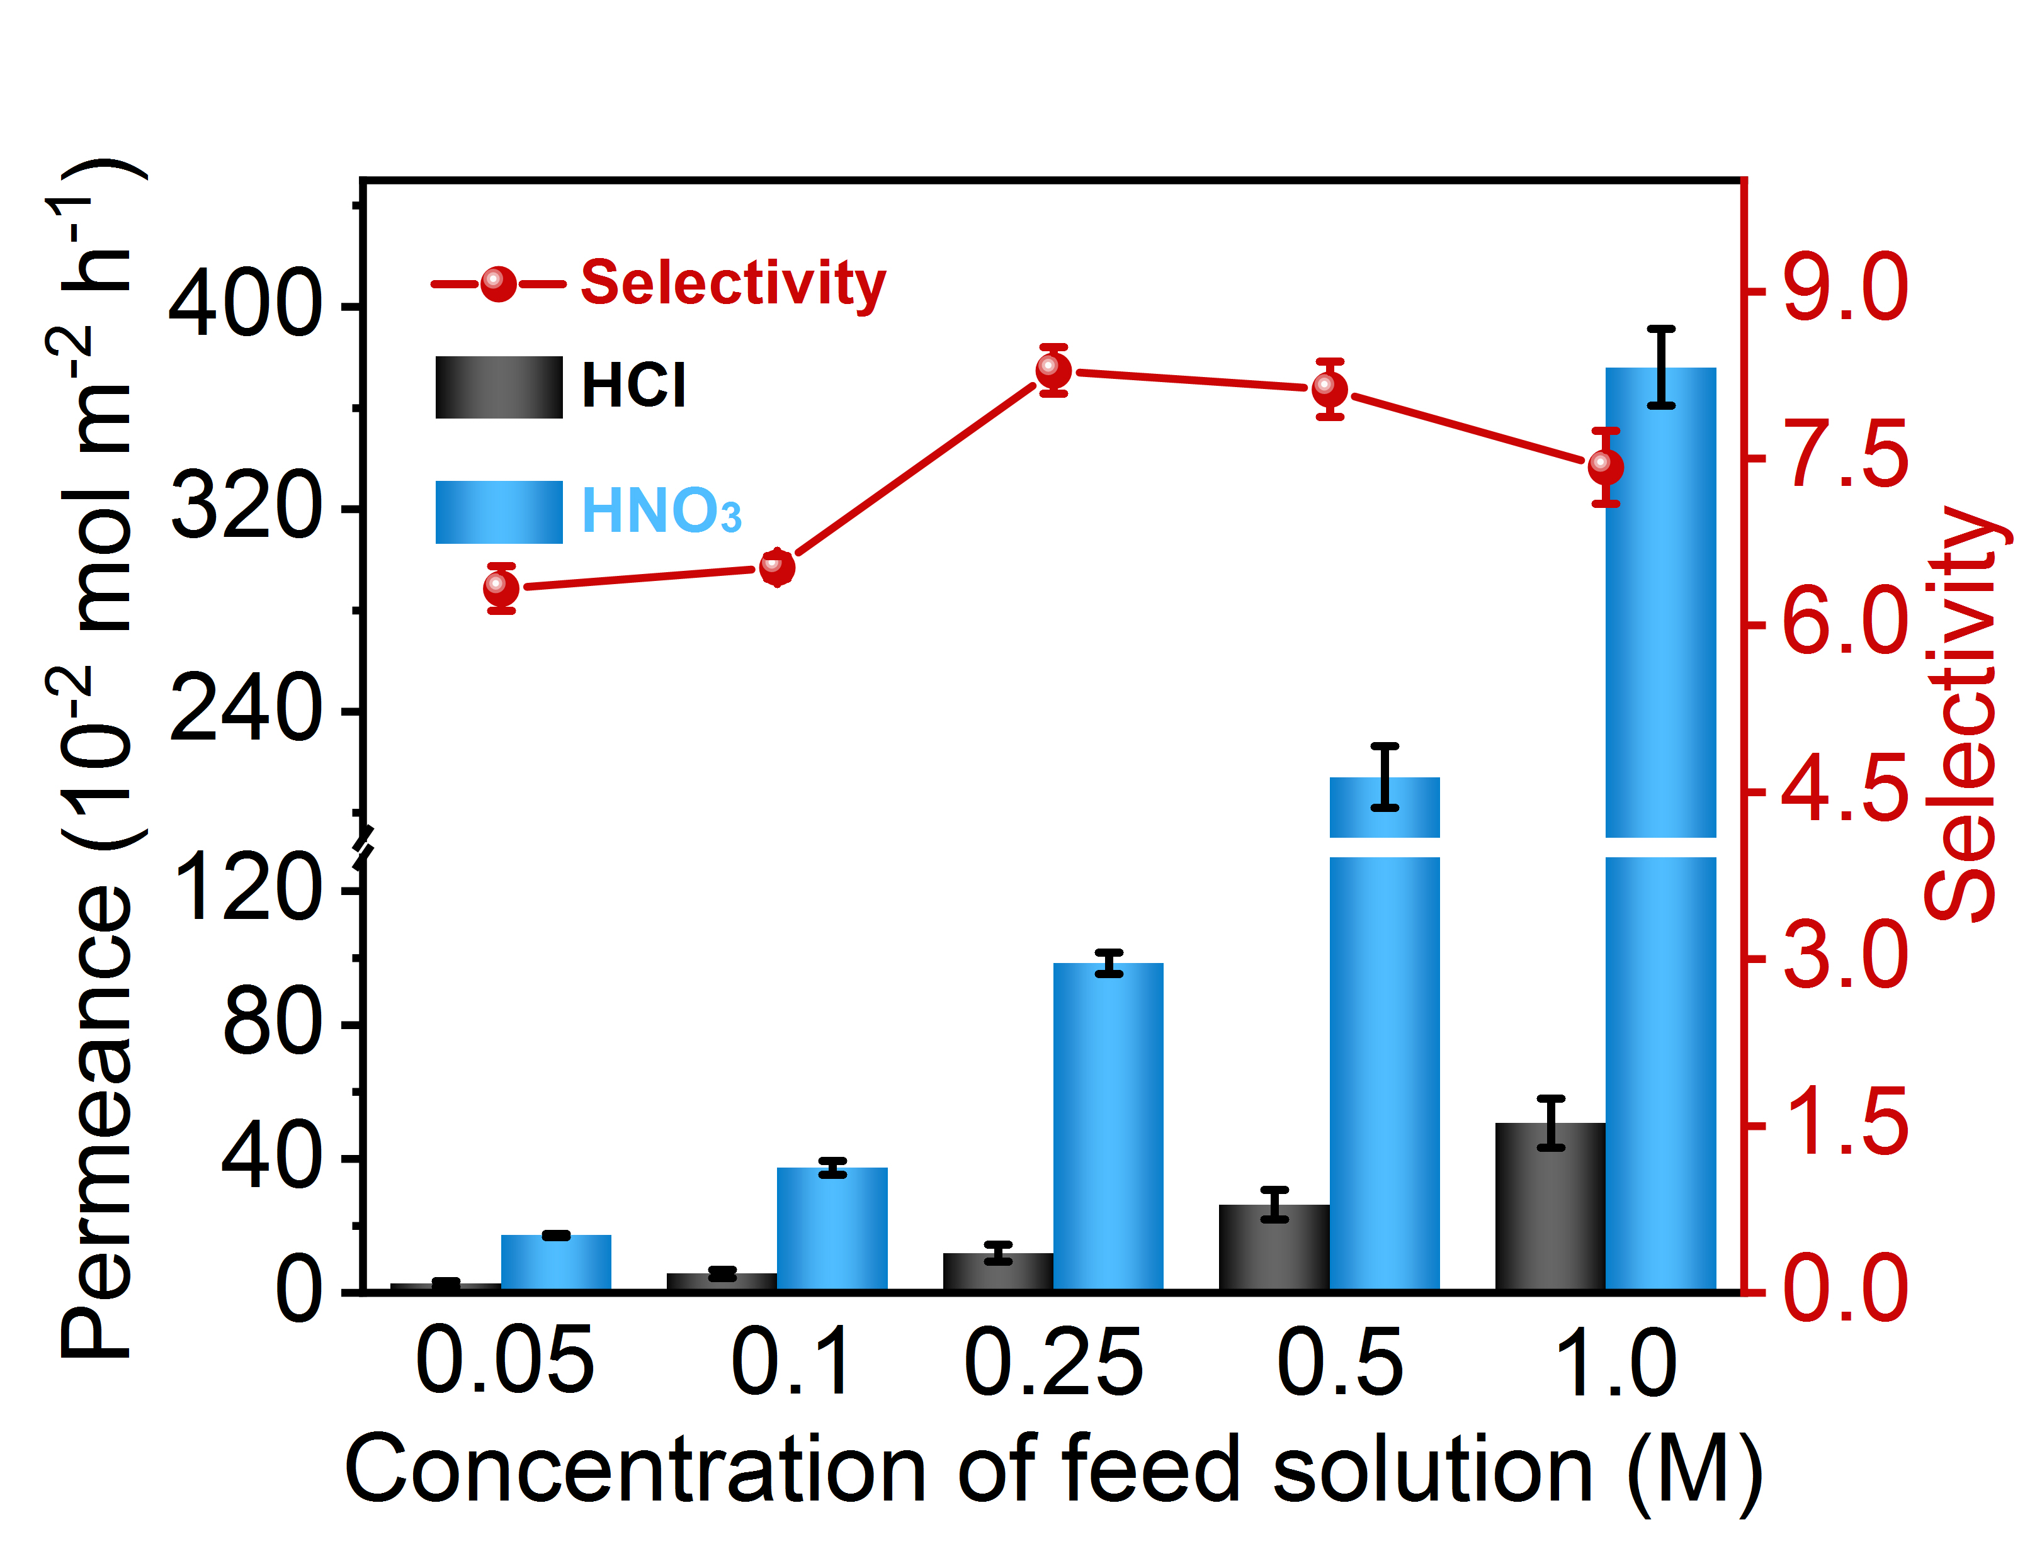
Supplementary Figure 24 | Impact of acid concentration on the HCl/HNO₃ separation. Summary of the permeance of HCl and HNO₃ and the corresponding selectivity of HCl to HNO₃ across TpTag-COF/PAN tested under binary acid conditions with various initial acid concentrations.

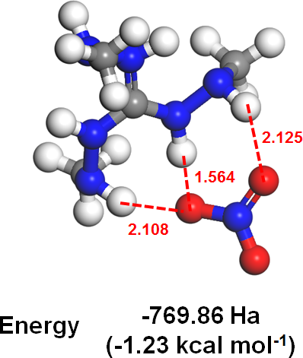
Supplementary Figure 25 | DFT calculation. Top-down view of minimum energy anion binding positions of NO₃⁻ with the guanidinium moiety. Grey, blue, red, and white atoms are carbon, nitrogen, oxygen, and H atoms, respectively.

Supplementary Reference

(1) Lu, T. molclus program, Version 1.9.9.7, http://www.keinsci.com/research/molclus.htm (2022).l
(2) Stewart, J. J. P. Mopac: a semiempirical molecular orbital program. J. Comput.-Aided Mol. Des. 4, 1-103, (1990).
(3) Frisch, M. J., Trucks, G. W., Schlegel, H. B., Scuseria, G. E., Robb, M. A., Cheeseman, J. R., Scalmani, G., Barone, V., Mennucci, B., Petersson, G. A., Nakatsuji, H., Caricato, M., Li, X., Hratchian, H. P., Izmaylov, A. F., Bloino, J., Zheng, G., Sonnenberg, J. L., Hada, M., Ehara, M., Toyota, K., Fukuda, R., Hasegawa, J., Ishida, M., Nakajima, T., Honda, Y., Kitao, O., Nakai, H., Vreven, T., Montgomery, J. A., Jr., Peralta, J. E., Ogliaro, F., Bearpark, M., Heyd, J. J., Brothers, E., Kudin, K. N., Staroverov, V. N., Kobayashi, R., Normand, J., Raghavachari, K., Rendell, A., Burant, J. C., Iyengar, S. S., Tomasi, J., Cossi, M., Rega, N., Millam, J. M., Klene, M., Knox, J. E., Cross, J. B., Bakken, V., Adamo, C., Jaramillo, J., Gomperts, R., Stratmann, R. E., Yazyev, O., Austin, A. J., Cammi, R., Pomelli, C., Ochterski, J. W., Martin, R. L., Morokuma, K., Zakrzewski, V. G., Voth, G. A., Salvador, P., Dannenberg, J. J., Dapprich, S., Daniels, A. D., Farkas, Ö., Foresman, J. B., Orti. Gaussian 09, Revision E.01: Wallingford CT (2009).
(4) Lu, T. & Chen, F. Multiwfn: a multifunctional wavefunction analyzer. J. Comput. Chem. 33, 580-592 (2012).
(5) Humphrey, W.; Dalke, A.; Schulten, K. VMD: Visual molecular dynamics. J. Mol. Graphics 14, 33-38 (1996).
(6) Hess, B., Kutzner, C., Spoel, D. V. D. & Lindahl, E. GROMACS 4: Algorithms for highly efficient, load-balanced, and scalable molecular simulation. J. Chem. Theory Comput. 4, 435-447 (2008).
(7) Sprenger, K. G., Jaeger, V. W. & Pfaendtner, J. The general AMBER force field (GAFF) can accurately. predict thermodynamic and transport properties of many ionic liquids. J. Phys. Chem. B 119, 5882-5895 (2015).
(8) Wang, J., Wolf, R. M., Caldwell, J. W., Kollman, P. A. & Case, D. A. Development and testing of a. general amber force field. J. Comput. Chem. 25, 1157-1174 (2004).
(9) Essmann, U., Perera, L., Berkowitz, M. L., Darden, T., Lee, H. & Pedersen, L. G. A smooth particle mesh. ewald method. J. Chem. Phys. 103, 8577-8593 (1995).
(10) Hess, B., Bekker, H., Berendsen, H. J. C. & Fraaije, J. G. E. M. LINCS: a linear constraint solver for. molecular simulations. J. Comput. Chem. 18, 1463-1472 (1997).

