Supplementary Material
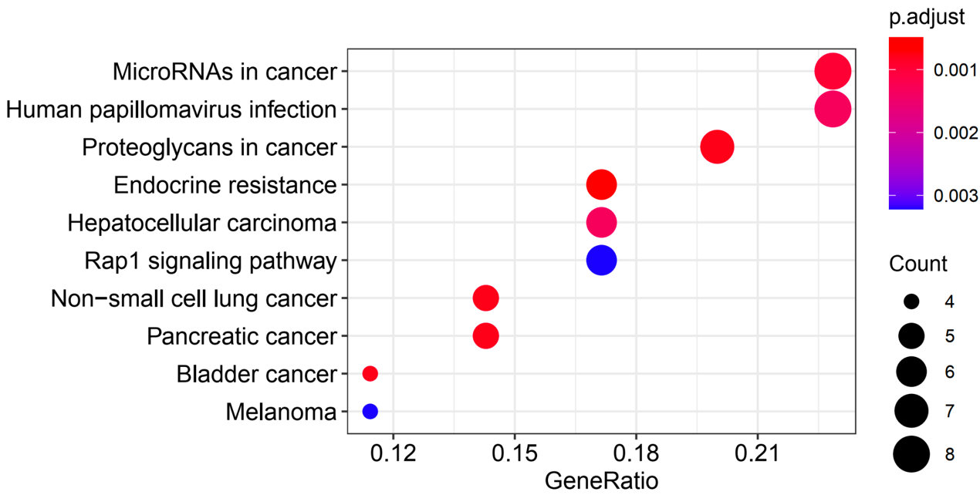
Figure S1 Dotplot of KEGG signal pathway enrichment.

