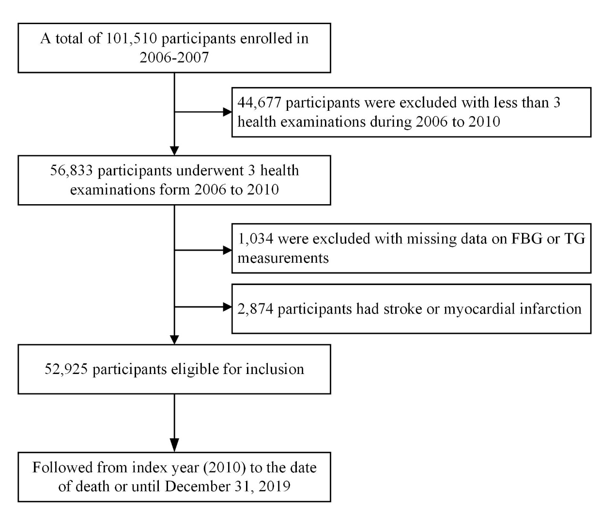
eFigure 1. Flowchart of Participants Selection

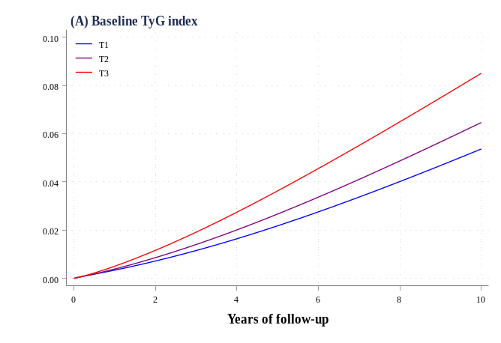
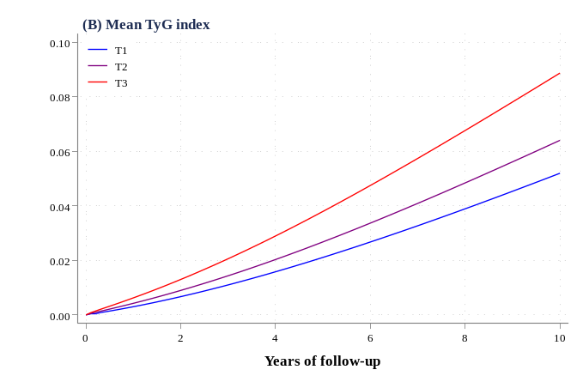
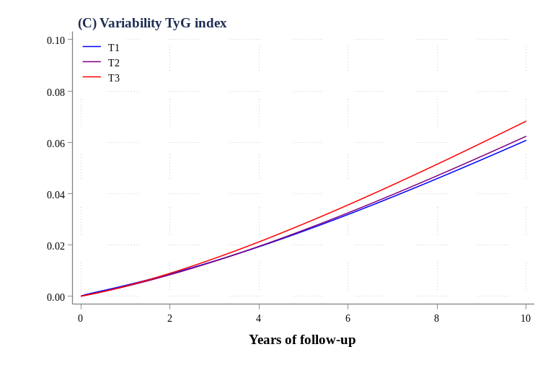

eFigure 2. Adjusted (Standardized) Cumulative Incidence Curve for Cardiovascular Disease Over 10-Years According to Baseline, Mean, and Variability of TyG Index

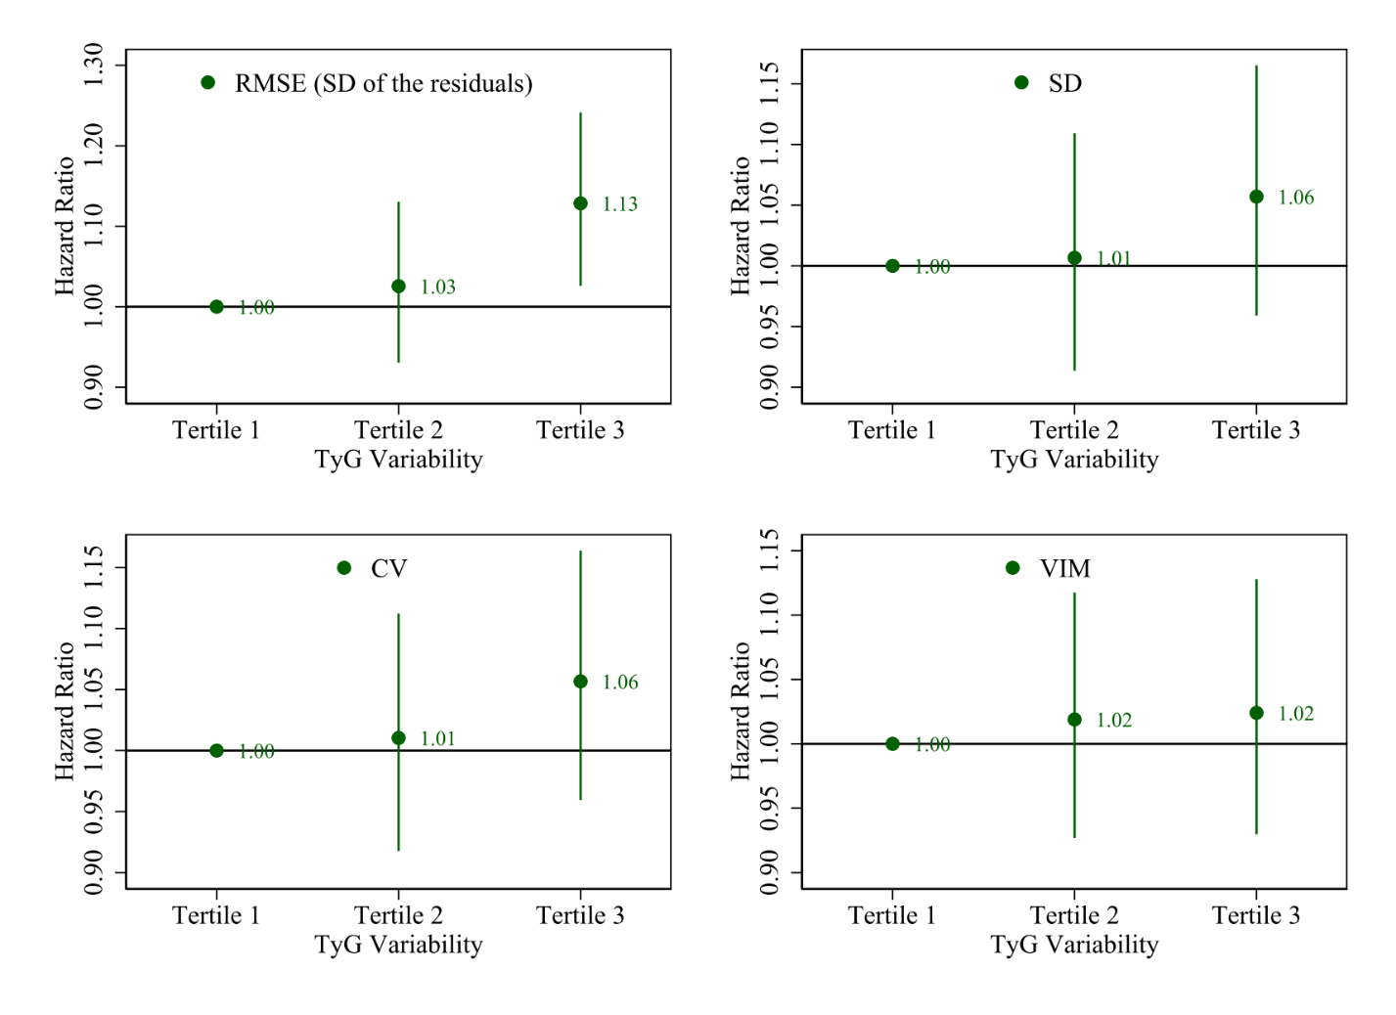
eFigure 3. Adjusted Hazard Ratio for Cardiovascular Disease by TyG Variability According to RMSE (Root-Mean-Square Error), SD (Standard Deviation), CV (Coeﬃcient of Variation), and VIM (Independent of the Mean)

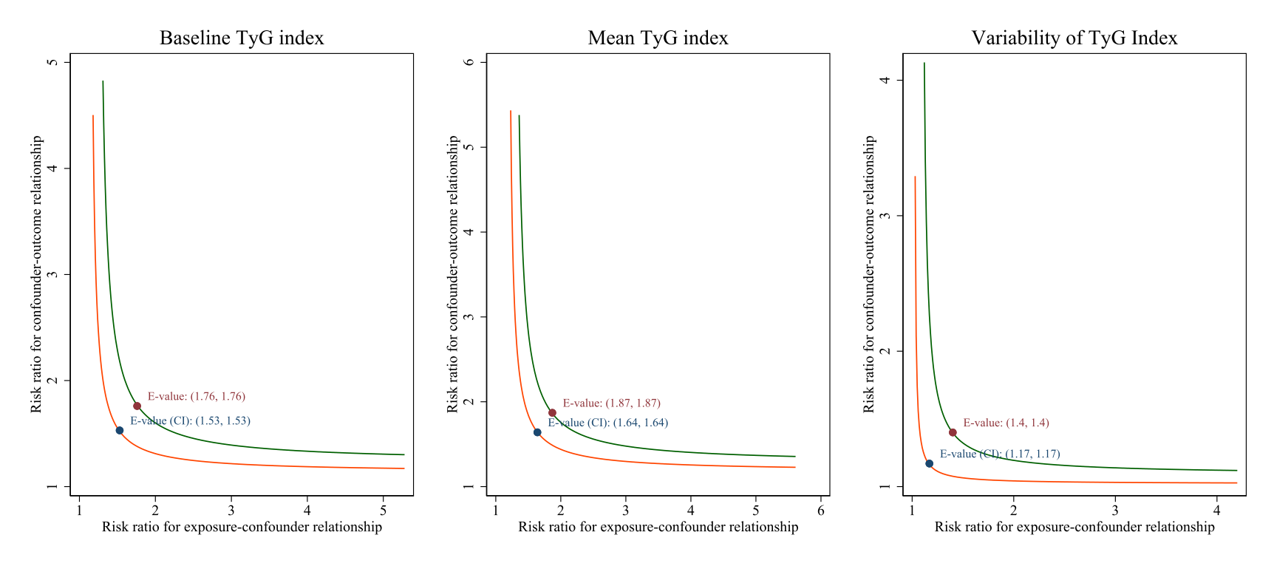
eFigure 4. E-Value for Cardiovascular Disease According to Baseline, Mean, and Variability of TyG Index

eTable 1. Sensitivity Analysis for the Association Between Tertiles of Baseline, Mean, and Variability of TyG Index and the Incidence of Cardiovascular Disease
 | Hazard ratio (95% CI)
 | Tertile 1 | Tertile 2 | Tertile 3 | P for trend
Baseline TyG index†
Excluding lipid-lowering agent users | 1 [Reference] | 1.22 (1.10-1.36) | 1.36 (1.21-1.53) | <0.001
Excluding antidiabetic agent users | 1 [Reference] | 1.21 (1.09-1.35) | 1.32 (1.18-1.48) | <0.001
Excluding fasting glucose ≥ 7.0 mmol/L or triglycerides ≥ 1.7 mmol/L at baseline | 1 [Reference] | 1.23 (1.10-1.36) | 1.32 (1.18-1.49) | <0.001
Competing risk regression analysis | 1 [Reference] | 1.22 (1.10-1.36) | 1.35 (1.20-1.52) | <0.001
2-y lag analysis | 1 [Reference] | 1.23 (1.09-1.38) | 1.37 (1.21-1.55) | <0.001
Mean TyG index†
Excluding lipid-lowering agent users | 1 [Reference] | 1.25 (1.12-1.40) | 1.44 (1.12-1.40) | <0.001
Excluding antidiabetic agent users | 1 [Reference] | 1.26 (1.13-1.40) | 1.43 (1.27-1.60) | <0.001
Excluding fasting glucose ≥ 7.0 mmol/L or triglycerides ≥ 1.7 mmol/L at baseline | 1 [Reference] | 1.25 (1.12-1.40) | 1.40 (1.25-1.58) | <0.001
Competing risk regression analysis | 1 [Reference] | 1.26 (1.13-1.41) | 1.42 (1.27-1.60) | <0.001
2-y lag analysis ^{e, f} | 1 [Reference] | 1.24 (1.10-1.40) | 1.43 (1.26-1.62) | <0.001
TyG Variability‡
Excluding lipid-lowering agent users | 1 [Reference] | 1.02 (0.93-1.13) | 1.13 (1.02-1.24) | 0.015
Excluding antidiabetic agent users | 1 [Reference] | 1.02 (0.92-1.12) | 1.12 (1.02-1.24) | 0.021
Excluding fasting glucose ≥ 7.0 mmol/L or triglycerides ≥ 1.7 mmol/L at baseline | 1 [Reference] | 1.02 (0.92-1.13) | 1.13 (1.02-1.25) | 0.017
Competing risk regression analysis | 1 [Reference] | 1.03 (0.93-1.13) | 1.13 (1.03-1.32) | 0.011
2-y lag analysis | 1 [Reference] | 1.05 (0.94-1.17) | 1.14 (1.03-1.27) | 0.012
†Adjusted for age, sex, education, income, current smoking, current drinking, physical activity, body mass index, diabetes, hypertension, chronic kidney disease, high-sensitivity C-reactive protein, use of lipid-lowering agents, total cholesterol, low-density lipoprotein cholesterol, and high-density lipoprotein cholesterol.
‡Additionally adjusted for baseline TyG index.

