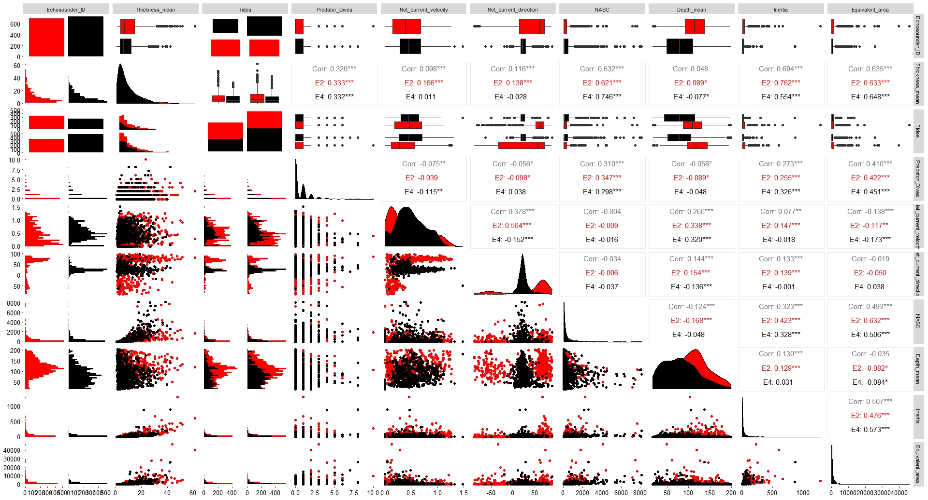
Fig. 1 Scatterplot matrix of A1-E2 data at Nelson Island (red) and E4-A5 data at Deception Island (black). Diagonal density curves (from left to right) show the distribution of each of the numerical variables and scatter plots show the relationship between variable pairs. Pearson’s correlation coefficients are given between each pair of variables for A1-E2 and E4-A5. Categorical data are shown by box-and-whisker plots showing the median (black line), interquartile ranges and outliers (black dots).

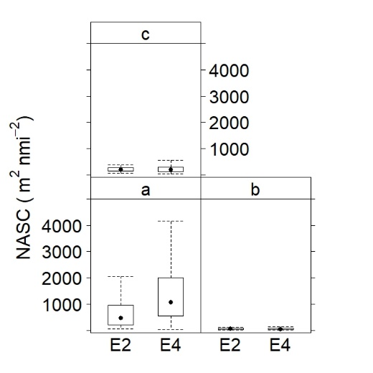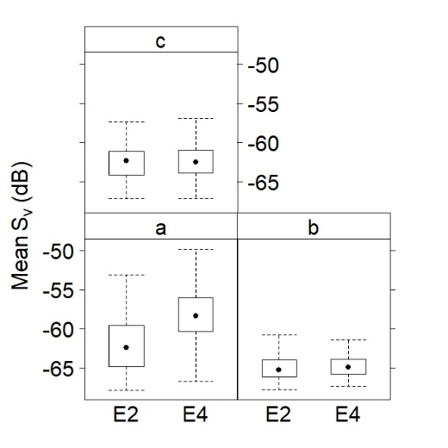
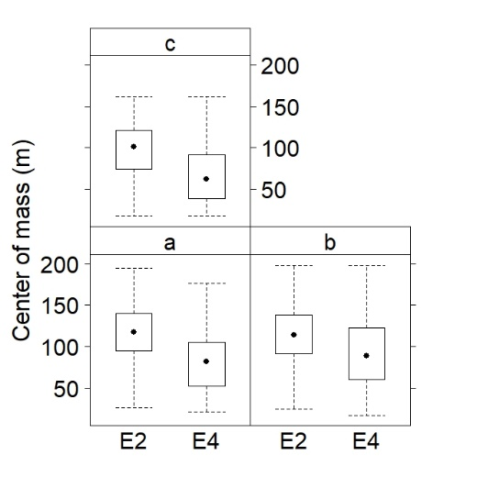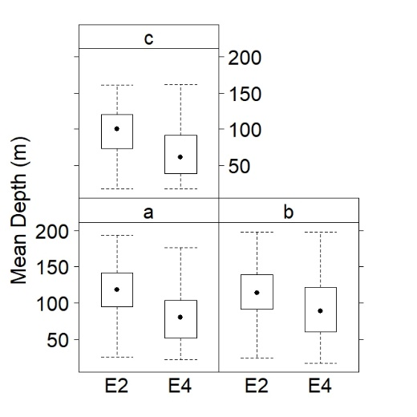
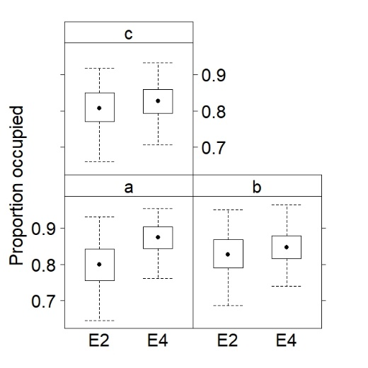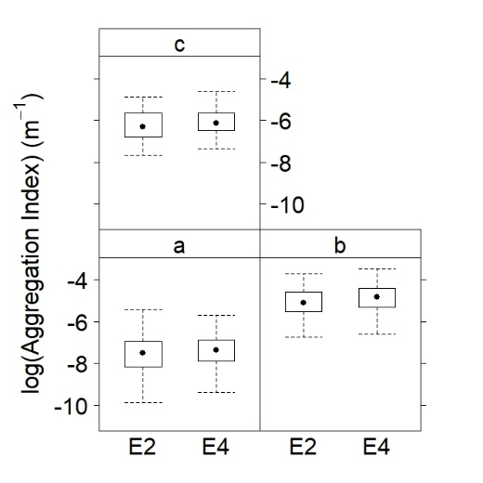
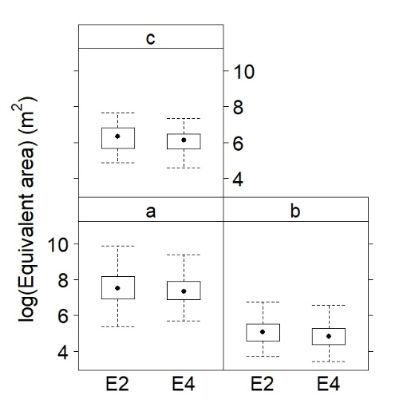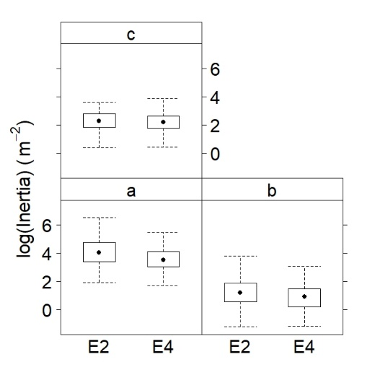
Fig. 2 Box-and-whisker plots showing the median (black dot) and interquartile ranges of Mean S_{v} and swarm descriptors (NASC, Mean Depth, Center of mass, Inertia, Equivalent area, Aggregation index and Proportion occupied) of echosounders 2 & 4 data series.

