Supplementary Materials
Characteristics of leachate from refuse transfer stations in the rural area of China
Huiming Xiangª, Le Cheng^{a,b}, Weiye Liu^{a,b}, Saier Wangª, Lianghu Su^{a,*}, Chaoqun Tan^{c}, Yuping Li^{b,*}
ª Nanjing Institute of Environmental Sciences, Ministry of Ecology and Environment, 8 Jiangwangmiao Street, Nanjing 210042, P.R. China
^{b} College of Civil Engineering and Transportation, Hohai University, No.1 Xikang Road, Nanjing 210024, P.R. China
^{c} Department of Municipal Engineering, Southeast University, Nanjing 211189, P.R. China
* Corresponding author
E-mail: sulianghu@nies.org (Lianghu Su); liyuping@hhu.edu.cn (Yuping Li)

NUMBER OF PAGES: 13
NUMBER OF TABLES: 3
NUMBER OF FIGURES: 6

Table S1 Results of OpenFluor database query.
Component | Ex_{max}/Em_{max} (nm) | Component author | Sample name | Sample source | Minimum similarity score | Reference
C1 | 276/340 | C1 | Anammox_EPS | wastewater, sewage and leachate of China | 0.99378 | [1]
C1 | 276/340 | C1 | Borisover_wastewater treatment plants  Overview | Wastewater of Mediterranean, Israel | 0.99104 | [2]
C1 | 276/340 | C5 | NeusePOMDOM | River and estuary of Coastal plain | 0.98978 | [3]
C1 | 276/340 | C1 | Intracellular algogenic organic matter | Algae from South Korea | 0.98457 | [4]
C2 | 270/301 | C3 | Arctic Seawater | Seawater from Chukchi Sea of the Arctic Ocean | 0.97573 | [5]
C2 | 270/301 | C5 | Urban_Coastal_Drainage | Estuary of Atlantic Coastal Plain | 0.96238 | [6]
C3 | 330, 246/422 | C2 | Dainard_Beaufort2013 | Chukchi and Beaufort Seas | 0.96755 | [7]

Table S2 Organic compounds detected in this study.
Compounds | Detection limits | Compounds | Detection limits
86 Volatile organic compounds (VOCs)
Benzene | 0.5 μg/L | Toluene | 0.5 μg/L
O-xylene | 0.5 μg/L | Paraxylene/M-xylene | 0.5 μg/L
4-Chlorotoluene | 0.5 μg/L | 2-Chlorotoluene | 0.5 μg/L
1,3,5-Tritoluene | 0.5 μg/L | P-Cumene | 0.5 μg/L
Ethylbenzene | 0.5 μg/L | 1,2,4-Tritoluene | 0.5 μg/L
Cumene | 0.5 μg/L | Styrene | 0.5 μg/L
Bromoform | 0.5 μg/L | Bromobenzene | 0.5 μg/L
Chloroform | 0.5 μg/L | Carrene | 0.5 μg/L
N-butylbenzene | 0.5 μg/L | N-propylbenzene | 0.5 μg/L
Tert-butylbenzene | 0.5 μg/L | Sec-butylbenzene | 0.5 μg/L
Bromochloromethane | 0.5 μg/L | Carbon tetrachloride | 0.5 μg/L
Chlorodibromomethane | 0.5 μg/L | Bromodichloromethane | 0.5 μg/L
1,1-Dichloroethane | 0.5 μg/L | Dibromomethane | 0.5 μg/L
1,1,1-Trichloroethane | 0.5 μg/L | 1,2-Dichloroethane | 0.5 μg/L
1,2-Dibromoethane | 0.5 μg/L | 1,1,2-Trichloroethane | 0.5 μg/L
1,1,2,2-Tetrachloroethane | 0.5 μg/L | 1,1,1,2-Tetrachloroethane | 0.5 μg/L
1,2-Dibromo-3-chloropropane | 0.5 μg/L | 1,1,2-Trichloropropane | 0.5 μg/L
1,3-Dichloropropane | 0.5 μg/L | 1,2-Dichloropropane | 0.5 μg/L
1,2,3-Trichloropropane | 0.5 μg/L | 2,2-Dichloropropane | 0.5 μg/L
1,2-Dichlorobenzene | 0.5 μg/L | Chlorobenzene | 0.5 μg/L
1,4-Dichlorobenzene | 0.5 μg/L | 1,3-Dichlorobenzene | 0.5 μg/L
1,2,4-Trichlorobenzene | 0.5 μg/L | 1,2,3-Trichlorobenzene | 0.5 μg/L
Cis-1,2-dichloroethylene | 0.5 μg/L | 1,1-dichloroethylene | 0.5 μg/L
Trans-1,2-dichloroethylene | 0.5 μg/L | Tetrachloroethylene | 0.5 μg/L
Hexachloro-1,3-butadiene | 0.5 μg/L | Cis-1,3-dichloropropene | 0.5 μg/L
Trichloroethylene | 0.5 μg/L | Trans-1,3-dichloropropene | 0.5 μg/L
1,1-Dichloropropene | 0.5 μg/L | Naphthalene | 0.5 μg/L
Ethanol | 100 μg/L | Tert-butanol | 100 μg/L
Diisopropyl ether | 1 μg/L | Ethyl tert-butyl ether | 1 μg/L
Methyl tert-amyl ether | 1 μg/L | Cis-1,4-dichloro-2-butene | 0.5 μg/L
Trans-1,4-dichloro-2-butene | 0.5 μg/L | Methyl tert-butyl ether | 1 μg/L
2-Chloroethyl | 1 μg/L | Ethyl acetate | 1 μg/L
Vinyl acetate | 1 μg/L | Methyl methacrylate | 1 μg/L
Methyl bromide | 0.5 μg/L | Methyl chloride | 0.5 μg/L
Methyl iodide | 5 μg/L | Dibromochloromethane | 0.5 μg/L
Dichlorodifluoromethane | 0.5 μg/L | Trichlorofluoromethane | 0.5 μg/L
Pentachloroethane | 0.5 μg/L | Ethyl chloride | 0.5 μg/L
Acetone | 5 μg/L | Vinyl chloride | 0.5 μg/L
2-Hexanone | 5 μg/L | 2-Butanone | 5 μg/L
Vinyl Dibromide | 5 μg/L | 4-Methyl-2-Panone | 5 μg/L
Pyridine | 20 μg/L | Carbon Disulfide | 5 μg/L
Acrolein | 20 μg/L | Acrylonitrile | 5 μg/L
Epoxy Chloropropane | 5 μg/L | Tetrahydrofuran | 5 μg/L
17 Organic chlorine pesticides (OCPs)
Hexachlorocyclohexane | 0.089 μg/L | DDT | 0.079 μg/L
Heptachlor | 0.042 μg/L | Aldrin | 0.035 μg/L
Dicofol | 0.031 μg/L | Epoxy Heptachlor | 0.053 μg/L
Epoxy Heptachlor | 0.04 μg/L | Gamma-Chordane | 0.044 μg/L
Alpha-Chordane | 0.055 μg/L | Endosulfan I | 0.032 μg/L
Endosulfan II | 0.044 μg/L | Methodil | 0.039 μg/L
Diesel Endrin | 0.043 μg/L | Endrin | 0.046 μg/L
Endrin Aldehyde | 0.051 μg/L | Endrin Sulfate | 0.043 μg/L
Endrin Ketone | 0.046 μg/L
6 Organic phosphorus pesticides (OPPs)
Methyl parathion  malathion | 0.028 μg/L  0.043 μg/L | parathion | 0.036 μg/L
Methyl parathion  malathion | 0.028 μg/L  0.043 μg/L | dimethoate | 0.038 μg/L
dichlorvos | 0.004 μg/L | trichlorfon | 0.0034 μg/L
Note: Compounds marked in bold were detected.
Table S3 Weights of 18 leachate pollutant parameters.
No. | Pollutant Parameters | Weight (w_{i})
1 | Total chromium | 0.064
2 | Lead | 0.063
3 | COD | 0.062
4 | Mercury | 0.062
5 | BOD₅ | 0.061
6 | Arsenic | 0.061
7 | Cyanide | 0.058
8 | Phenolic compounds | 0.057
9 | Zinc | 0.056
10 | pH | 0.055
11 | TKN | 0.053
12 | Nickel | 0.052
13 | Total coliform bacteria | 0.052
14 | Ammonia nitrogen | 0.051
15 | Total dissolved solids | 0.050
16 | Copper | 0.050
17 | Chlorides | 0.048
18 | Iron | 0.045
 | Total | 1.000

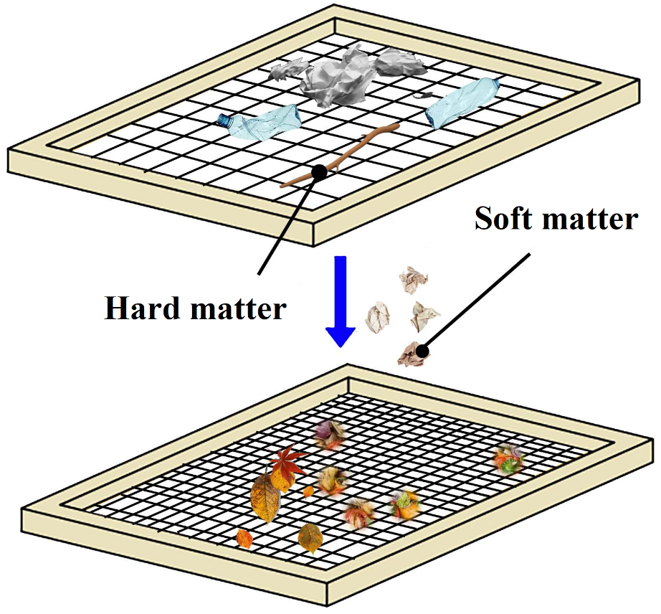
Fig. S1 Schematic diagram of SW sieving.

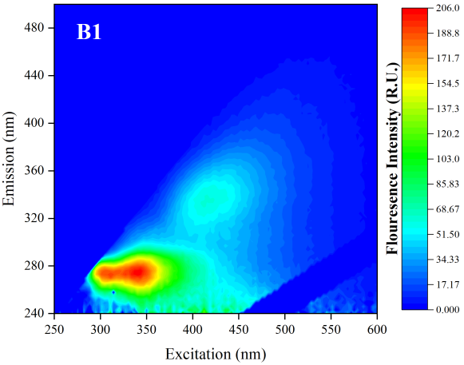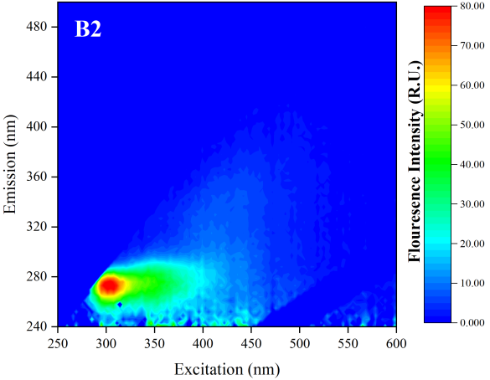
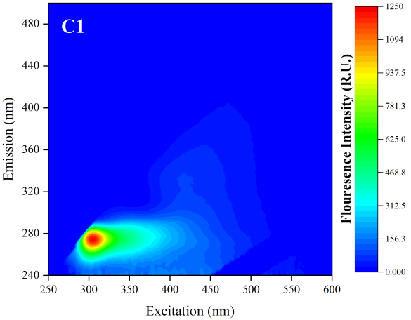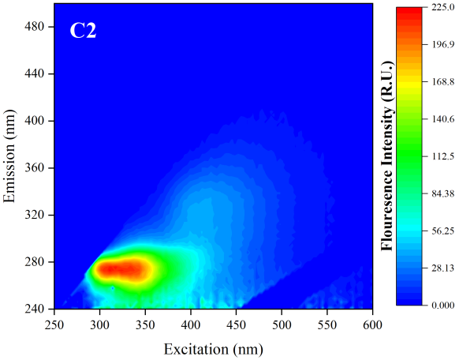
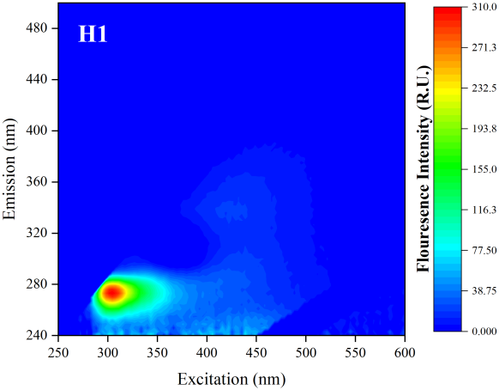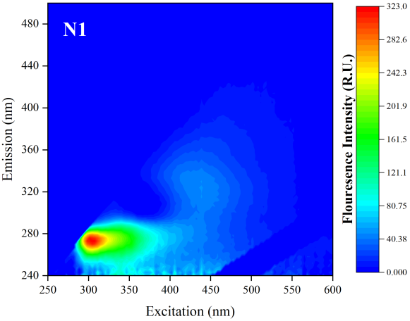
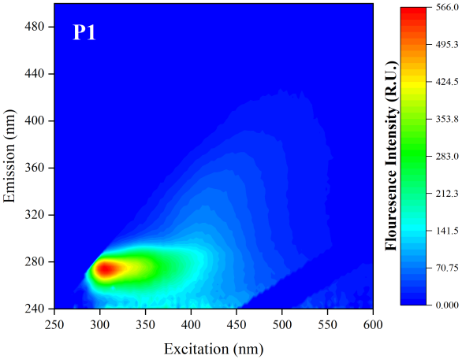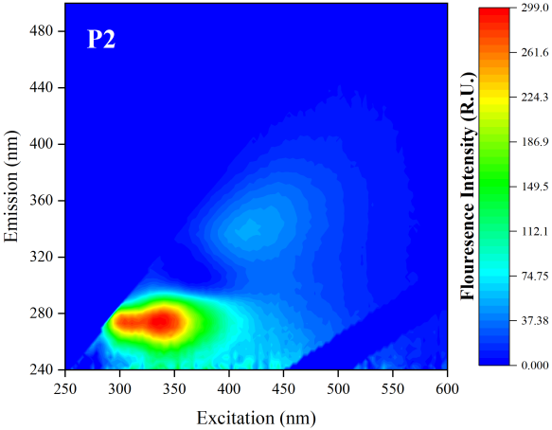
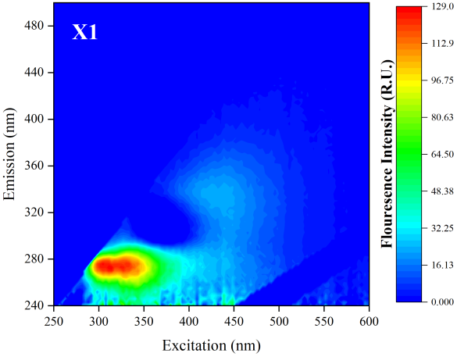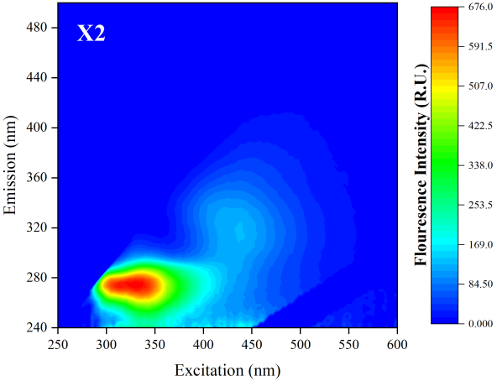
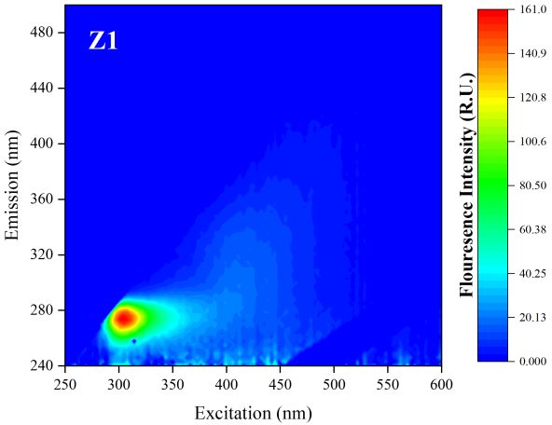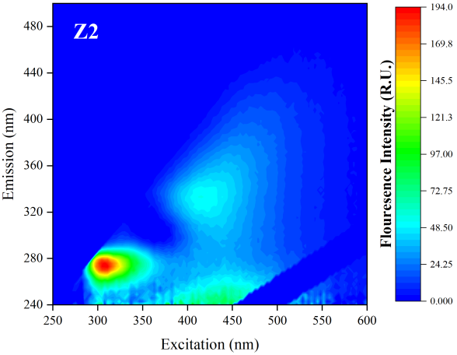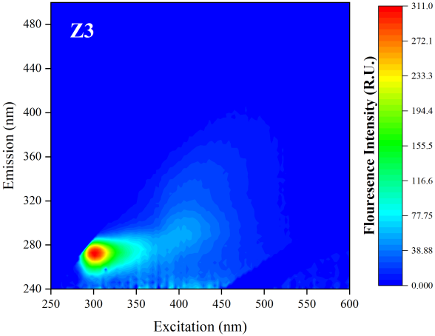
Fig. S2 Fluorescence EEMs of DOM of 14 leachate samples.

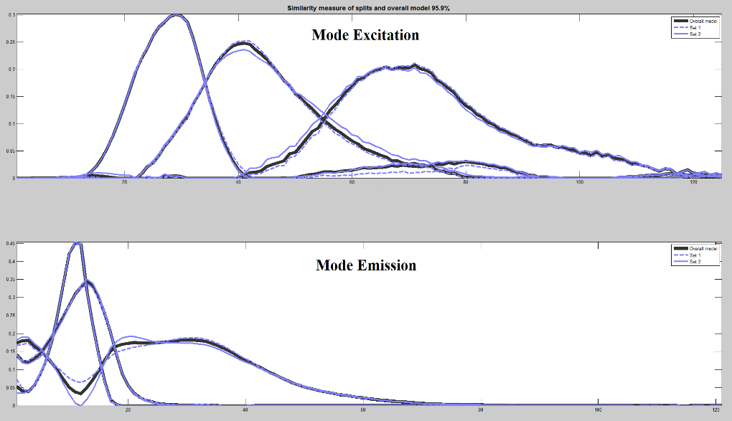
Fig. S3 Split half validation of 3 components via PARAFAC analysis.

Fig. S4 Fluorescence intensity and specific fluorescence intensity (SFI) of three components of DOM expressed as RU (a) Total, (b) C1, (c) C2, (d) C3 from 14 leachate samples.

Fig. S5 Proportion of different size SW.

Fig. S6 Proportion of SW composition.

Reference:

[1] F.X. Jia, Q. Yang, X.H. Liu, X.Y. Li, B.K. Li, L. Zhang, Y.Z. Peng, Stratification of Extracellular Polymeric Substances (EPS) for Aggregated Anammox Microorganisms, Environ Sci Technol 51(6) (2017) 3260-3268.
[2] E. Cohen, G.J. Levy, M. Borisover, Fluorescent components of organic matter in wastewater: Efficacy and selectivity of the water treatment, Water Res 55 (2014) 323-334.
[3] C.L. Osburn, L.T. Handsel, M.P. Mikan, H.W. Paerl, M.T. Montgomery, Fluorescence Tracking of Dissolved and Particulate Organic Matter Quality in a River-Dominated Estuary, Environ Sci Technol 46(16) (2012) 8628-8636.
[4] D. Lee, M. Kwon, Y. Ahn, Y. Jung, S.N. Nam, I.H. Choi, J.W. Kang, Characteristics of intracellular algogenic organic matter and its reactivity with hydroxyl radicals, Water Res 144 (2018) 13-25.
[5] M.L. Chen, J. Jung, Y.K. Lee, J. Hur, Surface accumulation of low molecular weight dissolved organic matter in surface waters and horizontal off-shelf spreading of nutrients and humic-like fluorescence in the Chukchi Sea of the Arctic Ocean, Sci Total Environ 639 (2018) 624-632.
[6] M.A. Smith, J.S. Kominoski, E.E. Gaiser, R.M. Price, T.G. Troxler, Stormwater Runoff and Tidal Flooding Transform Dissolved Organic Matter Composition and Increase Bioavailability in Urban Coastal Ecosystems, J Geophys Res-Biogeo 126(7) (2021).
[7] P.G. Dainard, C. Gueguen, Distribution of PARAFAC modeled CDOM components in the North Pacific Ocean, Bering, Chukchi and Beaufort Seas, Mar Chem 157 (2013) 216-223.

