Supplymentary Material
Frustrate microstructures composed PbS cluster’s size perspective from XRD by varient models of Williamson-Hall plot method

M. P.Tirpude^{1#*}N. T.Tayade^{2*}
¹Department of Physics, E.S. Andrades College of Science, Vasai Road, Palghar-401202, affiliated to University of Mumbai, Mumbai, Maharashtra, India
²Maitreya (Independent researcher), Modern School, Koradi Road, Bokhara, Nagpur – 441111, and Department of Physics(Formerly), Institute of Science, Nagpur-440001, Maharashtra, India.

# e-mail for correspondence: mptirpude@rediffmail.com, nishanttayade@rediffmail.com
*Authors are equally contributed.

Table S1: mWHP details
 |  |  |  |  |  | Size | Dislocation
 | slope | Intercept | R² | R | SQ Intercept | nm | m²
S100:E0 | 2.85E-04 | 2.69E-04 | 0.655 | 0.809321 | 0.016401 | 54.87397 | 1.02924E+14
S90:E10 | 2.76E-04 | 2.76E-04 | 0.658 | 0.811172 | 0.016613 | 54.17363 | 9.96742E+13
S80:E20 | 2.68E-04 | 2.81E-04 | 0.661 | 0.813019 | 0.016763 | 53.6895 | 9.67851E+13
S70:E30 | 2.60E-04 | 2.85E-04 | 0.664 | 0.814862 | 0.016882 | 53.3114 | 9.3896E+13
S60:E40 | 2.87E-04 | 2.87E-04 | 0.664 | 0.814862 | 0.016941 | 53.12532 | 1.03647E+14
S50:E50 | 2.46E-04 | 2.91E-04 | 0.666 | 0.816088 | 0.017059 | 52.75893 | 8.884E+13
S40:E60 | 2.39E-04 | 2.93E-04 | 0.667 | 0.816701 | 0.017117 | 52.57856 | 8.63121E+13
S30:E70 | 2.33E-04 | 2.94E-04 | 0.668 | 0.817313 | 0.017146 | 52.48907 | 8.41452E+13
S20:E80 | 2.26E-04 | 2.95E-04 | 0.668 | 0.817313 | 0.017176 | 52.40003 | 8.16173E+13
S10:E90 | 2.20E-04 | 2.96E-04 | 0.668 | 0.817313 | 0.017205 | 52.31144 | 7.94504E+13
S0:E100 | 2.15E-04 | 2.96E-04 | 0.668 | 0.817313 | 0.017205 | 52.31144 | 7.76447E+13

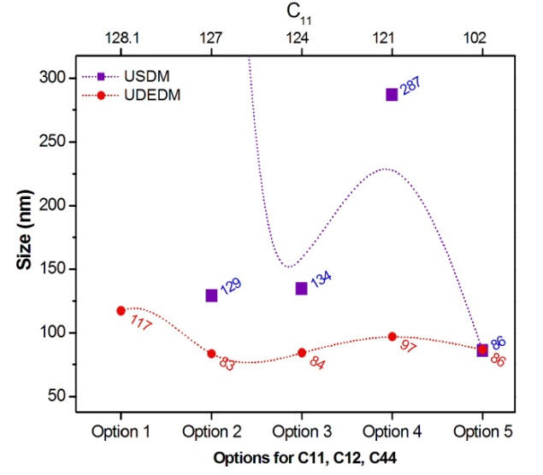
Fig. S1
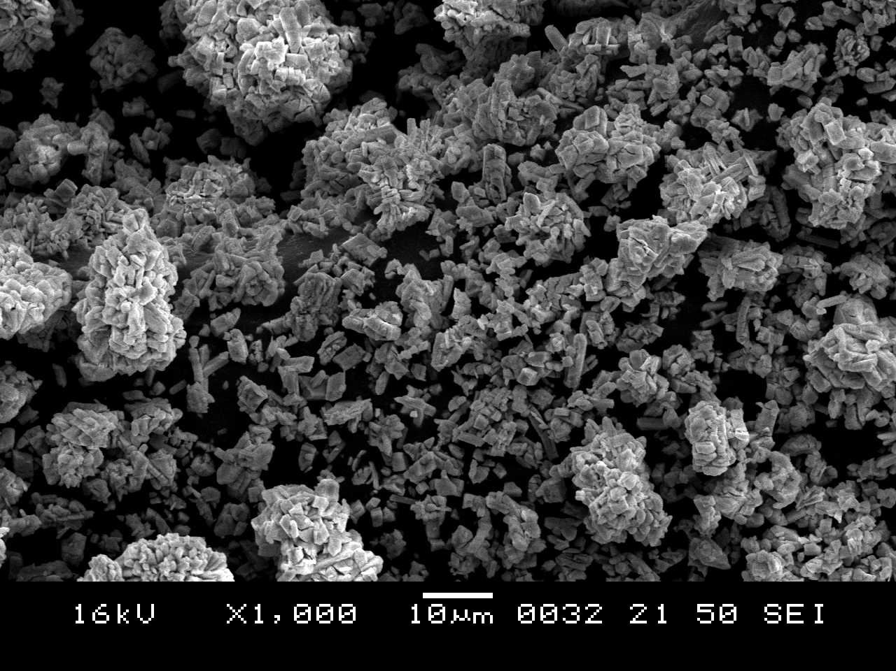
Fig. S2

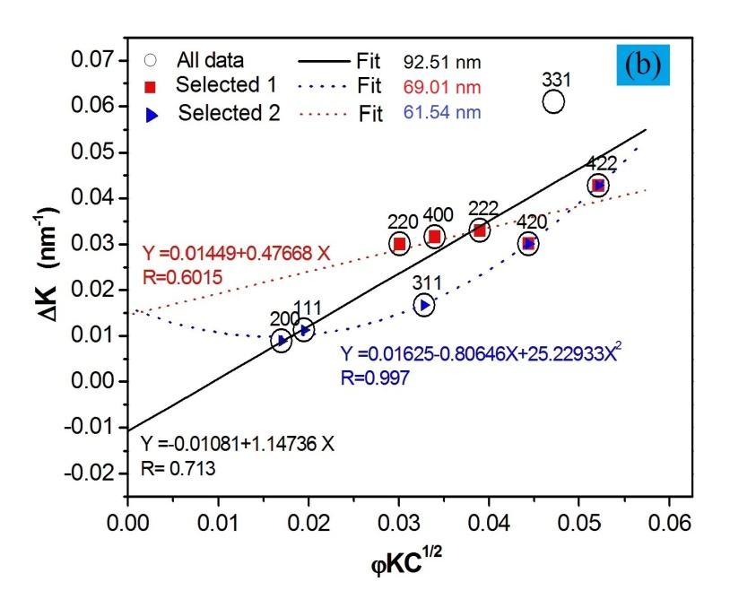
Fig. S3

