Supplemental Material

Risk Stratification of Patients with Acute Respiratory Distress Syndrome Complicated with Sepsis Using Lactate Trajectories

Content of Supplemental Material
Supplemental Table
Supplemental Table 1. Definition of study variables.
Supplemental Table 2. Missing rates of study variables.
Supplemental Table 3. Baseline characteristics by study outcomes.
Supplemental Table 4. The parameter for fitted models with different numbers of latent groups and different degrees of polynomials.
Supplemental Table 5. Baseline lactate characteristics between GBTM lactate groups.
Supplemental Table 6. Baseline characteristics by initial lactate.

Supplemental Figure
Supplemental Figure 1. Calculation of lactate AUC.
Supplemental Figure 2. Comparisons and descriptions of GBTM lactate groups by initial lactate, the highest value of lactate, lactate clearance and lactate AUC.
Supplemental Figure 3. The ROC with associated AUC, IDI, and NRI, for the combined assessment of diagnostic capacity when incorporating the GBTM lactate groups, highest value of lactate, lactate clearance and lactate AUC respectively into the established model (APACHE II score + initial lactate).
Supplemental Figure 4. Multivariable Cox proportional hazard analyses by initial lactate groups with respect to 30- (left) and 90-days mortality (right).
Supplemental Figure 5. A plot of estimated HRs of the nonlinearity on continuous age, eGFR, SOFA score, and APACHE II score between GBTM lactate groups and initial lactate groups assignment with respect to 90-days mortality.
Supplemental Table 1. Definition of study variables.
Variables | Definition | Continuous/Categorical/Binary
Demographics
Age | Years after birth | Continuous
Sex | Female and Male | Binary, Female/Male
Previous History
Hypertension | Self-reported use of medications to control blood pressure or previously measured SBP ≥140mmHg or DBP ≥90mmHg | Binary, Yes/No
Diabetes | Self-reported use of medications/lifestyle intervention to control blood glucose or physician-diagnosed type 2 diabetes mellitus | Binary, Yes/No
CAD | Self-reported history of CAD | Binary, Yes/No
Stroke | Self-reported history of stroke, include hemorrhagic stroke and ischemic stroke | Binary, Yes/No
Renal failure | Self-reported history of renal failure | Binary, Yes/No
Cancer | Self-reported history of Cancer | Binary, Yes/No
On-admission clinical characteristics
SBP | SBP measured on admission | Continuous, in mmHg
DBP | DBP measured on admission | Continuous, in mmHg
Heart rate | Heart rate measured on admission | Continuous, in beats per minute
eGFR | eGFR on admission calculated by CKD-EPI formula | Continuous, in mL/min/1.73m²
Fluid intake | Hourly intake within 24 hours of admission, including oral intake and intravenous intake, etc | Continuous, in mL/hour
Fluid outtake | Hourly output within 24 hours of admission, including urine volume, ultrafiltration (if CRRT), and drainage, etc | Continuous, in mL/hour
RBC | Red blood cell count measured on admission by routine blood test | Continuous, in 10⁹/L
WBC | White blood cell count measured on admission by routine blood test | Continuous, in 10⁹/L
Platelet | Platelet count measured on admission by routine blood test | Continuous, in 10⁹/L
Hemoglobin | Hemoglobin measured on admission by routine blood test | Continuous, in g/L
ALT | Plasma alanine aminotransferase measured on admission | Continuous, in U/L
AST | Plasma aspartate aminotransferase measured on admission | Continuous, in U/L
Albumin | Plasma albumin measured on admission | Continuous, in g/L
Oxygenation index | The ratio of PaO₂ to FiO₂ was obtained by arterial blood gas analysis on admission | Continuous, in mmHg
GCS score | GCS score evaluated on admission | Continuous
APACHE II Score | APACHE II score evaluated on admission | Continuous
SOFA Score | SOFA score evaluated on admission | Continuous
Emergency surgical operation | Surgical procedures in the first 24 h of admission | Binary, Yes/No
Invasive mechanical ventilation | Invasive mechanical ventilation during the entire ICU stays | Binary, Yes/No
Other in-hospital treatment within 24 hours of admission
Antibiotics | Antibiotics use within 24h after admission | Binary, Yes/No
Sedative and analgesic | Sedative and analgesic use within 24h after admission (including: propofol, dexmedetomidine, midazolam, opioids etc.) | Binary, Yes/No
Glucocorticoids | Glucocorticoids use within 24h after admission | Binary, Yes/No
CRRT | CRRT use within 24h after admission | Binary, Yes/No
LMWH | LMWH use within 24h after admission | Binary, Yes/No
Sodium Bicarbonate | Sodium Bicarbonate use within 24h after admission | Binary, Yes/No
Vasoactive medications | Vasoactive medications (norepinephrine/dopamine) use within 24h after admission | Binary, Yes/No
Blood component transfusions | Blood component transfusions (red cells, platelets, plasma, cryoprecipitated AHF, and granulocytes) use within 24h after admission | Binary, Yes/No
Abbreviations: ALT, alanine aminotransferase; APACHE II, Acute Physiology And Chronic Health Evaluation Ⅱ; AST, aspartate aminotransferase; CKD-EPI, Chronic Kidney Disease Epidemiology Collaboration; CRRT, continuous renal replacement therapy, DBP, diastolic blood pressure; eGFR, estimated glomerular filtration rate; GCS, Glasgow Coma Scale; LMWH, low molecular weight heparin; RBC, red blood cell; SBP, systolic blood pressure; SOFA, Sequential Organ Failure Assessment; WBC, white blood cell.
Supplemental Table 2. Missing rates of study variables.
Variables | Missing, N (%)  n=762
AaDO₂ | 71 (9.32)
Sodium | 3 (0.39)
Potassium | 1 (0.13)
Initial lactate | 11 (1.44)
Lactate at 6h after admission | 70 (9.19)
Lactate at 12h after admission | 85 (11.2)
Lactate at 18h after admission | 72 (9.45)
Lactate at 24h after admission | 53 (6.96)
Lactate at 30h after admission | 83 (10.9)
Lactate at 36h after admission | 108 (14.2)
Lactate at 42h after admission | 78 (10.2)
Lactate at 48h after admission | 52 (6.82)
Fluid intake | 3 (0.39)
Fluid outtake | 3 (0.39)
Blood component transfusion | 2 (0.26)
Abbreviations: AaDO₂, alveolar-arterial oxygen difference.
Supplemental Table 3. Baseline characteristics by study outcomes.
Characteristics | Total n=762 | 30-days mortality |  | P value | 90-days mortality |  | P value
Characteristics | Total n=762 | 30-days mortality (+) n=254 | 30-days mortality (-) n=508 | P value | 90-days mortality (+) n=306 | 90-days mortality (-) n=456 | P value
Lactate levels within 48 hours of admission, mmol/L
Initial lactate | 1.80 (1.30 to 3.30) | 2.35 (1.40 to 4.50) | 1.60 (1.20 to 2.80) | <0.001 | 2.30 (1.40 to 4.30) | 1.60 (1.20 to 2.70) | <0.001
Lactate at 6h after admission | 2.00 (1.30 to 3.00) | 2.50 (1.60 to 4.10) | 1.73 (1.30 to 2.60) | <0.001 | 2.40 (1.60 to 3.90) | 1.70 (1.30 to 2.50) | <0.001
Lactate at 12h after admission | 1.80 (1.30 to 2.70) | 2.31 (1.60 to 3.40) | 1.60 (1.30 to 2.40) | <0.001 | 2.20 (1.50 to 3.10) | 1.60 (1.30 to 2.33) | <0.001
Lactate at 18h after admission | 1.70 (1.30 to 2.50) | 2.13 (1.60 to 3.08) | 1.60 (1.20 to 2.20) | <0.001 | 2.00 (1.50 to 3.00) | 1.60 (1.20 to 2.10) | <0.001
Lactate at 24h after admission | 1.70 (1.30 to 2.37) | 2.10 (1.50 to 2.83) | 1.60 (1.20 to 2.10) | <0.001 | 2.00 (1.40 to 2.80) | 1.55 (1.20 to 2.01) | <0.001
Lactate at 30h after admission | 1.60 (1.30 to 2.20) | 1.94 (1.40 to 2.70) | 1.50 (1.20 to 2.10) | <0.001 | 1.90 (1.40 to 2.65) | 1.50 (1.20 to 1.98) | <0.001
Lactate at 36h after admission | 1.60 (1.20 to 2.10) | 1.90 (1.40 to 2.60) | 1.49 (1.20 to 1.90) | <0.001 | 1.90 (1.40 to 2.50) | 1.41 (1.20 to 1.90) | <0.001
Lactate at 42h after admission | 1.51 (1.20 to 2.16) | 1.90 (1.40 to 2.60) | 1.48 (1.20 to 1.90) | <0.001 | 1.80 (1.40 to 2.60) | 1.40 (1.10 to 1.90) | <0.001
Lactate at 48h after admission | 1.50 (1.20 to 2.10) | 1.90 (1.40 to 2.50) | 1.40 (1.10 to 1.90) | <0.001 | 1.81 (1.30 to 2.50) | 1.40 (1.10 to 1.90) | <0.001
Highest value of lactate within 48 hours after admission, mmol/L
 | 2.80 (1.90 to 4.70) | 3.70 (2.50 to 6.20) | 2.50 (1.80 to 3.90) | <0.001 | 3.60 (2.47 to 6.00) | 2.40 (1.80 to 3.90) | <0.001
Lactate clearance within 48 hours after admission, %
 | 20.0 (-16.7 to 48.3) | 24.4 (-16.7 to 48.6) | 17.4 (-16.8 to 48.1) | 0.85 | 23.0 (-18.8 to 51.2) | 17.4 (-16.7 to 46.5) | 0.69
Lactate AUC within 48 hours of admission
 | 0.08 (0.06 to 0.11) | 0.10 (0.07 to 0.14) | 0.07 (0.06 to 0.10) | <0.001 | 0.10 (0.07 to 0.13) | 0.07 (0.06 to 0.09) | <0.001
Demographics
Age, year | 62.6±16.7 | 66.5±13.7 | 60.6±17.7 | <0.001 | 66.7±13.8 | 59.8±17.9 | <0.001
Male, n (%) | 468 (61.4) | 154 (60.6) | 414 (61.8) | 0.75 | 189 (61.8) | 279 (61.2) | 0.88
Previous history
Hypertension, n (%) | 409 (53.7) | 144 (56.7) | 265 (52.2) | 0.25 | 176 (57.5) | 233 (51.1) | 0.088
Diabetes, n (%) | 242 (31.8) | 86 (33.9) | 156 (30.7) | 0.41 | 101 (33.0) | 141 (30.9) | 0.58
CAD, n (%) | 180 (23.6) | 65 (25.6) | 115 (22.6) | 0.37 | 81 (26.5) | 99 (21.7) | 0.14
Stroke, n (%) | 167 (21.9) | 57 (22.4) | 110 (21.7) | 0.85 | 75 (24.5) | 92 (20.2) | 0.18
Renal failure, n (%) | 84 (11.0) | 23 (9.10) | 61 (12.0) | 0.08 | 28 (9.20) | 56 (12.3) | 0.2
Cancer, n (%) | 96 (12.6) | 42 (16.5) | 54 (10.6) | 0.027 | 47 (15.4) | 49 (10.7) | 0.074
On-admission clinical characteristics
SBP, mmHg | 137.6±35.5 | 132.2±35.8 | 140.4±35.1 | 0.003 | 132.8±36.2 | 140.9±34.7 | 0.002
DBP, mmHg | 70.4±18.9 | 66.9±18.8 | 72.2±18.7 | <0.001 | 67.0±19.0 | 72.8±18.4 | <0.001
Heart rate, bpm | 101.4±24.4 | 102.6±25.2 | 100.7±24.0 | 0.3 | 102.1±24.7 | 100.8±24.3 | 0.47
eGFR, mL/min/1.73m² | 57.4±41.6 | 52.3±37.4 | 59.9±43.4 | 0.018 | 52.6±37.7 | 60.6±43.8 | 0.009
Fluid intake, mL/hour | 161.2 (109.1 to 240.8) | 168.2 (118.4 to 245.6) | 156.7 (106.3 to 233.3) | 0.076 | 165.2 (116.5 to 249.1) | 157.2 (106.3 to 229.6) | 0.087
Fluid outtake, mL/hour | 136.1 (82.5 to 235.1) | 132.4 (83.1 to 228.7) | 139.2 (81.7 to 237.4) | 0.48 | 128.8 (84.0 to 234.5) | 140.6 (81.2 to 236.4) | 0.51
RBC, 10⁹/L | 3.36 (2.63 to 4.11) | 3.11 (2.50 to 3.83) | 3.48 (2.73 to 4.19) | <0.001 | 3.14 (2.51 to 3.83) | 3.52 (2.81 to 4.22) | <0.001
WBC, 10⁹/L | 10.8 (7.66 to 15.8) | 11.2 (7.66 to 16.5) | 10.6 (7.66 to 15.5) | 0.35 | 11.0 (7.53 to 16.5) | 10.7 (7.75 to 15.5) | 0.6
Platelet, 10⁹/L | 165.0 (93.0 to 227.0) | 147.0 (77.0 to 196.0) | 172.0 (100.5 to 238.5) | <0.001 | 150.5 (80.0 to 214.0) | 172.0 (100.5 to 236.0) | 0.004
Hemoglobin, g/L | 101.5 (80.0 to 124.0) | 93.5 (75.0 to 120.0) | 104.0 (83.0 to 126.5) | 0.001 | 93.0 (76.0 to 119.0) | 105.5 (84.0 to 128.0) | <0.001
ALT, U/L | 36.0 (22.0 to 78.0) | 40.0 (24.0 to 87.0) | 34.0 (21.0 to 69.5) | 0.055 | 40.5 (24.0 to 86.0) | 33.0 (21.0 to 69.0) | 0.005
AST, U/L | 54.0 (32.0 to 119.0) | 63.5 (35.0 to 149.0) | 49.5 (30.0 to 107.5) | <0.001 | 64.0 (36.0 to 168.0) | 48.0 (29.0 to 105.0) | <0.001
Albumin, g/L | 30.0 (26.0 to 34.0) | 29.5 (25.0 to 33.0) | 31.0 (27.0 to 34.0) | 0.002 | 29.5 (25.0 to 33.0) | 31.0 (27.0 to 34.0) | <0.001
GCS Score | 13 (7 to 15) | 10 (5 to 15) | 14 (8.5 to 15) | <0.001 | 10 (6 to 15) | 14 (10 to 15) | <0.001
APACHE II Score | 18 (13 to 24) | 22 (16 to 27) | 17 (12 to 22) | <0.001 | 21 (16 to 27) | 17 (12 to 22) | <0.001
SOFA Score | 11 (8 to 14) | 13 (10 to 17) | 10 (8 to 13) | <0.001 | 12 (10 to 17) | 10 (8 to 13) | <0.001
ARDS Severity, n (%) |  |  |  | <0.001 |  |  | <0.001
Mild | 305 (40.0) | 78 (30.7) | 227(44.7) |  | 94 (30.7) | 211 (46.3)
Moderate | 326 (42.8) | 113 (44.5) | 213(41.9) |  | 140 (45.8) | 186 (40.8)
Severe | 131 (17.2) | 63 (24.8) | 68(13.4) |  | 72 (23.5) | 59 (12.9)
Emergency surgical operation, n (%)
 | 89 (11.7) | 53 (20.9) | 36 (7.10) | <0.001 | 61 (19.9) | 28 (6.10) | <0.001
Invasive mechanical ventilation, n (%)
 | 479 (62.9) | 226 (89.0) | 253 (49.8) | <0.001 | 265 (86.6) | 214 (46.9) | <0.001
Other in-hospital treatment within 24 hours of admission
Antibiotics, n (%) | 674 (88.5) | 228 (89.8) | 446 (87.8) | 0.47 | 277 (90.5) | 397 (87.1) | 0.17
Sedative and analgesic, n (%) | 463 (60.8) | 170 (66.9) | 293 (57.7) | 0.015 | 201 (65.7) | 262 (57.5) | 0.023
Glucocorticoid, n (%) | 336 (44.1) | 132 (52.0) | 204 (40.2) | 0.003 | 150 (49.0) | 186 (40.8) | 0.026
CRRT, n (%) | 262 (34.4) | 83 (32.7) | 177 (35.2) | 0.52 | 101 (33.0) | 161 (35.3) | 0.53
LWMH, n (%) | 101 (13.3) | 29 (11.4) | 72 (14.2) | 0.31 | 38 (12.4) | 63 (13.8) | 0.66
Sodium bicarbonate, n (%) | 361 (47.4) | 134 (52.8) | 227 (44.7) | 0.038 | 164 (53.6) | 197 (43.2) | 0.005
Vasoactive medications, n (%) | 249 (32.7) | 120 (47.2) | 129 (25.4) | <0.001 | 137 (44.8) | 112 (24.6) | <0.001
Blood component transfusion, n (%) | 267 (35.0) | 116 (45.7) | 151 (29.7) | <0.001 | 141 (46.1) | 126 (27.6) | <0.001
Abbreviations: ALT, alanine aminotransferase; APACHE II, Acute Physiology And Chronic Health Evaluation Ⅱ; AST, aspartate aminotransferase; AUC, area under curve; CRRT, continuous renal replacement therapy, DBP, diastolic blood pressure; eGFR, estimated glomerular filtration rate; GCS, Glasgow Coma Scale; ICU, intensive care unit; LMWH, low molecular weight heparin; RBC, red blood cell; SBP, systolic blood pressure; SOFA, Sequential Organ Failure Assessment; WBC, white blood cell.
Supplemental Table 4. The parameter for fitted models with different numbers of latent groups and different degrees of polynomials.
Polynomial | N | Percentage | Average Posterior Probabilities | Odds of Correct Classification by Weighted Posterior Proportions | Expection Based on the Posterior Probabilities | BIC | AIC
Intercept (0) | 562 | 73.75% | 98.26% | 20.1849 | 73.69% | -5048.38 | -5039.11
Intercept (0) | 200 | 26.25% | 95.35% | 57.40347 | 26.31% | -5048.38 | -5039.11
Intercept (0) | 541 | 71.00% | 98.31% | 23.66563 | 71.04% | -4919.91 | -4908.32
Linear (1) | 221 | 29.00% | 95.71% | 54.73546 | 28.96% | -4919.91 | -4908.32
Linear (1) | 576 | 75.59% | 98.62% | 22.53818 | 75.96% | -4990.51 | -4978.92
Intercept (0) | 186 | 24.41% | 94.21% | 51.3885 | 24.04% | -4990.51 | -4978.92
Linear (1) | 555 | 72.83% | 98.20% | 20.56116 | 72.59% | -4877.03 | -4863.12
Linear (1) | 207 | 27.17% | 96.07% | 64.68795 | 27.41% | -4877.03 | -4863.12
Intercept (0) | 539 | 70.73% | 98.37% | 24.87393 | 70.87% | -4918.21 | -4904.3
Quadratic (2) | 223 | 29.27% | 95.61% | 52.9856 | 29.13% | -4918.21 | -4904.3
Linear (1) | 551 | 72.31% | 98.44% | 24.071 | 72.42% | -4876.13 | -4859.9
Quadratic (2) | 211 | 27.69% | 95.55% | 56.35752 | 27.58% | -4876.13 | -4859.9
Quadratic (2) | 551 | 72.31% | 98.46% | 24.36729 | 72.45% | -4879.21 | -4860.66
Quadratic (2) | 211 | 27.69% | 95.47% | 55.43579 | 27.55% | -4879.21 | -4860.66
Quadratic (2) | 576 | 75.59% | 98.65% | 23.07314 | 76.02% | -4993.17 | -4979.26
Intercept (0) | 186 | 24.41% | 94.07% | 50.30502 | 23.98% | -4993.17 | -4979.26
Quadratic (2) | 555 | 72.83% | 98.23% | 20.92296 | 72.64% | -4880.02 | -4863.79
Linear (1) | 207 | 27.17% | 95.99% | 63.47198 | 27.36% | -4880.02 | -4863.79
Intercept (0) | 387 | 50.79% | 95.20% | 19.199 | 50.79% | -4452.87 | -4438.96
Intercept (0) | 322 | 42.26% | 93.95% | 21.12384 | 42.35% | -4452.87 | -4438.96
Intercept (0) | 53 | 6.96% | 96.99% | 437.4035 | 6.86% | -4452.87 | -4438.96
Linear (1) | 409 | 53.67% | 95.53% | 18.48032 | 53.62% | -4421.43 | -4405.2
Intercept (0) | 302 | 39.63% | 93.67% | 22.45654 | 39.71% | -4421.43 | -4405.2
Intercept (0) | 51 | 6.69% | 97.20% | 484.6073 | 6.67% | -4421.43 | -4405.2
Intercept (0) | 388 | 50.92% | 96.10% | 23.79757 | 50.88% | -4268.71 | -4252.48
Linear (1) | 322 | 42.26% | 95.01% | 26.00026 | 42.30% | -4268.71 | -4252.48
Intercept (0) | 52 | 6.82% | 97.64% | 564.3196 | 6.82% | -4268.71 | -4252.48
Intercept (0) | 379 | 49.74% | 95.25% | 20.15771 | 49.87% | -4424.73 | -4408.51
Intercept (0) | 326 | 42.78% | 94.04% | 21.07353 | 42.83% | -4424.73 | -4408.51
Linear (1) | 57 | 7.48% | 96.91% | 398.5644 | 7.30% | -4424.73 | -4408.51
Linear (1) | 395 | 51.84% | 96.51% | 25.25472 | 52.28% | -4254.01 | -4235.47
Linear (1) | 315 | 41.34% | 94.29% | 23.74408 | 41.03% | -4254.01 | -4235.47
Intercept (0) | 52 | 6.82% | 96.47% | 381.4636 | 6.69% | -4254.01 | -4235.47
Linear (1) | 405 | 53.15% | 94.82% | 16.58402 | 52.48% | -4394.09 | -4375.55
Intercept (0) | 302 | 39.63% | 94.38% | 24.8162 | 40.35% | -4394.09 | -4375.55
Linear (1) | 55 | 7.22% | 97.28% | 462.8481 | 7.16% | -4394.09 | -4375.55
Intercept (0) | 386 | 50.66% | 96.09% | 24.00192 | 50.62% | -4245.84 | -4227.3
Linear (1) | 322 | 42.26% | 95.29% | 27.40024 | 42.45% | -4245.84 | -4227.3
Linear (1) | 54 | 7.09% | 97.09% | 447.0492 | 6.93% | -4245.84 | -4227.3
Linear (1) | 393 | 51.57% | 96.43% | 25.02032 | 51.90% | -4231.23 | -4210.36
Linear (1) | 316 | 41.47% | 94.53% | 24.62729 | 41.25% | -4231.23 | -4210.36
Linear (1) | 53 | 6.96% | 97.08% | 451.9422 | 6.85% | -4231.23 | -4210.36
Quadratic (2) | 410 | 53.81% | 95.51% | 18.34973 | 53.67% | -4423.99 | -4405.45
Intercept (0) | 301 | 39.50% | 93.81% | 23.04894 | 39.66% | -4423.99 | -4405.45
Intercept (0) | 51 | 6.69% | 97.16% | 479.4603 | 6.67% | -4423.99 | -4405.45
Intercept (0) | 390 | 51.18% | 96.00% | 23.05593 | 51.03% | -4266.79 | -4248.25
Quadratic (2) | 320 | 41.99% | 95.12% | 26.77749 | 42.14% | -4266.79 | -4248.25
Intercept (0) | 52 | 6.82% | 97.77% | 597.8594 | 6.83% | -4266.79 | -4248.25
Intercept (0) | 379 | 49.74% | 95.25% | 20.14371 | 49.87% | -4428.04 | -4409.5
Intercept (0) | 326 | 42.78% | 94.05% | 21.09304 | 42.83% | -4428.04 | -4409.5
Quadratic (2) | 57 | 7.48% | 96.94% | 402.2182 | 7.31% | -4428.04 | -4409.5
Quadratic (2) | 395 | 51.84% | 96.65% | 26.17688 | 52.41% | -4255.42 | -4232.24
Quadratic (2) | 315 | 41.34% | 94.16% | 23.30302 | 40.89% | -4255.42 | -4232.24
Intercept (0) | 52 | 6.82% | 96.70% | 407.374 | 6.71% | -4255.42 | -4232.24
Quadratic (2) | 407 | 53.41% | 94.70% | 16.12843 | 52.55% | -4399.99 | -4376.81
Intercept (0) | 300 | 39.37% | 94.64% | 26.1554 | 40.29% | -4399.99 | -4376.81
Quadratic (2) | 55 | 7.22% | 97.25% | 458.9227 | 7.16% | -4399.99 | -4376.81
Intercept (0) | 389 | 51.05% | 95.85% | 22.43711 | 50.74% | -4247.04 | -4223.86
Quadratic (2) | 319 | 41.86% | 95.56% | 29.3746 | 42.30% | -4247.04 | -4223.86
Quadratic (2) | 54 | 7.09% | 97.50% | 520.7833 | 6.96% | -4247.04 | -4223.86
Quadratic (2) | 394 | 51.71% | 96.41% | 24.82723 | 51.99% | -4235.78 | -4207.96
Quadratic (2) | 314 | 41.21% | 94.73% | 25.72216 | 41.12% | -4235.78 | -4207.96
Quadratic (2) | 54 | 7.09% | 96.72% | 398.9661 | 6.89% | -4235.78 | -4207.96
Quadratic (2) | 393 | 51.57% | 96.42% | 24.98926 | 51.90% | -4234.24 | -4211.06
Linear (1) | 316 | 41.47% | 94.53% | 24.59924 | 41.25% | -4234.24 | -4211.06
Linear (1) | 53 | 6.96% | 97.08% | 451.5909 | 6.85% | -4234.24 | -4211.06
Linear (1) | 394 | 51.71% | 96.43% | 24.92196 | 52.00% | -4229.35 | -4206.17
Quadratic (2) | 314 | 41.21% | 94.71% | 25.63986 | 41.11% | -4229.35 | -4206.17
Linear (1) | 54 | 7.09% | 96.63% | 387.9732 | 6.88% | -4229.35 | -4206.17
Linear (1) | 393 | 51.57% | 96.42% | 24.94842 | 51.89% | -4234.5 | -4211.32
Linear (1) | 316 | 41.47% | 94.54% | 24.67096 | 41.25% | -4234.5 | -4211.32
Quadratic (2) | 53 | 6.96% | 97.16% | 464.1526 | 6.86% | -4234.5 | -4211.32
Quadratic (2) | 394 | 51.71% | 96.42% | 24.88402 | 52.00% | -4232.53 | -4207.03
Quadratic (2) | 314 | 41.21% | 94.71% | 25.65629 | 41.12% | -4232.53 | -4207.03
Linear (1) | 54 | 7.09% | 96.62% | 387.2053 | 6.88% | -4232.53 | -4207.03
Quadratic (2) | 393 | 51.57% | 96.41% | 24.91736 | 51.89% | -4237.51 | -4212.02
Linear (1) | 316 | 41.47% | 94.54% | 24.64295 | 41.25% | -4237.51 | -4212.02
Quadratic (2) | 53 | 6.96% | 97.16% | 463.7875 | 6.86% | -4237.51 | -4212.02
Linear (1) | 394 | 51.71% | 96.42% | 24.86496 | 51.99% | -4232.59 | -4207.1
Quadratic (2) | 314 | 41.21% | 94.72% | 25.70541 | 41.12% | -4232.59 | -4207.1
Quadratic (2) | 54 | 7.09% | 96.73% | 399.7495 | 6.89% | -4232.59 | -4207.1
Quadratic (2) | 394 | 51.71% | 96.41% | 24.82723 | 51.99% | -4235.78 | -4207.96
Quadratic (2) | 314 | 41.21% | 94.73% | 25.72216 | 41.12% | -4235.78 | -4207.96
Quadratic (2) | 54 | 7.09% | 96.72% | 398.9661 | 6.89% | -4235.78 | -4207.96
The grey shading parameter is finally selected (we decided on a model with three latent groups and linear, quadratic, and linear polynomials, respectively).
Supplemental Table 5. Baseline lactate characteristics between GBTM lactate groups.
Characteristics | Total n=762 | GBTM lactate groups |  |  | P value
Characteristics | Total n=762 | Group 1 n=394 | Group 2 n=314 | Group 3 n=54 | P value
Lactate levels within 48 hours of admission, mmol/L
Initial lactate | 1.80 (1.30 to 3.30) | 1.30 (1.10 to 1.80) | 2.87 (1.90 to 4.50) | 7.05 (5.20 to 10.7) | <0.001
Lactate at 6h after admission | 2.00 (1.30 to 3.00) | 1.40 (1.10 to 1.80) | 2.70 (2.10 to 3.60) | 7.50 (5.30 to 11.4) | <0.001
Lactate at 12h after admission | 1.80 (1.30 to 2.70) | 1.38 (1.10 to 1.60) | 2.50 (2.03 to 3.15) | 6.35 (4.70 to 8.90) | <0.001
Lactate at 18h after admission | 1.70 (1.30 to 2.50) | 1.36 (1.10 to 1.60) | 2.30 (1.80 to 2.90) | 6.05 (4.60 to 9.00) | <0.001
Lactate at 24h after admission | 1.70 (1.30 to 2.37) | 1.30 (1.10 to 1.60) | 2.20 (1.80 to 2.60) | 6.05 (4.30 to 7.90) | <0.001
Lactate at 30h after admission | 1.60 (1.30 to 2.20) | 1.30 (1.10 to 1.60) | 2.10 (1.70 to 2.60) | 5.35 (4.10 to 6.90) | <0.001
Lactate at 36h after admission | 1.60 (1.20 to 2.10) | 1.30 (1.10 to 1.50) | 2.00 (1.70 to 2.30) | 5.20 (3.60 to 6.30) | <0.001
Lactate at 42h after admission | 1.51 (1.20 to 2.16) | 1.30 (1.10 to 1.50) | 1.92 (1.50 to 2.40) | 4.85 (3.40 to 6.60) | <0.001
Lactate at 48h after admission | 1.50 (1.20 to 2.10) | 1.20 (1.00 to 1.50) | 1.90 (1.50 to 2.30) | 4.05 (3.20 to 7.10) | <0.001
Highest value of lactate within 48 hours after admission, mmol/L
 | 2.80 (1.90 to 4.70) | 1.90 (1.60 to 2.50) | 4.00 (3.10 to 5.60) | 11.1 (7.40 to 15.9) | <0.001
Lactate clearance within 48 hours after admission
 | 20.0 (-16.7 to 48.3) | 7.18 (-22.3 to 36.4) | 33.7 (-5.26 to 60.5) | 37.7 (-12.9 to 61.0) | <0.001
Lactate AUC within 48 hours of admission
 | 0.08 (0.06 to 0.11) | 0.06 (0.05 to 0.07) | 0.11 (0.09 to 0.12) | 0.26 (0.21 to 0.39) | <0.001
Abbreviations: AUC, area under curve; GBTM, group-based trajectory modeling.
Supplemental Table 6. Baseline characteristics by initial lactate
Characteristics | Total n=762 | Initial Lactate Groups |  |  | P value
Characteristics | Total n=762 | Group 1 n=412 | Group 2 n=204 | Group 3 n=146 | P value
Demographics
Age, year | 62.5±16.7 | 61.9±17.9 | 63.8±15.4 | 60.3±14.7 | 0.21
Male, n (%) | 468 (61.4) | 250 (63.5) | 189 (60.2) | 29 (53.7) | 0.32
Previous history
Hypertension, n (%) | 409 (53.7) | 219 (55.6) | 168 (53.5) | 22 (40.7) | 0.12
Diabetes, n (%) | 242 (31.8) | 141 (35.8) | 89 (28.3) | 12 (22.2) | 0.034
CAD, n (%) | 180 (23.6) | 103 (26.1) | 67 (21.3) | 10 (18.5) | 0.23
Stroke, n (%) | 167 (21.9) | 96 (24.4) | 65 (20.7) | 6 (11.1) | 0.069
Renal failure, n (%) | 84 (11.0) | 55 (14.0) | 47 (15.0) | 13 (24.1) | 0.003
Cancer, n (%) | 96 (12.6) | 36 (9.10) | 47 (15.0) | 13 (24.1) | 0.003
On-admission clinical characteristics
SBP, mmHg | 137.6±35.5 | 145.9 (34.8) | 131.4 (33.5) | 112.9 (34.0) | <0.001
DBP, mmHg | 70.4±18.9 | 74.7 (18.6) | 67.2 (17.8) | 57.8 (17.6) | <0.001
Heart rate, bpm | 101.4±24.4 | 97.2 (23.0) | 104.8 (25.1) | 111.3 (24.7) | <0.001
eGFR, mL/min/1.73m² | 57.4±41.6 | 60.3 (44.1) | 55.3 (38.6) | 48.5 (39.1) | 0.073
Fluid intake, mL/hour | 161.2 (109.1 to 240.8) | 150.7 (105.1 to 224.1) | 164.5 (112.6 to 233.4) | 259.8 (170.1 to 445.3) | <0.001
Fluid outtake, mL/hour | 136.1 (82.5 to 235.1) | 143.4 (84.0 to 228.0) | 122.4 (76.3 to 232.9) | 150.9 (100.4 to 325.5) | 0.12
RBC, 10⁹/L | 3.36 (2.63 to 4.11) | 3.37 (2.63 to 4.12) | 3.37 (2.66 to 4.09) | 3.07 (2.47 to 4.09) | 0.32
WBC, 10⁹/L | 10.8 (7.66 to 15.8) | 10.3 (7.51 to 14.1) | 11.9 (8.26 to 17.6) | 12.0 (6.94 to 19.3) | 0.002
Platelet, 10⁹/L | 165.0 (93.0 to 227.0) | 177.5 (122.0 to 246.0) | 151.5 (77.0 to 208.0) | 99.0 (37.0 to 161.0) | <0.001
Hemoglobin, g/L | 101.5 (80.0 to 124.0) | 101.0 (80.0 to 124.0) | 104.0 (81.0 to 124.0) | 94.5 (74.0 to 125.0) | 0.44
ALT, U/L | 36.0 (22.0 to 78.0) | 29.0 (20.0 to 55.0) | 44.5 (24.0 to 98.0) | 66.0 (37.0 to 254.0) | <0.001
AST, U/L | 54.0 (32.0 to 119.0) | 42.5 (27.0 to 76.0) | 67.5 (36.0 to 176.0) | 153.0 (63.0 to 472.0) | <0.001
Albumin, g/L | 30.0 (26.0 to 34.0) | 31.0 (28.0 to 35.0) | 30.0 (26.0 to 33.0) | 25.0 (22.0 to 30.0) | <0.001
GCS Score | 13 (7 to 15) | 14 (10 to 15) | 11 (5 to 15) | 13 (5 to 15) | <0.001
APACHE II Score | 18 (13 to 24) | 17 (12 to 22) | 21 (16 to 26) | 19 (15 to 31) | <0.001
SOFA Score | 11 (8 to 14) | 10 (7 to 12) | 12 (10 to 16) | 17 (13 to 20) | <0.001
ARDS Severity, n (%) |  |  |  |  | <0.001
Mild | 305 (40.0) | 196 (49.7) | 93 (29.6) | 16 (29.6)
Moderate | 326 (42.8) | 160 (40.6) | 139 (44.3) | 27 (50.0)
Severe | 131 (17.2) | 38 (9.60) | 82 (26.1) | 11 (20.4)
Emergency surgical operation, n (%)
 | 89 (11.7) | 30 (7.60) | 47 (15.0) | 12 (22.2) | <0.001
Invasive mechanical ventilation, n (%)
 | 479 (62.9) | 197 (50.0) | 236 (75.2) | 46 (85.2) | <0.001
Other in-hospital treatment within 24 hours of admission
Antibiotics, n (%) | 674 (88.5) | 339 (86.0) | 287 (91.4) | 48 (88.9) | 0.08
Sedative and analgesic, n (%) | 463 (60.8) | 225 (57.1) | 200 (63.7) | 38 (70.4) | 0.068
Glucocorticoid, n (%) | 336 (44.1) | 127 (32.2) | 178 (56.7) | 31 (57.4) | <0.001
CRRT, n (%) | 262 (34.4) | 132 (33.5) | 100 (31.8) | 30 (55.6) | 0.004
LWMH, n (%) | 101 (13.3) | 58 (14.7) | 40 (12.7) | 3 (5.60) | 0.16
Sodium bicarbonate, n (%) | 361 (47.4) | 155 (39.3) | 167 (53.2) | 39 (72.2) | <0.001
Vasoactive medications, n (%) | 249 (32.7) | 77 (19.5) | 132 (42.0) | 40 (74.1) | <0.001
Blood component transfusion, n (%) | 267 (35.0) | 108 (27.4) | 122 (38.9) | 37 (68.5) | <0.001
Abbreviations: ALT, alanine aminotransferase; APACHE II, Acute Physiology And Chronic Health Evaluation Ⅱ; AST, aspartate aminotransferase; AUC, area under curve; CRRT, continuous renal replacement therapy, DBP, diastolic blood pressure; eGFR, estimated glomerular filtration rate; GCS, Glasgow Coma Scale; LMWH, low molecular weight heparin; RBC, red blood cell; SBP, systolic blood pressure; SOFA, Sequential Organ Failure Assessment; WBC, white blood cell.

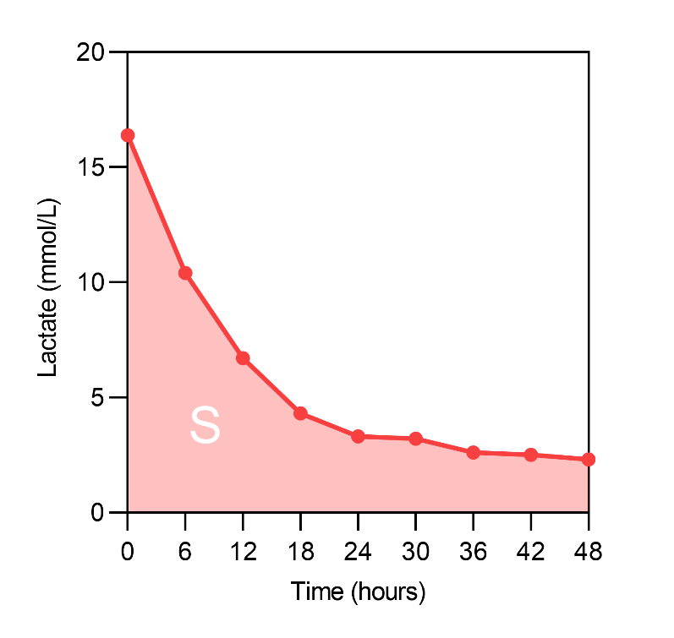
Supplemental Figure 1. Calculation of lactate AUC.
Lactate AUC=S/(20×48); the upper limit for measuring lactate in arterial blood gas is 20mmol/L.
Abbreviations: AUC, area under curve.
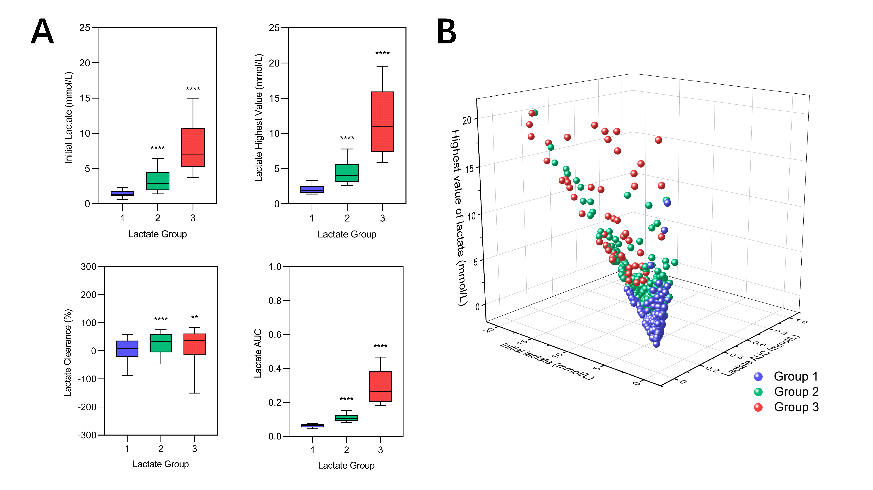
Supplemental Figure 2. Comparisons and descriptions of GBTM lactate groups by initial lactate, the highest value of lactate, lactate clearance and lactate AUC.
A. Comparisons of GBTM lactate groups by initial lactate, lactate highest value, lactate clearance and lactate AUC, presented with Box-Whisker plots, in which the boxes extend from the 25th percentile to the 75th percentile, with a line at the median. The whiskers show the 10th percentile to the 90th percentile. Statistical comparisons were performed with Mann-Whitney U test, and GBTM lactate group 1 was used as reference. ns indicates nonsignificant. *Indicates P<0.05. **Indicates P<0.01. ***Indicates P<0.001. ****Indicates P<0.0001.
B. The 3D scatter plots of GBTM lactate groups are described in three dimensions: initial lactate, lactate highest value, and lactate AUC.
Abbreviations: AUC, area under curve; GBTM, group-based trajectory modeling.
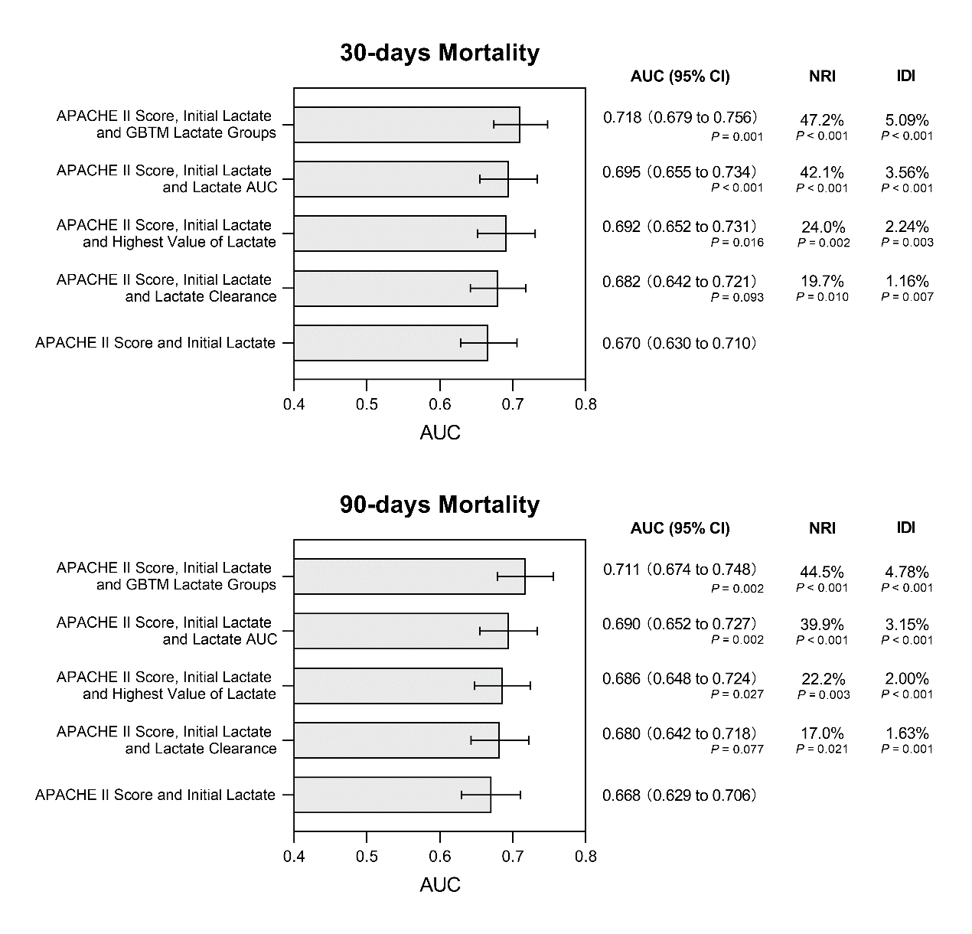
Supplemental Figure 3. The ROC with associated AUC, IDI, and NRI, for the combined assessment of diagnostic capacity when incorporating the GBTM lactate groups, highest value of lactate, lactate clearance and lactate AUC respectively into the established model (APACHE II score + initial lactate).
All P's represent comparisons with established model (APACHE II score + initial lactate).
Abbreviations: APACHE II score, Acute Physiology And Chronic Health Evaluation Ⅱ score; AUC, area under curve; IDI, integrated discrimination improvement; GBTM, group-based trajectory modeling; NRI, net reclassification improvement.
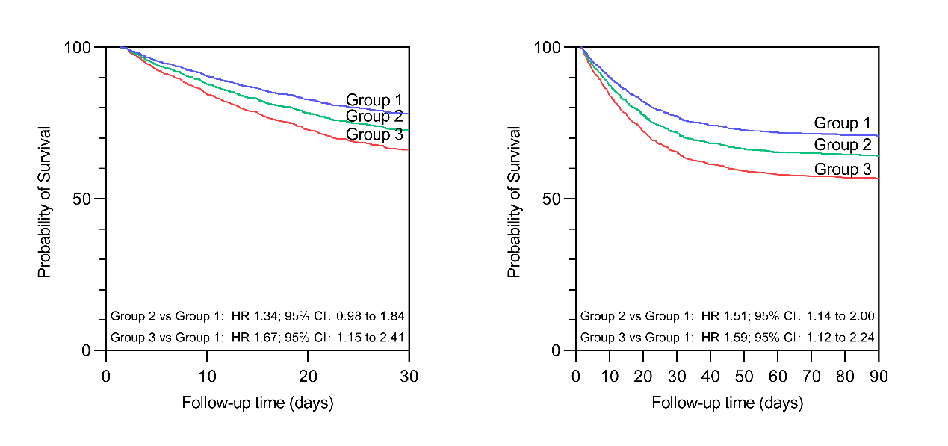
Supplemental Figure 4. Multivariable Cox proportional hazard analyses by initial lactate groups with respect to 30- (left) and 90-days mortality (right).
Abbreviations: CI, confidence intervals; HR, hazard ratio.

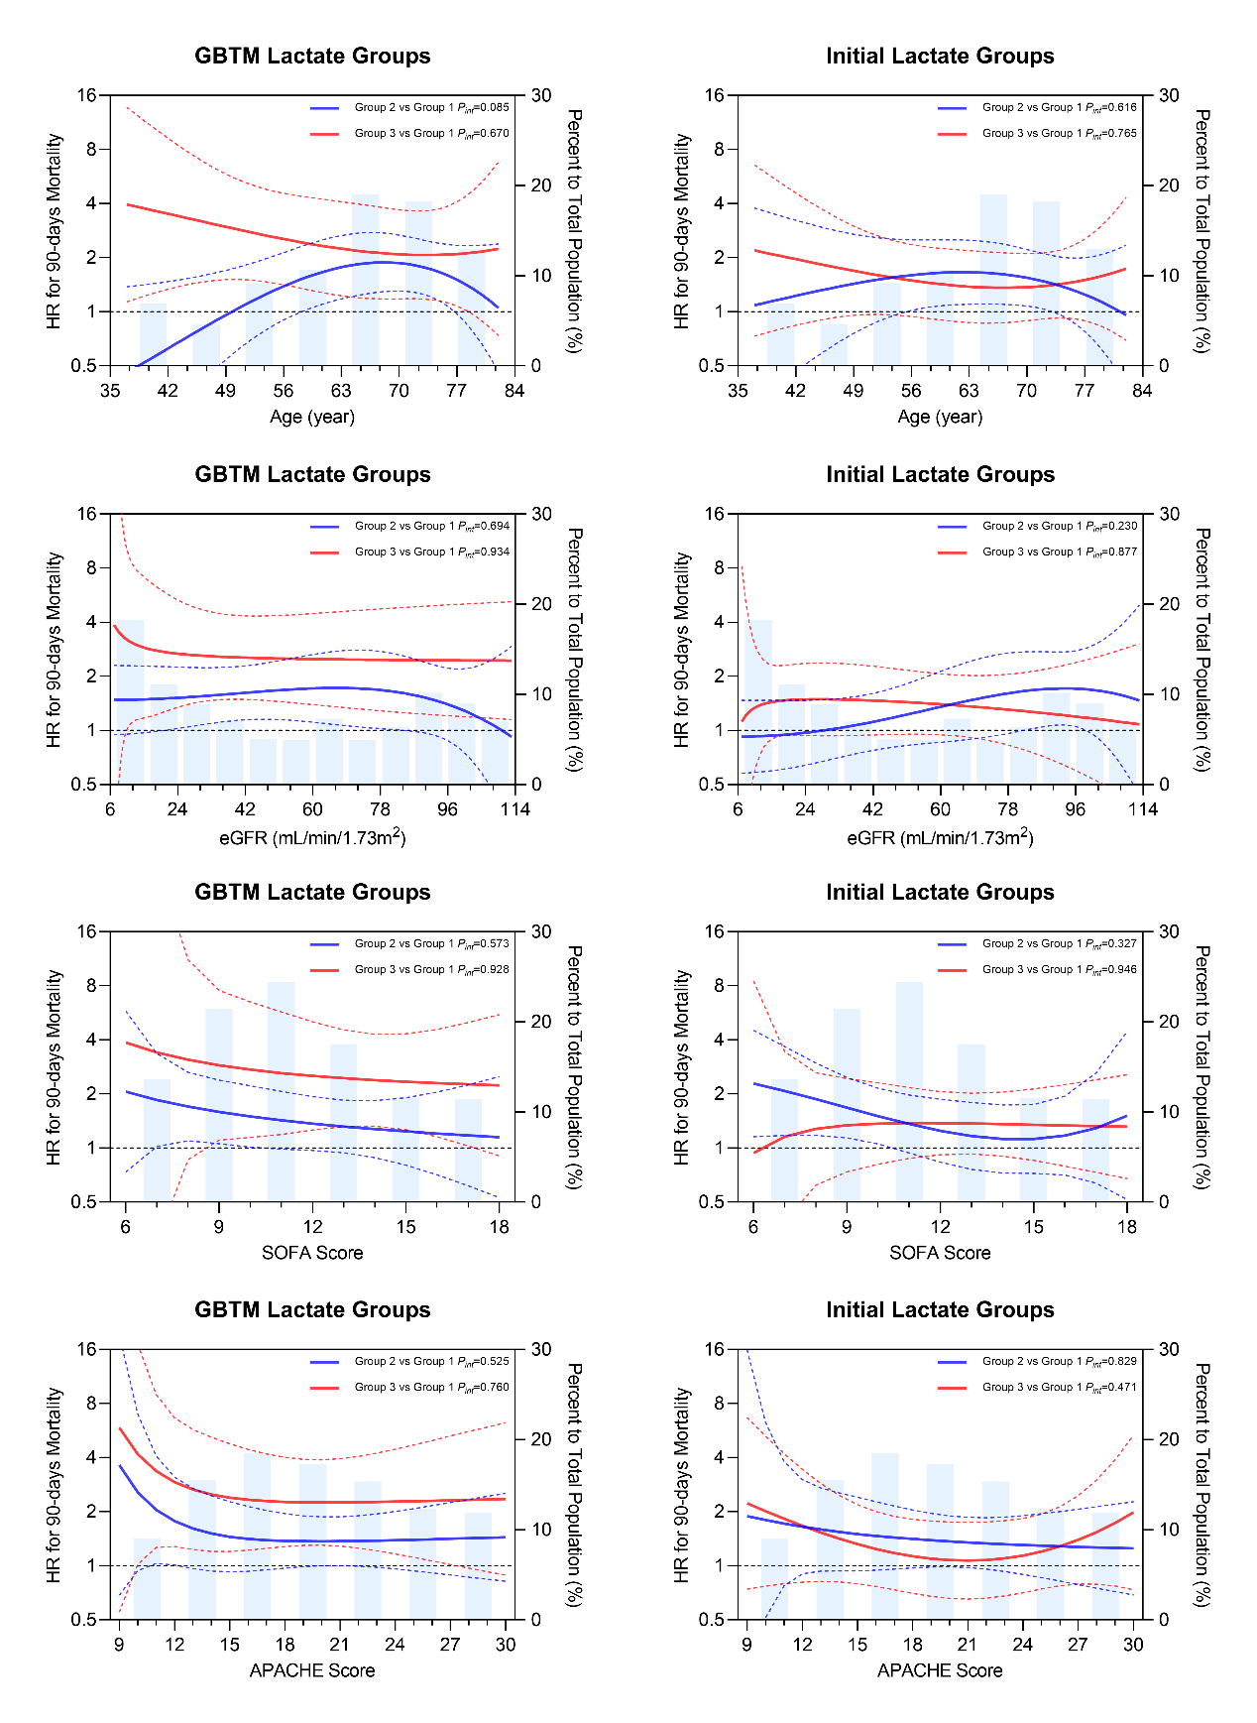
Supplemental Figure 5. A plot of estimated HRs of the nonlinearity on continuous age, eGFR, SOFA score, and APACHE II score between GBTM lactate groups and initial lactate groups assignment with respect to 90-days mortality.
The solid red and blue lines represent the estimated HRs of the group 3 and 2 compared to the group 1, respectively, and the red and blue dashed lines near them represent the CIs corresponding to the HRs, respectively. The horizontal black dashed lines denote HR of 1. A transparent blue histogram of the background represents the distribution of continuous variables. For the four continuous indicators, we adopted the 10th to the 90th quantile of distribution.
Abbreviations: APACHE II score, Acute Physiology And Chronic Health Evaluation Ⅱ score; CI, confidence intervals; eGFR, estimated glomerular filtration rate; GBTM, group-based trajectory modeling; HR, hazard ratio; SOFA score, Sequential Organ Failure Assessment score.

