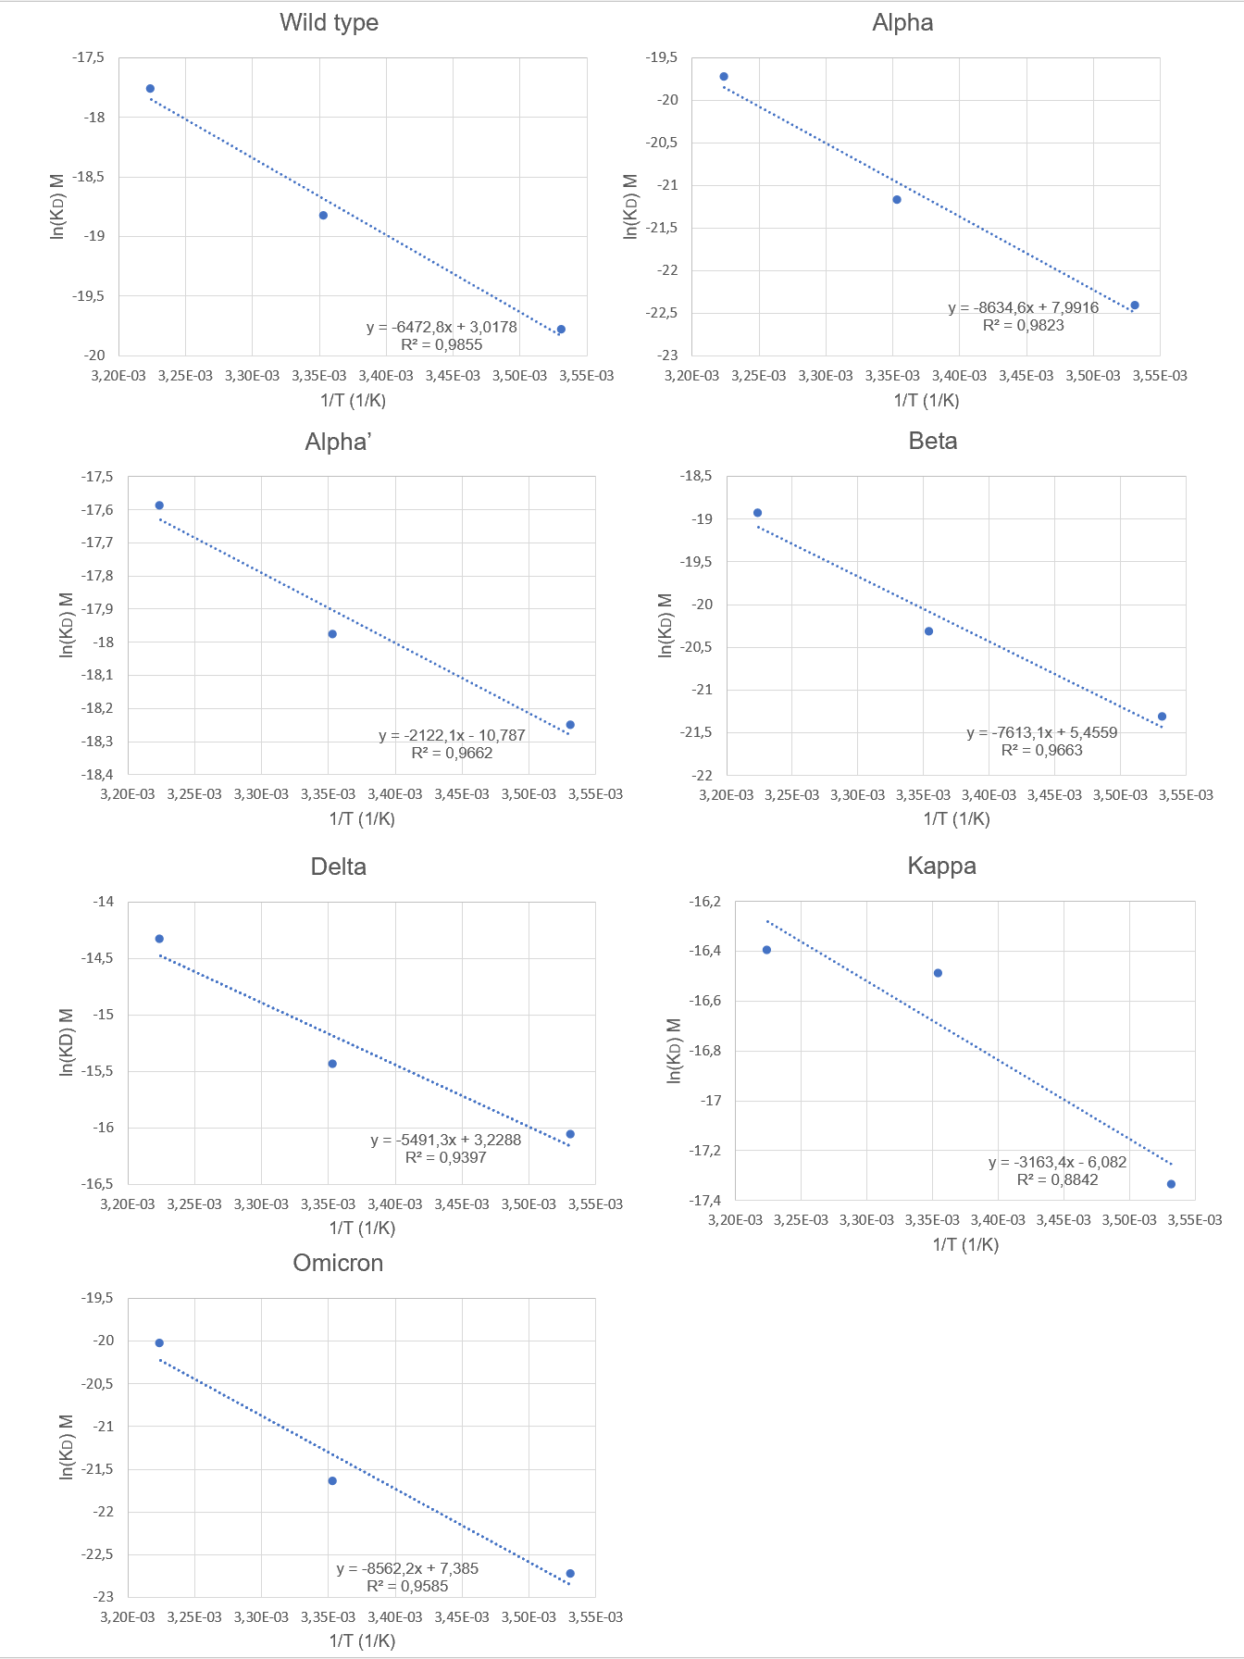
Figure S1 Van't Hoff plot for each RBD variants

