Supplementary Information
Boron-Magnet Nanoparticles Capture Lipopolysaccharide and Peptidoglycan for Bacteria-Infected Wound Healing

Yun Meng^{1,2#}, Lijie Chen ^{2#}, Yang Chen^{1,3#}, Jieyun Shi¹, Zheng Zhang⁴, Yiwen Wang⁴, Fan Wu², Xingwu Jiang², Wei Yang¹, Li Zhang ¹, Chaochao Wang¹, Xianfu Meng¹, Yelin Wu^{1*}, Wenbo Bu^{1,2*}

¹Tongji University Cancer Center, Shanghai Tenth People's Hospital, Tongji University School of Medicine, Shanghai 200072, P. R. China
²Department of Materials Science and State Key Laboratory of Molecular Engineering of Polymers, Fudan University, Shanghai 200433, P. R. China
³ School of Life Sciences and Technology, Tongji University, Shanghai 200092, P. R. China
⁴School of life Science, East China Normal University, Shanghai 200241, P. R. China
#These authors contributed equally to this work.
Email: sk_wuyelin@tongji.edu.cn; wbbu@fudan.edu.cn;

Supplementary Fig. 1. XRD patterns of (a) Nano-MgB₂, (b)Nano-AlB₂, and (c) Nano-BeB_{x}.

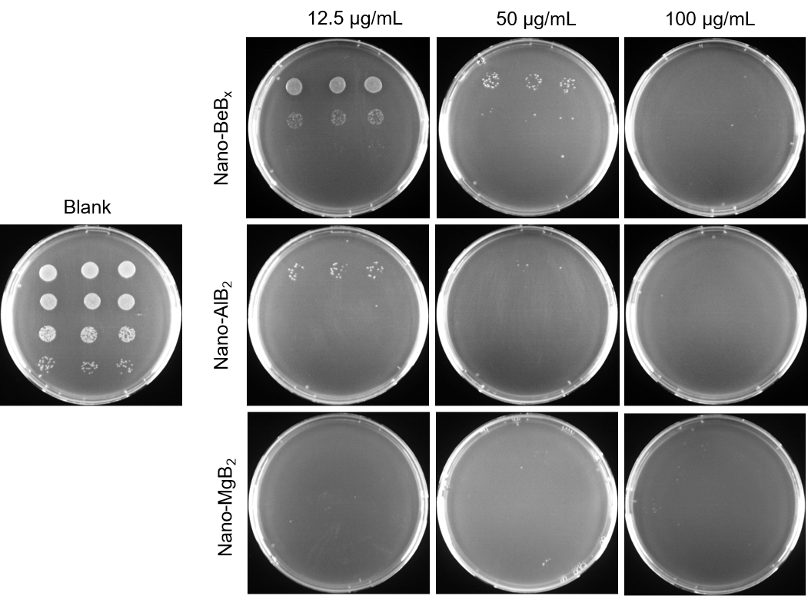

Supplementary Fig. 2. Antibacterial activity of Nano-MgB₂, Nano-AlB₂ and Nano-BeB_{x}. P. aeruginosa treated with different concentrations of Nano-MgB₂, Nano-AlB₂ and Nano-BeB_{x}.

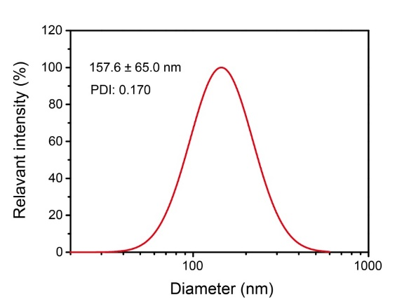
Supplementary Fig. 3. Hydrodynamic diameter of Nano-MgB_{2.}

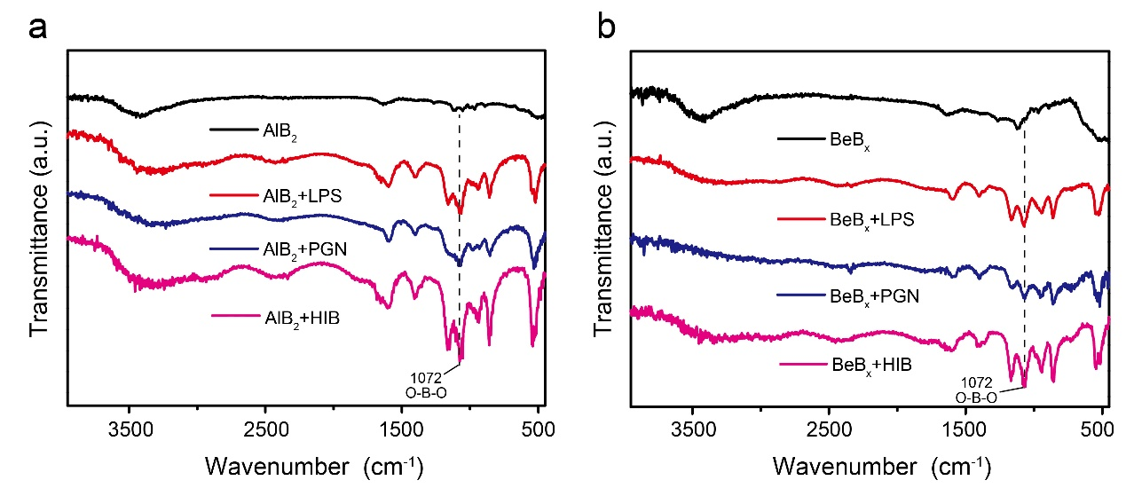
Supplementary Fig. 4. FTIR spectra of O-B-O of (a) Nano-AlB₂ and (b) Nano-BeB_{x} incubated with LPS, PGN, and HIB, respectively.

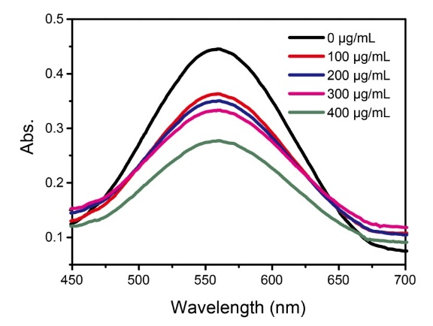
Supplementary Fig. 5. UV-vis spectra of PTIO• scavenging ability with different concentrations of Nano-MgB₂.

Supplementary Fig. 6. ESR spectra of Nano-MgB₂ under different conditions.

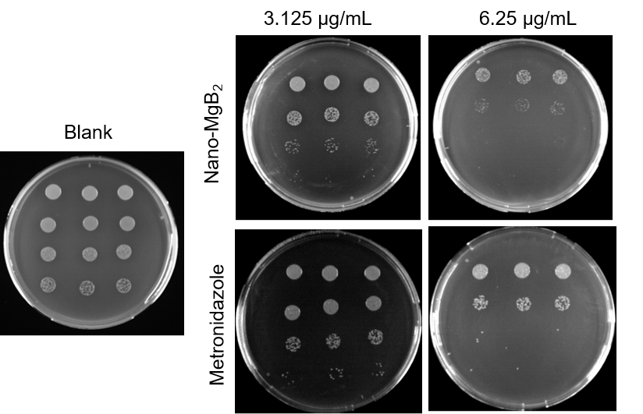
Supplementary Fig. 7. Antibacterial activity of Nano-MgB₂ and Metronidazole. P. aeruginosa treated with different concentrations of Nano-MgB₂ and metronidazole.

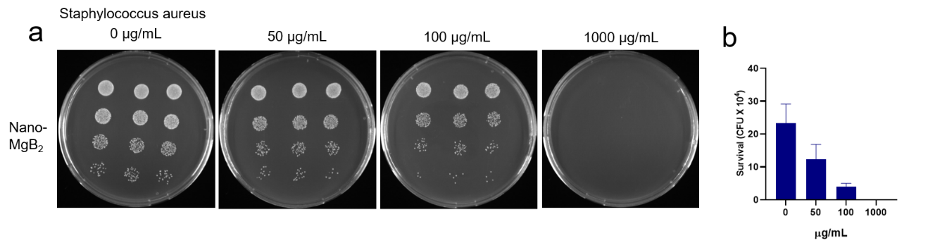
Supplementary Fig. 8. Antibacterial activity of Nano-MgB₂ against S. aureus. a, S. aureus treated with different concentrations of Nano-MgB₂ using colony-forming units counting method. b, Survival rates of S. aureus taken as in (a).

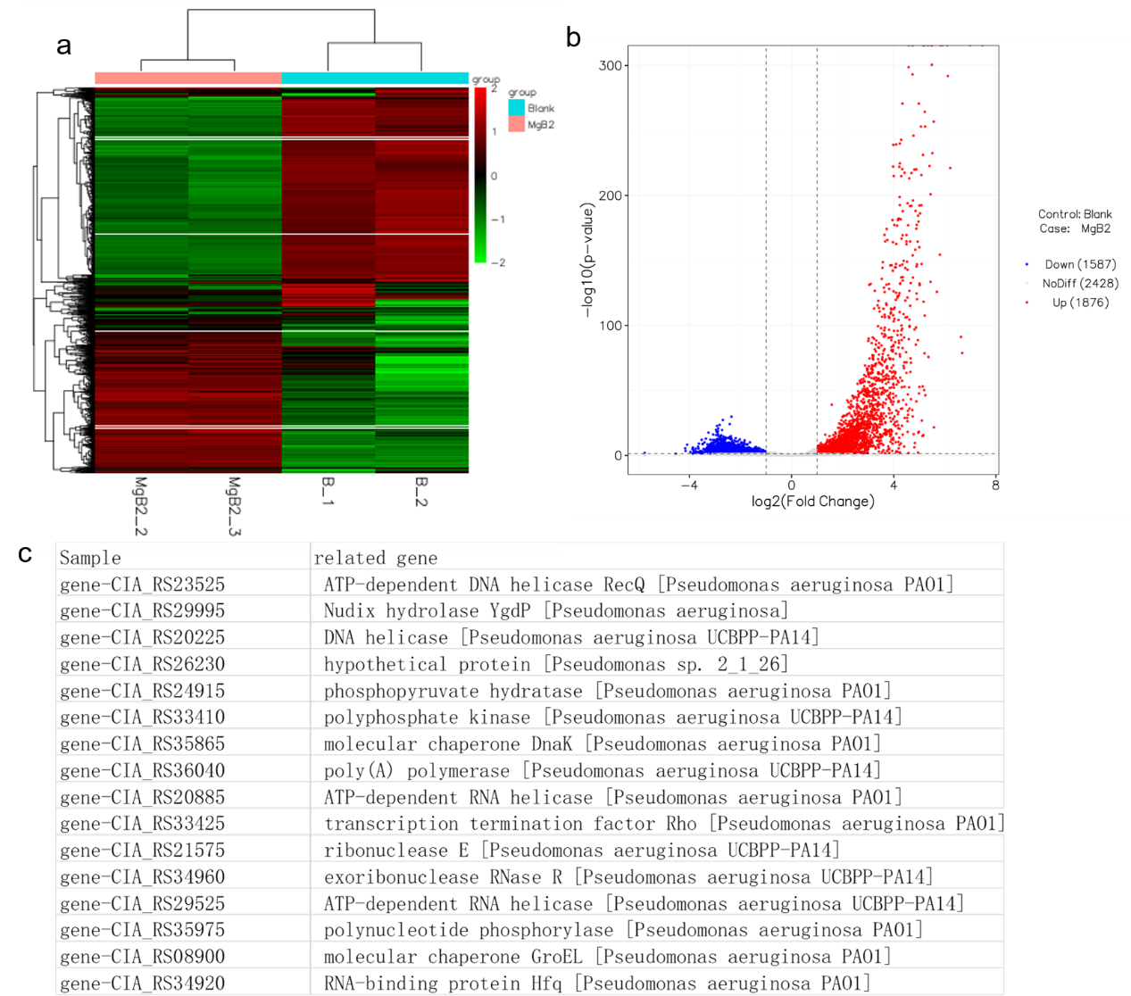

Supplementary Fig. 9. RNA seq of P. aeruginosa treated with Nano-MgB_{2.}

Supplementary Fig. 10. Biocompatibility of Nano-MgB₂. a-c, HaCaT cells treated with different concentrations of Nano-MgB₂, H₃BO₃ and MgCl₂. d, Raw 264.7 cells treated with different concentrations of Nano-MgB₂.

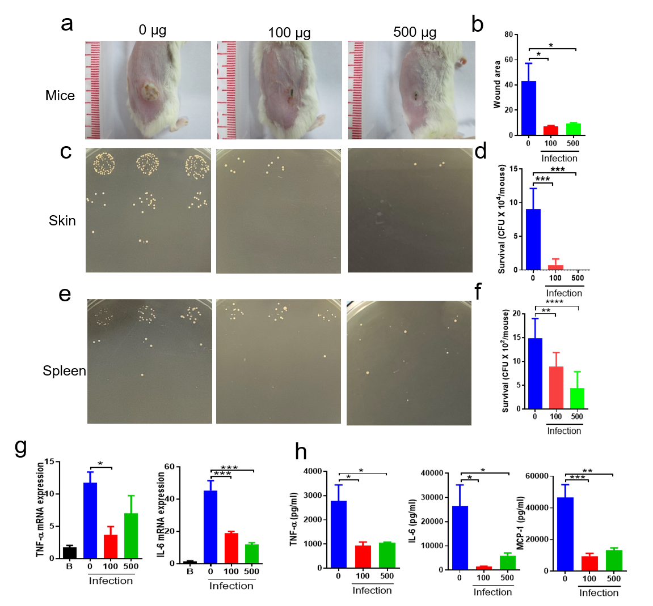
Supplementary Fig. 11. Nano-MgB₂ inhibited S. aureus-induced skin infection and inflammation. a, Photographs of S. aureus-infected mouse skin treated with or without 100 μg and 500 μg/mouse Nano-MgB₂ (n=5). b, The wound healing rate of mice treated as in (a). c, d, Survival of bacteria from S. aureus-infected mouse skin or (e, f,) spleen taken as in (a). g, QPCR of TNF-α and IL-6 in S. aureus-infected mouse skin taken as in (a). h, TNF-α, IL-6 and MCP-1 protein expression in S. aureus-infected mouse skin taken as in (a).

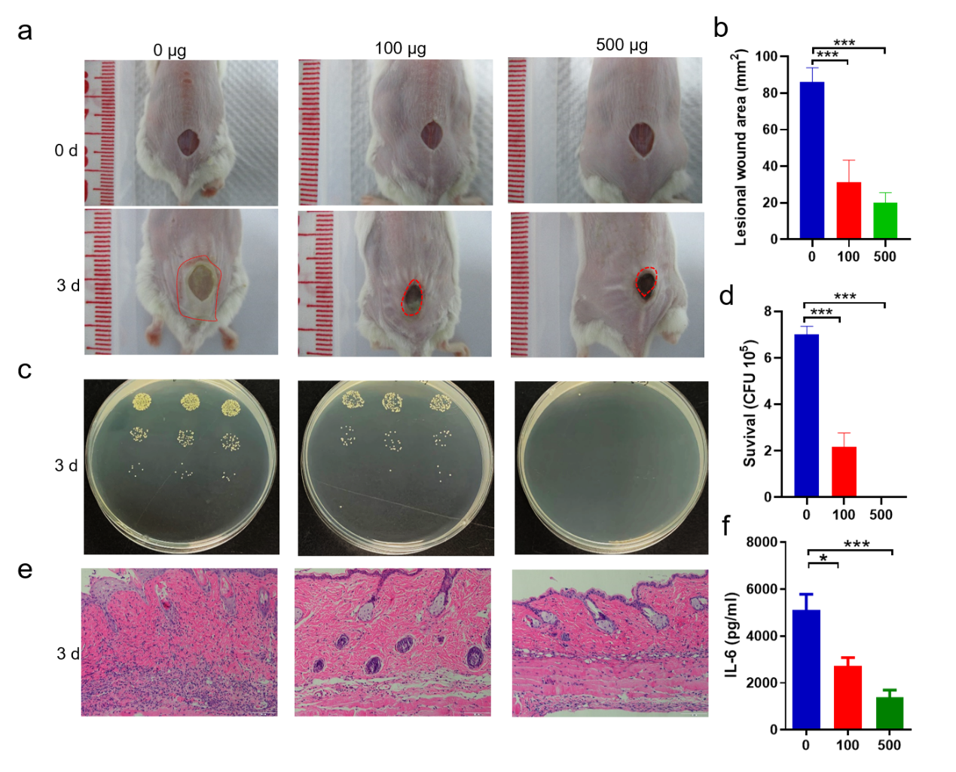
Supplementary Fig. 12. Nano-MgB₂ enhanced S. aureus-infected skin wound healing. a, Photographs of S. aureus-infected skin wounds topically treated with 100 μg and 500 μg/mouse Nano-MgB₂ for 3 days. b, The wound healing rate of mice treated as in (a). c, d, The survival of S. aureus in S. aureus-infected skin wounds and (e) the H&E staining of the infected wound areas. f, The Inflammatory factor IL-6 protein expression in the lesional skins from mice treated as in (a).

Supplementary Fig. 13. Nano-MgB₂ inhibited oxidative stress-related gene hmox1 expression in P. aeruginosa-infected skin wound.

Pseudomonas aeruginosa UCBPP-PA14 16S F (96bp) | TGCCTGGTAGTGGGGGATAA
Pseudomonas aeruginosa UCBPP-PA14 16S R(96bp) | TCTGATAGCGTGAGGTCCGA
gene-CIA_RS23525 F | GAAGAGCGGGAAATGTGGGA
gene-CIA_RS23525 R | GGGGAAGATCACATAGGGCG
gene-CIA_RS29995 F | ATCAGGAAGCCTGGCAGTTC
gene-CIA_RS29995 R | GCTTGAAGGTCACCACCTGT
gene-CIA_RS20225 F | AGTCCAAGGACGGCCTCTAT
gene-CIA_RS20225 R | CATCAGCCAGGGTATCGACC
gene-CIA_RS26230 F | ATCCACATCGACGGCATCAG
gene-CIA_RS26230 R | ATACGGTGCACGTAGTCGTC
gene-CIA_RS24915 F | AGATCGTCGACATCAAGGGC
gene-CIA_RS24915 R | CAGGATCACGTCCGCTTCAA
gene-CIA_RS33410 F | GACCGATCCGAAGGTCATCC
gene-CIA_RS33410 R | ATCGAGCGCACGTGGATATT
gene-CIA_RS35865 F | GTGATCGAGATCGCCGAAGT
gene-CIA_RS35865 R | GGTAGTCGATCAGGCGGATG
gene-CIA_RS36040 F | GCGACTTCACCATCAATGCC
gene-CIA_RS36040 R | CGATTGCGGATGTCGTGAAC
gene-CIA_RS20885 F | CACAGATCCTCGTCGCTACC
gene-CIA_RS20885 R | TTCCAGGTCGTCCATGAAGC
gene-CIA_RS33425 F | TCTTACGATTCTCGCCACGG
gene-CIA_RS33425 R | TTGATGTTGATGGCCGGGAA
gene-CIA_RS21575 F | CTGAACTTCATCCGCCAGGT
gene-CIA_RS21575 R | CTGGAAGCGATTGAACAGCG
gene-CIA_RS34960 F | CTGGAGAAGATCCACGACCG
gene-CIA_RS34960 R | GAGGTGAAGTGGGTGTAGGC
gene-CIA_RS29525 F | ATCCATGGCAACAAGAGCCA
gene-CIA_RS29525 R | CATGGGGCAACTGGTCGATA
gene-CIA_RS35975 F | CATCAAGCAGGACCGCTACA
gene-CIA_RS35975 R | CAGGCCGAATACGTCCTTGA
gene-CIA_RS08900 F | GTTAAGTTCGGCGATTCCGC
gene-CIA_RS08900 R | ACGACTTGTCCAGAACCACG
gene-CIA_RS34920 F | AGGGCATTCGCTACAAGACC
gene-CIA_RS34920 R | GTCGAAGGACTCGATCTGGC

Supplementary Fig. 14. QPCR primers for Pseudomonas aeruginosa

