Investigation of Synthesis of Biogenic Hematite Nanocubes for environmental Assessment and its innovative Applications associated with Antibacterial, Antifungal, and Antioxidant activity
¹Debasmita Das, ¹Salim Ali, ¹Biplab Rajbanshi, ¹Samapika Ray, ¹Sanjoy Barman, ²Divya Chouhan, ²Md Salman Haydar, ²Palash Mandal, ³Kanak Roy, ^{1, 3}* Mahendra Nath Roy

¹Department of Chemistry, University of North Bengal, Darjeeling, India.

²Nanobiology and Phytotherapy Laboratory, Department of Botany, University of North Bengal, Siliguri, West Bengal, India.
³Department of Chemistry, Alipurduar University, Alipurduar-736122, India
*Corresponding Authors: Mahendra Nath Roy, mahendraroy2002@yahoo.co.in

SUPPLEMENTARY MATERIALS

TABLE
tABLE S1 | PAGE 2
tABLE S2 | PAGE 2

FIGURE
fIGURE S1 | PAGE 3
FIGURE S2 | PAGE 4
FIGURE S3 | PAGE 5
FIGURE S4 | PAGE 6
Figure S5 | PAGE 7
fIGURE s6 | PAGE 8
fIGURE s7 | PAGE 8
fIGURE s8 | PAGE 9
fIGURE S9 | PAGE 10
FIGURE s10 | PAGE 10
Figure s11 | PAGE 11
Figure s12 | PAGE 11

Table S1 Phytochemical screening of Lemon Peel Extract

Sl. No. | Phytochemicals | Lemon peel
1 | Carbohydrates | +
2 | Protein | +
3 | Phenols and tanins | +
4 | Saponins | +
5 | Flavonoids | -
6 | Steroids | +
7 | Glycosides | +
8 | Terpenoids | -
9 | Alkaloids | -

Table S2 XRD diffraction data of IONPs (2θ, FWHM, Crystalline size (d. nm), Micro-strain, Dislocation Density)
 | 2θ |  | θ |  | FWHM |  | Crystalline size (dnm) |  | Average size |  | Micro-strain(ε×10-3) | Dislocation Density (δ×10⁻³ (nm⁻²)
24.49671 |  | 12.24836 |  | 0.15463 |  | 52.38233578 |  | 41.8203 |  | 3.392458284 |  | 3.6444356
33.22285 |  | 16.61143 |  | 0.32023 |  | 25.88851428 |  |  |  | 4.683627409 |  | 4.683627409
35.71506 |  | 17.85753 |  | 0.23782 |  | 35.09545979 |  |  |  | 3.220897066 |  | 3.220897066
40.93499 |  | 20.4675 |  | 0.20163 |  | 42.0552501 |  |  |  | 2.357145817 |  | 2.357145817
49.55147 |  | 24.77574 |  | 0.28193 |  | 31.03483222 |  |  |  | 2.665255988 |  | 2.665255988
54.14106 |  | 27.07053 |  | 0.28322 |  | 31.50090594 |  |  |  | 2.41799261 |  | 2.41799261

Fig. S1 Mechanism of interaction of phytochemicals of LPE and metal salt

Fig. S2 First order reaction kinetics for the decolorization of MB dye by the Fenton like reactions with (a) variation of H₂O₂ concentration at constant pH and amount of catalyst (b) Variation of pH with the constant amount of H₂O₂ and catalyst (c) variation of catalyst amount at constant pH and constant amount of H₂O₂.

Fig. S3 Plots for rate constant of first order reaction with (a) variation of catalyst amount at constant pH and constant amount of H₂O₂ (b) Variation of pH with constant amount of H₂O₂ and catalyst (c) variation of H₂O₂ concentration at constant pH and amount of catalyst

(d)
(b)

Fig. S4 Seed germination and seedling vigor evaluation of wheat seedlings through (a) germination index, (b) mean germination time, (c) co-efficient velocity of germination and (d) promptness index

(e)
(d)
(c)
(b)
(a)

Fig. S5 Evaluation of biochemical attributes of treated wheat seedlings through (a) Total Phenol content, (b) Total ortho-dihydric phenol, (c) Total Chlorophyll content, (d) Total reducing sugar and (e) Total flavonoid content estimation.

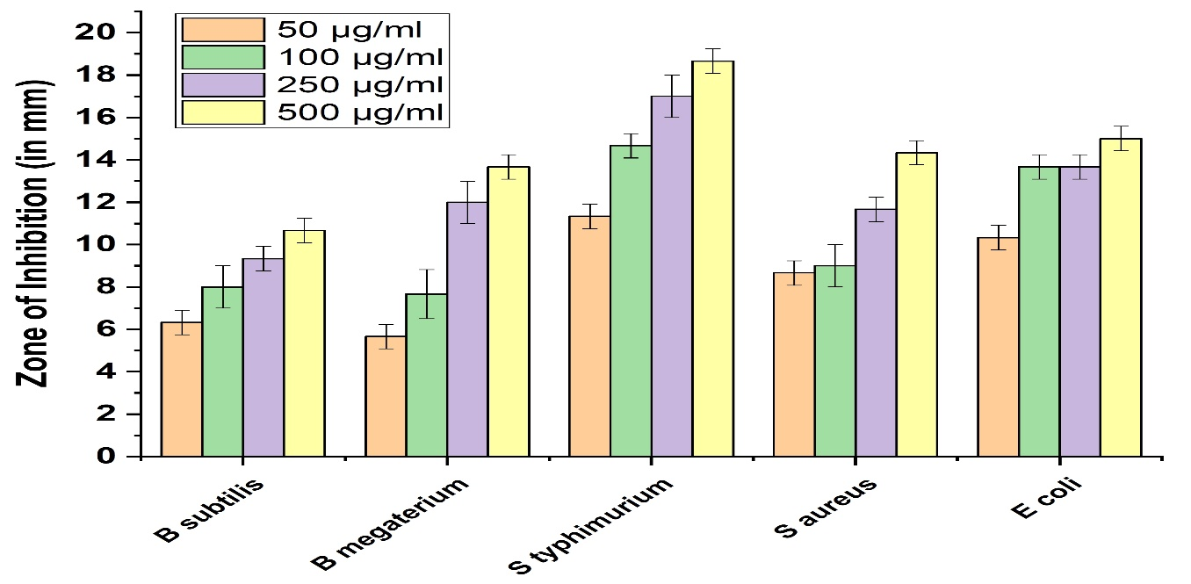
Fig. S6 Bar graph showing Zone of inhibition of introduced by IONPs against B Subtilis, B megaterium, S typhimurium, S aureus, E coli

Fig. S7 Visual representations of the proposed mechanisms of antibacterial activity of IONPs

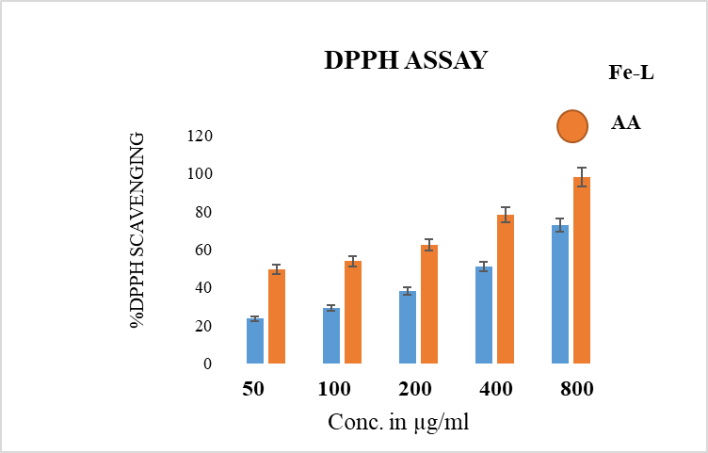

Fig. S8 Concentration-response curve on DPPH radical scavenging capacity of IONPs synthesized from LPE. Ascorbic acid was used as antioxidant reference.

Fig. S9 Effect of IONPs on mycelium radial growth of F. solani. (a) Mycelium radial growth of F. solani with different concentrations (0, 100, 250, 500, 1000, 2000, 3000 µg/mL) of IONPs on PDA plate; (b) Graph showing Percent Inhibition of Radial Growth (PIRG) of F. solani under tested concentrations of IONPs. Values are averages of three replicates (n=3), error bars indicate standard deviation (SD).

Fig. S10 Effect of IONPs on inhibition percentage of spore germination of F. solani.
0
10
20
30
0.1
₁
₁₀
100
1000
10000
Intensity (%)
Size (d.nm)

Fig. S11 DLS of recovered catalyst after third cycles
0
50000
100000
150000
200000
250000
-100
0
100
200
Total Counts
Apparent Zeta Potential (mV)
Fig. S12 Zeta potential of recovered catalyst after third cycle

