Insight into the mechanism of molecular recognition between human Integrin-Linked Kinase and Cpd22 and its implication at atomic level
Javier García-Marín, ^{a , b} †,* Diego Rodríguez-Puyol,^{c ,d} Juan J. Vaquero. ª
ª Departamento de Química Orgánica y Química Inorgánica, Instituto de Investigación Química Andrés M. del Río (IQAR), Universidad de Alcalá (IRYCIS), 28805–Alcalá de Henares, Madrid, Spain
^{b} Departamento de Química Biológica y Estructural, Centro de Investigaciones Biológicas, CIB-CSIC, C/Ramiro de Maeztu 9, 28040, Madrid, Spain.
^{c} Fundación de Investigación Biomédica, Sección de Nefrología del Hospital Príncipe de Asturias y Departamento de Medicina y Especialidades Médicas, Universidad de Alcalá (IRYCIS), 28805, Alcalá de Henares, Madrid (Spain)
^{d} Fundación Renal Iñigo Álvarez de Toledo (FRIAT) y Instituto de Salud Carlos III (REDinREN), Madrid, (Spain)

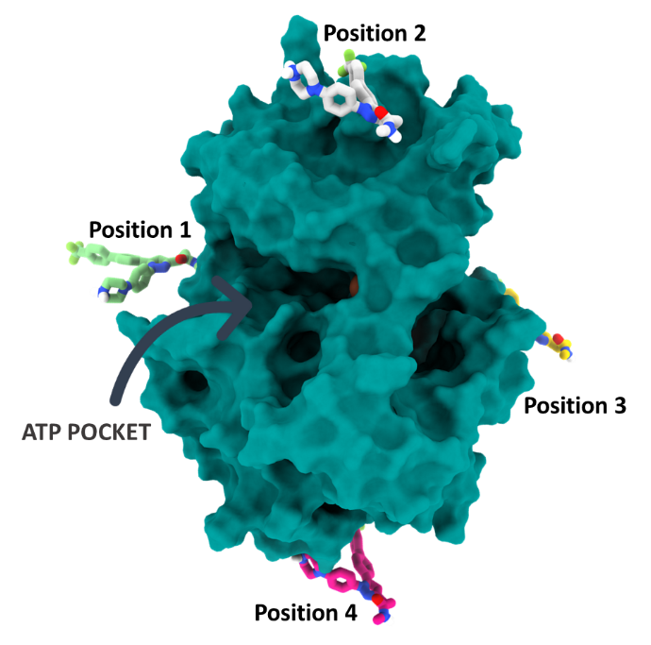
Fig. S 1 Around the whole ILK surface binding site exploration, four initial Cpd22 colored sticks) starting points placed manually for binding site exploration.
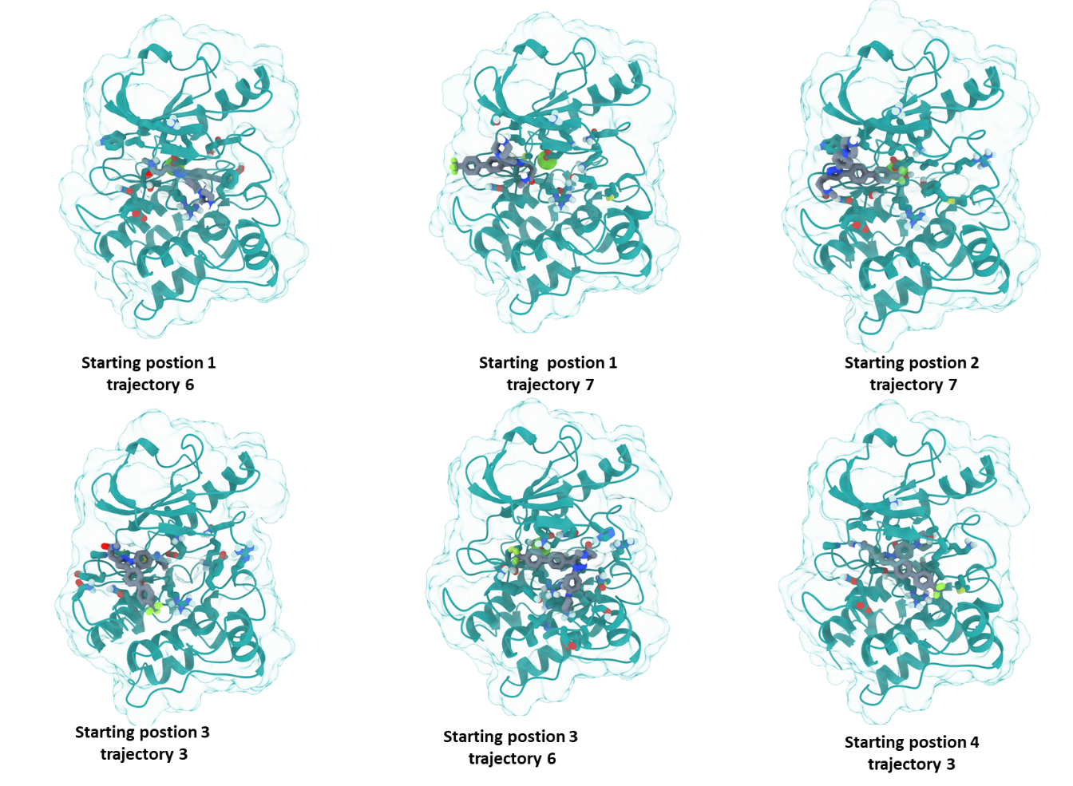
Fig. S 2 Last frames from PELE trajectories where Cpd22 reached the ATP cleft of ILK, which also corresponds to the most favorable in terms of calculated free energy.
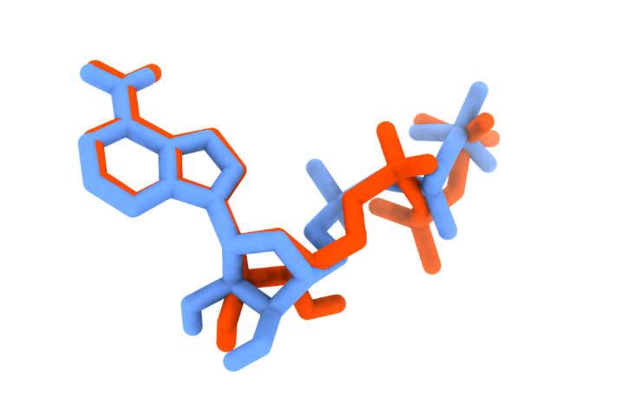
Fig. S 3 Redocking of ATP molecule. In blue sticks the crystallographic conformation of ATP (PDB: 3KMW) superimposed to the obtained docking pose (orange sticks) by Glide XP.
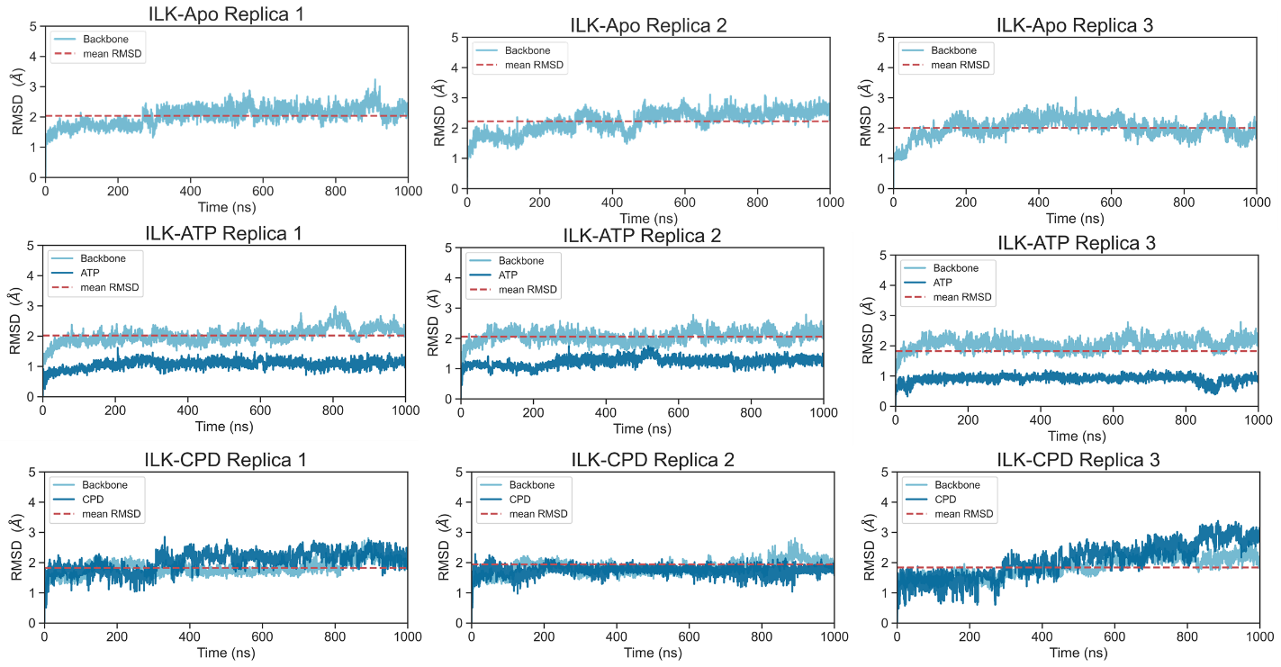
Fig. S 4 Plots with the root mean square deviations (RMSD, Å) of protein (backbone) and ligands (heavy atoms) during MD simulations. The red dashed line represents the mean RMSD value of the protein.
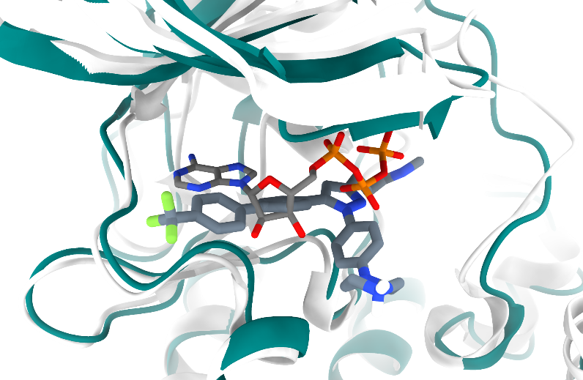
Fig. S 5 Superimposition of ILK crystal structure bound to ATP (PDB ID: 3KMW) onto a representative snapshot of the most populated cluster obtained from molecular dynamics of Cpd22 in complex with ILK.
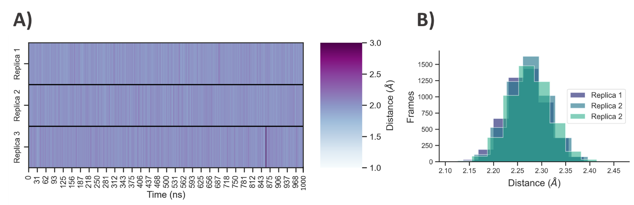
Fig. S 6 A) Heatmap plot for distance between Oxygen atom from Cpd22 carbonyl group and the Mg²⁺ cation present in the pseudo-active site of ILK during MD simulations. B) Distance values distribution for three replicas.

Table S 1. Protein radius of gyration mean values across trajectories (Å).
 | Replica1 | Replica1 | Replica 2 | Media | SD
Apo | 9.02 | 18.97 | 19.01 | 19.00 | 0.08
ATP | 19.15 | 19.15 | 18.96 | 19.09 | 0.10
Cpd22 | 19.20 | 19.11 | 19.09 | 19.13 | 0.09

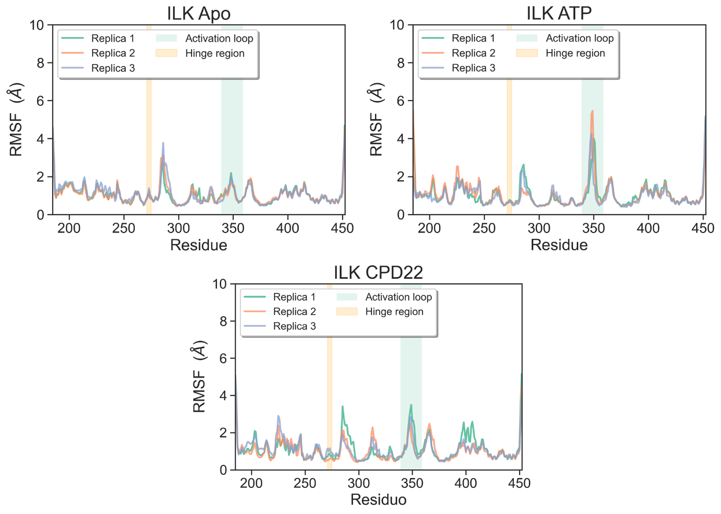
Fig. S 8 Comparisons of apo ILK, ILK-ATP and ILK-Cpd22 protein Cα carbons RMSF across replicas.

Table S 2 Predicted binding free energy for Cpd22 and ATP binding to ILK by MM-ISMSA algorithm (kcal/mol).
Replica | Total | VDW | QQ | DesolvLigand | DesolvReceptor | Apolar
ATP
1 | -36.11 | -11.48 | -35.90 | 12.74 | 2.32 | -3.79
2 | -51.29 | -16.60 | -31.50 | 11.65 | -10.31 | -4.54
3 | -64.08 | -12.81 | -38.17 | 11.56 | -20.49 | -4.17
Cpd22
1 | -54.12 | -51.15 | -14.45 | -1.50 | 17.47 | -4.48
2 | -41.82 | -42.93 | -13.61 | 2.13 | 16.54 | -3.95
3 | -50.85 | -45.18 | -15.35 | -3.74 | 17.63 | -4.21

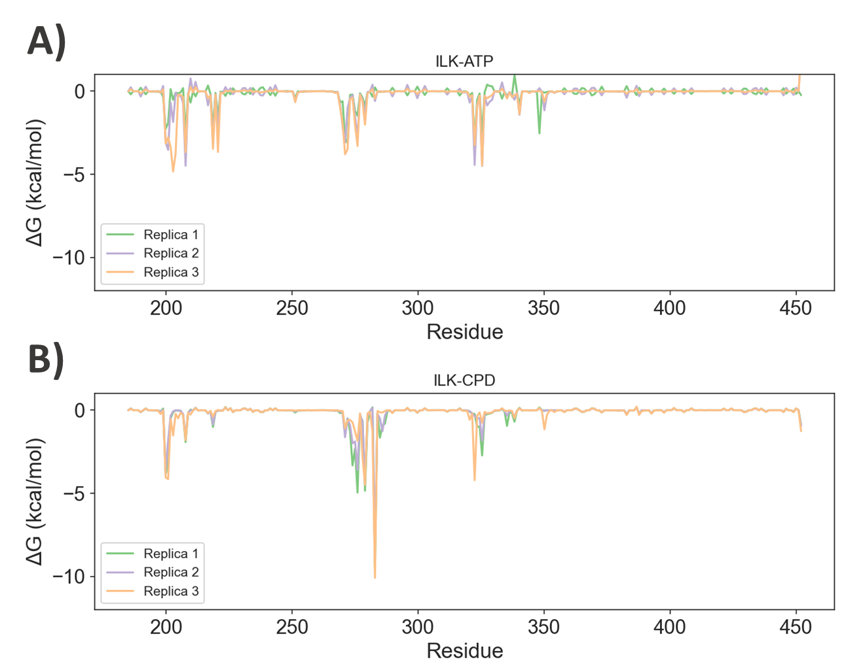
Fig. S 7 Residues contributing to the binding of ATP (A) or Cpd22 (B) with the value of the binding energy to ILK.

SMILES codes:
C1CNCCN1c(cc2)ccc2-n(nc3CCC(=O)NC)c(c3)-c4ccc(cc4)-c5ccc(C(F)(F)F)cc5,Cpd22
C1C[NH2+]CCN1c(cc2)ccc2-n(nc3CCC(=O)NC)c(c3)-c4ccc(cc4)-c5ccc(C(F)(F)F)cc5,Cpd22-H

