Time | Heavy duty vehicle (HDV) |  |  |  |  |  | Light duty vehicle (LDV) |  |  |  |  |  | Total
Time | J-1 | J-2 | J-3 | J-4 | J-5 | J-6 | J-1 | J-2 | J-3 | J-4 | J-5 | J-6 | Total
7:00-8:00AM | 156 | 61 | 148 | 275 | 69 | 93 | 1147 | 3018 | 1193 | 364 | 2763 | 1955 | 11242
8:00-9:00AM | 78 | 178 | 141 | 143 | 58 | 193 | 1569 | 4808 | 1662 | 2535 | 1471 | 3180 | 16016
9:00-10:00AM | 147 | 53 | 72 | 100 | 140 | 120 | 1327 | 1193 | 3654 | 2763 | 2143 | 2393 | 14105
10:00-11:00AM | 73 | 94 | 103 | 81 | 78 | 145 | 1373 | 1845 | 1106 | 2896 | 1734 | 978 | 10506
11:00-12:00AM | 86 | 52 | 147 | 97 | 61 | 178 | 1702 | 1414 | 994 | 2427 | 1229 | 2789 | 11176
12:00-1:00PM | 83 | 72 | 116 | 148 | 199 | 136 | 3360 | 2371 | 1021 | 1306 | 937 | 1775 | 11524
1:00-2:00PM | 78 | 81 | 141 | 108 | 195 | 123 | 1372 | 784 | 1161 | 856 | 1734 | 2086 | 8719
2:00-3:00PM | 73 | 136 | 104 | 170 | 124 | 122 | 3910 | 1256 | 1389 | 987 | 1790 | 1087 | 11148
3:00-4:00PM | 116 | 83 | 135 | 149 | 55 | 136 | 1021 | 1789 | 1364 | 1761 | 789 | 1262 | 8660
4:00-11:00PM | 150 | 69 | 65 | 196 | 77 | 83 | 3890 | 1850 | 1220 | 689 | 1610 | 2107 | 12006
11:00-12:00PM | 136 | 55 | 61 | 75 | 91 | 44 | 718 | 1096 | 2851 | 1258 | 2348 | 1162 | 9895
Table 1 Average Car counted

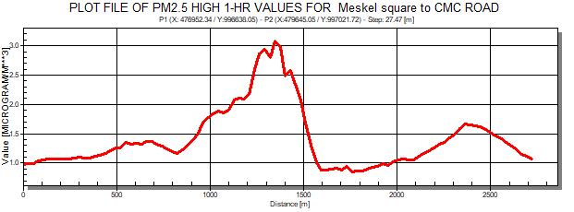
a
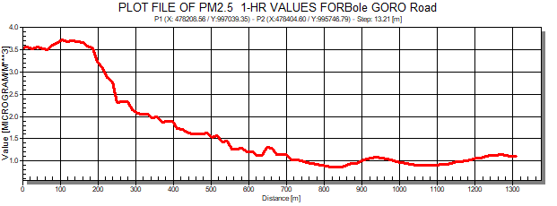 b 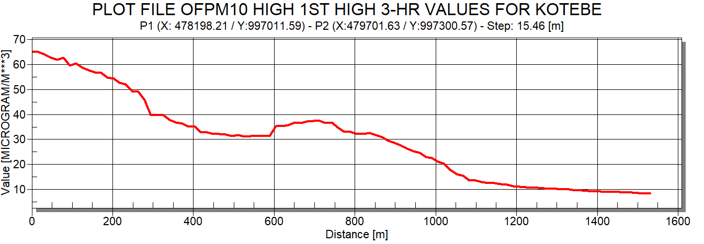 c
d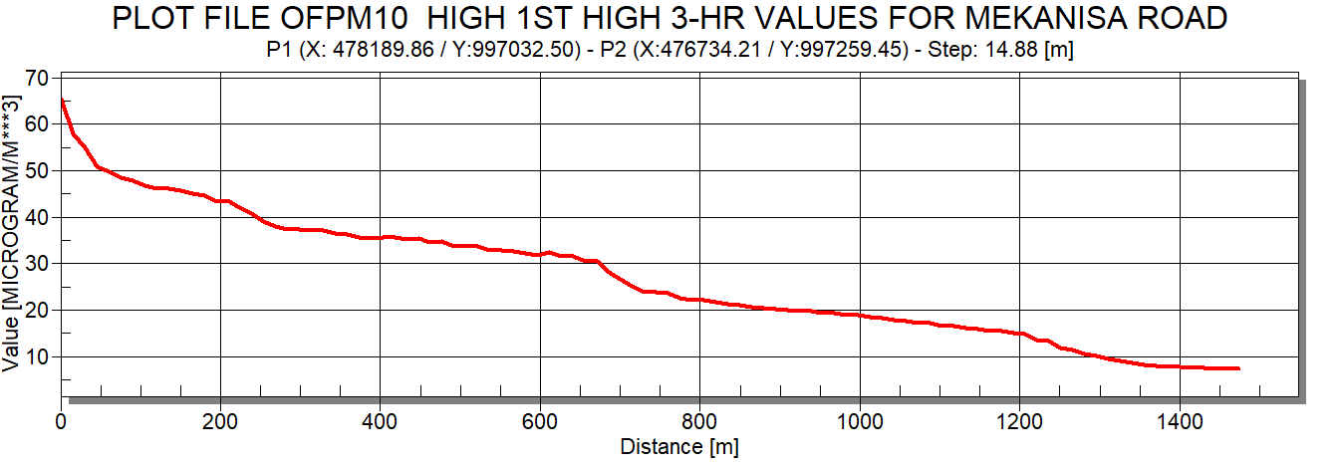

Figure 1 Profile of PM with respect to distance

Graphical Abstract

