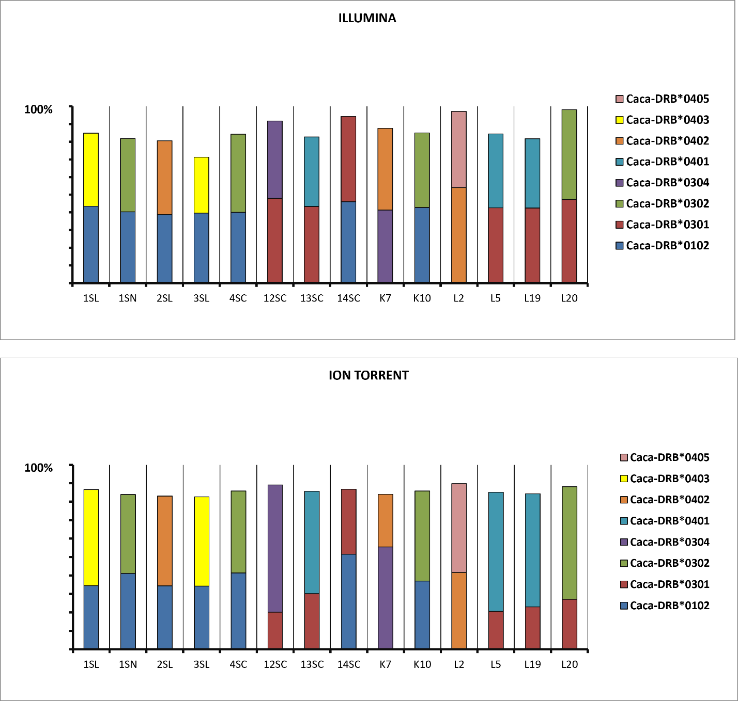
Figure S1 MHC-DRB allele frequency ratios detected in European roe deer by utilisation of Illumina (left bar) and Ion Torrent (right bar) sequencing followed by AmpliSAS web analysis (a subset of 5,000 reads)

