Supplementary Information to
High-resolution neutron imaging of carbonate precipitation and water transport in zero-gap CO₂ electrolysis
Joey Disch^{a,b}, Luca Bohn^{a,b}, Susanne Koch^{a,c}, Michael Schulz^{d}, Yiyong Han^{d}, Alessandro Tengattini^{e,f}, Lukas Helfen^{f}, Matthias Breitwieser^{a,c} and Severin Vierrath*^{a,b,c}
ªElectrochemical Energy Systems, IMTEK - Department of Microsystems Engineering, University of Freiburg, Georges-Koehler-Allee 103, 79110 Freiburg, Germany
^{b}University of Freiburg, Institute and FIT – Freiburg Center for Interactive Materials and Bioinspired Technologies, Georges-Köhler-Allee 105, 79110 Freiburg
^{c}Hahn-Schickard, Georges-Koehler-Allee 103, 79110 Freiburg, Germany
^{d}FRM II and Faculty for Physics E21, Technische Universität München, Garching, Germany
^{e}Grenoble INP, CNRS, 3SR, Univ. Grenoble Alpes, 38000, Grenoble, France
^{f}Institute Laue-Langevin, 71 avenue des Martyrs - CS 20156, 38042 Grenoble, France

S 1 Explosion view of the custom-built electrolysis cell. (End plates: Stainless steel, flow fields: Au coated Ti grade 2, gaskets: PTFE) 2
S 2 Schematic drawing of the electrolysis test setup (MFC: Mass flow controller, PI: Pressure sensor, TC: Temperature controller, GC: Gas chromatograph). 2
S 3 a) VI-Curve, b) Faraday efficiencies and c) partial current densities of the identical cell (cell 2) at 50 °C cell temperature (0.1 M KOH anolyte, 10 min current steps). Measured additionally after completing the replication measurements. 3
S 4 Selected regions for channel and land area comparison in Figure 5. 4
S 5 Selected regions for cathode GDL (left), membrane (middle) and anode channel (right) vertical profiles of Figure 4. 5
S 6 Calculated neutron transmission for different compounds and sample thicknesses calculated with the online calculator from “NIST Center for Neutron Research” [https://www.ncnr.nist.gov/resources/activation/, Date: 02.2022]. The wavelength was set to 3 Å. 6

Cell fixture

The cell fixture is designed for in-plane neutron imaging. It consists of two stainless steel end plates and two flow fields made from titanium grade 2 coated in gold. The neutron beam enters through the in-cut window of the flow fields. In the window region the flow fields measure 2 cm in beam direction and the active cell area measures 2 cm vertically and 1 cm horizontally (in beam direction). Two heating cartridges inserted in the endplates (two holes going in from the front) can heat up the cell. Two centering pins ensure proper alignment of all fixture components. Custom punching tools were used to reproducibly cut gaskets and electrodes in size. The cell was mounted onto an electronically steered stage for precise alignment of the cell between the detector and neutron beam.

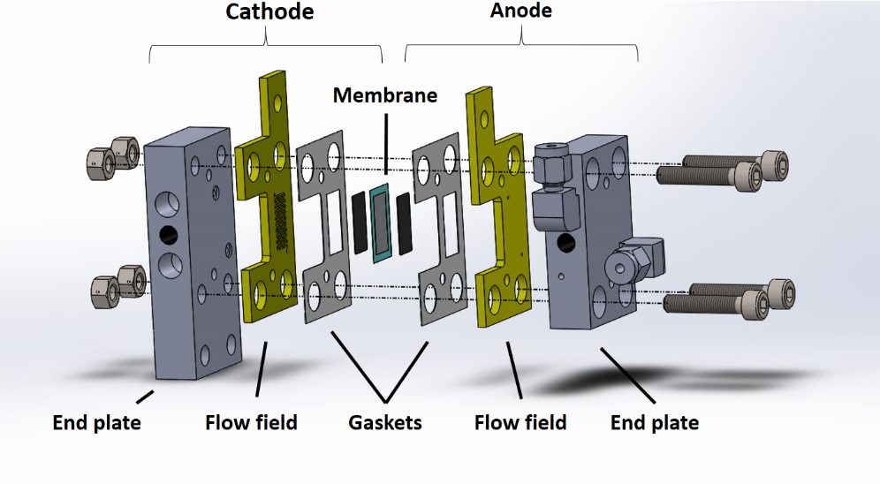
S 1 Explosion view of the custom-built electrolysis cell. (End plates: Stainless steel, flow fields: Au coated Ti grade 2, gaskets: PTFE)

Experimental setup
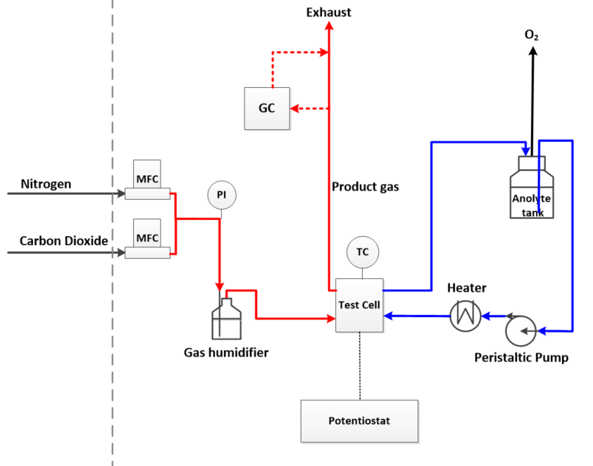
S 2 Schematic drawing of the electrolysis test setup (MFC: Mass flow controller, PI: Pressure sensor, TC: Temperature controller, GC: Gas chromatograph).

Electrochemical measurements at 50 °C cell temperature
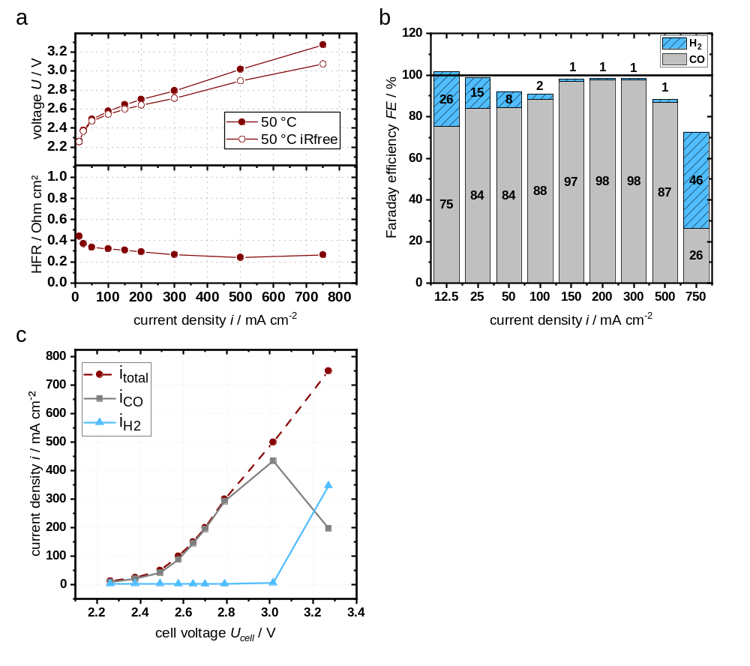
S 3 a) VI-Curve, b) Faraday efficiencies and c) partial current densities of the identical cell (cell 2) at 50 °C cell temperature (0.1 M KOH anolyte, 10 min current steps). Measured additionally after completing the replication measurements.
Electrochemical calculations
The cell potential corrected by the contribution of ohmic overpotential (U_{iRfree}) was calculated as follows:
$$U_{iRfree} = U_{cell} – i * { HFR}_{i}.$$
U_{cell} stands for the measured cell potential, i for current density and HFR_{i} for the high frequency resistance at the specific current density. The HFR was determined by taking the x-axes intercept of a Nyquist plot of the EIS measurements conducted at each current density.
The Faraday efficiency for the product x was calculate using this equation
${FE}_{x}=n_{x}*\left(\frac{F*z*p}{R*T}\right)*\frac{\dot{V}}{I}$.

Where n_{x} is the measured mole fraction of the individual product measured by GC, F the Faraday constant, z the charge transfer number, p the pressure, R the ideal gas constant, T the temperature, V̇ the volume flow and I the total current. The nitrogen flow rate is assumed to be constant and not to be affected by processes in the cell. The change of the nitrogen fraction of the product gas is used to calculate a corrected volume flow to compensate for the reduction in volume flow due to CO₂ crossover.
The partial current density of the product x was calculated by multiplying the corresponding Faraday efficiency with the total current density
$${ i}_{x} = {FE}_{x} * i.$$
Conditioning and pretest protocol
After cell assembly the cell was put on the holder and connected to the tubing as fast as possible to avoid drying of the cell. Gas flow and anolyte flow were started immediately after connecting the tubing. The cell was flushed with electrolyte for approximately 10 min before starting the first measurements. Before the presented measurements, several pretests were conducted. The pretest protocol starts with several voltages steps from 1.5 V to 3.2 V of 50 s each followed by an EIS measurement and a linear sweep voltammetry. Immediately after that the first current step experiment was started with a bubbler temperature of 30 °C. Due to the very short pause between the pretests and the current steps, the cell did not have enough time to reach an equilibrated state. The effects on the water content of the pretests were superposing the actual effects of the low current densities (25 – 50 mA cm⁻²) applied in the current step experiment. Therefore, that data was not evaluated.
Neutron Imaging
The normalization of the neutron radiographic images was conducted as:
IMG_{norm} = (IMG_{cell} – IMG_{dark})/(IMG_{open} – IMG_{dark}).
Where: IMG_{norm}: normalized image, IMG_{cell}: obtained radiography of the electrolysis cell, IMG_{dark}: dark image of the detector, IMG_{open}: open beam image taken without electrolysis cell.
To highlight the intensity changes at the different operating points, the images were referenced to an image of the zero current cell. This was done by dividing the averaged and normalized image of the particular current density (IMG_{i}) by the averaged and normalized image of the zero current cell (IMG₀ ) :
IMG_{i}^{referenced} = IMG_{i}/IMG₀.
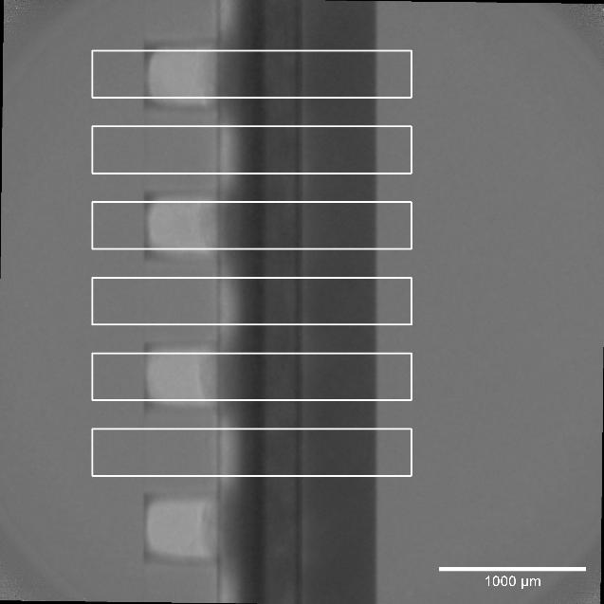
S 4 Selected regions for channel and land area comparison in Figure 5.

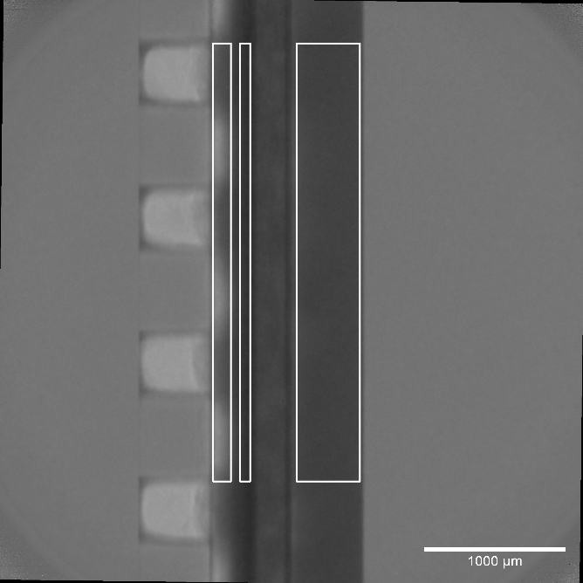
S 5 Selected regions for cathode GDL (left), membrane (middle) and anode channel (right) vertical profiles of Figure 4.
Neutron transmission
Table 1: Neutron transmission rates for different substances and materials at a wavelength of 3 Å *calculated with the online calculator from “NIST Center for Neutron Research” [https://www.ncnr.nist.gov/resources/activation/, Date: 02.2022)]. The width of the active cell area in beam direction is 1 cm.
 | thickness / cm | density / kg/L | neutron transmission*
H2O | 1 | 1.00000 | 0.0%
KHCO3 | 1 | 2.17000 | 30.3%
K2CO3 | 1 | 2.43000 | 96.0%
H2 | 1 | 0.00009 | 99.6%
CO2 | 1 | 0.00198 | 100.0%
CO | 1 | 0.00125 | 100.0%
HCOOH | 1 | 1.22000 | 6.1%
KCOOH | 1 | 1.91000 | 28.8%
C | 1 | 2.26000 | 100.0%
Au | 1 | 19.32000 | 3.9%
Ti | 1 | 4.50000 | 70.0%
H2O vapor | 1 | 0.00059 | 99.7%

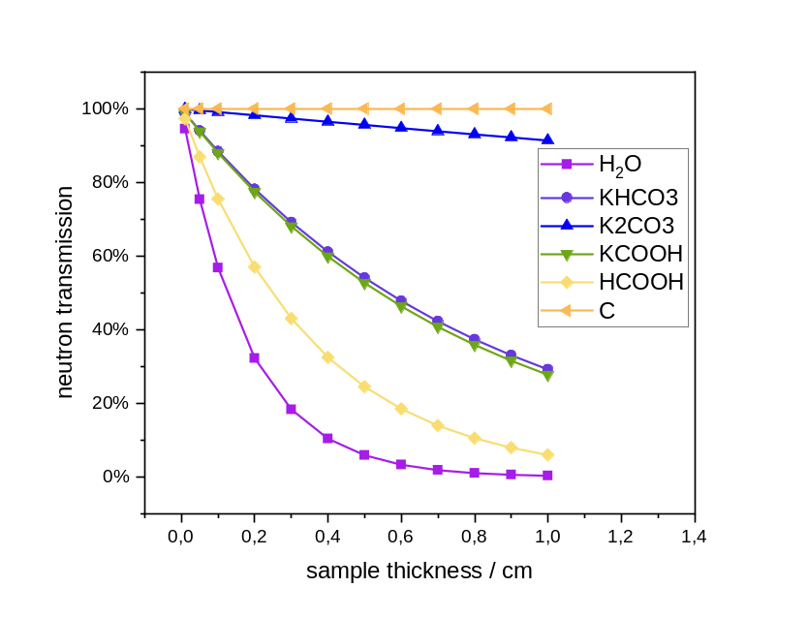
S 6 Calculated neutron transmission for different compounds and sample thicknesses calculated with the online calculator from “NIST Center for Neutron Research” [https://www.ncnr.nist.gov/resources/activation/, Date: 02.2022]. The wavelength was set to 3 Å.

