Table S1. Univariate and multivariate Cox analysis of 43 patients who received ChT plus anti-PD-1 mAb treatment.
 | Univariate analysis |  | Multivariate analysis
 | HR (95% CI) | P | HR (95% CI) | P
Age (years old)  (≤60 vs.＞60) | 0.687(0.093-5.081) | 0.713
Gender  (Female vs. Male) | 0.870(0.387-1.954) | 0.735
ECOG PS  (0-1 vs.≥2) | 3.844(1.647-8.972) | 0.002* | 4.468(1.836-10.874) | 0.001*
Primary lesion location  (Nasal vs. Non-nasal) | 1.154(0.532-2.506) | 0.716
BM involvement  (No vs. Yes) | 2.553(1.156-5.641) | 0.020* | 3.650(1.586-8.402) | 0.002*
Ann Arbor stage  (I-II vs. III-IV) | 2.510(0.591-10.658) | 0.212
Elevated LDH  (No vs. Yes) | 0.531(0.199-1.416) | 0.206
PINK-E score  (0-1 vs. 2) | 2.370(0.491-11.440) | 0.283
(0-1 vs.≥3) | 3.112(0.715-13.548) | 0.130
With pegaspargase  (No vs. Yes) | 0.345(0.153-0.775) | 0.010* | 0.530(0.206-1.362) | 0.530
HLH classification  (ND-HLH vs.SD-HLH) | 2.898(1.279-6.564) | 0.011* | 2.783(1.055-7.340) | 0.039*

Figure S1. Some representative ¹⁸FDG PET/CT images of patients treated with anti-PD-1 mAb combined with ChT when HLH was diagnosed (left) and CR (right) of anti-ENKTL was achieved.
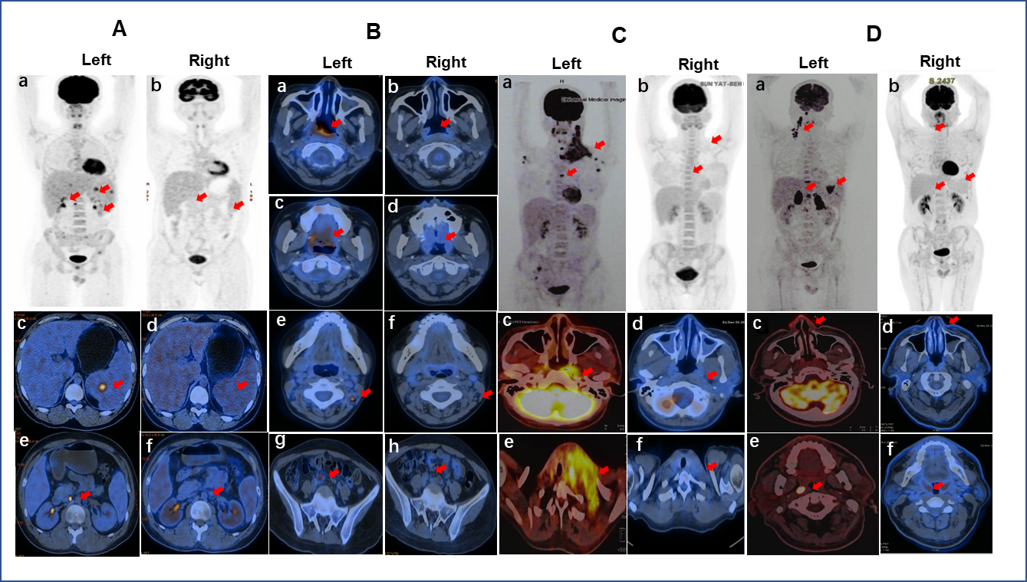
Figure S2. The clinical data of long-term survival patients received anti-PD-1 mAb (mOS＞6months).
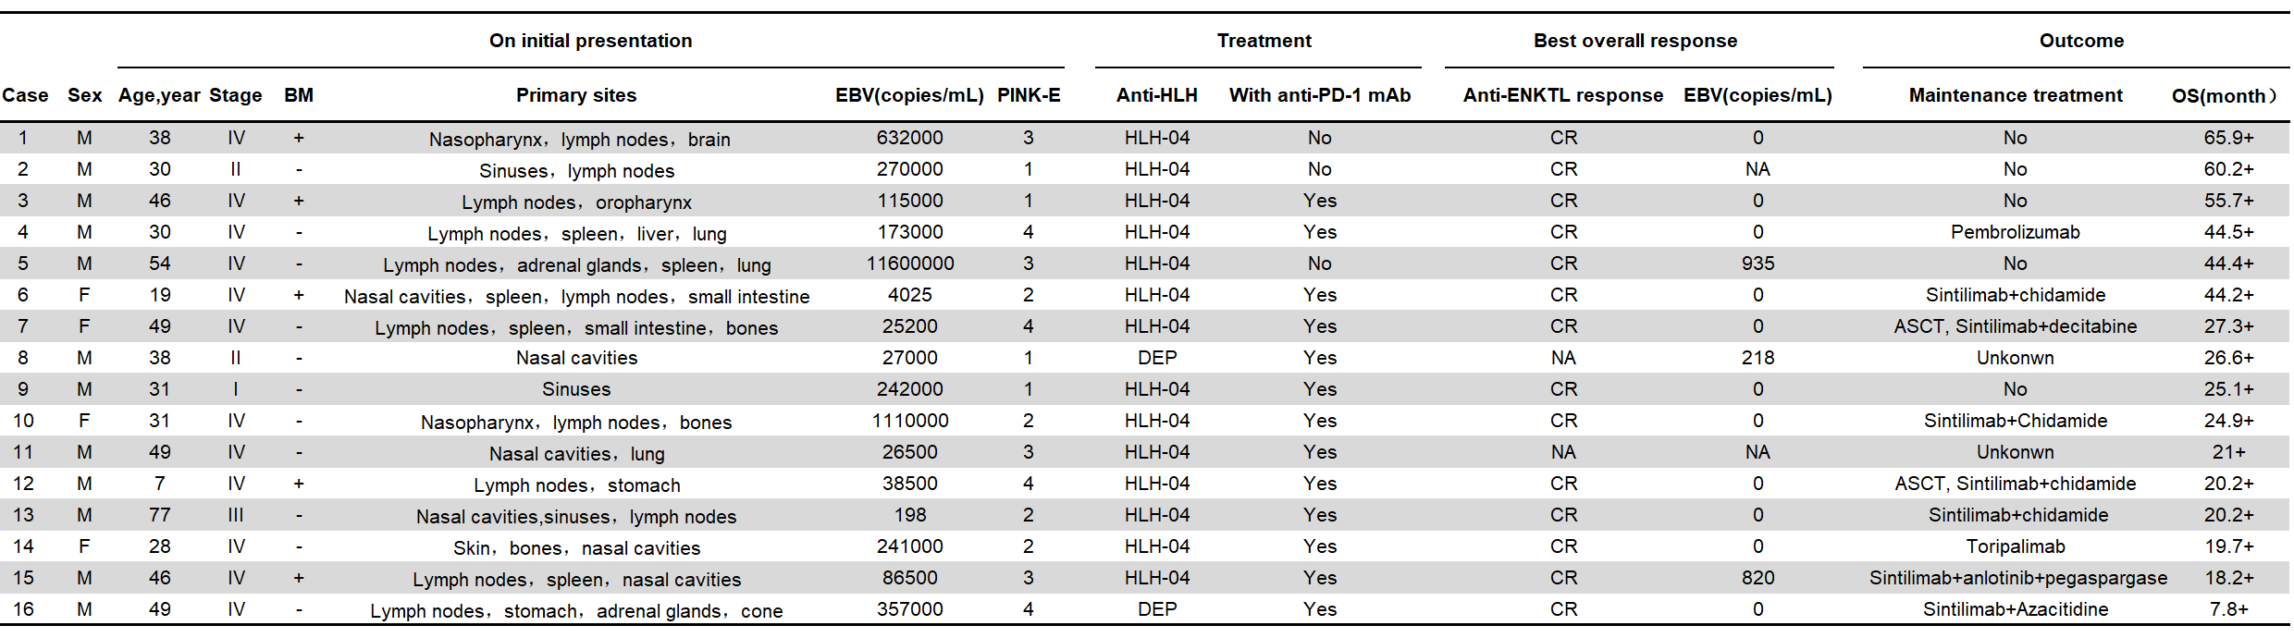
Figure S3. Kaplan-Meier survival analysis of 43 NK/T-LAHS patients treated with ChT plus anti-PD-1 antibody. (A) Patients with ECOG PS of 0-1 vs. ECOG PS≥2. (B) Patients without bone marrow involvement vs. with bone marrow involvement. (C) Patients received pegaspargase vs. patients didn’t receive pegaspargase treatment. (D) Newly diagnosed HLH vs. Secondary HLH. (E) Nasal vs.Non-nasal.(F) Stage I-II vs. Stage III-IV.
