Table S1: Descriptive Statistics of Chemical parameter
Parameters | LU | Mean | Median | CV (%) | SD | Min | Max | Range | IQR | Skewness | Kurtosis
Temp  (℃) | Res. | 25.6 | 25.40 | 12.02 | 3.08 | 20.3 | 31.9 | 11.60 | 3.00 | 0.308 | 0.696
Temp  (℃) | Com. | 25.5 | 25.20 | 9.92 | 2.54 | 22.0 | 29.7 | 7.70 | 4.43 | 0.325 | -1.260
Temp  (℃) | Ins. | 26.7 | 27.10 | 7.95 | 2.13 | 24.0 | 31.9 | 7.90 | 2.50 | 0.957 | 1.122
Temp  (℃) | Ind. | 25.5 | 24.60 | 9.70 | 2.47 | 23.5 | 31.9 | 8.40 | 1.85 | 1.883 | 2.815
TDS  (mg/L) | Res. | 705 | 230 | 125.42 | 884.69 | 70 | 2260 | 2190 | 1200 | 1.383 | -0.003
TDS  (mg/L) | Com. | 371 | 150 | 109.40 | 405.67 | 70 | 1040 | 970 | 750 | 1.220 | -0.479
TDS  (mg/L) | Ins. | 192 | 140 | 63.09 | 121.14 | 100 | 540 | 440 | 120 | 1.941 | 4.237
TDS  (mg/L) | Ind. | 297 | 240 | 76.88 | 227.99 | 70 | 680 | 610 | 460 | 0.442 | -1.538
TSS  (mg/L) | Res. | 1157 | 965 | 109.54 | 1267.69 | 95 | 4065 | 4770 | 1353 | 2.270 | 6.406
TSS  (mg/L) | Com. | 941 | 627 | 135.38 | 1273.61 | 97 | 4272 | 4768 | 537 | 3.106 | 10.239
TSS  (mg/L) | Ins. | 842 | 461 | 141.00 | 1187.20 | 122 | 4654 | 4743 | 610 | 3.154 | 10.790
TSS  (mg/L) | Ind. | 1658 | 1355 | 86.07 | 1426.82 | 255 | 4865 | 4610 | 2033 | 1.081 | 0.434
Turbidity  (NTU) | Res. | 370 | 340 | 70.81 | 262.15 | 38 | 749 | 711 | 540 | 0.149 | -1.652
Turbidity  (NTU) | Com. | 100 | 45 | 100.40 | 99.99 | 20 | 340 | 320 | 102 | 1.623 | 2.104
Turbidity  (NTU) | Ins. | 150 | 101 | 111.36 | 166.65 | 16 | 588 | 572 | 201 | 1.652 | 2.306
Turbidity  (NTU) | Ind. | 187 | 119 | 84.89 | 158.98 | 41 | 588 | 547 | 223 | 1.418 | 1.718
Color  (PCU) | Res. | 628 | 506 | 66.22 | 416.11 | 155 | 1854 | 1699 | 369 | 2.308 | 6.771
Color  (PCU) | Com. | 481 | 502 | 99.00 | 476.51 | 15 | 1854 | 1839 | 331 | 2.359 | 7.142
Color  (PCU) | Ins. | 476 | 405 | 87.90 | 418.74 | 110 | 1854 | 1744 | 299 | 2.809 | 9.258
Color  (PCU) | Ind. | 778 | 654 | 59.50 | 462.63 | 275 | 1854 | 1579 | 546 | 1.283 | 1.200
EC  (mS/cm) | Res. | 1.42 | 0.47 | 124.79 | 1.77 | 0.14 | 4.54 | 4.40 | 2.39 | 1.382 | -0.005
EC  (mS/cm) | Com. | 0.76 | 0.31 | 109.96 | 0.84 | 0.14 | 2.19 | 2.05 | 1.50 | 1.235 | -0.443
EC  (mS/cm) | Ins. | 0.40 | 0.29 | 61.53 | 0.24 | 0.20 | 1.10 | 0.90 | 0.24 | 1.928 | 4.341
EC  (mS/cm) | Ind. | 0.60 | 0.48 | 77.02 | 0.46 | 0.15 | 1.41 | 1.26 | 0.94 | 0.494 | -1.424
Salinity  (ppt) | Res. | 0.65 | 0.22 | 129.49 | 0.84 | 0.05 | 2.25 | 2.20 | 1.11 | 1.400 | 0.072
Salinity  (ppt) | Com. | 0.33 | 0.11 | 116.91 | 0.38 | 0.08 | 1.00 | 0.92 | 0.68 | 1.259 | -0.405
Salinity  (ppt) | Ins. | 0.16 | 0.11 | 68.94 | 0.11 | 0.08 | 0.49 | 0.41 | 0.12 | 2.031 | 4.786
Salinity  (ppt) | Ind. | 0.26 | 0.19 | 84.06 | 0.22 | 0.01 | 0.57 | 0.56 | 0.43 | 0.328 | -1.858

Table S2: Descriptive Statistics of Chemical parameters
Parameters | LU | Mean | Median | CV (%) | SD | Min | Max | Range | IQR | Skewness | Kurtosis
pH | Res. | 8.12 | 8.27 | 4.83 | 0.39 | 7.43 | 8.73 | 1.30 | 0.61 | -0.559 | -0.615
pH | Com. | 7.80 | 7.52 | 9.87 | 0.77 | 6.87 | 9.38 | 2.51 | 0.91 | 1.187 | 0.568
pH | Ins. | 8.21 | 8.15 | 3.74 | 0.31 | 7.85 | 8.78 | 0.93 | 0.56 | 0.631 | -0.729
pH | Ind. | 7.97 | 8.12 | 6.28 | 0.50 | 7.07 | 8.73 | 1.66 | 0.51 | -0.807 | -0.080
DO  (mg/L) | Res. | 5.35 | 5.43 | 9.60 | 0.51 | 4.57 | 6.22 | 1.65 | 0.63 | 0.333 | -0.497
DO  (mg/L) | Com. | 4.86 | 4.85 | 9.56 | 0.46 | 4.09 | 5.43 | 1.34 | 0.90 | -0.210 | -1.277
DO  (mg/L) | Ins. | 5.14 | 4.85 | 11.23 | 0.58 | 4.36 | 6.12 | 1.76 | 0.84 | 0.430 | -0.969
DO  (mg/L) | Ind. | 5.15 | 5.35 | 13.19 | 0.68 | 3.81 | 5.92 | 2.11 | 0.84 | -1.082 | 0.138
NH₃-N  (mg/L) | Res. | 2.04 | 0.25 | 167.32 | 3.41 | 0.00 | 8.00 | 8.00 | 4.50 | 1.423 | 0.054
NH₃-N  (mg/L) | Com. | 2.08 | 0.25 | 171.34 | 3.57 | 0.00 | 8.00 | 8.00 | 6.06 | 1.323 | -0.330
NH₃-N  (mg/L) | Ins. | 0.28 | 0.25 | 99.31 | 0.28 | 0.00 | 1.00 | 1.00 | 0.50 | 1.091 | 1.576
NH₃-N  (mg/L) | Ind. | 1.30 | 0.25 | 181.66 | 2.37 | 0.00 | 8.00 | 8.00 | 1.19 | 2.191 | 4.465
BOD₅  (mg/L) | Res. | 6.92 | 5.50 | 56.61 | 3.91 | 1.80 | 13.40 | 11.60 | 7.10 | 0.388 | -1.134
BOD₅  (mg/L) | Com. | 5.89 | 5.80 | 28.52 | 1.68 | 3.10 | 8.20 | 5.10 | 2.98 | -0.058 | -0.996
BOD₅  (mg/L) | Ins. | 2.91 | 2.40 | 68.58 | 1.99 | 0.40 | 7.60 | 7.20 | 3.40 | 0.861 | 0.561
BOD₅  (mg/L) | Ind. | 11.21 | 9.80 | 47.27 | 5.30 | 2.10 | 18.70 | 16.60 | 7.50 | -0.147 | -0.857
COD  (mg/L) | Res. | 45.02 | 44.30 | 63.25 | 28.47 | 8.40 | 95.10 | 86.70 | 50.45 | 0.403 | -0.948
COD  (mg/L) | Com. | 48.64 | 49.70 | 33.69 | 16.39 | 11.90 | 72.30 | 60.40 | 21.93 | -0.687 | 1.167
COD  (mg/L) | Ins. | 15.37 | 13.50 | 58.93 | 9.06 | 0.30 | 28.60 | 28.30 | 17.20 | 0.143 | -1.302
COD  (mg/L) | Ind. | 45.28 | 43.80 | 51.80 | 23.46 | 8.40 | 85.10 | 76.70 | 36.70 | 0.084 | -0.867

Figure S1: Correlation Matrix (Residential)
Figure S2: Correlation Matrix (commercial)

Figure S3: Correlation Matrix (Institutional)
Figure S4: Correlation Matrix (Industrial)
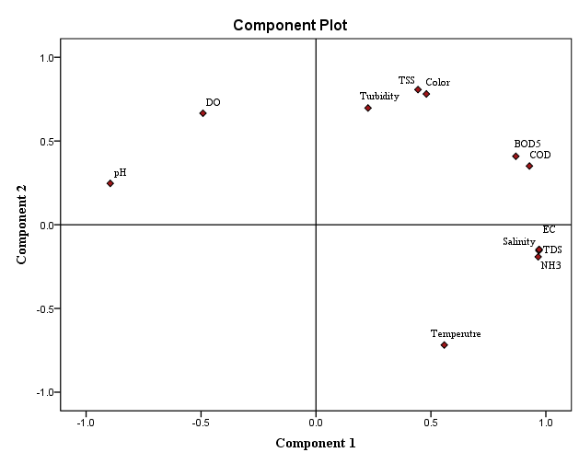
(a)
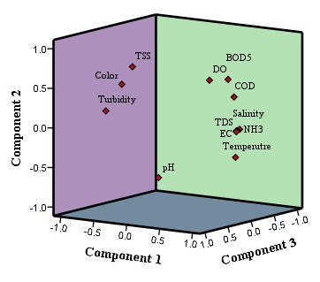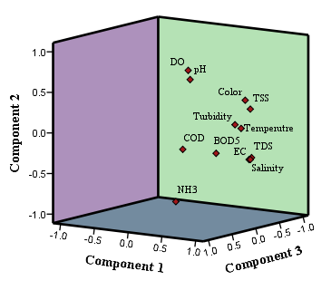
(b) (c)
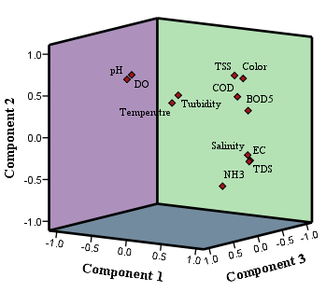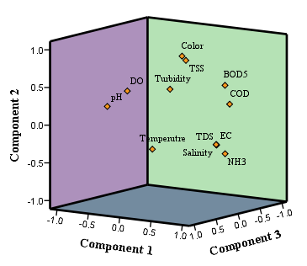
(d) (e)
Figure S5: Principal component analysis of Surface runoff Quality (a) Residential (b) Commercial (c) Institutional (d) Industrial (e) Combined
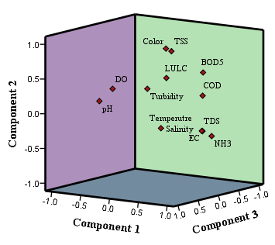
Figure S6: Principal component analysis for runoff quality parameters and LULC

