Assessing use of surrogate outcome measures in randomized controlled trials investigating venous thromboembolism prophylaxis: Online Supplement
Search terms/strategies
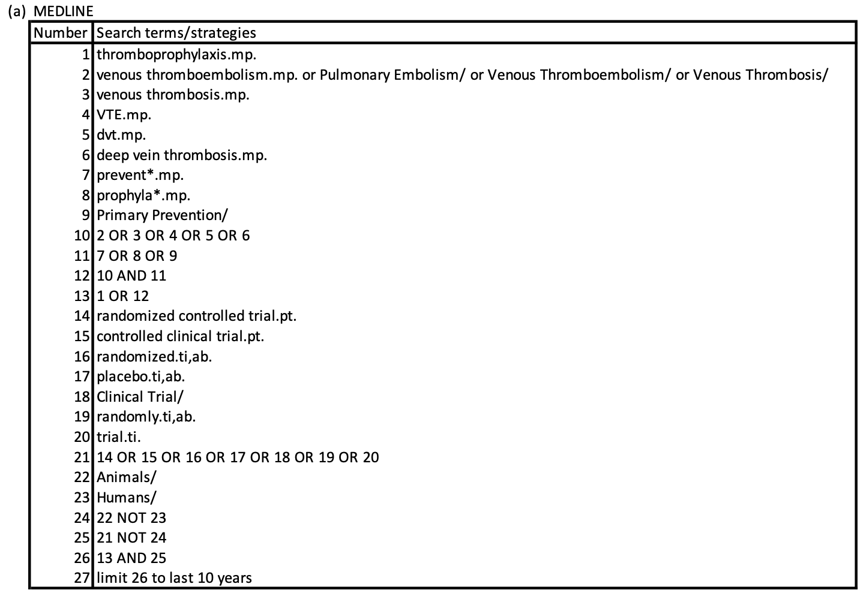
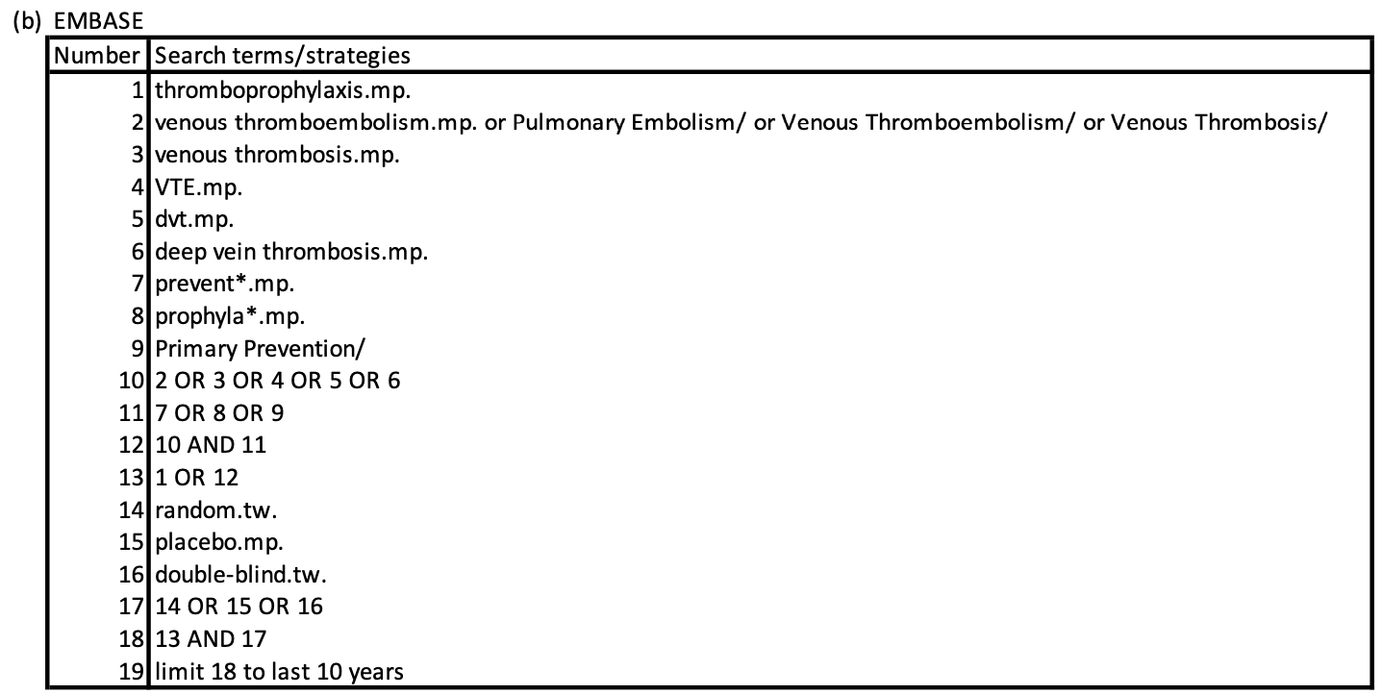
Online Supplement

