Fig. S1 (R, S)-DMPM High performance liquid chromatography (HPLC) detection chart.

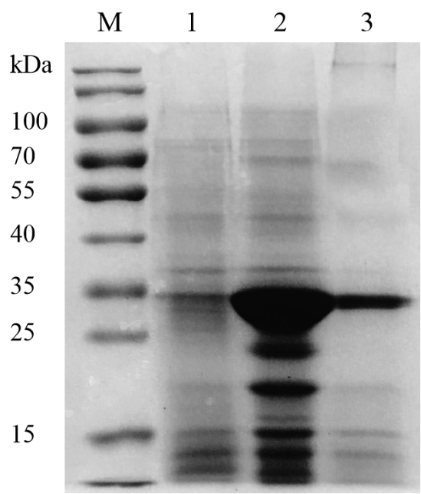
Fig. S2 SDS-PAGE analysis of esterase PAE07. M—Protein marker; 1—Uninduced bacterial liquid; 2—Crude enzyme liquid after induction; 3—Purified esterase PAE07.

Fig. S3 Effects of Rotation Speed on Biocatalytic Resolution of (R, S)-DMPM. Reaction conditions: 0.02 g immobilized esterase,50 mM (R, S)-DMPM in 1 mL 50 mM pH 7.5 PB buffer, 100-350 rpm, 35 °C, 30 min; titrated with 4 M HCl.

