Supporting Information
Long-term elevated atmospheric CO₂ and warming affect the root-associated microbiomes of rice and wheat
Ke Gaoª, Zhenbo Maoª, Enxi Mengª, Jie Li^{b}, Cheng Liu^{b}, Xiaoyu Liu^{b}, Yingying Zhangª, Long Zhangª, Guangli Wangª, Yuan Liu^{a*}

ª College of Life Science, Huaibei Normal University, Huaibei 235000, Anhui, P. R., China
^{b} Institute of Resources, Ecosystem and Environment of Agriculture, Nanjing Agricultural University, 1 Weigang, Nanjing 210095, China

*Corresponding author: Yuan Liu
Yuan Liu, Email: liuyuan0813@aliyun.com

Table S1 Pearson correlation between soil enzyme activities, OTU richness and Shannon diversity of microbial communities and soil properties in each sample.
 | AG | BG | CB | XYL | LAP | NAG | PHOS | Bacterial |  | Fungal
 |  |  |  |  |  |  |  | Richness | Shannon | Richness | Shannon
pH | -0.127 | -0.293 | -0.264 | -0.380 | -0.142 | -0.107 | -0.748** | 0.102 | -0.034 | -0.605** | -0.738**
SOC | 0.380 | 0.609** | 0.389 | 0.655** | 0.147 | 0.192 | 0.734** | 0.005 | 0.129 | 0.690** | 0.628**
TN | 0.553** | 0.529** | 0.593** | 0.495* | 0.103 | 0.305 | 0.695** | -0.007 | 0.037 | 0.419* | 0.509*
AN | 0.351 | 0.232 | 0.324 | 0.338 | 0.240 | 0.231 | 0.584** | -0.049 | 0.081 | 0.198 | 0.313
AP | -0.017 | -0.460* | -0.384 | -0.546** | 0.042 | -0.322 | -0.351 | -0.266 | -0.260 | -0.577** | -0.363
AK | 0.401 | 0.064 | -0.027 | 0.095 | 0.313 | 0.029 | 0.198 | -0.138 | -0.081 | -0.500* | -0.320
Significant effects are in bold and * and ** represent the significant correlation at P < 0.05 and P < 0.01, respectively. AG, α-glucosidase; BG, β-glucosidase; CB, β-D-cellobiosidase; XYL, β-xylosidase; LAP, leucine aminopeptidase; NAG, Nacetyl-β-glucosaminidase; PHOS, phosphatase.

Table S2 The number of sequences of root-associated bacteria and fungi in each sample.
 |  | Rice |  |  | Wheat
 |  | endosphere | rhizosphere |  | endosphere | rhizosphere
Bacteria | CK1 | 65270 | 68530 |  | 65876 | 64791
Bacteria | CK2 | 64967 | 58257 |  | 67319 | 61528
Bacteria | CK3 | 68076 | 64826 |  | 65286 | 64803
Bacteria | CE1 | 63620 | 56388 |  | 69508 | 66446
Bacteria | CE2 | 66489 | 62154 |  | 65137 | 68884
Bacteria | CE3 | 66021 | 65532 |  | 66838 | 65895
Bacteria | WA1 | 67768 | 64823 |  | 66014 | 54180
Bacteria | WA2 | 64906 | 67532 |  | 65256 | 68204
Bacteria | WA3 | 64776 | 66377 |  | 66497 | 68717
Bacteria | CW1 | 64678 | 68130 |  | 65564 | 65452
Bacteria | CW2 | 67011 | 67218 |  | 67234 | 65237
Bacteria | CW3 | 68910 | 61616 |  | 69030 | 65777
Fungi | CK1 | 51339 | 66241 |  | 65038 | 68512
Fungi | CK2 | 65013 | 66430 |  | 64749 | 67982
Fungi | CK3 | 66734 | 65534 |  | 53388 | 68206
Fungi | CE1 | 58805 | 63575 |  | 57720 | 49537
Fungi | CE2 | 58121 | 65839 |  | 65845 | 67543
Fungi | CE3 | 65837 | 68736 |  | 46462 | 67258
Fungi | WA1 | 66204 | 67449 |  | 46248 | 66798
Fungi | WA2 | 65008 | 63815 |  | 65176 | 66348
Fungi | WA3 | 62246 | 68056 |  | 68240 | 64474
Fungi | CW1 | 65750 | 68062 |  | 66355 | 68514
Fungi | CW2 | 65492 | 68613 |  | 53906 | 67950
Fungi | CW3 | 58705 | 67754 |  | 65576 | 64648
CK, ambient condition; CE, elevated CO₂; WA, canopy warming; CW, elevated CO₂ plus canopy warming.

Table S3 The Good’s coverage of root-associated bacteria and fungi in each sample.
 |  | Rice |  |  | Wheat
 |  | endosphere | rhizosphere |  | endosphere | rhizosphere
Bacteria | CK1 | 99.98% | 99.81% |  | 99.98% | 99.84%
Bacteria | CK2 | 99.99% | 99.97% |  | 99.97% | 99.91%
Bacteria | CK3 | 99.98% | 99.91% |  | 99.99% | 99.87%
Bacteria | CE1 | 99.98% | 99.98% |  | 99.99% | 99.89%
Bacteria | CE2 | 99.99% | 99.95% |  | 99.99% | 99.86%
Bacteria | CE3 | 100.00% | 99.89% |  | 99.98% | 99.90%
Bacteria | WA1 | 99.99% | 99.89% |  | 99.98% | 99.98%
Bacteria | WA2 | 99.98% | 99.84% |  | 99.97% | 99.81%
Bacteria | WA3 | 99.98% | 99.84% |  | 99.99% | 99.83%
Bacteria | CW1 | 99.98% | 99.84% |  | 99.98% | 99.84%
Bacteria | CW2 | 99.97% | 99.87% |  | 99.98% | 99.85%
Bacteria | CW3 | 99.96% | 99.94% |  | 99.98% | 99.86%
Fungi | CK1 | 100.00% | 99.98% |  | 99.99% | 99.96%
Fungi | CK2 | 100.00% | 99.96% |  | 99.99% | 99.94%
Fungi | CK3 | 99.99% | 99.96% |  | 99.99% | 99.95%
Fungi | CE1 | 100.00% | 99.97% |  | 100.00% | 99.99%
Fungi | CE2 | 100.00% | 99.96% |  | 100.00% | 99.96%
Fungi | CE3 | 99.99% | 99.96% |  | 100.00% | 99.96%
Fungi | WA1 | 100.00% | 99.97% |  | 100.00% | 99.95%
Fungi | WA2 | 99.99% | 99.97% |  | 99.99% | 99.95%
Fungi | WA3 | 100.00% | 99.97% |  | 99.99% | 99.96%
Fungi | CW1 | 100.00% | 99.96% |  | 99.99% | 99.94%
Fungi | CW2 | 99.99% | 99.97% |  | 100.00% | 99.95%
Fungi | CW3 | 99.99% | 99.96% |  | 100.00% | 99.95%
CK, ambient condition; CE, elevated CO₂; WA, canopy warming; CW, elevated CO₂ plus canopy warming.

Table S4 Effects of elevated CO₂ and warming on the relative abundance of major bacterial and fungal phylum in root endosphere and rhizosphere soil.
 | Phylum | Rice endosphere |  |  | Rice rhizosphere |  |  | Wheat endosphere |  |  | Wheat rhizosphere
 | Phylum | CO₂ | W | CO₂×W | CO₂ | W | CO₂×W | CO₂ | W | CO₂×W | CO₂ | W | CO₂×W
Fungi | Ascomycota | ns | ns | ns | ** | ns | ns | ns | ns | ns | ** | ns | ns
 | Basidiomycota | ns | ns | ns | *** | ns | * | ns | ns | ns | ns | ns | ns
 | Rozellomycota |  |  |  | ns | ns | ns |  |  |  | *** | ** | ***
 | Mortierellomycota |  |  |  | ns | ns | ns |  |  |  | ns | ns | ns
Bacteria | Proteobacteria | * | ns | ns | *** | *** | * | * | ns | ns | * | ns | ns
Bacteria | Bacteroidetes | * | ns | ns | *** | ns | * | * | ns | ns | *** | ** | ns
Bacteria | Acidobacteria | ns | ns | ns | *** | ns | ** | ns | ns | ns | *** | ** | ns
Bacteria | Actinobacteria | ns | ns | ns | *** | ** | ns | ns | ns | ns | ns | ns | ns
Bacteria | Gemmatimonadetes | ns | ns | ns | *** | ** | ns | ns | ns | ns | *** | ns | ns
Bacteria | Firmicutes | ns | ns | ns | ns | ns | ns | ns | ns | ns | ns | ns | ns
Bacteria | Nitrospirae |  |  |  | ns | *** | ** |  |  |  | ns | ns | ns
Bacteria | Ignavibacteriae |  |  |  | ** | *** | ns |  |  |  | ns | ns | ns
Bacteria | Verrucomicrobia |  |  |  | ns | ns | ns |  |  |  | ns | ns | **
Bacteria | Spirochaetes |  |  |  | ns | ns | ns
Bacteria | Chlamydiae |  |  |  |  |  |  |  |  |  | ns | ns | ns
The significant effects of elevated CO₂ (CO₂), warming (W) and their interaction (CO₂×W) are indicated in asterisk. The “***”, “**”, “*” and “ns” indicate significant levels with P < 0.001, P < 0.01, P < 0.05 and no significant (P > 0.05), respectively.
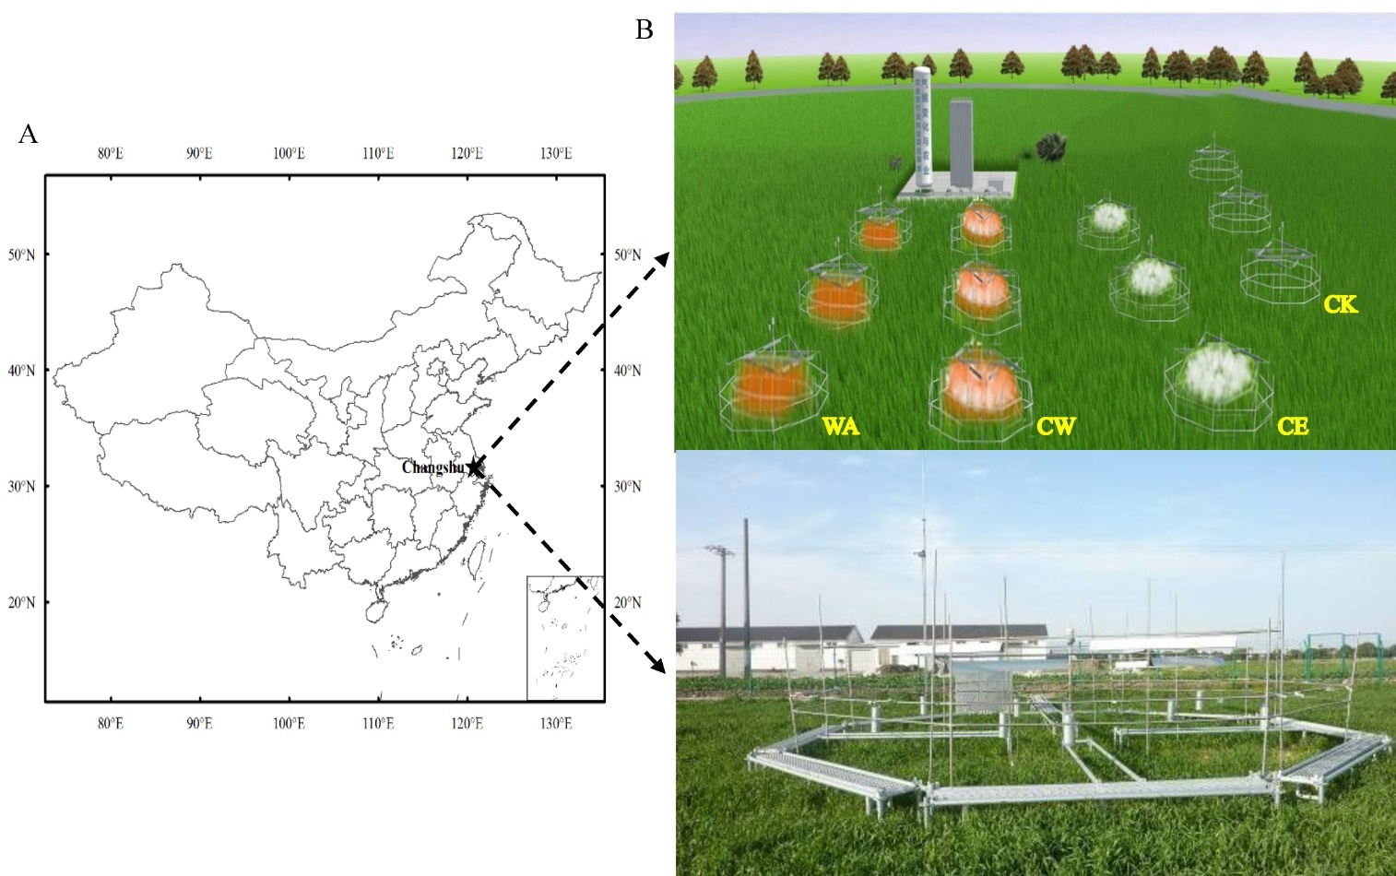

Fig. S1 The site location (A) and schematic diagram of the infrared heating facility of FACE (B) employed in this study.

Fig. S2 The OTU richness (A) and Shannon diversity (B) of bacterial community in root endosphere and rhizosphere soil of rice and wheat across the treatments. The various lowercase letters indicate significance differences at the P < 0.05 level. Ambient condition (CK), CO₂ enrichment (CE), canopy air warming (WA), CO₂ enrichment plus canopy warming (CW). The significant effects of elevated CO₂ (CO₂), warming (W) and their interaction (CO₂×W) are presented: ***, P < 0.001; **, P < 0.01; *, P < 0.05; ns, no significant.

Fig. S3 Redundancy analysis (RDA) of soil variables and the fungal (A and C) and bacterial (B and D) communities at phylum level in the rhizosphere and root endosphere, respectively. SOC: soil organic carbon; TN: total nitrogen; AN: available nitrogen, AP: available phosphorus; AK: available potassium.

Fig. S4 Heatmap of the Spearman correlation analysis between soil variables and the 10 most dominant fungal (A) and bacterial (B) genera in root endosphere. Asterisks denote significant correlation as follow: *, P < 0.05; **, P < 0.01; ***, P < 0.001.

Fig. S5 Relative abundance of the 10 most dominant bacterial genera in root endosphere (A) and the rhizosphere (B). Ambient condition (CK), CO₂ enrichment (CE), canopy air warming (WA), CO₂ enrichment plus canopy warming (CW).The significant effects of elevated CO₂ (C), warming (W) and their interaction (C×W) are presented: ***, P < 0.001; **, P < 0.01; *, P < 0.05; ns, no significant.

Fig. S6 Co-occurrence network of root-associated fungal community in root endosphere (A) and rhizosphere soil (B). Ambient condition (CK), CO₂ enrichment (CE), canopy air warming (WA), CO₂ enrichment plus canopy warming (CW).

Fig. S7 Co-occurrence network of root-associated bacterial community in root endosphere (A) and rhizosphere soil (B). Ambient condition (CK), CO₂ enrichment (CE), canopy air warming (WA), CO₂ enrichment plus canopy warming (CW).

