Supporting Information
ML-guided discovery of La-Co-Pb ternary compounds involving immiscible pairs of Co and Pb elements
Renhai Wang^{1,3}, Weiyi Xia^{2,3}, Tyler J. Slade^{2,3}, Xinyu Fan⁴, Huafeng Dong¹, Kai-Ming Ho^{2,3}, Paul C. Canfield^{2,3}, Cai-Zhuang Wang^{2,3*}
¹School of Physics and Optoelectronic Engineering, Guangdong University of Technology, Guangzhou 510006, China
²Ames Laboratory-USDOE, Iowa State University, Ames, Iowa 50011, USA
³Department of Physics and Astronomy, Iowa State University, Ames, Iowa 50011, United States
⁴Department of Physics, University of Science and Technology of China, Hefei 230026, China

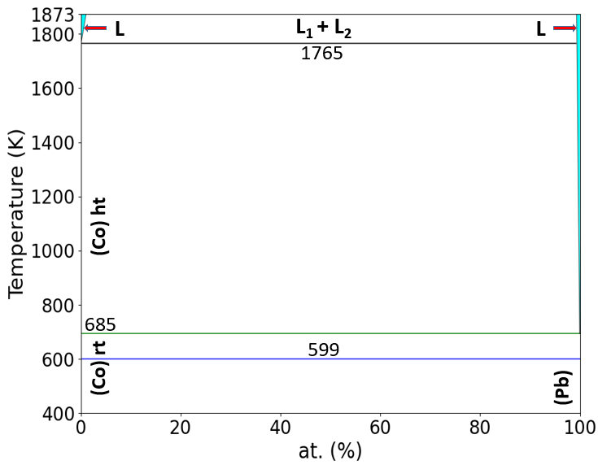
Figure S1. The Co-Pb binary phase diagram from ASM Alloy Phase Diagram DatabaseTM.

Figure S2. The La₅CoPb₃, La₁₂Co₆Pb and La₆Co₁₃Pb structures predicted by our ML approach after DFT optimization (top raw) that are the same as the three known La-Co-Pb compounds (bottom raw).
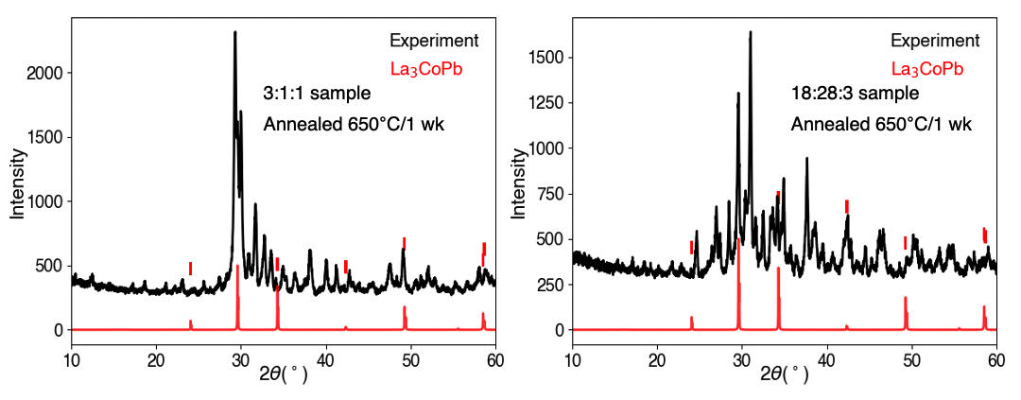
Figure S3. Calculated PXRD spectrum of the newly predicted La₃CoPb phase with the lattice constant reduced by 2.0% is compared with the experimental powder diffraction patterns obtained from pieces of the arc melted La-Co-Pb pellet (left: 3:1:1 sample, right: 18:28:3 sample). The experimental samples are annealed at 650°C for one week.
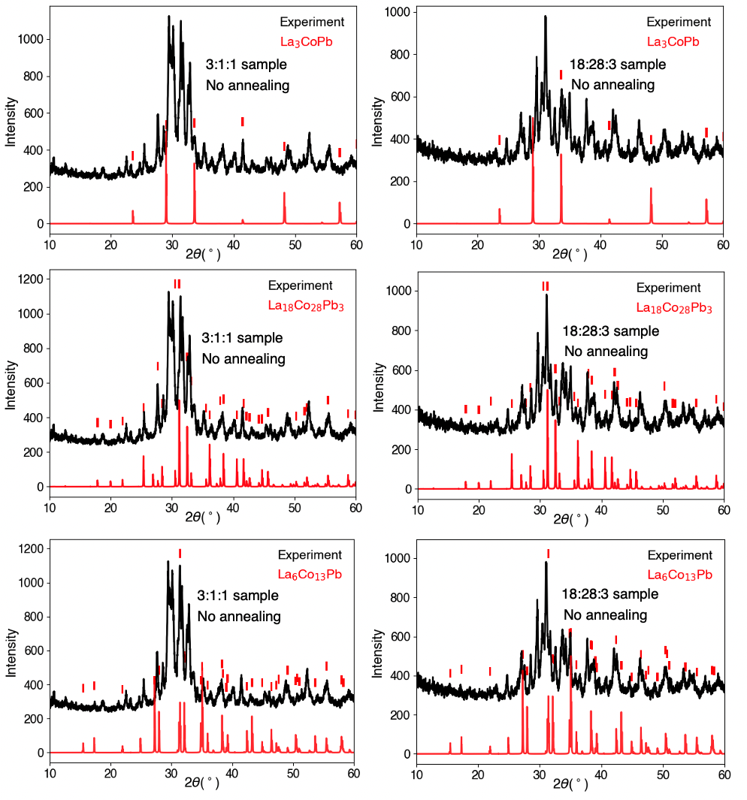
Figure S4. Powder diffraction patterns obtained from pieces of the arc melted La-Co-Pb pellet (left column: the 3:1:1 sample; right column: the 18:28:3 sample) before annealing. Calculated PXRD of the predicted La₃CoPb and La₁₈Co₂₈Pb₃ ternary phases, and the known La₆Co₁₃Pb phases are also shown in the top, middle, and bottom rows respectively for comparison.
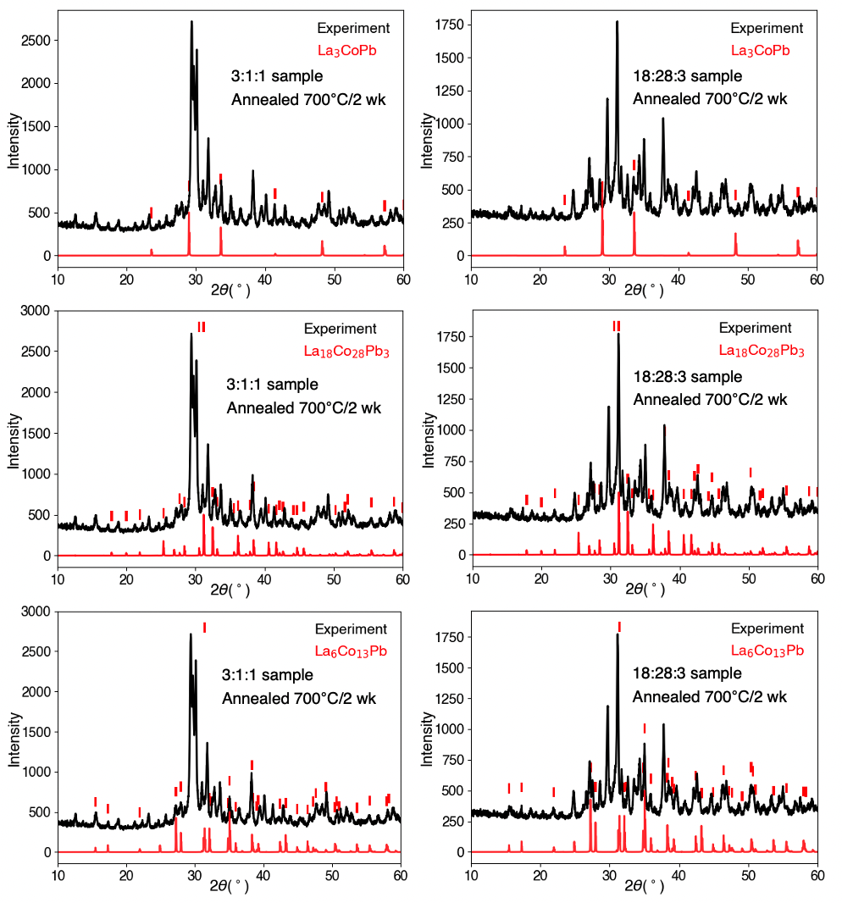
Figure S5. Powder diffraction patterns obtained from pieces of the arc melted La-Co-Pb pellet (left column: the 3:1:1 sample; right column: the 18:28:3 sample) after annealing 700°C for two week. Calculated PXRD of the predicted La₃CoPb and La₁₈Co₂₈Pb₃ ternary phases, and the known La₆Co₁₃Pb phases are also shown in the top, middle, and bottom rows respectively for comparison.
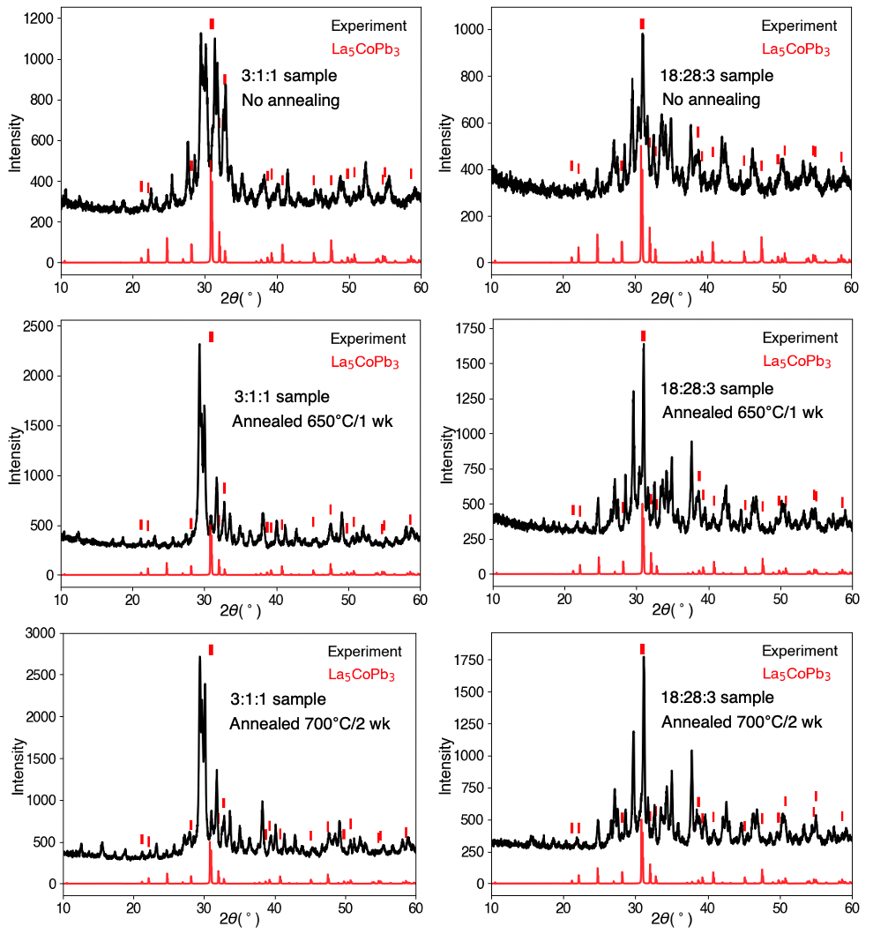
Figure S6. Calculated PXRD of the known La₅CoPb₃ phase is compared with the powder diffraction patterns obtained from pieces of the arc melted La-Co-Pb pellet (left column: the 3:1:1 sample; right column: the 18:28:3 sample).
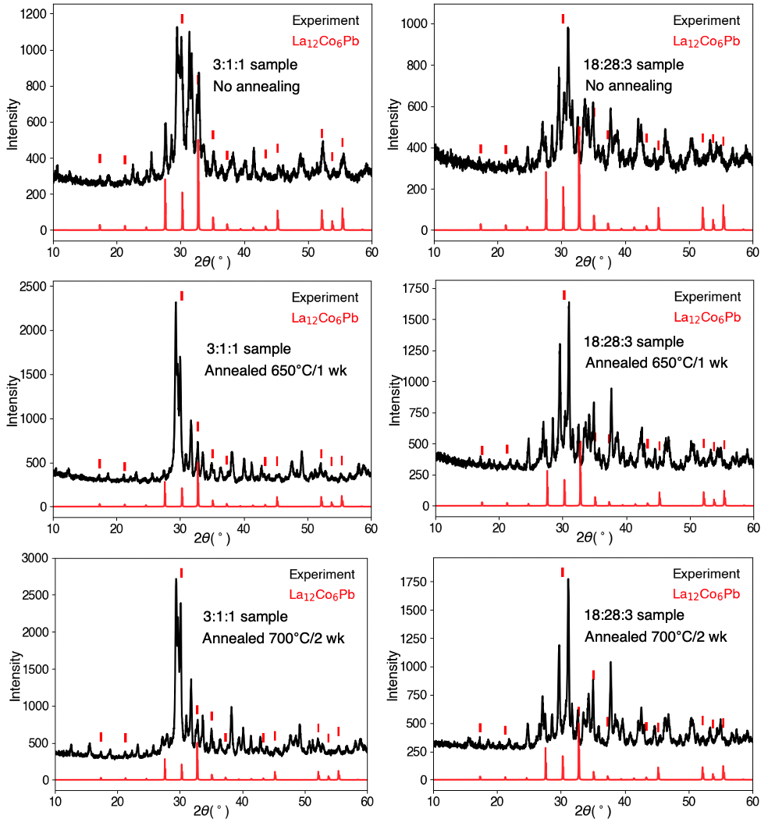
Figure S7. Calculated PXRD of the known La₁₂Co₆Pb₃ phase is compared with the powder diffraction patterns obtained from pieces of the arc melted La-Co-Pb pellet (left column: the 3:1:1 sample; right column: the 18:28:3 sample).
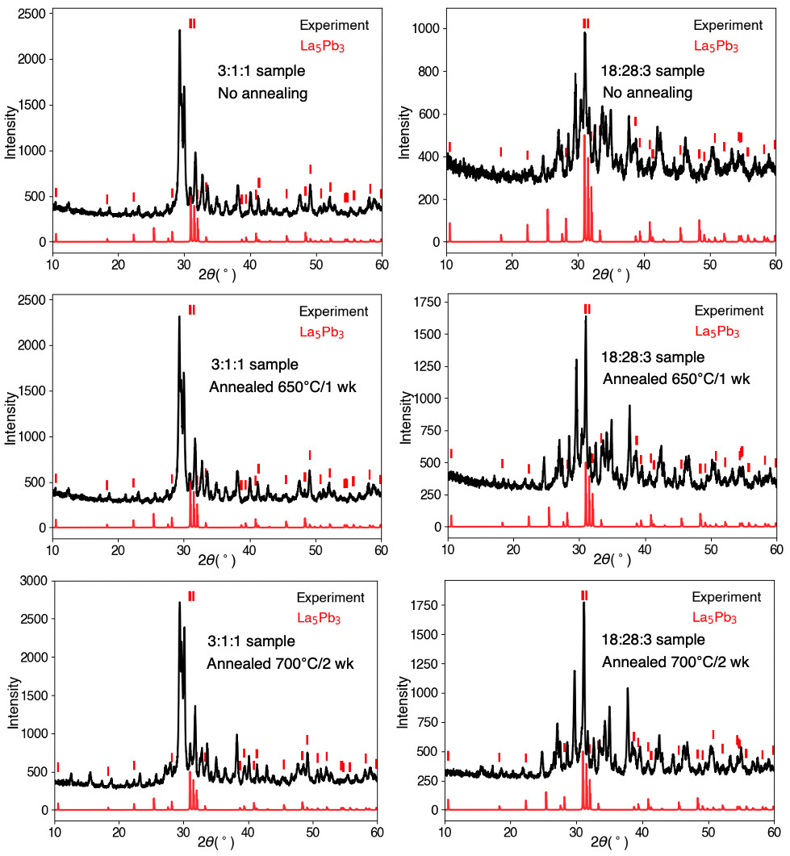
Figure S8. Calculated PXRD of binary La₅Pb₃ phase is compared with the powder diffraction patterns obtained from pieces of the arc melted La-Co-Pb pellet (left column: the 3:1:1 sample; right column: the 18:28:3 sample).
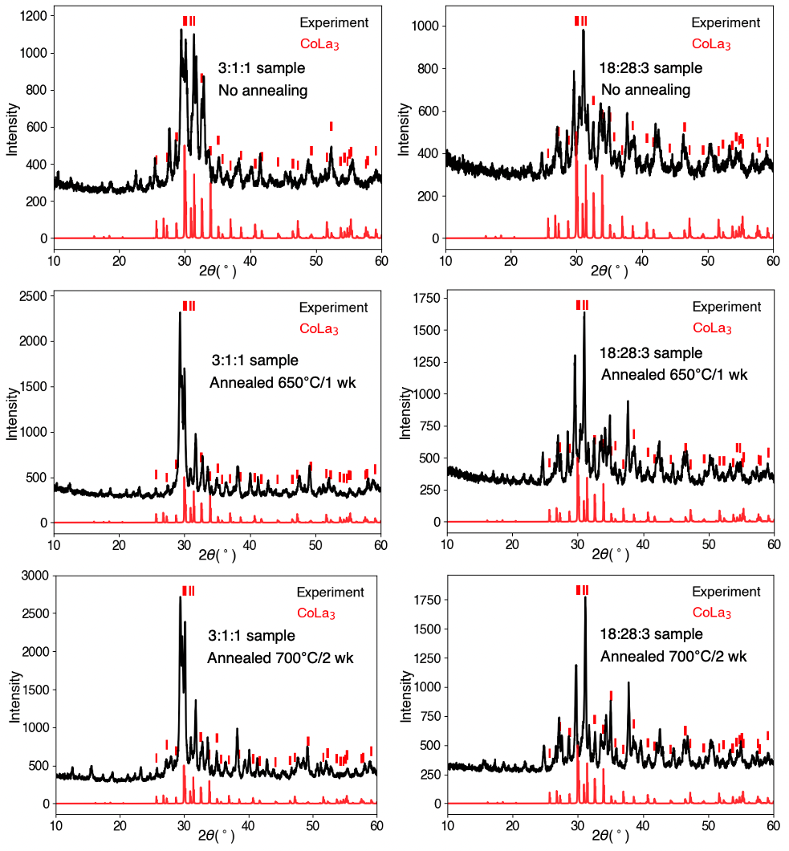
Figure S9. Calculated PXRD of binary La₃Co phase is compared with the powder diffraction patterns obtained from pieces of the arc melted La-Co-Pb pellet (left column: the 3:1:1 sample; right column: the 18:28:3 sample).

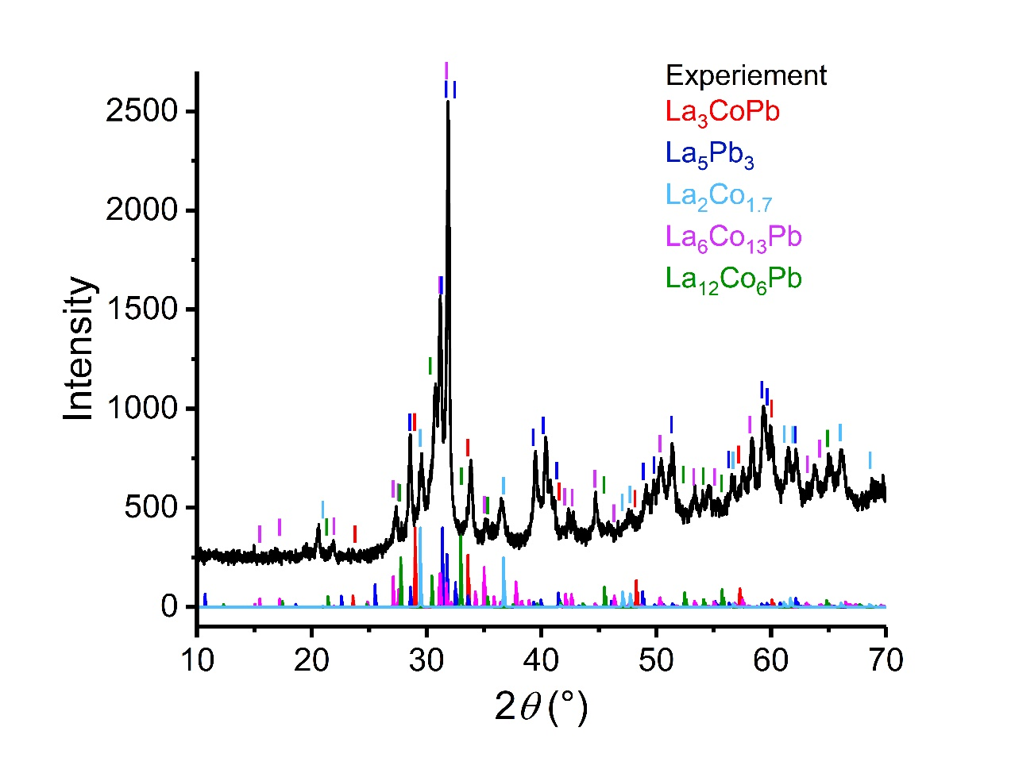
Figure S10. Experimental PXRD data (black) from the 3:1:1 sample synthesized under pressure (see the text for more details). Calculated PXRD patterns of some known ternary and binary phases are also shown for comparison.

Table S1. Structure database of the La-Co-Pb system, including existing phases, CGCNN predicted stable phases and metastable phases. The formation energies (H) are referenced to the stable phases that form Gibbs triangles. The phases in bold are thermodynamically stable. The results are based on GGA calculation.
 | Phases | Symmetry | a (Å) | b (Å) | c (Å) | H (meV/atom)
Existing stable phases | La | P6₃/mmc | 3.75 | 3.75 | 12.12 | 0
Existing stable phases | Co | P6₃/mmc | 2.49 | 2.49 | 4.02 | 0
Existing stable phases | Pb | Fm-3m | 5.0 | 5.0 | 5.0 | 0
Existing stable phases | La₃Co | Pnma | 7.10 | 10.13 | 6.60 | 0
Existing stable phases | LaCo₁₃ | Fm-3c | 11.26 | 11.26 | 11.26 | 0
Existing stable phases | LaPb₃ | Pm-3m | 4.98 | 4.98 | 4.98 | 0
Existing stable phases | La₅Pb₄ | Pnma | 8.66 | 16.47 | 8.77 | 0
Existing stable phases | La₄Pb₃ | I-43d | 9.94 | 9.94 | 9.94 | 0
Existing stable phases | La₅Pb₃ | P6₃/mcm | 9.64 | 9.64 | 7.04 | 0
Existing stable phases | La₃Pb | Pm-3m | 5.08 | 5.08 | 5.08 | 0
Existing stable phases | La₆Co₁₃Pb | I4/mcm | 8.08 | 8.08 | 23.43 | 0
Existing stable phases | La₁₂Co₆Pb | Im-3 | 10.20 | 10.20 | 10.20 | 0
ML+DFT predicted stable phase | La₃CoPb | Pm-3m | 5.33 | 5.33 | 5.33 | 0
Existing metastable phases | La₅CoPb₃ | P6₃/mcm | 9.71 | 9.71 | 9.71 | 35
ML+DFT predicted metastable phases | La₁₈Co₂₈Pb₃ | I4/mmm | 14.05 | 14.05 | 9.92 | 7
ML+DFT predicted metastable phases | La₁₃Co₄Pb₅ | C/2m | 7.30 | 7.31 | 25.87 | 11
ML+DFT predicted metastable phases | La₂₄CoPb₈ | Pm-3m | 10.23 | 10.23 | 10.23 | 14
 | La₁₂CoPb₄ | Im-3m | 10.31 | 10.31 | 10.31 | 22
 | La₅CoPb | Cmcm | 13.77 | 11.79 | 11.19 | 22
 | La₅Co₂Pb | C2/c | 16.05 | 7.83 | 7.83 | 31

ML+DFT predicted metastable phases  (continued) | La₂₃Co₇Pb₄ | P6₃mc | 10.10 | 10.10 | 22.69 | 36
ML+DFT predicted metastable phases  (continued) | La₁₂Co₇Pb | I4/mcm | 12.10 | 12.10 | 13.74 | 38
ML+DFT predicted metastable phases  (continued) | La₁₁Co₄Pb₆ | P1 | 4.53 | 9.96 | 15.04 | 46
 | La₁₈Co₂Pb₉ | Pmma | 23.21 | 4.58 | 18.33 | 47
 | La₁₀Co₂Pb₁₁ | C2/m | 21.87 | 4.82 | 14.55 | 48
 | La₁₇Co₆Pb₃ | C2/m | 43.89 | 3.84 | 17.88 | 48
 | La₁₃Co₃Pb₇ | Pnma | 13.52 | 25.08 | 8.88 | 50
 | La₂₆Co₁₀Pb₇ | P4/mbm | 12.54 | 12.54 | 15.64 | 53
 | La₂₃Co₁₄Pb₄ | P1 | 11.78 | 13.96 | 14.55 | 54
 | La₂₆Co₁₁Pb₆ | P4/mbm | 12.38 | 12.38 | 15.71 | 54
 | La₁₄CoPb₁₁ | C2/c | 22.22 | 24.98 | 16.76 | 55
 | La₆Co₁₃Pb | I4/mcm | 8.01 | 8.01 | 23.41 | 57
 | La₁₁Co₆Pb₄ | R-3c | 10.13 | 10.13 | 36.68 | 62
 | La₁₆Co₅Pb₆ | Cm | 6.79 | 19.91 | 12.80 | 62
 | La₁₇Co₃Pb₄ | P2₁/c | 10.15 | 28.26 | 12.04 | 62
 | La₂₃Co₆Pb₄ | C2/m | 20.22 | 4.91 | 20.86 | 62
 | La₇Co₃Pb | I4₁/amd | 10.26 | 10.26 | 22.76 | 62
 | La₁₁CoPb₉ | Iba2 | 12.33 | 12.79 | 17.66 | 64
 | La₁₈Co₅Pb₄ | P1 | 4.83 | 10.55 | 17.00 | 69
 | La₁₄Co₅Pb₃ | Pm | 11.02 | 10.81 | 21.17 | 70
 | La₈CoPb₂ | P4/mmm | 4.99 | 4.99 | 14.11 | 70
 | La₁₃Co₁₂Pb₃ | R-3 | 10.24 | 10.24 | 46.02 | 75
 | La₁₈Co₁₁Pb₃ | P1 | 4.09 | 12.06 | 18.29 | 77
 | La₇Co₅Pb | P2₁/m | 8.70 | 4.17 | 18.46 | 77
 | La₇CoPb₄ | Pba2 | 13.13 | 13.13 | 9.18 | 77
 | La₇Co₆Pb | R$\overline{3}$ | 10.23 | 10.23 | 23.45 | 78
 | La₉Co₅Pb | P4/n | 10.80 | 10.80 | 6.64 | 78
 | La₁₇Co₁₅Pb₃ | P6₃/m | 10.20 | 10.20 | 19.51 | 79
 | La₁₉Co₁₅Pb₂ | R-3c | 10.57 | 10.57 | 58.28 | 79
 | La₂₀Co₉Pb₇ | P2₁ | 8.54 | 24.98 | 9.69 | 79
 | La₂₃Co₂₁Pb₅ | P6₃/m | 10.24 | 10.24 | 26.91 | 79
 | La₈Co₅Pb | C2/m | 20.39 | 4.10 | 9.52 | 79
 | La₈CoPb₂₄ | Pm-3m | 10.00 | 10.00 | 10.00 | 79
 | La₂CoPb₂ | P4/mmm | 5.28 | 5.28 | 5.02 | 80
 | La₃₁Co₂₇Pb₅ | P6₃/m | 10.25 | 10.25 | 35.01 | 80
 | La₁₀Co₉Pb₂ | P-1 | 10.24 | 10.24 | 13.04 | 81
 | La₁₂Co₃Pb₅ | Amm2 | 4.57 | 22.62 | 13.05 | 85
 | La₃Co₂Pb₇ | Cmmm | 28.45 | 4.82 | 4.77 | 85
 | La₂₃Co₄Pb₇ | Cmc2₁ | 10.44 | 18.08 | 23.38 | 87
 | La₂₄Co₉Pb₄ | P1 | 8.92 | 9.16 | 14.74 | 87
 | La₁₅Co₈Pb₃ | C2/c | 14.28 | 11.14 | 18.58 | 88
 | La₁₇Co₉Pb₄ | Pbam | 25.31 | 16.98 | 4.03 | 88
 | La₂₁Co₁₃Pb₃ | Cm | 22.53 | 21.20 | 8.80 | 89
 | La₇Co₂Pb | R-3m | 7.68 | 7.68 | 18.81 | 90
 | La₈Co₃Pb₅ | I4/mmm | 16.71 | 16.71 | 6.99 | 90
 | La₁₂Co₄Pb | Im-3 | 10.35 | 10.35 | 10.35 | 91
 | La₁₃Co₄Pb₇ | P4/m | 11.95 | 11.95 | 5.02 | 95
 | La₂₁Co₄Pb₁₈ | C2/m | 17.79 | 17.29 | 17.65 | 96
 | La₉Co₃Pb₂ | Cmcm | 15.46 | 9.28 | 11.28 | 97
 | La₈Co₃Pb₄ | P1 | 10.76 | 10.76 | 10.76 | 98
 | La₁₁Co₉Pb₂ | R-3c | 10.48 | 10.48 | 36.18 | 99

Table S2. Crystallographic data of La₃CoPb (space group of Pm-3m).
phase | Lattice  param. | Wyckoff site | Atom | x | y | z
La₃CoPb | a =5.331  α=90° | 3c | La | 0.0 | 0.5 | 0.5
La₃CoPb | a =5.331  α=90° | 1b | Co | 0.5 | 0.5 | 0.5
La₃CoPb | a =5.331  α=90° | 1a | Pb | 0.0 | 0.0 | 0.0

Table S3. Crystallographic data of La₁₈Co₂₈Pb₃ (space group of I4/mmm). E_hull = 7meV
Phase | Lattice param. | Wyckoff site | Atom | x | y | z
La₂₈Co₁₈Pb₃ | a=14.049  b=14.049  c=9.918  α=β=γ=90° | 4c | La | 0 | 0.5 | 0
La₂₈Co₁₈Pb₃ | a=14.049  b=14.049  c=9.918  α=β=γ=90° | 8i | La | 0.23636 | 0 | 0
La₂₈Co₁₈Pb₃ | a=14.049  b=14.049  c=9.918  α=β=γ=90° | 16m | La | 0.33361 | 0.33361 | 0.23933
La₂₈Co₁₈Pb₃ | a=14.049  b=14.049  c=9.918  α=β=γ=90° | 8j | La | 0.75076 | 0.5 | 0
La₂₈Co₁₈Pb₃ | a=14.049  b=14.049  c=9.918  α=β=γ=90° | 32o | Co | 0.35595 | 0.8514 | 0.37739
La₂₈Co₁₈Pb₃ | a=14.049  b=14.049  c=9.918  α=β=γ=90° | 16n | Co | 0 | 0.6238 | 0.25083
La₂₈Co₁₈Pb₃ | a=14.049  b=14.049  c=9.918  α=β=γ=90° | 8h | Co | 0.75585 | 0.75585 | 0
 |  | 2b | Pb | 0 | 0 | 0.5
 |  | 4e | Pb | 0 | 0 | 0.83897
 |  | 4c | La | 0 | 0.5 | 0

Table S4. Crystallographic data of La₁₃Co₄Pb₅ (space group of C/2m). E_hull = 11 meV
Phase | Lattice param. | Wyckoff site | Atom | x | y | z
La₁₃Co₄Pb₅ | a=7.306  b=7.325  c=25.869  α= γ=90°  β=97.96° | 4i | La | 0.88576 | 0 | 0.77901
La₁₃Co₄Pb₅ | a=7.306  b=7.325  c=25.869  α= γ=90°  β=97.96° | 8j | La | 0.08334 | 0.25028 | 0.66902
La₁₃Co₄Pb₅ | a=7.306  b=7.325  c=25.869  α= γ=90°  β=97.96° | 8j | La | 0.19593 | 0.24951 | 0.88997
La₁₃Co₄Pb₅ | a=7.306  b=7.325  c=25.869  α= γ=90°  β=97.96° | 4i | La | 0.77495 | 0 | 0.54961
La₁₃Co₄Pb₅ | a=7.306  b=7.325  c=25.869  α= γ=90°  β=97.96° | 2a | La | 0 | 0 | 0
La₁₃Co₄Pb₅ | a=7.306  b=7.325  c=25.869  α= γ=90°  β=97.96° | 4i | Co | 0.83192 | 0 | 0.66684
La₁₃Co₄Pb₅ | a=7.306  b=7.325  c=25.869  α= γ=90°  β=97.96° | 4i | Co | 0.05368 | 0 | 0.1106
 |  | 4i | Pb | 0.71057 | 0 | 0.42136
 |  | 4i | Pb | 0.60455 | 0 | 0.21691
 |  | 2b | Pb | 0 | 0.5 | 0

Table S5. Crystallographic data of La₂₄CoPb₈ (space group of Pm-3m). E_hull = 14 meV
Phase | Lattice param. | Wyckoff site | Atom | x | y | z
La₂₄CoPb₈ | a=10.232  b=10.232  c=10.232  α=β=γ=90° | 4i | La | 0.74756 | 0.5 | 0.5
La₂₄CoPb₈ | a=10.232  b=10.232  c=10.232  α=β=γ=90° | 8j | La | 0.74045 | 0 | 0
La₂₄CoPb₈ | a=10.232  b=10.232  c=10.232  α=β=γ=90° | 8j | La | 0.25493 | 0.5 | 0
La₂₄CoPb₈ | a=10.232  b=10.232  c=10.232  α=β=γ=90° | 4i | Co | 0 | 0 | 0
La₂₄CoPb₈ | a=10.232  b=10.232  c=10.232  α=β=γ=90° | 2a | Pb | 0.7483 | 0.7483 | 0.7483

Table S6. Crystallographic data of La₁₂CoPb₄ (space group of Im-3m). E_hull = 22 meV
Phase | Lattice param. | Wyckoff site | Atom | x | y | z
La₁₂CoPb4 | a=10.308  b=10.308  c=10.308  α=β=γ=90° | 12d | La | 0.25 | 0 | 0.5
La₁₂CoPb4 | a=10.308  b=10.308  c=10.308  α=β=γ=90° | 12e | La | 0.25861 | 0 | 0
La₁₂CoPb4 | a=10.308  b=10.308  c=10.308  α=β=γ=90° | 2a | La | 0 | 0 | 0
La₁₂CoPb4 | a=10.308  b=10.308  c=10.308  α=β=γ=90° | 8c | Pb | 0.25 | 0.25 | 0.25

Table S7. Crystallographic data of La₅CoPb (space group of Cmcm). E_hull = 22 meV
Phase | Lattice param. | Wyckoff site | Atom | x | y | z
La₅CoPb | a=13.768  b=11.786  c=11.189  α=β=γ=90° | 16h | La | 0.87012 | 0.33042 | 0.44825
La₅CoPb | a=13.768  b=11.786  c=11.189  α=β=γ=90° | 4c | La | 0.00000 | 0.54813 | 0.25000
La₅CoPb | a=13.768  b=11.786  c=11.189  α=β=γ=90° | 4c | La | 0.00000 | 0.11795 | 0.25000
La₅CoPb | a=13.768  b=11.786  c=11.189  α=β=γ=90° | 8e | La | 0.13139 | 0.00000 | 0.00000
La₅CoPb | a=13.768  b=11.786  c=11.189  α=β=γ=90° | 8g | La | 0.37049 | 0.31916 | 0.25000
La₅CoPb | a=13.768  b=11.786  c=11.189  α=β=γ=90° | 8f | Co | 0.00000 | 0.18440 | 0.53823
La₅CoPb | a=13.768  b=11.786  c=11.189  α=β=γ=90° | 8g | Pb | 0.74490 | 0.07658 | 0.25000

Table S8. Crystallographic data of La₅Co₂Pb (space group of C2/c). E_hull = 31 meV
Phase | Lattice param. | Wyckoff site | Atom | x | y | z
La₅Co₂Pb | a=16.054  b=7.833  c=7.834  α=γ=90°  β=119.05° | 8f | La | 0.88204 | 0.40526 | -0.02258
La₅Co₂Pb | a=16.054  b=7.833  c=7.834  α=γ=90°  β=119.05° | 8f | La | 0.61849 | 0.40689 | 0.71088
La₅Co₂Pb | a=16.054  b=7.833  c=7.834  α=γ=90°  β=119.05° | 4c | La | 0.25 | 0.25 | 0
La₅Co₂Pb | a=16.054  b=7.833  c=7.834  α=γ=90°  β=119.05° | 8f | Co | 0.24992 | 0.3894 | 0.36059
La₅Co₂Pb | a=16.054  b=7.833  c=7.834  α=γ=90°  β=119.05° | 4e | Pb | 0 | 0.75 | 0.25

Table S9. Crystallographic data of La₂₃Co₇Pb₄ (space group of P6₃mc). E_hull = 36 meV
Phase | Lattice param. | Wyckoff site | Atom | x | y | z
La₂₃Co₇Pb₄ | a=10.105  b=10.105  c=22.691  α= β =90°  γ =120° | 6c | La | 0.1274 | 0.8726 | 0.37299
La₂₃Co₇Pb₄ | a=10.105  b=10.105  c=22.691  α= β =90°  γ =120° | 6c | La | 0.20417 | 0.79583 | 0.21853
La₂₃Co₇Pb₄ | a=10.105  b=10.105  c=22.691  α= β =90°  γ =120° | 6c | La | 0.2055 | 0.7945 | 0.05119
La₂₃Co₇Pb₄ | a=10.105  b=10.105  c=22.691  α= β =90°  γ =120° | 6c | La | 0.21608 | 0.78392 | 0.50469
La₂₃Co₇Pb₄ | a=10.105  b=10.105  c=22.691  α= β =90°  γ =120° | 6c | La | 0.5405 | 0.4595 | 0.41271
La₂₃Co₇Pb₄ | a=10.105  b=10.105  c=22.691  α= β =90°  γ =120° | 6c | La | 0.53617 | 0.46383 | 0.14794
La₂₃Co₇Pb₄ | a=10.105  b=10.105  c=22.691  α= β =90°  γ =120° | 2b | La | 0.33333 | 0.66667 | 0.34761
 |  | 2a | La | 0 | 0 | 0.50387
 |  | 6c | La | 0.79588 | 0.20412 | 0.28042
 |  | 6c | Co | 0.48386 | 0.51614 | 0.2843
 |  | 6c | Co | 0.85533 | 0.14467 | 0.44144
 |  | 2b | Co | 0.33333 | 0.66667 | 0.13071
 |  | 6c | Pb | 0.88412 | 0.11588 | 0.13319
 |  | 2a | Pb | 0 | 0 | 0.25913

Table S10. Crystallographic data of La₁₂Co₇Pb₁ (space group of I4/mcm). E_hull = 38 meV
Phase | Lattice param. | Wyckoff site | Atom | x | y | z
La₁₂Co₇Pb | a=12.104  b=12.104  c=13.745  α=β=γ=90° | 32m | La | 0.57452 | 0.71431 | 0.3531
La₁₂Co₇Pb | a=12.104  b=12.104  c=13.745  α=β=γ=90° | 8h | La | 0.82583 | 0.32583 | 0
La₁₂Co₇Pb | a=12.104  b=12.104  c=13.745  α=β=γ=90° | 8g | La | 0 | 0.5 | 0.36717
La₁₂Co₇Pb | a=12.104  b=12.104  c=13.745  α=β=γ=90° | 16l | Co | 0.31736 | 0.81736 | 0.31187
La₁₂Co₇Pb | a=12.104  b=12.104  c=13.745  α=β=γ=90° | 8h | Co | 0.37459 | 0.87459 | 0
 |  | 4a | Co | 0 | 0 | 0.25
 |  | 4c | Pb | 0 | 0 | 0

Table S11. Crystallographic data of La₁₀Co₂Pb₁₁ (space group of C2/m). E_hull = 48 meV
Phase | Lattice param. | Wyckoff site | Atom | x | y | z
La₁₀Co₂Pb₁₁ | a=21.874  b=4.820  c=14.554  α= γ =90° | 4i | La | 0.18365 | 0 | 0.54056
La₁₀Co₂Pb₁₁ | a=21.874  b=4.820  c=14.554  α= γ =90° | 4i | La | 0.59724 | 0 | 0.24272
La₁₀Co₂Pb₁₁ | a=21.874  b=4.820  c=14.554  α= γ =90° | 4i | La | 0.75683 | 0 | 0.1625
La₁₀Co₂Pb₁₁ | a=21.874  b=4.820  c=14.554  α= γ =90° | 4i | La | -0.03704 | 0 | 0.35765
La₁₀Co₂Pb₁₁ | a=21.874  b=4.820  c=14.554  α= γ =90° | 4i | La | 0.37017 | 0 | 0.08016
 | β =109.4° | 4i | Co | 0.76477 | 0 | -0.00734
 |  | 4i | Pb | 0.78659 | 0 | 0.66729
 |  | 4i | Pb | 0.01529 | 0 | 0.84939
 |  | 4i | Pb | 0.64933 | 0 | 0.69359
 |  | 4i | Pb | 0.56623 | 0 | 0.46876
 |  | 4i | Pb | 0.87026 | 0 | -0.08978
 |  | 2b | Pb | 0 | 0.5 | 0

Table S12. Crystallographic data of La₁₇Co₆Pb₃ (space group of C2/m). E_hull = 48 meV
Phase | Lattice param. | Wyckoff site | Atom | x | y | z
La₁₀Co₂Pb₁₁ | a=43.886  b=3.841  c=17.882  α= γ =90° | 4i | La | 0.18365 | 0 | 0.54056
La₁₀Co₂Pb₁₁ | a=43.886  b=3.841  c=17.882  α= γ =90° | 4i | La | 0.59724 | 0 | 0.24272
La₁₀Co₂Pb₁₁ | a=43.886  b=3.841  c=17.882  α= γ =90° | 4i | La | 0.75683 | 0 | 0.1625
La₁₀Co₂Pb₁₁ | a=43.886  b=3.841  c=17.882  α= γ =90° | 4i | La | -0.03704 | 0 | 0.35765
La₁₀Co₂Pb₁₁ | a=43.886  b=3.841  c=17.882  α= γ =90° | 4i | La | 0.37017 | 0 | 0.08016
 | β =93.58° | 4i | Co | 0.76477 | 0 | -0.00734
 |  | 4i | Pb | 0.78659 | 0 | 0.66729
 |  | 4i | Pb | 0.01529 | 0 | 0.84939
 |  | 4i | Pb | 0.64933 | 0 | 0.69359
 |  | 4i | Pb | 0.56623 | 0 | 0.46876
 |  | 4i | Pb | 0.87026 | 0 | -0.08978
 |  | 2b | Pb | 0 | 0.5 | 0

