The contribution of international food trade to dietary risks and mortality at global, regional, and national levels

Supplementary Information

M. Springmann¹*, H. Kennard², C. Dalin³, F. Freund⁴

¹Environmental Change Institute, Oxford University Centre for the Environment, University of Oxford. Address: South Parks Road, Oxford, OX1 3QY, UK. Email: marco.springmann@ouce.ox.ac.uk.

²UCL Energy Institute, Bartlett School of Environment, Energy and Resources, University College London. Address: Central House, 14 Upper Woburn Place, London, WC1H 0NN. Email: h.kennard@ucl.ac.uk.

³UCL Institute for Sustainable Resources, Bartlett School of Environment, Energy and Resources, University College London. Address: Central House, 14 Upper Woburn Place, London, WC1H 0NN. Email: c.dalin@ucl.ac.uk.

⁴Johann Heinrich von Thünen Institute – Federal Research Institute for Rural Areas, Forestry and Fisheries, Institute of Market Analysis. Address: Bundesallee 63, 38116 Braunschweig, Germany. Email: florian.freund@thuenen.de.

*Correspondence to: marco.springmann@ouce.ox.ac.uk.

Table of Contents
Bilateral trade data 2
Comparative risk assessment 16
Supplementary results 19
References 24

Bilateral trade data

For tracking food trade between countries, we made use of detailed trade data provided by the FAO. The dataset is collected, processed and disseminated by FAO according to the standard International Merchandise Trade Statistics (IMTS) Methodology. It is based on source data provided by UNSD, Eurostat, and other national authorities as needed. This source data is checked by FAO for outliers, trade partner data is used for non-reporting countries or missing cells, and data on food aid is added to take into account total cross-border trade flows. The trade database includes all food and agricultural products imported and exported annually by all the countries in the world.

In order to calculate the movement of food groups and agricultural products worldwide, we converted secondary processed foods into primary crop and animal product equivalents using values collated by Dalin and colleagues that were based on FAO product categorisation (SI Table 1).¹ Next, we used an algorithm developed by Kastner and colleagues which corrects FAO trade values to account for re-export of goods, and applied it to the FAO production and trade values.² This algorithm removes re-exports and allows the originating country of the product in question to be attributed the correct production quantity. This process provides a second-order correction to trade flows, with largest impacts in global hub countries such as the Netherlands, which import and re-export large quantities of agricultural products.

The following provides a summary of the trade-correction algorithm. Its structure is analogous to approaches taken in input-output analyses, where matrices of economic relations are converted into a form which shows the underlying reliance between sectors or regions. The derivation here is reproduced from Kastner and colleagues with additional comments for clarification.²

The goal of the analysis is to calculate the corrected trade matrix $\overline{R}$, which is composed of the proportion of the domestic material input which is produced in another country. It is assumed that goods are consumed in a country in the same proportion as the imports and domestic production. The domestic material input (DMI) can be calculated from production and trade data by the following equation:

$$x=p+Z∙i$$

where $x$ is the vector of DMI, $p$ the production vector, and $Z$ the bilateral trade matrix, which is multiplied by a vector of ones. Each row of each vector or matrix in the following corresponds to a specific country. The calculation is repeated for each year and commodity considered, with the commodities converted to primary equivalents (using the values in SI Table 1).

The first order case begins by assuming that the consumption (production plus imports) of a country in a given year, of a given commodity, is given by:

$$R^{A}=\hat{p}+Z$$

where $\hat{p}$ is a matrix containing the elements of the production vector $p$ on the diagonal.

Following the central assumption of this approach, the matrix of shares of exports in DMI according to the country of destination is:

$$A=Z∙{\hat{x}}^{-1}$$

Substituting this into the previous equation, and expanding the terms gives:

$R^{A}=\hat{p}+A∙\hat{p}+A∙(\hat{x}-\hat{p})$.

Here, the second and third terms presents the bilateral trade matrix split into two parts, corresponding to the exporting countries’ production and the goods imported by the exporting country for other countries. The second order approximation of the corrected DMI then follows as:
$$R^{B}=\hat{p}+A∙\hat{p}+A∙A∙\hat{p}+A∙Z$$

and splitting the matrix $Z$ again yields:

$$R^{B}=\hat{p}+A∙\hat{p}+A∙A∙\hat{p}+A∙A∙(\hat{x}-\hat{p})$$

This process can be continued to create further refinements towards the corrected matrix $R$, which converges on the following form:

$$R= \lim_{s→∞}{(\sum_{n=0}^{s}{A^{n})}∙}\hat{p}+\lim_{s→∞}A^{s}∙Z={(I-A)}^{-1}⋅\hat{p}$$

The matrix ${(I-A)}^{-1}$ is equivalent to the Leontief inverse or the total requirements matrix which appears in input-output analyses of national economies.³

Finally the assumption of equal distribution of consumption and exports is used to derive the matrix
$$\overline{R}=\hat{c}⋅R$$

for which $\hat{c}$ is vector comprised of elements $c_{i}=\frac{1}{x_{i}}(x_{i}-\sum_{k}{z_{kj})}$, where $x_{i}$ is the DMI in country $i$, and $z_{kj}$ the exports of country $k$ to country $j$.

For example, if for a given commodity the in-country production is 1800 tonnes, the imports 50 tonnes, and the exports are 500 tonnes, the consumption is equal to 1800+50-500 = 1350, yielding a consumption share of 1350/1850. Kastner and colleagues also provide the example of a hypothetical four-country trading system to demonstrate the impact of the correction (SI Table 2).

Following trade correction, we aggregate the commodity level detail to food groups relevant for health analyses, including to fruits, vegetables, pulses, nuts, and red meat (SI Table 3).

SI Table 1. Complete list of commodity equivalents used for converting from secondary products to primary equivalents. Those given a conversion factor of 0, and a primary value of “out” are excluded.
Item | FAO Item Code | Conversion factor | Primary
Agave fibres nes | 800 | 0 | out
Alfalfa meal and pellets | 862 | 0 | out
Almonds shelled | 231 | 2.5 | almond
Almonds, with shell | 221 | 1 | almond
Animals live nes | 1171 | 0 | out
Animals, live, non-food | 1169 | 0 | out
Anise, badian, fennel, coriander | 711 | 1 | aniseetc
Apples | 515 | 1 | apple
Apricots | 526 | 1 | apricot
Apricots, dry | 527 | 3.448275862 | apricot
Areca nuts | 226 | 0 | areca
Artichokes | 366 | 1 | artichoke
Asparagus | 367 | 1 | asparagus
Asses | 1107 | 0 | out
Avocados | 572 | 1 | avocado
Bacon and ham | 1039 | 1.298701299 | pig
Bambara beans | 203 | 1 | bambara
Bananas | 486 | 1 | banana
Barley | 44 | 1 | barley
Barley, pearled | 46 | 0.149510354 | barley
Bastfibres, other | 782 | 0 | out
Beans, dry | 176 | 1 | bean
Beans, green | 414 | 1 | greenbean
Beef and Buffalo Meat | 1806 | 1 | out
Beehives | 1181 | 0 | out
Beer of barley | 51 | 0.18637592 | barley
Beeswax | 1183 | 0 | out
Beet pulp | 169 | 1 | sugarbeet
Berries nes | 558 | 0 | berrynes
Beverages, distilled alcoholic | 634 | 0 | out
Beverages, fermented rice | 39 | 0.476190476 | rice
Beverages, non alcoholic | 633 | 0 | out
Blueberries | 552 | 1 | blueberry
Bran, buckwheat | 91 | 1.052631579 | buckwheat
Bran, maize | 59 | 1.01010101 | maize
Bran, millet | 81 | 1.041666667 | millet
Bran, sorghum | 85 | 1.020408163 | sorghum
Bran, wheat | 17 | 1.01010101 | wheat
Brazil nuts, shelled | 229 | 2.272727273 | brazil
Brazil nuts, with shell | 216 | 1 | brazil
Bread | 20 | 0.878348704 | wheat
Broad beans, horse beans, dry | 181 | 1 | broadbean
Buckwheat | 89 | 1 | buckwheat
Buffaloes | 946 | 0 | out
Bulgur | 21 | 1.052631579 | wheat
Butter of karite nuts | 264 | 3.846153846 | out
Butter, cow milk | 886 | 1.020408163 | cowmilk
Buttermilk, curdled, acidified milk | 893 | 1.020408163 | cowmilk
Cabbages and other brassicas | 358 | 1 | cabbage
Cake, copra | 253 | 4.909180167 | coconut
Cake, cottonseed | 332 | 1.287001287 | cotton
Cake, groundnuts | 245 | 1.47275405 | groundnut
Cake, hempseed | 338 | 1.086956522 | hempseed
Cake, kapok | 314 | 1.515151515 | kapok
Cake, linseed | 335 | 1.020408163 | linseed
Cake, maize | 61 | 1.041341248 | maize
Cake, mustard | 294 | 1.041666667 | mustard
Cake, palm kernel | 259 | 4.081632653 | oilpalm
Cake, rapeseed | 272 | 1.020408163 | rapeseed
Cake, rice bran | 37 | 1.709401709 | rice
Cake, safflower | 282 | 1.086956522 | safflower
Cake, sesame seed | 291 | 1.063829787 | sesame
Cake, soybeans | 238 | 1.030927835 | soybean
Cake, sunflower | 269 | 1.136363636 | sunflower
Camelids, other | 1157 | 0 | out
Camels | 1126 | 0 | out
Canary seed | 101 | 1 | canaryseed
Cane tops | 630 | 0 | out
Carobs | 461 | 0 | carob
Carrots and turnips | 426 | 1 | carrot
Cashew nuts, shelled | 230 | 4.166666667 | cashew
Cashew nuts, with shell | 217 | 1 | cashew
Cashewapple | 591 | 1 | cashewapple
Cassava | 125 | 1 | cassava
Cassava dried | 128 | 3.571428571 | cassava
Cassava leaves | 378 | 0 | out
Castor oil seed | 265 | 1 | castor
Cattle | 866 | 0 | out
Cauliflowers and broccoli | 393 | 1 | cauliflower
Cereal preparations nes | 113 | 0 | out
Cereals nes | 108 | 1 | cerealnes
Cereals, breakfast | 41 | 1.176470588 | wheat
Cereals, Total | 1717 | 0 | out
Cheese, processed | 907 | 5.649717514 | cowmilk
Cheese, sheep milk | 984 | 4.615384615 | sheepmilk
Cheese, whole cow milk | 901 | 1.136363636 | cowmilk
Cherries | 531 | 1 | cherry
Cherries, sour | 530 | 1 | sourcherry
Chestnut | 220 | 1 | chestnut
Chick peas | 191 | 1 | chickpea
Chickens | 1057 | 0 | out
Chicory roots | 459 | 0 | chicory
Chillies and peppers, dry | 689 | 1 | pimento
Chillies and peppers, green | 401 | 1 | chilleetc
Chocolate products nes | 666 | 0.212765957 | cocoa
Cider etc | 517 | 0 | out
Cigarettes | 828 | 0 | out
Cigars, cheroots | 829 | 0 | out
Cinnamon (cannella) | 693 | 1 | cinnamon
Citrus Fruit, Total | 1804 | 0 | out
Cloves | 698 | 1 | clove
Cocoa, beans | 661 | 1 | cocoa
Cocoa, butter | 664 | 1 | cocoa
Cocoa, paste | 662 | 1 | cocoa
Cocoa, powder & cake | 665 | 1 | cocoa
Coconuts | 249 | 1 | coconut
Coconuts, desiccated | 250 | 5 | coconut
Cocoons, unreelable & waste | 1187 | 0 | out
Coffee, extracts | 659 | 2.941176471 | coffee
Coffee, green | 656 | 1 | coffee
Coffee, husks and skins | 660 | 0 | out
Coffee, roasted | 657 | 1.25 | coffee
Coffee, substitutes containing coffee | 658 | 1.428571429 | coffee
Coir | 813 | 0 | coir
Copra | 251 | 4.761904762 | coconut
Cotton lint | 767 | 0.965250965 | cotton
Cotton linter | 770 | 1.287001287 | cotton
Cotton waste | 769 | 0.965250965 | cotton
Cotton, carded, combed | 768 | 0 | out
Cottonseed | 329 | 0.965250965 | cotton
Cow peas, dry | 195 | 0 | cowpea
Cranberries | 554 | 1 | cranberry
Cream fresh | 885 | 6.666666667 | cowmilk
Crude materials | 1293 | 0 | out
Cucumbers and gherkins | 397 | 1 | cucumberetc
Currants | 550 | 1 | currant
Dates | 577 | 1 | date
Dregs from brewing, distillation | 654 | 0 | out
Ducks | 1068 | 0 | out
Eggplants (aubergines) | 399 | 1 | eggplant
Eggs Primary | 1783 | 1 | egg
Eggs, dried | 1064 | 3.555555556 | egg
Eggs, hen, in shell | 1062 | 1 | egg
Eggs, hen, in shell (number) | 1067 | 0 | out
Eggs, liquid | 1063 | 1 | egg
Eggs, other bird, in shell | 1091 | 1 | egg
Eggs, other bird, in shell (number) | 1092 | 0 | out
Fat nes, prepared | 1243 | 0 | out
Fat, buffaloes | 949 | 0 | out
Fat, camels | 1129 | 0 | out
Fat, cattle | 869 | 0 | out
Fat, goats | 1019 | 0 | out
Fat, liver prepared (foie gras) | 1060 | 0 | out
Fat, pigs | 1037 | 0 | out
Fat, sheep | 979 | 0 | out
Fatty acids | 1276 | 0 | out
Fatty substance residues | 1277 | 0 | out
Feed and meal, gluten | 846 | 0 | out
Feed minerals | 855 | 0 | out
Feed supplements | 850 | 0 | out
Feed, compound nes | 845 | 0 | out
Feed, pulp of fruit | 628 | 0 | out
Feed, vegetable products nes | 652 | 0 | out
Fibre crops nes | 821 | 0 | out
Fibre Crops Primary | 1753 | 0 | out
Figs | 569 | 1 | fig
Figs dried | 570 | 2.857142857 | fig
Flax fibre and tow | 773 | 1 | flax
Flax fibre raw | 771 | 0 | out
Flax tow waste | 774 | 0 | out
Flour, cassava | 126 | 4.166666667 | cassava
Flour, cereals | 111 | 1.101591187 | out
Flour, maize | 58 | 1.01010101 | maize
Flour, mixed grain | 104 | 1.041666667 | out
Flour, mustard | 295 | 1.5625 | mustard
Flour, potatoes | 117 | 5 | potato
Flour, pulses | 212 | 1.052631579 | pulsenes
Flour, rice | 38 | 1 | rice
Flour, roots and tubers nes | 150 | 2.272727273 | rootnes
Flour, wheat | 16 | 1.01010101 | wheat
Fonio | 94 | 1 | fonio
Food prep nes | 1232 | 0 | out
Food preparations, flour, malt extract | 115 | 0 | out
Food wastes | 653 | 0 | out
Forage products | 651 | 1 | out
Fructose and syrup, other | 166 | 0 | out
Fruit Primary | 1738 | 0 | out
Fruit, citrus nes | 512 | 1 | citrusnes
Fruit, cooked, homogenized preparations | 626 | 1 | out
Fruit, dried nes | 620 | 1 | out
Fruit, fresh nes | 619 | 1 | fruitnes
Fruit, pome nes | 542 | 0 | out
Fruit, prepared nes | 623 | 1 | out
Fruit, stone nes | 541 | 0 | out
Fruit, tropical fresh nes | 603 | 1 | tropicalnes
Garlic | 406 | 1 | garlic
Germ, maize | 57 | 1.01010101 | maize
Ghee, buffalo milk | 953 | 6.538461538 | buffalomilk
Ginger | 720 | 1 | ginger
Glucose and dextrose | 172 | 0 | out
Goats | 1016 | 0 | out
Gooseberries | 549 | 1 | gooseberry
Grain, mixed | 103 | 1 | out
Grapefruit (inc. pomelos) | 507 | 1 | grapefruitetc
Grapes | 560 | 1 | grape
Grease incl. lanolin wool | 994 | 0 | out
Groundnuts, prepared | 246 | 0 | out
Groundnuts, shelled | 243 | 1.428571429 | groundnut
Groundnuts, with shell | 242 | 1 | groundnut
Gums, natural | 839 | 1 | gums
Hair, fine | 1218 | 0 | out
Hair, goat, coarse | 1031 | 0 | out
Hay (clover, lucerne,etc) | 858 | 0 | out
Hay (unspecified) | 859 | 0 | out
Hazelnuts, shelled | 233 | 2.5 | hazelnut
Hazelnuts, with shell | 225 | 1 | hazelnut
Hemp tow waste | 777 | 0 | out
Hempseed | 336 | 1 | hempseed
Hides and skins nes, fresh | 1213 | 0 | out
Hides nes | 1216 | 0 | out
Hides, buffalo, dry salted | 959 | 0 | out
Hides, buffalo, fresh | 957 | 0 | out
Hides, buffalo, wet salted | 958 | 0 | out
Hides, camel, wet salted | 1134 | 0 | out
Hides, cattle, fresh | 919 | 0 | out
Hides, cattle, wet salted | 920 | 0 | out
Hides, horse, dry salted | 1104 | 0 | out
Honey, natural | 1182 | 0 | out
Hops | 677 | 1 | hop
Horses | 1096 | 0 | out
Ice cream and edible ice | 910 | 2 | cowmilk
Infant food | 109 | 0 | out
Jojoba seed | 277 | 0 | out
Juice, apple, concentrated | 519 | 0 | apple
Juice, apple, single strength | 518 | 0 | apple
Juice, citrus, concentrated | 514 | 1.897533207 | citrusnes
Juice, citrus, single strength | 513 | 1.897533207 | citrusnes
Juice, fruit nes | 622 | 0 | fruitnes
Juice, grape | 562 | 1.333333333 | grape
Juice, grapefruit | 509 | 1.639344262 | grapefruitetc
Juice, grapefruit, concentrated | 510 | 1.639344262 | grapefruitetc
Juice, lemon, concentrated | 499 | 2.057613169 | lemonlime
Juice, lemon, single strength | 498 | 0 | lemonlime
Juice, orange, concentrated | 492 | 10 | orange
Juice, orange, single strength | 491 | 2.272727273 | orange
Juice, pineapple | 576 | 1.388888889 | pineapple
Juice, pineapple, concentrated | 580 | 5 | pineapple
Juice, plum, concentrated | 539 | 12.5 | plum
Juice, tomato | 390 | 1.5625 | tomato
Jute | 780 | 1 | out
Kapok fibre | 778 | 3.03030303 | out
Kapok fruit | 310 | 1 | kapok
Kapokseed in shell | 311 | 1.515151515 | kapok
Karite nuts (sheanuts) | 263 | 1 | karite
Kiwi fruit | 592 | 1 | kiwi
Kola nuts | 224 | 1 | kolanut
Lactose | 173 | 1.020408163 | cowmilk
Lard | 1043 | 0 | out
Leeks, other alliaceous vegetables | 407 | 0 | out
Lemons and limes | 497 | 1 | lemonlime
Lentils | 201 | 1 | lentil
Lettuce and chicory | 372 | 1 | lettuce
Linseed | 333 | 1 | linseed
Lupins | 210 | 1 | lupin
Macaroni | 18 | 1.01010101 | wheat
Maize | 56 | 1 | maize
Maize, green | 446 | 1 | greencorn
Malt | 49 | 1.369863014 | barley
Mangoes, mangosteens, guavas | 571 | 1 | mango
Manila fibre (abaca) | 809 | 1 | out
Maple sugar and syrups | 160 | 0 | out
Margarine, liquid | 1241 | 0 | out
Margarine, short | 1242 | 0 | out
Mat<e9> | 671 | 1 | mate
Maté | 671 | 1 | mate
Meal, meat | 1173 | 0 | out
Meat nes | 1166 | 0 | out
Meat, ass | 1108 | 0 | out
Meat, beef and veal sausages | 874 | 1 | cowmeat
Meat, beef, preparations | 875 | 1 | cowmeat
Meat, bird nes | 1089 | 0 | out
Meat, buffalo | 947 | 1 | buffalomeat
Meat, camel | 1127 | 0 | out
Meat, cattle | 867 | 1 | cowmeat
Meat, cattle, boneless (beef & veal) | 870 | 1.408450704 | cowmeat
Meat, chicken | 1058 | 1 | chickenmeat
Meat, chicken, canned | 1061 | 1.111111111 | chickenmeat
Meat, dried nes | 1164 | 0 | out
Meat, duck | 1069 | 1 | duckmeat
Meat, game | 1163 | 0 | out
Meat, goat | 1017 | 1 | goatmeat
Meat, goose and guinea fowl | 1073 | 1 | goosemeat
Meat, horse | 1097 | 0 | out
Meat, mule | 1111 | 0 | out
Meat, other camelids | 1158 | 0 | out
Meat, other rodents | 1151 | 0 | out
Meat, pig | 1035 | 1 | pig
Meat, pig sausages | 1041 | 1.176470588 | pig
Meat, pig, preparations | 1042 | 1.136363636 | pig
Meat, pork | 1038 | 1.369863014 | pig
Meat, Poultry | 1808 | 1 | out
Meat, rabbit | 1141 | 0 | out
Meat, sheep | 977 | 1 | sheepmeat
Meat, Total | 1765 | 0 | out
Meat, turkey | 1080 | 1 | turkeymeat
Melons, other (inc.cantaloupes) | 568 | 1 | melonseed
Melonseed | 299 | 1 | melonseed
Milk, products of natural constituents nes | 909 | 2 | cowmilk
Milk, skimmed cow | 888 | 1.020408163 | cowmilk
Milk, skimmed dried | 898 | 10.20408163 | cowmilk
Milk, Total | 1780 | 0 | out
Milk, whole condensed | 889 | 3.03030303 | cowmilk
Milk, whole dried | 897 | 6.666666667 | cowmilk
Milk, whole evaporated | 894 | 2.5 | cowmilk
Milk, whole fresh buffalo | 951 | 1 | buffalomilk
Milk, whole fresh camel | 1130 | 0 | out
Milk, whole fresh cow | 882 | 1 | cowmilk
Milk, whole fresh goat | 1020 | 1 | goatmilk
Milk, whole fresh sheep | 982 | 1 | sheepmilk
Millet | 79 | 1 | millet
Mixes and doughs | 114 | 0 | out
Molasses | 165 | 1 | sugarcane
Mules | 1110 | 0 | out
Mushrooms and truffles | 449 | 1 | mushroom
Mushrooms, canned | 451 | 1.136363636 | mushroom
Mustard seed | 292 | 1 | mustard
Nutmeg, mace and cardamoms | 702 | 1 | nutmeg
Nuts nes | 234 | 1 | nutnes
Nuts, prepared (exc. groundnuts) | 235 | 2.083333333 | nutnes
Oats | 75 | 1 | oats
Oats rolled | 76 | 1.369863014 | oats
Offals, edible, buffaloes | 948 | 0 | out
Offals, edible, camels | 1128 | 0 | out
Offals, edible, cattle | 868 | 0 | out
Offals, edible, goats | 1018 | 0 | out
Offals, horses | 1098 | 0 | out
Offals, liver chicken | 1059 | 0 | out
Offals, liver duck | 1075 | 0 | out
Offals, liver geese | 1074 | 0 | out
Offals, other camelids | 1159 | 0 | out
Offals, pigs, edible | 1036 | 0 | out
Offals, sheep,edible | 978 | 0 | out
Oil palm fruit | 254 | 1 | oilpalm
Oil, boiled etc | 1274 | 0 | out
Oil, castor beans | 266 | 2.5 | castor
Oil, citronella | 737 | 0 | out
Oil, coconut (copra) | 252 | 4.909180167 | coconut
Oil, cottonseed | 331 | 1.287001287 | cotton
Oil, essential nes | 753 | 0 | out
Oil, groundnut | 244 | 1.47275405 | groundnut
Oil, kapok | 313 | 1.515151515 | kapok
Oil, linseed | 334 | 1.020408163 | linseed
Oil, maize | 60 | 1.041341248 | maize
Oil, olive residues | 274 | 1.923076923 | olive
Oil, olive, virgin | 261 | 1.923076923 | olive
Oil, palm | 257 | 4 | oilpalm
Oil, palm kernel | 258 | 4.081632653 | oilpalm
Oil, poppy | 297 | 1.086956522 | poppy
Oil, rapeseed | 271 | 1.020408163 | rapeseed
Oil, rice bran | 36 | 1.709401709 | rice
Oil, safflower | 281 | 1.086956522 | safflower
Oil, sesame | 290 | 1.063829787 | sesame
Oil, soybean | 237 | 1.030927835 | soybean
Oil, sunflower | 268 | 1.136363636 | sunflower
Oil, vegetable origin nes | 340 | 1.086956522 | out
Oilcrops | 1731 | 0 | out
Oilcrops, Cake Equivalent | 1841 | 0 | out
Oilcrops, Oil Equivalent | 1732 | 0 | out
Oils, fats of animal nes | 1168 | 0 | out
Oilseeds nes | 339 | 1 | oilseednes
Okra | 430 | 1 | okra
Olives | 260 | 1 | olive
Olives preserved | 262 | 1.25 | olive
Onions, dry | 403 | 1 | onion
Onions, shallots, green | 402 | 1 | onion
Oranges | 490 | 1 | orange
Papayas | 600 | 1 | papaya
Pastry | 22 | 0.878348704 | wheat
Peaches and nectarines | 534 | 1 | peachetc
Peanut butter | 247 | 2.100840336 | groundnut
Pears | 521 | 1 | pear
Peas, dry | 187 | 1 | pea
Peas, green | 417 | 1.23985 | greenpea
Pepper (piper spp.) | 687 | 1 | pepper
Peppermint | 748 | 1 | peppermint
Persimmons | 587 | 1 | persimmon
Pet food | 843 | 0 | out
Pigeon peas | 197 | 1 | pigeonpea
Pigeons, other birds | 1083 | 0 | out
Pigs | 1034 | 0 | out
Pineapples | 574 | 1 | pineapple
Pineapples canned | 575 | 1.388888889 | pineapple
Pistachios | 223 | 1 | pistachio
Plantains and others | 489 | 1 | plantain
Plums and sloes | 536 | 1 | plum
Plums dried (prunes) | 537 | 2.857142857 | plum
Poppy seed | 296 | 1 | poppy
Potato offals | 120 | 1.020408163 | potato
Potatoes | 116 | 1 | potato
Potatoes, frozen | 118 | 1.020408163 | potato
Pulses nes | 211 | 1 | pulsenes
Pulses, Total | 1726 | 1 | out
Pumpkins, squash and gourds | 394 | 1 | pumpkinetc
Pyrethrum, dried | 754 | 1 | pyrethrum
Pyrethrum, extraction | 755 | 0 | pyrethrum
Quinces | 523 | 1 | quince
Quinoa | 92 | 1 | quinoa
Rabbits and hares | 1140 | 0 | out
Raisins | 561 | 4 | grape
Ramie | 788 | 0 | ramie
Rapeseed | 270 | 1 | rapeseed
Raspberries | 547 | 1 | rasberry
Rice, broken | 32 | 1.666666667 | rice
Rice, husked | 28 | 1.298701299 | rice
Rice, milled | 31 | 1.333333333 | rice
Rice, milled/husked | 29 | 0 | out
Rice, paddy | 27 | 1 | rice
Rice, paddy (rice milled equivalent) | 30 | 1.492537313 | out
Rodents, other | 1150 | 0 | out
Roots and tubers nes | 149 | 1 | rootnes
Roots and Tubers, Total | 1720 | 0 | out
Rubber natural dry | 837 | 0 | out
Rubber, natural | 836 | 1 | out
Rye | 71 | 1 | rye
Safflower seed | 280 | 1 | safflower
Seed cotton | 328 | 1 | cotton
Sesame seed | 289 | 1 | sesame
Sheep | 976 | 0 | out
Sheep and Goat Meat | 1807 | 1 | out
Silk, raw | 1186 | 0 | out
Silk-worm cocoons, reelable | 1185 | 0 | out
Sisal | 789 | 0 | out
Skins, calve, wet salted | 928 | 0 | out
Skins, goat, fresh | 1025 | 0 | out
Skins, goat, wet salted | 1026 | 0 | out
Skins, sheep, dry salted | 997 | 0 | out
Skins, sheep, fresh | 995 | 0 | out
Skins, sheep, wet salted | 996 | 0 | out
Skins, sheep, with wool | 999 | 0 | out
Snails, not sea | 1176 | 0 | out
Sorghum | 83 | 1 | sorghum
Soya paste | 240 | 0.222222222 | soybean
Soya sauce | 239 | 0.285714286 | soybean
Soybeans | 236 | 1 | soybean
Spices nes | 723 | 1 | spicenes
Spinach | 373 | 1 | spinach
Starch, cassava | 129 | 5 | cassava
Straw husks | 635 | 0 | out
Strawberries | 544 | 1 | strawberry
String beans | 423 | 1 | stringbean
Sugar beet | 157 | 0.84 | sugarbeet
Sugar cane | 156 | 1 | sugarcane
Sugar confectionery | 168 | 0.5 | sugarnes
Sugar crops nes | 161 | 1 | sugarnes
Sugar Crops Primary | 1723 | 0 | out
Sugar flavoured | 171 | 0.5 | sugarnes
Sugar nes | 167 | 1 | sugarnes
Sugar non-centrifugal | 163 | 1 | sugarnes
Sugar Raw Centrifugal | 162 | 11.11111111 | sugarnes
Sugar refined | 164 | 2.409638554 | sugarnes
Sunflower seed | 267 | 1 | sunflower
Sweet corn frozen | 447 | 3.703703704 | greencorn
Sweet corn prep or preserved | 448 | 2.5 | greencorn
Sweet potatoes | 122 | 1 | sweetpotato
Tallow | 1225 | 0 | out
Tallowtree seed | 305 | 0 | out
Tangerines, mandarins, clementines, satsumas | 495 | 1 | tangetc
Taro (cocoyam) | 136 | 1 | taro
Tea | 667 | 1 | tea
Tea, mate extracts | 672 | 1 | tea
Tobacco products nes | 831 | 0 | out
Tobacco, unmanufactured | 826 | 1 | out
Tomatoes | 388 | 1 | tomato
Tomatoes, paste | 391 | 5 | tomato
Tomatoes, peeled | 392 | 1.5625 | tomato
Treenuts, Total | 1729 | 0 | out
Triticale | 97 | 1 | triticale
Tung nuts | 275 | 1 | tung
Turkeys | 1079 | 0 | out
Turnips for fodder | 646 | 1 | out
Vanilla | 692 | 1 | vanilla
Vegetable tallow | 306 | 0 | out
Vegetables in vinegar | 471 | 1.25 | vegetablenes
Vegetables Primary | 1735 | 0 | out
Vegetables, canned nes | 465 | 1.111111111 | vegetablenes
Vegetables, dehydrated | 469 | 6.666666667 | vegetablenes
Vegetables, dried nes | 464 | 5 | vegetablenes
Vegetables, fresh nes | 463 | 1 | vegetablenes
Vegetables, fresh or dried products nes | 460 | 0 | out
Vegetables, frozen | 473 | 1.25 | vegetablenes
Vegetables, homogenized preparations | 476 | 1 | out
Vegetables, leguminous nes | 420 | 1 | greenbroadbean
Vegetables, preserved nes | 472 | 1.25 | vegetablenes
Vegetables, preserved, frozen | 475 | 1.111111111 | vegetablenes
Vegetables, temporarily preserved | 474 | 1.111111111 | vegetablenes
Vermouths & similar | 565 | 0 | out
Vetches | 205 | 1 | vetch
Vitamins | 853 | 0 | out
Wafers | 110 | 0.878348704 | wheat
Walnuts, shelled | 232 | 2.358490566 | walnut
Walnuts, with shell | 222 | 1 | walnut
Watermelons | 567 | 1 | watermelon
Waters,ice etc | 631 | 0 | out
Waxes vegetable | 1296 | 0 | out
Wheat | 15 | 1 | wheat
Whey, condensed | 890 | 1.020408163 | cowmilk
Whey, dry | 900 | 1.020408163 | cowmilk
Wine | 564 | 1.111111111 | out
Wool, degreased | 988 | 0 | out
Wool, greasy | 987 | 0 | out
Wool, hair waste | 1009 | 0 | out
Yams | 137 | 1 | yam
Yautia (cocoyam) | 135 | 1 | yautia
Yoghurt | 891 | 1.020408163 | cowmilk
Yoghurt, concentrated or not | 892 | 1.020408163 | cowmilk

SI Table 2 Example of the impact of the trade matrix correction, adapted from Kastner and colleagues.²
Total apparent consumption | Place of consumption | Reported trade links $R^{A}$ |  |  |  |  | After correction $\overline{R}$
 |  | A | B | C | D | A |  | B | C | D
400 | A | 160 | 0 | 80 | 160 | 174 |  | 191 | 31 | 4
450 | B | 0 | 450 | 0 | 0 | 0 |  | 450 | 0 | 0
250 | C | 23 | 159 | 45 | 23 | 11 |  | 188 | 49 | 1
210 | D | 23 | 91 | 91 | 5 | 14 |  | 171 | 20 | 5

SI Table 3. Classification of food commodities, with names according to Carlson and colleagues.⁴
Fruits | Vegetables | Pulses | Nuts | Red meat
apple | artichoke | bambara | almond | cowmeat
apricot | asparagus | bean | brazil | pig
avocado | greenbean | broadbean | cashew | sheepmeat
banana | cabbage | chickpea | chestnut | goatmeat
berrynes | carrot | cowpea | hazelnut
blueberry | cauliflower | lentil | nutnes
carob | chilleetc | lupin | pistachio
cashewapple | cucumberetc | pea | walnut
cherry | eggplant | pigeonpea | groundnut
citrusnes | garlic | pulsenes
cranberry | greenbroadbean | vetch
currant | lettuce
date | greencorn
fig | mushroom
fruitnes | okra
tropicalnes | greenonion
gooseberry | onion
grapefruitetc | greenpea
grape | pumpkinetc
kiwi | spinach
lemonlime | stringbean
mango | tomato
orange | vegetablenes
papaya
peachetc
pear
persimmon
pineapple
plantain
plum
quince
rasberry
sourcherry
stonefruitnes
strawberry
tangetc
watermelon
melonetc

Comparative risk assessment

We estimated the mortality and disease burden attributable to dietary risk factors by calculating population impact fractions (PIFs) which represent the proportions of disease cases that would be avoided when the risk exposure was changed from a baseline situation to a counterfactual situation. For calculating PIFs, we used the general formula^{5–7}:

$$PIF=\frac{\int{RR\left(x\right)P\left(x\right)dx-\int{RR\left(x\right)P^{'}\left(x\right)dx}}}{\int{RR\left(x\right)P\left(x\right)dx}}$$

where $RR\left(x\right)$ is the relative risk of disease for risk factor level $x$, $P\left(x\right)$ is the number of people in the population with risk factor level $x$ in the baseline scenario, and $P^{'}\left(x\right)$ is the number of people in the population with risk factor level $x$ in the counterfactual scenario. We assumed that changes in relative risks follow a dose-response relationship,⁶ and that PIFs combine multiplicatively, i.e. $PIF=1-\prod_{i}{(1-PIF_{i})}$ where the i’s denote independent risk factors.^{6,8}

The number of avoided deaths due to the change in risk exposure of risk i, Δdeaths_{i}, was calculated by multiplying the associated PIF by disease-specific death rates, DR, and by the number of people alive within a population, P:

$$Δdeaths_{i}(r,a,d)=PIF_{i}(r,d)∙DR(r,a,d)∙P(r,a)$$
where PIFs are differentiated by region r and disease/cause of death d; the death rates are differentiated by region, age group a, and disease; the population groups are differentiated by region and age group; and the change in the number of deaths is differentiated by region, age group and disease.

We used publicly available data sources to parameterize the comparative risk analysis. Mortality and population data were adopted from the Global Burden of Disease project.⁹ The relative risk estimates that relate the risk factors to the disease endpoints were adopted from meta-analyses of prospective cohort studies for dietary risks.^{10–15} As our analysis was primarily focused on mortality from chronic diseases, we focused on adults aged 20 year or older, and we adjusted the relative-risk estimates for attenuation with age based on a pooled analysis of cohort studies focussed on metabolic risk factors,¹⁶ in line with other assessments.^{7,17}

SI Table 4 provides an overview of the relative-risk parameters used. The selection of risk-disease associations used in the health analysis was supported by available criteria used to judge the certainty of evidence, such as the Bradford-Hill criteria used by the Nutrition and Chronic Diseases Expert Group (NutriCoDE),¹⁷ the World-Cancer-Research-Fund criteria used by the Global Burden of Disease project,¹⁸ as well as NutriGrade (SI Table 5).¹⁹ The certainty of evidence supporting the associations of dietary risks and disease outcomes as used here were graded as moderate or high with NutriGrade,^{13–15} and/or assessed as probable or convincing by the Nutrition and Chronic Diseases Expert Group,¹⁷ and by the World Cancer Research Fund.²⁰ The certainty of evidence grading in each case relates to the general relationship between a risk factor and a health outcome, and not to a specific relative-risk value.

We did not include all available risk-disease associations that were graded as having a moderate certainty of evidence and showed statistically significant results in the meta-analyses that included NutriGrade assessments.^{13–15} That was because for some associations, such as for milk and fish, more detailed meta-analyses (with more sensitivity analyses) were available that indicated potential confounding with other major dietary risks or health status at baseline.^{21–23} Such sensitivity analyses were not presented in the meta-analyses that included NutriGrade assessments, but they are important for health assessments that evaluate changes in multiple risk factors.

We calculated uncertainty intervals associated with changes in mortality based on standard methods of error propagation and the confidence intervals of the relative risk parameters. For the error propagation, we approximated the error distribution of the relative risks by a normal distribution and used that side of deviations from the mean which was largest. This method leads to conservative and potentially larger uncertainty intervals as probabilistic methods, such as Monte Carlo sampling, but it has significant computational advantages, and is justified for the magnitude of errors dealt with here (<50%) (see e.g. IPCC Uncertainty Guidelines).

SI Table 4. Relative risk parameters (mean and low and high values of 95% confidence intervals) for dietary risks.
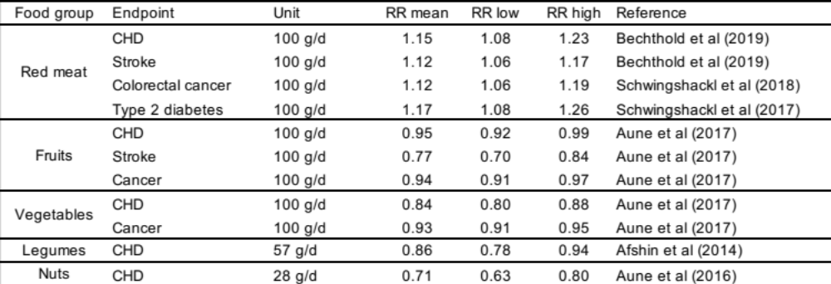

SI Table 5. Overview of existing ratings on the certainty of evidence for a statistically significant association between a risk factor and a disease endpoint. The ratings include those of the Nutrition and Chronic Diseases Expert Group (NutriCoDE),¹⁷ the World Cancer Research Fund,²⁰ and NutriGrade.^{13–15} The ratings relate to the risk-disease associations in general, and not to the specific relative-risk factor used for those associations in this analysis.
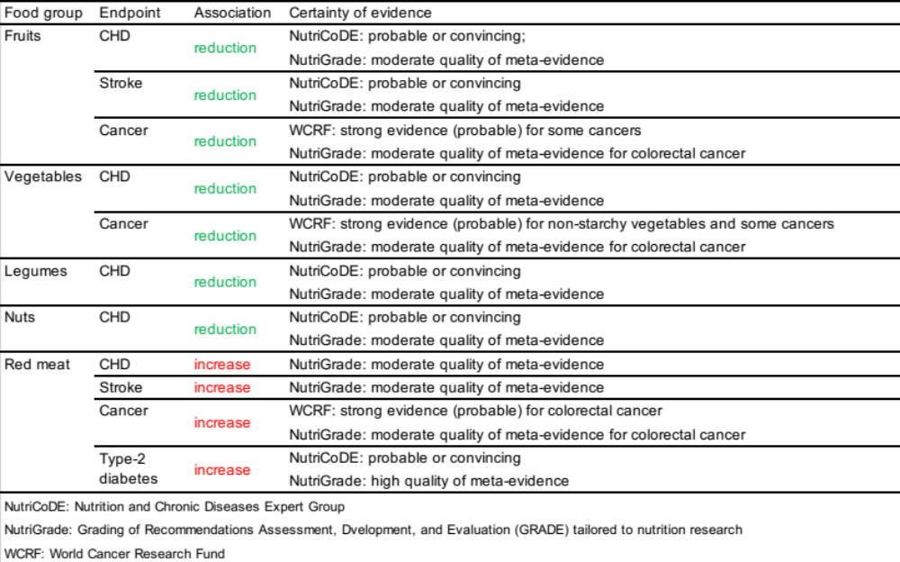

Supplementary results

SI Table 6. Regional flows of international food trade between exporting and importing regions (in kilo tonnes per year, kt/yr, and as a percentage of production in the exporting region, %prod).
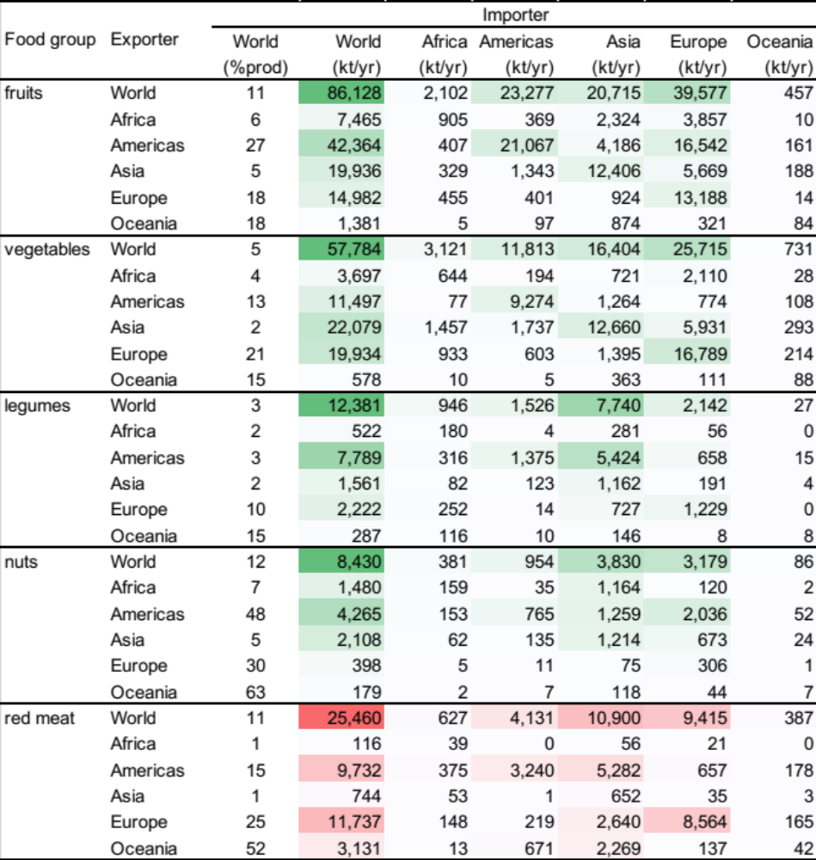

SI Table 7. Changes in regional food availability per person (in grams per person per day, g/d, and as a percentage of regional food demand) in importing regions due to foods exported from exporting regions.
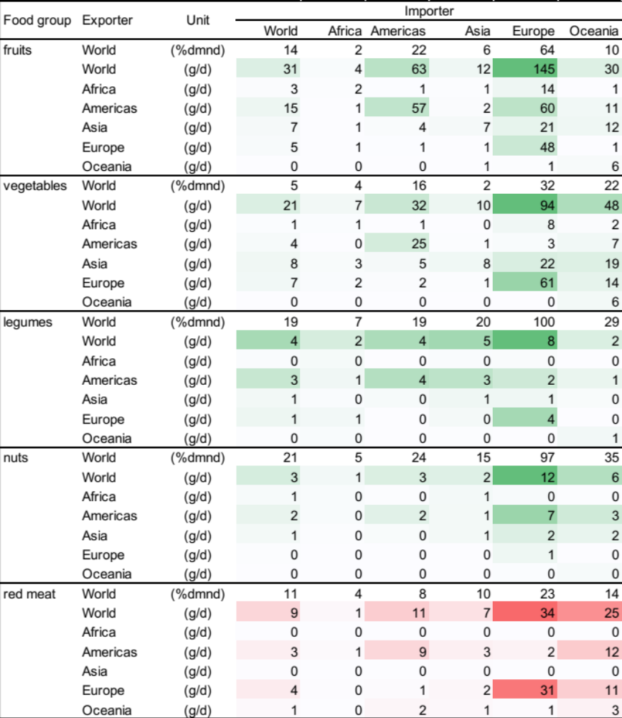

SI Figure 1. Leading exporters and importers of foods related to dietary risk, with trade flows measured in kilo tonnes per year (kt/yr).

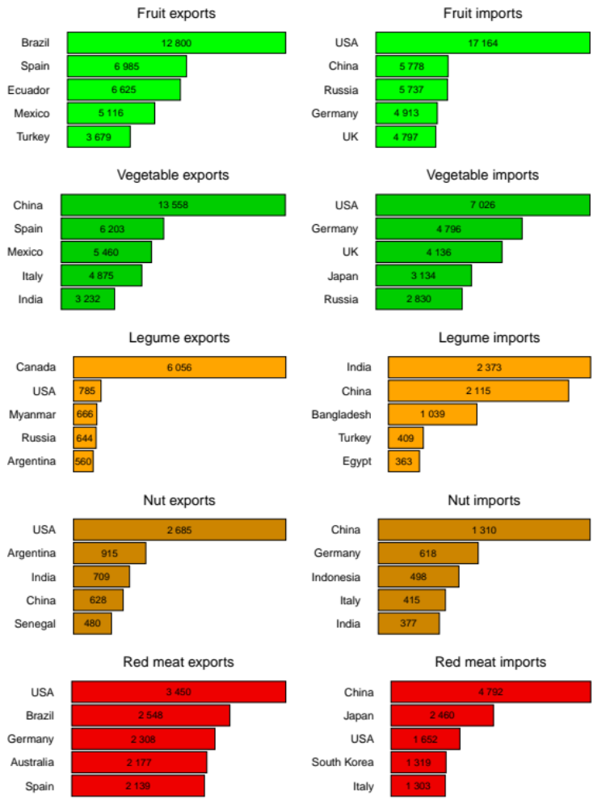

SI Table 8. Changes in mortality attributed to foods that are related to dietary risks and that are traded from exporting to importing regions, measured in changes in the number of deaths (deaths) and as a percentage of the diet-related burden of the same set of risk factors (%burden).
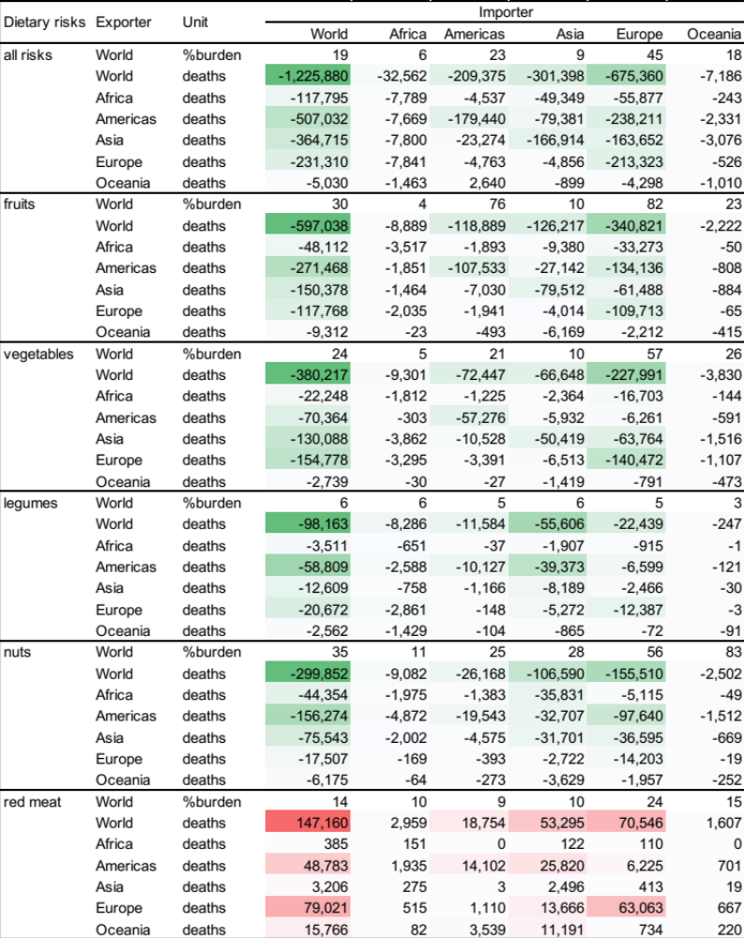

SI Figure 2. Exporters and importers of dietary risks related to fruits (a, b), vegetables (c, d), legumes (e, f), nuts (g, h), and red meat (i, j), measured in mortality changes.
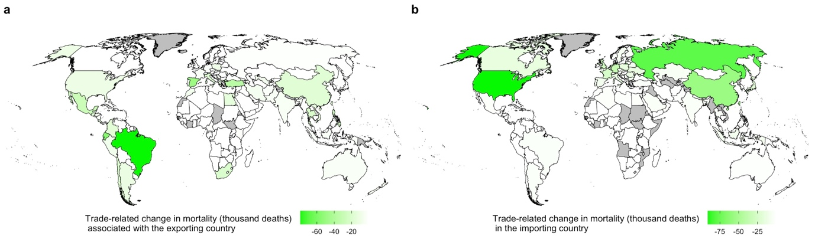
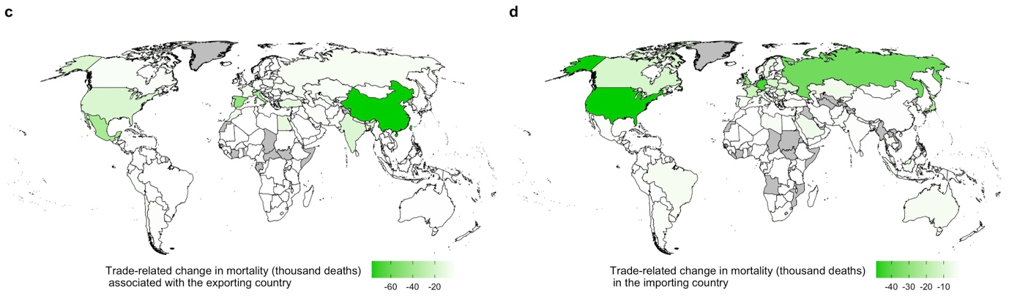
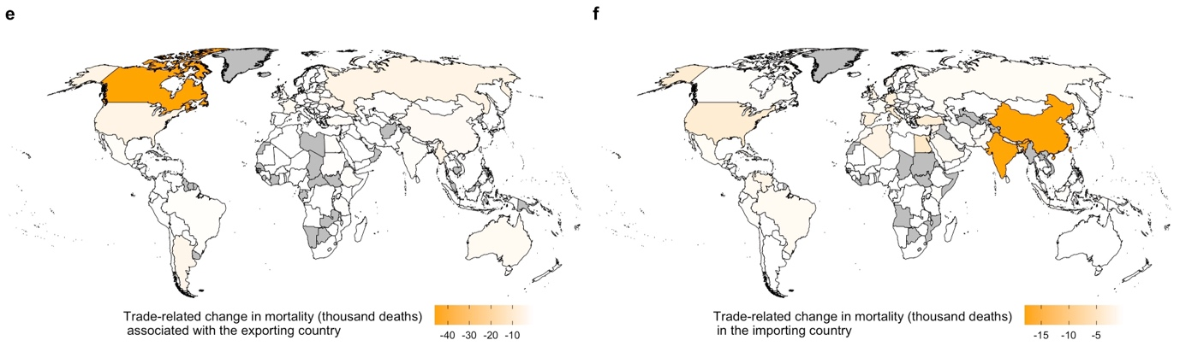
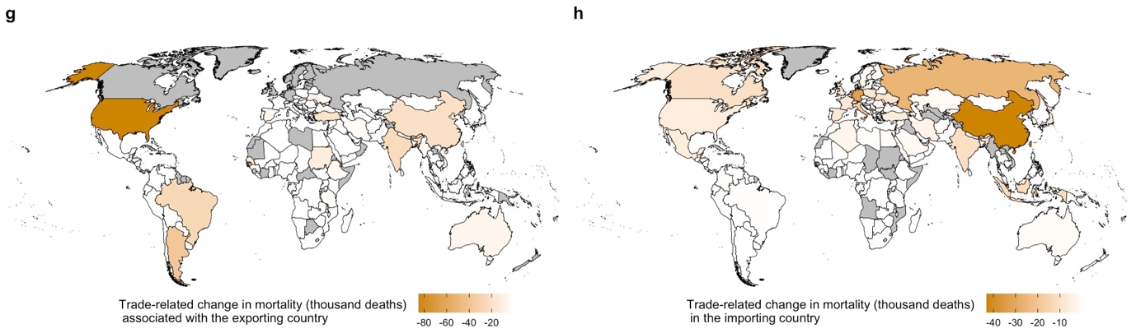
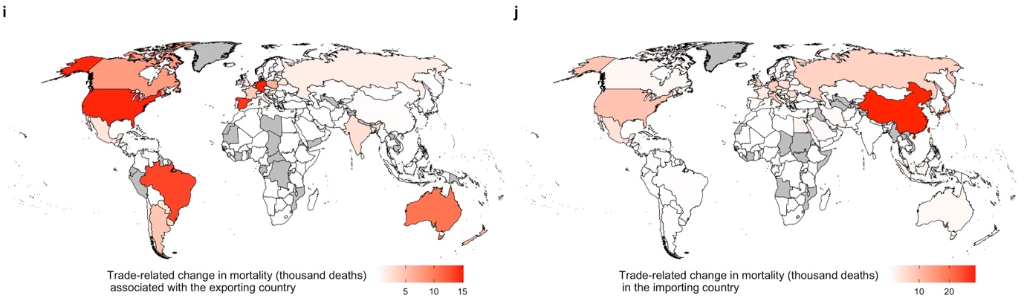

References

1 Dalin C, Wada Y, Kastner T, Puma MJ. Groundwater depletion embedded in international food trade. Nature 2017; 543: 700–4.
2 Kastner T, Kastner M, Nonhebel S. Tracing distant environmental impacts of agricultural products from a consumer perspective. Ecological Economics 2011; 70: 1032–40.
3 Miller RE, Blair PD. Input-output analysis: foundations and extensions. Cambridge University Press, 2009.
4 Carlson KM, Gerber JS, Mueller ND, et al. Greenhouse gas emissions intensity of global croplands. Nature Climate Change 2017; 7: 63–8.
5 Murray CJL, Ezzati M, Lopez AD, Rodgers A, Vander Hoorn S. Comparative quantification of health risks: conceptual framework and methodological issues. Population Health Metrics 2003; 1: 1.
6 Lim SS, Vos T, Flaxman AD, et al. A comparative risk assessment of burden of disease and injury attributable to 67 risk factors and risk factor clusters in 21 regions, 1990–2010: a systematic analysis for the Global Burden of Disease Study 2010. The Lancet 2012; 380: 2224–60.
7 Forouzanfar MH, Alexander L, Anderson HR, et al. Global, regional, and national comparative risk assessment of 79 behavioural, environmental and occupational, and metabolic risks or clusters of risks in 188 countries, 1990–2013: a systematic analysis for the Global Burden of Disease Study 2013. The Lancet 2015; 386: 2287–323.
8 Murray CJL, Ezzati M, Flaxman AD, et al. GBD 2010: design, definitions, and metrics. Lancet 2012; 380: 2063–6.
9 Lozano R, Naghavi M, Foreman K, et al. Global and regional mortality from 235 causes of death for 20 age groups in 1990 and 2010: a systematic analysis for the Global Burden of Disease Study 2010. The Lancet 2012; 380: 2095–128.
10 Afshin A, Micha R, Khatibzadeh S, Mozaffarian D. Consumption of nuts and legumes and risk of incident ischemic heart disease, stroke, and diabetes: a systematic review and meta-analysis. The American Journal of Clinical Nutrition 2014; : ajcn.076901.
11 Aune D, Keum N, Giovannucci E, et al. Nut consumption and risk of cardiovascular disease, total cancer, all-cause and cause-specific mortality: a systematic review and dose-response meta-analysis of prospective studies. BMC medicine 2016; 14: 207.
12 Aune D, Giovannucci E, Boffetta P, et al. Fruit and vegetable intake and the risk of cardiovascular disease, total cancer and all-cause mortality–a systematic review and dose-response meta-analysis of prospective studies. International Journal of Epidemiology 2016; published online March 18.
13 Bechthold A, Boeing H, Schwedhelm C, et al. Food groups and risk of coronary heart disease, stroke and heart failure: A systematic review and dose-response meta-analysis of prospective studies. Critical Reviews in Food Science and Nutrition 2019; 59: 1071–90.
14 Schwingshackl L, Hoffmann G, Lampousi AM, et al. Food groups and risk of type 2 diabetes mellitus: a systematic review and meta-analysis of prospective studies. European Journal of Epidemiology 2017; 32: 363–75.
15 Schwingshackl L, Schwedhelm C, Hoffmann G, et al. Food groups and risk of colorectal cancer. International Journal of Cancer 2018; 142: 1748–58.
16 Singh GM, Danaei G, Farzadfar F, et al. The Age-Specific Quantitative Effects of Metabolic Risk Factors on Cardiovascular Diseases and Diabetes: A Pooled Analysis. PLOS ONE 2013; 8: e65174.
17 Micha R, Shulkin ML, Peñalvo JL, et al. Etiologic effects and optimal intakes of foods and nutrients for risk of cardiovascular diseases and diabetes: Systematic reviews and meta-analyses from the Nutrition and Chronic Diseases Expert Group (NutriCoDE). PLOS ONE 2017; 12: e0175149.
18 GBD 2017 Diet Collaborators A, Sur PJ, Fay KA, et al. Health effects of dietary risks in 195 countries, 1990-2017: a systematic analysis for the Global Burden of Disease Study 2017. Lancet (London, England) 2019; 0. DOI:10.1016/S0140-6736(19)30041-8.
19 Schwingshackl L, Knüppel S, Schwedhelm C, et al. Perspective: NutriGrade: A Scoring System to Assess and Judge the Meta-Evidence of Randomized Controlled Trials and Cohort Studies in Nutrition Research. Advances in Nutrition: An International Review Journal 2016; 7: 994–1004.
20 World Cancer Research Fund/American Institute for Cancer Research. Diet, Nutrition, Physical Activity and Cancer: A Global Perspective. Continuous Update Project Expert Report. 2018.
21 Aune D, Norat T, Romundstad P, Vatten LJ. Dairy products and the risk of type 2 diabetes: a systematic review and dose-response meta-analysis of cohort studies. The American Journal of Clinical Nutrition 2013; 98: 1066–83.
22 Aune D, Lau R, Chan DSM, et al. Dairy products and colorectal cancer risk: a systematic review and meta-analysis of cohort studies. Annals of Oncology: Official Journal of the European Society for Medical Oncology 2012; 23: 37–45.
23 Mohan D, Mente A, Dehghan M, et al. Associations of Fish Consumption With Risk of Cardiovascular Disease and Mortality Among Individuals With or Without Vascular Disease From 58 Countries. JAMA Internal Medicine 2021; published online March 8. DOI:10.1001/jamainternmed.2021.0036.

