Supplementary materials

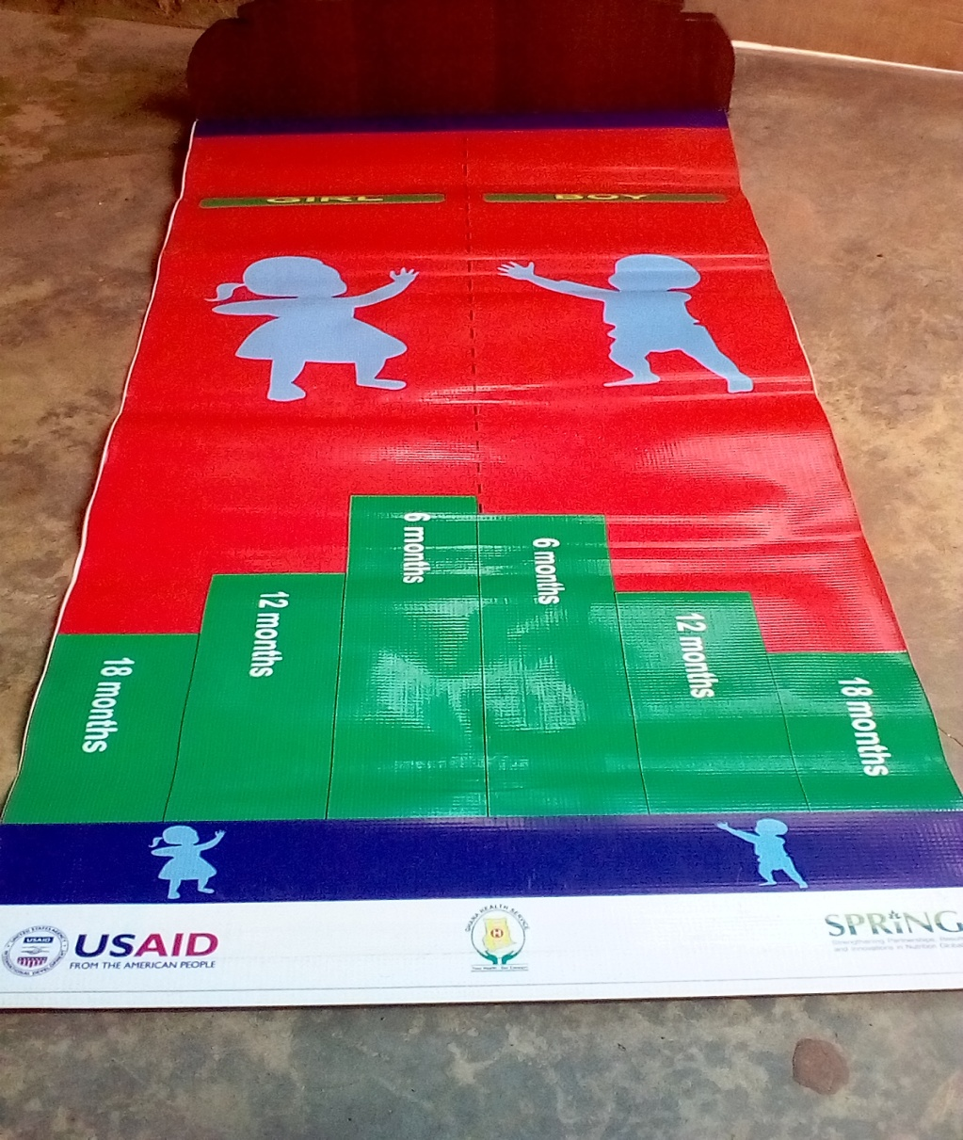

Supplementary Figure S1: Stunting mat

Supplementary Table S1: Interpretability and acceptability of Stunting mat
Difficulties | WHO procedure |  | Stunting mat
 | Frequency | % | Frequency | %
Difficulty laying a child on the tool | 7 | 43.7 | 3 | 18.8
Difficulty reading from tape | 1 | 6.3 | 0 | 0
Difficulty comparing with age | 2 | 12.5 | 0 | 0
Graduations not indicated | 0 | 0 | 1 | 6.3
No difficulty at all | 6 | 37.5 | 12 | 73.0

