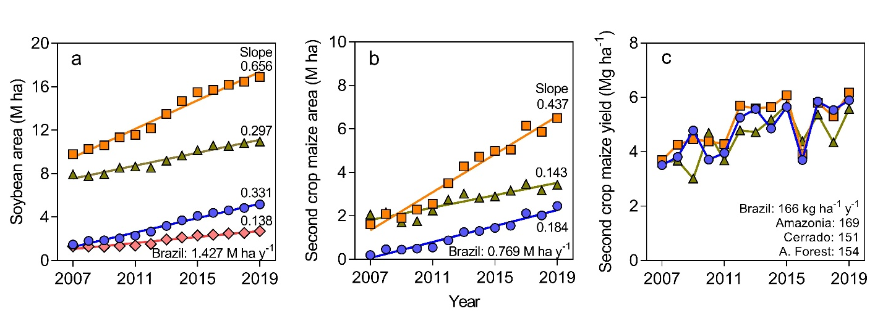
Extended Data Figure 1. Historical trends of yield and harvested area for soybean and second-crop maize in Brazil. Fitted models are shown in (a) and (b), but not in (c) to avoid overlapping. Slopes of the fitted linear regression models are shown. Slopes were statistically different from zero in all cases (double-tailed, t-test, P<0.05). Data on yield and crop area was retrieved from IGBE (2021)¹⁶.
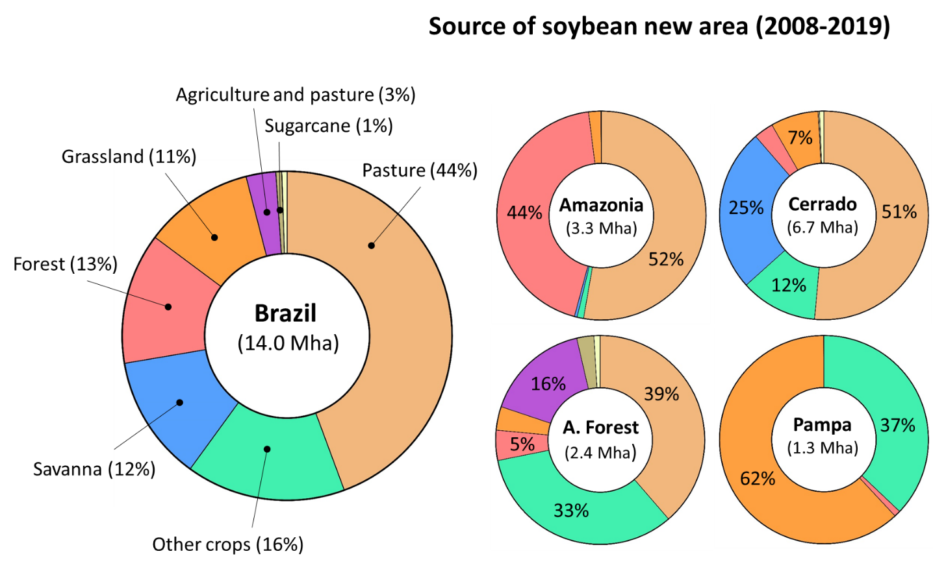
Extended Data Figure 2. Land use change driven by soybean production in Brazil. Proportion of land type by year 2000 that was converted for soybean production during the 2008-2019 period as estimated from the MAPBIOMAS Project – Collection 5.0¹⁰. Separate pie charts are shown for the whole Brazil and for each of the soybean producing regions. See Supplementary Information for details on calculations of land-use change.

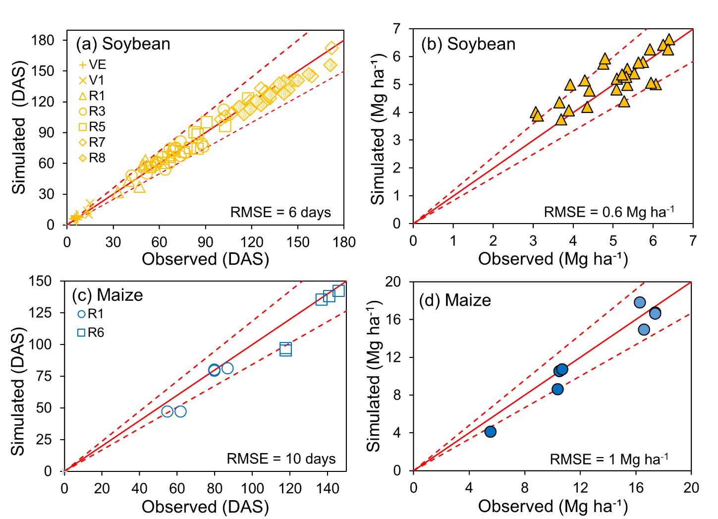
Extended Data Figure 3. Evaluation of crop models used for estimation of yield potential for maize and soybean in Brazil. Comparison of simulated and observed phenology (left) and grain yields (right) for soybean (upper panels) and maize (bottom panel) based on well-managed experiments conducted across main producing regions in Brazil, where crops were grown without nutrient limitations and kept free from incidence of biotic stresses such as weeds, insect pests, and pathogens. The solid red line represents y = x and the dashed red lines represent ± 20% deviation from the y = x line. The latter is considered a good threshold to assess accuracy in model prediction. The root mean square error is shown in absolute terms (RMSE). The phenological stages for soybean and maize were based on Fehr and Caviness⁵³ and Ritchie et al.⁵⁴, respectively, and expressed in days after sowing (DAS).
Supplementary information for “Agricultural intensification can help protect the Amazon forest and reduce global warming” by Marin et al.

- Description of study region…………………………………………………………. 2
- Yield definitions……………………………………………………………………... 3
- Yield gap analysis………………………………………………………………….... 4
3.1 Site selection……………………………….. 4
3.2. Weather data ................................................4
3.3. Soil data ........................................................ 5
3.4. Management data ........................................ 5

Supplementary Tables 1-6.……………………………………………………………… 7

- Description of study regions
We focused here on four biomes (Amazonia, Cerrado, Atlantic Forest, and Pampa) accounting for 99% of the soybean harvested area. The Brazilian Cerrado is one of the most important regions for agricultural production in Brazil, the second-largest biome in the country (22% of the national territory), and one of the world's most biodiverse hotspots of the world due to its endemic species ^{55,56}. It has a rainy season that starts between September-October and lasts until March-April. Average annual temperatures range from 18 to 27 ºC⁵⁷. The region consists of a mosaic of vegetation, ranging from dense grassland, usually with a sparse covering of shrubs and trees, to an almost closed tall-trees woodland^{58,59}. The Amazonia biome is the greatest territorial extension in Brazil and represents the largest biodiversity in the world and plays a key role in regulating the world's climate due to producing immense amounts of water^{16,56}. It is the largest tropical forest on the planet, hosting a quarter of the world's terrestrial species⁶⁰. Average annual temperatures range from 22 to 28ºC, with certain thermal stability throughout the year. The total annual rainfall varies from 1,400 to 3,500 mm per year. The Atlantic Forest occupies 13% of the Brazilian territory and has a great diversity of vegetation. It is one of the most degraded biomes, with only 15% of its original vegetation remaining⁵⁶. The elevation ranges from sea level to 2,900m, with abrupt changes in the type and depth of soils and in the average air temperature⁶¹. The more inland, the more seasonal the forests become, with rainfall falling from^{61,62}. Most of the long-term agricultural land of the country is in the Atlantic Forest, with crops like sugarcane, maize, soybean, and beans. The Pampa biome represents approximately 2% of the national territory and it is characterized by plains and smooth relief, undulated with shallow soils, infertile and susceptible to erosion⁵⁶. It is under a temperate climate, characterized by great seasonal variation, with hot summers and very harsh winters, with the occurrence of frost and occasional snowfall⁶³. Extensive livestock has been the main activity of the biome, even contributing to its preservation, but in the recent period, there have been important changes in land use, in particular the advance of soybean and rice.

2. Yield definitions
Yield potential is defined as the yield of an adapted crop cultivar as determined by solar radiation, temperature, carbon dioxide, and genetic traits that govern length of growing period, light interception by the crop canopy and its conversion to biomass, and partition of biomass to the harvestable organs^{64,65}. In rainfed crops, yield potential is also determined by the water supply amount and distribution during the crop growth period and soil properties influencing the water balance such as soil depth, texture, and slope⁶⁵. Reaching yield potential in farmer fields is neither feasible nor desirable as it would require large amounts of inputs, leading to reduced profit and a large negative environmental impact. Instead, reaching 80% of the yield potential is an attainable target in cropping systems where farmers have access to markets, inputs, and extension services^{66,67}. Finally, the exploitable yield gap is defined as the difference between the attainable yield and average farmer yield. The magnitude of yield gap provides a benchmark of current land productivity in relation to the biophysical yield ceiling, and an estimate of the additional crop production that could potentially be achieved, on existing cropland area, through improved management that alleviates all yield limiting and reducing factors^{65,67}.

3. Yield gap analysis

3.1. Site selection
Based on crop harvested area distribution (MAPSPAM)⁶⁸ and the agro-climatic zones defined for Brazil⁶⁹, buffer zones (radius: 100 km) were defined around existing weather stations, with their borders clipped so that the buffers do not extend into different climate zones. Weather stations with long-term weather records are required to estimate yield potential and its variability. Buffers were selected successively, starting from the one with the highest share of national soybean area, and then eliminating those buffers that overlap with the selected buffer by more than 20%. The process was repeated and more buffers were selected until reaching a coverage of 50% of national soybean area. We created additional buffers (from ‘hypothetical weather stations’) to cover important soybean producing areas that were not selected because of absence of weather stations or inaccuracies in soybean area maps. A total of 32 buffers (referred to as ‘sites’ in the main text) were selected for soybean (Supplementary Table S2). Eight of the 32 buffers included second-crop maize (Supplementary Table S3).

3.2. Weather data
Long-term (20 years) daily weather data for each site were retrieved from Brazilian Institute of Meteorology (INMET)⁴⁰, which included maximum and minimum temperature and precipitation for the period between years 1999 and 2018. Relative humidity, dew temperature, and ETo were estimated following Allen et al.⁷⁰. Quality control and filling/correction of the weather data were performed based on the propagation technique developed by Van Wart et al. (2013)⁶⁹. In all cases, solar radiation was retrieved from NASA-POWER, which has shown good correlation with measured solar radiation^{71,72}. Measured weather data were not available in 10 of 32 buffers; hence, we used weather data (including all variables) from NASA-POWER⁷³.

  - Soil data
Up to three dominant soil series were identified for each buffer based on data from the Radambrasil project³⁹. In each buffer, dominant soils were selected to cover at least 30% of the crop harvested area. Each selected soil had at least 10% of the area. Selected soils were verified by local experts and modified as needed to ensure that simulated soils represented the most common agricultural soils within each buffer. For the simulations, rooting depth was set at 0.8 m (soybean and maize) to reflect the limitation to root growth in deep horizons due to low pH^{74–76}. Calibrated pedo-transference functions for tropical soils were used to derive soil water limits, including field capacity and permanent wilting point⁷⁷. Field capacity was set at -10 kPa for estimation of plant available water content, following the observations for tropical soils by Reichardt⁷⁸ and Tomasella and Hodnett⁷⁹. Default values for tropical soils were used for other soil parameters associated with albedo, surface runoff, and soil evaporation, but adjusted as needed to portray no-till practices, which are dominant in soybean production in Brazil. As maize and soybean sowing dates coincides with the wet season, the entire crop sequence for maize and soybean (including fallow) simulations were started assuming initial soil water at sowing equal to 100% of plant available soil water

  - Management data
Management practices for each buffer were retrieved from local EMBRAPA agronomists. Requested information include: dominant crop rotations and proportion of each of them to the total harvested area, sowing window, dominant cultivar name and maturity, and optimal plant population density. The provided data were subsequently corroborated by other local and national experts. Typical soybean systems are single soybean (one crop per year) and soybean-second crop maize (two crops within 12 months). In the latter, soybean is planted with the onset of rains in October and matures in January. Maize is sown after soybean harvest. The rainy season ends before maize maturity, leading to terminal drought in most years.
Applied inputs (fertilizers, pesticides, seeds, and lime) and diesel data needed to estimate the annual GHG emissions were derived from different sources depending on the region. For Pampa and Atlantic Forest, we used data derived from on-farm surveys conducted from 2017 to 2021 (900 surveys for soybean and 400 for maize)^{80,81}. Management data for Cerrado and Amazônia were obtained from Embrapa Soja, Embrapa Milho e Sorgo and Foundation Mato Grosso crop management guidelines, and from local consultants^{81–83}. In the case of the BAU scenario, Averaged values of applied inputs for each region were used for the BAU scenario, while the values corresponding to the top 10% of the highest yielding farms were used for the INT and INT-TE scenarios (Supplementary Table S6), except for fertilizer rates, which were estimated following a nutrient-balance approach. In the case of the BAU, we assumed applied N, P, and K fertilizer to be equivalent to the amount needed to replace the grain nutrient removal^{84,85}, except for N in soybean for which we assumed no fertilizer application as biological N fixation and soil N mineralization are usually sufficient to meet soybean N requirements (Supplementary Table 6). A similar approach was followed to estimate P and K inputs in the INT and INT-TE scenarios. In the case of second-crop maize, we assumed that the amount applied should be equal to the total N uptake by the crop⁸⁵. That amount would lead to a small positive partial N balance (+50 kg N) that would compensate for unavoidable losses and help maintain SOC at steady state over the long term⁸⁶. Other agricultural inputs (pesticides, lime, and fuel) were assumed to remain the same as in the BAU scenario, while we used higher rates for the INT and INT-TE scenarios based on current recommended management practices (Supplementary Table 6).
Supplementary Table S1. Land use by year 2000 of the new soybean area between 2008-2019 and current land use (2019) per region and for the entire Brazil.

Land use (thousands ha) in year 2000 of soybean area expanded in 2008-2019
 | Amazonia | % | Cerrado | % | A. Forest | % | Pampa | % | Brazil | %
Forest | 1,457 | 44 | 203 | 3 | 116 | 5 | 14 | 1 | 1,791 | 13
Forest Plantation | 0 | 0 | 46 | 1 | 24 | 1 | 1 | 0 | 72 | 1
Grassland | 63 | 2 | 496 | 7 | 91 | 4 | 847 | 62 | 1,496 | 11
Mosaic of Agric. & Past. | 0 | 0 | 0 | 0 | 403 | 16 | 1 | 0 | 404 | 3
Cropland | 39 | 1 | 798 | 12 | 825 | 33 | 508 | 37 | 2,170 | 16
Pasture | 1,752 | 53 | 3,446 | 51 | 961 | 39 | 1 | 0 | 6,160 | 44
Savanna | 14 | 0 | 1,695 | 25 | 0 | 0 | 0 | 0 | 1,711 | 12
Sugarcane | 2 | 0 | 14 | 0 | 66 | 3 | 0 | 0 | 81 | 1
Total soybean expansion (2008-2019) | 3,328 | 100 | 6,698 | 100 | 2,486 | 100 | 1,369 | 100 | 13,884 | 100
Land use in each region by 2019 (thousand ha)
 | Amazonia | % | Cerrado | % | A. Forest | % | Pampa | % | Brazil | %
Forest | 334,636 | 79 | 28,865 | 15 | 30,447 | 28 | 2,549 | 13 | 403,430 | 47
Forest Plantation | 148 | 0 | 3,172 | 2 | 4,237 | 4 | 456 | 2 | 8,019 | 1
Grassland | 14,732 | 3 | 16,476 | 8 | 1,017 | 1 | 6,199 | 32 | 47,095 | 6
Mosaic of Agric. & Past. | 0 | 0 | 0 | 0 | 17,151 | 15 | 0 | 0 | 23,309 | 3
Cropland | 1,058 | 0 | 4,053 | 2 | 3,922 | 4 | 4,014 | 21 | 15,402 | 2
Pasture | 53,017 | 13 | 60,579 | 31 | 29,559 | 27 | 0 | 0 | 167,082 | 20
Savanna | 651 | 0 | 60,885 | 31 | 2,698 | 2 | 0 | 0 | 112,661 | 13
Sugarcane | 99 | 0 | 3,517 | 2 | 6,699 | 6 | 0 | 0 | 10,344 | 1
Total area (including other land uses) | 421,202 | 100 | 198,456 | 100 | 110,655 | 100 | 19,391 | 100 | 851,060 | 100

Supplementary Table 2. Selected sites for soybean and associated coordinates (in decimal degrees), average water-limited yield potential (Yw), actual yield (Ya), and exploitable yield gap (Yg: 80% of Yw-Ya). Parenthetic values show the temporal coefficients of variation for Yw and Ya at each site.
Name | Long. | Lat. | Yw  (Mg ha⁻¹) | Ya  (Mg ha⁻¹) | Exploitable Yg (Mg ha⁻¹) | Region
Baixa Grande do Ribeiro | -45.09 | -8.33 | 5.0 (0.18) | 2.4 (0.30) | 1.6 | Cerrado
Brasilândia do Sul | -53.46 | -24.12 | 4.9 (0.45) | 3.1 (0.20) | 0.9 | A. Forest
Campo Mourão | -52.36 | -24.05 | 5.5 (0.32) | 3.2 (0.10) | 1.1 | A. Forest
Campo Verde | -55.41 | -15.81 | 6.9 (0.04) | 3.1 (0.04) | 2.4 | Cerrado
Canarana | -52.27 | -13.47 | 5.6 (0.14) | 2.9 (0.14) | 1.6 | A. Forest, Amazonia
Capinópolis | -49.55 | -18.71 | 5.8 (0.13) | 2.9 (0.16) | 1.8 | Cerrado
Catalão | -47.95 | -18.18 | 6.1 (0.19) | 3.2 (0.07) | 1.7 | Cerrado
Cruz Alta | -53.60 | -28.63 | 3.7 (0.65) | 2.9 (0.28) | 0.0 | A. Forest, Pampa
Gleba Celeste | -56.50 | -12.20 | 5.5 (0.12) | 3.1 (0.07) | 1.3 | Amazonia, Cerrado
Ivinhema | -53.81 | -22.30 | 4.2 (0.39) | 2.9 (0.14) | 0.5 | A. Forest, Cerrado
Ibirubá | -53.11 | -28.65 | 4.2 (0.48) | 2.8 (0.31) | 0.5 | A. Forest, Pampa
Irati | -50.63 | -25.46 | 5.8 (0.20) | 3.3 (0.07) | 1.3 | A. Forest
Iraí | -53.23 | -27.18 | 4.0 (0.39) | 2.7 (0.29) | 0.6 | A. Forest
Lagoa Vermelha | -51.50 | -28.21 | 5.4 (0.31) | 3.2 (0.17) | 1.1 | A. Forest
Lucas do Rio Verde | -55.54 | -13.37 | 6.3 (0.04) | 3.2 (0.06) | 1.9 | Cerrado, Amazonia
Maringá | -51.91 | -23.40 | 5.0 (0.38) | 3.0 (0.14) | 1.0 | A. Forest
Mineiros | -52.62 | -18.04 | 6.8 (0.05) | 3.2 (0.04) | 2.2 | Cerrado
Paracatu | -46.88 | -17.23 | 4.9 (0.21) | 3.0 (0.10) | 0.9 | Cerrado
Pato Branco | -52.61 | -26.29 | 5.6 (0.29) | 3.1 (0.18) | 1.4 | A. Forest
Ponta Porã | -55.53 | -22.53 | 5.4 (0.27) | 2.9 (0.15) | 1.4 | A. Forest, Cerrado
Poxoréo | -54.38 | -15.83 | 6.4 (0.05) | 3.1 (0.03) | 2.1 | Cerrado
Primavera do Leste | -54.21 | -14.96 | 6.7 (0.05) | 3.1 (0.02) | 2.3 | Cerrado
Quedas do Iguaçu | -52.96 | -25.46 | 5.6 (0.41) | 3.1 (0.17) | 1.4 | A. Forest
Rio Verde | -50.91 | -17.80 | 6.2 (0.13) | 3.0 (0.14) | 1.9 | Cerrado
Santa Carmem | -54.96 | -12.04 | 5.3 (0.15) | 3.1 (0.06) | 1.2 | Amazonia
Sapezal | -58.37 | -13.46 | 6.2 (0.04) | 3.1 (0.04) | 1.9 | Cerrado, Amazonia
São José do Rio Claro | -56.71 | -13.43 | 5.9 (0.12) | 3.0 (0.04) | 1.7 | Cerrado, Amazonia
São Luiz Gonzaga | -55.01 | -28.40 | 3.1 (0.80) | 2.3 (0.40) | 0.2 | Pampa, A. Forest
São Pedro do Iguaçu | -53.71 | -24.96 | 4.9 (0.45) | 3.3 (0.21) | 0.6 | A. Forest
Taguatinga | -46.41 | -12.40 | 5.3 (0.20) | 2.8 (0.19) | 1.5 | Cerrado
Tarumã | -50.62 | -22.79 | 6.0 (0.26) | 2.8 (0.18) | 2.0 | A. Forest
Uberaba | -47.95 | -19.73 | 6.4 (0.18) | 3.0 (0.14) | 2.0 | Cerrado

Supplementary Table 3. Selected sites for second-crop maize and associated coordinates (in decimal degrees), average water-limited yield potential (Yw), actual yield (Ya), and exploitable yield gap (Yg: 80% of Yw-Ya). Parenthetic values show the temporal coefficients of variation for Yw and Ya at each site.
Name | Long. | Lat. | Yw  (Mg ha⁻¹) | Ya  (Mg ha⁻¹) | Exploitable Yg (Mg ha⁻¹) | Region
Campo Mourão | -52.36 | -24.05 | 11.9 (0.43) | 5.4 (0.08) | 4.1 | A. Forest
Gleba Celeste | -56.50 | -12.20 | 10.6 (0.13) | 5.3 (0.15) | 3.2 | Amazonia, Cerrado
Ivinhema | -53.81 | -22.30 | 8.7 (0.57) | 4.8 (0.17) | 2.2 | A. Forest, Cerrado
Maringá | -51.91 | -23.40 | 10.5 (0.40) | 4.9 (0.15) | 3.5 | A. Forest
Ponta Porã | -55.53 | -22.53 | 12.6 (0.43) | 4.8 (0.20) | 5.3 | A. Forest, Cerrado
Poxoréo | -54.38 | -15.83 | 10.6 (0.14) | 5.9 (0.09) | 2.6 | Cerrado
Rio Verde | -50.91 | -17.80 | 10.0 (0.35) | 5.7 (0.21) | 2.3 | Cerrado
São José do Rio Claro | -56.71 | -13.43 | 11.2 (0.11) | 5.5 (0.12) | 3.5 | Cerrado, Amazonia

Supplementary Table 4. Description of soybean and second crop maize area and yield trends in Amazonia (AMA), Cerrado (CER), Atlantic Forest (ATL), and Pampa (PAM) in three scenarios: business as usual (BAU), intensification (INT), and intensification plus target expansion (INT+TE). Parenthetic values indicate projected values for each value by 2035.

 | BAU | INT | INT+TE
Soybean area expansion | Same as 2007-2019 | No expansion | No expansion in Amazonia; expansion in 10% of current pastures and grasslands area in other regions
AMA | 0.331 M ha y⁻¹ (10.5 M ha) | 0 M ha y⁻¹ (5.2 M ha) | 0 M ha y⁻¹ (5.2 M ha)
CER | 0.656 M ha y⁻¹ (27.4 M ha) | 0 M ha y⁻¹ (16.9 M ha) | 0.482 M ha y⁻¹ (24.6 M ha)
ATL | 0.297 M ha y⁻¹ (15.7 M ha) | 0 M ha y⁻¹ (11.0 M ha) | 0.191 M ha y⁻¹ (14.0 M ha)
PAM | 0.138 M ha y⁻¹ (4.9 M ha) | 0 M ha y⁻¹ (2.7 M ha) | 0.039 M ha y⁻¹ (3.3 M ha)
Soybean yield gain | Same as 2007-2019 until reaching attainable yield. | Yield gain that allows 50% closure of exploitable yield gap in Cerrado and Amazonia by 2035. Continuation of current yield gain in Pampa and Atlantic Forest until reaching attainable yield. | Same as INT
AMA | 15 kg ha⁻¹ y⁻¹ (3.4) | 41 kg ha⁻¹ y⁻¹ (3.8) | 41 kg ha⁻¹ y⁻¹ (3.8)
CER | 27 kg ha⁻¹ y⁻¹ (3.6) | 55 kg ha⁻¹ y⁻¹ (4.0) | 55 kg ha⁻¹ y⁻¹ (4.0)
ATL | 73 kg ha⁻¹ y⁻¹ (4.0) | 73 kg ha⁻¹ y⁻¹ (4.0) | 73 kg ha⁻¹ y⁻¹ (4.0)
PAM | 69 kg ha⁻¹ y⁻¹ (2.8) | 69 kg ha⁻¹ y⁻¹ (2.8) | 69 kg ha⁻¹ y⁻¹ (2.8)
Second crop maize area expansion | Same as 2007-2019 | Full adoption of double cropping where possible | Same as INT
AMA | 85% † | 100% | 100%
CER | 70% | 70% | 70%
ATL | 42% | 50% | 50%
Second crop maize yield gain | Same as 2007-2019 | Yield gain that allows full closure of exploitable yield gap by 2035 | Same as INT
AMA | 169 kg ha⁻¹ y⁻¹ (8.5) | 187 kg ha⁻¹ y⁻¹ (8.5) | 187 kg ha⁻¹ y⁻¹ (8.5)
CER | 151 kg ha⁻¹ y⁻¹ (8.4) | 151 kg ha⁻¹ y⁻¹ (8.4) | 151 kg ha⁻¹ y⁻¹ (8.4)
ATL | 154 kg ha⁻¹ y⁻¹ (8.0) | 233 kg ha⁻¹ y⁻¹ (9.0) | 233 kg ha⁻¹ y⁻¹ (9.0)
† Percentage values show the proportion of soybean area following double cropping by year 2035, except for Pampa where double cropping is not practiced.
Supplementary Table 5. Total carbon (C) stocks in biomass and soil organic C (SOC) by dominant land use type in each region: Amazonia (AMA), Cerrado (CER), Atlantic Forest (ATL), and Pampa (PAM).

Region | Land cover type | Biomass C stocks (t C ha⁻¹) † | SOC (t C ha⁻¹)‡
AMA | Grassland/Pastures | 8.4 | 29.0
 | Forest | 151.6 | 48.8
ATL | Grassland | 12.6 | 39.6
 | Forest | 96.1 | 84.1
CER | Grassland | 8.4 | 39.6
 | Forest | 57.1 | 48.2
 | Savanna | 47.7 | 39.6
PAM | Grassland | 12.6 | 39.6
 | Forest | 86.8 | 53.9

† Includes below and aboveground biomass, and dead organic matter (necromass and litter).
‡ Grassland, pasture, and savanna are assumed to have similar SOC⁴⁶.

Supplementary Table 6. Description of applied inputs in soybean and second crop maize in Amazonia (AMA), Cerrado (CER), Atlantic Forest (ATL), and Pampa (PAM) for the baseline (year 2019) and three projected scenarios: business as usual (BAU), intensification (INT), and intensification plus target expansion (INT+TE). Fertilizers are expressed as elemental nutrients (N: nitrogen; P: phosphorous; K: potassium) while herbicides, fungicides and insecticides are expressed as active ingredients.
Inputs (per ha) | Baseline (year 2019) |  |  |  |  | BAU |  |  |  |  | INT & INT+TE
 | AMA | CER | ATL | PAM† |  | AMA | CER | ATL | PAM |  | AMA | CER | ATL | PAM
Soybean
P fertilizer (kg) | 41 | 39 | 31 | 30 |  | 41 | 39 | 32 | 34 |  | 45 | 48 | 32 | 34
K fertilizer (kg) | 74 | 74 | 60 | 64 |  | 74 | 74 | 71 | 73 |  | 87 | 91 | 71 | 73
Lime (t) | 1.5 | 1 | 0.6 | 0.83 |  | 1.5 | 1 | 0.6 | 0.83 |  | 1.50 | 1.33 | 0.83 | 1
Seed (kg) | 78 | 68 | 57 | 65 |  | 78 | 68 | 57 | 65 |  | 78 | 68 | 57 | 65
Diesel (l) | 27 | 28 | 27 | 26.5 |  | 27 | 28 | 27 | 27 |  | 27.7 | 29.5 | 27 | 27
Herbicides (kg) | 2.13 | 2.58 | 3.61 | 3.99 |  | 2.13 | 2.58 | 3.61 | 3.99 |  | 2.24 | 2.62 | 3.61 | 5.53
Fungicides (kg) | 0.47 | 1.54 | 0.49 | 0.28 |  | 0.47 | 1.54 | 0.49 | 0.28 |  | 0.47 | 1.54 | 0.46 | 0.36
Insecticides (kg) | 0.16 | 0.15 | 0.92 | 0.93 |  | 0.16 | 0.15 | 0.92 | 0.93 |  | 0.17 | 0.15 | 0.92 | 0.93
Maize
N fertilizer (kg) | 60 | 80 | 88 | - |  | 88 | 89 | 88 | - |  | 139 | 132 | 145 | -
P fertilizer (kg) | 20 | 20 | 27 | - |  | 23 | 23 | 27 | - |  | 23 | 26 | 31 | -
K fertilizer (kg) | 33 | 37 | 48 | - |  | 33 | 37 | 48 | - |  | 41 | 45 | 54 | -
Seed (kg) | 25 | 18 | 18 | - |  | 25 | 18 | 18 | - |  | 25 | 18 | 18 | -
Diesel (l) | 28.7 | 31 | 27.3 | - |  | 28.7 | 31.0 | 27.3 | - |  | 29.5 | 32.3 | 28.6 | -
Herbicides (kg) | 2.46 | 2.46 | 3.56 | - |  | 2.46 | 2.46 | 3.56 | - |  | 2.46 | 2.46 | 3.56 | -
Fungicides (kg) | 0.06 | 0.09 | 0.13 | - |  | 0.06 | 0.09 | 0.13 | - |  | 0.06 | 0.09 | 0.19 | -
Insecticides (kg) | 0.16 | 1.11 | 0.02 | - |  | 0.16 | 1.11 | 0.02 | - |  | 0.17 | 1.15 | 0.03 | -
† Double cropping is not practiced in Pampa.

