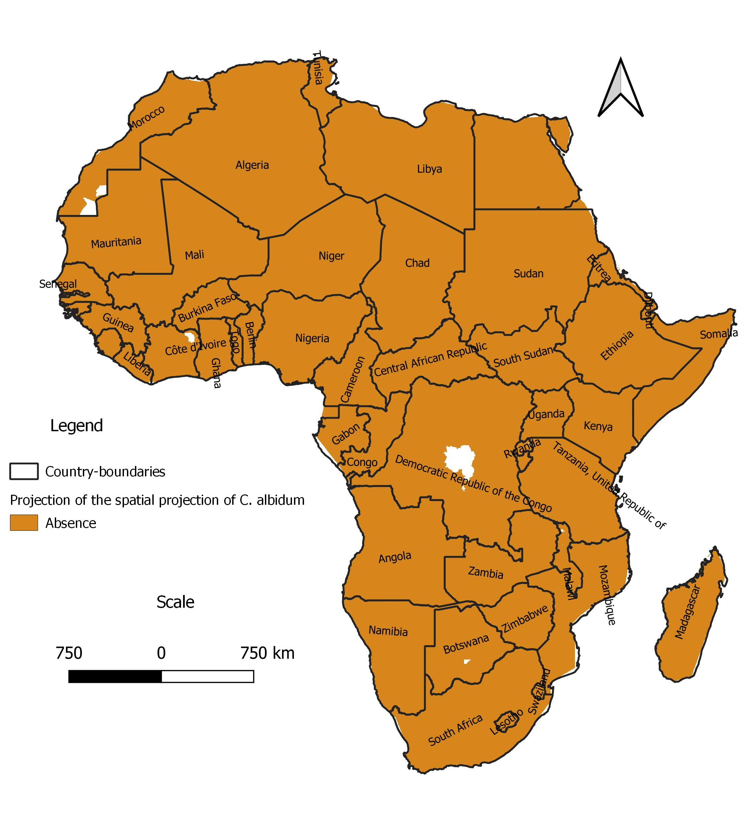
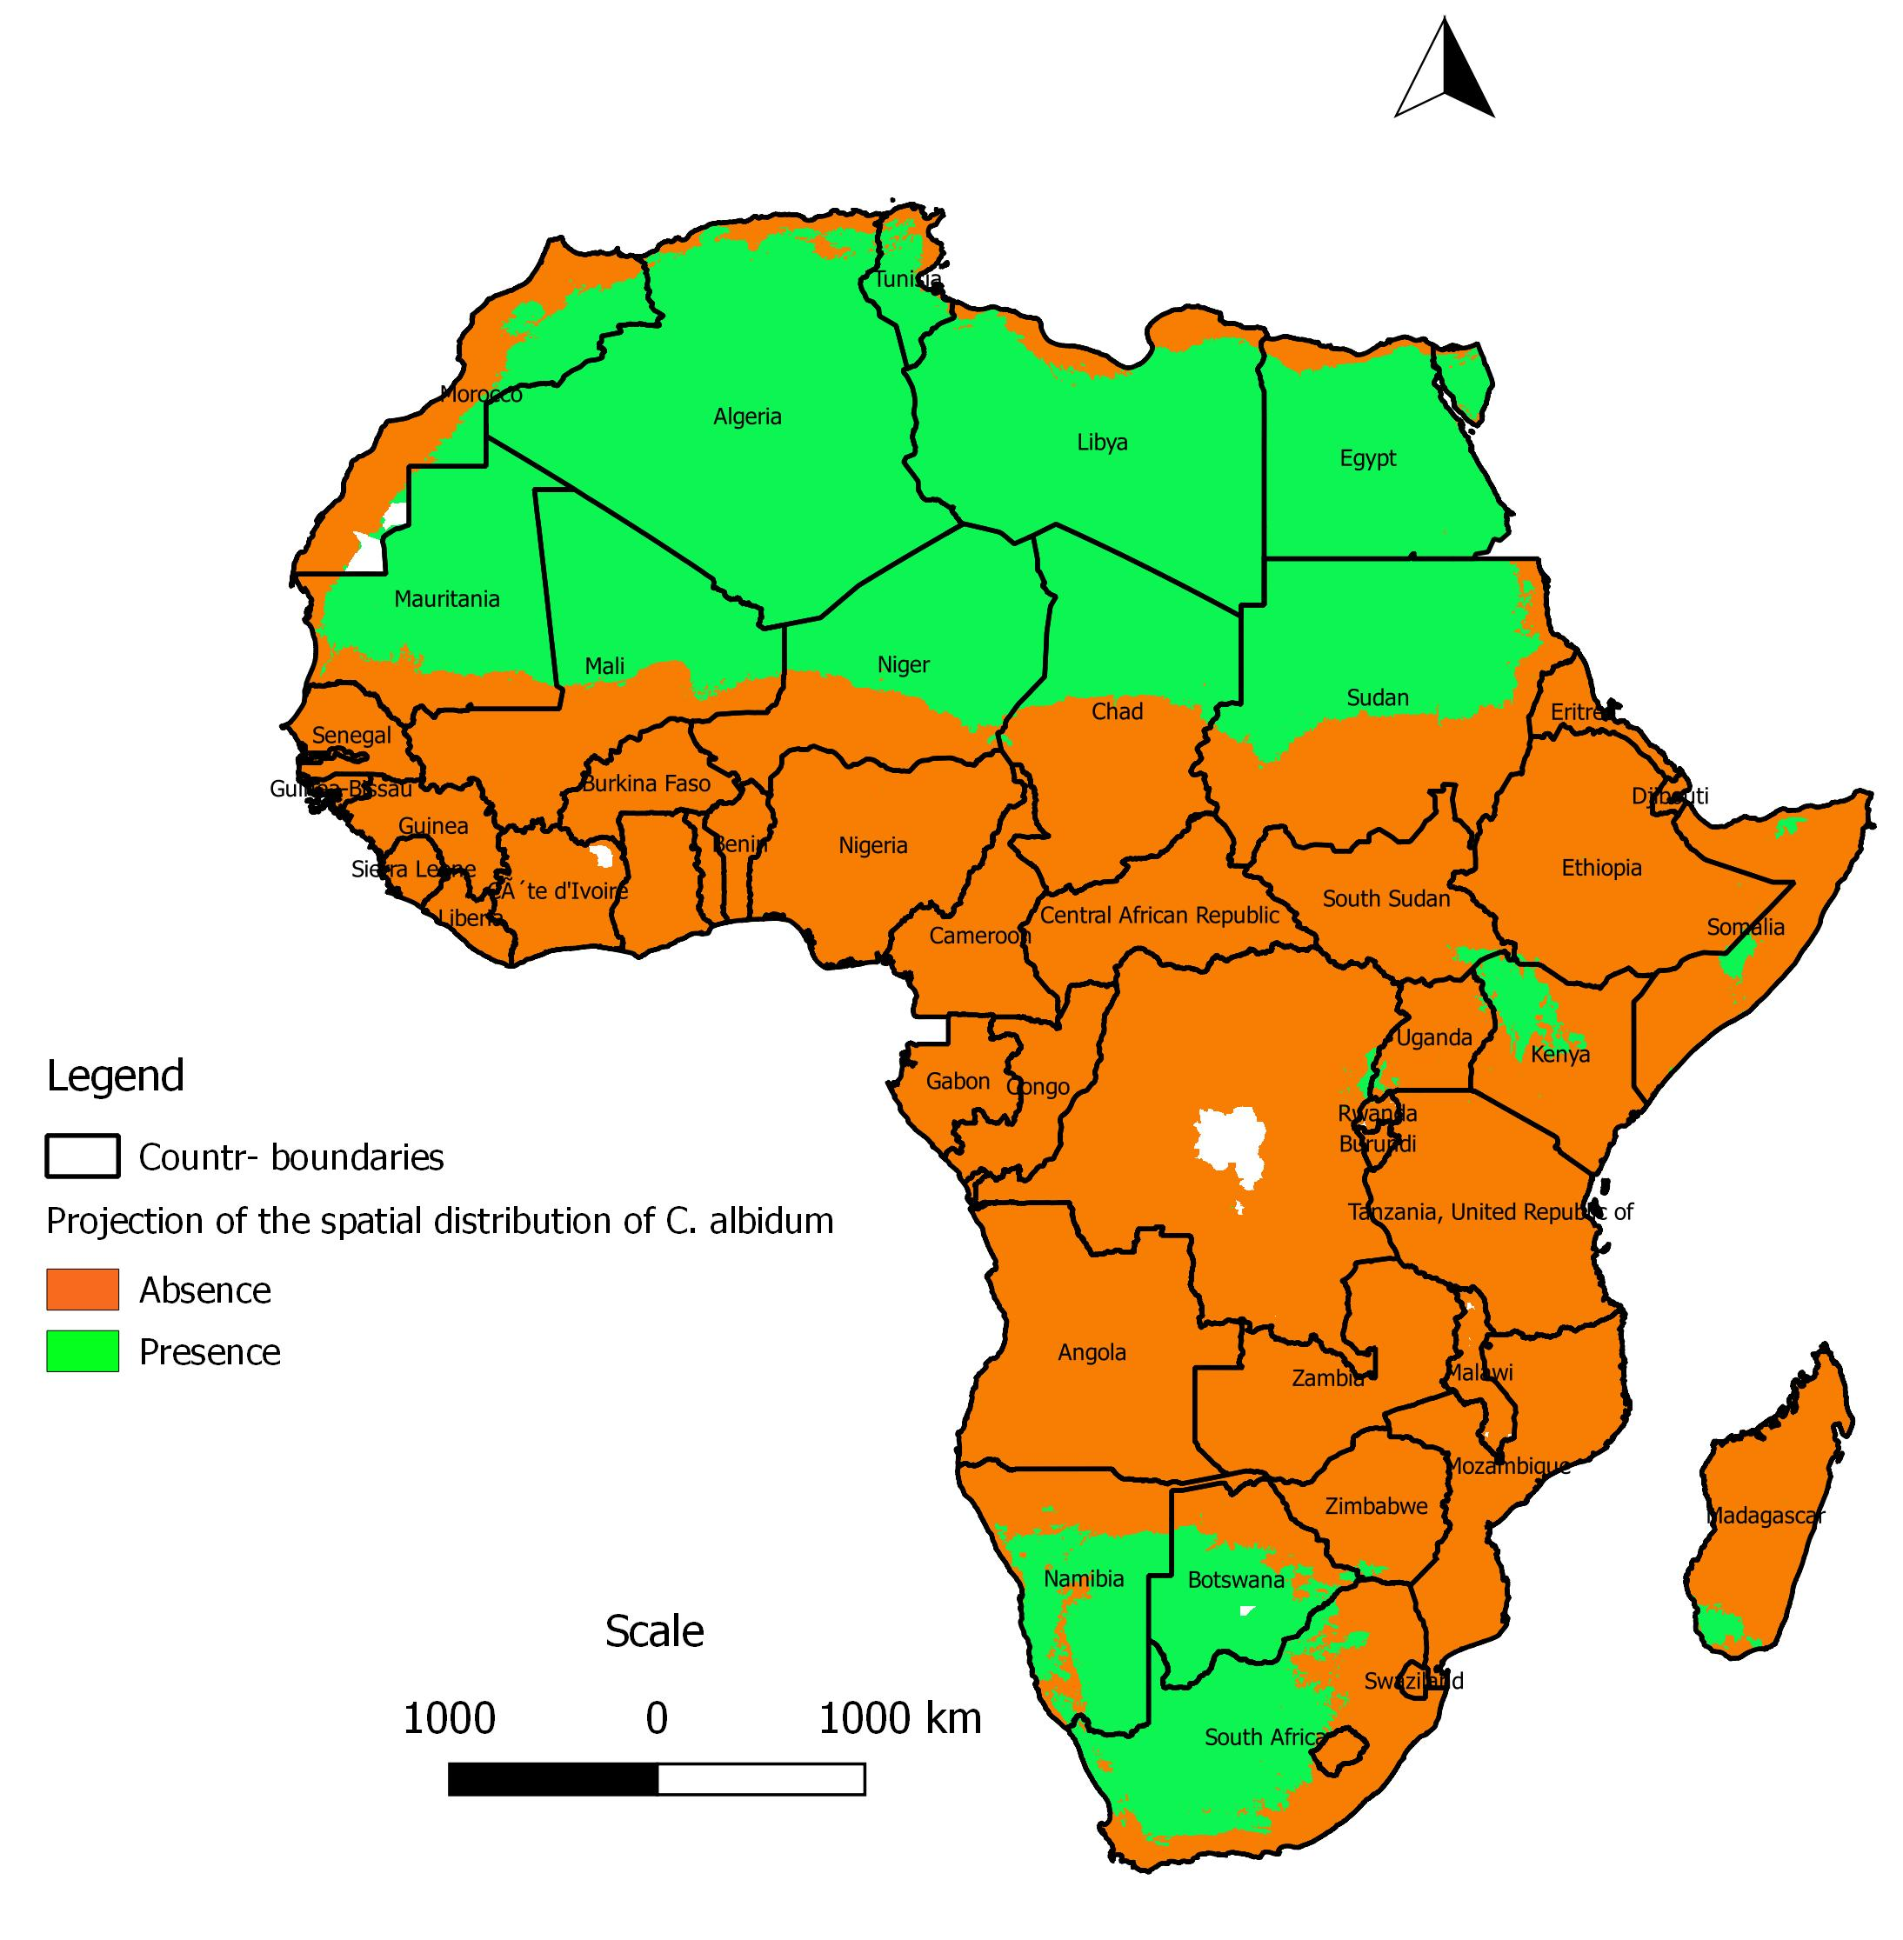
Appendix 1: Projection at present of the spatial distribution of C. albidum across Africa according to GLM

Appendix 2: Projection at present of the spatial distribution of C. albidum across Africa according to GAM or MARS

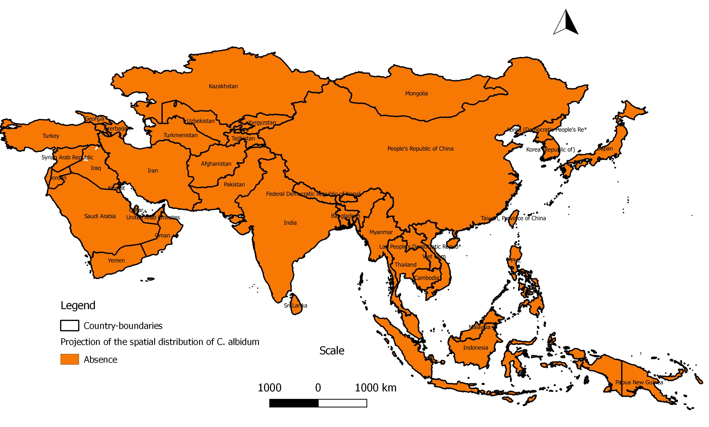

Appendix 3: Projection of the spatial distribution of C. albidum across tropical Asia according to Maxent

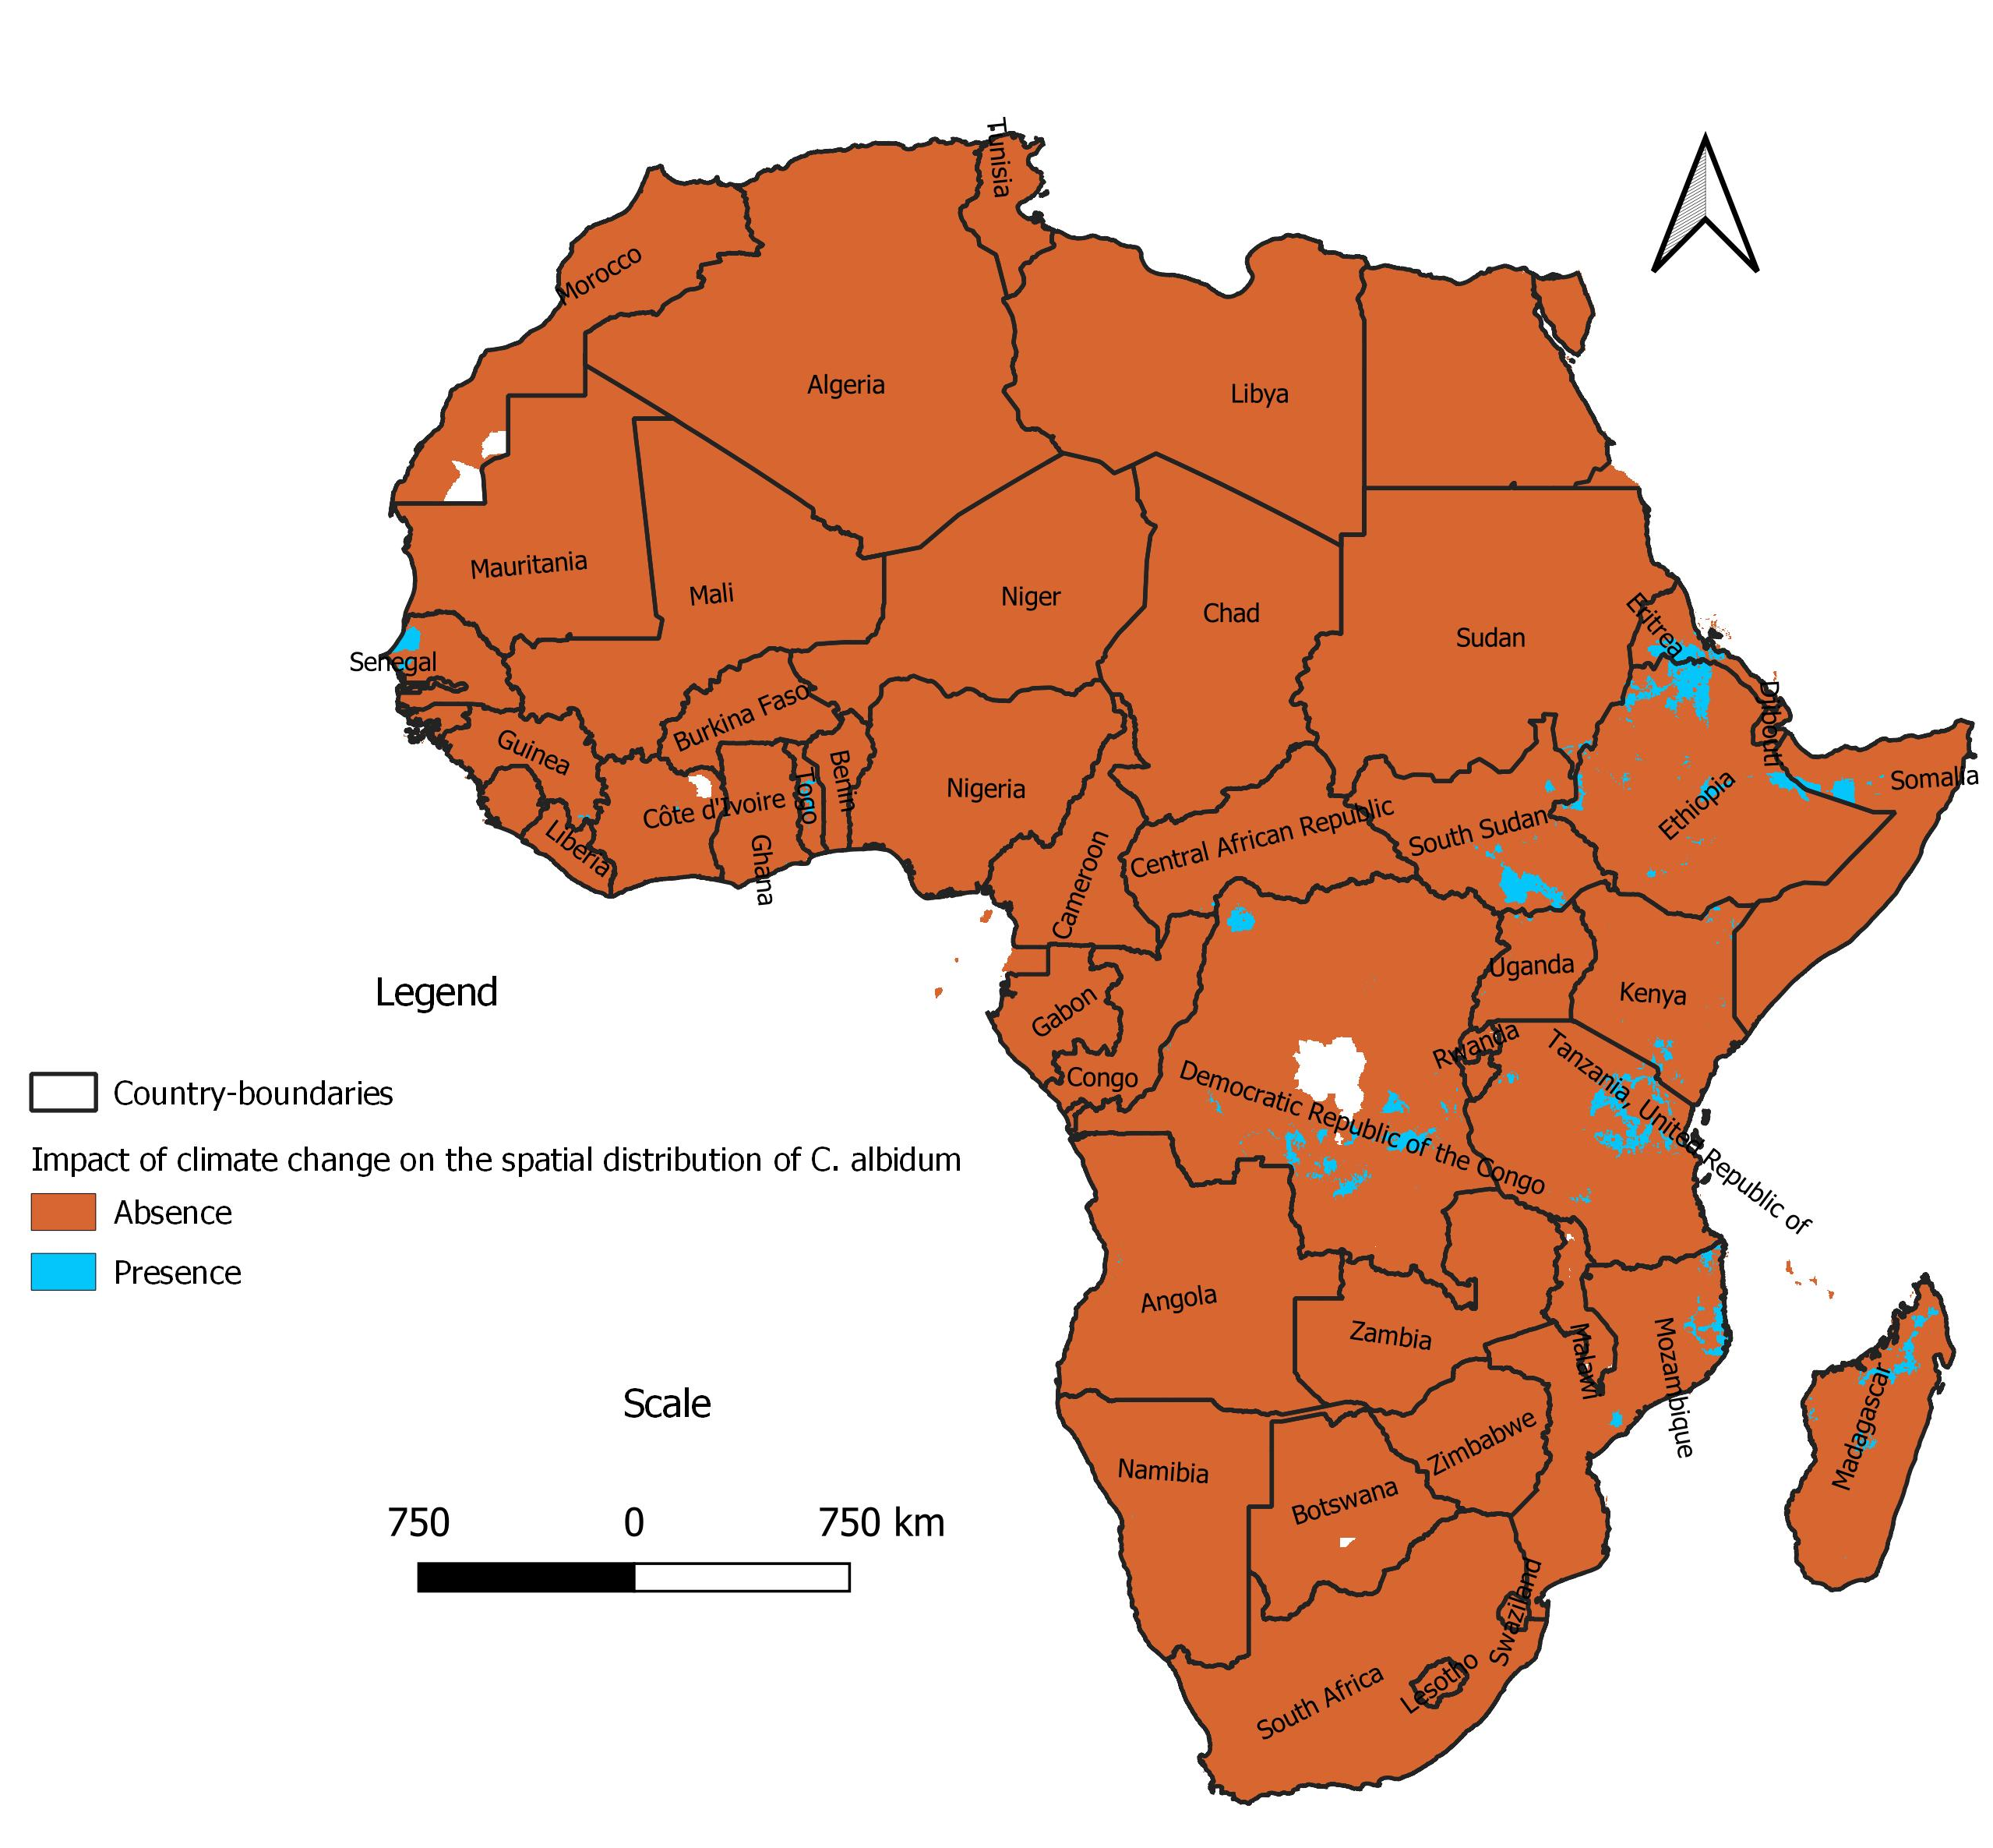

Appendix 4: Loss of favorable area of C. albidum with Africlim at horizon 2055, rcp 4.5 with respect to present, according to Maxent

(b)
(a)
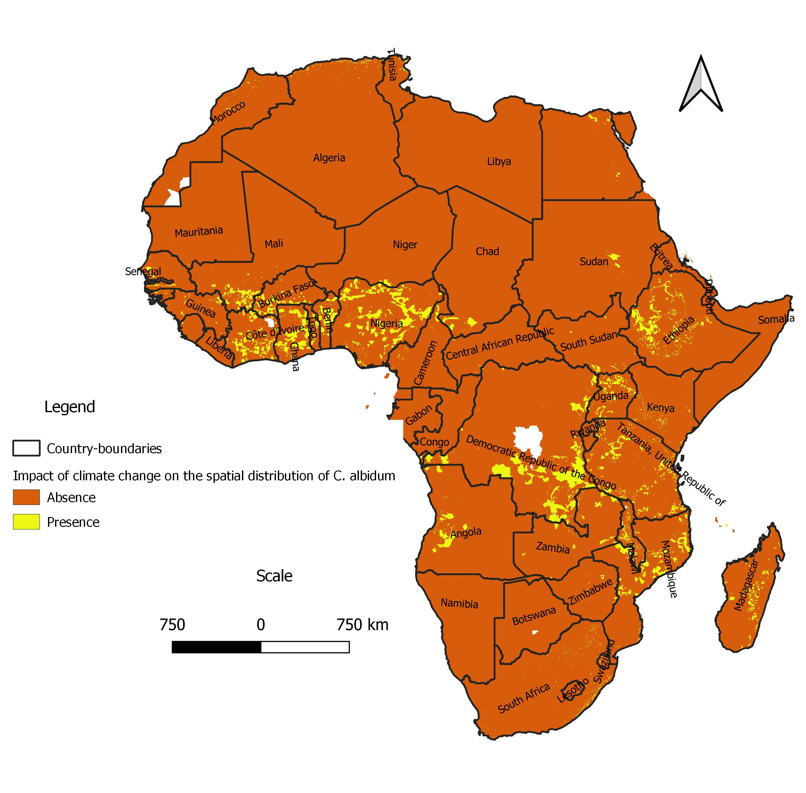
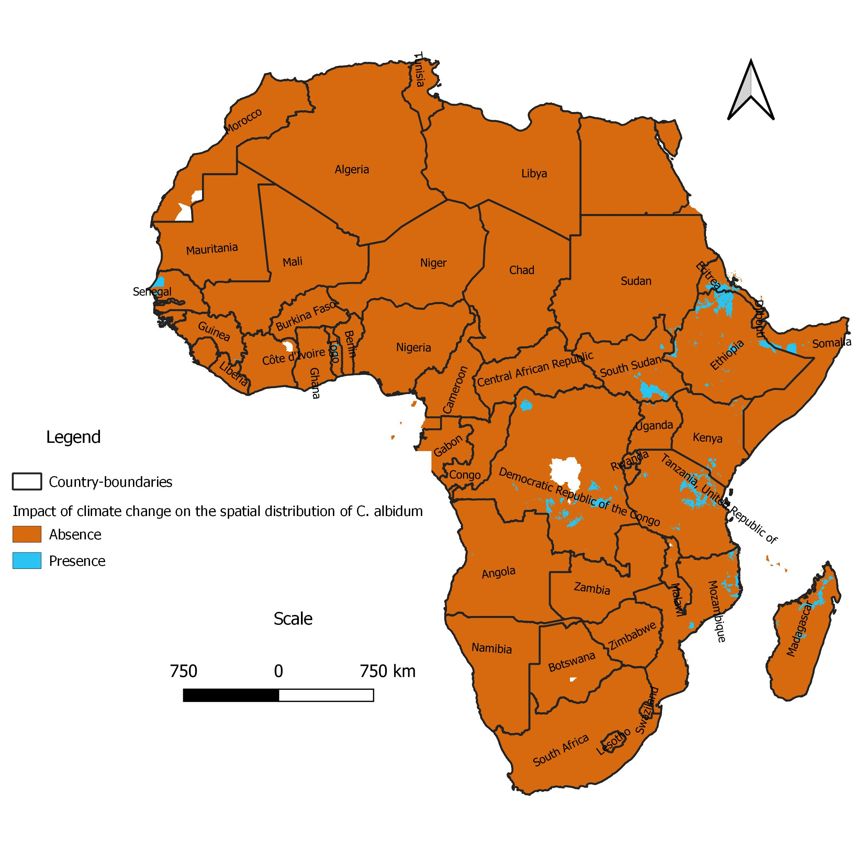

Appendix 5: Spatial distribution of C. albidum across Africa according to Maxent under rcp 8.5 horizon 2055 : a) extension of favorable area with respect to rcp 4.5., and b) loss of favorable area with respect to the present.

