Additional file 2: Directed acyclic graph
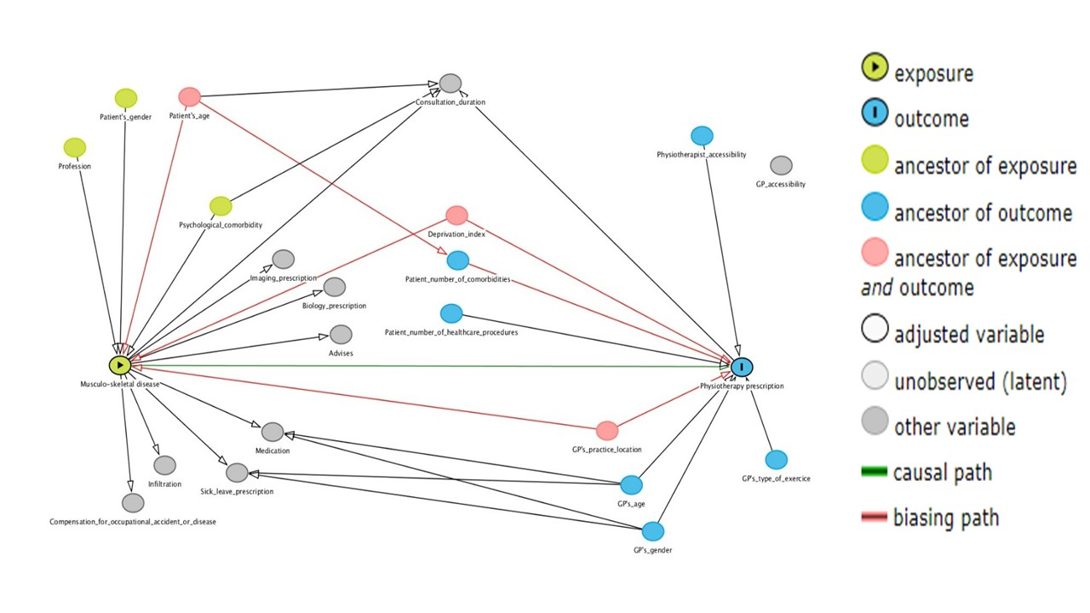
This directed acyclic graph is based on literature findings and was used to identify relevant clinical variables and potential confounders

